Feedbacks on Audit Software 1.0
26 January 2023

No | Details | Screenshot | Response from IT
1 | Comments section is undeletable/ uneditable – to have the function to delete/edit comments by the creator/ team lead
2 | To create a temporary section to store all the superseded files after new upload (up to 2 latest versions). This section must be cleared/deleted before archive. For example:  Before upload  Main storage section:  File A (v1)  After upload  Main storage section:  File A (v2)  Superseded storage section:  File A (v1)
3 | When a file with the same name but placed inside the trash bin is uploaded, the new file uploaded directly update the file in the trash bin despite reflecting the file on the main page. | Deleted file in recycle bin  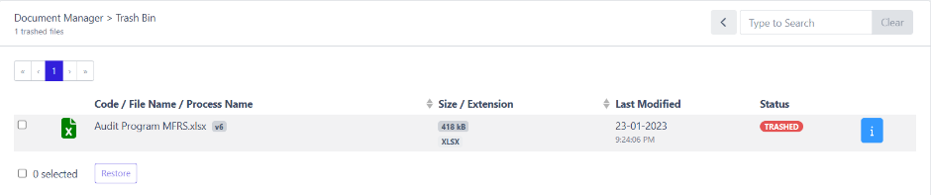  New version upload but reflect in the recycle bin instead of document manager  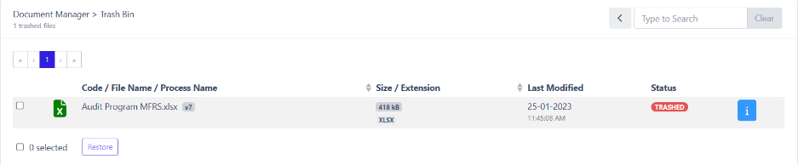
4 | “Browse” button -> change to "Upload"
5 | What would happen if we reach full storage? To consider of having the need to expand the storage in the future for archiving purposes. | 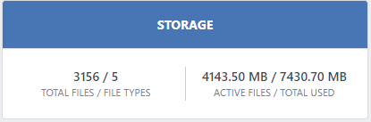
6 | Under activity:  - to consider of having a link to specific process on the files commented | 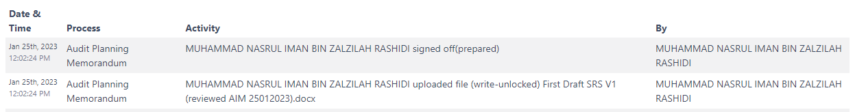
7 | Is there limit to file size uploaded?
8 | To add deadlines for archiving (60 days after the signing date). If the engagement team does not archive within the stipulated time, audit software will not be able to archive.
9 | To add restriction in the software – all team members including team leader/audit partner shall not be able to sign-off after date of signing
10 | To have a specific column/ area for us to see the preparer and reviewer sign-off (together with the date) on each process. | The sign off will appear as follow:
  Document name | Preparer sign-off | Reviewer sign-off
  File 123 | MFBA 23/01/2023 | AIM 26/01/2023
 | The job summary to have a:  - numbered days to the deadline to create urgency of the deliverables  - numbered day to the archiving date.  To have a notification sent to team lead/ reviewers’ email on daily basis, 3 weeks before deadline. | 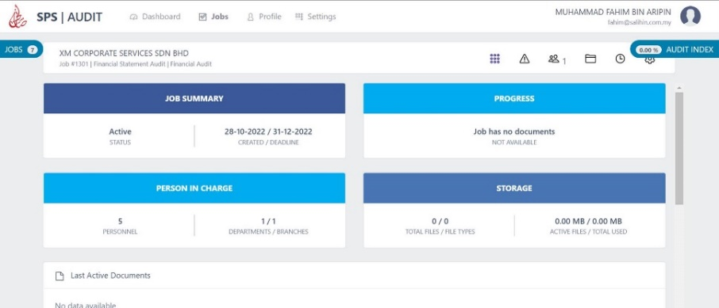
11 | For the issues raised by the reviewer, we would suggest to have a button that allow the preparer to the address and clear the issue on top of have it seen in the activity history of the respective engagement.
12 | Under document manager, to have a process called “Permanent Audit Files”
13 | To have another column to link the issues to specific document / process | 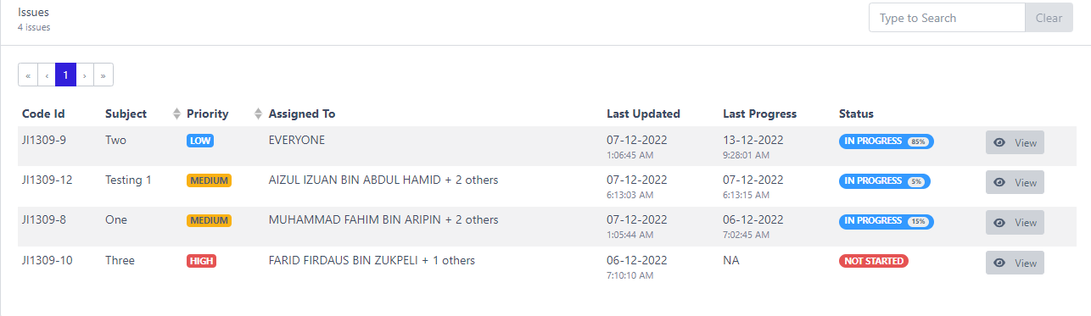
14 | To allow the user to set their own initial in profile setting details
15 | To incorporate hand over features/ assigned task - suggest to add on hand over button to assign document/ process for review (similar as task assignment function).  Reviewer will receive notification within the system or via email.
16 | To have a function of co-team lead. Team leader can delegate/assign his authority to co-team lead to execute his/her role (for example, unlock locked files)
17 | Process that requires EP sign-off must be evidenced by the sign-off by the partner in the reviewer column (as mentioned in item #10 above) in the audit software. If the partner did not sign off, the audit software will not be able to archive.
18 | Whenever a new document (that has already been signed-off) is uploaded, the document/process is required to be re-sign off by both preparer & reviewer.
19 | For each process, there must be a document attached before archive. If there is process without any document attached, the software will not be able to archive.

