SPS 14.01.05 User Manual

Installation

STEP 1: First of all, please insert or plug-in your SPS thumb drive into your machine. Select the language that you prefer to use during the installation either in English or Malay.

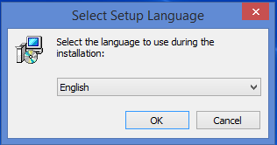

Click OK to proceed

STEP 2: Welcome to the SPS Setup Wizard. This installer will install the SPS Version 14.01 on your computer. It is recommended that you close all the other applications before continuing. Click Next to continue, or Cancel to exit the installation setup.

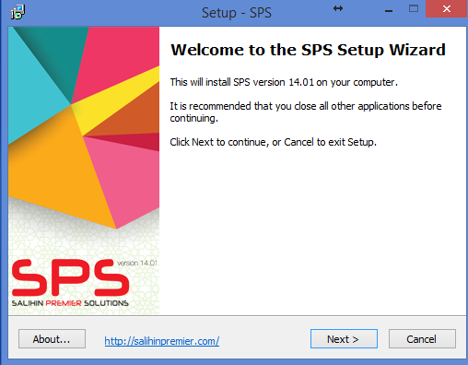

Click Next to continue

STEP 3: In this part, the list of component will be installed automatically. Then, click Next button.

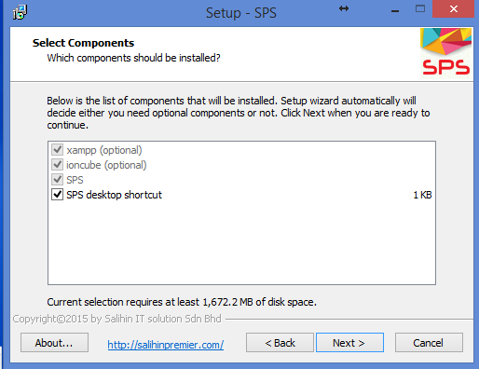

Click Next to continue

STEP 4: Click Install button to continue with the installation, or click Back button if you want to review or change any settings.

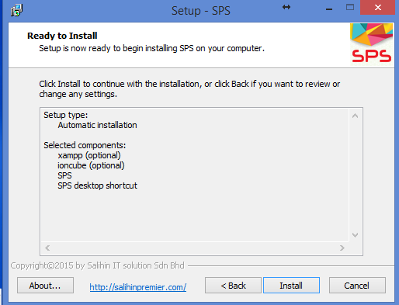

Click Install to continue with the installation

STEP 5: Please wait while Setup install SPS on your computer.

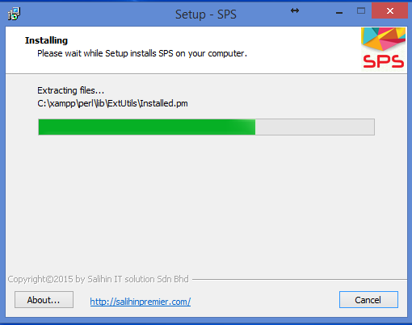

STEP 6: Congratulation! Setup has finished installing SPS on your computer. Please make sure that you RESTART your XAMPP before you tick the Open SPS registration on browser localhost/sps/installation option. Click Finish to exit Setup.

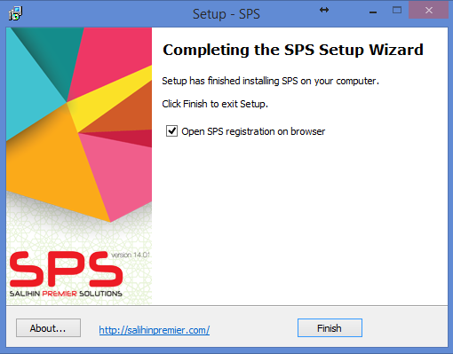

Click Finish to exit Setup

STEP 7: Type localhost/sps/installation. You will see the Welcome to the SPS Version 14.01 Setup Wizard. Click Next to continue.

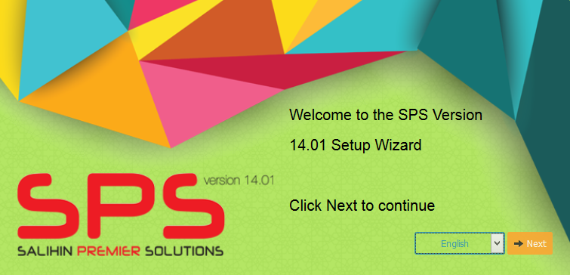

STEP 8: To continue, you have to accept the software license agreement by clicking the box. If you do not agree with the license agreement, the Next button will be disabled.

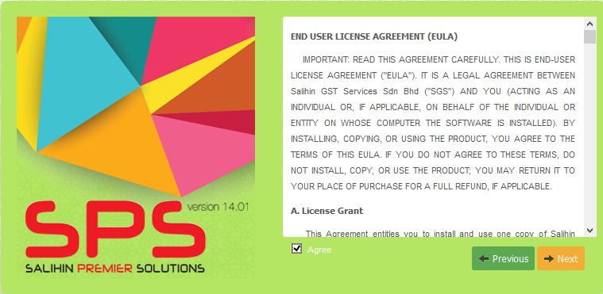

Click and tick the checkbox button here

STEP 9: Check your email, we have send Username/Email and Password. You need to enter your Username/Email, Password and Serial No that located at your SPS Packaging. Then, click Next button to continue.

Note: Make sure there is no SPACE when you copy and paste. IF you are failed to validate, please contact your Dealer.

Auto generate installation code

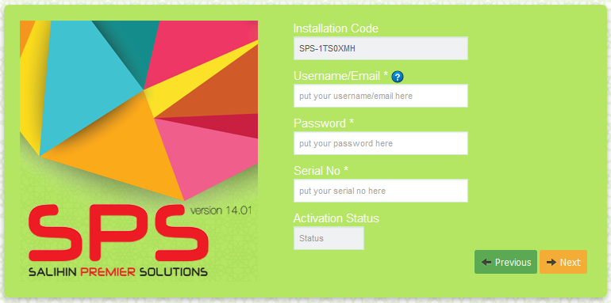
Activation status will be change to ‘Active’ with green colour if you enter the right information.

STEP 10: Check the Pre-Installation. Click Confirm Install button to continue.

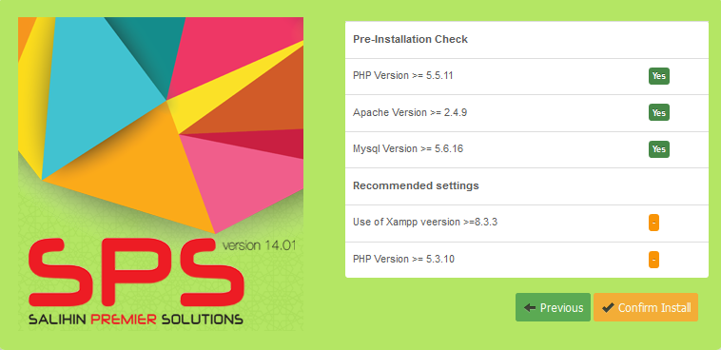

STEP 11: Once finished, you will see this interface. Here, you will enter the following details:
Username: demo
Password: demo
Company: Demo Demo Sdn Bhd [demo]

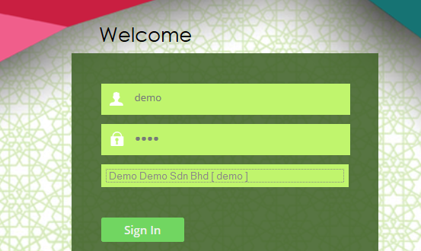

Setting Up

1. SPS Setup Flow

Note: For further details to setup your SPS, you can refer to Admin and General Setup Module in SPS User Manual.

2. Register Company

SCREEN: HOW TO GET COMPANY ACTIVATION KEY
To get your company activation key, please follow the steps below:
- Open new browser and type demo.salihinpremier.com/ss-ss/customerlogin
- Enter your username and password. (Please check your email OR you can call Support Team to get the details).
- Next, click the SPS License as shown below.

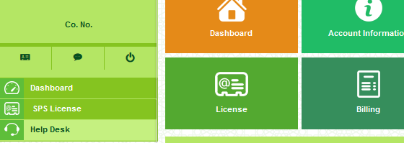

Next, click the link of SPS SerialNo. Then, click continue to proceed. You will be directed to your SPS License details. Scroll down and go to SPS Registered Company Key section.

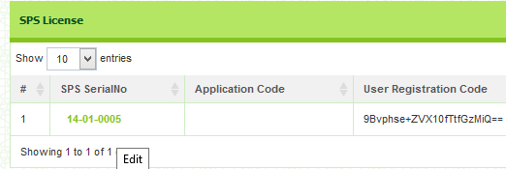
Click your SPS SerialNo here to proceed.

Go to SPS Registered Company Key. Then, click Add Company button.

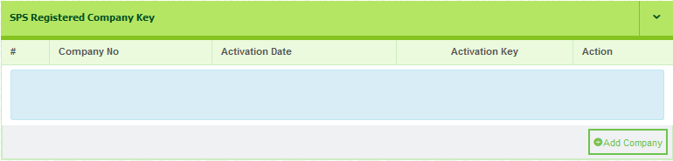

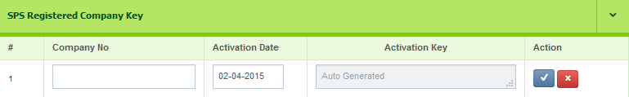
Once click, you need to entered Company No. Activation Date and Activation Key will be generated automatically. Next, click save button.
666768-V
Save Button

9999-T

Note: Make sure there is no SPACE when you copy and paste. IF you are failed to validate, please contact your Dealer.

Next, copy your Activation Key.
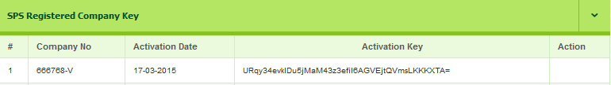
9999-T
02-04-2015

Then, open your Company Master page in SPS. Paste your Activation Key and paste the code into Company Activation Key column besides Company No.

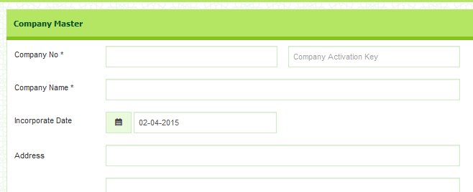
AHMED FURNITURE SDN BHD
9999-T

GENERAL LEDGER
Setup > Financial Year Calendar

You need to setup Financial Year Calendar before start doing any transaction. This refers to the 12-month time frame used to define your accounting year. For example, if a company’s financial year starts on 1 January 2015 and ends on 31 December, this will be Financial Year 2015. If a company’s financial year starts on 1 July 2015 and ends on 30 June 2016, this will be Financial Year 2016.
Start Period refer to the period you want to start the transaction. Basically, if start period is 1, system will assume a company just started its operation and there is no opening balance yet. You will unable to enter the opening balance in Statement of Comprehensive Income.
No of period normally will be 12. However, if your start period is 2, you need to add 1 from 12 period which means the number of period will be 13.
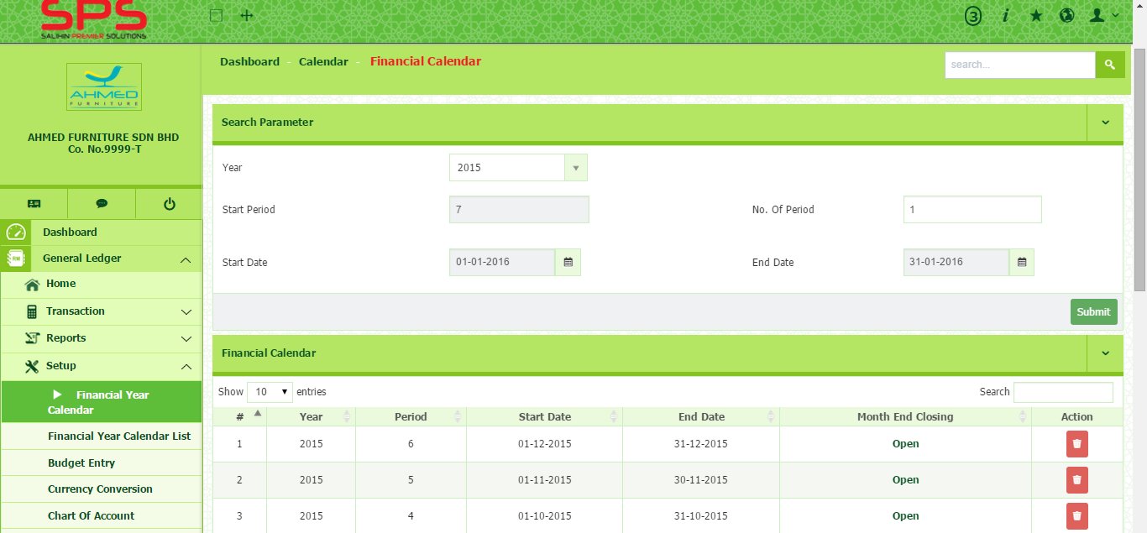
- Go to General ledger Setup Financial Year Calendar.
1
1

- Select Year, Start period, No. of Period and Start Date. The end date will be automatically appeared.
2
2
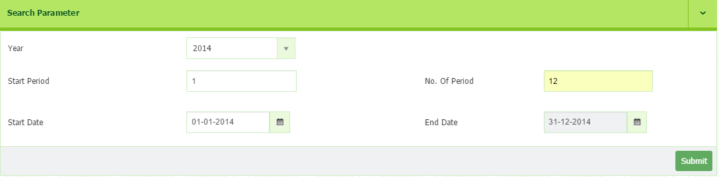
- Click Submit button to save.
- The list of Financial Year Calendar will be appeared.
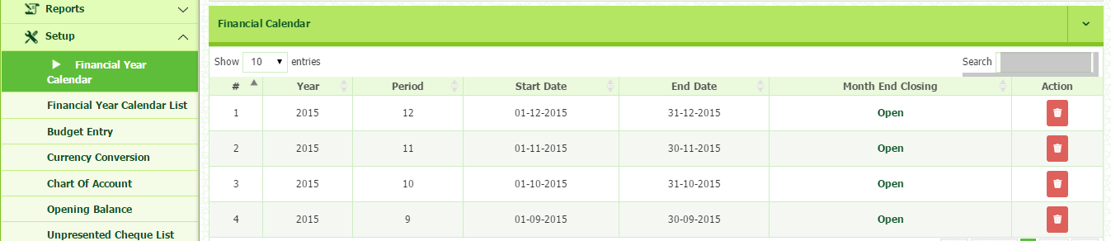

- To change status in the column of month end closing, click at the status “open” or “Close” to modify.
3
3
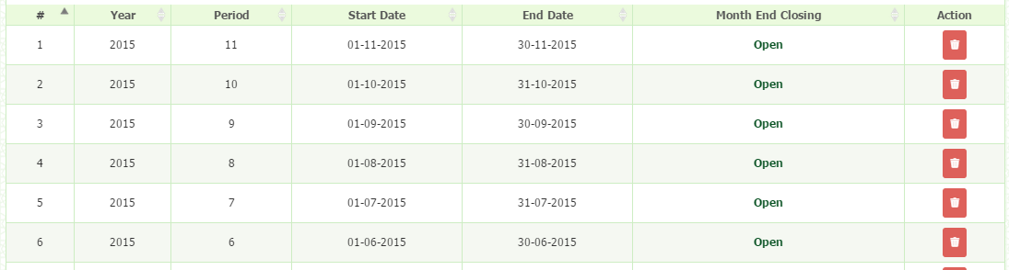
- Click Continue.

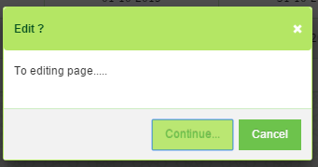

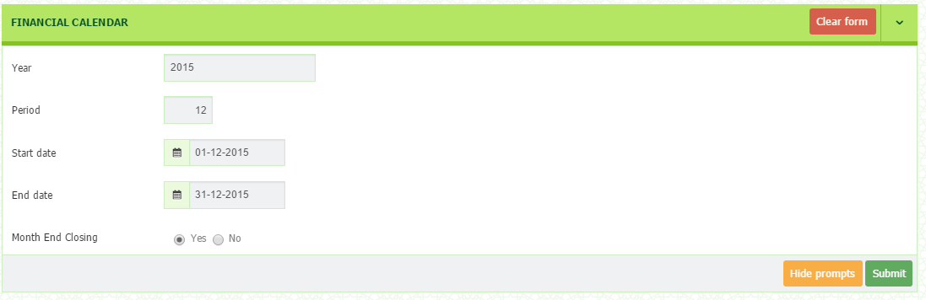
- Change the status at the month end closing row.

- Then, click Submit button to save.

Setup > Financial Year Calendar List
This section will show the list of the Financial Year Calendar.
1
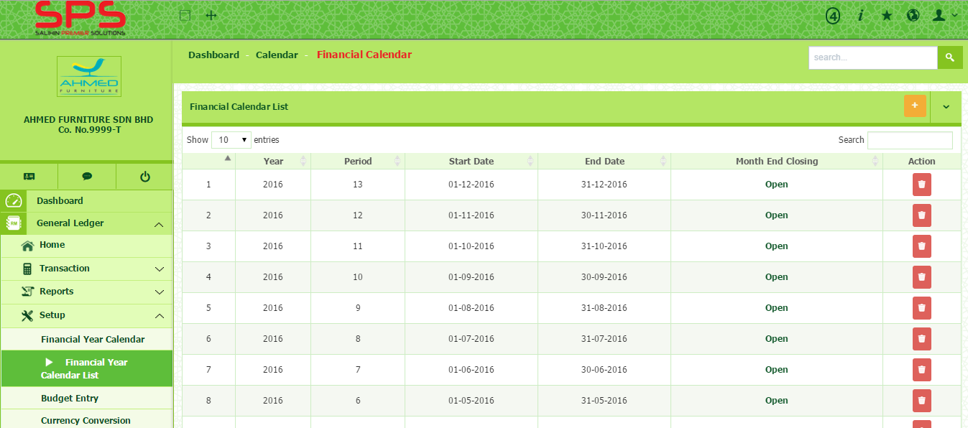
- Go to General ledger Setup Financial Year Calendar List
1

- Click + button on the top of right corner to add New Financial Calendar List
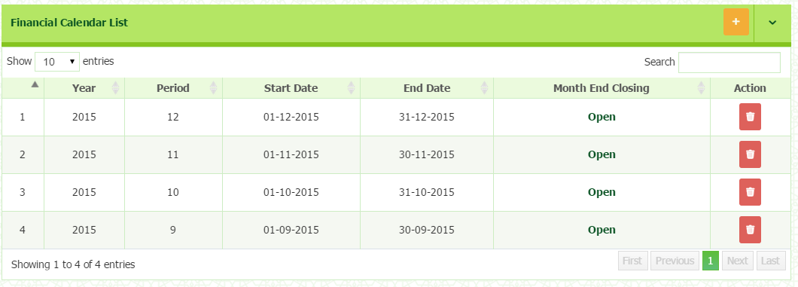

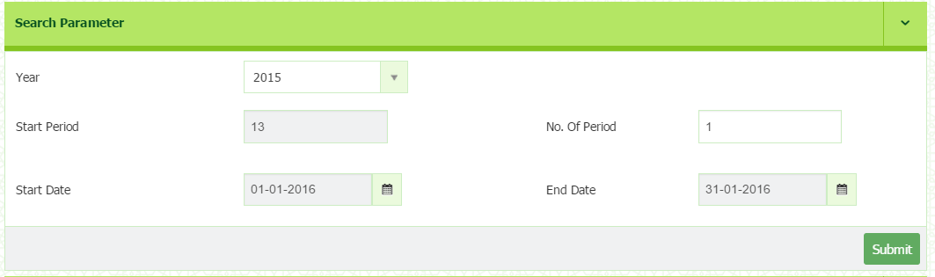
- You will be directed to Financial Year Calendar. Select Year and No of Period correctly.

- Click Submit button to save.
Setup > Budget Entry

1
- Go to General ledger Setup Budget Entry.
2
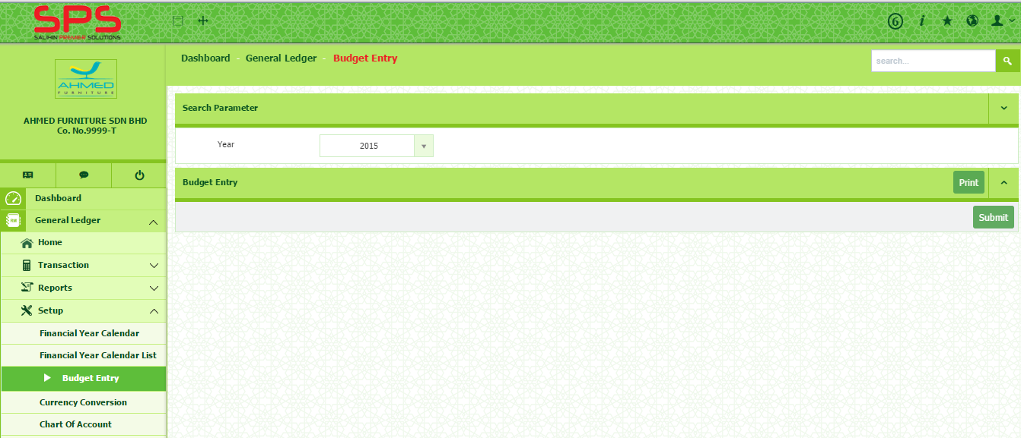
- Select Year
2
1
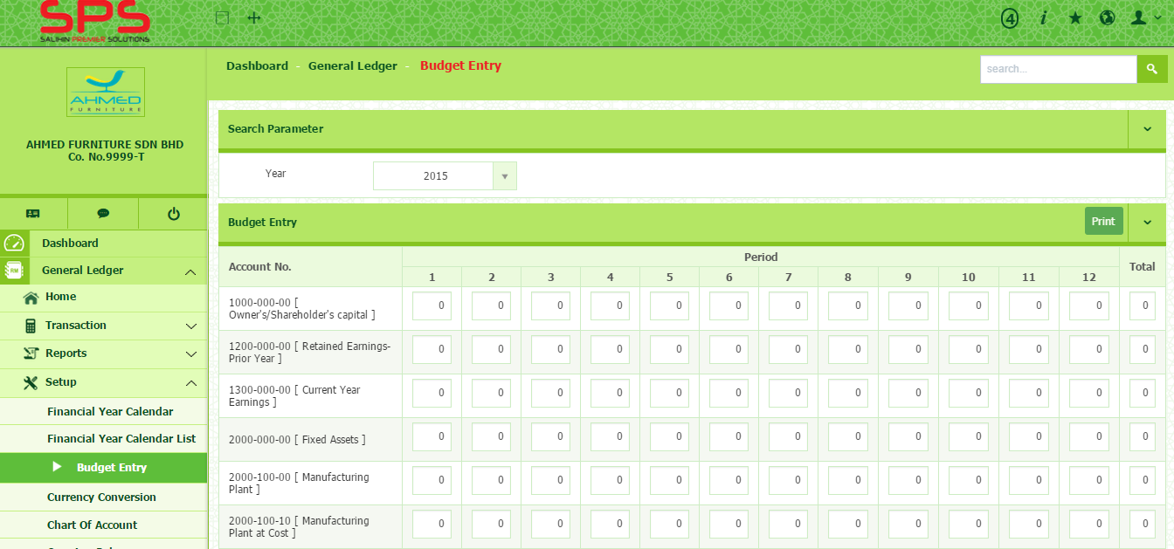
- Enter the budget amount inside the box.
3
3
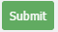
- Click button.
- Click button to print.

Setup > Currency Conversion
Currency Conversion is a tool that converts the value or quantity of one currency into the relative values or quantities of other currencies.
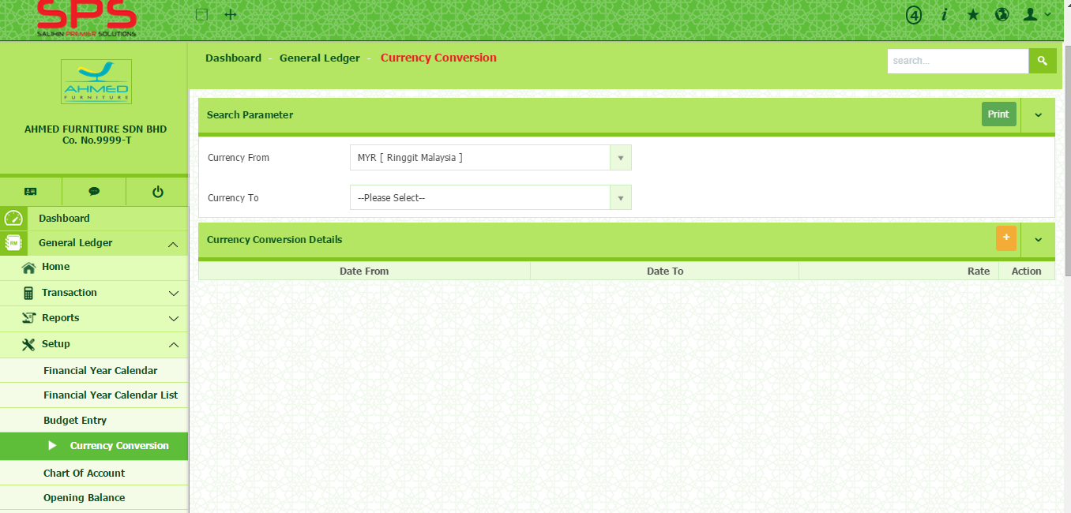
- Go to General ledger Setup Currency Conversion
1
1

- Select which currency you want to convert by clicking Currency From and Currency To.
2
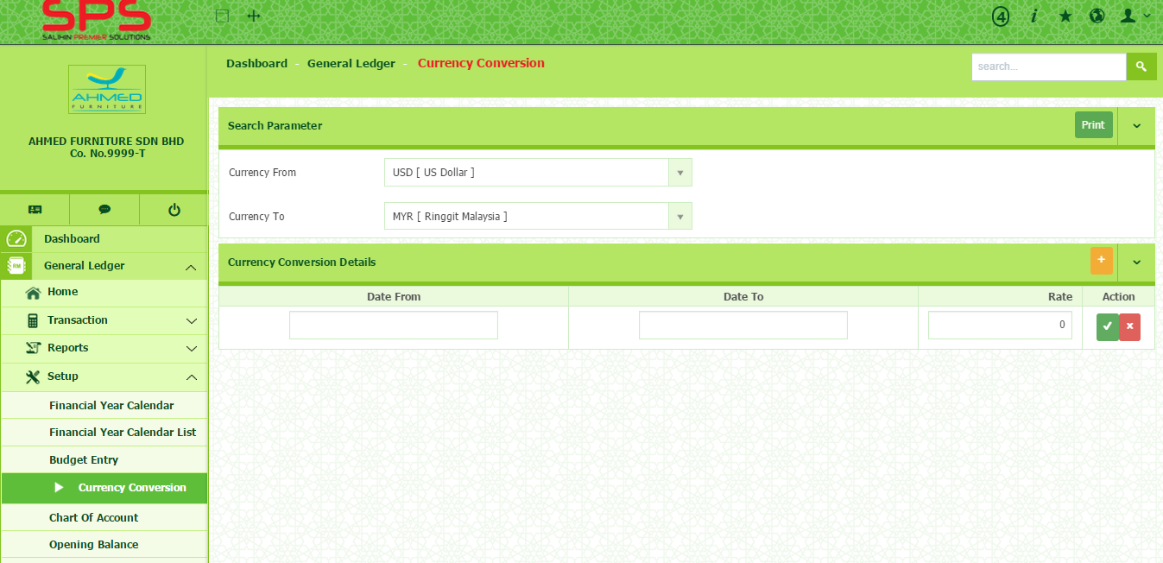
- Click + button on the top of right corner to add currency conversion.
2
- Enter Date From, Date To and Rate. Then click button.

Setup > Chart of Account

SPS have already set up Chart of Account by default. However, you can change chart of account as you prefer.
- Go to General ledger Setup Chart of Account.
1
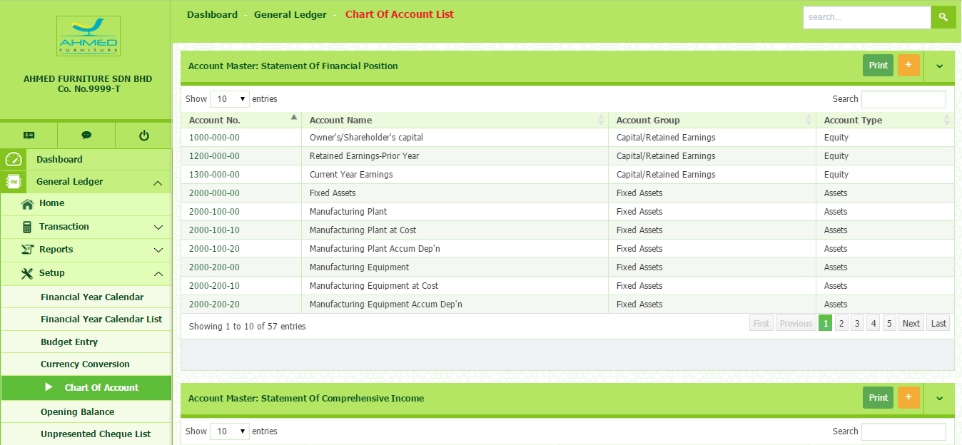
- Click + button to add account master.
1

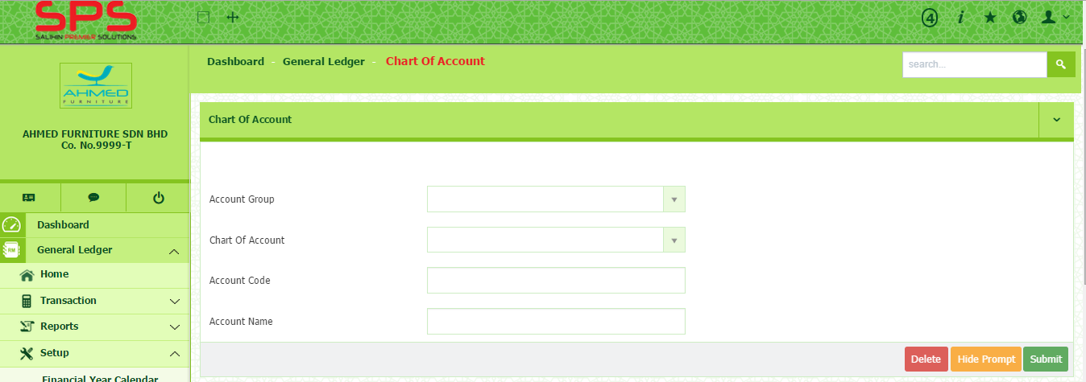
- Select Account Group and Chart of Account.
2
2

- Type account Code and Account Name.
- Click Submit button.
- To delete, click Delete button.

1
Setup > Opening Balance
- Go to General ledger Setup Opening Balance.
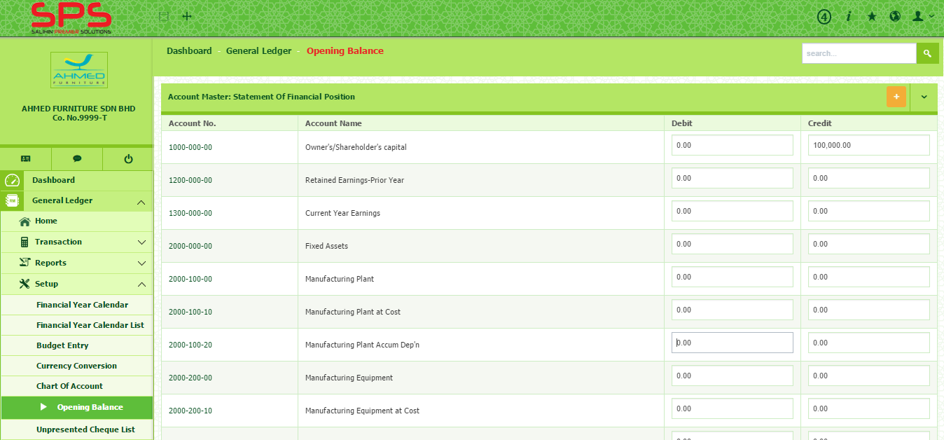
- Key in the amount under Debit and Credit column.
1

Setup > Unpresented Cheque List
1
- Go to General ledger Setup Unpresented Cheque List
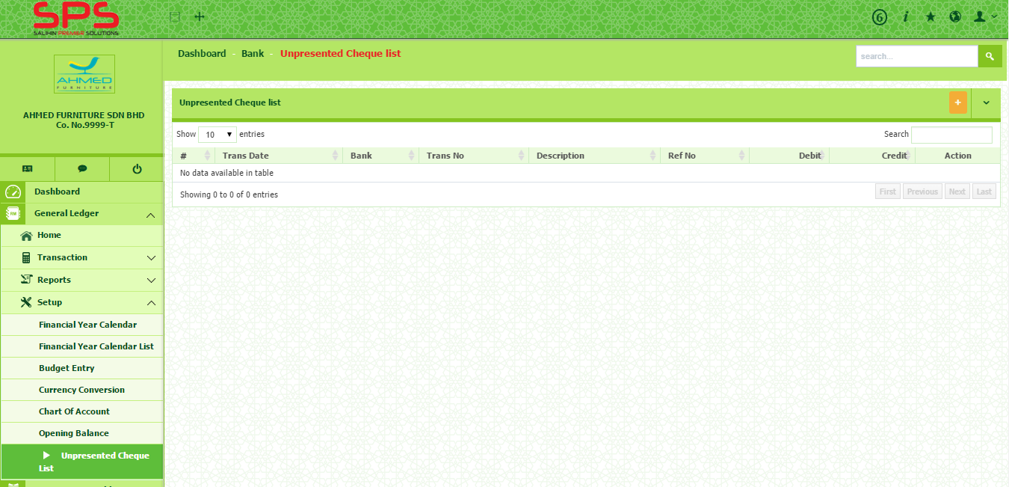
- Click + button to add.
1

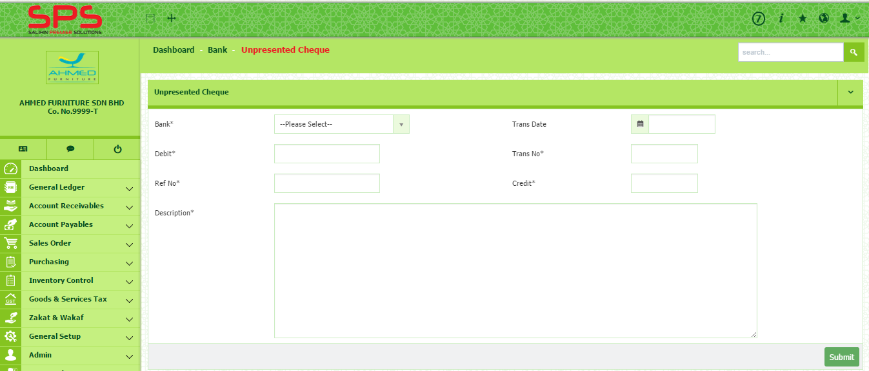
- You will be directed to the Unpresented Cheque List page. Insert all the information required.
2
2

- Then, click Submit button.
Transaction: Journal Entry
General Ledger: How to Setup a Transaction

1
- Go to General ledger Transaction Journal Entry
2
- Enter all the information required.
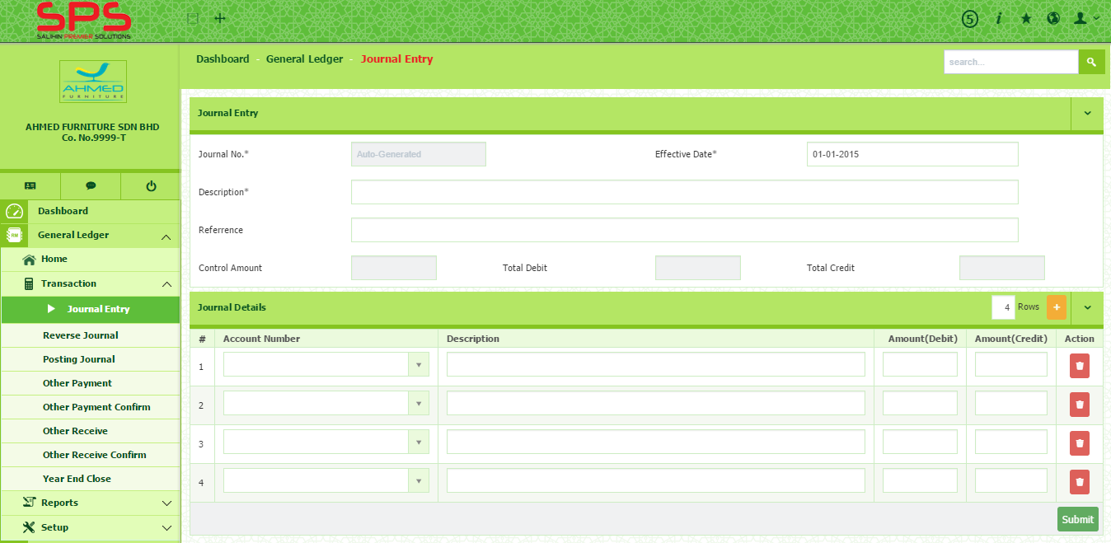
- Click on + button on the top of right corner of the journal details to add transaction.
3
3
2
1

- Select the Account Number from the drop down list. Insert the description and the amount of debit or credit.
- Click Submit button to save.
- Journal No. will be automatically generated once the user click Submit button.
- The transaction will be appeared in the Posting Journal.

Transaction: Posting Journal
1
- Go to General ledger Transaction Posting Journal
2
1
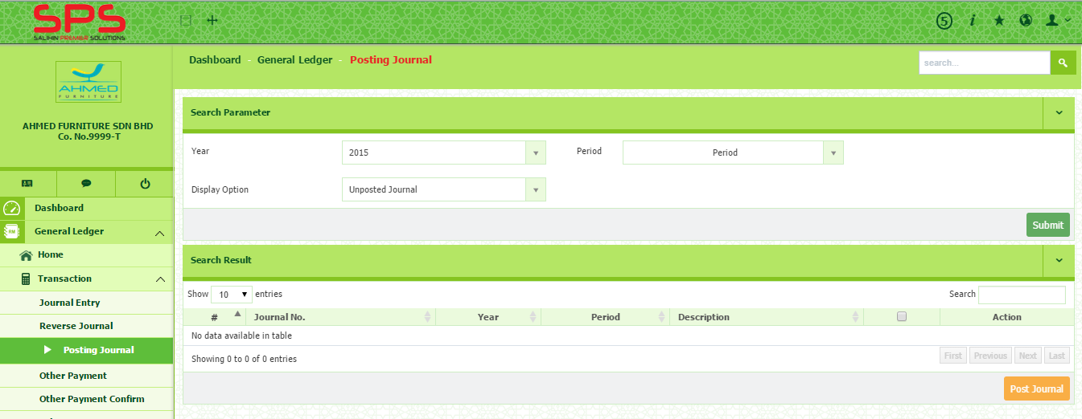
- Select Year and Period then click Submit button.
2
1
- You may see the journal details by clicking on the Journal No.
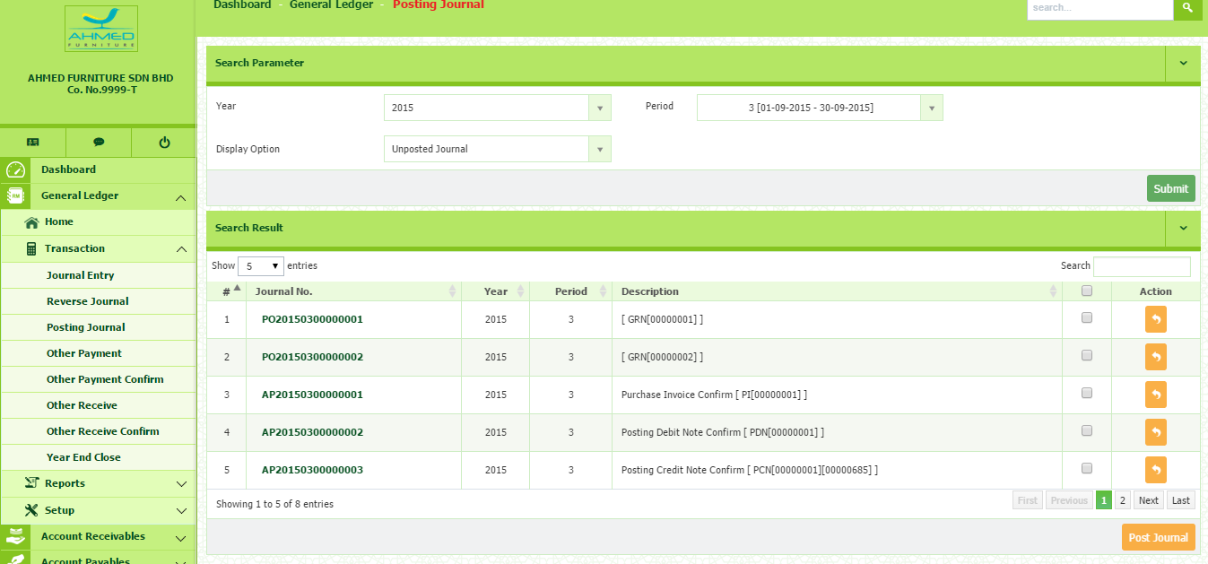
- You need to tick the box before post the journal.
1
- Click Post Journal button to post the journal.
- Please be noted, once the Journal has been posted, you are unable to reedit the details.
Transaction: Other Payment

1
- Go to General ledger Transaction Other Payment
- Key in all the information required in New Other Payment Section. You may type or select from drop down list.
2
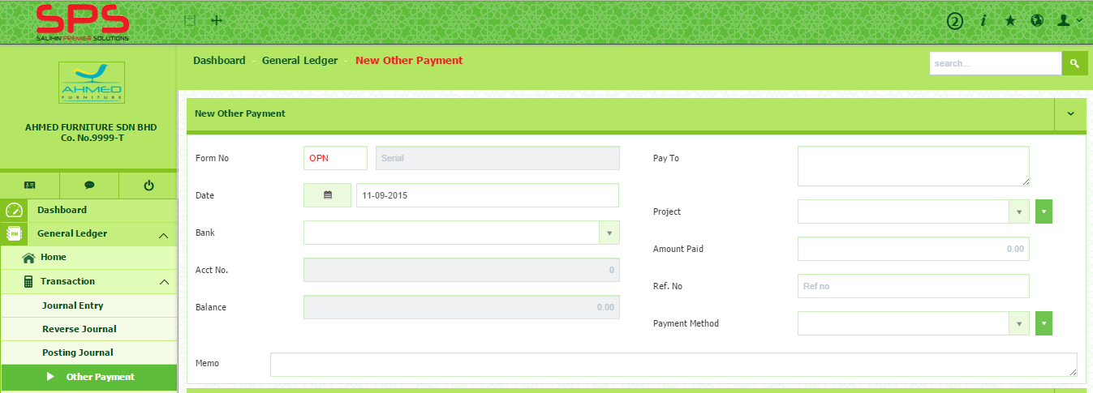
In Payment Details section, click Add New Payment to create payment voucher.
2
1
1
- Select account group and tax code from drop down button. Insert transaction and amount.
2
- Tick the box in column inclusive tax to represent the amount inserted is inclusive of GST.
4
3
- Click button in the action column to save.
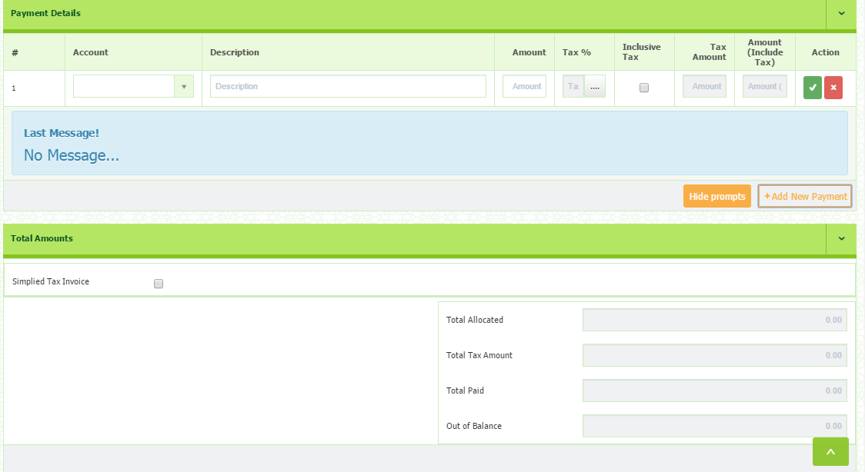
1
4
3
2
1
Transaction: Other Payment Confirm
- Go to General ledger Transaction Other Payment Confirm
2
- Select Year and Period.
3
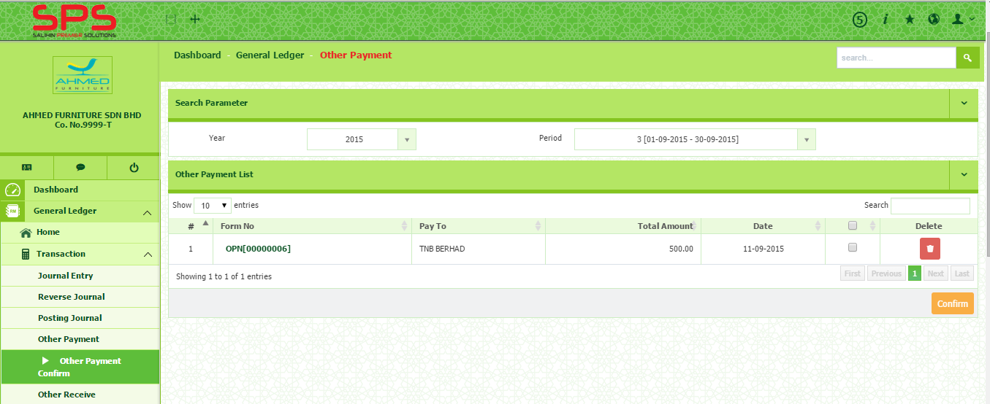
- Tick the box and click Confirm button.
3
3
1
2

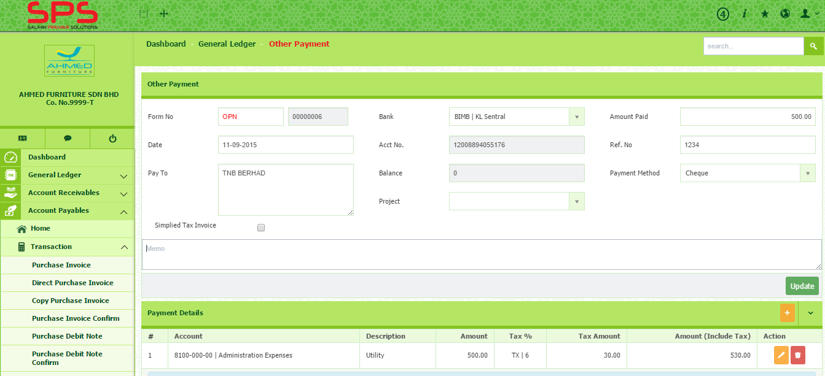
- To edit, click on the Form No. You will be directed to the payment detail page.
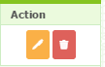
- Click on the in the action column.
- After edit, click on button.
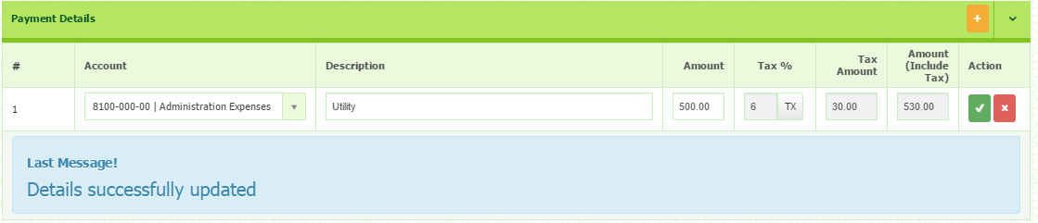

Transaction: Other Receive
1
- Go to General ledger Transaction Other Receive
2
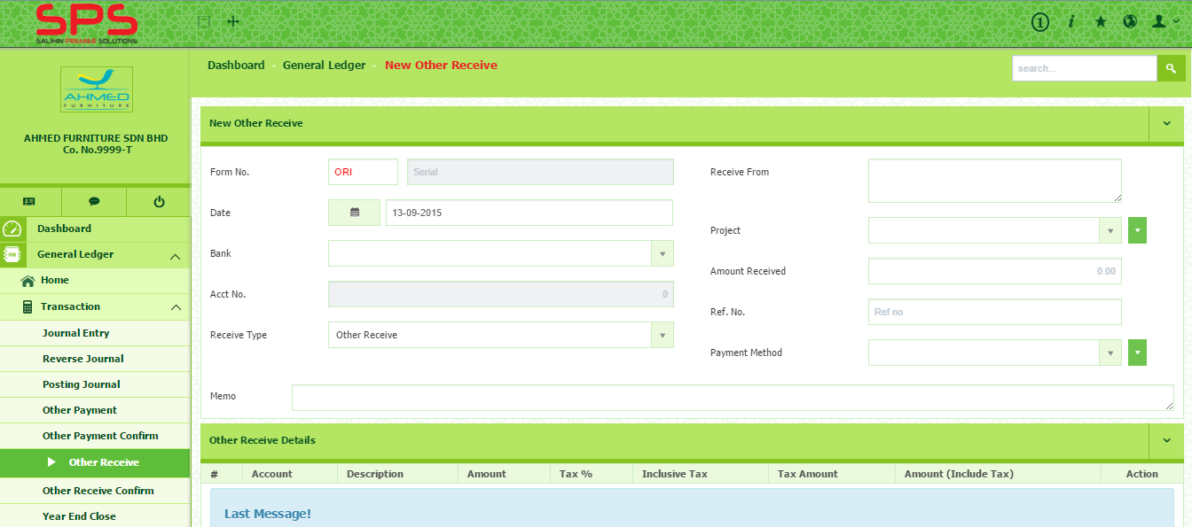
- Fill in all the information required in the New Other Receive section
2
1

- In Other Receive Details section, click Add New Payment to record any payment received.
3
- Select account group and tax code from drop down button. Insert transaction and amount.
4
- Tick the box in column inclusive tax to represent the amount inserted is inclusive of GST.
5
- Click button in the action column to save.
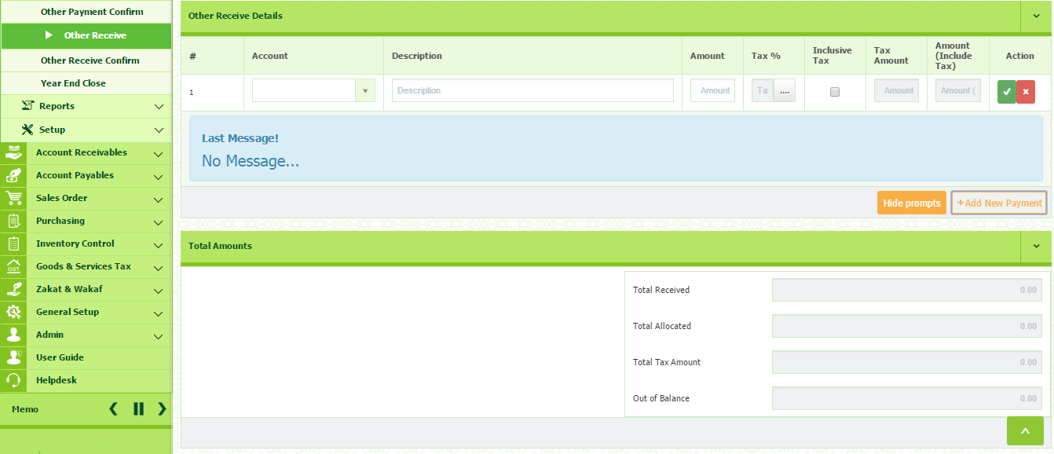
4
5
3

Transaction: Other Receive Confirm
You need to confirm other receive by confirming at Other Receive Confirm
1
- Go to General ledger Transaction Other Receive Confirm
2
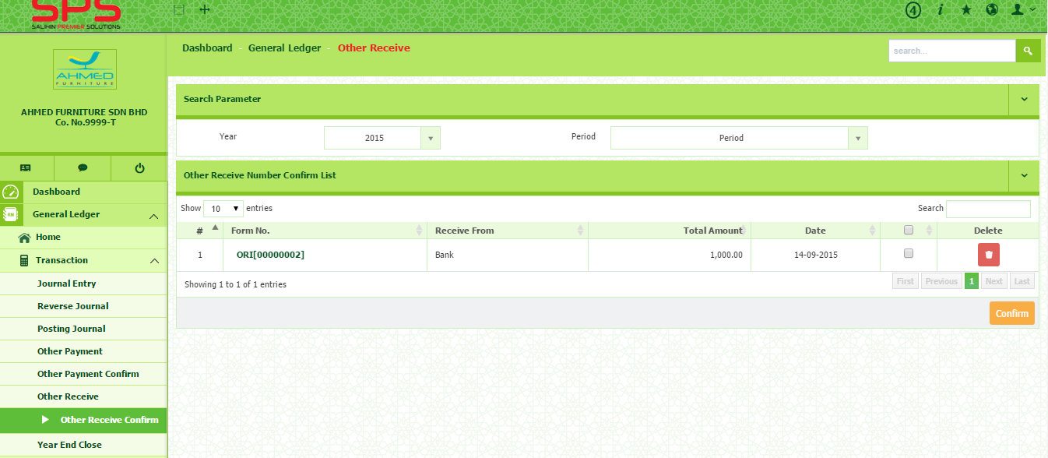
- Select Year and Period.
2
1

- Select Form No that want to be confirmed and tick the box. Then click Confirm.

Transaction: Year End Closing
1
- Go to General ledger Transaction Year End Close
2
- Select Year
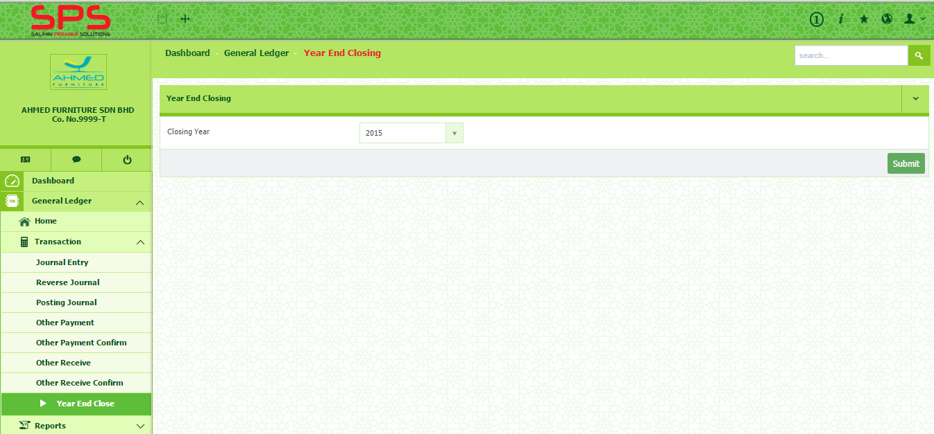
- Click Submit.
2
1
Report: Account Balance Summary
1

General Ledger: How to Setup a Report
Report: Account Balance Summary

- Go to General ledger Report Account Balance Summary
2
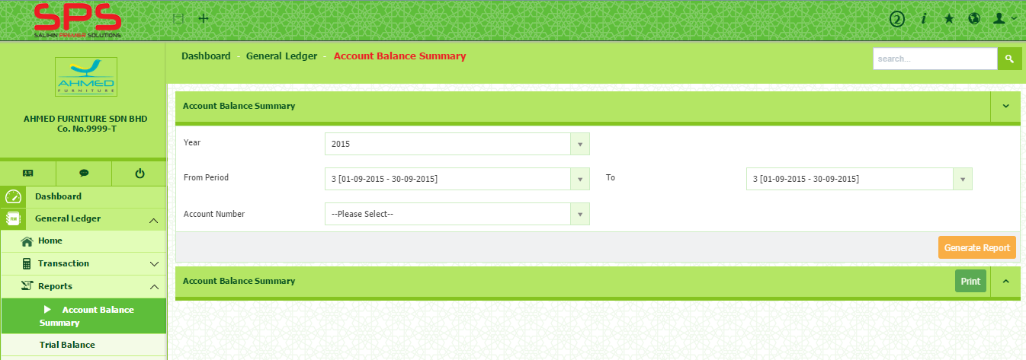
- Select Year, Period and Account Number
2
1

- Click Generate Report button to generate the report.
- You can print the report by clicking Print button

1
Report: Trial Balance
- Go to General ledger Report Trial Balance
2
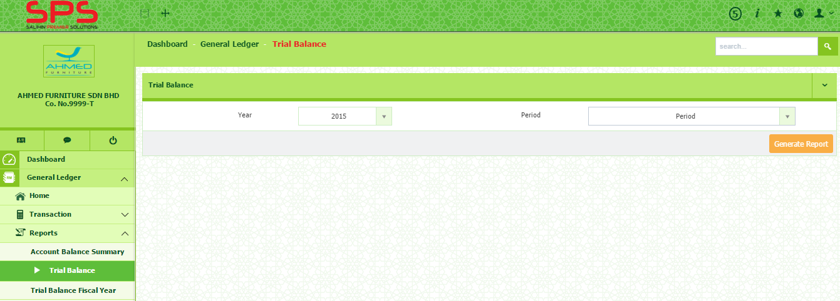
- Select Year and Period
2
1

- Click Generate Report button to generate the report.
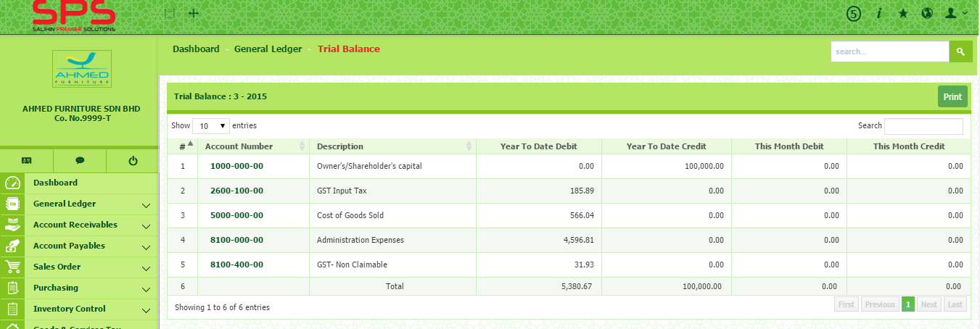
- You can print the report by clicking Print button

1
Report: Trial Balance Fiscal Year
- Go to General ledger Report Trial Balance Fiscal Year
2
- Select Year.
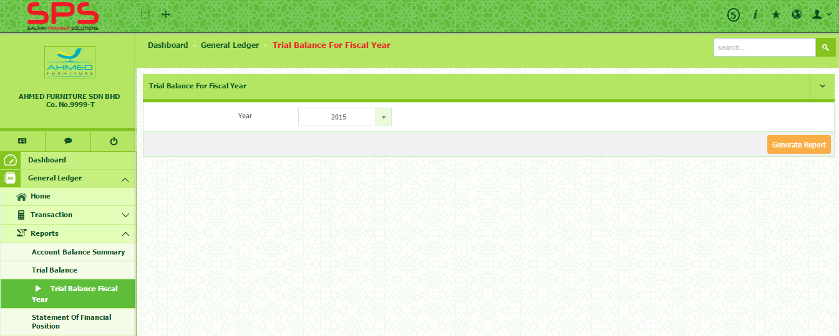
- Click Generate Report button to generate the report.
2
1

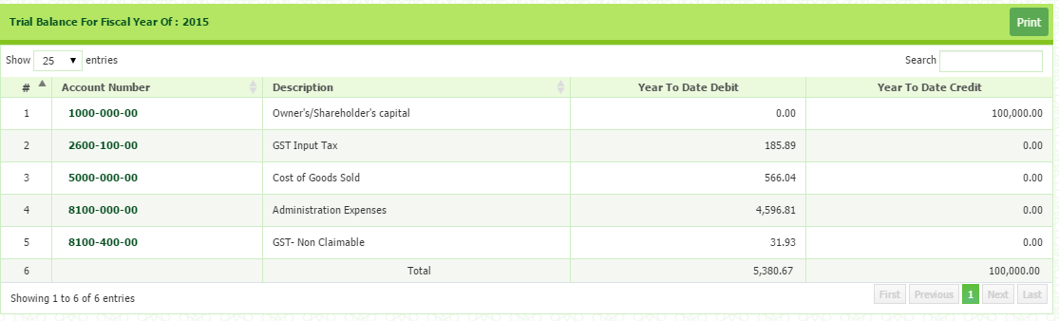
- Once report is generated, you can print the report by clicking Print button

1
Report: Statement of Financial Position
- Go to General ledger Report Statement of Financial Position
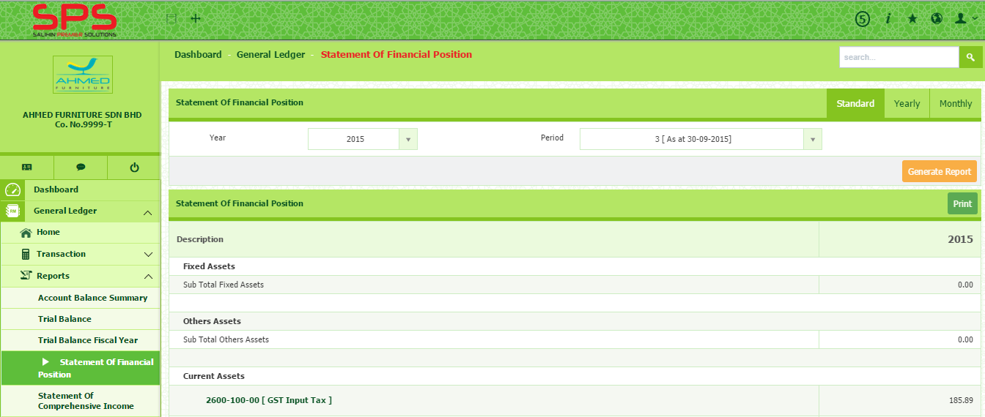
- You may choose the format of the report: standard, yearly or monthly on the top of right corner.
2
2
1

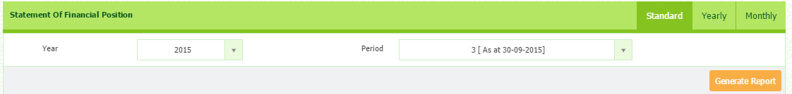
- For standard, select Year and Period and click Generate Report button

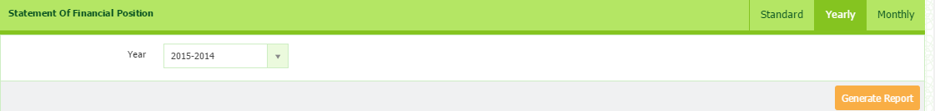
- For Yearly, select Year and click Generate Report button

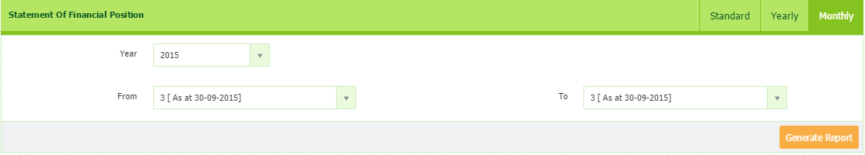
- For Monthly, select Year, Period From and Period To and click Generate Report button.

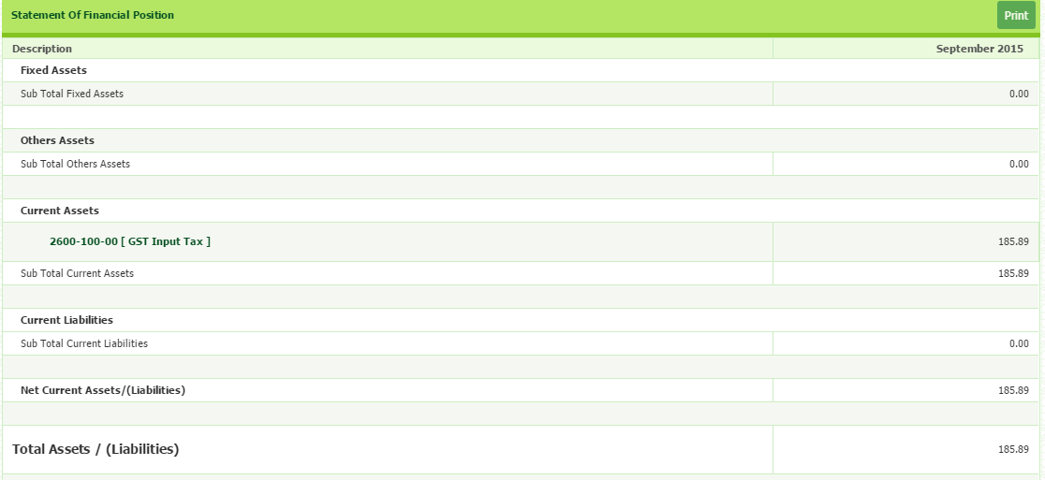
- You can print the report by clicking Print button

Report: Statement of Comprehensive Income
- Go to General ledger Report Statement of Comprehensive Income
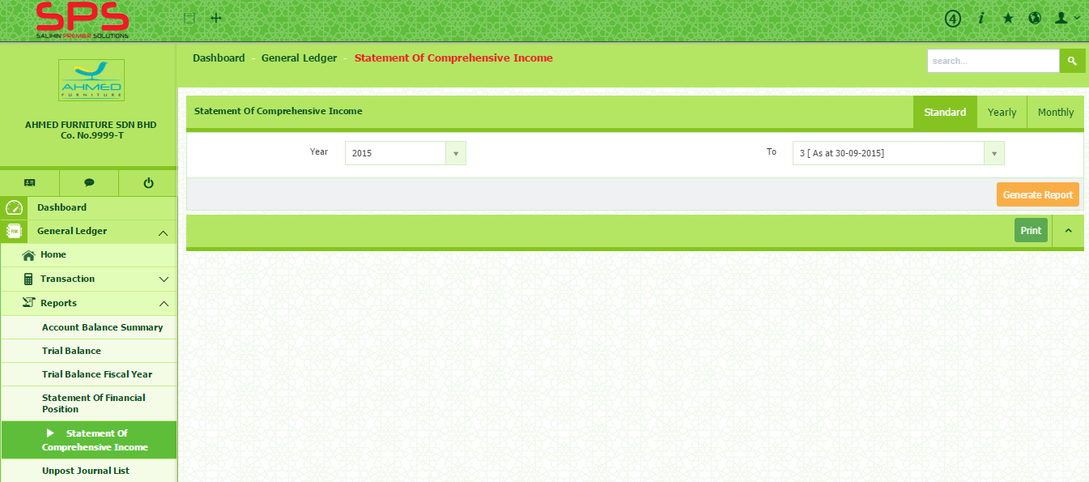
- You may choose the format of the report: standard, yearly or monthly on the top of right corner.
2
1

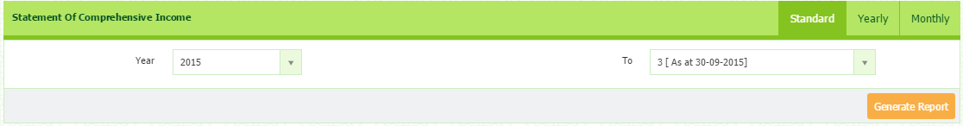
- For standard, select Year and Period and click Generate Report button

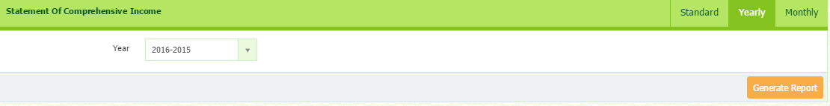
- For Yearly, select Year and click Generate Report button.

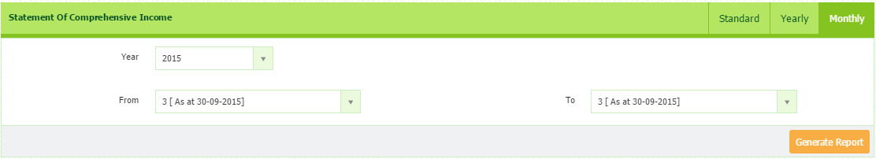
- For Monthly, select Year, Period From and Period To and click Generate Report button

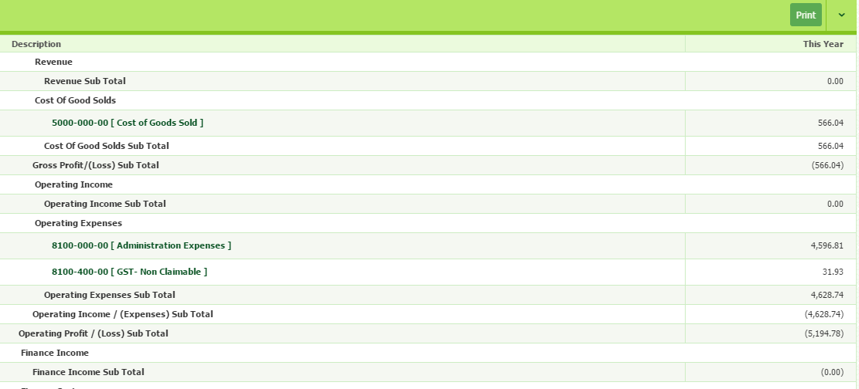
- You can print the report by clicking Print button

Report: Unpost Journal List
1
- Go to General ledger Report Unpost Journal List
2
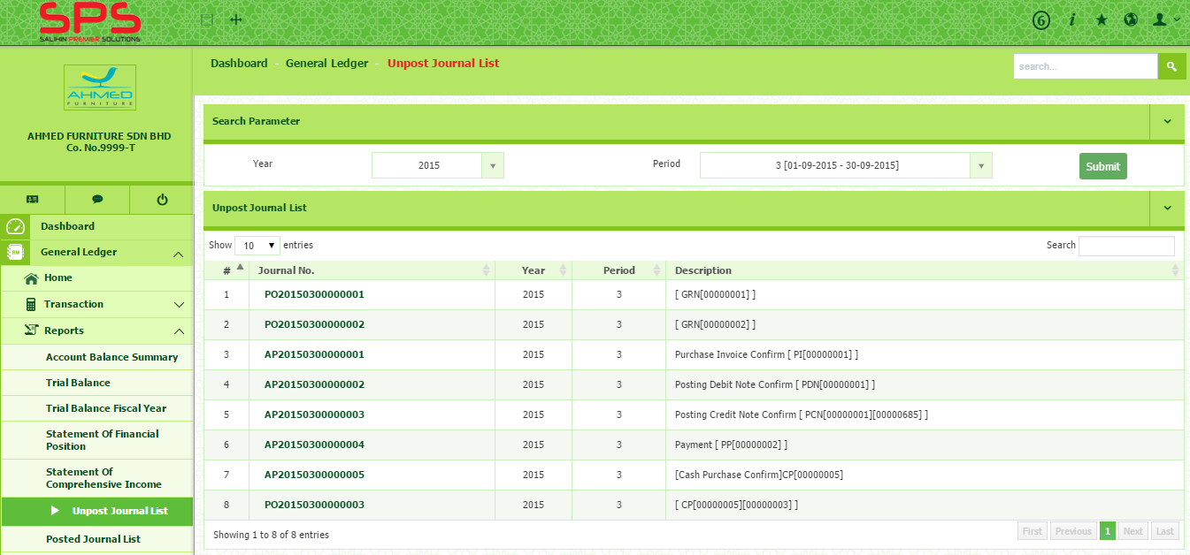
- Select Year and Period and Click Submit button. The list will appear at the bottom.
2
1

1
Report: Posted Journal List
- Go to General ledger Report Posted Journal List
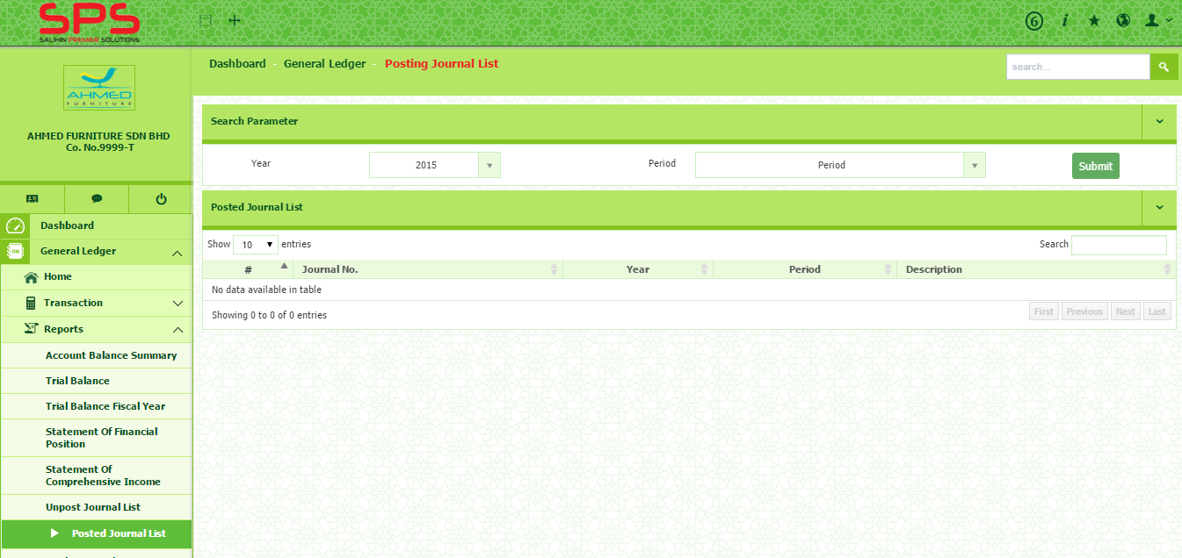
- Select Year and Period, then click Submit button. The list will appear at the bottom.
2
2
1

1
Report: Bank Reconciliation
- Go to General ledger Report Bank Reconciliation
2
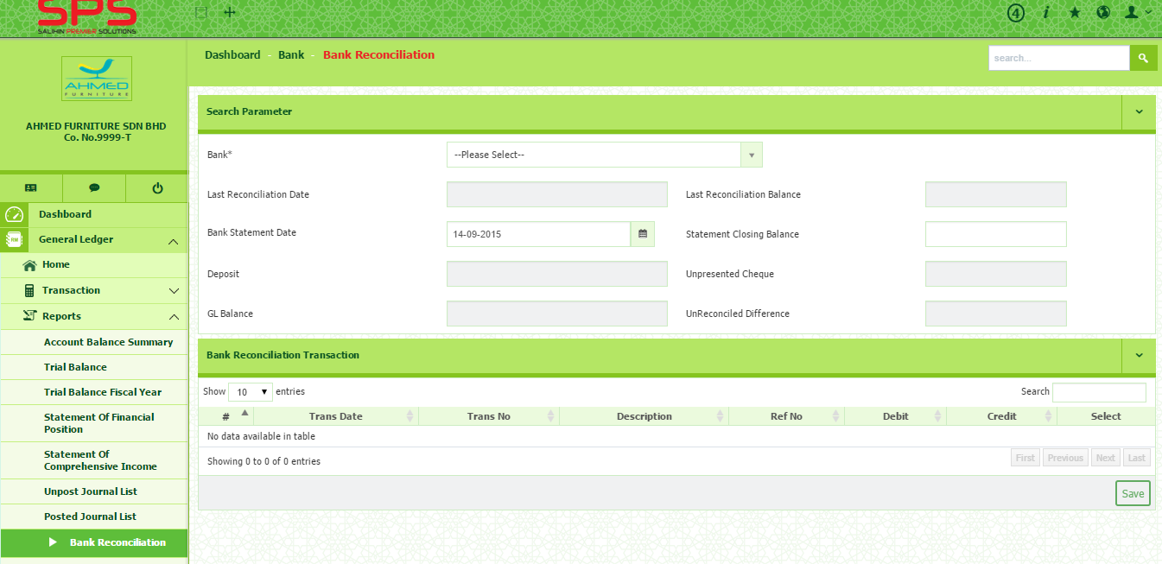
- Select Bank, Bank Statement Date and enter Statement Closing Balance.
2
1

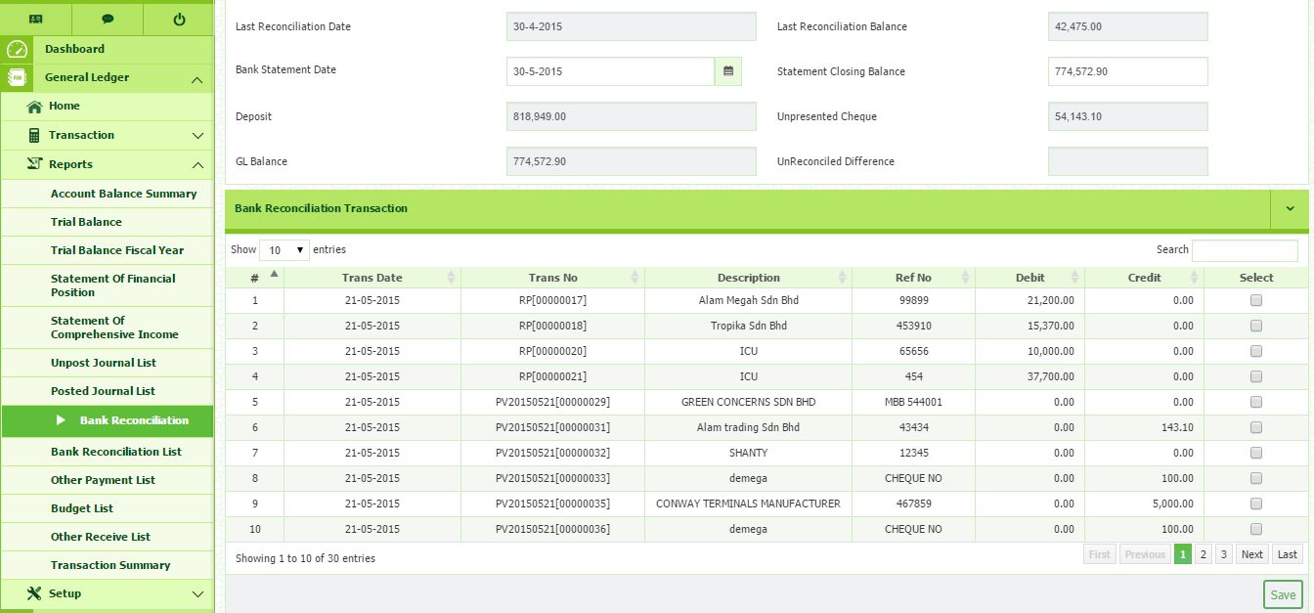
4
3
- The screen will show the last reconciliation balance, statement closing balance, unpresented cheque and unreconciled difference amount.
3
- Bank reconciliation transaction will be appeared at the bottom side. To reconcile, tick the box in Select column of each transaction that you intended to reconcile.
4
- Then, click Save button.

1
Report: Bank Reconciliation List
- Go to General ledger Report Bank Reconciliation List
2
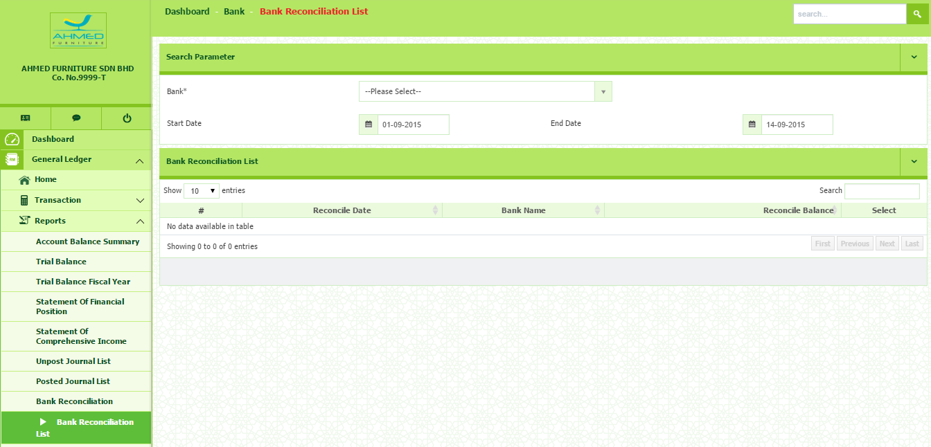
- Select Bank, Start Date and End Date
2
1

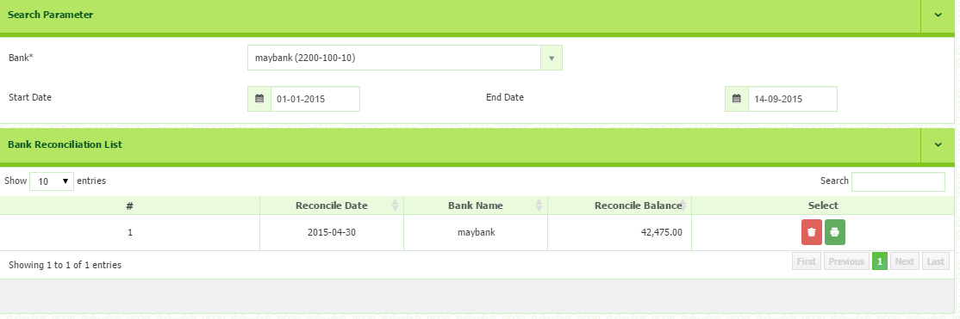
- Click button to print.

Report: Other Payment List
1
- Go to General ledger Report Other Payment List
2
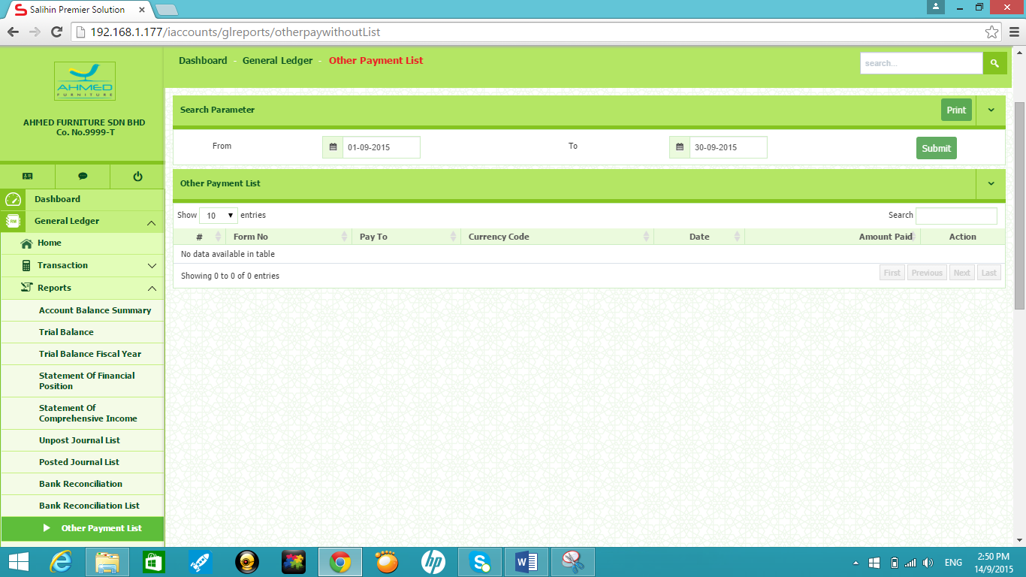
- Select From and To. Then, click Submit button.
2
1

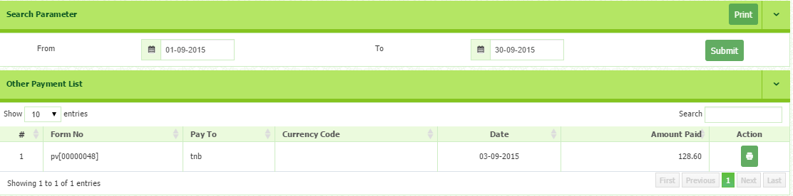
- You can print the report by clicking Print button

1
Report: Budget List
- Go to General ledger Report Budget List
2
- Select Year and click Generate Report button.
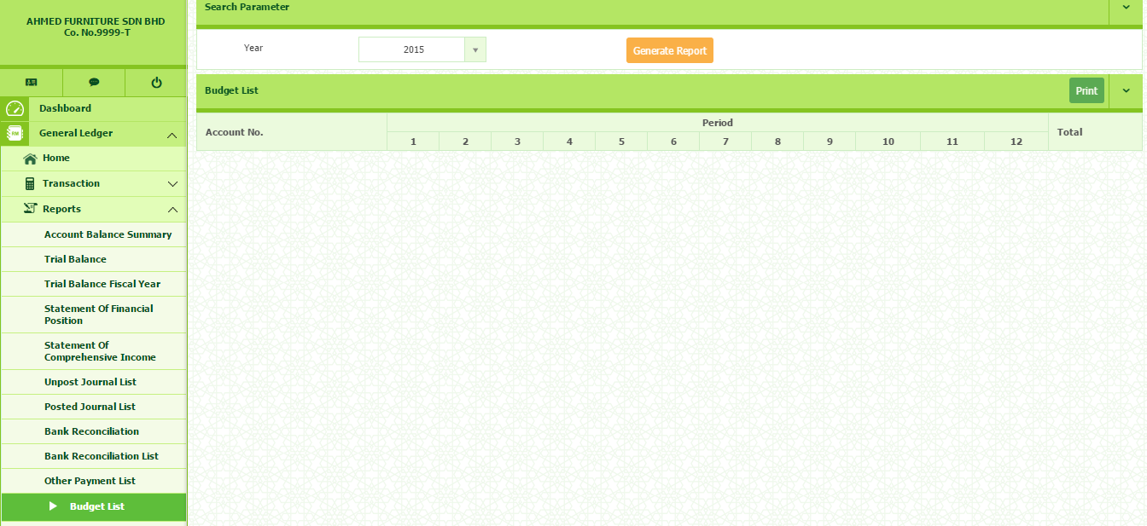
- Click Print button to print.
2
1
Report: Other Receive List

1
Report: Other Receive List
- Go to General ledger Report Other Receive List
2
- Select From and To, then click Submit button
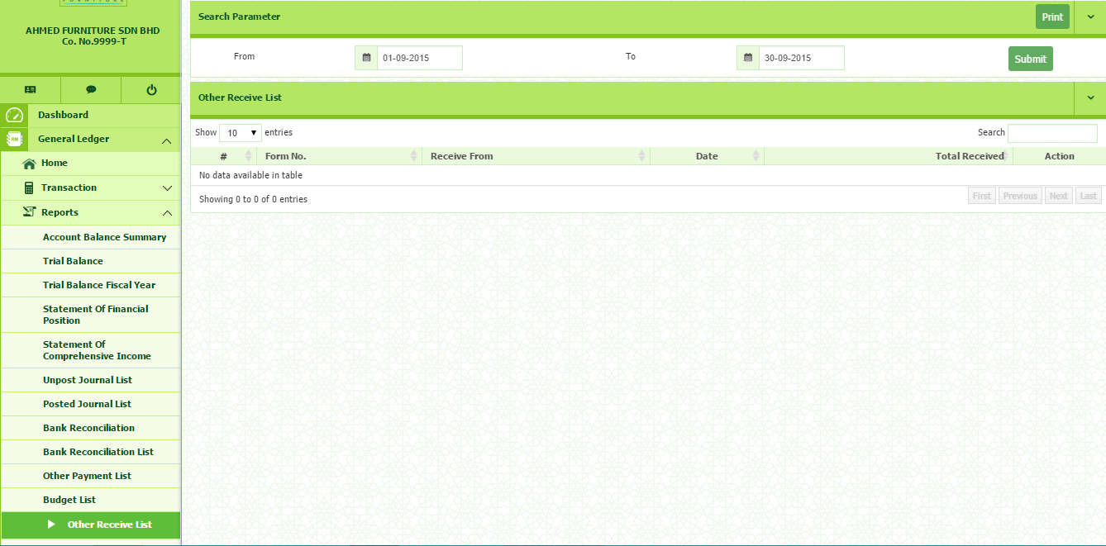
- Click Print button to print. It will print all the listed transactions under other received.
2
1

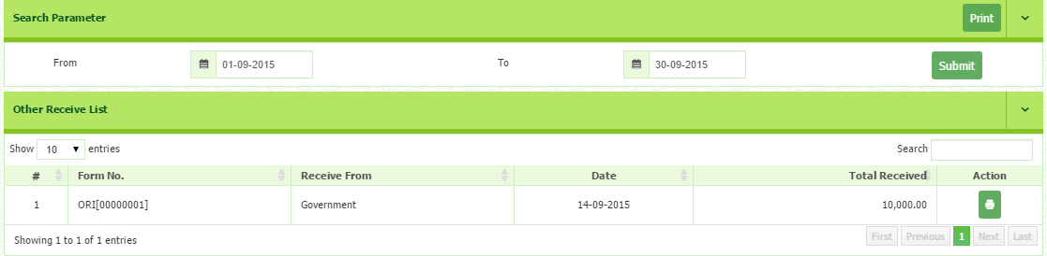
- Click Print button in the Action column to print.

Report: Transaction Summary
1
- Go to General ledger Report Transaction Summary
2
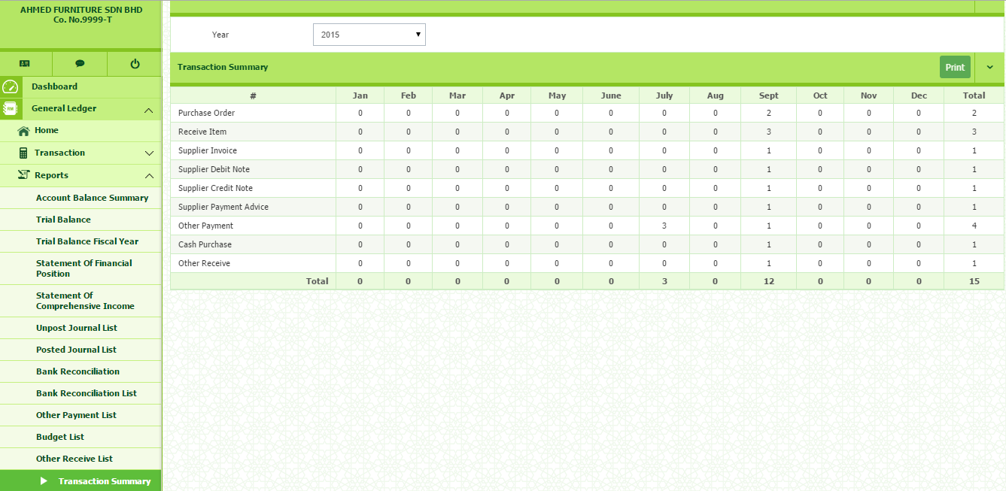
- Select Year and click Print button to print.
2
1

Setup
How to Setup Account Receivables

Before you going to prepare an invoice for the sale items, you have to make sure that the following required information has been setup.
- Customer Setup

SETUP
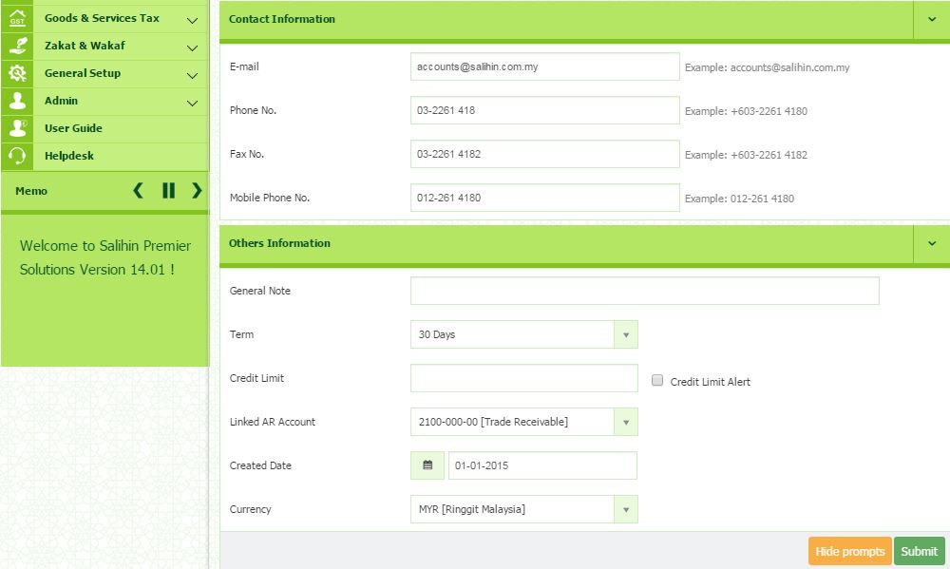

- Go to setup Customer, go to Account Receivables Setup Customer Setup
- There will appear the list of Customers that have been create.
- Click (+) button at the right top of page to create new customer.
- Enter the Customer Code.
- Enter the Customer Company Number
*given by SSM during registration
- Enter the GST Registration Number
*given by Custom Royal Malaysian
- Enter the Customer Name
- Enter the Customer Address, City, Postcode, Country and State.
- Enter an E-mail address
- Enter the Phone Number
- Enter the Fax Number
- Enter the Mobile Phone
- In the General Note part, you may fill it with any information we want.
- Select the Term from the dropdown list that we created in Term Setup.
- You may set the Credit Limit if necessary and tick (√) the Credit Limit Alert for any notification.
- Select the right Linked AR Account that we set by default (2100-000-00[Trade Receivable]) or the new Chart of Account you created.
- Enter Create Date of the customer’s company.
- Select the Currency.
- Click the Submit (green) button on the right bottom of the transaction to record the data

Transaction: Sales Invoice

Here you are going to prepare an invoice for the sale items. There are two methods:-
- Sales Invoice
- Direct Sales Invoice

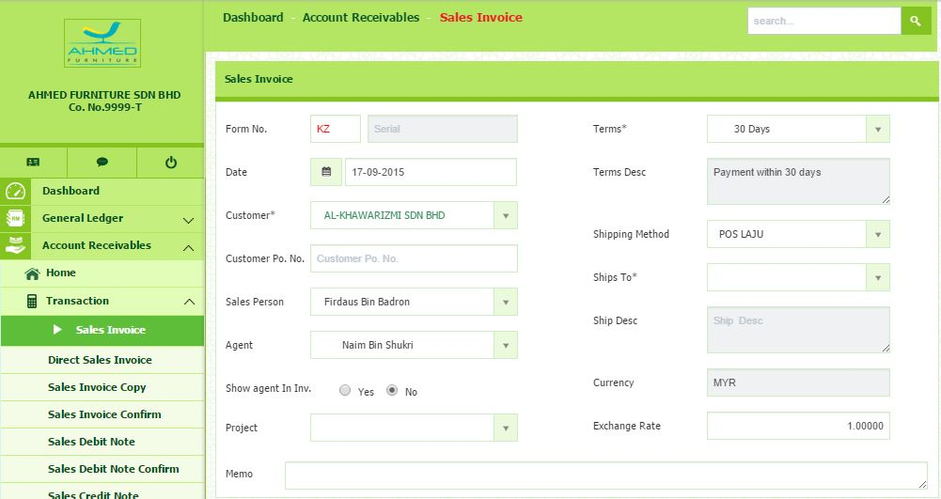

- Go to Account Receivables Transaction Sales Invoice
- Enter Form Number if necessary but the serial number will generate automatically.
- Select Date
*If we do not change the date, it will record the current date
- Select the Customer from the drop down list that created in the Customer setup.
- Insert the Customer PO Number
*You may type Customer Po No according to customer format.
- Select the Agent, Project, Terms, and Shipping Method, and Ships To from the drop down list.
*Any new addition/ registration and refresh list, can be done by clicking the Green button
- Any description or reminder can be insert in the Memo.
*You can select either to show agent or not in invoice.

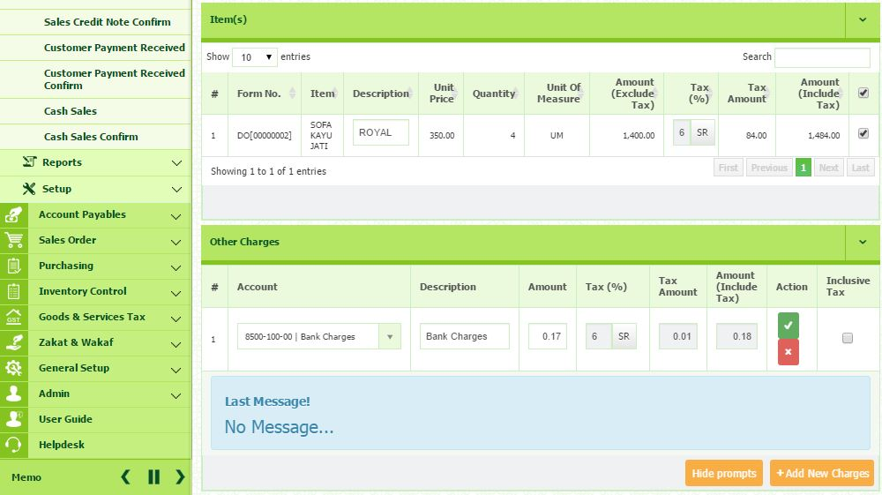

ITEMS
- Once customer has been selected, the details of Item will be display in Item(s) section.
- In the details of the Item(s), you have to fill in the Description, and Tax (%).
- Click the Save Invoice (green) button on the right bottom of the transaction to record the data.

OTHER CHARGES
- Click (Add New Charges) button to add new line for Other Charges.
- Select the Account from the drop down list that created in the Chart of Account.
- Fill in the Description as it has no letters limit, Amount, Tax (%).
*Tick (√) in the Inclusive Tax column if the amount already including GST.
- Click the (√) button in the Action column to record the data.
- Click the (x) button in the Action column to delete the data.
- The total amount will be automatically calculate and appear in Total Amounts section.

Transaction: New Direct Sales Invoice

You can prepare the new direct sales invoice, if you want to proceed without sales order items.
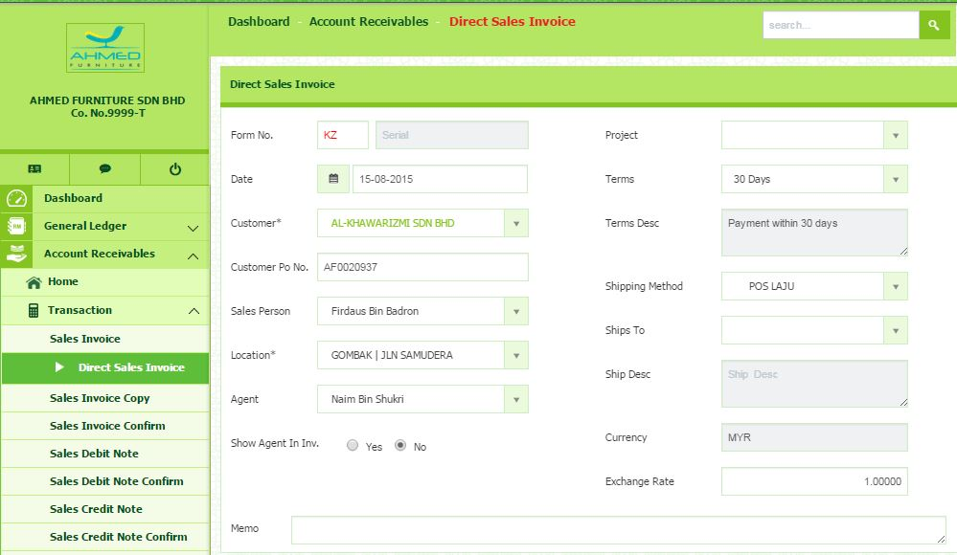

- Go to Account Receivables Transaction Direct Sales Invoice
- Enter Form Number if necessary but the serial number will generate automatically.
- Select Date
*If we do not change the date, it will record the current date
- Select the Customer from the drop down list that created in the Customer setup.
- Insert the Customer PO Number
*You may type Customer Po No according to customer format.
- Select the Sales Person, Location, Agent, Project, Terms, Shipping Method, and Ships To from the dropdown list.
*Any new addition/ registration and refresh list, can be done by clicking the Green button
- Any description or reminder can be insert in the Memo.
*You can select either to show agent or not in invoice.

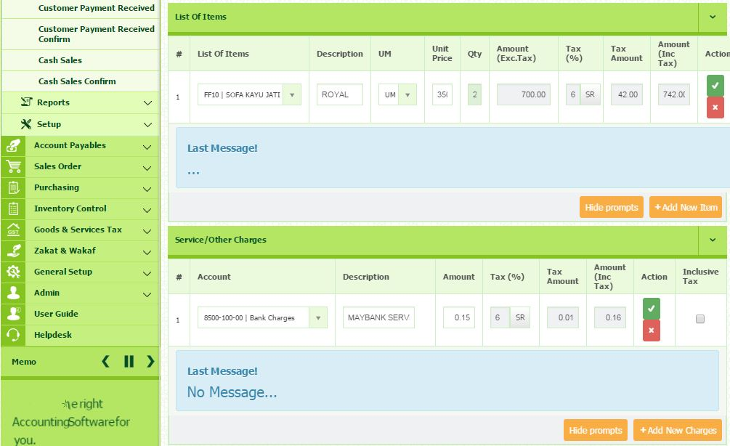

LIST OF ITEMS
- Click (Add New Item) button to add new line for Other Charges.
- Select List of Items from the drop down list that created in the Inventory Setup.
- Fill in the Description as it has no letters limit, Unit Measure, Unit Price, Quantity, Amount, Tax (%).
- Click the (√) button in the Action column to record the data.
- Click the (x) button in the Action column to delete the data.

SERVICE/OTHER CHARGES
- Click (Add New Charges) button to add new line for Other Charges.
- Select the Account from the drop down list that created in the Chart of Account.
- Fill in the Description as it has no letters limit, Amount, Tax (%).
*Tick (√) in the Inclusive Tax column if the amount already including GST.
- Click the (√) button in the Action column to record the data.
- Click the (x) button in the Action column to delete the data.
- The total amount will be automatically calculate and appear in Total Amounts section.

Transaction: Copy Sales Invoice

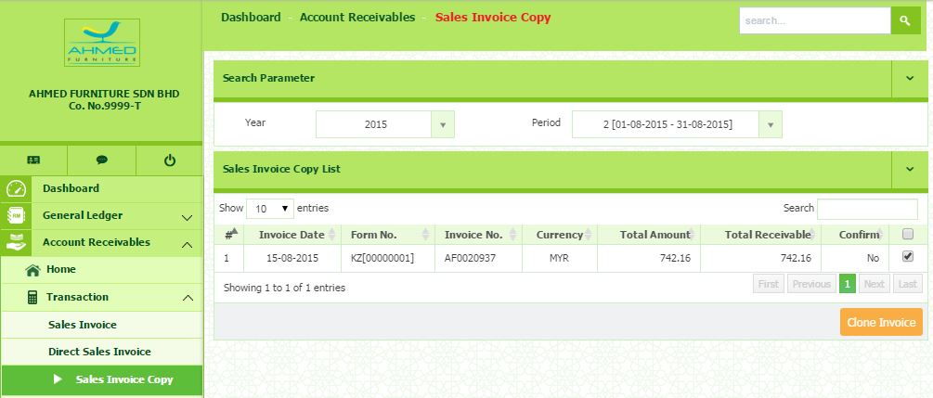

- Go to Account Receivables Transaction Copy Sales Invoice
- Select the Customer from the drop down list.
- Select the Agent, Project, Location, Terms, and Ships To from the drop down list.
- If the required information has not been setup yet, you can simply click the drop down button at each field. Click (Add New) to proceed.
- You may type Customer Po No according to your company standard.
- You can select either to display agent name or not in invoice.
- Once customer has been selected, the details of Item will be display in Item(s) section.
- Select the particular row of items.
- In Other Charges section, you can add new charges if needed and remove the other charges.
- Select the Shipping Method and Sale Person from the drop down button.
- Click Calculate Total to get the Total Amount, Total Tax Amount and Total Receivable.
- To save sales invoice, simply click Save Invoice.

Transaction: Sales Invoice Confirm

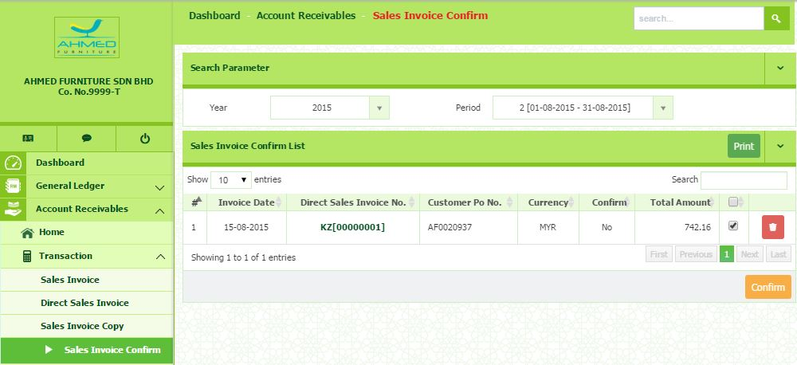

- Go to Account Receivables Transaction Sales Invoice Confirm
- Select Year and Period that invoice exist in it.
- Click the Invoice Number to re-check the details of the invoice created.
- Tick (√) in the Confirm column if you are sure to do the confirmation.
- Click the (x) button in the Action column to delete the data.
- Click (Add New Charges) button to confirming the invoice.

Transaction: Sales Debit Note

The Sales Debit Notes is issued as an adjustment to the invoice that you have previously created to increase the value of goods.
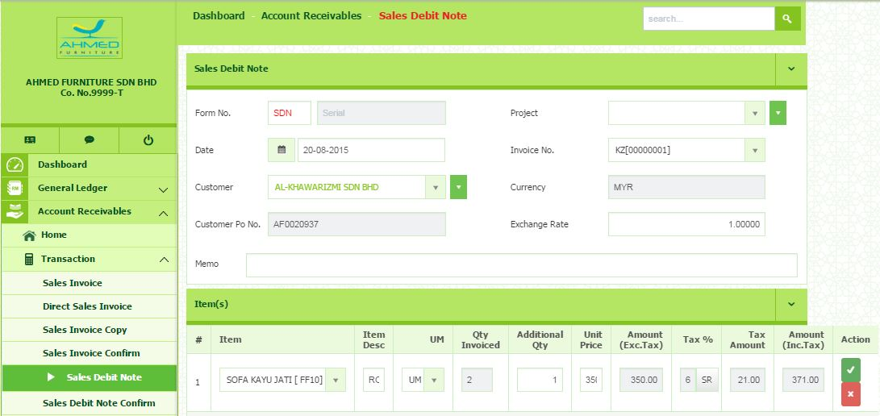
- Go to Account Receivables Transaction Sales Debit Note
- Enter Form Number if necessary but the serial number will generate automatically.
- Select Date
*If we do not change the date, it will record the current date.
- Select the Customer from the drop down list that created in the Customer setup.
*Any new addition/ registration and refresh list, can be done by clicking the Green button.
- Select the Project that from the drop down list created in the Project setup.
*Any new addition/ registration and refresh list, can be done by clicking the Green button
- Select the Invoice Number that created in Direct Sales Invoice or Sales Invoice where we want to the debit note.
- Insert the Exchange Rate.
- Any description or reminder can be insert in the Memo.

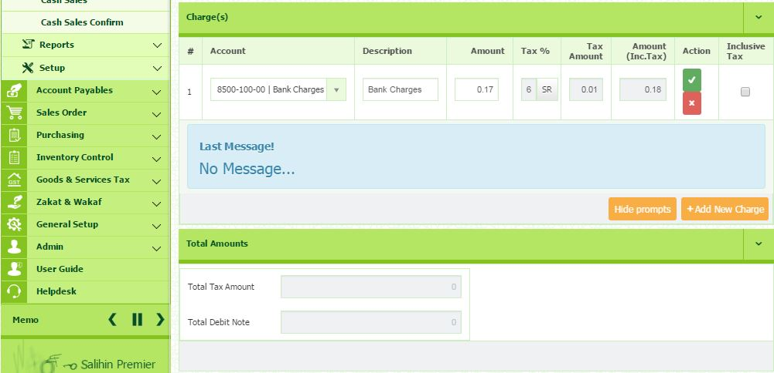

LIST OF ITEMS
- Click (Add New Item) button to add new line for Other Charges.
- Select List of Items from the drop down list that created in the Inventory Setup.
*You MUST select the same chart of account that used in Direct Sales Invoice or Sales Invoice.
- Fill in the Description as it has no letters limit, Unit Measure, Unit Price, Quantity, Amount, Tax (%).
- Click the (√) button in the Action column to record the data.
- Click the (x) button in the Action column to delete the data.

SERVICE/OTHER CHARGES
- Click (Add New Charges) button to add new line for Other Charges.
- Select the Account from the drop down list that created in the Chart of Account.
*You MUST select the same chart of account that used in Direct Sales Invoice or Sales Invoice.
- Fill in the Description as it has no letters limit, Amount, Tax (%).
*Tick (√) in the Inclusive Tax column if the amount already including GST.
- Click the (√) button in the Action column to record the data.
- Click the (x) button in the Action column to delete the data.
- The total amount will be automatically calculate and appear in Total Amounts section.

Transaction: Sales Debit Note Confirm

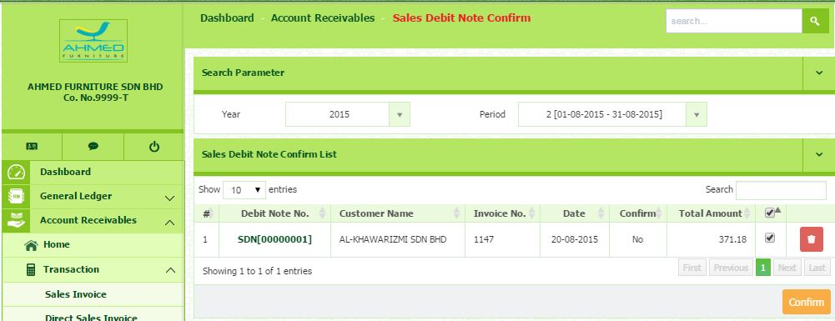

- Go to Account Receivables Transaction Sales Debit Note Confirm
- Select Year and Period that invoice exist in it.
- Click the Invoice Number to re-check the details of the invoice created.
- Tick (√) in the Confirm column if you are sure to do the confirmation.
- Click the (x) button in the Action column to delete the data.
- Click (Add New Charges) button to confirming the invoice.

Transaction: Sales Credit Note
The Sales Credit Note is issued as an adjustment to the invoice that you have previously created to decrease the value of the goods. For example, goods that returned from customer and also discounts given on that goods.

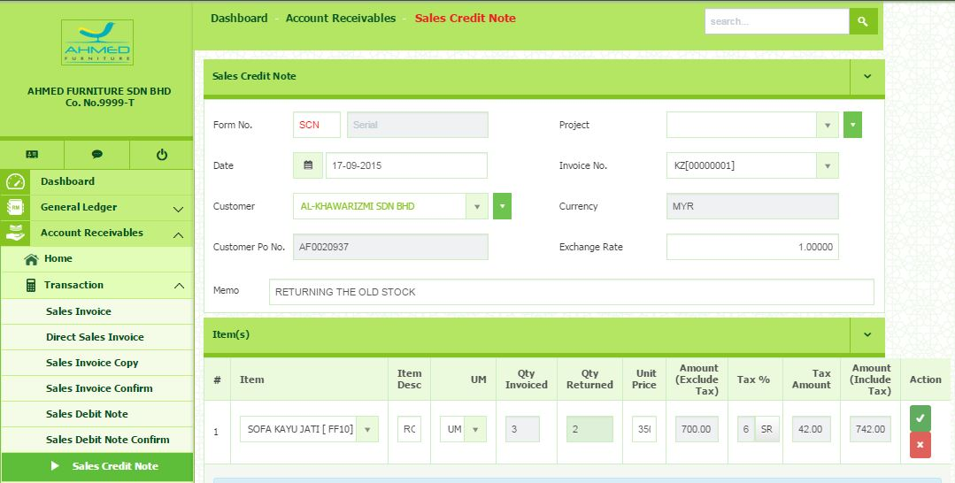

- Go to Account Receivables Transaction Sales Credit Note
- Enter Form Number if necessary but the serial number will generate automatically.
- Select Date
*If we do not change the date, it will record the current date
- Select the Customer from the drop down list that created in the Customer setup.
*Any new addition/ registration and refresh list, can be done by clicking the Green button.
- Select the Project that from the drop down list created in the Project setup
*Any new addition/ registration and refresh list, can be done by clicking the Green button
- Select the Invoice Number that created in Direct Sales Invoice or Sales Invoice where we want to the debit note.
- Insert the Exchange Rate.
- Any description or reminder can be insert in the Memo.

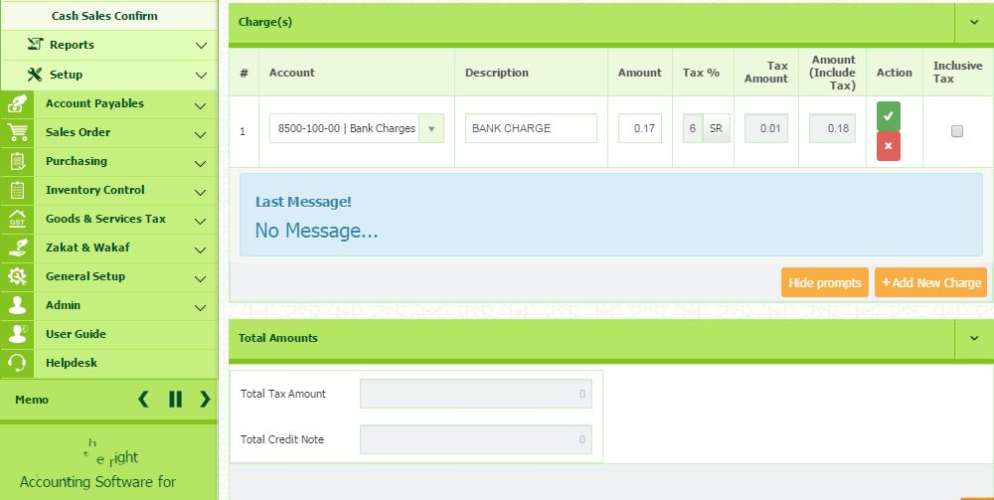

LIST OF ITEMS
- Click (Add New Item) button to add new line for Other Charges.
- Select List of Items from the drop down list that created in the Inventory Setup.
*You MUST select the same chart of account that used in Direct Sales Invoice or Sales Invoice.
- Fill in the Description as it has no letters limit, Unit Measure, Unit Price, Quantity, Amount, Tax (%).
- Click the (√) button in the Action column to record the data.
- Click the (x) button in the Action column to delete the data.

SERVICE/OTHER CHARGES
- Click (Add New Charges) button to add new line for Other Charges.
- Select the Account from the drop down list that created in the Chart of Account.
*You MUST select the same chart of account that used in Direct Sales Invoice or Sales Invoice.
- Fill in the Description as it has no letters limit, Amount, Tax (%).
*Tick (√) in the Inclusive Tax column if the amount already including GST.
- Click the (√) button in the Action column to record the data.
- Click the (x) button in the Action column to delete the data.
- The total amount will be automatically calculate and appear in Total Amounts section.

Transaction: Sales Credit Note Confirm

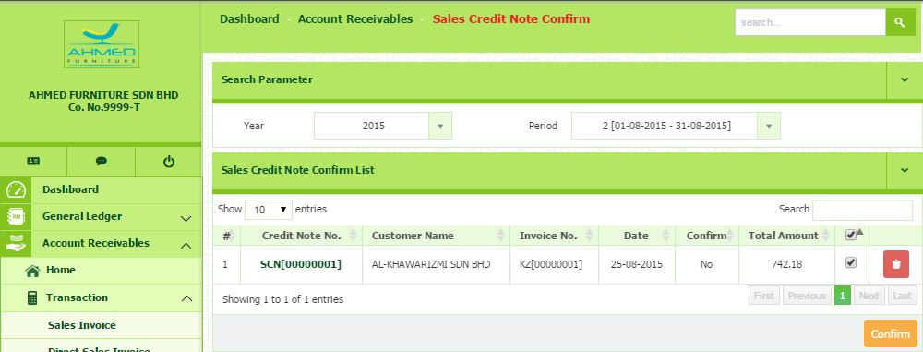

- Go to Account Receivables Transaction Sales Credit Note Confirm
- Select Year and Period that invoice exist in it.
- Click the Invoice Number to re-check the details of the invoice created.
- Tick (√) in the Confirm column if you are sure to do the confirmation.
- Click the (x) button in the Action column to delete the data.
- Click (Add New Charges) button to confirming the invoice.
Transaction: Receive Payment

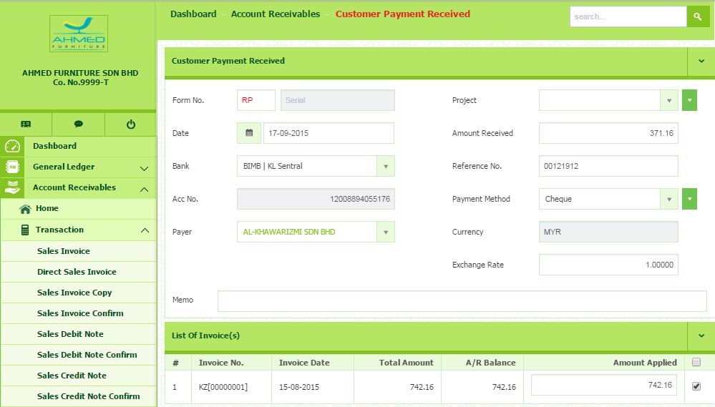

- Go to Account Receivables Transaction Receive Payment
- Enter Form Number if necessary but the serial number will generate automatically.
- Select Date
*If we do not change the date, it will record the current date
- Select name of bank from dropdown list. Account Number will be automatically appear only when bank has been selected.
- Select name of the Payer from the dropdown list. Payer also known as Customer.
- Select name of the project from the dropdown list.
- Enter the received amount.
*Including the GST amount.
- You have to enter the Reference No for your reference or office use.
*You may insert Cheque number in this area.
- Select the payment method either Cash or Cheque from the dropdown list.
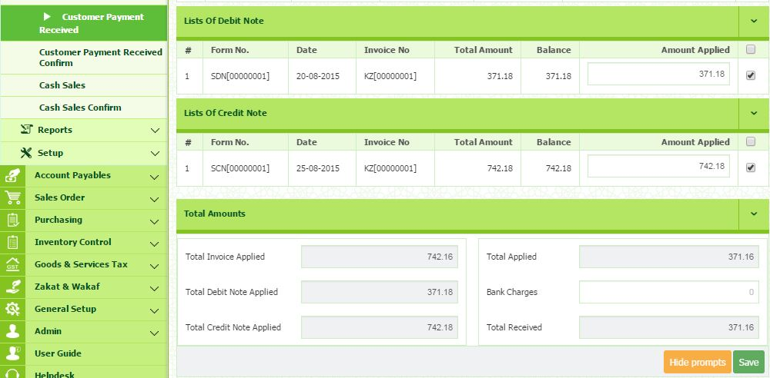

LIST(S) OF INVOICES
- In the List of Invoice section, it will display all the listing of invoices.
- By selecting the particular row, you can decide amount of discount and amount applied.
- Once the row has been selected, you will see the summary of Total Discount, Bank Charges, Total Other Charges, Total Received, Total Applied, Total Other Charges and Out of Balance.
- Click Save button to save it.

Transaction: Receive Payment Confirm

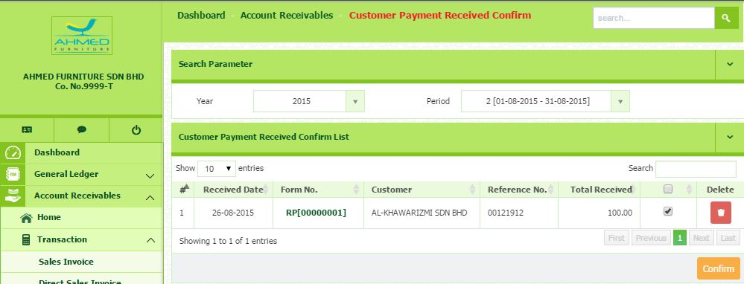

- Go to Account Receivables Transaction Customer Payment Received Confirm
- Select Year and Period and click submit to get the Sales Payment Confirm List.
- You may edit the header and Item(s) details.
- Tick (√) in the Confirm column if you are sure to do the confirmation.
- Click the (x) button in the Action column to delete the data.
- Click (Add New Charges) button to confirming the invoice
Transaction: Cash Sales
.
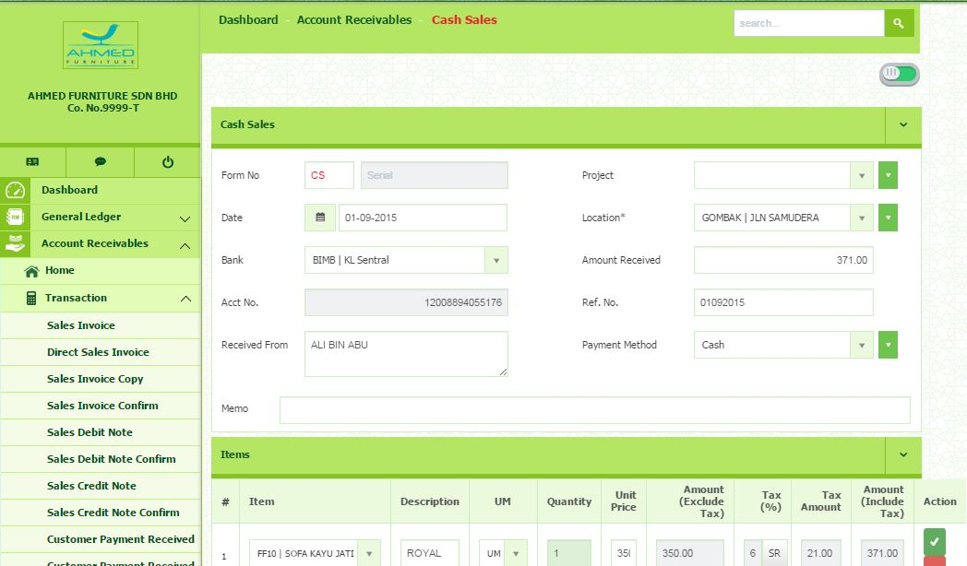
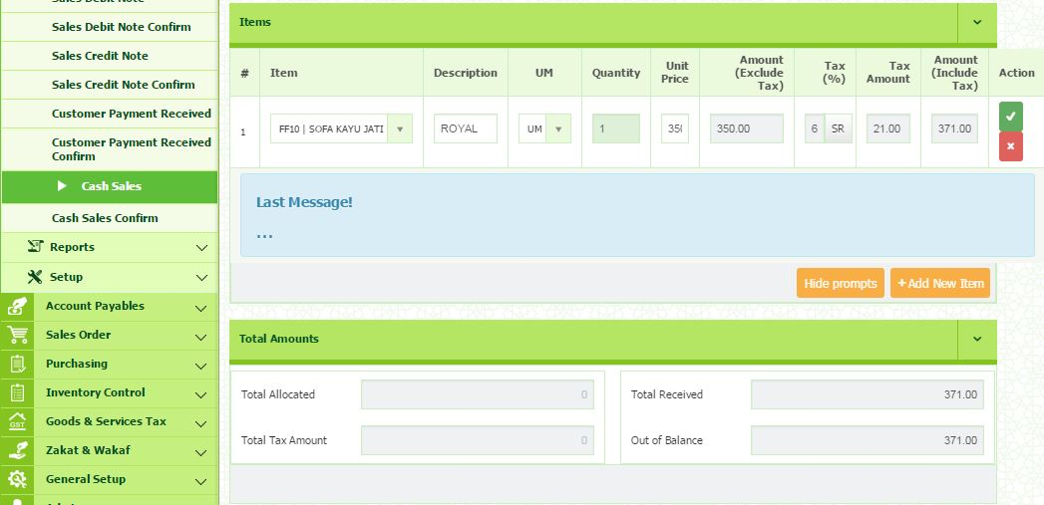
- Go to Account Receivables Transaction Customer Payment Received Confirm
- Select Year and Period and click submit to get the Sales Payment Confirm List.
- You may edit the header and Item(s) details.
- Tick (√) in the Confirm column if you are sure to do the confirmation.
- Click the (x) button in the Action column to delete the data.
- Click (Add New Charges) button to confirming the invoice

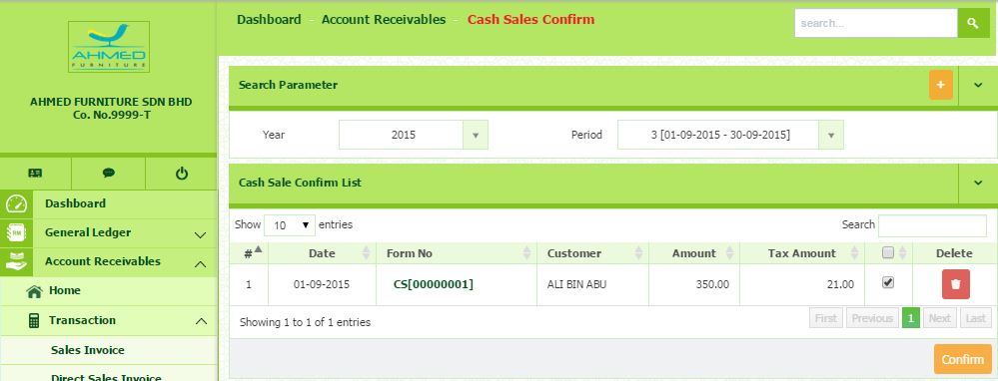

Direct Sales Invoice List
Account Receivable: How to Setup a Report

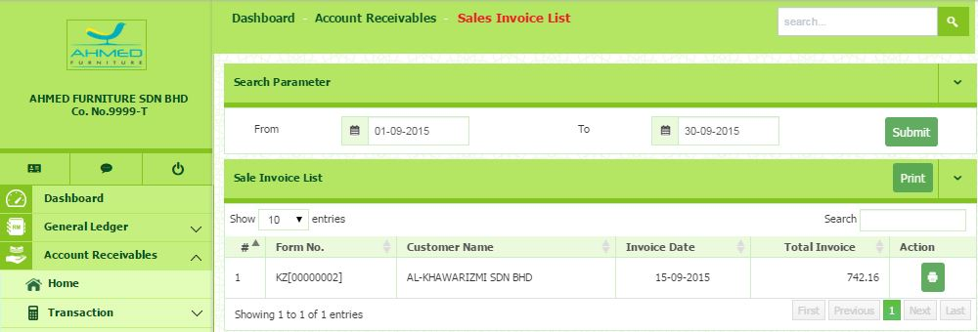
- Go to Account Receivables Reports Sales Invoice List
- Select the Parameter by From and To of the period/month that invoice exist in it, then click the (Submit) button.
- Select the Invoice from the list that created in Sales Invoice/Direct Sales Invoice.
- Click (Print) button in the Action row.
- Click the (Print) button to print all the list of the invoices.
*All the invoice list will appear if we do the Sales Invoice Confirm.

Sales Debit Note List

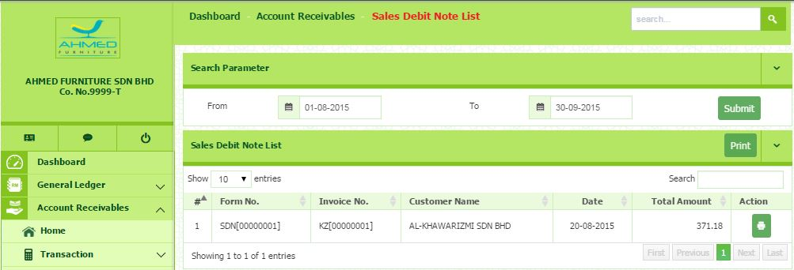

- Go to Account Receivables Reports Sales Debit Note List
- Select the Parameter by From and To of the period/month that invoice exist in it, then click the (Submit) button.
- Select the Invoice from the list that created in Sales Debit Note.
- Click (Print) button in the Action row.
- Click the (Print) button to print all the list of the invoices.
*All the invoice list will appear if we do the Sales Debit Note Confirm
Sales Credit Note List

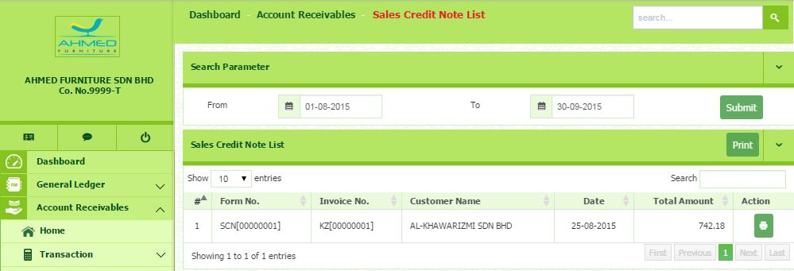

- Go to Account Receivables Reports Sales Credit Note List
- Select the Parameter by From and To of the period/month that invoice exist in it, then click the (Submit) button.
- Select the Invoice from the list that created in Sales Credit Note.
- Click (Print) button in the Action row to see and print in hardcopy.
- Click the (Print) button to print all the list of the invoices.
*All the invoice list will appear if we do the Sales Credit Note Confirm.
Receive Payment List

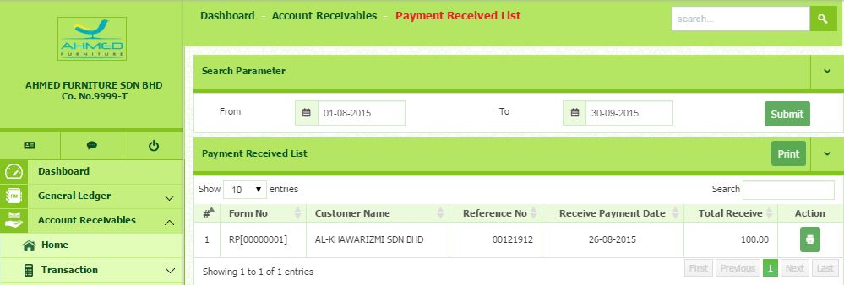

- Go to Account Receivables Reports Receive Payment List
- Select the Parameter by From and To of the period/month that invoice exist in it, then click the (Submit) button.
- Select the Form Number from the list that created in Customer Payment Receive.
- Click (Print) button in the Action row to see and print in hardcopy.
- Click the (Print) button to print all the list of the invoices.
*All the invoice list will appear if we do the Customer Payment Received Confirm.
Customer Statement

- Go to Account Receivables Reports Customer Statement
- You can search customer statement by Customer Name.
- You can print the report, details of each customer statement by clicking the (Print) button.
- You also can print all the customer statement list by click (Print) button.
AR Summary

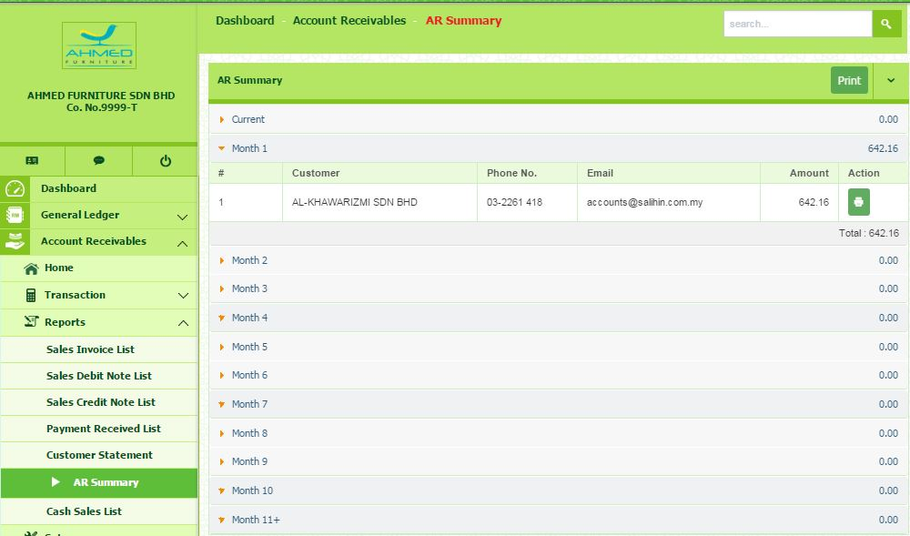
- Go to Account Receivables Reports AR Summary
- Click the Period or Month.
- It will list all the AR transaction by recording it by monthly.
- You can print the report, details of each transaction by clicking the (Print) button.
- You also can print all the customer statement list by click (Print).
Cash Sales List

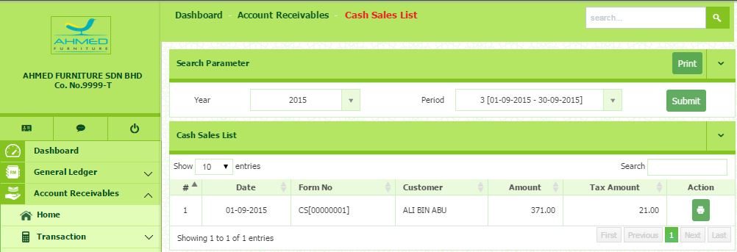

- Go to Account Receivables Reports Cash Sales List
- Select the Parameter by From and To of the period/month that invoice exist in it, then click the submit button.
- Select the Cash Sales from the list that created in Cash Sales.
- Click (Print) button in the Action row to see and print in hardcopy.
- Click the (Print) button to print all the list of the invoices.
*All the invoice list will appear if we do the Cash Sales Confirm.

Setup
How to Setup Account Payable

Account Payable is money which a company owes to Supplier for goods and services purchased on credit. This item appears on the company Statement of Financial Position as a current liability, since the expectation is that the liability will be fulfilled in less than a year.

Account Payable contains the following required information such as supplier setup, purchase order and created purchase invoice for the suppliers. Here you need to setup the supplier information first.
Setup
- Go to Account Payable Setup Supplier Setup
- Click (+) button on the right top of the pages, to setup a New Supplier.
- Enter your Supplier Code, Supplier Company No and Supplier Name.
- If your Supplier is registered to GST, enter the GST Registration No. If not, just leave it blank.

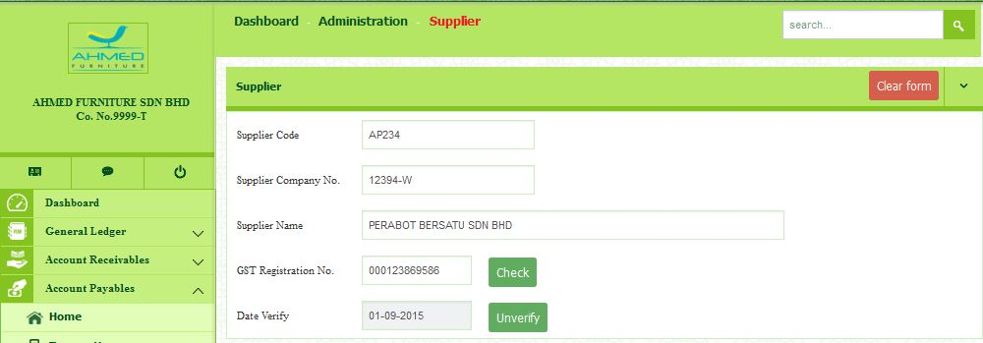

- Enter all the address information.
- Enter all the contact information.
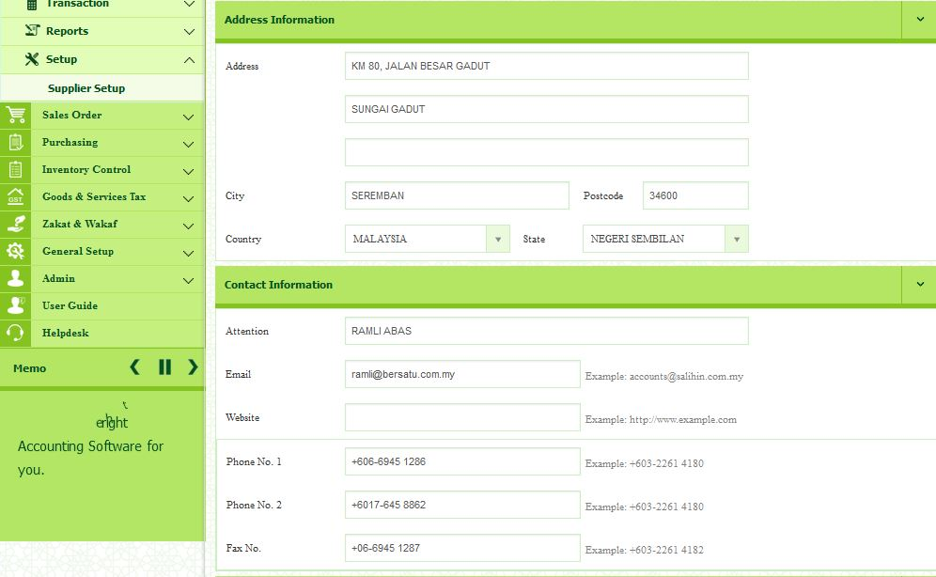

- Enter others information.
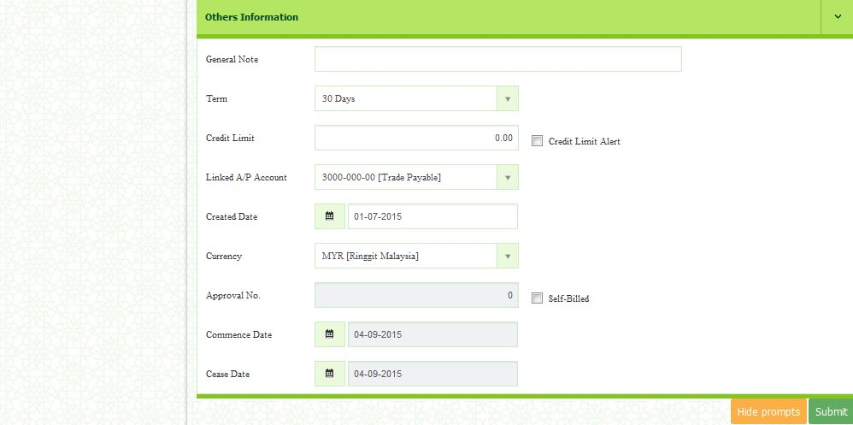

- After completed, click Submit button to save.

Purchase Invoice
Account Payable: How to Do a Transaction

In this section, you will create a new purchase invoice.
- Go to Account Payable Transaction New Purchase Invoice
- Before you create the New Purchase Invoice, please make sure that you already setup the suppliers, terms, project and ships to.
- Select the supplier.
- Select Shipping Method form the drop down list.
- Select the Ship To.

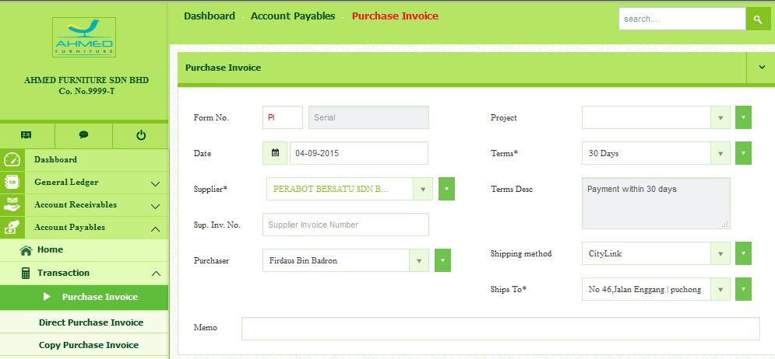

Items
- In the Item(s) section, you may set the price, quantity and tax of the items.
- Tick the selected purchase invoice.

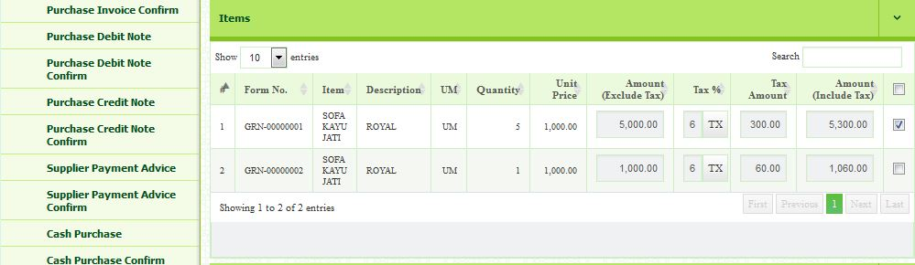

Service/Other Charge
- In the Service/Other Charge section, you may select the account, enter the description, amount, tax and tax amount by click (Add New Charge) button.
- Click (Save) Invoice button to save the current information.

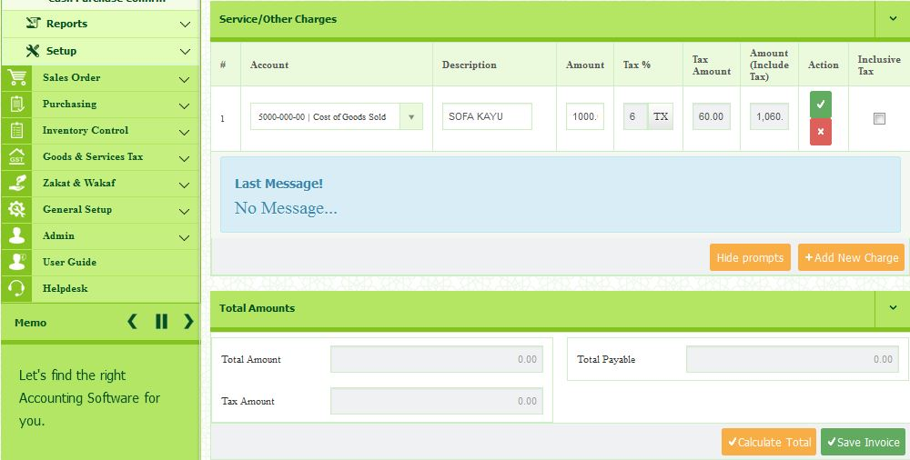

Transaction: Direct Purchase Invoice

In here, you are enables to create a purchase invoice and receipt at the same time.
- Select the Supplier from the drop down list.
- Enter Supplier Invoice No.
- Select Purchaser.
- Select Location.
- Select Shipping Method.
- Select Ships To.
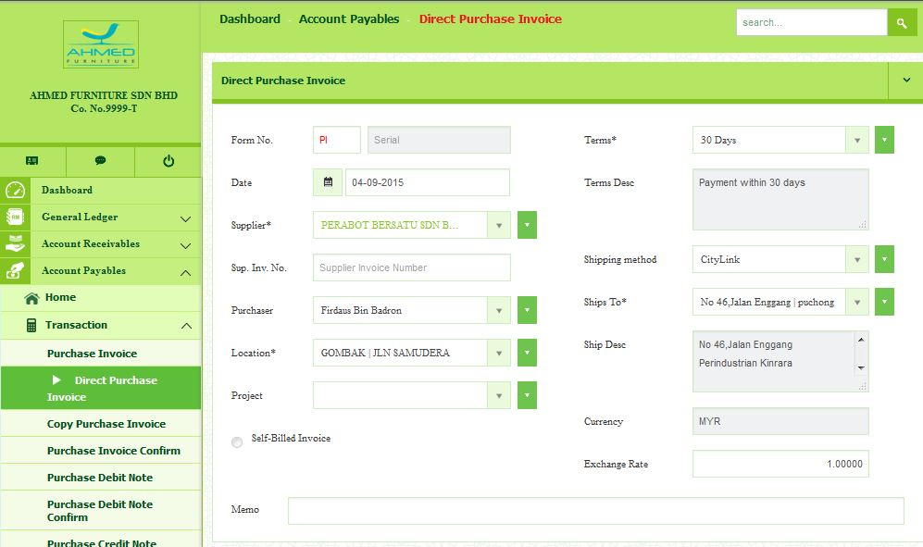

Item
- Select Item from the drop down list.
- Enter the Item Description.
- Enter the Unit Price.
- Enter the Quantity.
- Select the Tax (%) from the Tax Master list.
- To save, click the (√) button.

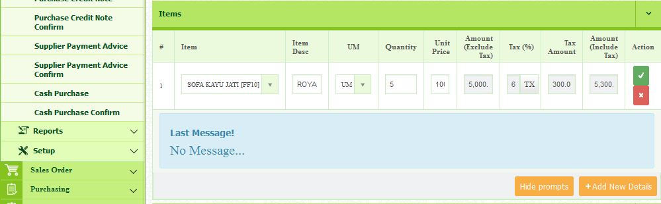

Service/Other Charge
- Select the Account from the dropdown list.
- Enter the Description.
- Enter the Amount.
- Select Tax (%).
- Enter Tax Amount.
- To save, click the (√) button.

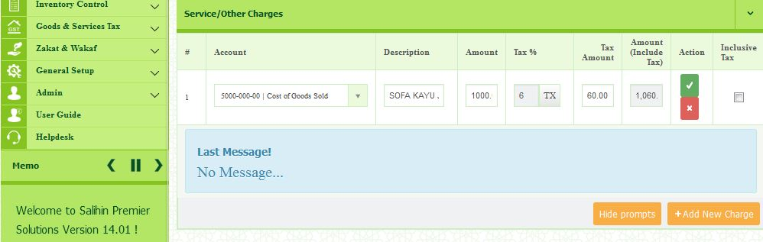
Transaction: Purchase Invoice Copy
3) Copy Purchase Invoice

In this section, you will create a new purchase invoice.
- Go to Account Payables Transaction Copy Purchase Invoice
- Select Year and Period, then click (Submit) button.
- Select the Purchase Invoice that you want to duplicate.
- Then, click Clone Invoice button.

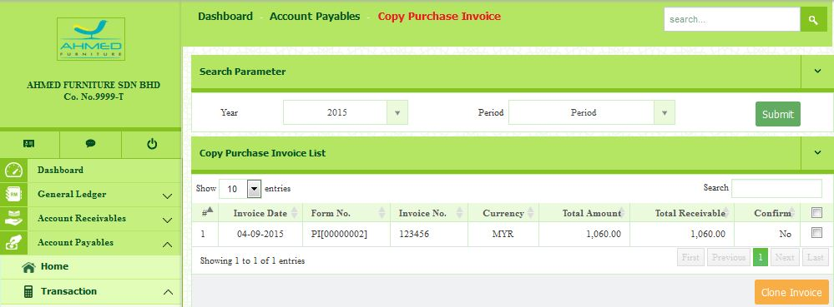

Transaction: Purchase Invoice Confirm
- Go to Account Payables Transaction Purchase Invoice Confirm
- Select Year and Period.
- Select the Purchase invoice that you want to confirm.
- Then, click (Confirm).

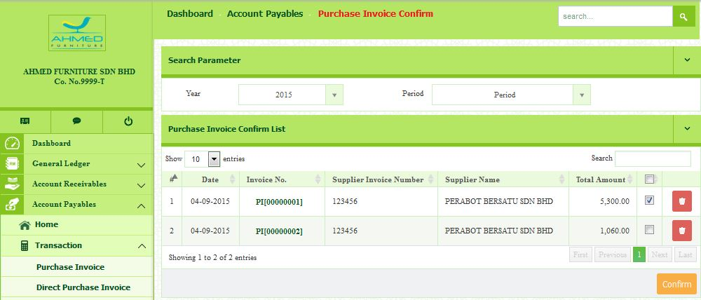
Transaction: Purchase Debit Note

In this section, the purchase debit note is issued as an adjustment to the invoice you received from the supplier to decrease the value of goods.
- Go to Account Payables Transaction Purchase Debit Note
- Select the Supplier.
- Select the Invoice No.

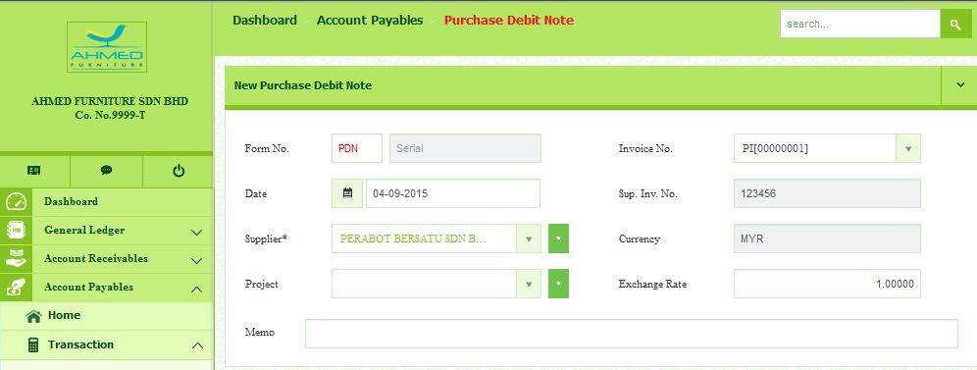
Items
- Click the (Add New Details) button.
- Select the item.
- Enter the Item Description.
- Enter the Unit Price.
- Enter the Quantity.
- Select the Tax (%) from the Tax Master list.
- To save, click the (√) button.

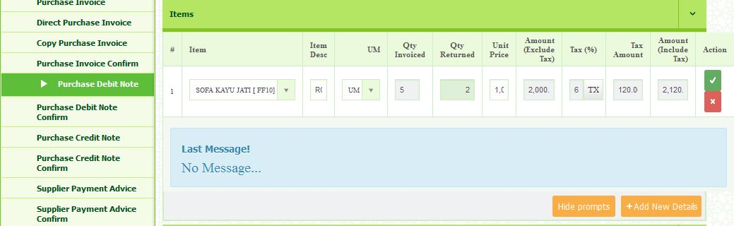

Service/Other Charges
- Click the (Add New Charge) button.
- Select Account.
- Enter the Description.
- Enter the Amount.
- Select Tax (%).
- Enter Tax Amount.
- To save, click the (√) button.

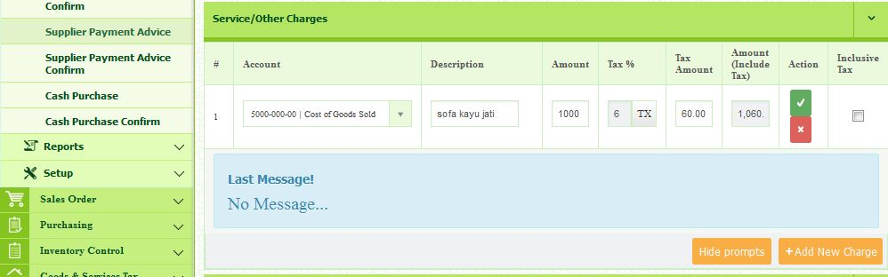

Transaction: Purchase Debit Note Confirm

- Go to Account Payable Transaction Purchase Debit Note Confirm
- Select Year and Period.
- Select the Purchase Debit Note List that you want to confirm.
- Then, click (Confirm).

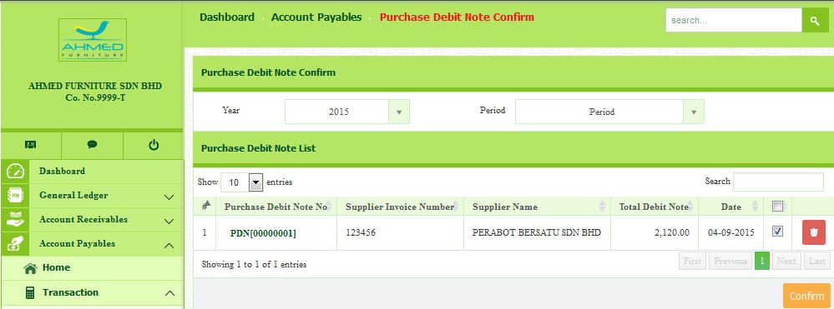
Transaction: Purchase Credit Note

In this section, the purchase credit note is issued as an adjustment to the invoice received from supplier to increase the value of the goods.
- Go to Account Payable Transaction New Purchase Credit Note
- Select the Supplier.
- Select the Invoice No.

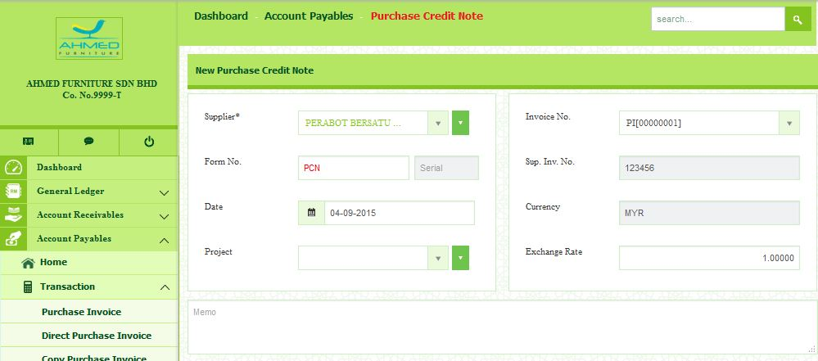
Items
- Click the Add New Details button.
- Select the item.
- Enter the Item Description
- Enter the Quantity.
- Enter the Unit Price
- Select the Tax (%) from the Tax Master list.
- To save, click the button.

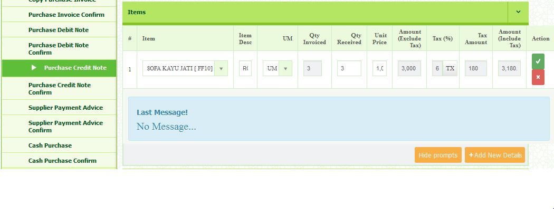

Service/Other Charges
- Click the Add New Charge button.
- Select Account Type.
- Enter the Description.
- Enter the Amount.
- Select Tax %.
- To save, click the button.

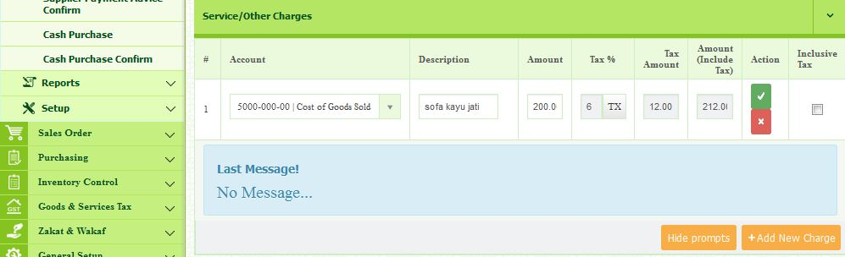
Transaction: Purchase Credit Note Confirm

- Go to Account Payable Transaction Purchase Credit Note Confirm
- Select Year and Period.
- Select the Purchase Credit Note List that you want to confirm.
- Then, click Confirm.

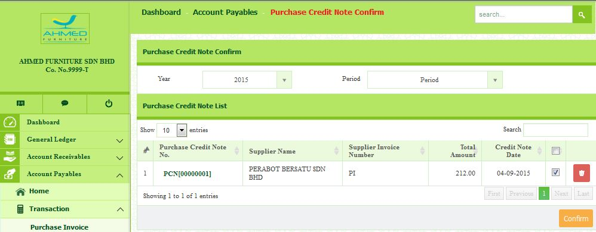
Transaction: Supplier payment advice

- Go to Account Payables Transaction Supplier Payment Advice
- Select Supplier.
- Select Payment Method.
- Enter Reference No.
- Enter Description.
- Select Payment Date.
- Select the Bank.
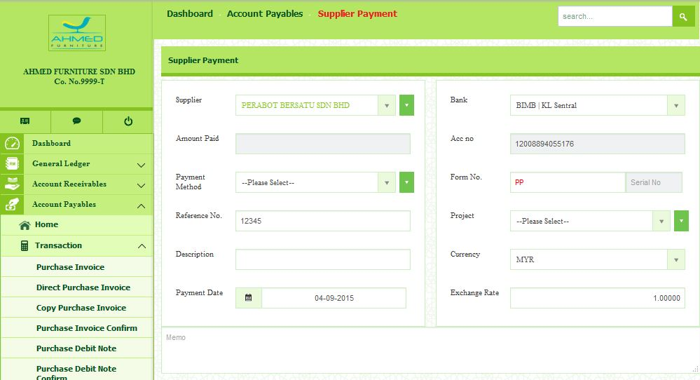

- Select the Invoice that you want to pay.
- Then, click Save.

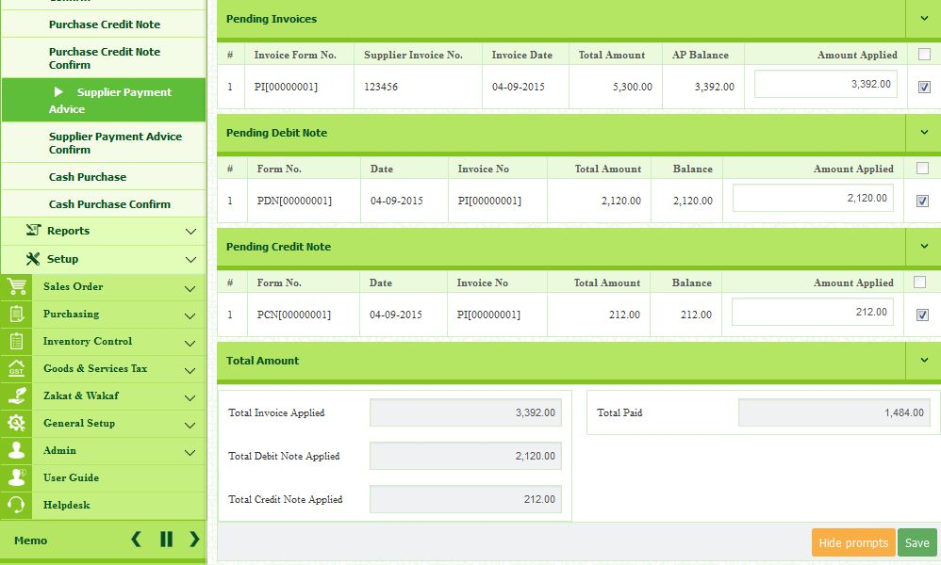

Transaction: Supplier Payment Confirm

- Go to Account Receivables Transaction Copy Sales Invoice
- Select Year and Period and click Submit.
- All list of invoice will be displayed.
- Select/Tick the invoices you with to reuse.
- Once selected, click Clone Invoice button.

- Go to Account Payables Transaction Supplier Payment Confirm
- Select Year and Period.
- Select Supplier Payment Advice To Confirm List.
- Then, Click Confirm.

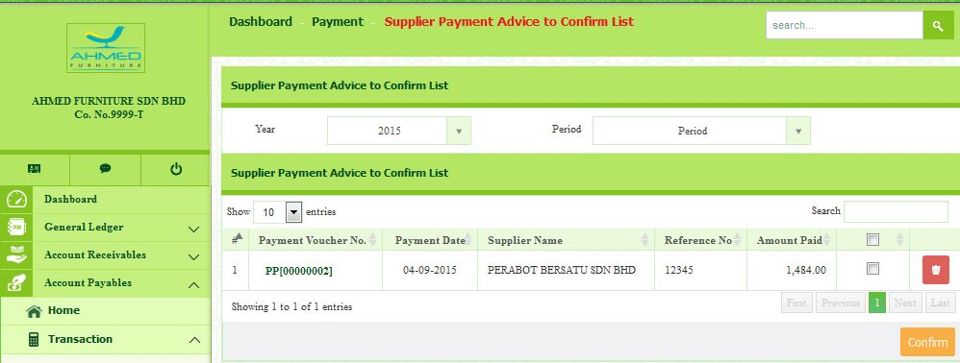
Transaction: Cash Purchase

- Go to Account Payables Transaction Cash Purchase
- Select the Date.
- For Pay To field, enter the details of receiver such as Name and Address.
- Select the Bank.
- Enter the Amount Paid.
- Enter the Reference No.
- Select the Payment Method.
- Select Location
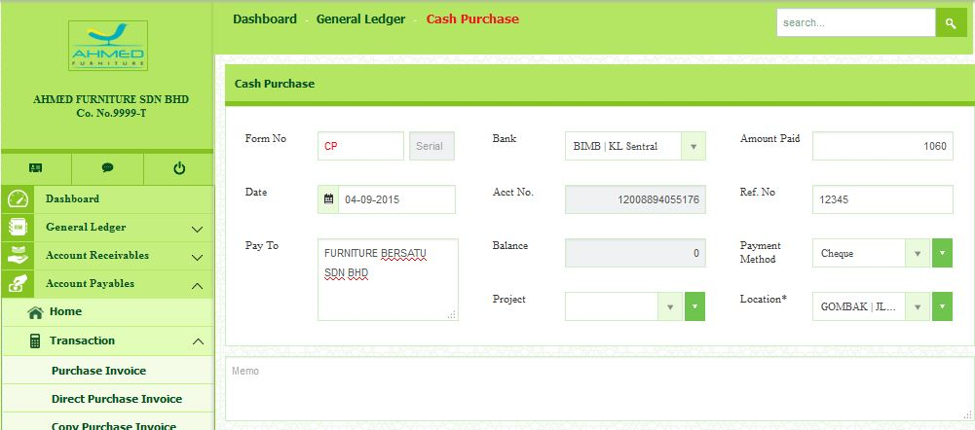

Items
- Click the + button to insert the Items.
- Select Item.
- Enter the description.
- Enter the Unit Price.
- Enter Quantity.
- Select the Tax (%) from the Tax Master.
- Click to save.
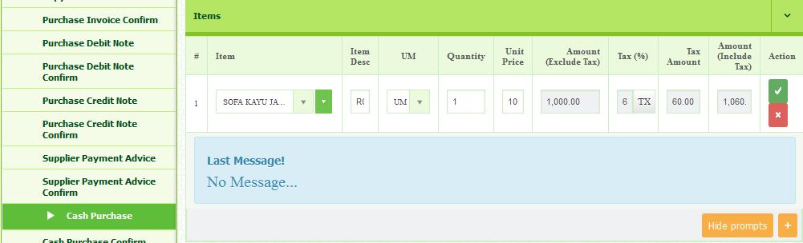
Transaction: Cash Purchase Confirm

- Go to Account Payables Transaction Cash Purchase Confirm.
- Select Year and Period.
- Select Cash Purchase that you want to confirm.
- Then, Click Confirm.

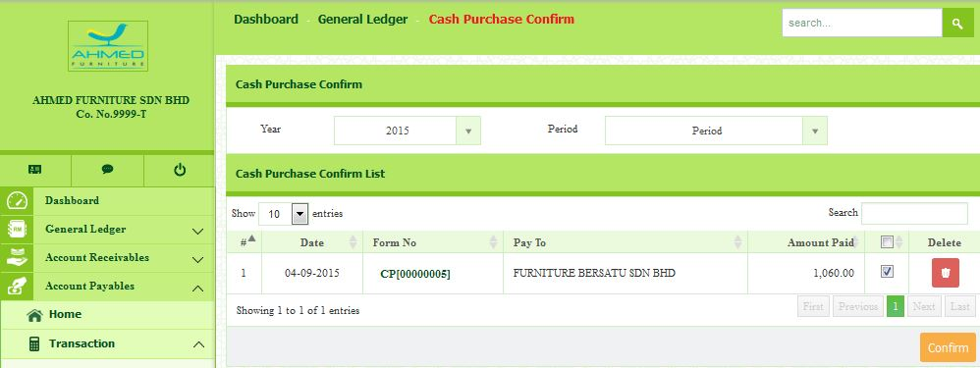

Report
Transaction: Purchase Invoice List

- Select the Period.
- Click Submit.
- Click Action to review and print the report.

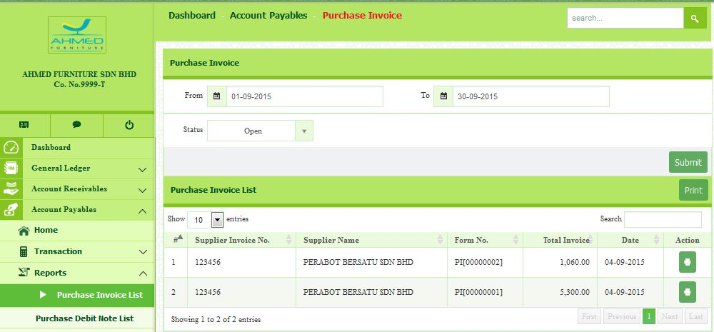

- Example of Purchase Invoice List
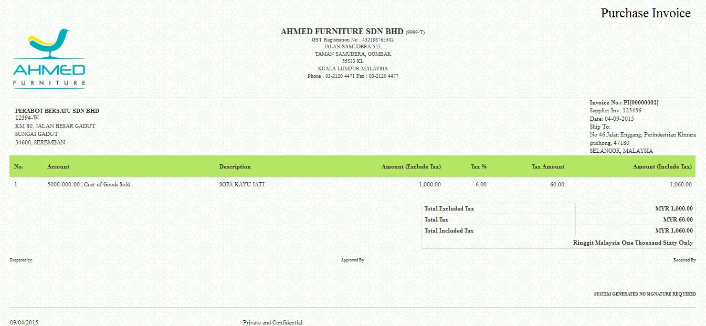

Transaction: Purchase Debit Note List

- Go to Account Payables Reports Purchase Debit Note List.
- Select the Period.
- Click Submit.
- Click Action to review and print the report.

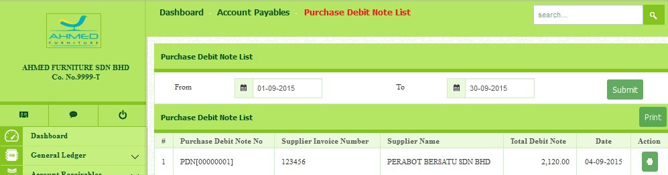

- Example of Purchase Debit Note List.

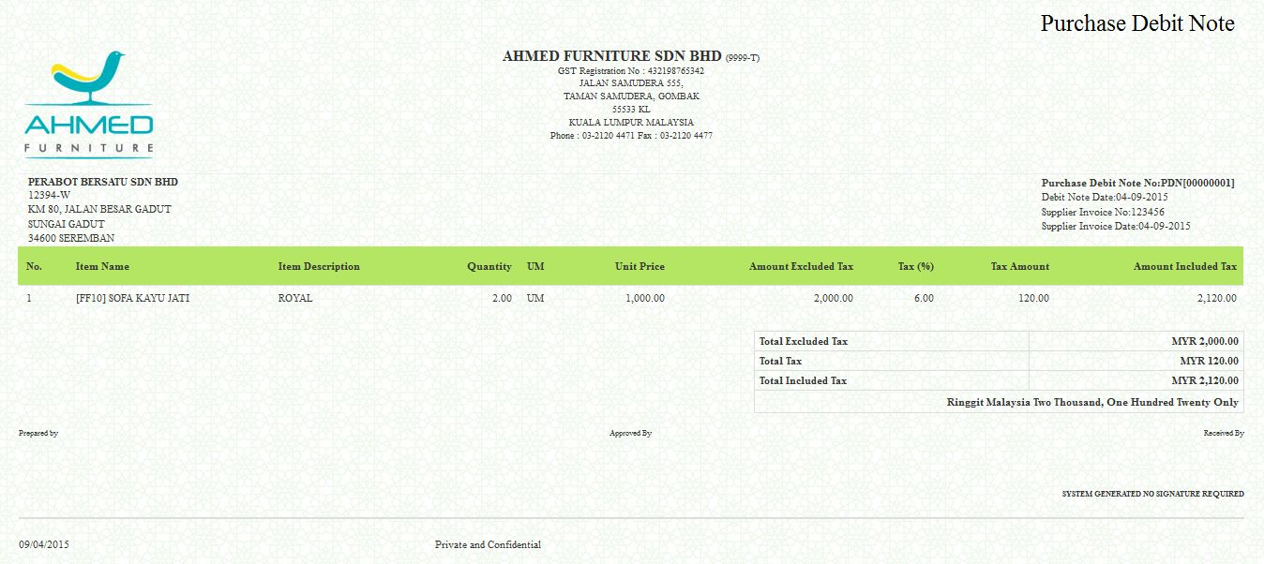
Transaction: Purchase Credit Note List

- Go to Account Payables Reports Purchase Credit Note List.
- Select the Period.
- Click Submit.
- Click Action to review and print the report.

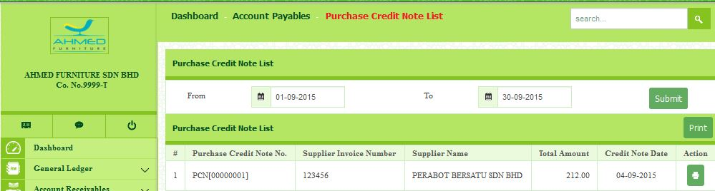

- Example of Purchase Credit Note List.

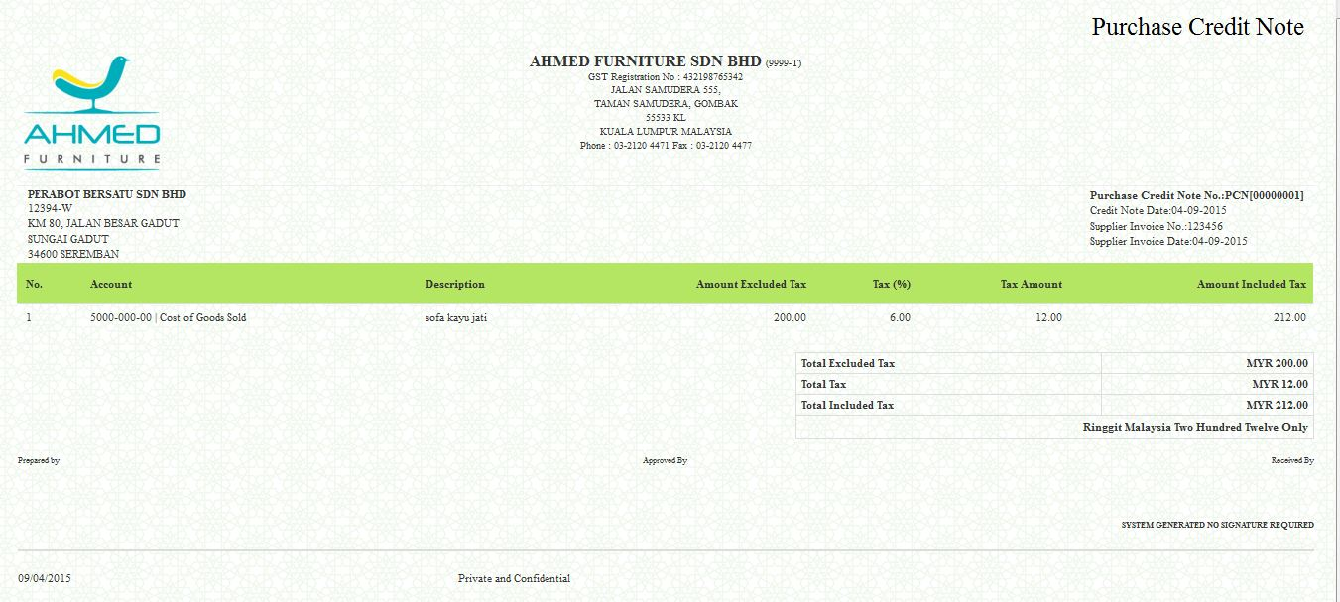
Transaction: Supplier Payment List

- Go to Account Payables Reports Supplier Payment List.
- Select the Period.
- Click Submit.
- Click Action to review and print the report.

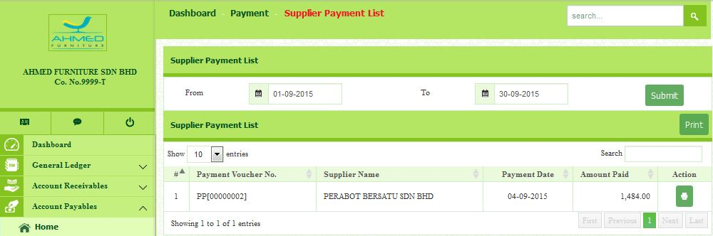

- Example of Supplier Payment List.

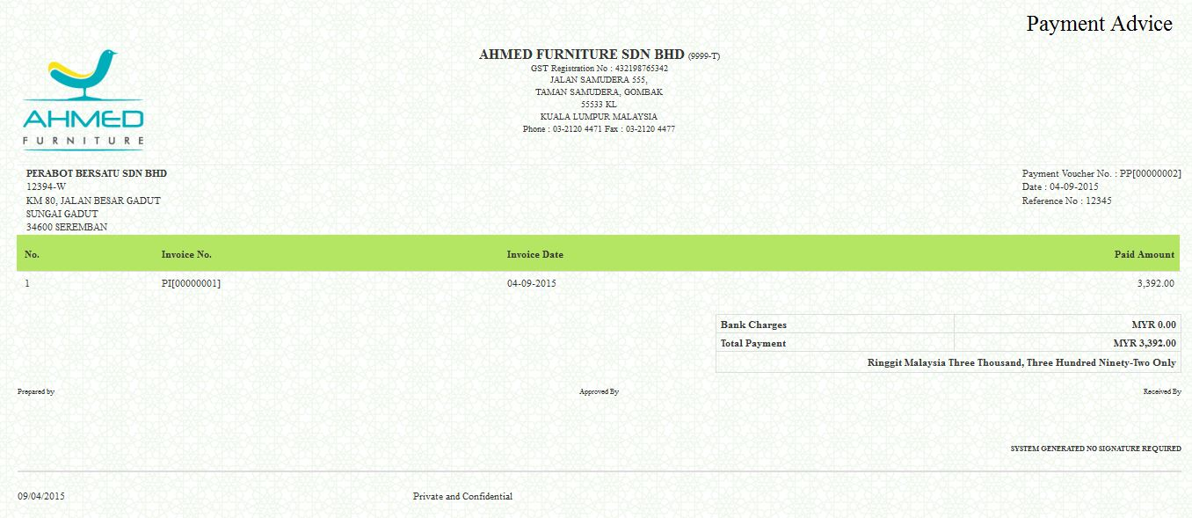
Transaction: Supplier Statement List

- Enter Default Footer Message.
- Select the Supplier name.
- Click Action to review and print the report.

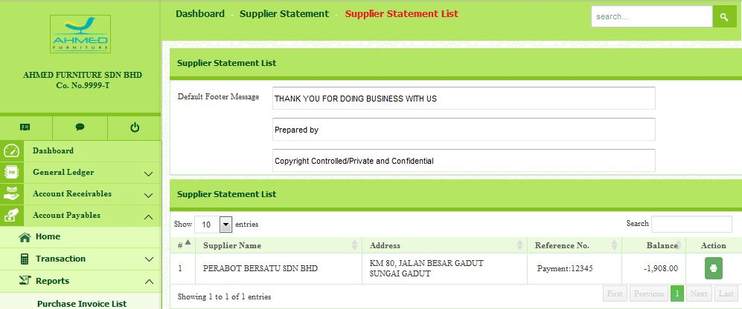

- Example of Supplier Statement List.

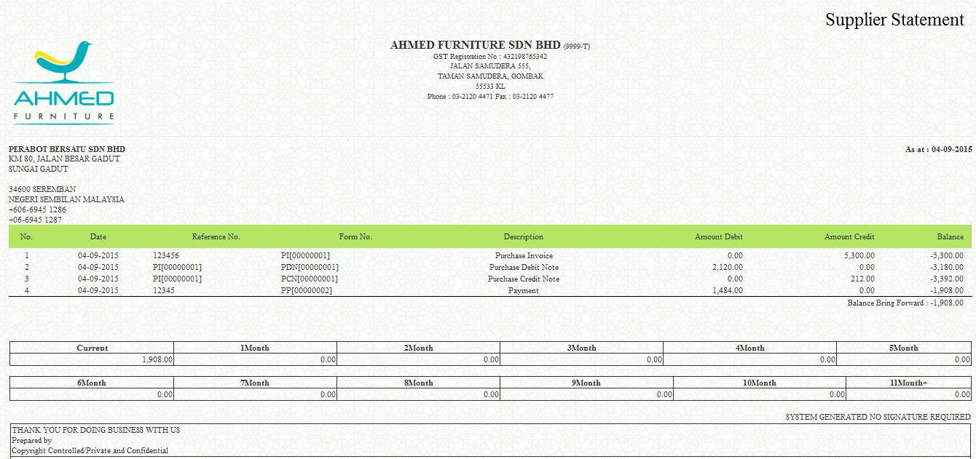
Transaction: Cash Purchase List

- Go to Account Payables Reports Cash Purchase List.
- Select the Period.
- Click Submit.
- Click Action to review and print the report.

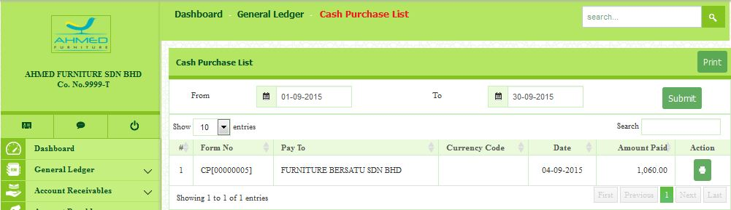

- Example of Purchase Credit Note List.

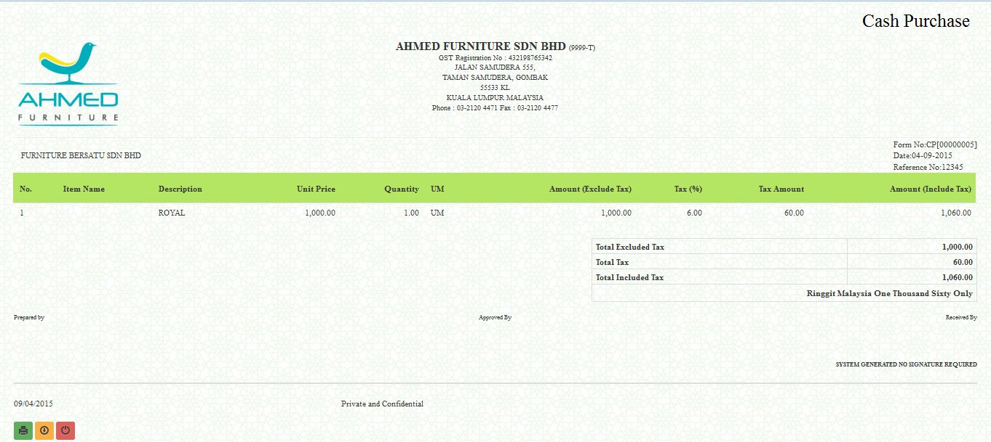

Sales Price
How to Sales Order

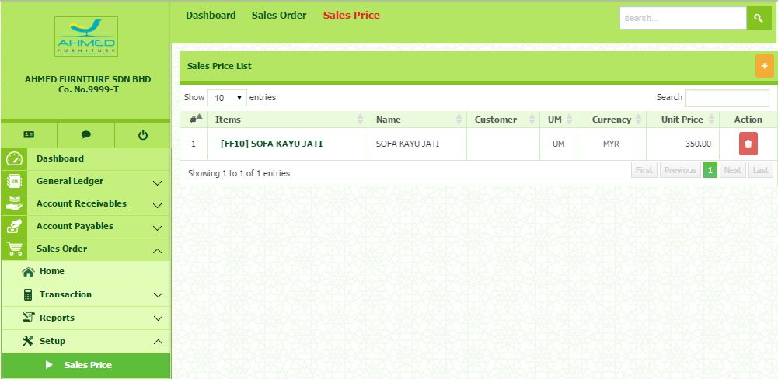
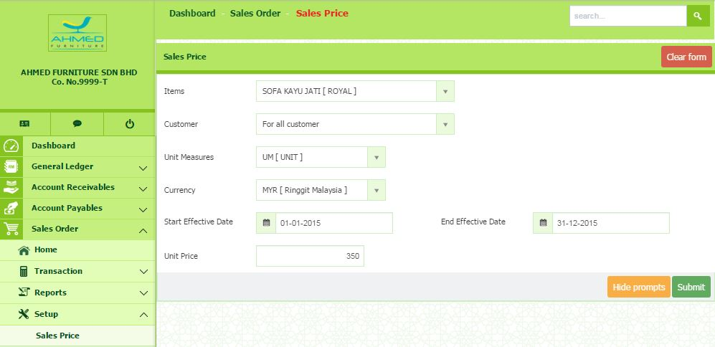
- Go to Sales Order Setup Sales Price
- There will appear the list of Sales Price that have been create.
- Click + button at the right top of page to insert new sales price.
- Select Items from the dropdown list that we created in Inventory module.
- Select the Customer from the dropdown list that we created in Account Receivable module.
- Select the Unit Measures from the dropdown list that we created in Inventory module.
- Select the Currency from the drop down list.
- Select the Start Effective date and End Effective Date *if we did not change the date, it will record the current date.
- Enter Unit Price as it is per quantity.
- Please be noted, the Unit Price will be effective due to the selected date.
- Once you completed, click the Submit button to save.
- To modify the items details including price, simply click the link of items that you have choose.
- You will be directed to the page where you can modify needed information.
- Once completed, click the Submit button to update.
- To delete the existing items list, choose the items and click the delete button.
Sales Quotation

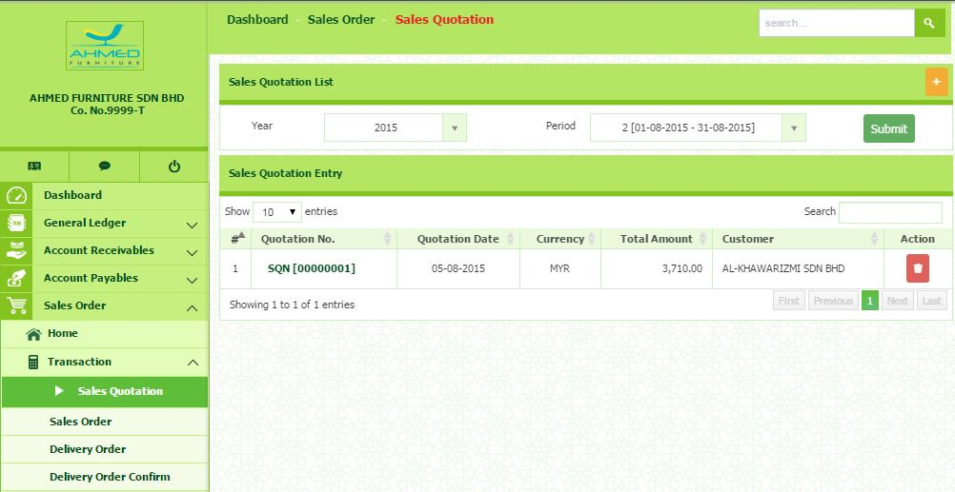
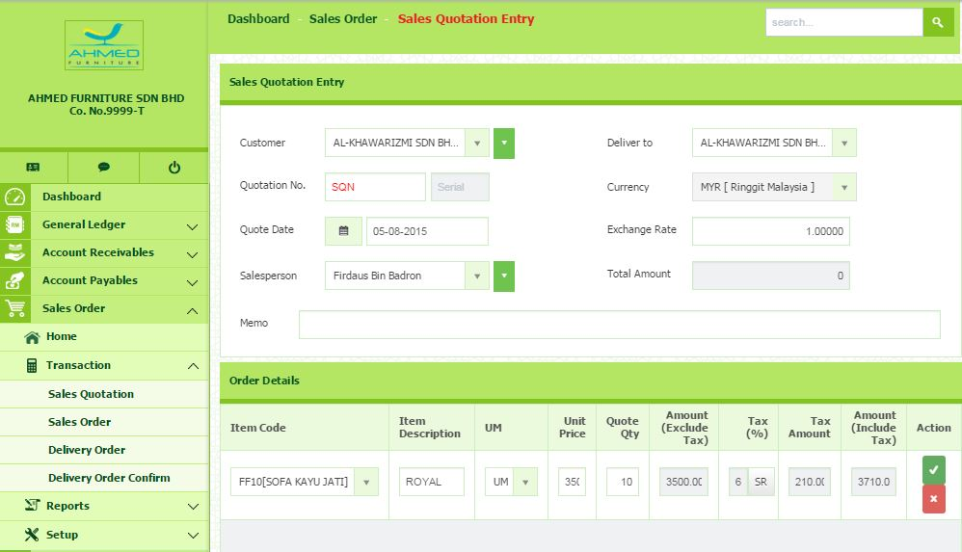
- Go to Sales Order Transaction Sales Quotation
- There will appear the list of Sales Price that have been create.
- Click + button at the right top of page to insert new sales quotation.
*You may click the Remove (red/dustbin) button in action column for any quotation deletion.
- Select the Customer from the dropdown list that we created in the Account Receivable module *Click the green button beside to add new customer and refresh the customer list.
- Enter the Quotation Number if necessary.
- Select the Salesperson from the dropdown list that we created in Employee setup *Click the green button beside to add new Salesperson and refresh the customer list.
- Enter Memo
- Select Deliver to from the dropdown list that we created in????.
- Currency and Exchange Rate will be automatically display once customer is selected.
- The total amount will automatically appeared from the amount in Order Details part.
ORDER DETAILS
- To enter the new Item details, you may click the Add New Line button.
- Select the Item Code then, enter Unit Price and Quotation Quantity.
- Click the Save (green) button in Action row to record the data.
- Item deletion can be made by clicking the Delete (red/dustbin) button in action column.
Sales Order

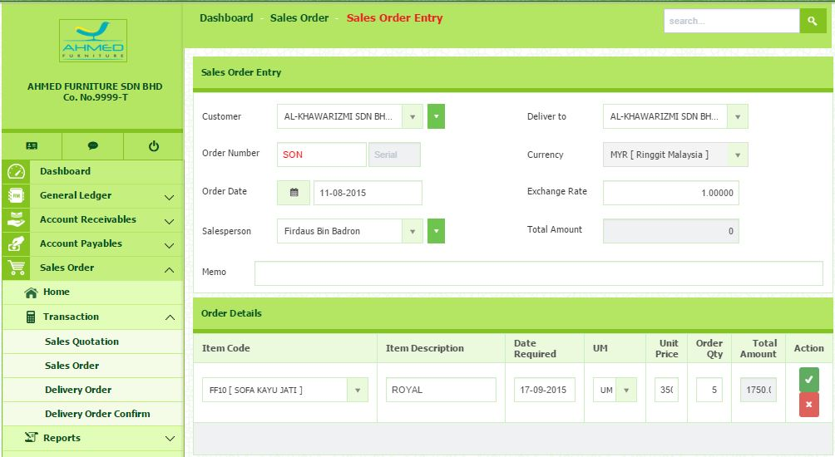
- Go to Sales Order Transaction Sales Order
- There will appear the list of Sales Order that have been create.
- Click + button at the right top of page to insert new sales order.
- Select the Customer from the dropdown list that we created in the Account Receivable module *Click the green button beside to add new customer and refresh the customer list.
- Enter Order Number if necessary but the serial number will generate automatically.
- Enter the Order Date *if we do not change the date, it will record the current date.
- Select the Salesperson that we created in Employee setup.
*Click the green button beside to add new customer and refresh the Salesperson list.
- Select Deliver To from the drop down list
- Currency and Exchange Rate will be automatically display once customer is selected.
ORDER DETAILS
- Click Add New Line button.
- Select the Item Code.
- Fill in the Item Description as it has no letters limit, date required and unit measures will be appear automatically once item code is selected.
- Enter your Unit Price and enter your Order Quantity.
- Click the Save (green) button in Action row to record the data.
- Item deletion can be made by clicking the Delete (red/dustbin) button in action column.
- Total Amount will be display after you save the order details.
Delivery Order

Here you need to maintain the delivery items. Which are delivered to the customer.
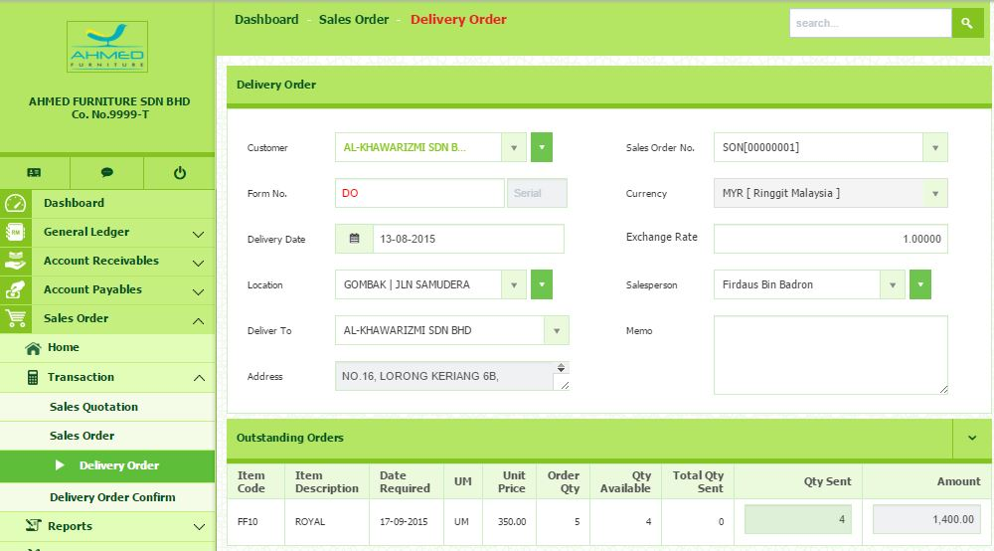
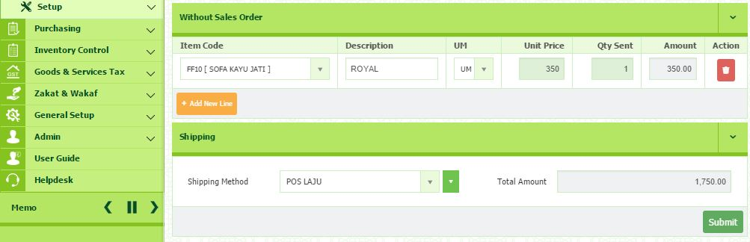
- Go to Sales Order Transaction Delivery Order
- Select the Customer from the dropdown list that we created in the Account Receivable module *Click the green button beside to add new customer and refresh the customer list.
- Enter Form Number if necessary but the serial number will generate automatically.
- Enter the Delivery Date *if we do not change the date, it will record the current date.
- Select location from the dropdown list that we created in the Inventory module.
*Click the green button beside to add new customer and refresh the customer list.
- Deliver To and Address will appear automatically when location is selected.
- Select Sales Order No. that we created in the Sales Order transaction to get the details of the outstanding orders.
- Currency and Exchange Rate will appear automatically.
- Select the Salesperson that we created in Employee setup.
*Click the green button beside to add new customer and refresh the Salesperson list.
- Any description or reminder can be insert in the Memo.
- Select Shipping Method from the dropdown list that we created in the Ship To setup.

OUTSTANDING ORDERS
- Once Sales Order No. is selected, the details of outstanding orders will be listed.
- It will tell us how much quantity are available for delivery.
*If the quantity available are less than the order quantity, you may refer to the Purchase Order module if the incoming quantity can recover the order quantity.
- You can decide the total of quantity to be sent. It depend on the Order Quantity.
- Amount will be calculate automatically based on orders.
- Click the Submit (green) button on the right bottom of the transaction to record the data.

WITHOUT SALES ORDER
- If you request to make new order, which not include in the previous order, you can simply click Add New Line (orange) button.
- Select Item Code from the dropdown list that we created in the Item Setup.
- Fill in the Description as it has no letters limit, unit measures, unit price and quantity sent.
- Amount will be calculate automatically based on your orders.
- Total Amount will be calculated automatically.
*You may delete the order by clicking the Deletion (red/dustbin) button in the row Action.
- Click the Submit (green) button on the right bottom of the transaction to record the data.
Delivery Order Confirm

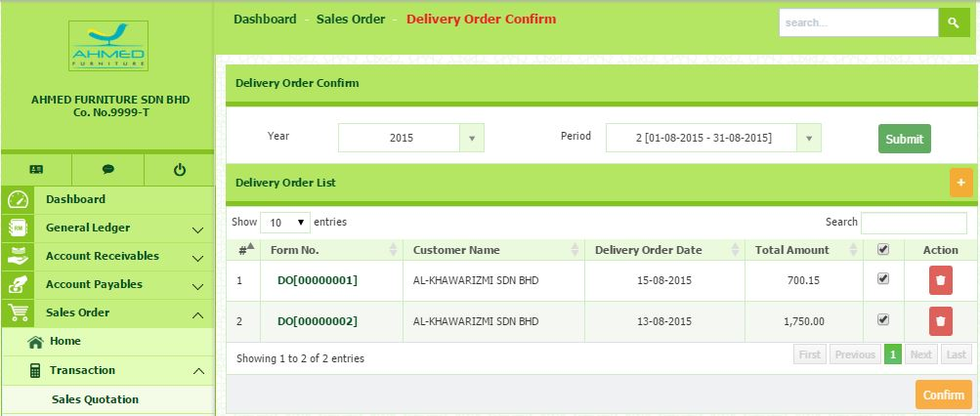
- Go to Sales Order Transaction Delivery Order Confirm
- Select Year and Period. Then, click Submit button.
- Delivery Order will be listed based on selected year and period.
- If the Delivery Order not in the list, you may create new Delivery Order by clicking the Add New (orange) button.
- If you wish to modify needed information, choose the delivery order from the list and simply click the link at Form No column.
- If the Delivery Order is already correct, you may do the confirmation by clicking (√) and click the Confirm (orange) button at the bottom of the transaction.
Sales Order: How to Setup a Report
Sales Price

- Go to Account Receivables Reports Sales Price
- Select the Parameter by From and To of the year/month that invoice exist in it, then click the submit button.
- Select the Sales Price from the list that created in Sales Order Setup.
- Click Print button in the Action row.
- Click the Print button to print all the list of the invoices.

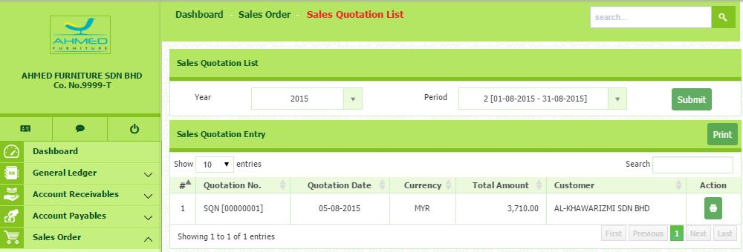
Sales Quotation List
- Go to Account Receivables Reports Sales Quotation List
- Select the Parameter by From and To of the year/month that invoice exist in it, then click the submit button.
- Select the Sales Quotation from the list that created in Sales Quotation.
- Click Print button in the Action row.
- Click the Print button to print all the list of the invoices.

Sales Order List

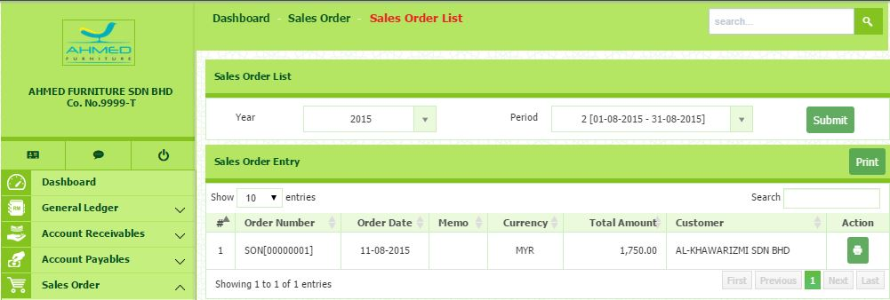
- Go to Account Receivables Reports Sales Order List
- Select the Parameter by From and To of the year/month that invoice exist in it, then click the submit button.
- Select the Sales Price from the list that created in Sales Order.
- Click Print button in the Action row.
- Click the Print button to print all the list of the invoices.

Delivery Order List

- Go to Sales Order Reports Delivery Order List
- Select the Parameter by From and To of the year/month that invoice exist in it, then click the submit button.
- Select the Sales Price from the list that created in Delivery Order.
- Click Print button in the Action row.
- Click the Print button to print all the list of the invoices.
Sales By Customers

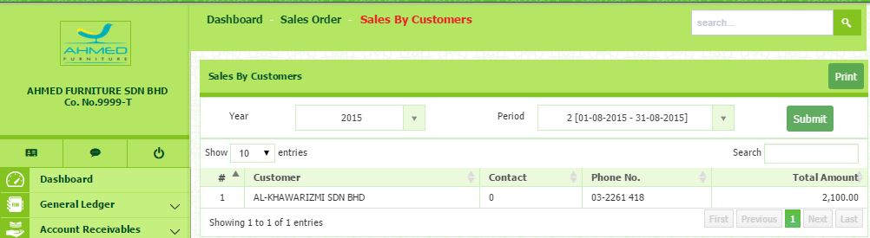

- Go to Sales Order Reports Sales By Customers
- Select the Parameter by From and To of the year/month that invoice exist in it, then click the submit button.
- Select the Sales Price from the list that created in Sales Order.
- Click Print button in the Action row.
- Click the Print button to print all the list of the invoices.

Yearly Sales By Customers

- Go to Sales Order Reports Yearly Sales By Customers
- Select the Parameter by the year that invoice exist in it, then click the submit button.
- Select the Sales Price from the list that created in Sales Order Setup.
- Click Print button in the Action row.
- Click the Print button to print all the list of the invoices
Sales By Item

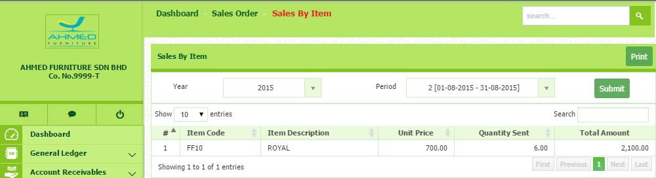

- Go to Sales Order Reports Sales Order By Item
- Select the Parameter year/period that invoice exist in it, then click the submit button.
- Select the Sales Price from the list that created in Sales Order.
- Click Print button in the Action row.
- Click the Print button to print all the list of the invoices.
Sales Orders By Customers

- Go to Sales Order Reports Sales Order By Customers
- Select the Parameter by the year/period that invoice exist in it, then click the submit button.
- Select the Sales Price from the list that created in Sales Order Setup.
- Click Print button in the Action row.
- Click the Print button to print all the list of the invoices.
Sales Orders By Item

- Go to Sales Order Reports Sales Order By Item
- Select the Parameter by From and To of the year/month that invoice exist in it, then click the submit button.
- Select the Sales Price from the list that created in Sales Order.
- Click Print button in the Action row.
- Click the Print button to print all the list of the invoices.
Outstanding Sales Orders By Item

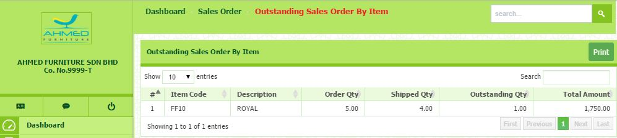

- Go to Sales Order Reports Outstanding Sales Order By Item
- It will display the table that have all the data.
Setup
How to Do Purchasing

Purchasing is the activity of acquiring goods or services to accomplish the goals of an organization.

Setup

1) Setup: Suppliers List
- Before you proceed to do a transaction under Purchasing, firstly you need to setup or maintain the supplier’s details.
- Go to Purchasing Setup Suppliers List
- Click the + button to Add New Supplier
- Enter your Supplier Code, Supplier Company No and Supplier Name.
- If your Supplier is registered to GST, enter the GST Registration No. If not, just leave it blank.
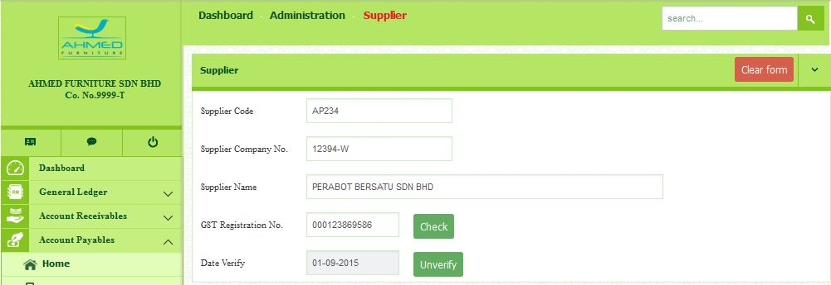

- Enter all the address information.

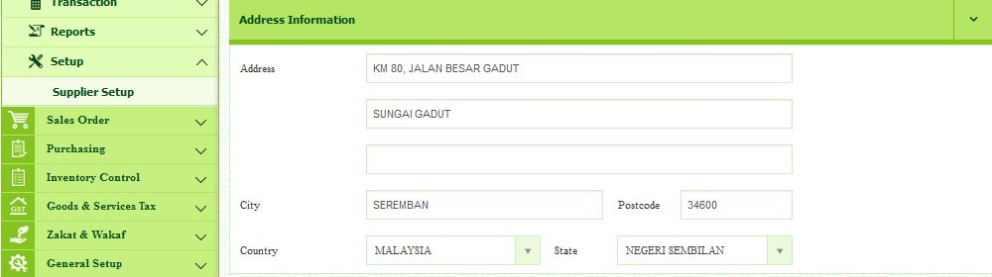
- Enter all the contact information.
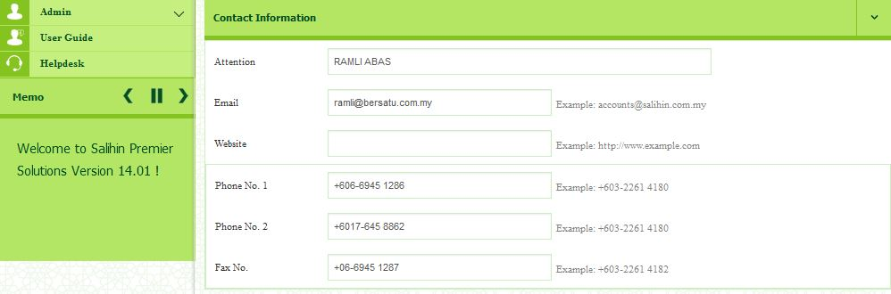

- Enter others information.

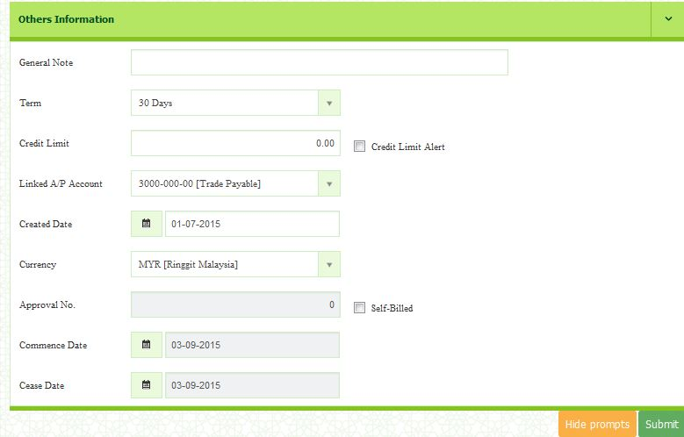

- After completed, click Submit button to save.
- To edit, click the link of Company No that you want to modify. You will be directed to the page where you can update the existing supplier information. Then, click Submit button to save.

- To delete the existing supplier, you can click the delete button that situated in the same row of selected supplier.

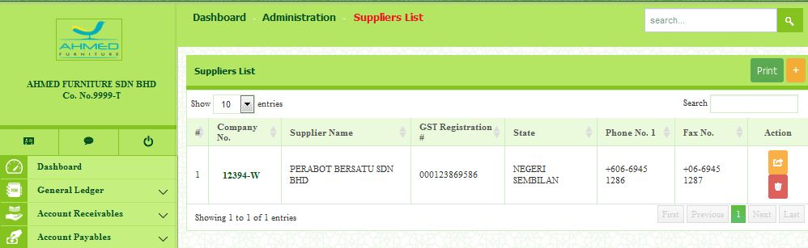
To edit
Delete button
Purchase Pricing

- Go to Purchasing Setup Purchase Pricing
- Select Item.
- Select Supplier.
- Select Unit of measure.
- Select Currency.
- Select Start Effective Date and End Effective Date.
- Enter Unit price. It depends on your goods market value.
- Click Save button to save.

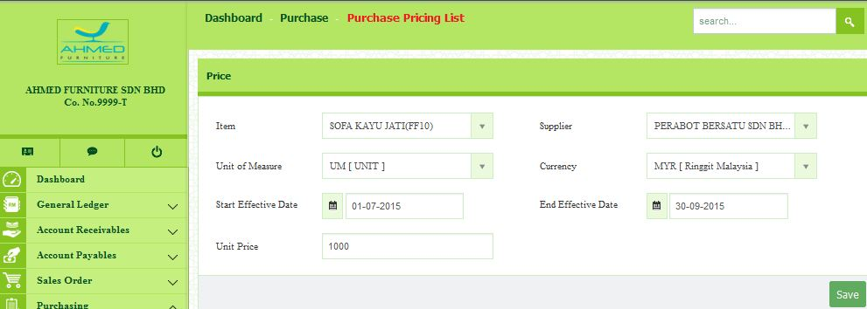

Transaction: Purchase Order

- Go to Purchasing Transaction Purchase Order
- Select the Supplier. Form No will be auto generated. The system allow user to change the Form No format.
- Select the date.
- Terms Description will be display automatically when Term is selected.
- Currency will be display automatically when Supplier is selected.
- Select Ship To.
- Select Purchaser.

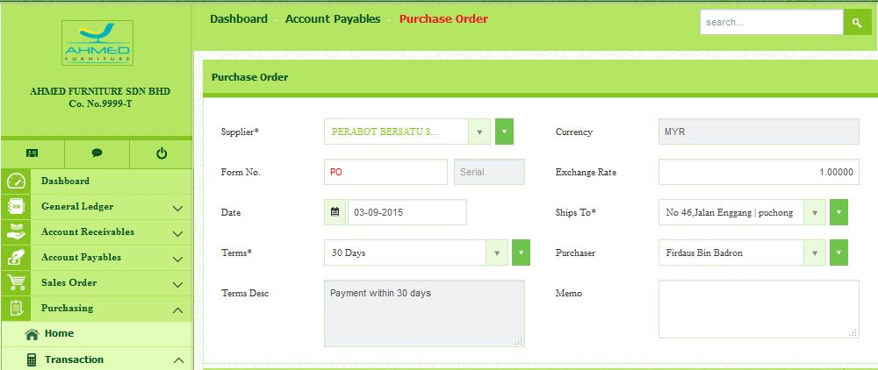

Item
- Click Add New Details.
- Select Item.
- Enter the price Unit of your Item.
- Enter the Quantity Order.
- Amount will be calculated automatically when Unit Price and Quantity is entered.
- Please ensure that your item is correct. Click the button to save.
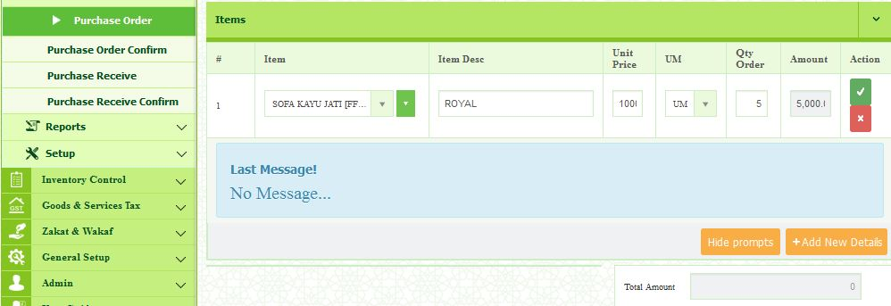
Transaction: Purchase Order Confirm

- Go to Purchasing Transaction Purchase Order Confirm
- Select the period.
- All purchase order to confirm will be listed.
- Tick the selected purchase order no.
- Click Confirm.
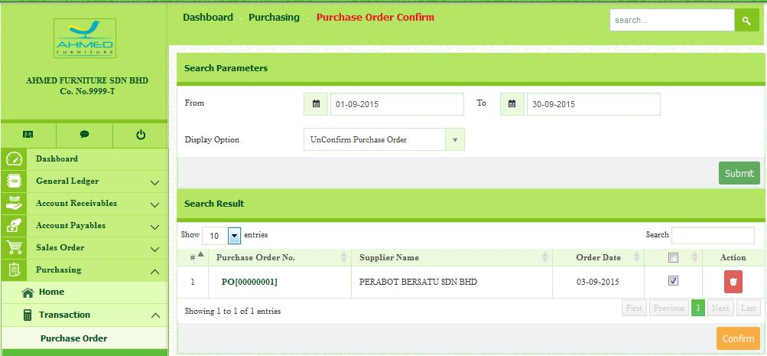
Transaction: Purchase Receive

- Go to Purchasing Transaction Purchase Receive
- Select the Supplier from the drop down list.
- Form No will be automatically display.
- Select the date.
- Enter the Supplier Do No.
- Select the Purchase Order.
- Select the shipping method.
- Select the Location.
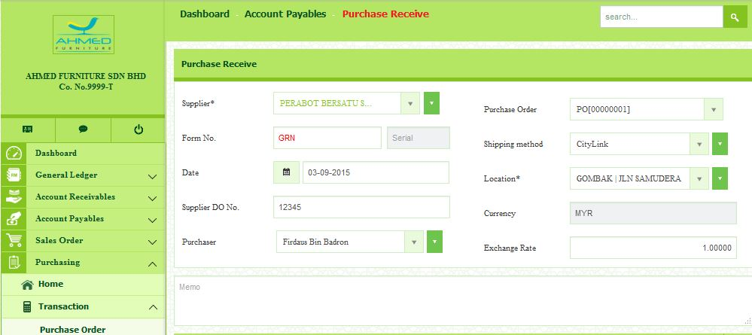

Outstanding Purchase Order Items
- Item details will be listed once the purchase order is selected.
- Enter the Quantity Received and click button.

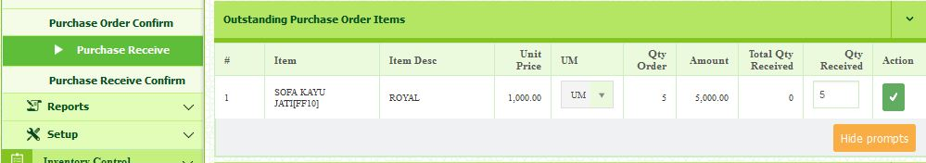

Current Items Received
- In this part, it will display the current item received that you have entered in previous outstanding purchase order items.

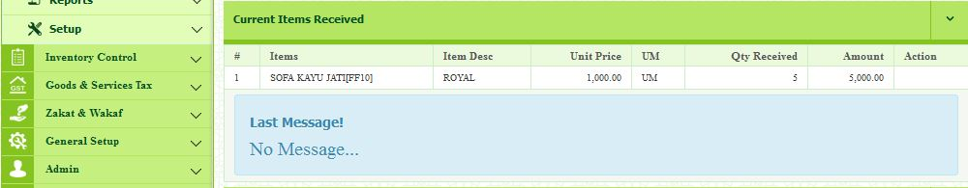

Items Not Include In Purchase Order
- In this part, you are allowed to add new item even the details it’s not include in previous purchase order.
- For example, you want to add on 1 monitor, you can request to do so.
- The both item details will be combine in one purchase order

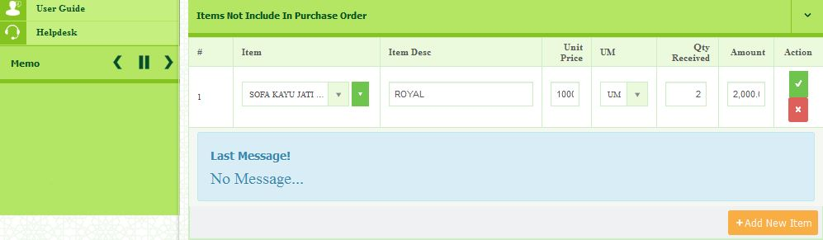

- Go to Purchasing Transaction Purchase Receive Confirm
- Select the Year and Period, then click Submit button.
- Purchase receive item list will be listed for selected period.
- Tick the selected purchase order that need to be confirm.
- Once selected, click the Confirm button.
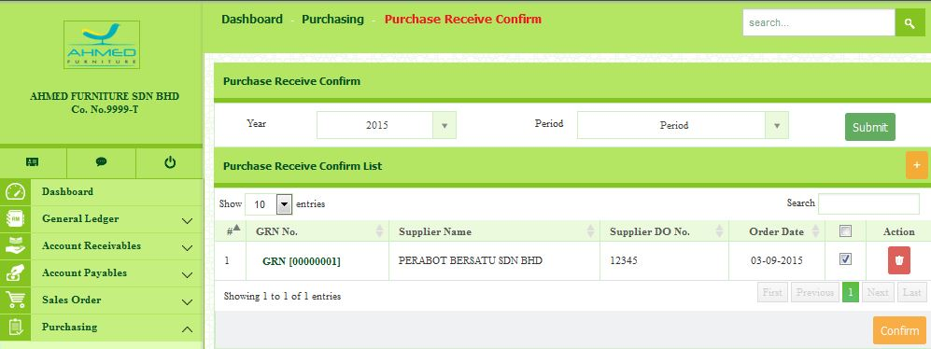
Report

Report: Purchase Pricing List

- Go to Purchasing Reports Purchase Pricing
- Select the Year and Period, then click Submit button.
- Purchase Pricing List will be listed for selected period.
- Click Print to review and print the Purchase Pricing List.

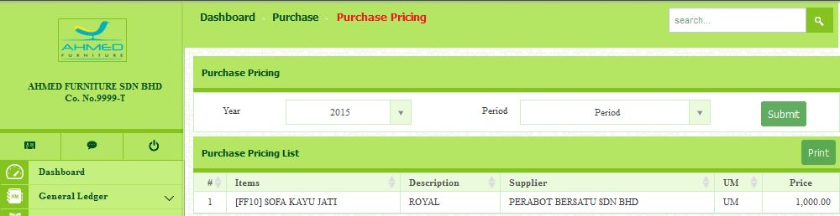

- Example of Purchase Pricing List Report.

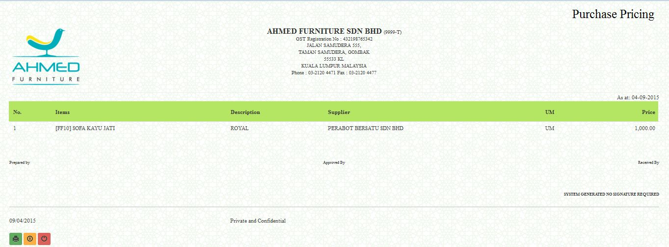
Report: Purchase Order List

- Go to Purchasing Report Purchase Order List
- Select the period.
- Click Report to review and print the report.

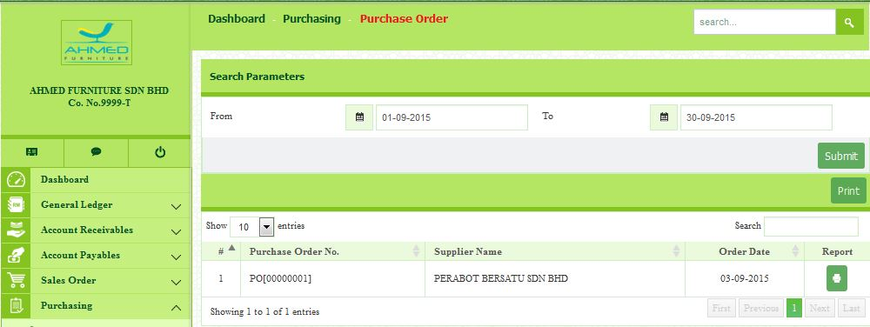
- Example of Purchase Order List Report

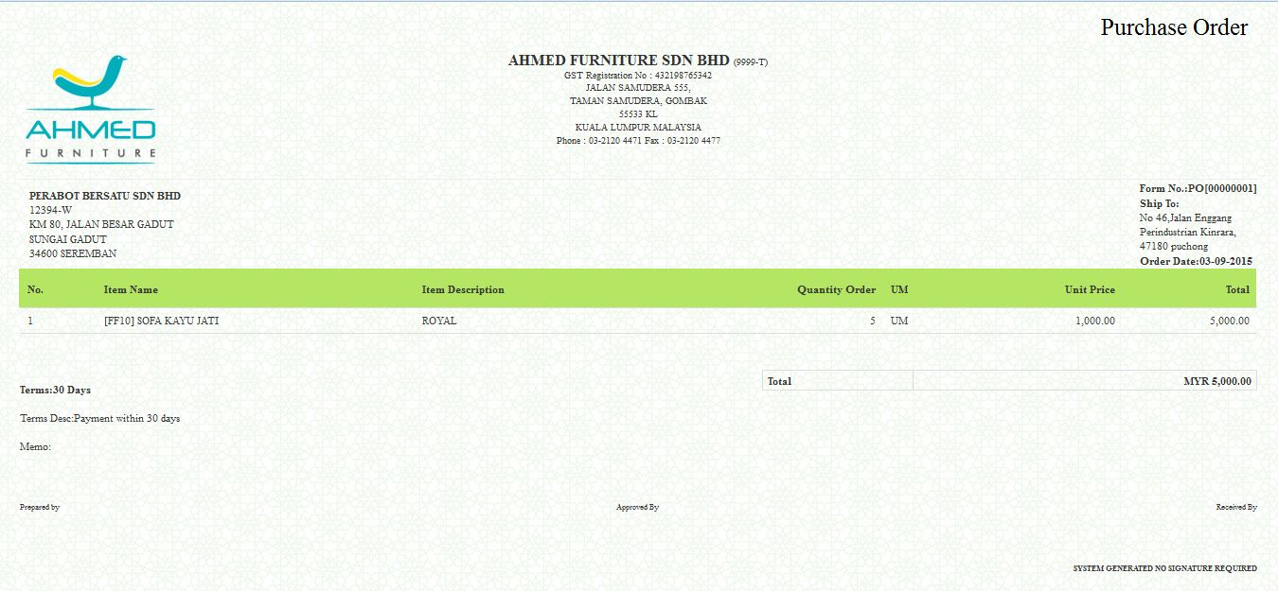
Report: Purchase Received List

- Go to Purchasing Reports Purchase Received List.
- Select the Period.
- Click Report to review and print the report.

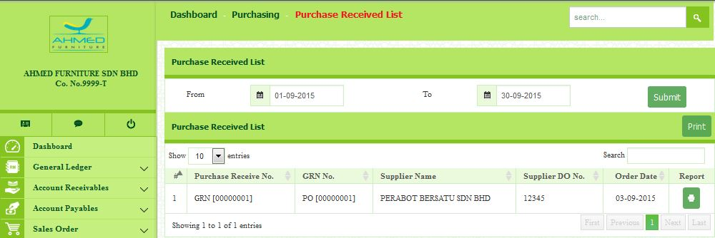

- Example of Purchase Received List Report.

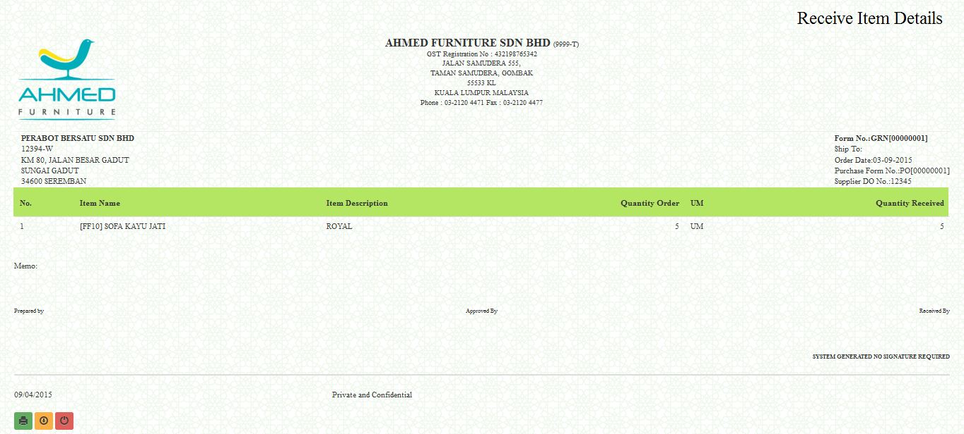

Report: Outstanding GRN Report

- Go to Purchasing Reports Outstanding GRN Report

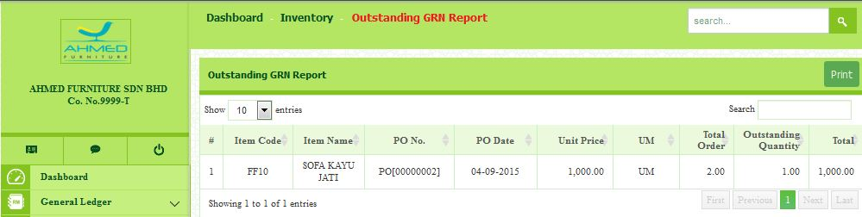

GENERAL SETUP
System setup allows you to maintain general setting of the software according to your company’s requirements. It is highly recommended to set all the requirements before you start off with the system.

Add Company
- Go to General Setup > Company Setup > Company Master List. The Company Master List window appears.
- Click on + button on the top right of the page to add New Company.
- You will be directed to the page where you can enter all the required information.

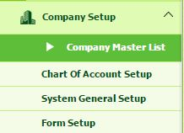
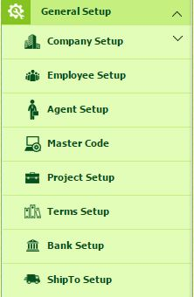

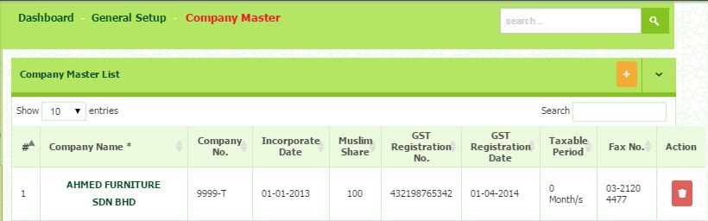

- In this section, all the blank space must be filled in.
- Company number (limit up to 20 character)
- Company activation key (will be given through email)
- Company name (according to registered)
- Incorporate date (company registration date)
- Address (company location)
- City (location in the state)
- Post code (as example given)
- Country & State (as located)
- Phone No., Fax No., Email, Website ( as example given)
- Currency (as preferred currency)

Note: Mandatory fields are marked with an asterisk (*).

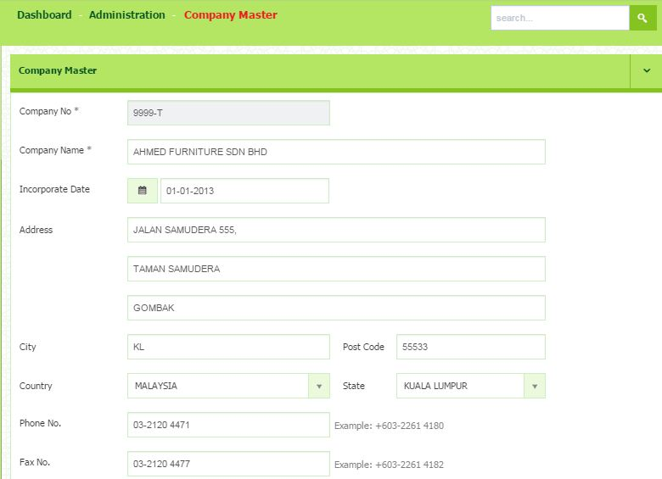

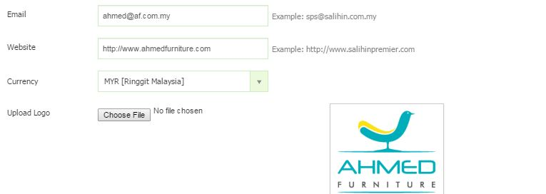

- GST Registration No. (as given by the royal customs)
- GST Registration Date (date registered)
- Taxable Period (by monthly/quarterly)
- MSIC Code (as given by royal customs)
- Zakat & Wakaf percentage ( own preference)

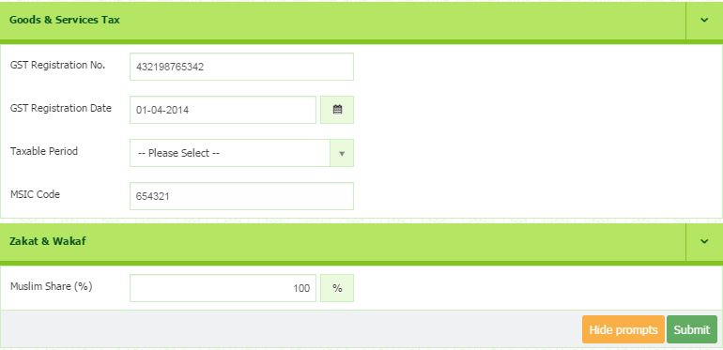

Edit Company
- Go to Company Setup > List. The Company Master List window appears.
- In the Company Name column, identify and select the particular company. The Edit dialog box will appear.
- Click Continue, the page of the selected company's details (Company Master) appears. Edit the relevant information.
- Once completed, click Submit button to save.
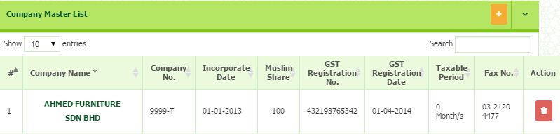
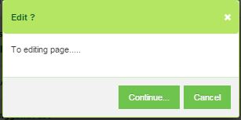

Remove Company
- Go to Company Setup > List. The Company Master List window appears.
- In the Company Name column, identify the company's name from the list.
- Click Delete (image bin) button in the Action column.
- When prompted, click Delete button.

Warning! : Please be careful before remove the company. Charge may be implied for data recovery.
Please make sure that you register your Company no. to proceed, login to demo.salihinpremier.com/ss-ss/customerlogin
Click Here

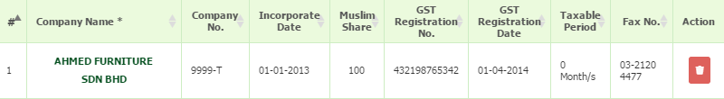

Company List
- To view Company List, go to General Setup > Company Setup > List.
- You can view the company from the Company Master List screen.

To add Chart of Account, kindly follow the steps below:-
- Go to General Setup > Company Setup > Chart of Account Setup. The Chart of Account List windows appears.
- Select the Industry Classification.
- Select the Type of Business.

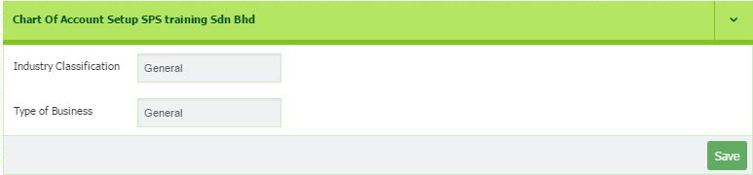
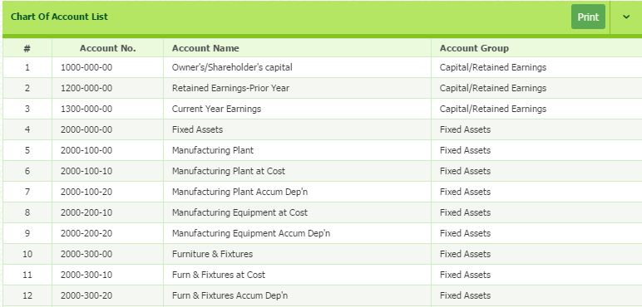

System General Setup
- Go To General Setup > System General Setup. The General Setup window appears.
- In this section, the system set the default for all setup and customizes according to your company’s suitability and needs.

Account No. | Related Amount
1xxx/xxx | - Retailed earning  - Current year earning  - Owners/shareholders capital
2xxx/xxx | - Fixed asset  - Trade receivable  - Cash & bank balance  - Inventories  - Other receivable  - Prepayment & deposit  - Tax claimable
3xxx/xxx | - Trade payable  - Invoice/Good not receive  - Other payable  - Accruals  - Client deposit  - Deffered tax liabilities  - Borrowing
4xxx/xxx | - Sales  - Wholesale  - Consignment  - Miscellaneous income
5xxx/xxx | - Cost of goods sold  - Purchase price variance  - Purchases  - Wholesale cost of sales  - Consignment cost of sales  - Materials & supplier  - Freight  - Commission expenses  - Inventory adjust account
7xxx/xxx | - Other operating income
8xxx/xxx | - Administration expenses  - Employment expenses  - Finance cost  - Income tax expenses  - Other comprehensive income
9xxx/xxx | - Finance income  - Interest income

- The main function of this section is to create the auto journal (the information are available by default).
- For the GST section, it will relate to Item Setup.
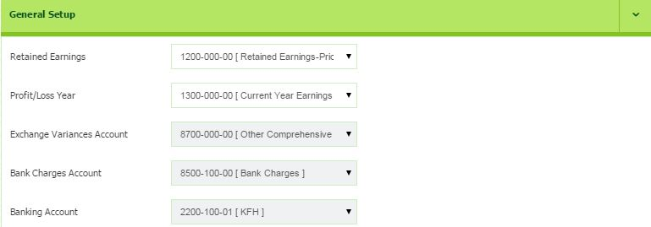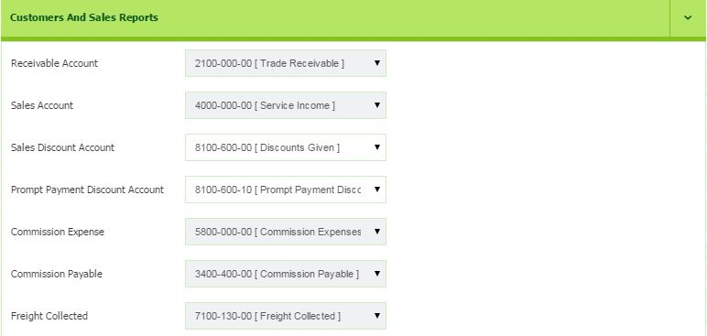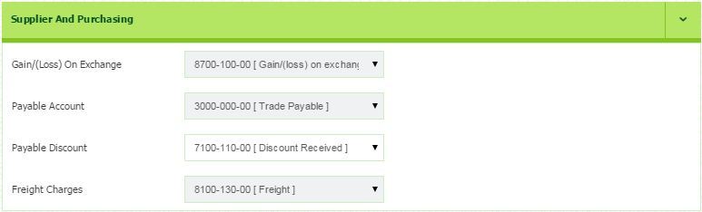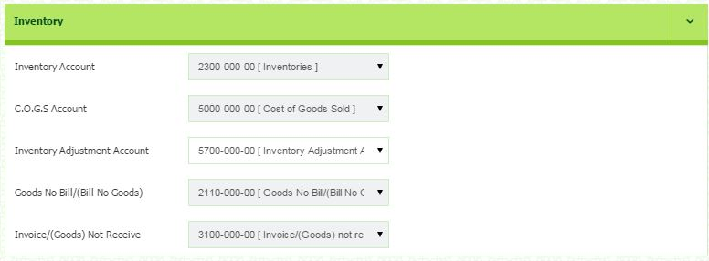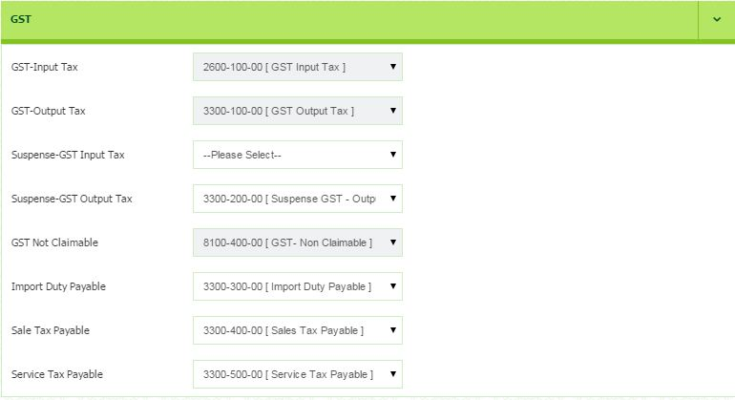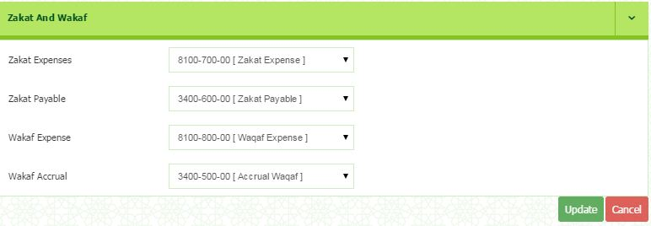

Form Setup
- Go To General Setup > Company Setup > Form Setup. The Form Setup List window appears.
- In this section, you can set your Serial Startup No.
- You also can set your Special Coding for each form type.
- To insert your special coding and serial startup number, double click at the selected field.
- Press Enter and click Save to save the data.
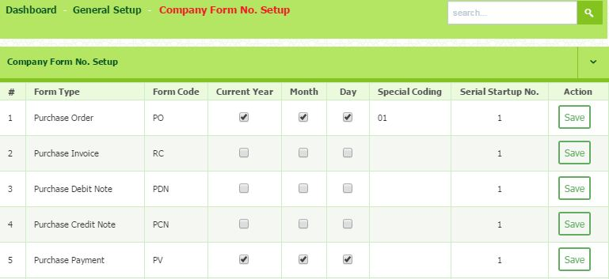

Add New Employee
- Go To General Setup > Employee Setup. The Employee Master List window appears.
- Click on + button on the top right-side of the page to add New Employee.
- You will be directed to the page where you can enter all the required information.
- After data entry, click Submit button to save.
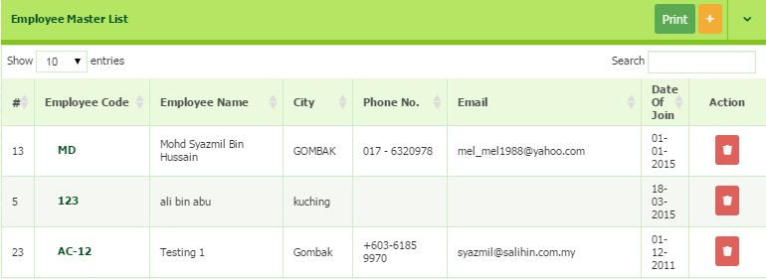

View Employee
- Go To General Setup > Employee Setup. The Employee Master List window appears.
- Fill up the requirement such as employee code (i.d), employee name, employee position and other required information.
- Once filled up, click submit button to save the details.
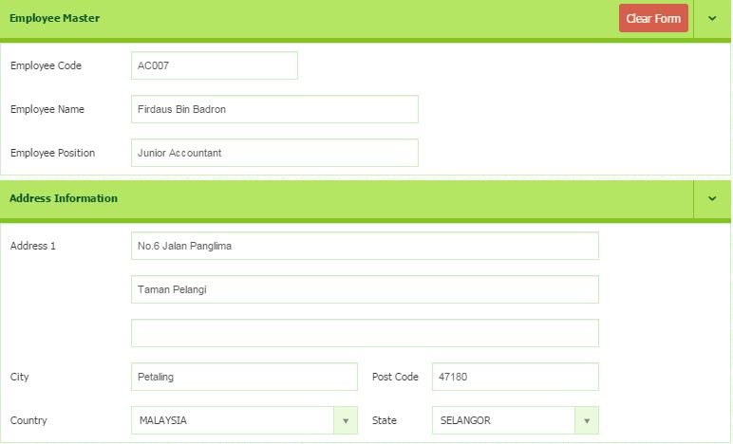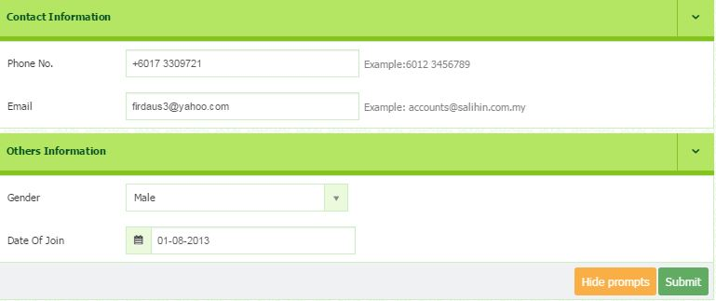

- In the Search field, search the employee’s name by entering his/her name.
- You can choose the number of entries of employee to be displayed.
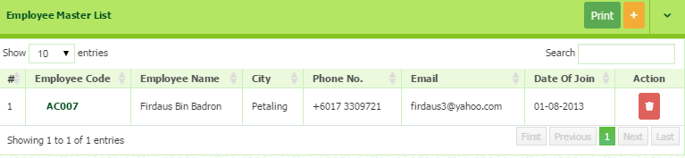

Edit Employee
- Go To General Setup > Employee Setup. The Employee Master List window appears.
- In the Employee Name field, identify the employee and select the particular employee’s name. The Edit dialog box will appear.
- Click Continue, the Employee Master window appears. Edit the relevant information.
- Once completed, click Submit button to save.
Remove Employee
- Go To General Setup > Employee Setup. The Employee Master List window appears.
- To remove employee from the list, identify the employee name row.
- In the Action field on the right-side of the row, click the Delete button (image).
- Dialog box of deletion confirmation appears, then click the Delete button.
Print Employee
- To print, click the Print button on the top right-side of the page.
- Employee list window appears.
- Click (print image) to print the data or (download image) to open/save the data in excel format (.xls)

Add New Agent
- Go To General Setup > Agent Setup. The Agent Master List window appears.
- Click on + button on the top right-side of the page to add New Agent.
- You will be directed to the page where you can enter all the required information.
- After data entry, click Submit button to save.

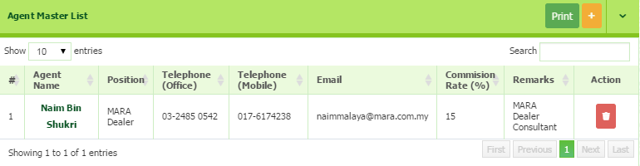

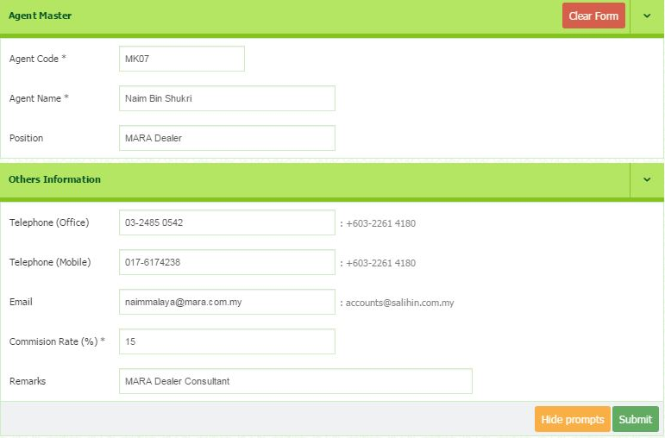

View Agent
- Go To General Setup > Agent Setup. The Agent Master List window appears.
- In the Search field, search the agent’s name by entering his/her name.
- You can choose the number of entries of agent to be displayed.

Edit Agent
- Go To General Setup > Agent Setup. The Agent Master List window appears.
- In the Agent Name field, identify the agent and select the particular agent’s name. The Edit dialog box will appear.
- Click Continue, the Agent Master window appears. Edit the relevant information.
- Once completed, click Submit button to save.

Remove Agent
- Go To General Setup > Agent Setup. The Agent Master List window appears.
- To remove agent from the list, identify the agent name row.
- In the Action field on the right-side of the row, click the Delete button (image).
- Dialog box of deletion confirmation appears, then click the Delete button.

Print Agent
- To print, click the Print button on the top right-side of the page.
- Agent list window appears.
- Click (print image) to print the data or (download image) to open/save the data in excel format (.xls)

Add New Terms
- Go To General Setup > Terms Setup. The Credit Terms and Condition List window appears.
- Click on + button on the top right-side of the page to add New Terms.
- You will be directed to the page where you can enter all the information required.
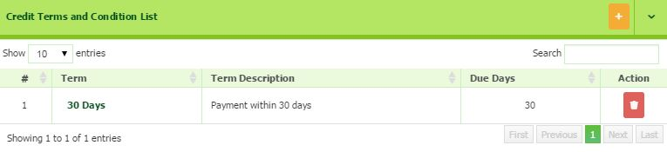

- Fill up the particulars as required
- In this section, all the particulars must be filled in.
- Term Name ( the period/time frame given )
- Description ( based on user understanding/preference)
- Due days ( dateline given for the term to be completed)
- After data entry, click Submit button to save.
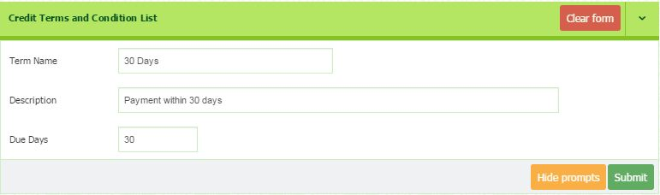

View Terms
- Go To General Setup > Terms Setup. The Credit Terms and Condition List window appears.
- In the search field, you can search terms by entering the terms.
- You can choose the number of entries of terms to be displayed.

Edit Terms
- Go To General Setup > Terms Setup. The Credit Terms and Condition List window appears.
- In the Terms field, identify the term and select the Term Period. Edit dialog box will appear.
- Click Continue, the Credit Terms and Condition List window appears. Edit the relevant information.
- After completed, click Submit button to save.

Delete Terms
- Go To General Setup > Terms Setup. The Credit Terms and Condition List window appears.
- To delete the existing terms, identify the terms row.
- In the Action field on the right-side of the row, click the Delete button.
- Dialog box of deletion confirmation appears, then click the Delete button.

Bank Setup

Add New Bank
- Go To General Setup > Bank Setup. The Bank Master List window appears.
- Click on + Button on the top right-side of the page to add New Bank.
- You will be directed to the page where you can enter all the required information.
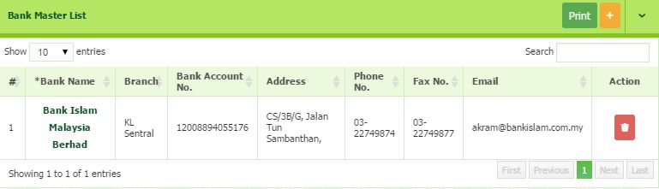

- In this section, the bank profile has to be filled up
  - Filled up all the requirement in all 4 sections ( Bank Master, Address Information, Contact Information, Others Information ). Examples are as given.
- After completed, click Submit button to save.

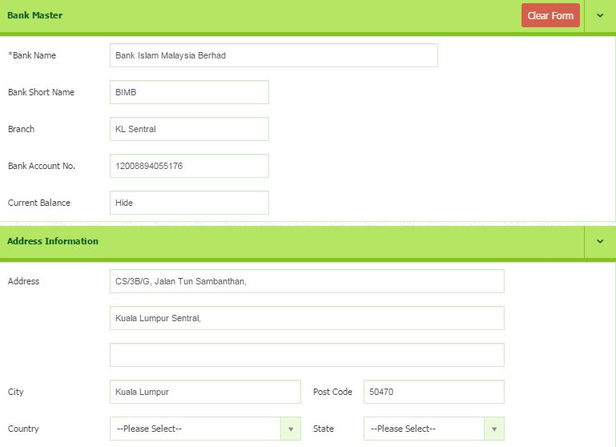
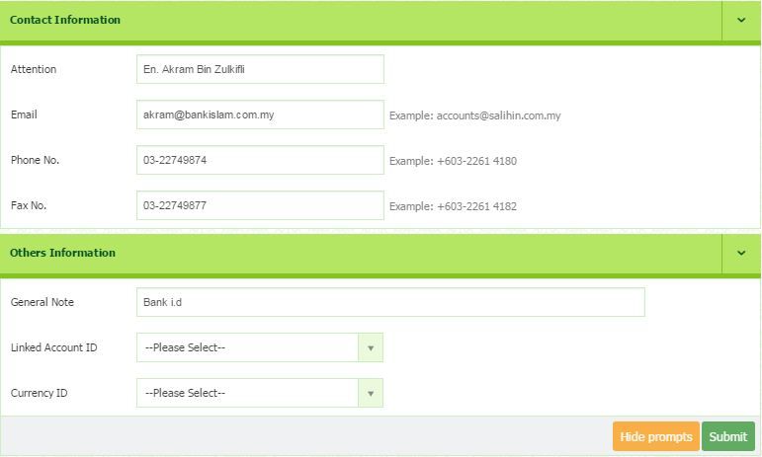
View List of Bank
- Go To General Setup > Bank Setup. The Bank Master List window appears.
- In the search field, you can search any particular bank by entering the bank name.
- You can choose the number of entries of the Bank Name to be displayed.

Edit Bank
- Go To General Setup > Bank Setup. The Bank Master List window appears.
- In the Bank Name field, identify the bank and select the particular bank name. The Edit dialog box appears.
- Click Continue, the Bank Master window appears. Edit the relevant information.
- Once completed, click Submit button to save.

Remove Bank
- Go To General Setup > Bank Setup. The Bank Master List window appears.
- To remove the existing bank, identify the bank row.
- In the Action field on the right-side of the row, click the Delete button (image).
- Dialog box of deletion confirmation appears, then click the Delete button.

Print Bank
- To print, click the Print button on the top right-side of the page.
- Bank Master List window appears.
- Click Print button to print the data or download to open/save the data in excel format (.xls)

Ship To
- Go to General Setup > Ship To. The Company Ship To windows appear.
- (This section is enable if the company has more than one (1) warehouse at different location.)
- To add new Company Ship To, click the + Button.
- Fill in the information required.
- To Save, click the Submit button.
- You are also able to edit the information by click the link of address.
- If the company ship to no longer available, you can remove the list by click the Delete button that situated in the same row of the list.
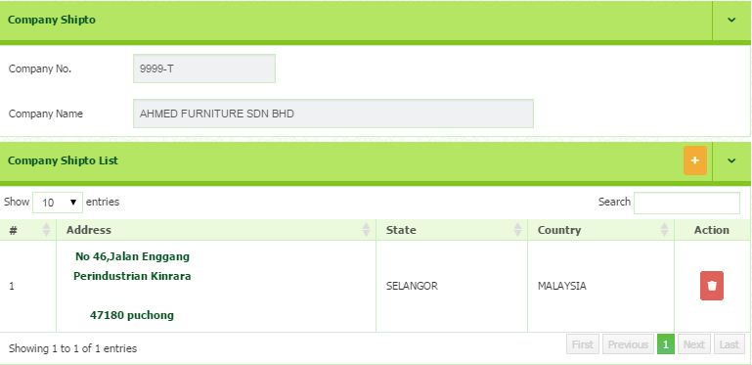

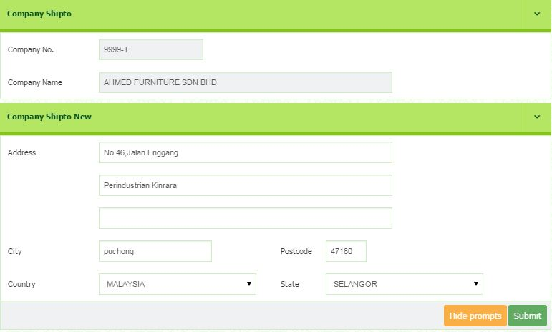

SPS 14.01.05 User Manual

Admin

User Master

1. Create New User
To create a new user, please follow the step below:-
- Go to Admin User Master. The User Master List window appears.
+ button to add new user
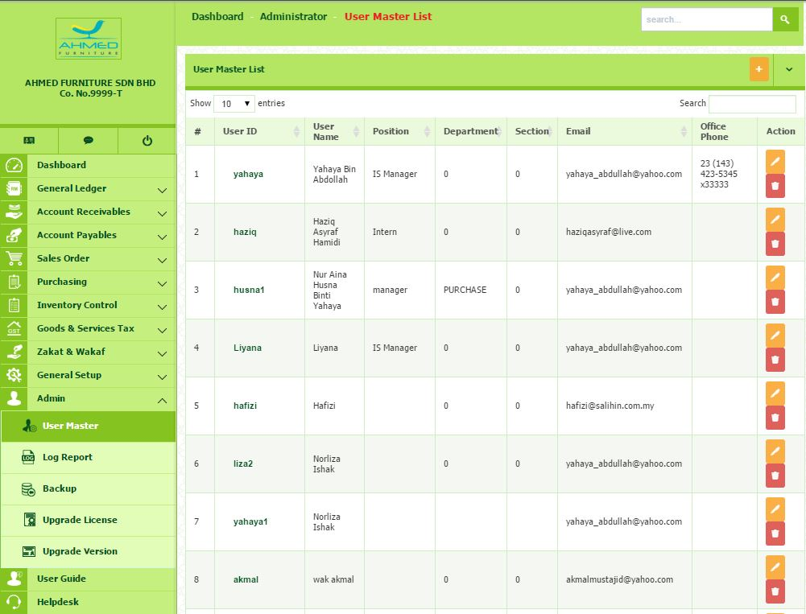
- In this section, Admin has the privileged to control the user registration and access right.
- In this section also, you can view all the User Master List
- To add new user, click button on the top right corner of the page.
- You will be directed to the page where you have to insert all the following required information.

  - User ID, Password and Confirm Password
  - Full Name and Position
  - Contact information such as Phone Office, Mobile No. and Email address

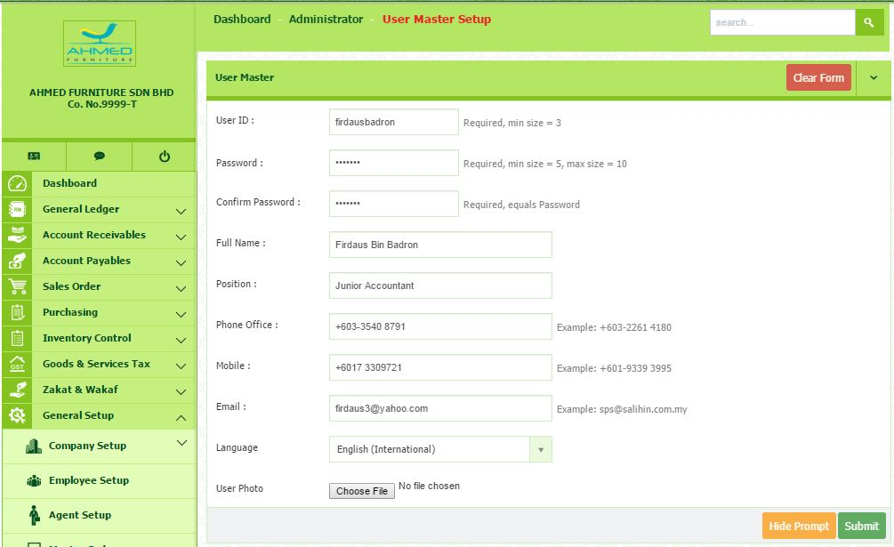
Upload user photo

- Select your preferred language. If you did not choose your preferred language, the system set English as the default language.
- To upload User Photo, click the Choose File button, upload the required image (image can be BMP, PNG, JPEG or GIF files and should measure 120 x 120).
- Click Submit button to save.

2. Grant the Permission on Access Right
- First, choose the existing user master from the list.
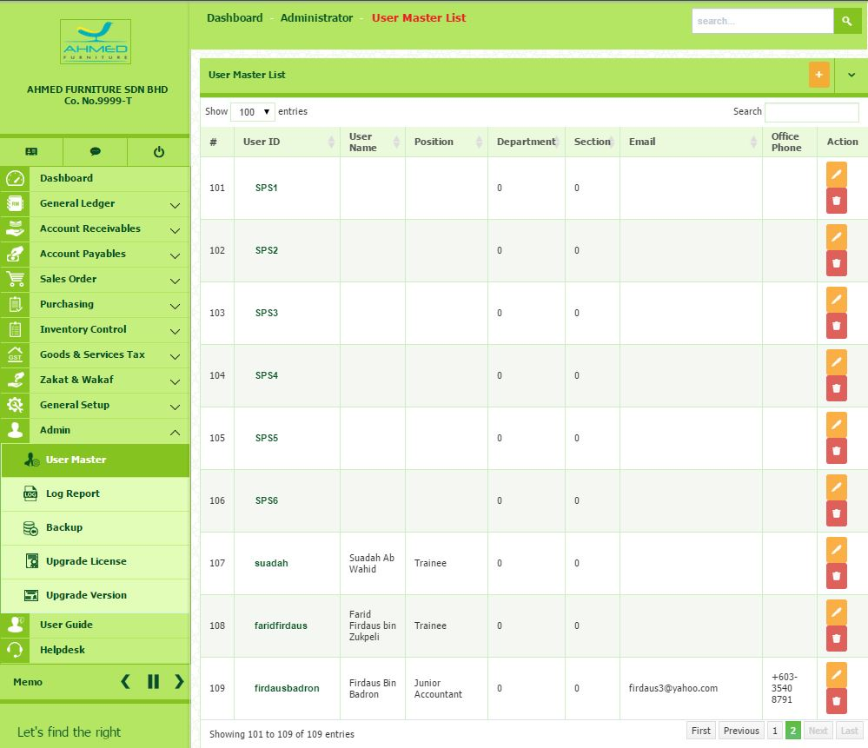
Click the identified User ID

- Click the identified User ID in the User ID field.

- You will be directed to User Access for the user you have selected. The Setting User Access dialog box will appear. Click OK to continue.
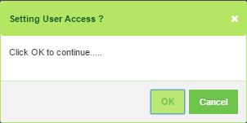
- The User Access for the selected user appears and selects the Company from the list.
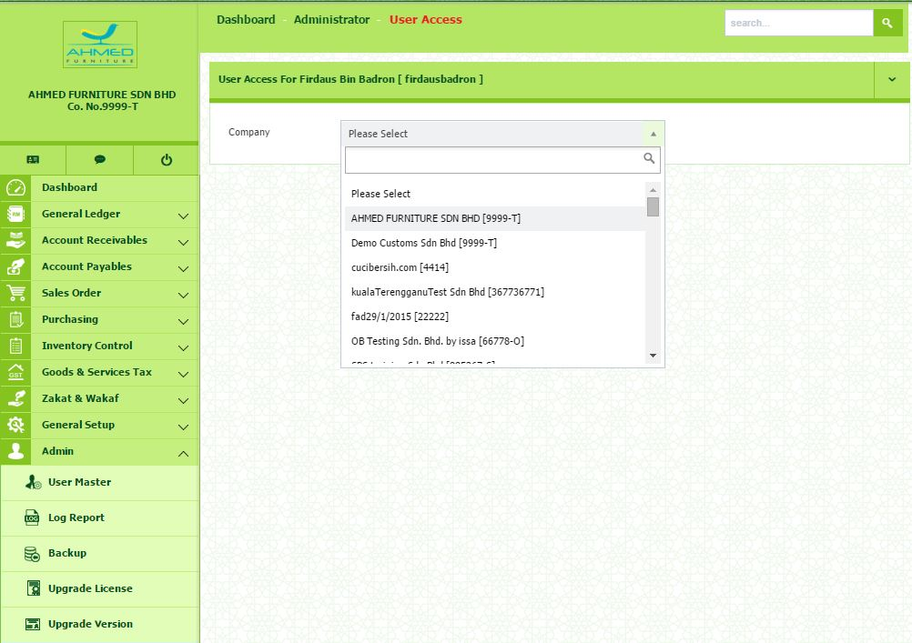
Select the company from the list to give permission to a user access to any module(s) in SPS

- Once selected, all the modules will be displayed.
- In this section, Admin has the full control to give permission to a user access to any particular module(s).
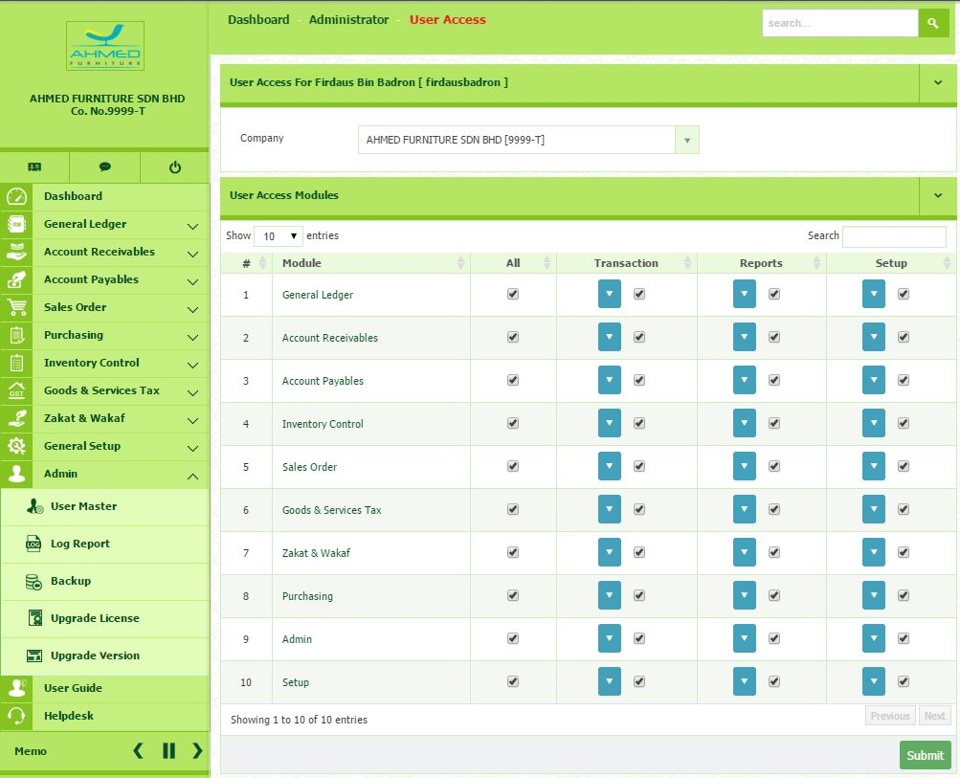
- For example, if you want the user to access only the Goods & Services Tax and can execute transactions, you have to tick the box under Transaction menu.

- Next, click the drop down button. You can see all the menus under Transaction.
- In this section you can choose which menu to allow them to access.
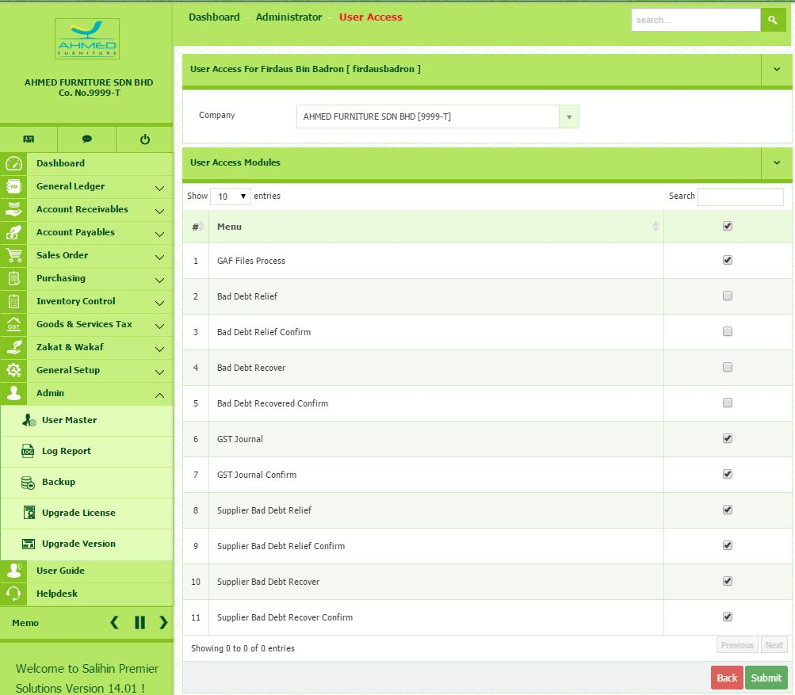

NOTE: Please make sure to limit the access right for User Demo. This is required after you already successful registered new company and assign user.

3. View User Master List
To view the User Master List, please follow the step below:-
- Go to Admin User Master
- You will directed to the page where it will display all the listing of the User.
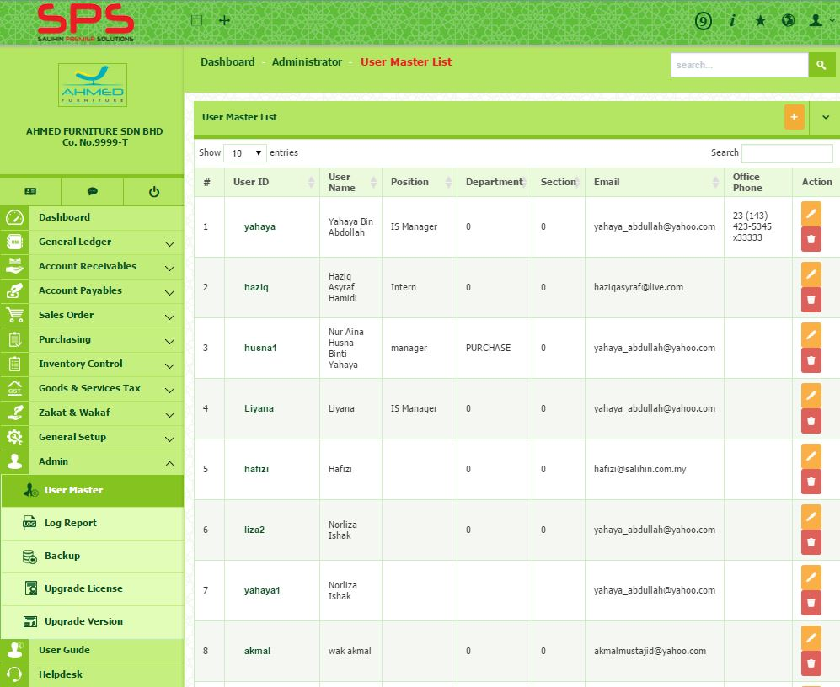
Delete button
Edit button
- To edit existing user, you may click the Edit button that situated at the same row of selected user that you choose.
- To delete existing user, you may click the Delete button that situated at the same row of selected user that you choose.
- To setting the user access, you may click the name of the User ID and select the company from the drop down list. (For step no. 5, 6 and 7 please refer to Grant the Permission on Access Right step)
- Once selected, you will be directed to the page that display listing of module. In this part you may give the permission or access right to the selected user.
- Once setting is set up, click Submit button.
NOTE: If you are super admin for that selected company, please be careful and confirm on which modules you want to give privilege.

Log Report
- Go to Admin Log Report. The Log Report windows will appear.
Select the type of query either insert or update
Use any keyword to run searching on the Search box
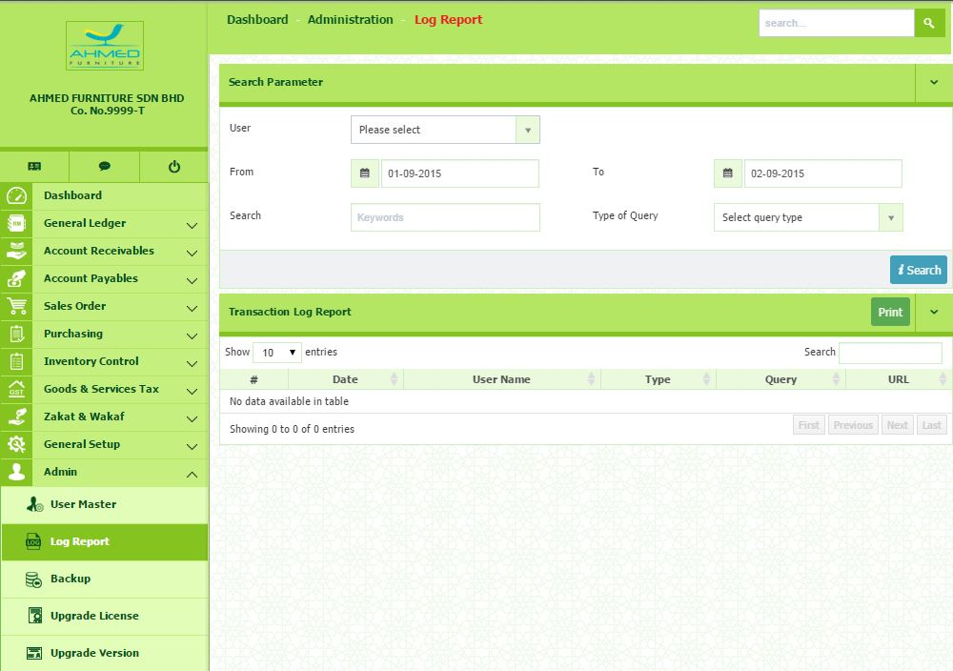

- Select the User from the list.
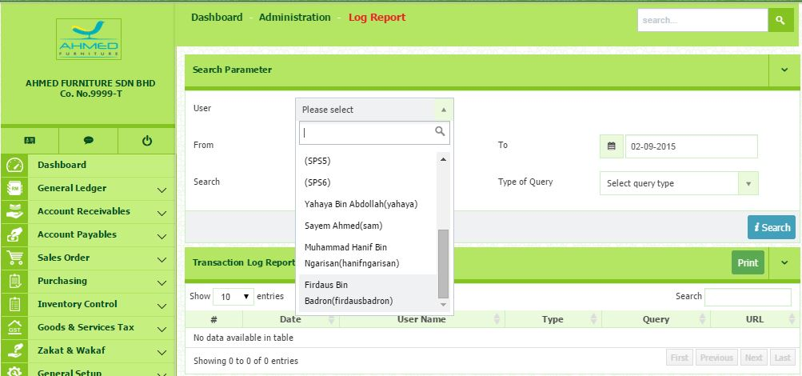
Click Search button to submit
- Select the Date From and Date To.
- You are enable to use any keyword to run searching on the Search box.
- Select the type of query. You can select from the list either insert or update.
- Then, click Search button.
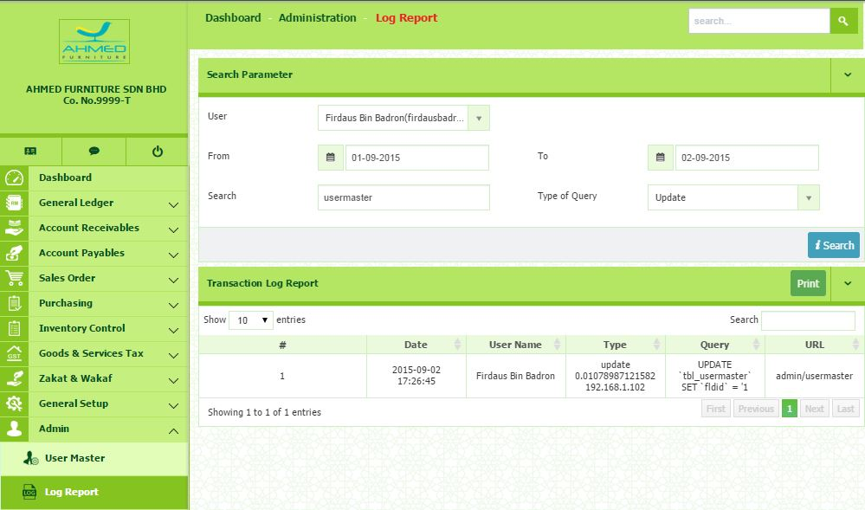
Example of Log Report

Backup

How To Do Backup
- Go to Admin Backup.
- Select the backup dates. Then, click Find Backup button.
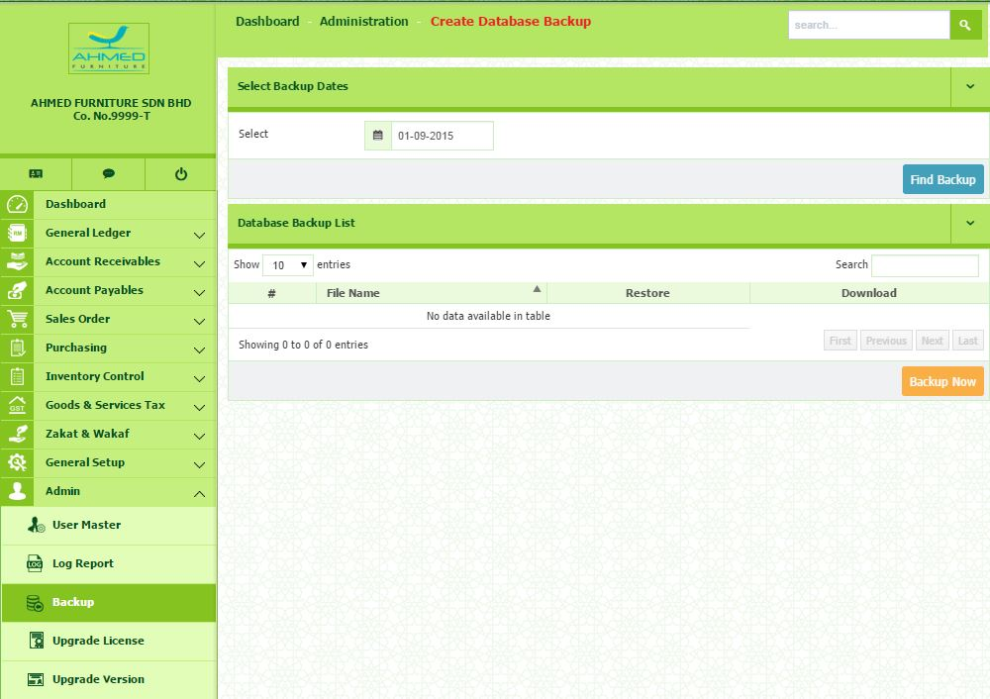
Click this button to backup current database of SPS

- All the database backup will be listed.
- If you are wish to restore the database, select the row of database and click the Restore button.

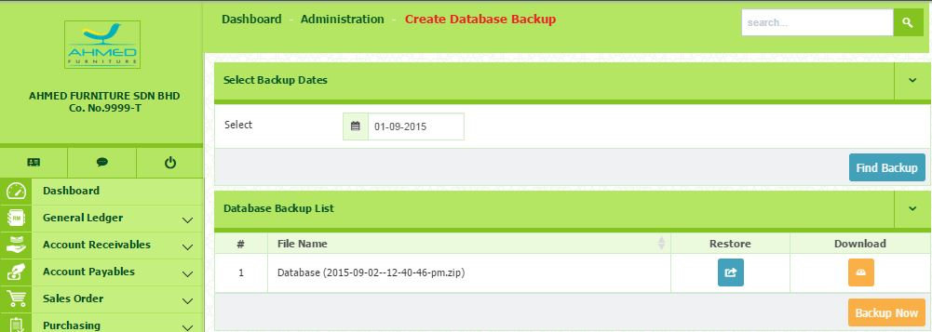
Restore button
Download button

