INVENTORY CONTROL
To account for any movement of your stock, kindly follow the steps below:
- Go to Inventory Control > Transaction > Location Transfer. The Location Transfer window appears.
- Select From Location and To Location from the drop down list.
- Enter your Reference.
- Select your Movement Type from the drop down list.
- Select Date Transfer.
- Enter Memo.
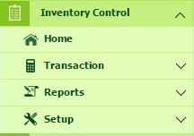
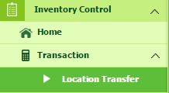

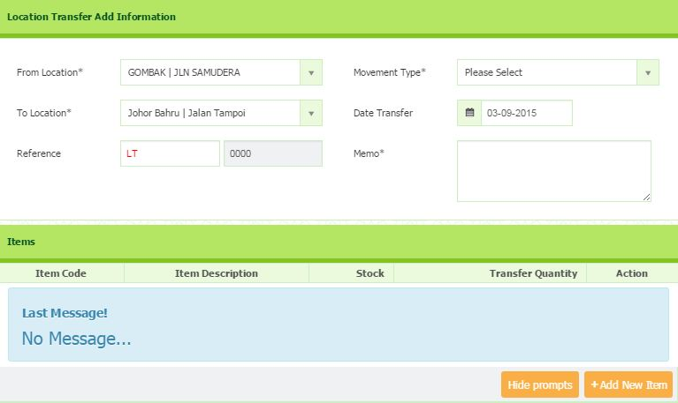

ITEMS
- Click “Add New Item” button.
- Then you will be directed to a page to fill in the entries.
- Select your Item Code and Item Description.
- Enter your Transfer Quantity.
- Click (tick) button to save.
- Please be noted, to adding new item, you have to select location first.

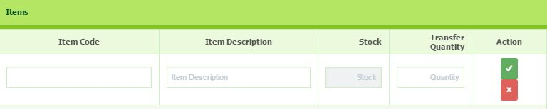

- Go to Inventory Setup > Transaction > Location Transfer Confirm. The Location Transfer List window appears.
- Click + button on the top right to add relevant information.
- Note that, make sure all relevant information given is correct before you proceed to Confirm transaction.
- To edit the information, click the link of selected Form No in the Form No. field. The Edit dialog box will appear, click Continue to edit.
- You will be directed to the page where you can edit the information.
- Once completed, click Update Save button to save.
- Once submitted, you will be directed to the Location Transfer List.
- You can choose either to confirm the entire list or selected list only. If you wish to confirm the entire list, tick the box on the top right-side of the page OR if you want to confirm selected list, tick the respective boxes of the related rows only.
- Then click Confirm Transaction button to proceed to confirm the transfer.
- Note that, once you proceed for transaction confirmation, editing information is disabled.
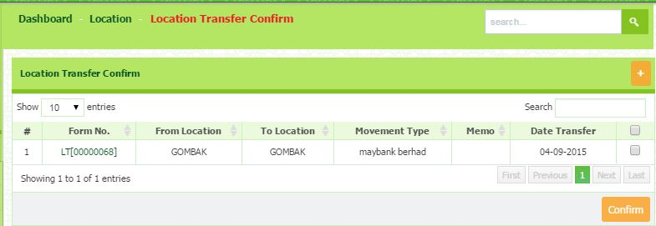

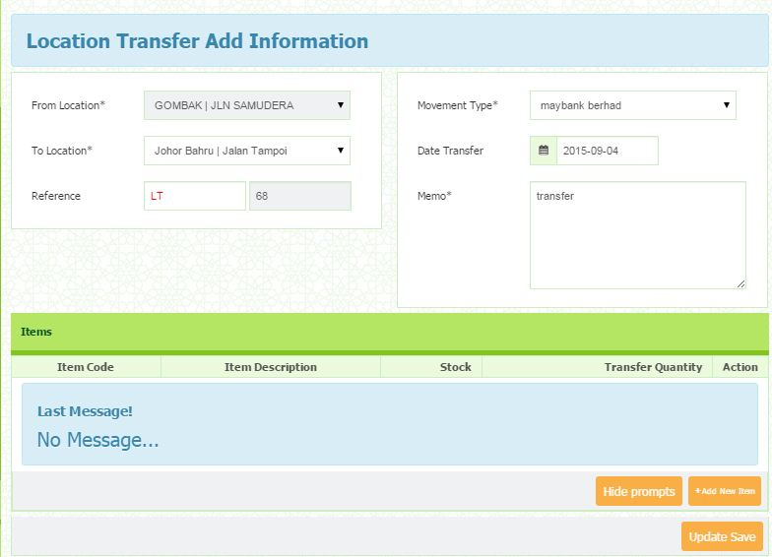

ITEM COUNT AND ADJUST
- Go to Inventory Setup > Transaction > Item Count and Adjust.
- Select Location from the drop down list.
- Once selected, all the listing of item details will be displayed.
- Double click at Counted field to adjust.
- The total of Variance, Cost and Cost Variance will be automatically changes according to the counted adjustment.
- After completed, click Save button.

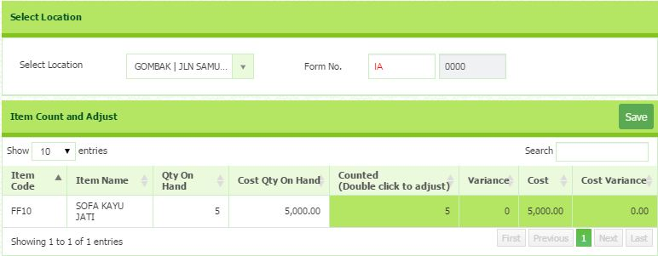

ITEM COUNT AND ADJUST CONFIRM
- Go to Inventory Setup > Transaction > Item Count and Adjust.
- Please be noted that, before you proceed to confirm adjustment, please make sure that all information given is correct.
- You can modify adjustment by click the link of selected Form No.
- You will directed to the page where you can modify the information.
- After completed, Click Update Save button to save.
- Once submitted, you will directed back to the Item Count and Adjust list.
- You can select all the list or either selected list to proceed to confirm adjustment.
- After selected, click Confirm Transaction button to proceed transfer confirmation.

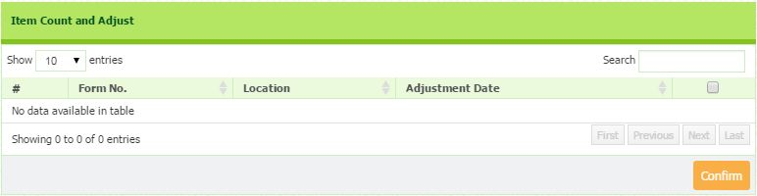

ITEM DETAIL
- Go to Inventory Control > Reports > Item Details. The Item Details List window appears.
- All the listing of Item Details will be listed.
- Fill in the entries such as:
- Item Code e.g: FF10
- Item Name e.g: Sofa Kayu Jati
- Location e.g: Jln Samudera(Gombak)
- Unit Measure e.g: UM
- Quantity e.g: 4.00
- Click the Print Button that situated at the top right of page.
- You will be direct to the Item Details List Report.
- You are allow to print or save the report by clicking the button.
- Otherwise, you can close the report by click the Close Button
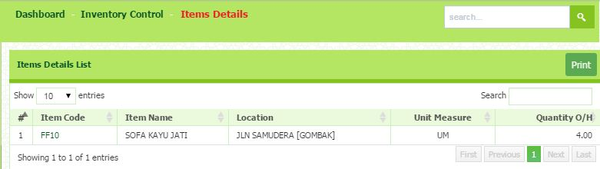

LOCATION TRANSFER LIST
- Go to Inventory Control > Reports > Location Transfer List.
- Select the Date From and Date To.
- All the location transfer list will be listed.
- To print the summary report, click Print button that situated on the top right page.
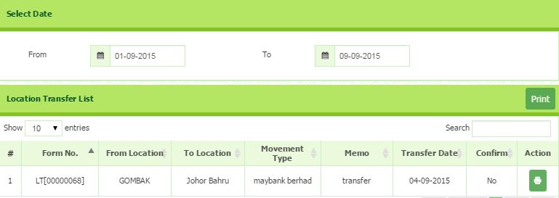

ITEM ADJUSTMENT LIST
- Go to Inventory Control > Reports > Item Adjustment List. The Item Adjustment List window appears.
- All the listing of Item Adjustment List will be listed under Item Adjustment List.
- Select the Adjustment List that you want to print by click the Print button that situated in the same row of the list.
- You will be direct to the Item Adjustment List Report.
- You are allow to print or save the report by clicking the button.
- Otherwise, you can close the report by click the Close Button
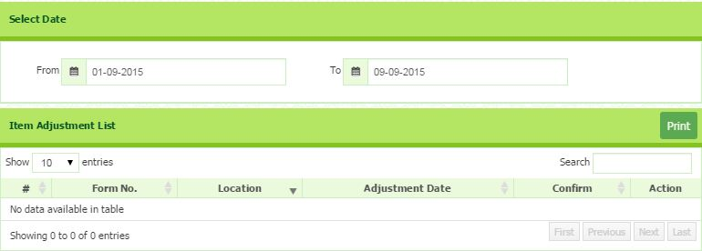

INVENTORY PLANNING REPORT
- Go to Inventory Control > Reports > Inventory Planning Report. The Inventory Planning Report List window appears.
- Select the Location from the list. Once selected, all the details will be listed under Inventory Status.
- Click the Print Button that situated at the top right of page.
- You will be direct to the Inventory Status Report.
- You are allow to print or save the report by clicking the button.
- Otherwise, you can close the report by click the Close Button.
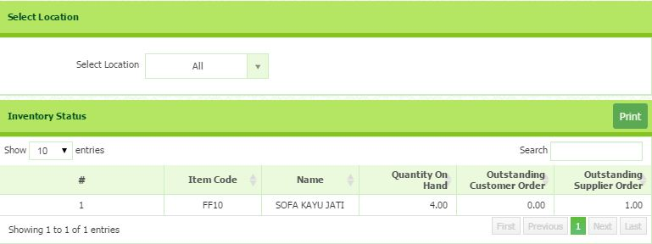

INVENTORY VALUATION REPORT

- Go to Inventory Control > Reports > Inventory Valuation Report.
- All the Inventory Summary will be listed.
- To print the summary report, click Print button that situated on the top right page.
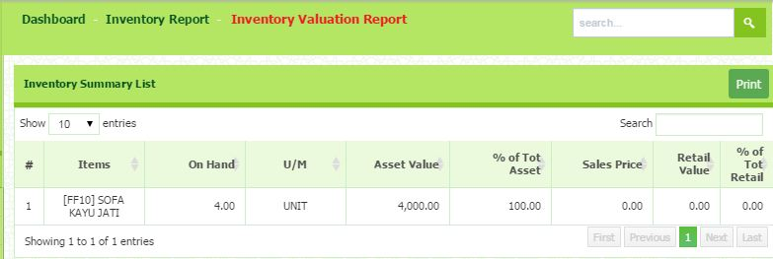

STOCK COUNT SHEET
- Go to Inventory Control > Reports > Stock Count Sheet. The Stock Count Sheet windows appear.
- Select your warehouse location from the list.
- Once selected, the details of stock count will be listed.
- To generate report, simply click the Print button.
- You will be direct to the Stock Count Report.
- In this report, you can see the details such Item, Unit Measure (UM), Quality On Hand and Actual Quantity.
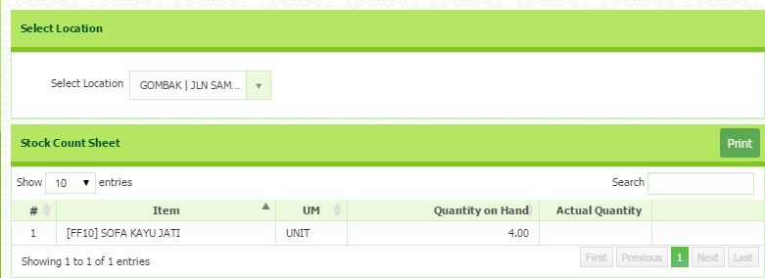
STOCK CHECK REPORT
- Go to Inventory Control > Reports > Stock Check Report.
- All the Item Master list will be listed.
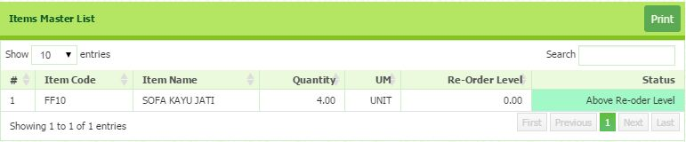
- To print the summary report, click Print button that situated on the top right page.

OUTSTANDING GRN REPORT
- Go to Purchasing > Reports > Outstanding GRN Report.
- You can print the details, by click the Print button.
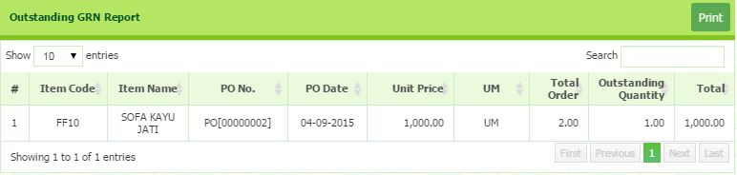

INVENTORY TRANSACTION REPORT
- Go to Inventory Control > Reports > Inventory Transaction Report. The Inventory Transaction Report window appears.
- Please select Date From and Date To.
- Select the Location and Item.
- All the listing details will be listed under Inventory Transaction Report.
- To print all the details, click the Print Button that situated at the top right of page.
- You will be direct to the Inventory Movement Report.
- You are allow to print or save the report by clicking the button.
- Otherwise, you can close the report by click the Close Button.

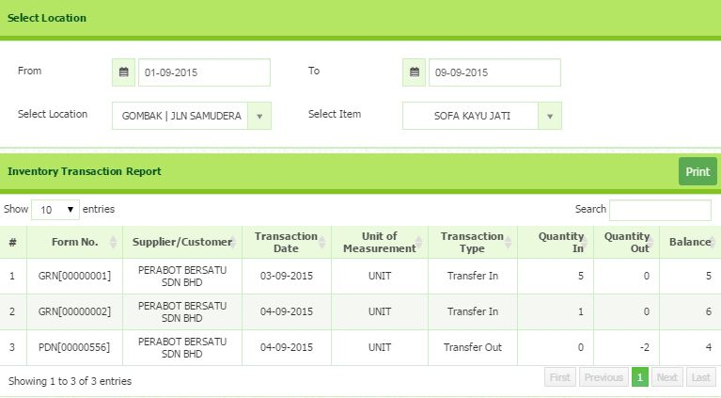

INVENTORY LIST
- Go to Inventory Control > Reports > Inventory List. The Inventory List window appears.
- Select the Location from the list. Once selected, all the details will be listed under Inventory List By Location.
- Click the Print Button that situated at the top right of page.
- You will be direct to the Inventory List By Location Report.
- You are allow to print or save the report by clicking the button.
- Otherwise, you can close the report by click the Close Button.
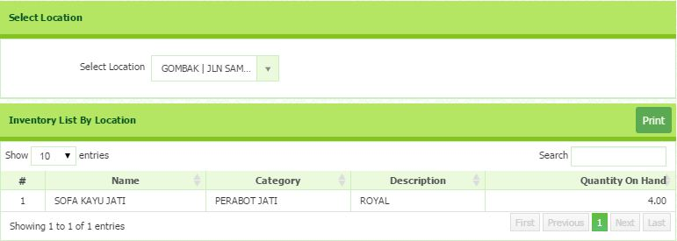

ITEM CATEGORY
To Setup Item Category details, kindly follow the steps below:
- Click Inventory Control > Setup > Item Category.
- Click + button on the top right corner of the page to add a new item category.
- After filling out the Item category details, click submit to save the details.
- To edit the item's details, click on the item that you want to edit. You can also edit it by clicking on the blue colored icon in the action column.
- After done editing the details, click submit to save the changes.
- You can also delete the existing item category by selecting that particular item and click the delete button that is situated on the same row.
- To search an item category, type the name of the item category in the search field.

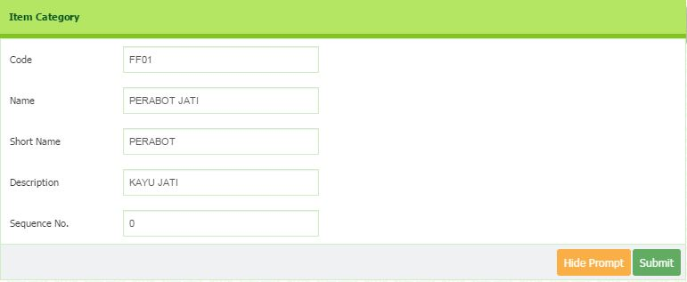
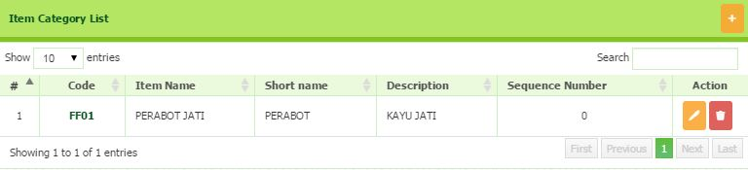

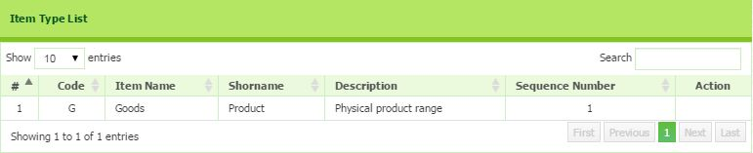
ITEM TYPE LIST

ITEM SETUP
- Go to Inventory Setup > Setup > Item Setup.
- Click the + button to add new Item Setup.
- Enter the Item Code, Item Name and Item Description.
- Select the Item Category, Item Type, Unit of Measure, and Item Status from the drop down list.
- Set your Reorder Level (Quantity of your item).
- Select Income, COGS, Inventories, Input Tax and Output Tax from the drop down list.
- You can upload your inventory image by click the Browse button.
- After completed, you may click Submit button to save.

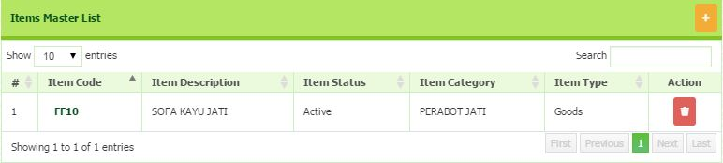
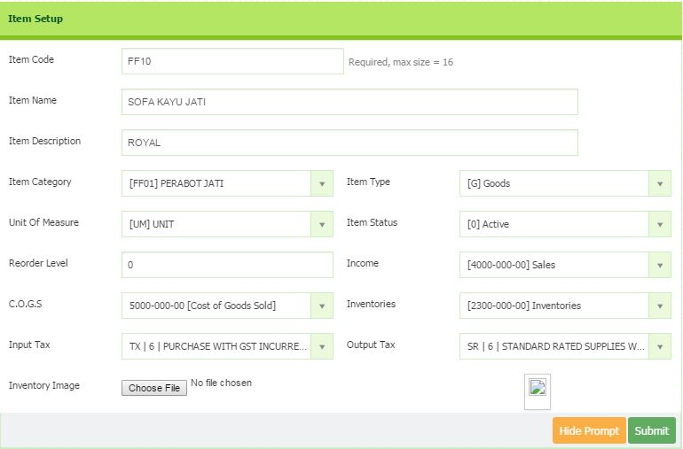

LOCATION MASTER

Add New Location Master
- Go To Inventory Control > Setup > Location Master. The Location Master List window appears.
- Click on + button on the top right-side of the page to add New Location Master.
- You will be directed to the page where you can enter all the required information.
- After data entry, click Submit button to save.
View Location Master
- Go to Inventory Control  Setup > Location Master.The Location Master List window appears.
- In the Search field, search the location by entering the location code or name.
- You can choose the number of entries of location to be displayed.
Edit Location Master
- Go to Inventory Control  Setup > Location Master.The Location Master List window appears.
- Click the Edit button that situated in the same of location row. The Edit dialog box will appear.
- Click Continue, the Location Master window appears. Edit the relevant information.
- Once completed, click Submit button to save.
Remove Location Master
- Go to Inventory Control  Setup > Location Master. The Location Master List window appears.
- To remove location from the list, identify the location row.
- In the Action field on the right-side of the row, click the Delete button (image).
- Dialog box of deletion confirmation appears, then click the Delete button.

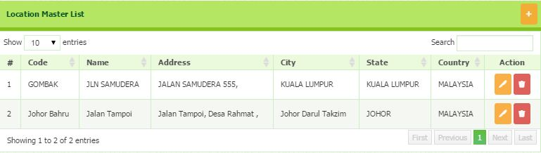

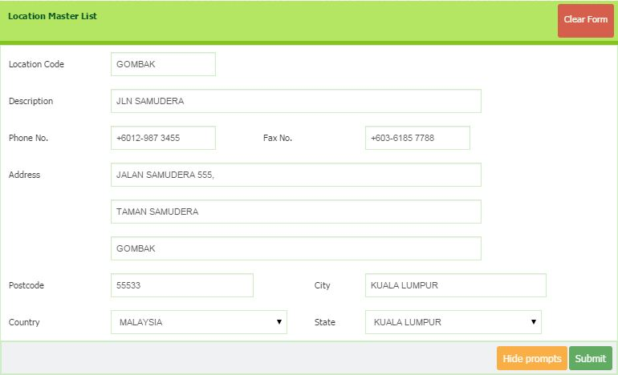

Unit Measure
- Go to Inventory Control > Setup > Unit Measures. The Unit of Measure List window appears.
- Click on + button on the top right-side of the page to add New Unit of Measure.
- Enter Code and Description.
- Once entered, click Save button.
- To delete the list, click the delete button that situated in the same row of the Unit Measure List
