MODULE: GENERAL SETUP
System setup allows you to maintain general setting of the software according to your company’s requirements. It is highly recommended to setting up all the information before you start off with the system

- How to setting up Company
After system installation, the first things you have to setting up is your company details. Company should function as the foundation of an accounting system that the business will use during future years.
    - Create/Add New Company
- Go to General Setup > Company Setup > Company Master List
- Click + button that located on top right page
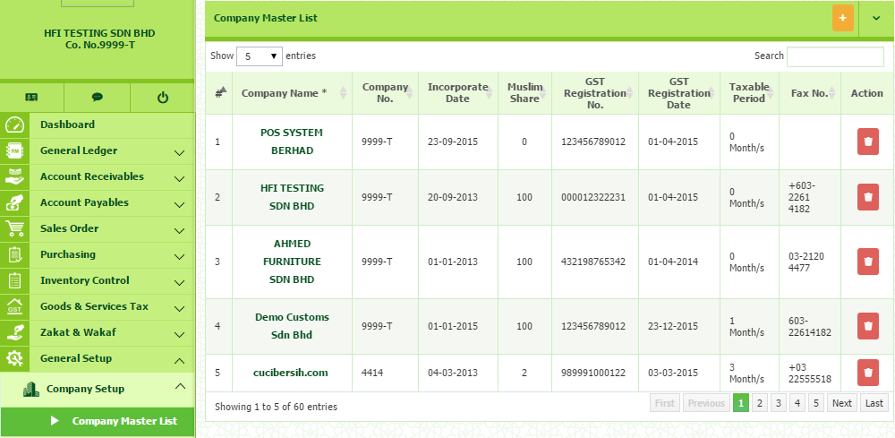
Once click, you will be direct to company master pages. In this section, you need to fill in all the required information needed.

There are three (3) sections that need to be fill in:-
- Company Master
Basic information of the company that you want to setting up. All the related information.
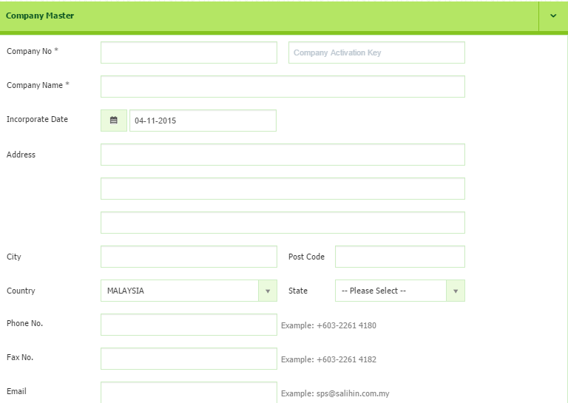

Before you continue to fill in all the required information, you need to get the Company Activation Key first. Please follows the following steps as below:-

    - How to get Company Activation Key
- Open new browser and type demo.salihinpremier.com/ss-ss/customerlogin
- Enter your username and password. (Please check your email OR contact SPS Support Team to get the details)
- Once login, you will be direct to Customer Login page.

Below is the main interface of Customer Login page. Continue the following steps:-
- Click the SPS License from the menu
- Then, click the SPS Serial No.

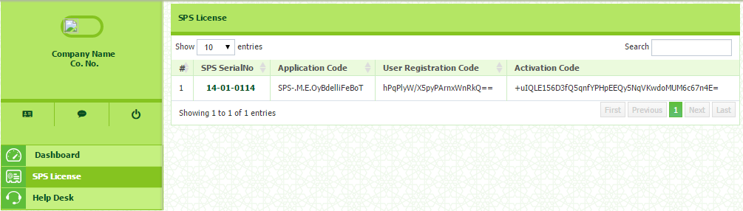

Below is the main interface of you License and Company Registration details.
- Proceed to the SPS Registered Company Key
- Click Add Company button
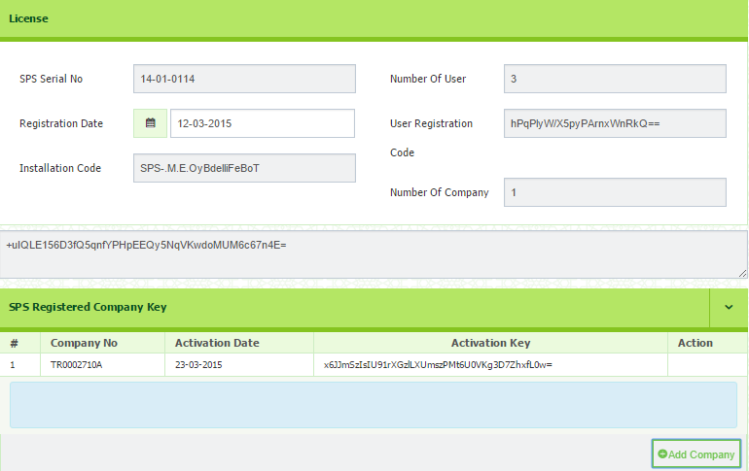

- Once click, you need to entered Company No. , Activation Date.
- Then click the button. Once click, the Activation Key will be automatically appear.
- Next copy the Activation Key as appeared
- Then, open your Company Master page in SPS. Paste your Activation Key and paste the code into Company Activation Key column besides Company No. (Please refer Company Master Interface)

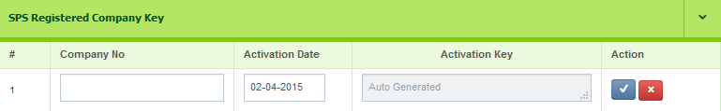

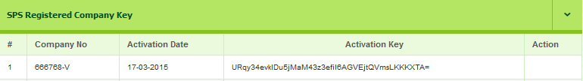

 WARNING!

- Make sure there is no SPACE when you copy and paste. IF you are failed to validate, please contact your Dealer.
- Please be careful before you remove the registered company. Charge may be implied for data recovery.

    - Failed to Add New Company
If you having this problem to adding new company registration, kindly please check again your company license that you already purchased. If you purchased for 1 Company, you are unable to proceed for any new company registration.

If you are wish to have more than 1 company license, do call your dealer or SPS Support Team to consult you on the volume of licensing according to your business activities.
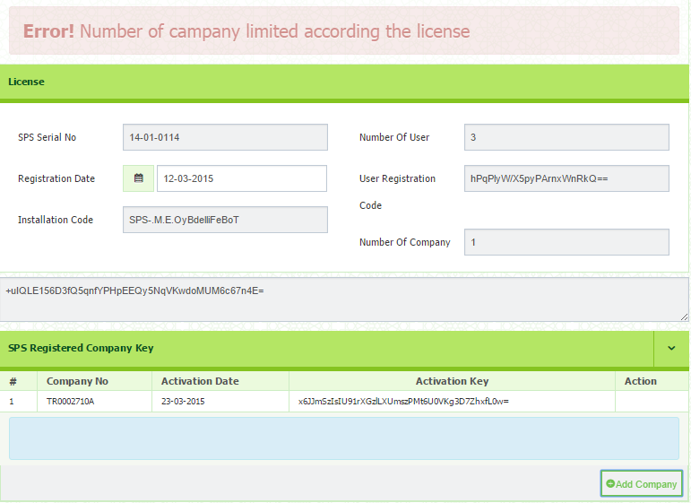

    - How to Upload Image/Company Logo
- Click the Choose File button
- Select images from your drive , where the logo is located and stored
- Images can be BMP, PNG, JPEG or GIF files and should measure 120 x 120.
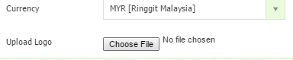

    - Goods & Services Tax
Information of your GST No, GST Registration Date, Taxable Period and MSIC
Code.
- GST Registration No – Must be 14 digits
- GST Registration Date – Refer your references copy from Customs.
- Taxable Period – Only appeared when you select the Registration Date. You can select taxable period from the drop down menu, either as Monthly, Every 3 Months, Every 6 Months or Yearly.
- MSIC Code – Refer your references copy from Customs.

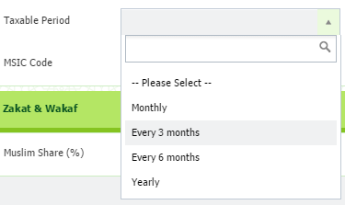
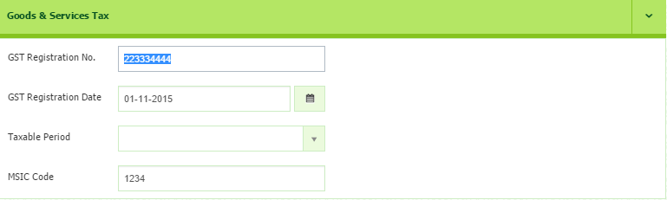

    - Zakat & Wakaf
Enter the amount (%) of your zakat & wakaf
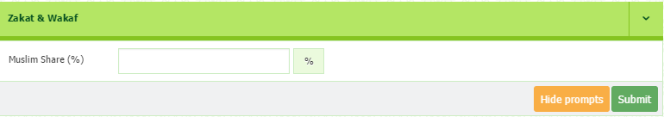
After Company Activation Key has been updated, you may proceed to click Submit button to save all the information.
1.1 How to View / Edit Company
1.1.1 View Company Details
To view your listing of registered company, please follow the following step:-
- Go to General Setup > Company Setup > Company Master List
1.1.2 Edit Company Details
To reedit your company details, please follow the following step-
- Go to General Setup > Company Setup > Company Master List
- Click the link of Company Name
- Then, click Continue
- Click Submit button to save.
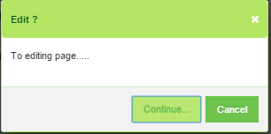
WARNING!
You are NOT ALLOWED to reedit the Company No.

- How to Create New User
In this section, you can create your new user. The user can be 1 or more depends to the pattern of your business type. You are also enabled to set the User Access Right to control and prevent data from unauthorized user.
2.0.1 Creating New User
To create new user, please follow the following steps:-
- Go to Admin > User Master > User Master List
- Click + button that located on the top right page
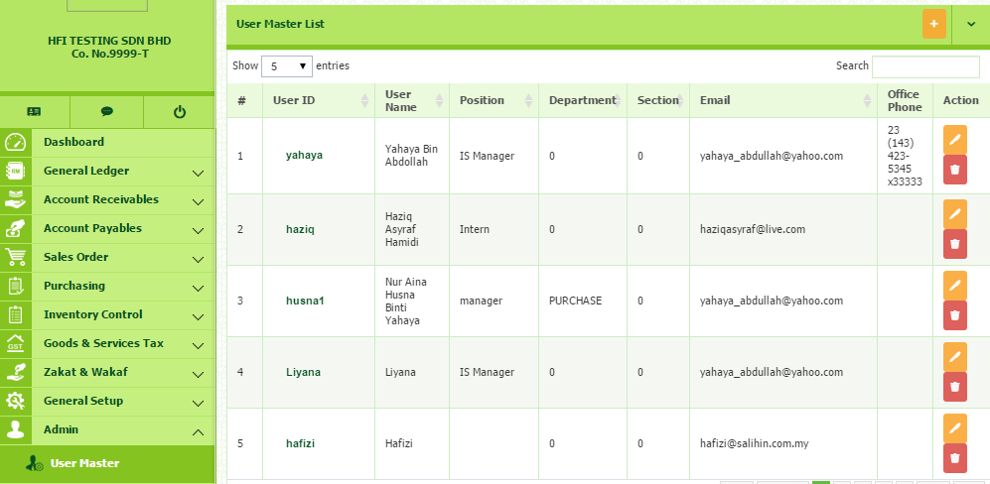

Once click, you will be direct to the User Master page (as shown below). In this section you need to setup your user details.
User ID | Required. Min size = 3
Password | Required. Min size = 5, Max size = 10
Confirm Password | Required. Please make sure the password is same as created before

- Once completed, click Submit button to save.
- Click Clear Form button to reset all the information.
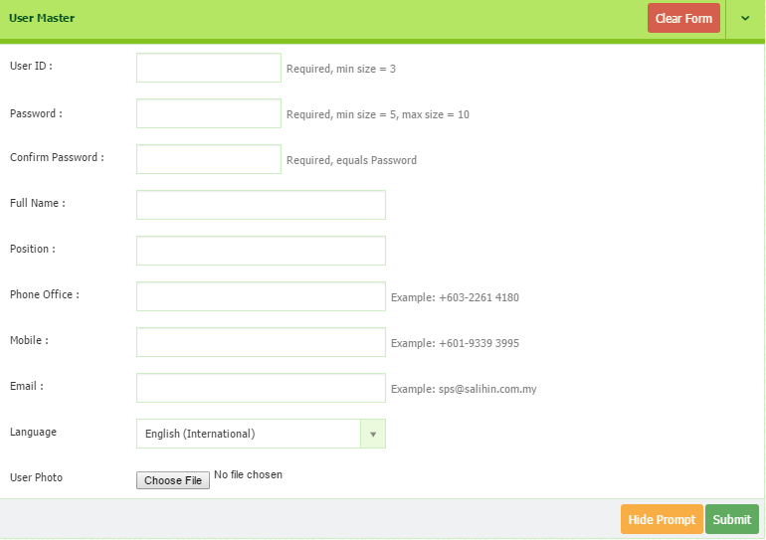
2.0.2 How to View/Edit User
To view the listing of User:-
- Go to Admin > User Master > User Master List
- To edit, click button that located in Action column.

2.0.3 How to Delete User
To delete the listing of User:-
- Go to Admin > User Master > User Master List
- Select the identified user
- To edit, click button that located in Action column.
WARNING!
Please be careful before you remove the registered user. Charge may be implied for data recovery.

2.1 How to Grant User Access Right
This section is to guide you as admin to set the user access right. It will help you to control and prevent the data/information from unauthorized user. Please follow the following step:
- Go to Admin > User Master > User Master List
- Click the identified User ID / Username
- You will be directed to User Access for the user you have selected. The Setting User Access dialog box will appear. Click OK to continue
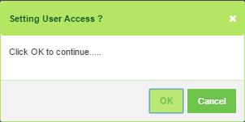

- You will be direct to User Access Right page. In this section, you need to select the company from the drop down menu.
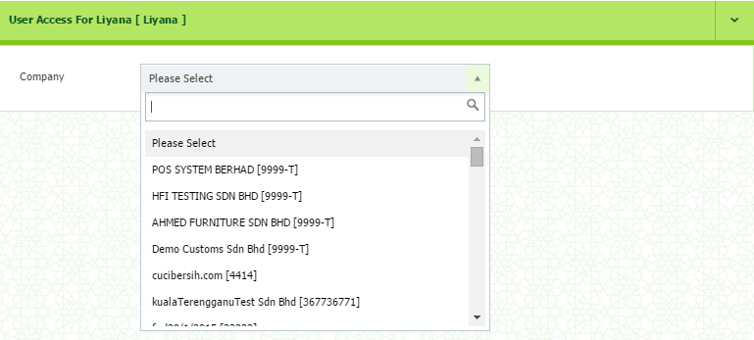
- Once selected, the User Access will be listed.
- In this part, you may choose which modules you want to grant a permission. If you wish to grant permission to all modules, tick the box under ALL column.
- Then, click submit button
- Please wait for a while, until the message box is prompt. (as shown below)
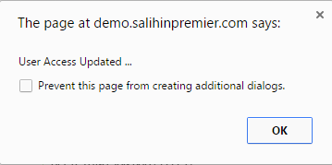
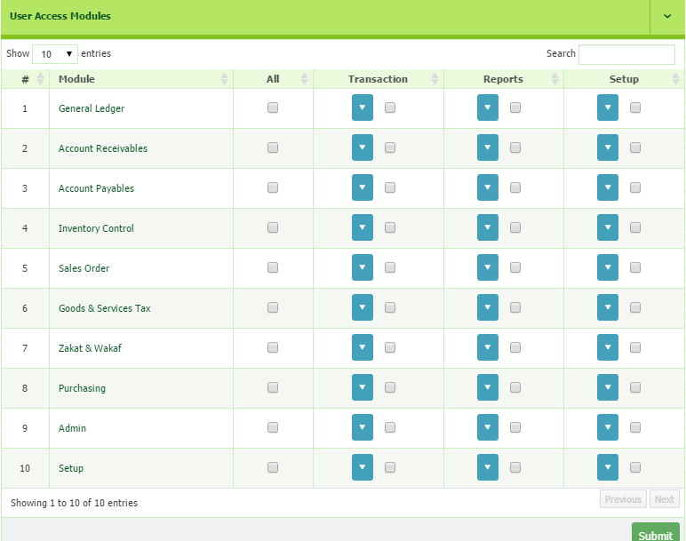

2.1.1 Example 1
For example, if you want the user to access only the Goods & Services Tax and can execute transactions, you have to tick the box under Transaction menu.
- Next, click the drop down button. You can see all the menus under Transaction.
- In this section you can choose which menu to allow them to access.
- Once selected, click Submit button to save.
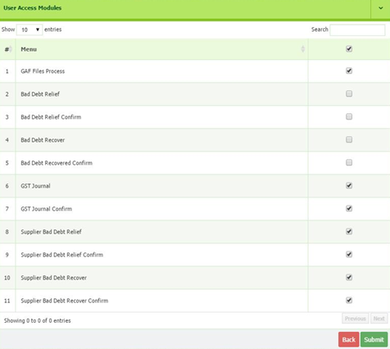
WARNING!
1) Please make sure to limit the access right for User Demo. This is required after you already successful registered new company and assigned user.
2) If you are super admin for that selected company, please be careful and confirmed on which modules you want to give privilege.

2.2 How to Reset Password
If you are the user, you need to contact your admin to request for Reset Password. Reset password is request when, for example, the user no longer working at your company, so you need to set a new password to prevent from the unauthorized person or you forget the password.

Please follow the steps below:-
- Go to Admin > User Master > User Master List
- Select the identified user and click button that located in action column
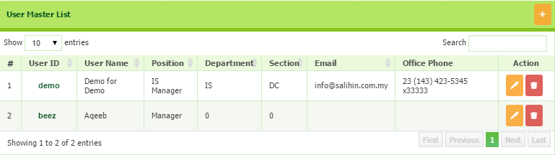

- You will be direct to the User Master page.
- Click the Reset Password button.
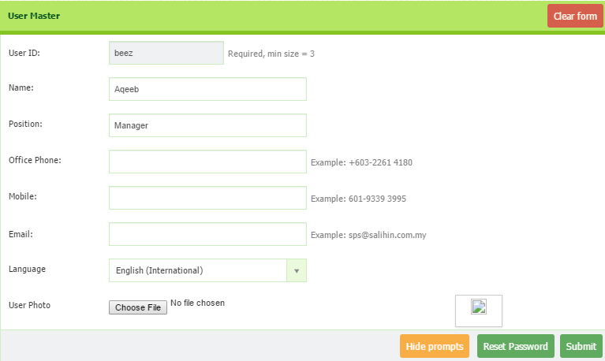

- Once click, you will be direct to Forget Password page
- Insert your new password, then click Submit
- Once submitted, there is a message to prompt that reset password is success.
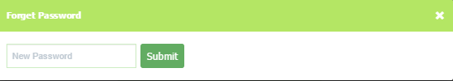
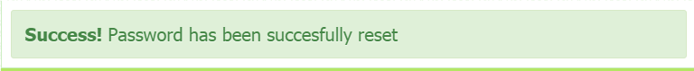
WARNING!
Super Administrator need to keep a copies of username and password of the registered user.

- How to Setup Chart of Account
After you have registered your company and user master, next step is to setup your Chart of Account. In this part, you need to identify your Industry Classification and Type of Business.
- Go to General Setup > Company Setup > Chart of Account Setup
- You will be direct to page as shown below
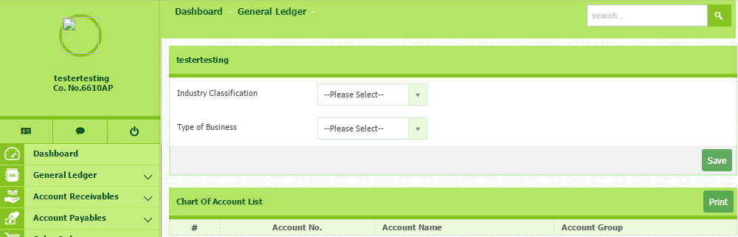
- Next, select your Industry Classification and Type of Business from the dropdown menu
- Chart of Account List will be listed automatically when Type of Business selected.
- Then, click Save button
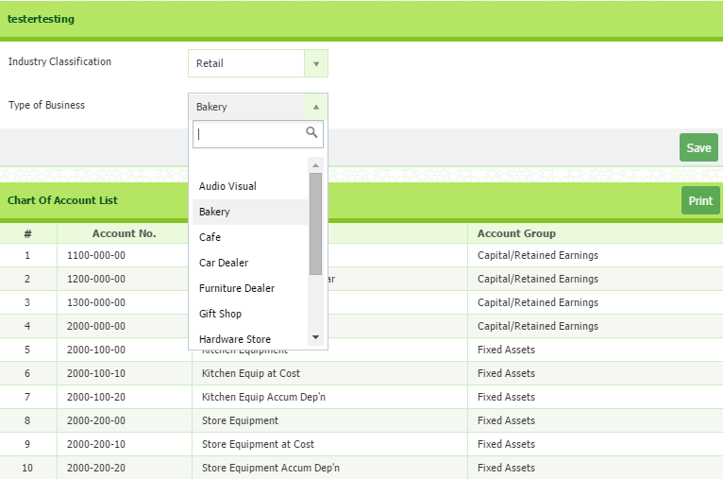

3.0.1 How to Add New Account Code
SPS have already set up Chart of Account by default. However, you can change chart of account as you prefer. For example, when you have a new customer, you need to create a new ledger for his/her account. Any related transaction to that customer will be recorded into the ledger that you have created.

You can see the different of this account ledger in Statement of Financial Position Report and Statement of Comprehensive Income Report.

- Go to Go to General ledger > Setup > Chart of Account.
- To add new account master, click + button that located on top right of page
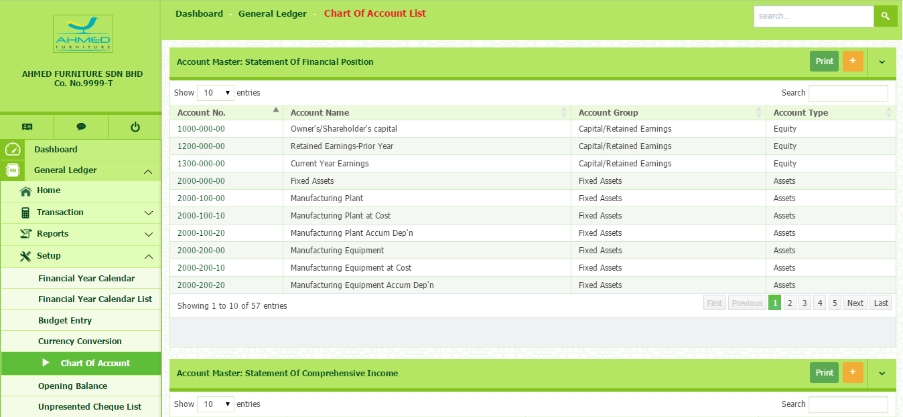
- You will be direct to the page as shown below

- Next, select Account Group and Chart of Account from the dropdown menu
- Type your Account Code and Account Name
- Then click Submit button to save
- To delete, click the Delete button
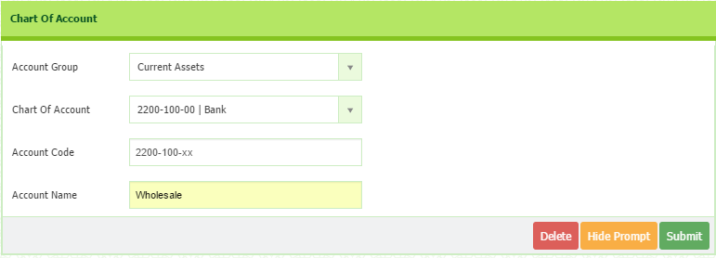
4.0 How to Setup System General
- Go To General Setup > System General Setup. The General Setup window appears.
- In this section, the system set the default for all setup and customizes according to your company’s suitability and needs.

Account No. | Related Amount
1xxx/xxx | - Retailed earning  - Current year earning  - Owners/shareholders capital
2xxx/xxx | - Fixed asset  - Trade receivable  - Cash & bank balance  - Inventories  - Other receivable  - Prepayment & deposit  - Tax claimable
3xxx/xxx | - Trade payable  - Invoice/Good not receive  - Other payable  - Accruals  - Client deposit  - Deffered tax liabilities  - Borrowing
4xxx/xxx | - Sales  - Wholesale  - Consignment  - Miscellaneous income
5xxx/xxx | - Cost of goods sold  - Purchase price variance  - Purchases  - Wholesale cost of sales  - Consignment cost of sales  - Materials & supplier  - Freight  - Commission expenses  - Inventory adjust account
7xxx/xxx | - Other operating income
8xxx/xxx | - Administration expenses  - Employment expenses  - Finance cost  - Income tax expenses  - Other comprehensive income
9xxx/xxx | - Finance income  - Interest income
- The main function of this section is to create the auto journal (the information are available by default).
- For the GST section, it will relate to Item Setup.
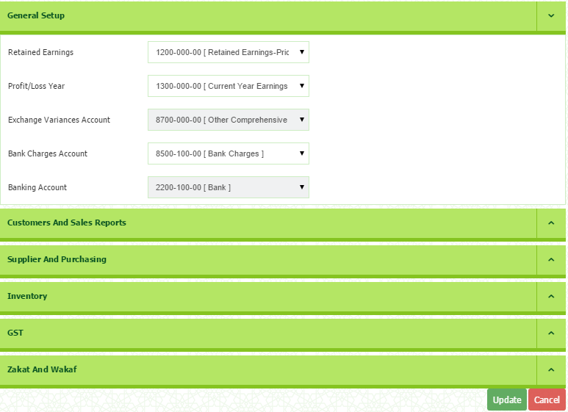

5.0 How to Set Form Setup
- Go To General Setup > Company Setup > Form Setup. The Form Setup List window appears.
- In this section, you can set your Serial Startup No.
- You also can set your Special Coding for each form type.
- To insert your special coding and serial startup number, double click at the selected field.
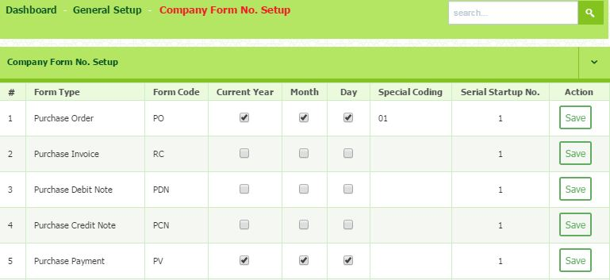
- Press Enter and click Save to save the data.

6.0 How to Setup Employee
You need to setup a basic information of your employee. Employee is the person who will create an invoices.
- Go to General Setup > Employee Setup
- You will direct to the Employee Master List. Then, click + button that located on the top right page.
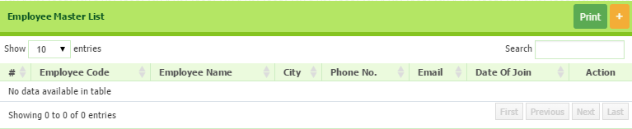

- Next, you need to fill in all the required information.
- For an Employee Code, for example, you can entered Staff ID. It’s depend on for your own company references.

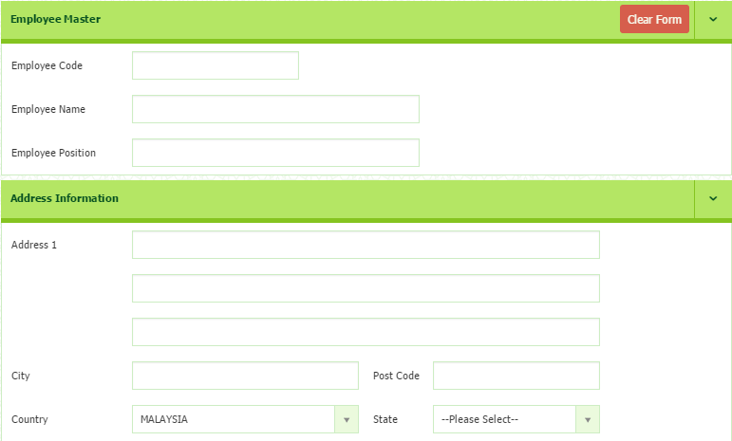

- Once completed, click Submit button to save.
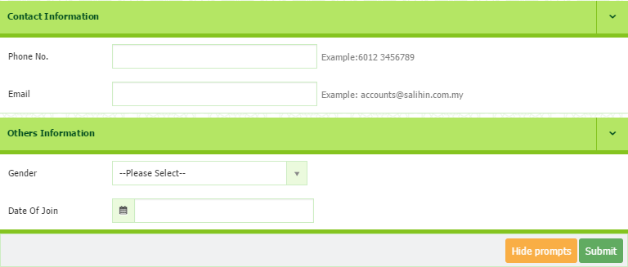

6.0.1 How to View/Edit Employee
- Go To General Setup > Employee Setup. The Employee Master List window appears.
- Fill up the requirement such as employee code (ID), employee name, employee position and other required information.
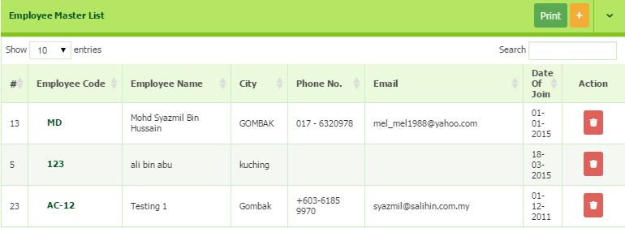
- Once filled up, click submit button to save the details.
- In the Employee Name field, identify the employee and select the particular employee’s name. The Edit dialog box will appear.
- To edit, click the link of your Employee Code
- Click Continue, the Employee Master window appears. Edit the relevant information.
- Once completed, click Submit button to save.
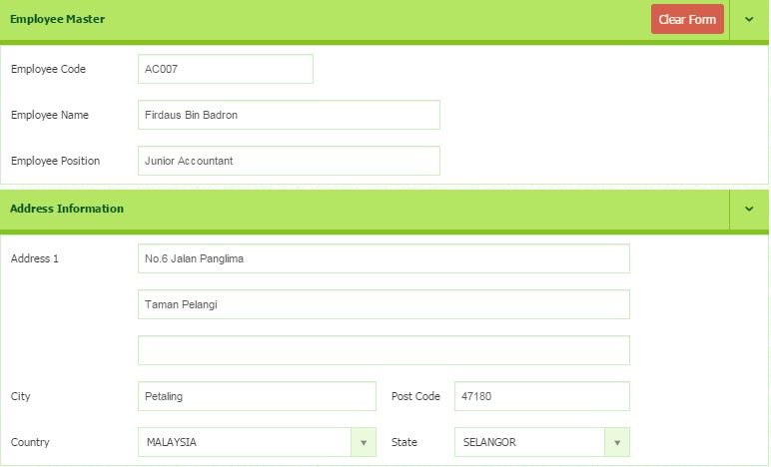
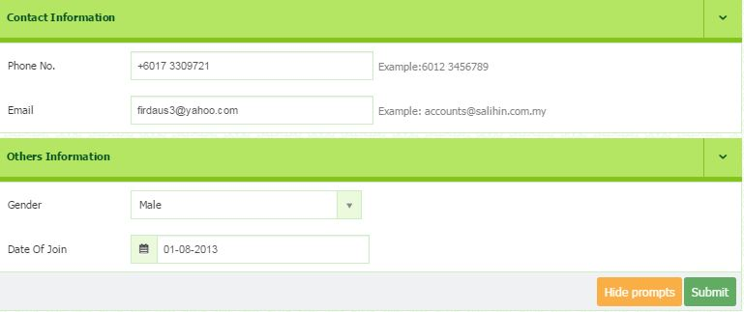

6.0.2 How to Remove Existing Employee
- Go To General Setup > Employee Setup. The Employee Master List window appears.
- To remove employee from the list, identify the employee name row.
- In the Action field on the right-side of the row, click the Delete button (image).
- Dialog box of deletion confirmation appears, then click the Delete button.

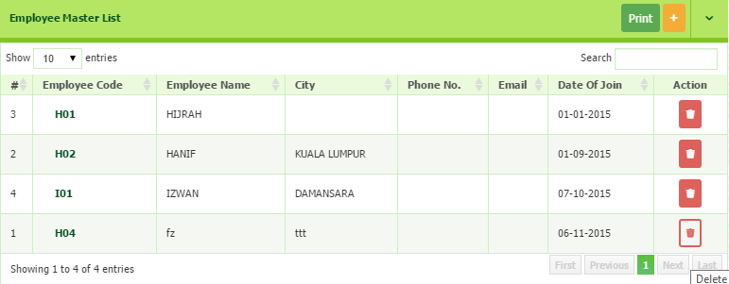
6.0.3 How to Print Employee Details
- To print, click the Print button on the top right-side of the page.
- Employee list window appears.
- Click (print image) to print the data or (download image) to open/save the data in excel format (.xls)

7.0 How to Setup Agent
In this section, you need to setting up your Agent details. Basically this information will be use when you want to make a payment to your agent according to the commission rate.
- Go To General Setup > Agent Setup. The Agent Master List window appears.
- Click on + button on the top right-side of the page to add New Agent.
- You will be directed to the page where you can enter all the required information.
- After completed, click Submit button to save.
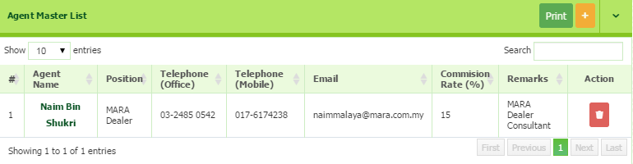
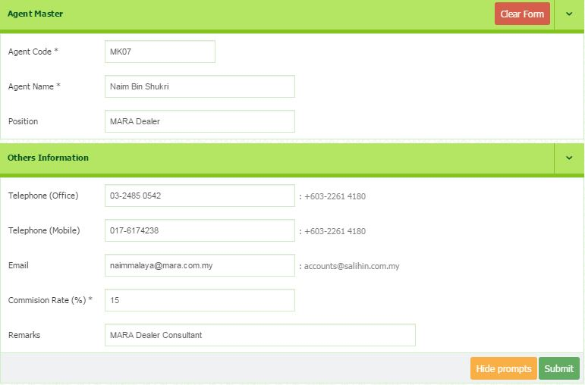

7.0.1 How to View/Edit Agent Details
- Go To General Setup > Agent Setup. The Agent Master List window appears.
- In the Agent Name field, identify the agent and select the particular agent’s name.
- Click the link of Agent Name. The Edit dialog box will appear.
- Click Continue, the Agent Master window appears. Edit the relevant information.
- Once completed, click Submit button to save.
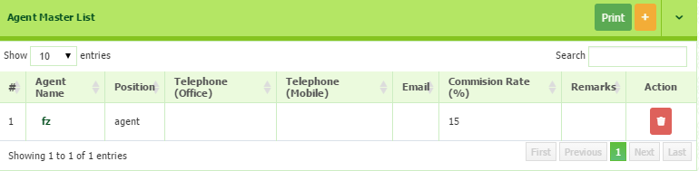
7.0.2 How to Delete Agent Details
- Go To General Setup > Agent Setup. The Agent Master List window appears.
- To remove agent from the list, identify the agent name row.
- In the Action field on the right-side of the row, click the Delete button (image).
- Dialog box of deletion confirmation appears, then click the Delete button.

7.0.3 How to Print Agent Details
- To print, click the Print button on the top right-side of the page.
- Agent list window appears.
- Click (print image) to print the data or (download image) to open/save the data in excel format (.xls)

8.0 How to set Terms Setup
You need to set your Credit Terms and Condition List. It will be appear when you create an invoices.
- Go to General Setup > Terms Setup
- To Add New, click + button on top right of page
- In this section, all the particulars must be filled in.
  - Term Name ( the period/time frame given )
  - Description ( based on user understanding/preference)
  - Due days ( dateline given for the term to be completed)
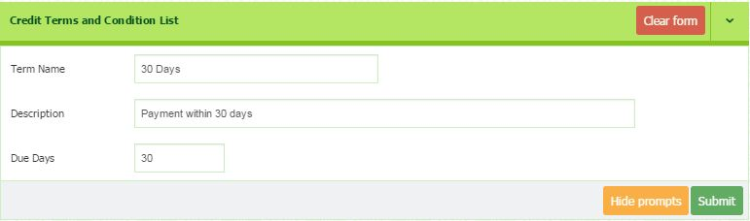
- Once completed, then click Submit button to save.
8.0.1 How to View/Edit Terms
- Go to General Setup > Terms Setup
- To Edit, click the link of identified Terms
- You will be direct to the editing page. Once completed, click Submit to save.

8.0.2 How to Delete Terms List
- Go to General Setup > Terms Setup
- You will be direct to the Credit Terms and Condition List page.
- Identified the Terms that you want to remove.
- Click the delete button that located in Action column.

9.0 How to set Bank Setup
- Go To General Setup > Bank Setup. The Bank Master List window appears.
- Click on + Button on the top right-side of the page to add New Bank.
- You will be directed to the page where you can enter all the required information.
- Once completed, click Submit button to save.
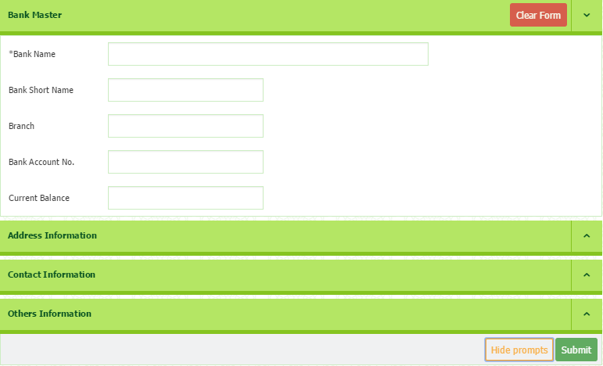
9.0.1 How to View/Edit Bank Listing
- Go To General Setup > Bank Setup. The Bank Master List window appears.
- In the search field, you can search any particular bank by entering the bank name.
- You can choose the number of entries of the Bank Name to be displayed.
- In the Bank Name field, identify the bank and select the particular bank name. The Edit dialog box appears.
- Click Continue, the Bank Master window appears. Edit the relevant information.
- Once completed, click Submit button to save.

9.0.2 How to Delete Bank Listing
- Go To General Setup > Bank Setup. The Bank Master List window appears.
- To remove the existing bank, identify the bank row.
- In the Action field on the right-side of the row, click the Delete button (image).
- Dialog box of deletion confirmation appears, then click the Delete button.
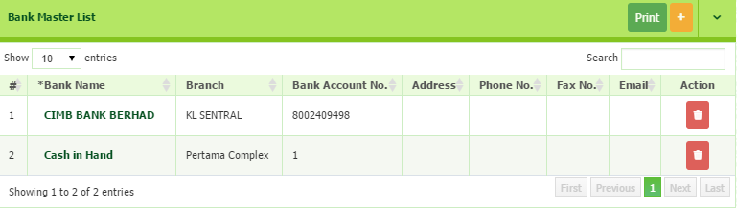

10.0 How to Setup ShipTo
- Go to General Setup > Ship To. The Company Ship To windows appear.
- (This section is enable if the company has more than one (1) warehouse at different location.)
- To add new Company Ship To, click the + Button.
- Fill in the information required.
- To Save, click the Submit button.
- You are also able to edit the information by click the link of address.
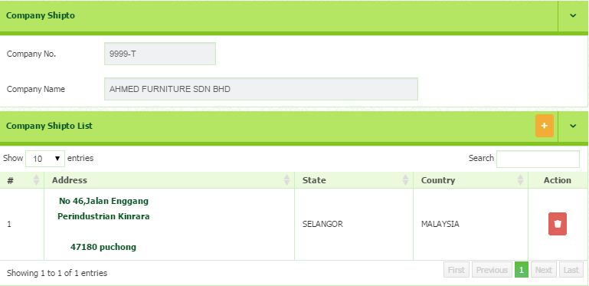
- If the company ship to no longer available, you can remove the list by click the Delete button that situated in the same row of the list.

