MODULE: ACCOUNT RECEIVABLES
In this section, you will be guide to setup your customer details and how to create an sales invoice….

1.0 How to set Customer Setup
Before you going to prepare an invoice for the sale items, you have to make sure that the following required information has been setup.

- Go to Account Receivable > Setup > Customer Setup
- To add your new customer, click + button that located at the top right page
- Fill in all the required information. Once completed, click Submit to save.
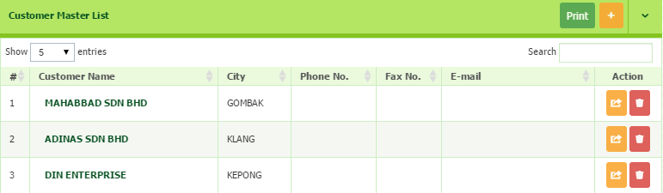

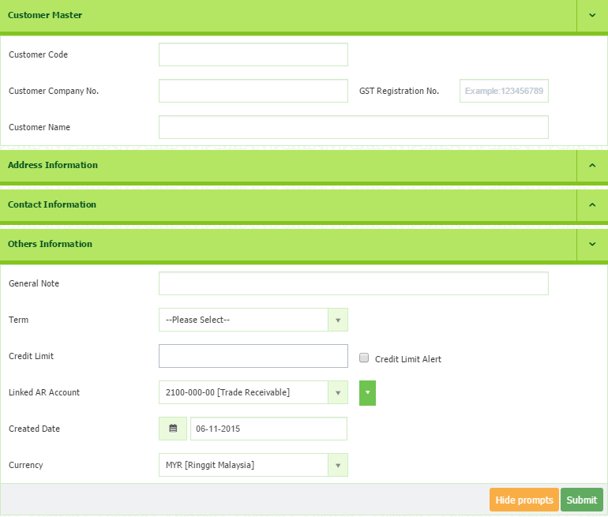
2.0 How to Create Direct Sales Invoice
Here you are going to prepare an invoice for the sale items. There are two methods:-
- Sales Invoice
- Direct Sales Invoice
Before we create Direct Sales Invoice, please setting up all the basic information.
- Customer Details
- Sales Person
- Terms Setup If you are not setting up the details yet, you can
- Agent Details directly setup by click the dropdown menu at each
- Shipping Methods required field.
- Locations
- Shipto

Step 1: Direct Sales Invoice
- Go to Account Receivables Transaction Sales Invoice
- Enter Form Number if necessary but the serial number will generate automatically.
- Select Date
  - *If we do not change the date, it will record the current date
- Select the Customer from the drop down list that created in the Customer setup.
- Insert the Customer PO Number
  - *You may type Customer Po No according to customer format.
- Select the Agent, Project, Terms, and Shipping Method, and Ships To from the drop down list.
  - *Any new addition/ registration and refresh list, can be done by clicking the Green button
- Any description or reminder can be insert in the Memo.
  - *You can select either to show agent or not in invoice.
