SPS 14.01.05 User Manual

Admin

User Master

1. Create New User
To create a new user, please follow the step below:-
- Go to Admin User Master. The User Master List window appears.
+ button to add new user
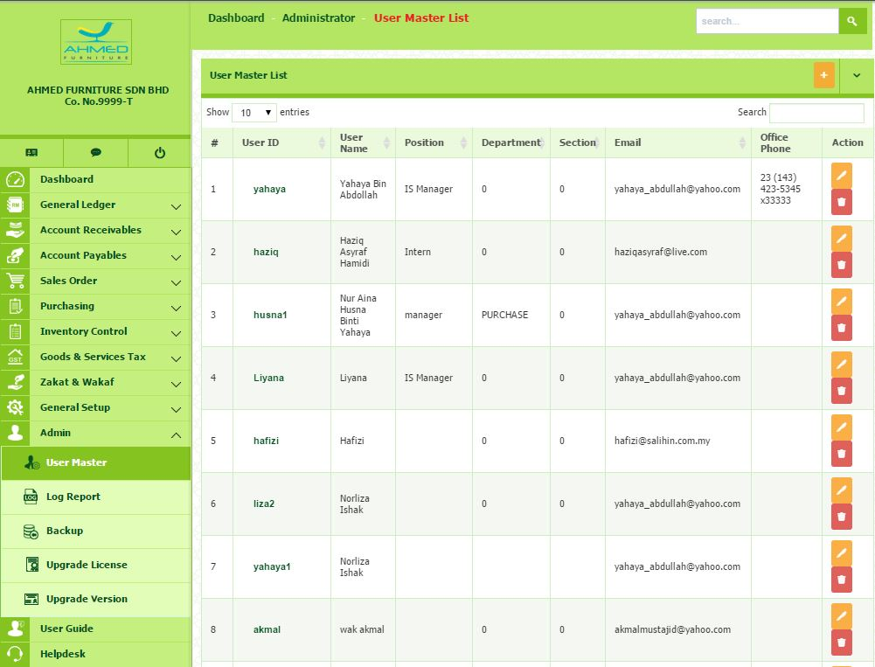
- In this section, Admin has the privileged to control the user registration and access right.
- In this section also, you can view all the User Master List
- To add new user, click button on the top right corner of the page.
- You will be directed to the page where you have to insert all the following required information.

  - User ID, Password and Confirm Password
  - Full Name and Position
  - Contact information such as Phone Office, Mobile No. and Email address

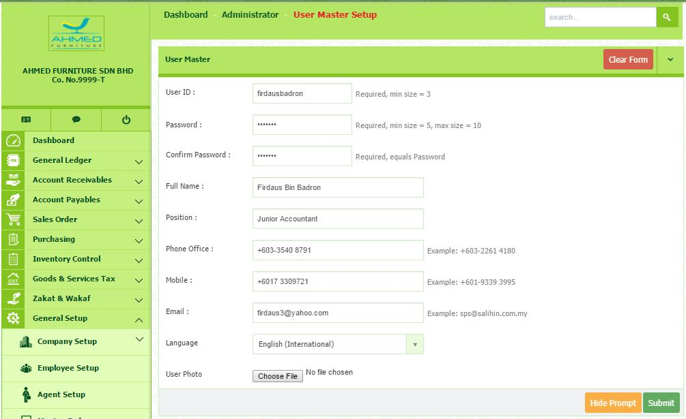
Upload user photo

- Select your preferred language. If you did not choose your preferred language, the system set English as the default language.
- To upload User Photo, click the Choose File button, upload the required image (image can be BMP, PNG, JPEG or GIF files and should measure 120 x 120).
- Click Submit button to save.

2. Grant the Permission on Access Right
- First, choose the existing user master from the list.
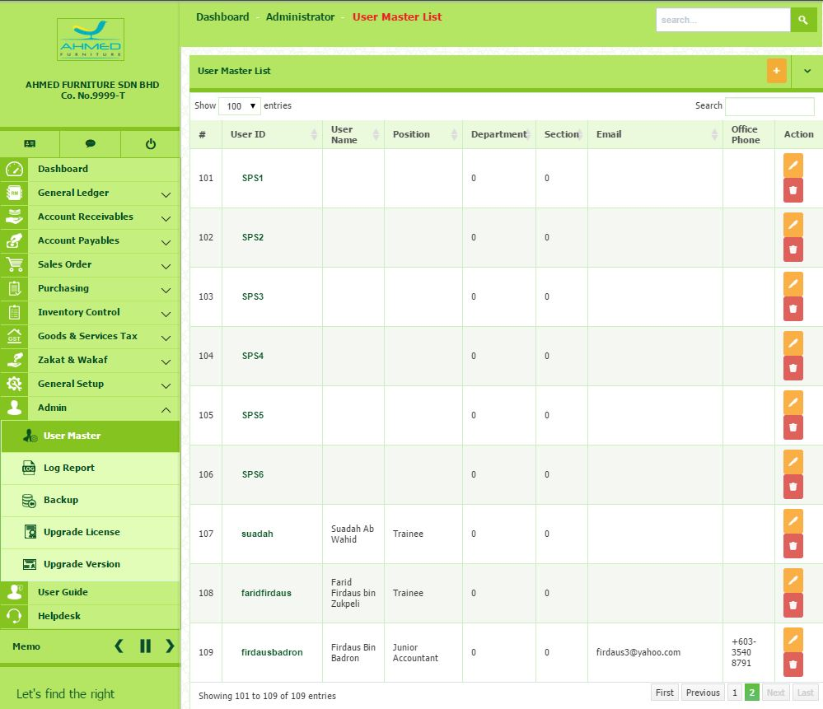
Click the identified User ID

- Click the identified User ID in the User ID field.

- You will be directed to User Access for the user you have selected. The Setting User Access dialog box will appear. Click OK to continue.
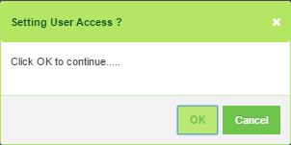
- The User Access for the selected user appears and selects the Company from the list.
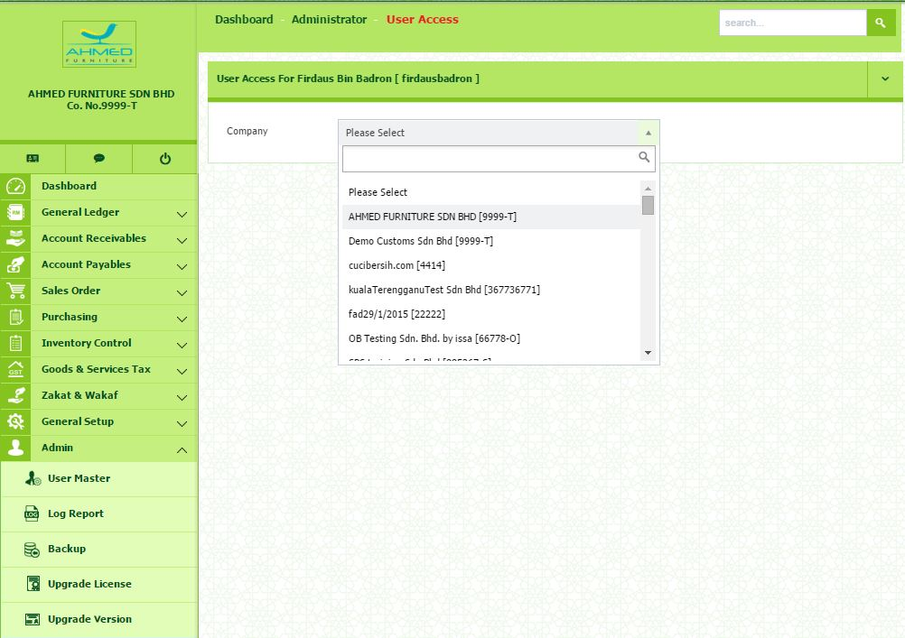
Select the company from the list to give permission to a user access to any module(s) in SPS

- Once selected, all the modules will be displayed.
- In this section, Admin has the full control to give permission to a user access to any particular module(s).
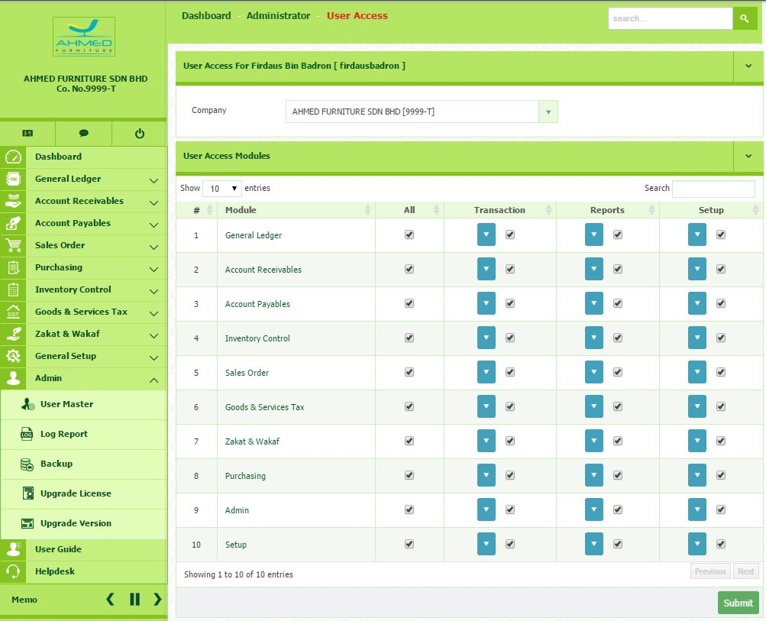
- For example, if you want the user to access only the Goods & Services Tax and can execute transactions, you have to tick the box under Transaction menu.

- Next, click the drop down button. You can see all the menus under Transaction.
- In this section you can choose which menu to allow them to access.
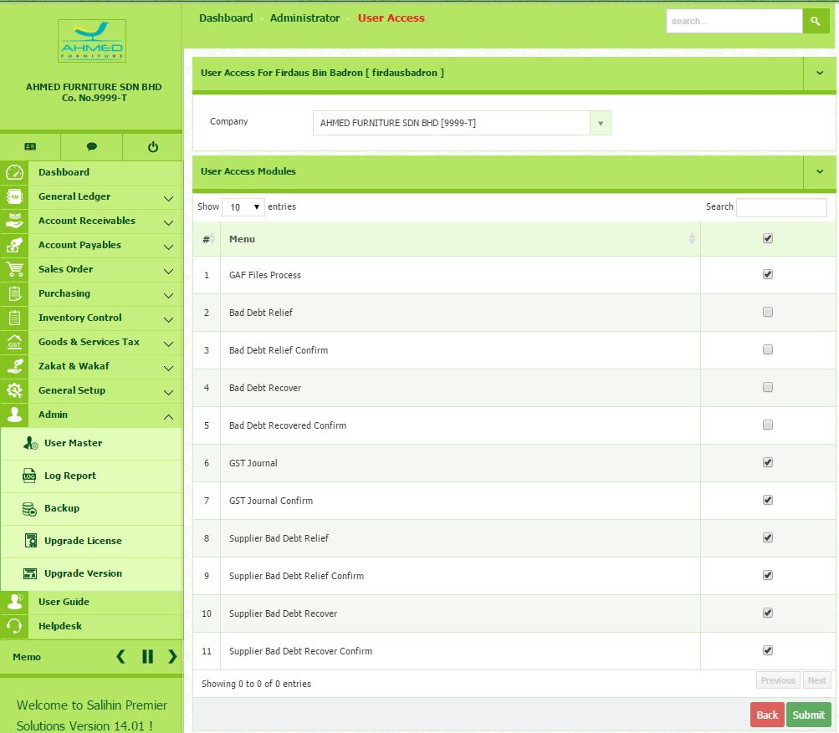

NOTE: Please make sure to limit the access right for User Demo. This is required after you already successful registered new company and assign user.

3. View User Master List
To view the User Master List, please follow the step below:-
- Go to Admin User Master
- You will directed to the page where it will display all the listing of the User.
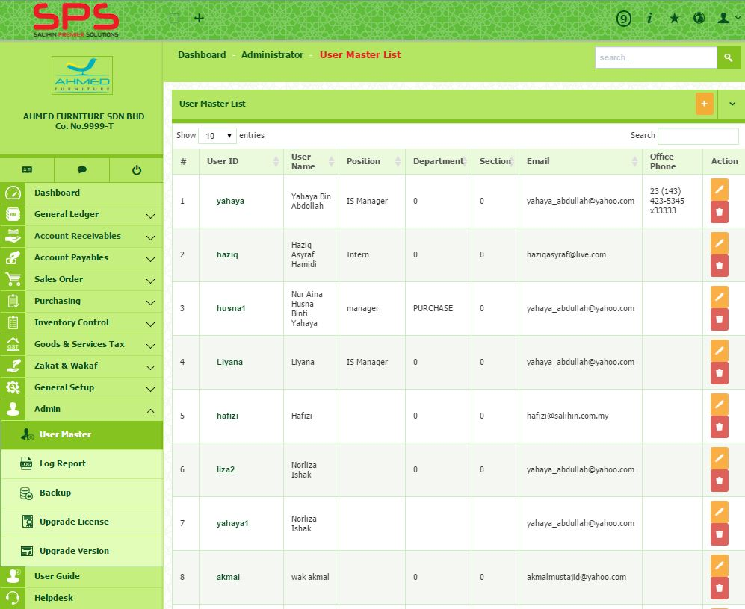
Delete button
Edit button
- To edit existing user, you may click the Edit button that situated at the same row of selected user that you choose.
- To delete existing user, you may click the Delete button that situated at the same row of selected user that you choose.
- To setting the user access, you may click the name of the User ID and select the company from the drop down list. (For step no. 5, 6 and 7 please refer to Grant the Permission on Access Right step)
- Once selected, you will be directed to the page that display listing of module. In this part you may give the permission or access right to the selected user.
- Once setting is set up, click Submit button.
NOTE: If you are super admin for that selected company, please be careful and confirm on which modules you want to give privilege.

Log Report
- Go to Admin Log Report. The Log Report windows will appear.
Select the type of query either insert or update
Use any keyword to run searching on the Search box
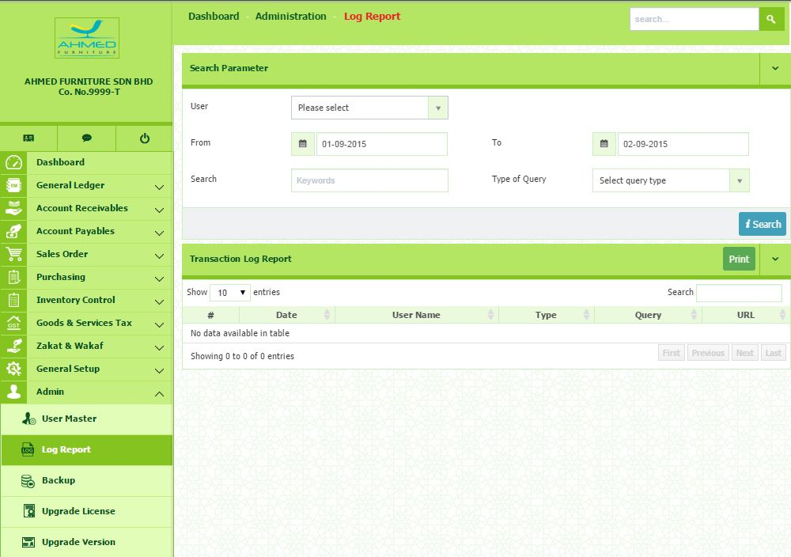

- Select the User from the list.
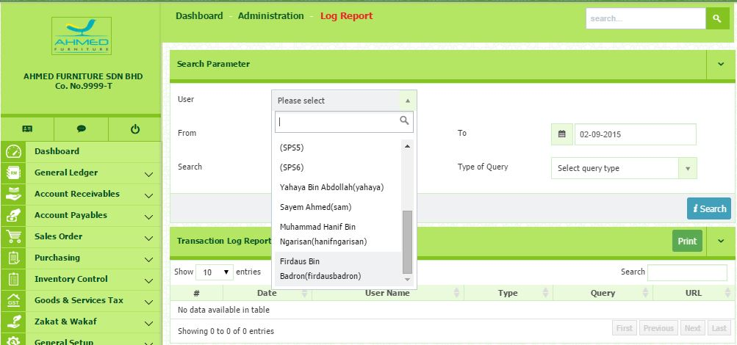
Click Search button to submit
- Select the Date From and Date To.
- You are enable to use any keyword to run searching on the Search box.
- Select the type of query. You can select from the list either insert or update.
- Then, click Search button.
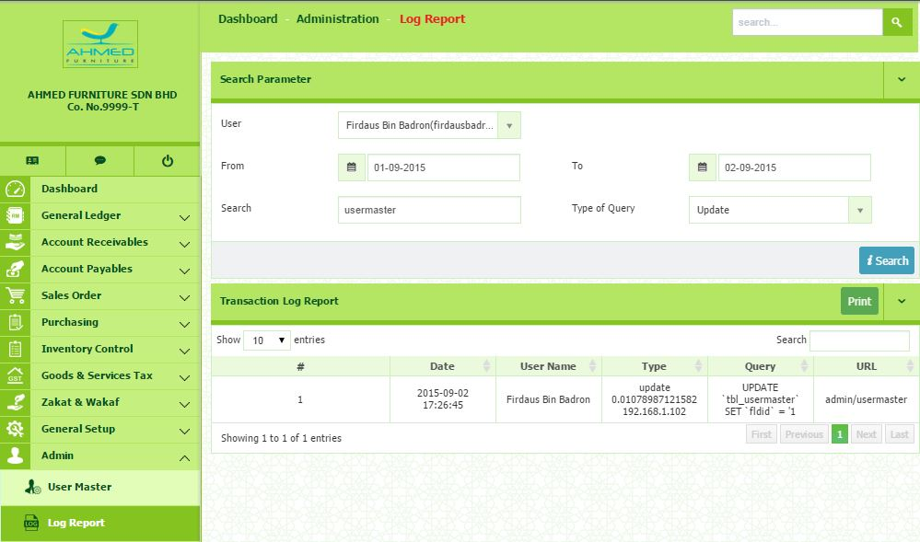
Example of Log Report

Backup

How To Do Backup
- Go to Admin Backup.
- Select the backup dates. Then, click Find Backup button.
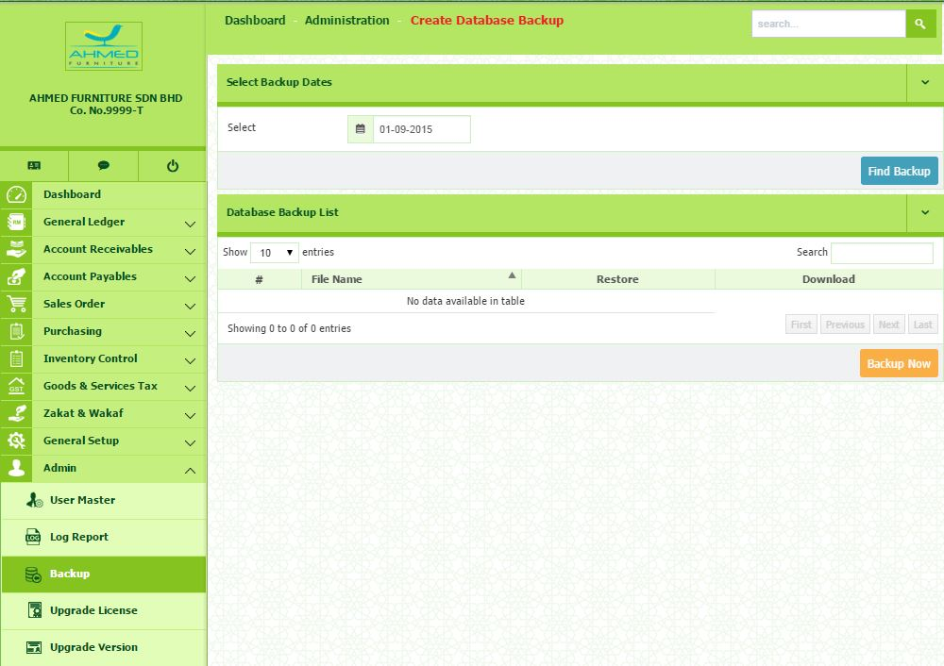
Click this button to backup current database of SPS

- All the database backup will be listed.
- If you are wish to restore the database, select the row of database and click the Restore button.
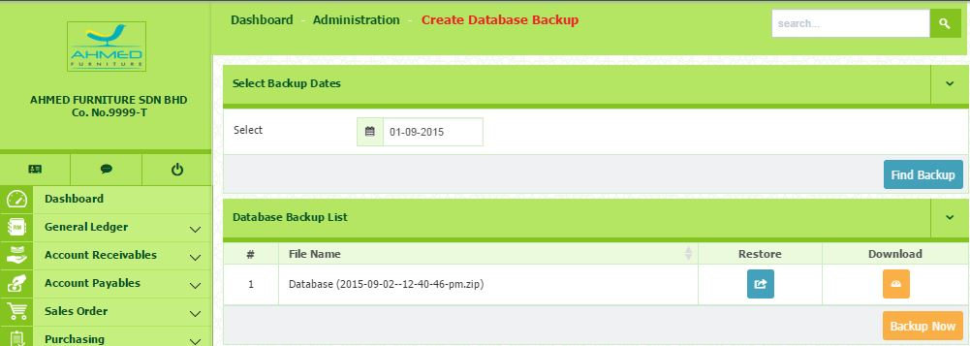
Download button
Restore button

