Purchasing
Purchasing is the activity of acquiring goods or services to accomplish the goals of an organization.

Setup

1) Setup: Suppliers List
- Before you proceed to do a transaction under Purchasing, firstly you need to setup or maintain the supplier’s details.
- Go to Purchasing Setup Suppliers List
- Click the + button to Add New Supplier
- Enter your Supplier Code, Supplier Company No and Supplier Name.
- If your Supplier is registered to GST, enter the GST Registration No. If not, just leave it blank.
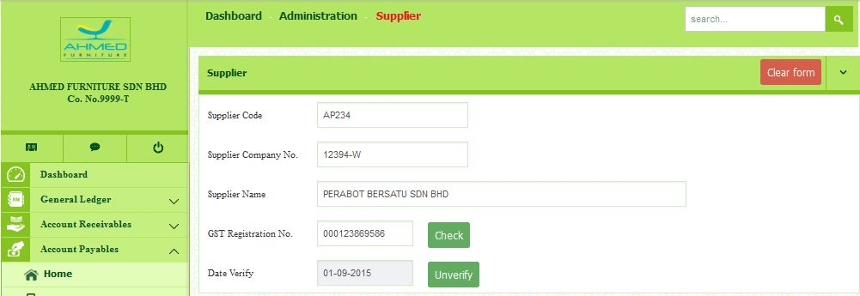

- Enter all the address information.

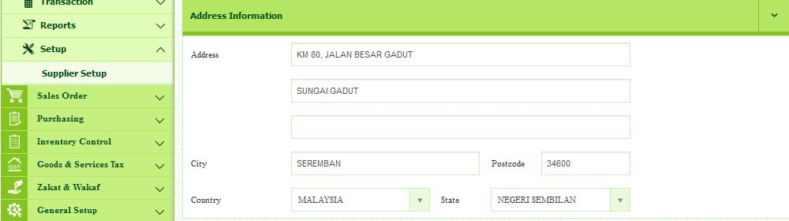
- Enter all the contact information.
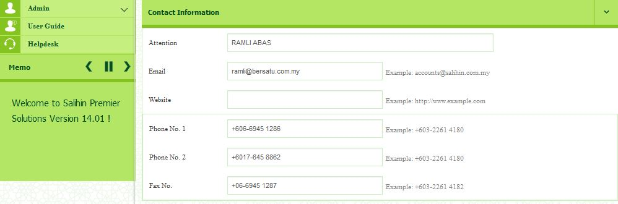

- Enter others information.

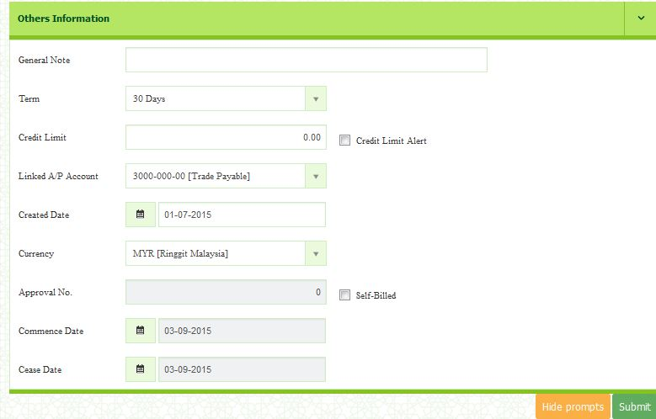

- After completed, click Submit button to save.
- To edit, click the link of Company No that you want to modify. You will be directed to the page where you can update the existing supplier information. Then, click Submit button to save.

- To delete the existing supplier, you can click the delete button that situated in the same row of selected supplier.

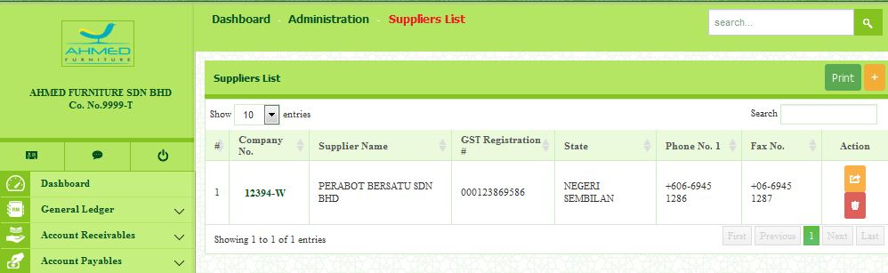
To edit
Delete button

2) Setup: Purchase Pricing
- Go to Purchasing Setup Purchase Pricing
- Select Item.
- Select Supplier.
- Select Unit of measure.
- Select Currency.
- Select Start Effective Date and End Effective Date.
- Enter Unit price. It depends on your goods market value.
- Click Save button to save.

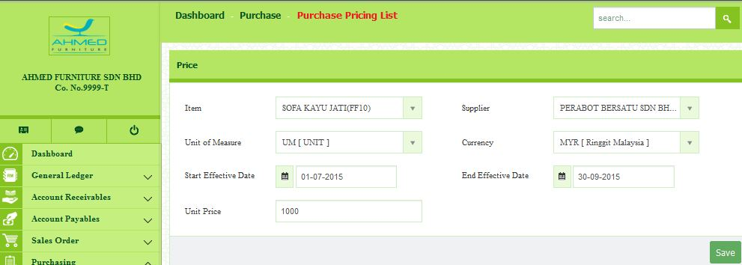

Transaction
1) Transaction: Purchase Order
- Go to Purchasing Transaction Purchase Order
- Select the Supplier. Form No will be auto generated. The system allow user to change the Form No format.
- Select the date.
- Terms Description will be display automatically when Term is selected.
- Currency will be display automatically when Supplier is selected.
- Select Ship To.
- Select Purchaser.
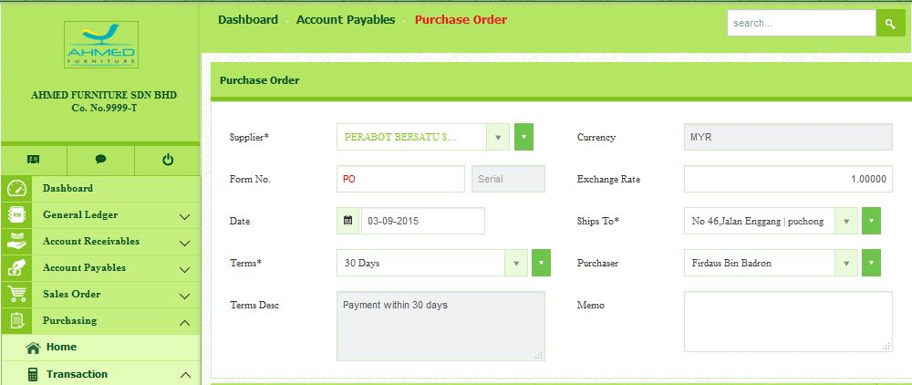

Item
- Click Add New Details.
- Select Item.
- Enter the price Unit of your Item.
- Enter the Quantity Order.
- Amount will be calculated automatically when Unit Price and Quantity is entered.
- Please ensure that your item is correct. Click the button to save.
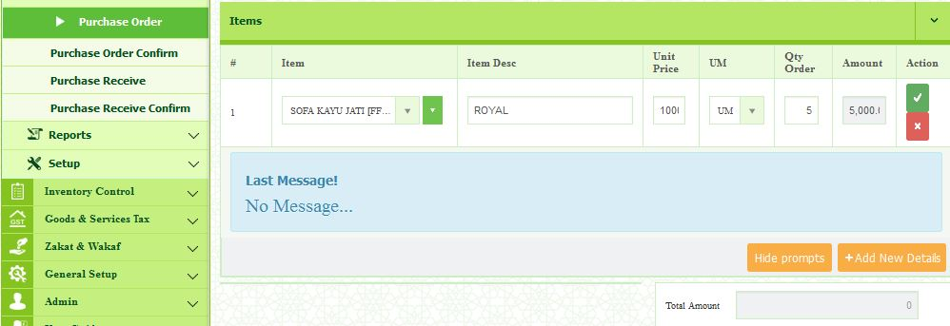

2) Transaction: Purchase Order Confirm
- Go to Purchasing Transaction Purchase Order Confirm
- Select the period.
- All purchase order to confirm will be listed.
- Tick the selected purchase order no.
- Click Confirm.

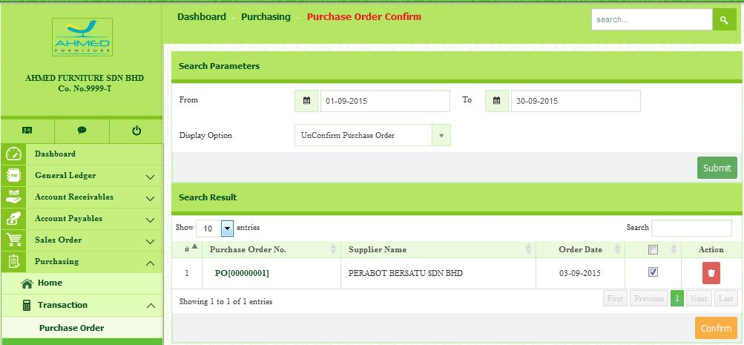

3) Transaction: Purchase Receive
- Go to Purchasing Transaction Purchase Receive
- Select the Supplier from the drop down list.
- Form No will be automatically display.
- Select the date.
- Enter the Supplier Do No.
- Select the Purchase Order.
- Select the shipping method.
- Select the Location.

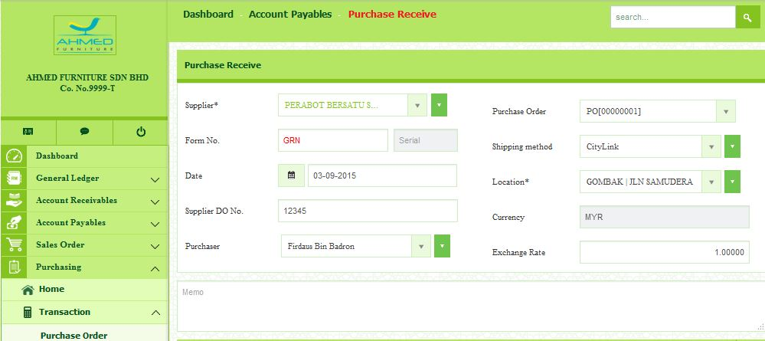

Outstanding Purchase Order Items
- Item details will be listed once the purchase order is selected.
- Enter the Quantity Received and click button.

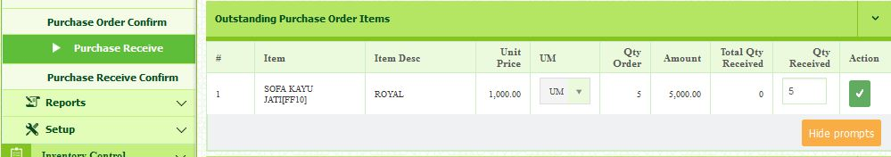

Current Items Received
- In this part, it will display the current item received that you have entered in previous outstanding purchase order items.

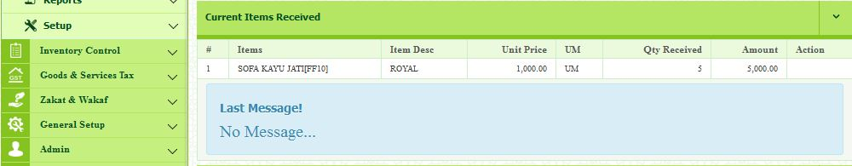

Items Not Include In Purchase Order
- In this part, you are allowed to add new item even the details it’s not include in previous purchase order.
- For example, you want to add on 1 monitor, you can request to do so.
- The both item details will be combine in one purchase order

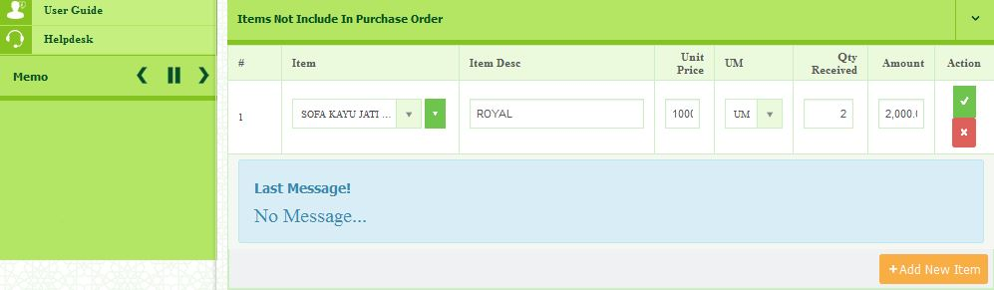

4) Transaction: Purchase Receive Confirm
- Go to Purchasing Transaction Purchase Receive Confirm
- Select the Year and Period, then click Submit button.
- Purchase receive item list will be listed for selected period.
- Tick the selected purchase order that need to be confirm.
- Once selected, click the Confirm button.

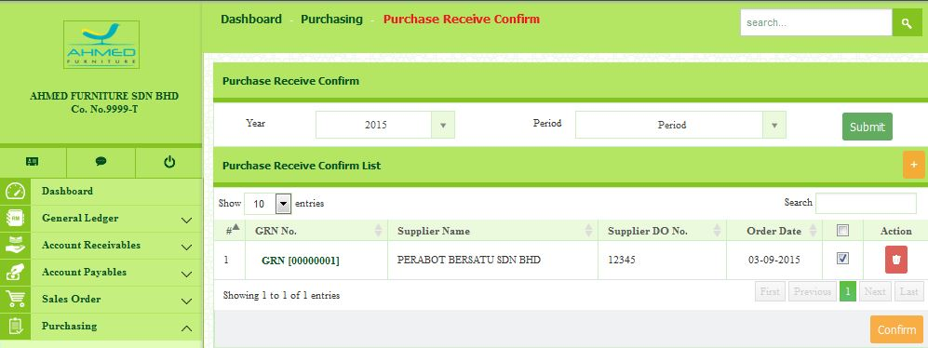

Report
1) Report: Purchase Pricing
- Go to Purchasing Reports Purchase Pricing
- Select the Year and Period, then click Submit button.
- Purchase Pricing List will be listed for selected period.
- Click Print to review and print the Purchase Pricing List.

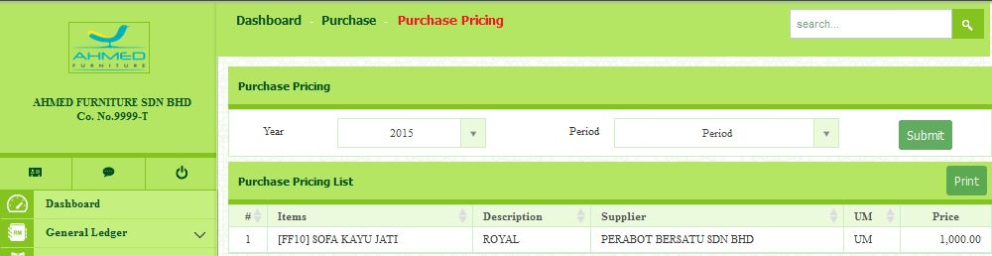

- Example of Purchase Pricing List Report.

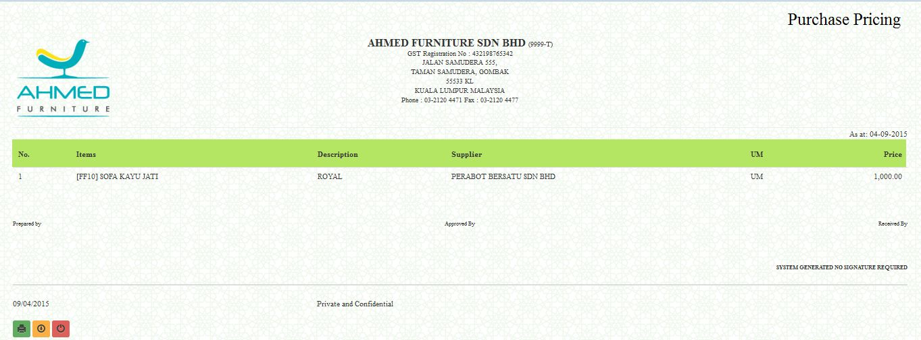

2) Report: Purchase Order List
- Go to Purchasing Report Purchase Order List
- Select the period.
- Click Report to review and print the report.

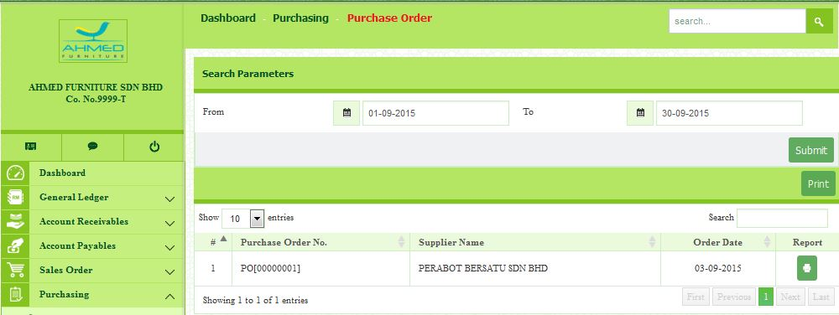

- Example of Purchase Order List Report

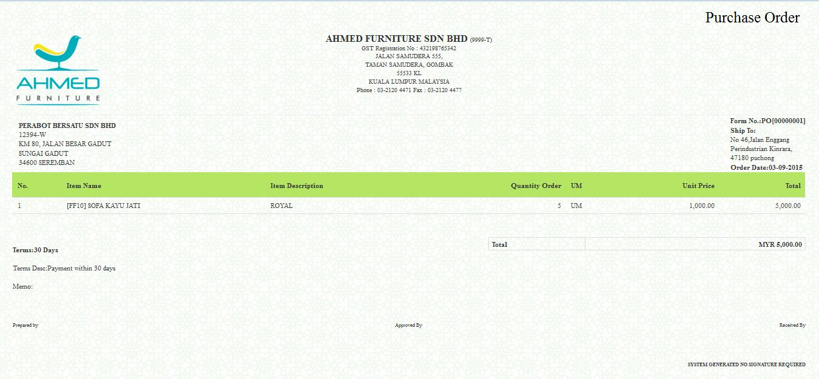

3) Report: Purchase Received List
- Go to Purchasing Reports Purchase Received List.
- Select the Period.
- Click Report to review and print the report.

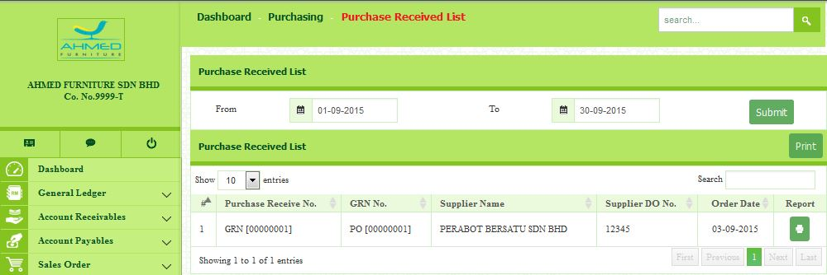

- Example of Purchase Received List Report.

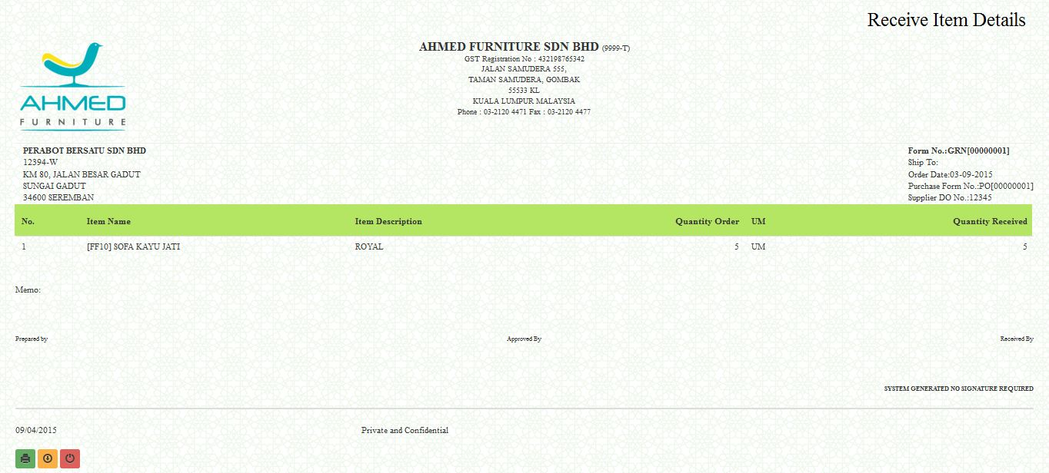

4) Report: Outstanding GRN Report

- Go to Purchasing Reports Outstanding GRN Report

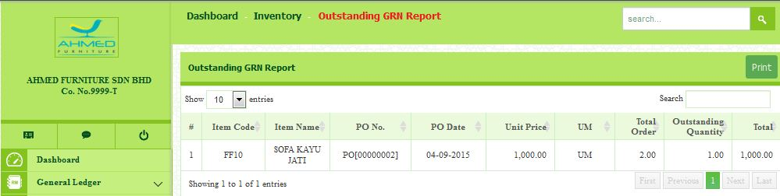

Account Payables

Account Payable is money which a company owes to Supplier for goods and services purchased on credit. This item appears on the company Statement of Financial Position as a current liability, since the expectation is that the liability will be fulfilled in less than a year.

Account Payable contains the following required information such as supplier setup, purchase order and created purchase invoice for the suppliers. Here you need to setup the supplier information first.
Setup
- Go to Account Payable Setup Supplier Setup
- Click + button on the right top of the pages, to setup a New Supplier.
- Enter your Supplier Code, Supplier Company No and Supplier Name.
- If your Supplier is registered to GST, enter the GST Registration No. If not, just leave it blank.

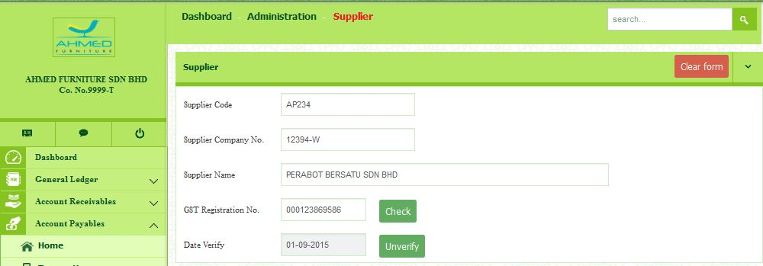

- Enter all the address information.
- Enter all the contact information.
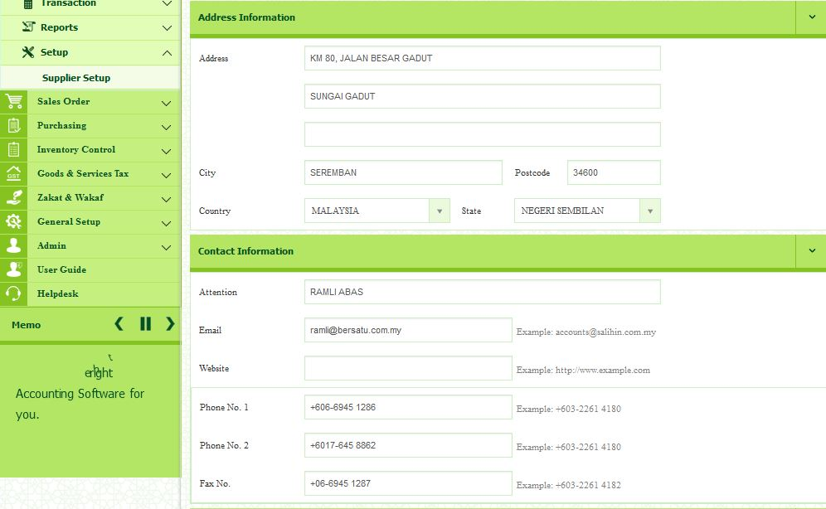

- Enter others information.
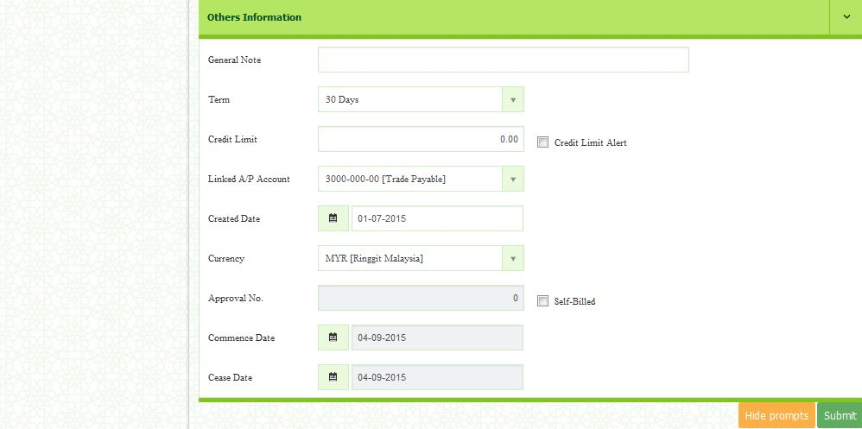

- After completed, click Submit button to save.
Transaction
1) Purchase Invoice
In this section, you will create a new purchase invoice.
- Go to Account Payable Transaction New Purchase Invoice
- Before you create the New Purchase Invoice, please make sure that you already setup the suppliers, terms, project and ships to.
- Select the supplier.
- Select Shipping Method form the drop down list.
- Select the Ship To.

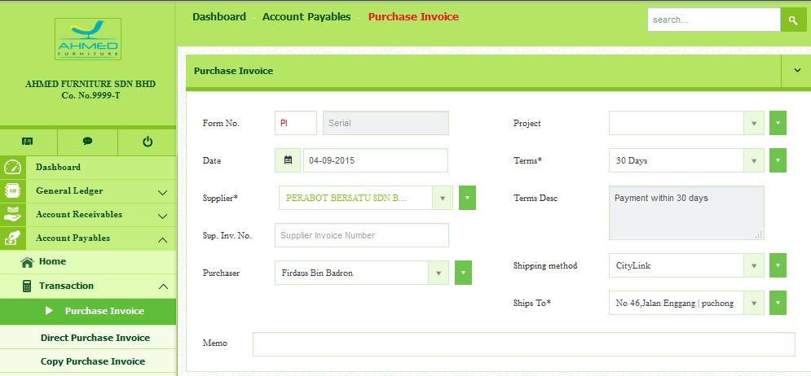

Items
- In the Item(s) section, you may set the price, quantity and tax of the items.
- Tick the selected purchase invoice.

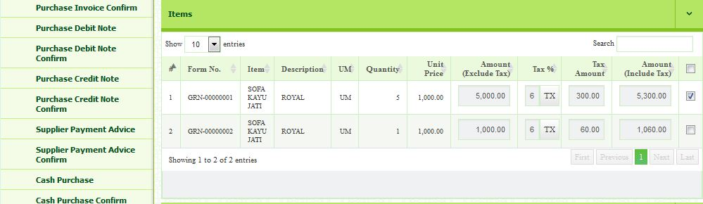
Service/Other Charge
- In the Service/Other Charge section, you may select the account, enter the description, amount, tax and tax amount by click Add New Charge button.
- Click Save Invoice button to save the current information.

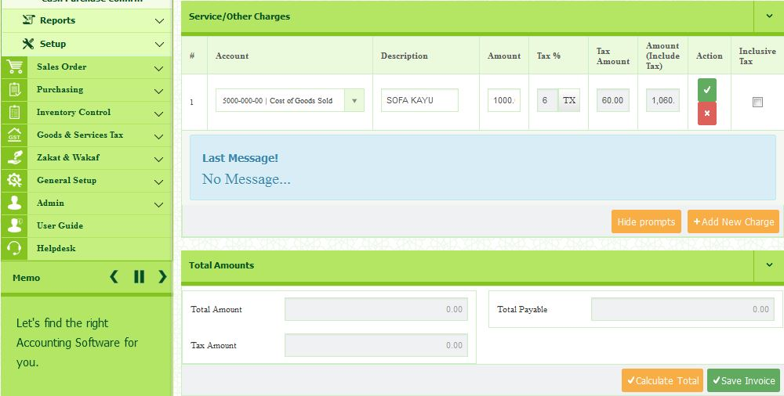

2) Direct Purchase Invoice

In here, you are enables to create a purchase invoice and receipt at the same time.
- Select the Supplier from the drop down list.
- Enter Supplier Invoice No.
- Select Purchaser.
- Select Location.
- Select Shipping Method.
- Select Ships To.
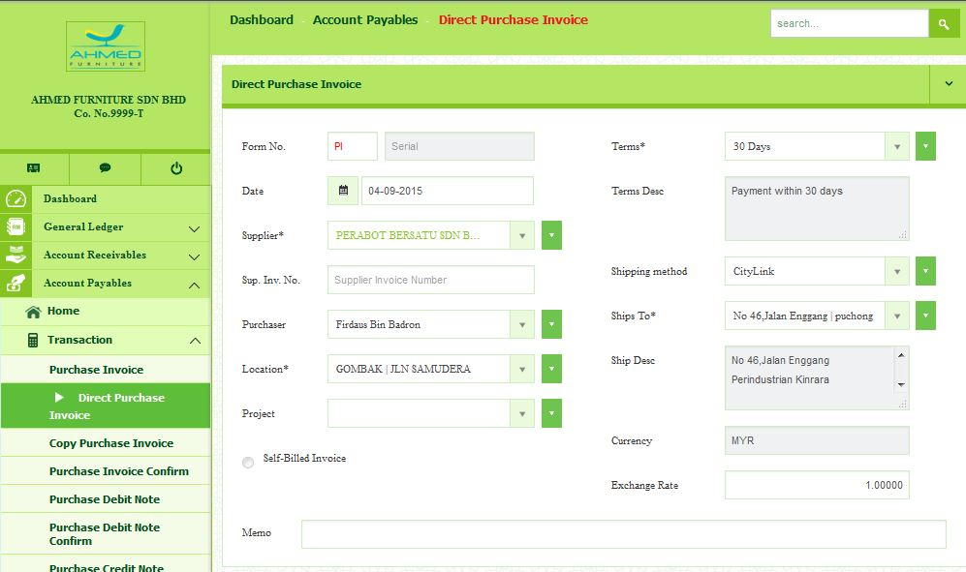

Item
- Select Item from the drop down list.
- Enter the Item Description.
- Enter the Unit Price.
- Enter the Quantity.
- Select the Tax (%) from the Tax Master list.
- To save, click the button.

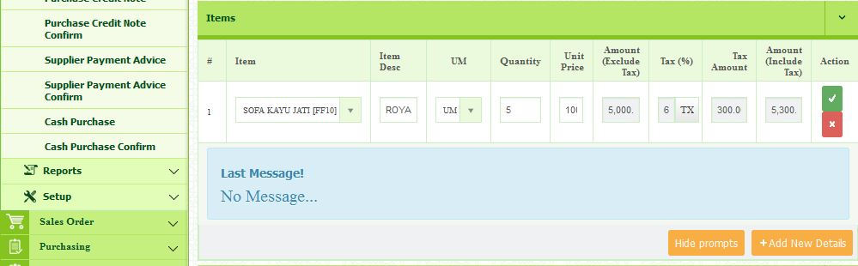

Service/Other Charge
- Select the Account from the dropdown list.
- Enter the Description.
- Enter the Amount.
- Select Tax %.
- Enter Tax Amount.
- To save, click the button.

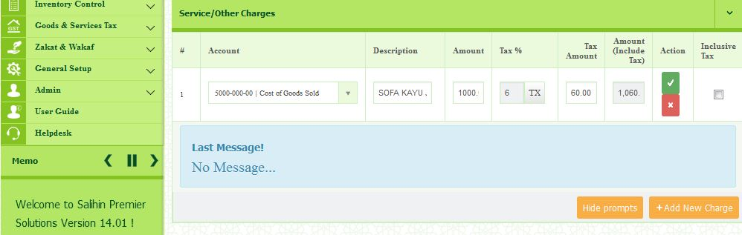

3) Copy Purchase Invoice
In this section, you will create a new purchase invoice.
- Go to Account Payables Transaction Copy Purchase Invoice
- Select Year and Period, then click Submit button.
- Select the Purchase Invoice that you want to duplicate.
- Then, click Clone Invoice button.

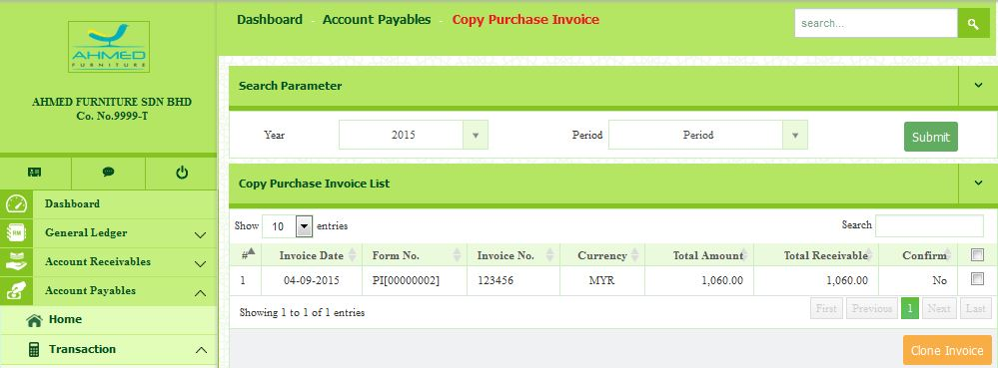

4) Purchase Invoice Confirm
- Go to Account Payables Transaction Purchase Invoice Confirm
- Select Year and Period.
- Select the Purchase invoice that you want to confirm.
- Then, click Confirm.

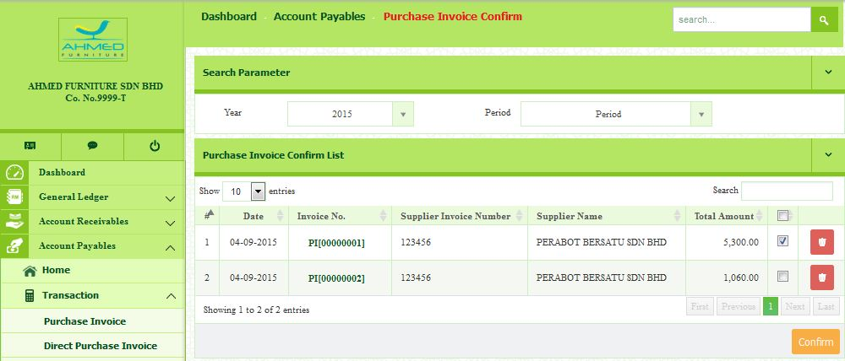

5) Purchase Debit Note
In this section, the purchase debit note is issued as an adjustment to the invoice you received from the supplier to decrease the value of goods.
- Go to Account Payables Transaction Purchase Debit Note
- Select the Supplier.
- Select the Invoice No.

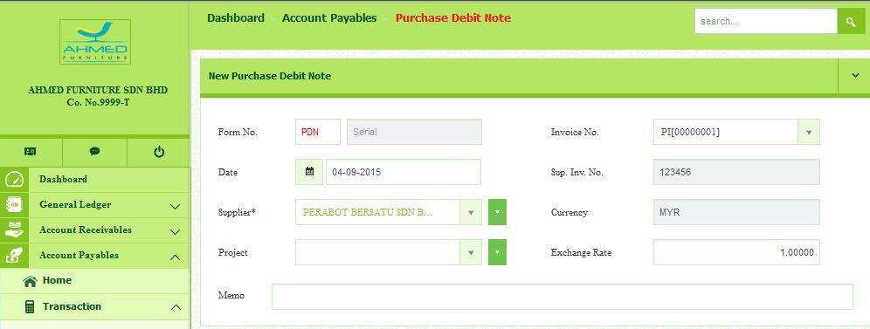
Items
- Click the Add New Details button.
- Select the item.
- Enter the Item Description.
- Enter the Unit Price.
- Enter the Quantity.
- Select the Tax (%) from the Tax Master list.
- To save, click the button.

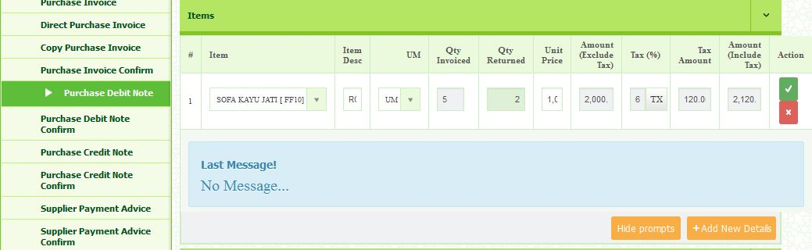

Service/Other Charges
- Click the Add New Charge button.
- Select Account.
- Enter the Description.
- Enter the Amount.
- Select Tax %.
- Enter Tax Amount.
- To save, click the button.

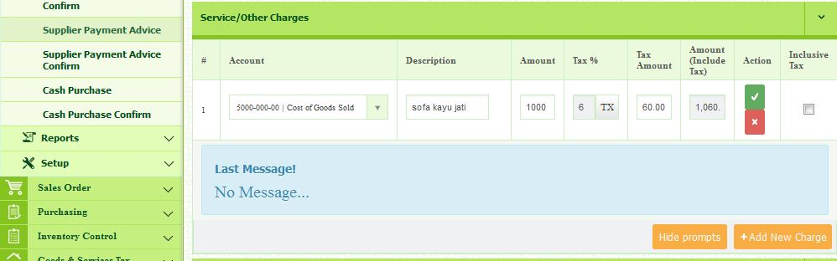

6) Purchase Debit Note Confirm
- Go to Account Payable Transaction Purchase Debit Note Confirm
- Select Year and Period.
- Select the Purchase Debit Note List that you want to confirm.
- Then, click Confirm.

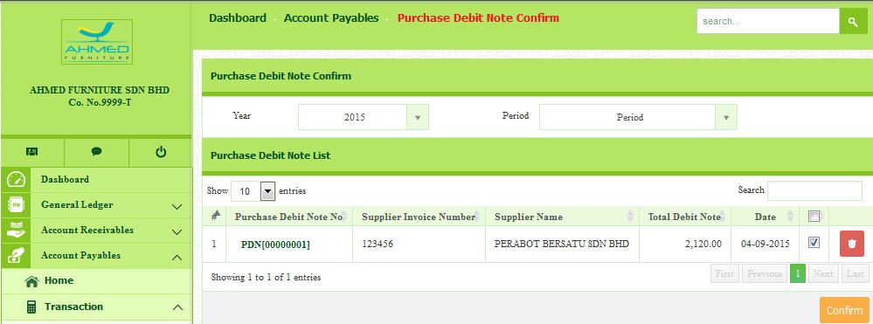

7) Purchase Credit Note
In this section, the purchase credit note is issued as an adjustment to the invoice received from supplier to increase the value of the goods.
- Go to Account Payable Transaction New Purchase Debit Note
- Select the Supplier.
- Select the Invoice No.

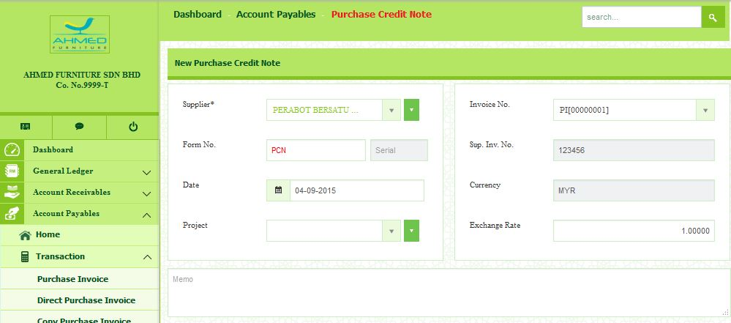
Items
- Click the Add New Details button.
- Select the item.
- Enter the Item Description
- Enter the Quantity.
- Enter the Unit Price
- Select the Tax (%) from the Tax Master list.
- To save, click the button.

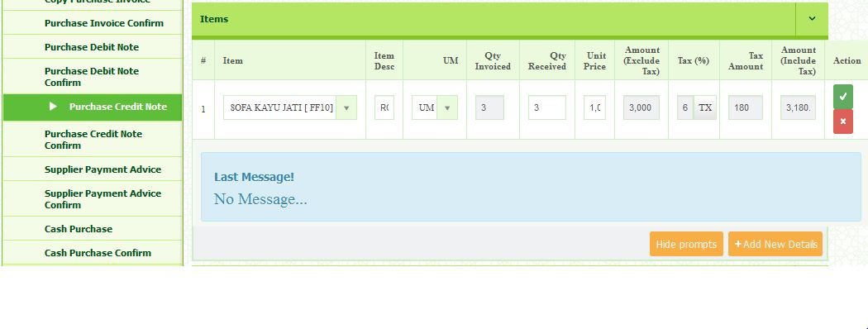

Service/Other Charges
- Click the Add New Charge button.
- Select Account Type.
- Enter the Description.
- Enter the Amount.
- Select Tax %.
- To save, click the button.

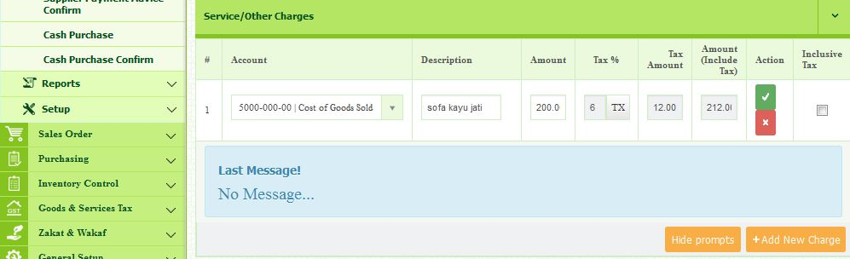

8) Purchase Credit Note Confirm
- Go to Account Payable Transaction Purchase Credit Note Confirm
- Select Year and Period.
- Select the Purchase Credit Note List that you want to confirm.
- Then, click Confirm.

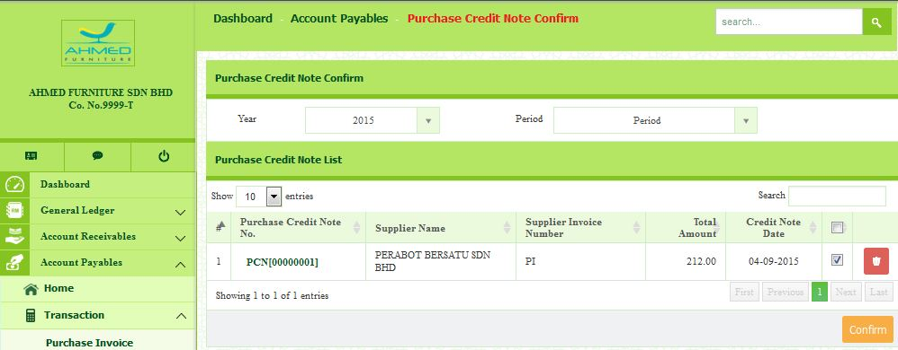

9) Supplier Payment Advice
- Go to Account Payables Transaction Supplier Payment Advice
- Select Supplier.
- Select Payment Method.
- Enter Reference No.
- Enter Description.
- Select Payment Date.
- Select the Bank.

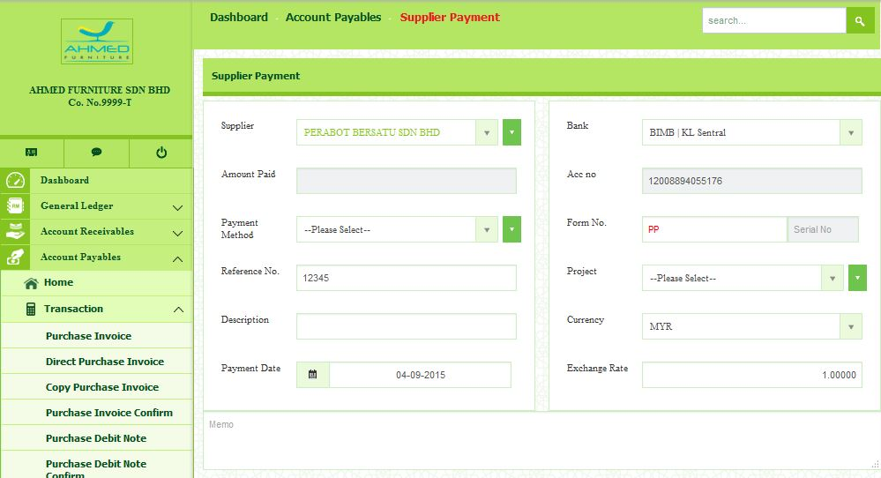

- Select the Invoice that you want to pay.
- Then, click Save.

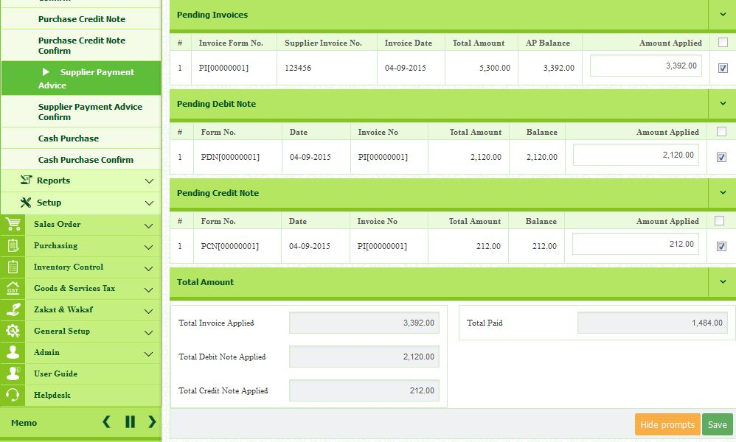

- Go to Account Receivables Transaction Copy Sales Invoice
- Select Year and Period and click Submit.
- All list of invoice will be displayed.
- Select/Tick the invoices you with to reuse.
- Once selected, click Clone Invoice button.

10) Supplier Payment Confirm
- Go to Account Payables Transaction Supplier Payment Advice
- Select Year and Period.
- Select Supplier Payment Advice To Confirm List.
- Then, Click Confirm.

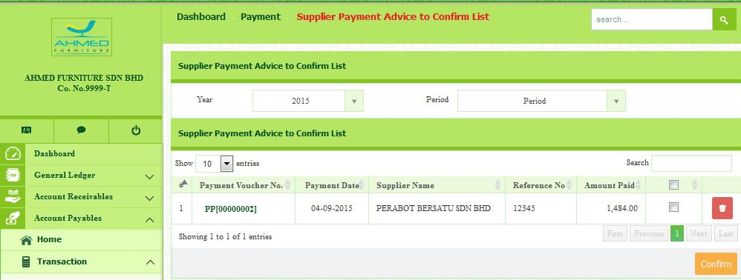

11) Cash Purchase
- Go to Account Payables Transaction Cash Purchase
- Select the Date.
- For Pay To field, enter the details of receiver such as Name and Address.
- Select the Bank.
- Enter the Amount Paid.
- Enter the Reference No.
- Select the Payment Method.
- Select Location.

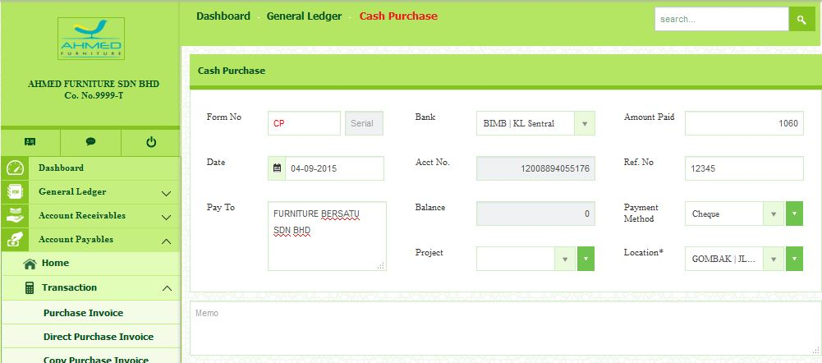

Items
- Click the + button to insert the Items.
- Select Item.
- Enter the description.
- Enter the Unit Price.
- Enter Quantity.
- Select the Tax (%) from the Tax Master.
- Click to save.

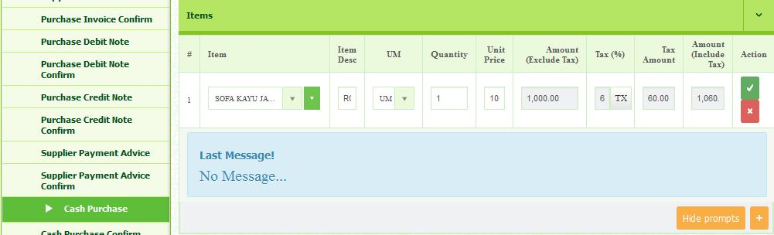

12) Cash Purchase Confirm
- Go to Account Payables Transaction Cash Purchase Confirm.
- Select Year and Period.
- Select Cash Purchase that you want to confirm.
- Then, Click Confirm.

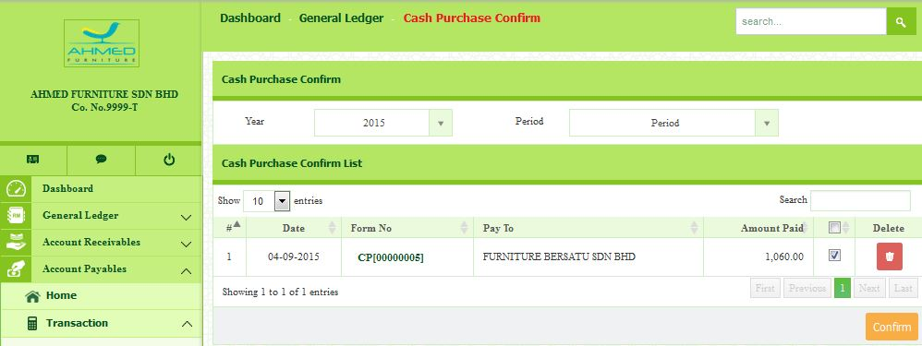

Report
1) Purchase Invoice List
- Go to Account Payables Reports Purchase Invoice List.
- Select the Period.
- Click Submit.
- Click Action to review and print the report.

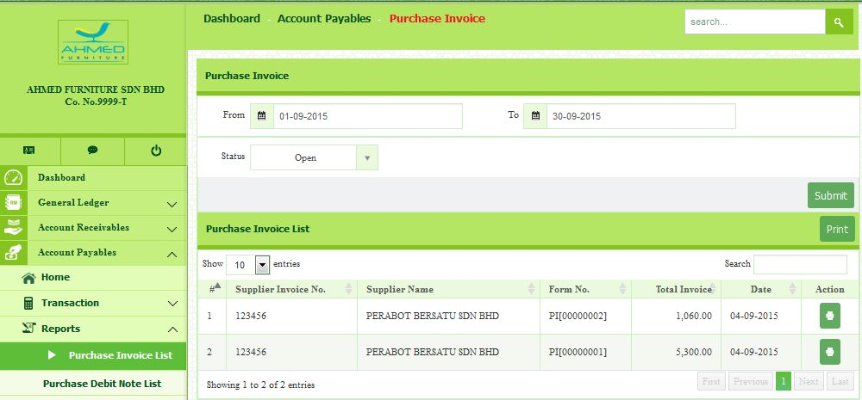

- Example of Purchase Invoice List
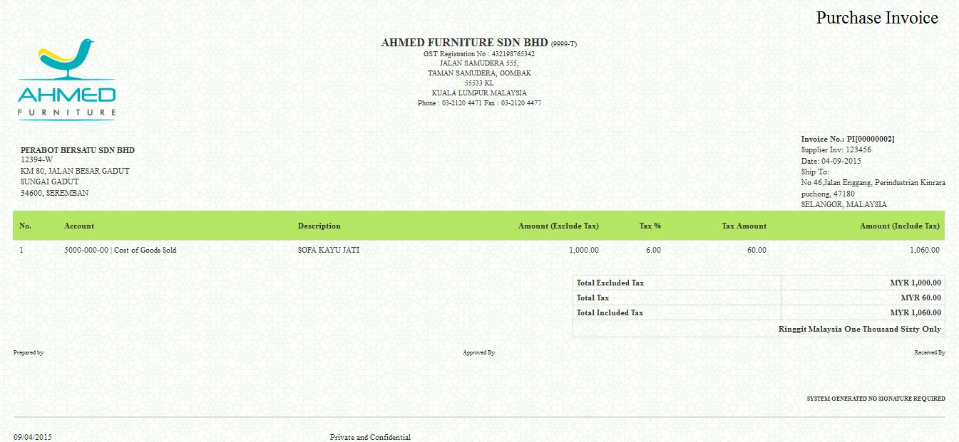

2) Purchase Debit Note List
- Go to Account Payables Reports Purchase Debit Note List.
- Select the Period.
- Click Submit.
- Click Action to review and print the report.

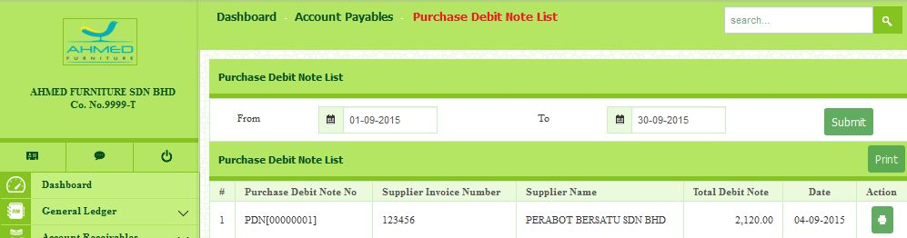

- Example of Purchase Debit Note List.

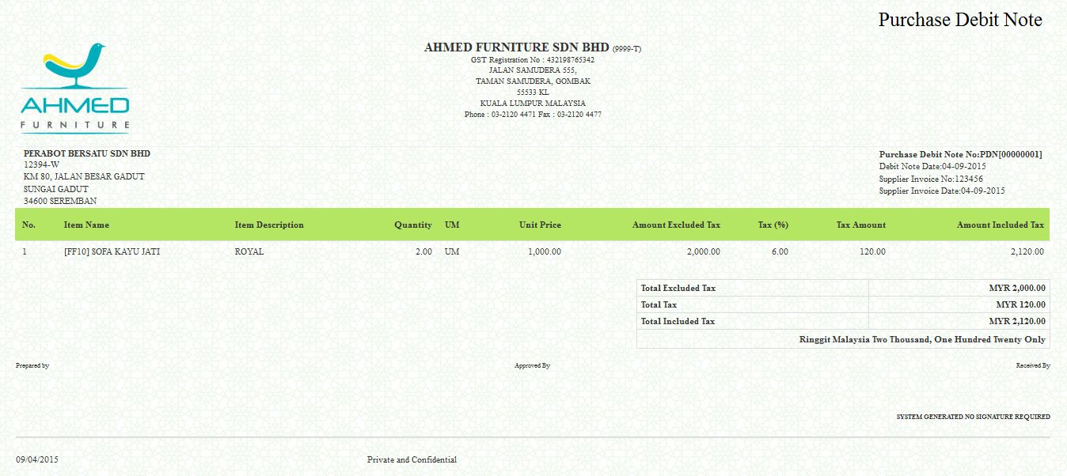

3) Purchase Credit Note List
- Go to Account Payables Reports Purchase Credit Note List.
- Select the Period.
- Click Submit.
- Click Action to review and print the report.

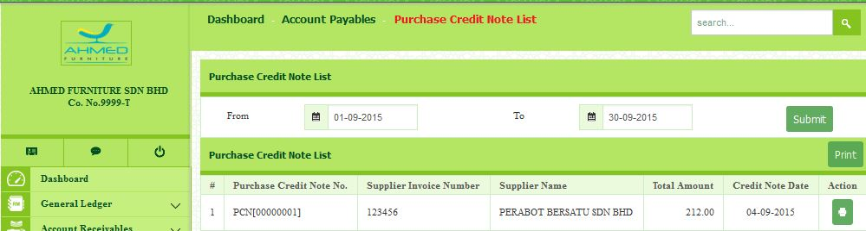

- Example of Purchase Credit Note List.

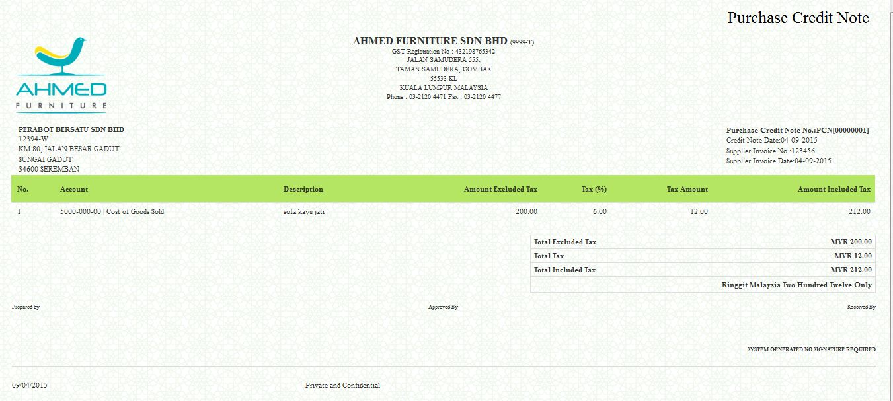

4) Supplier Payment List
- Go to Account Payables Reports Supplier Payment List.
- Select the Period.
- Click Submit.
- Click Action to review and print the report.

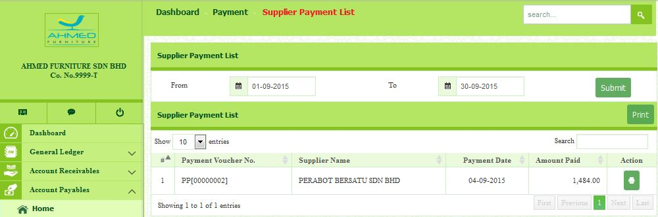

- Example of Purchase Credit Note List.

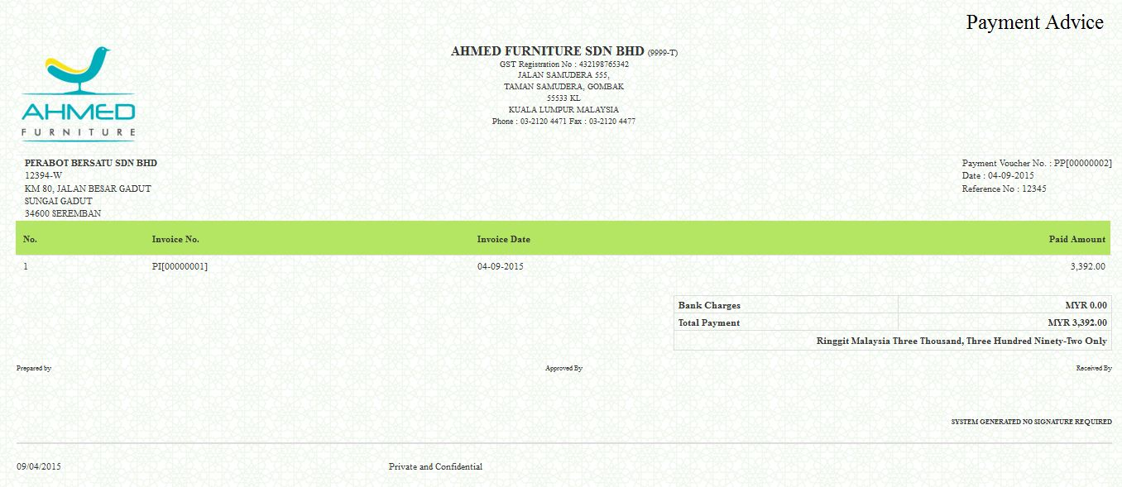

5) Supplier Statement List
- Enter Default Footer Message.
- Select the Supplier name.
- Click Action to review and print the report.

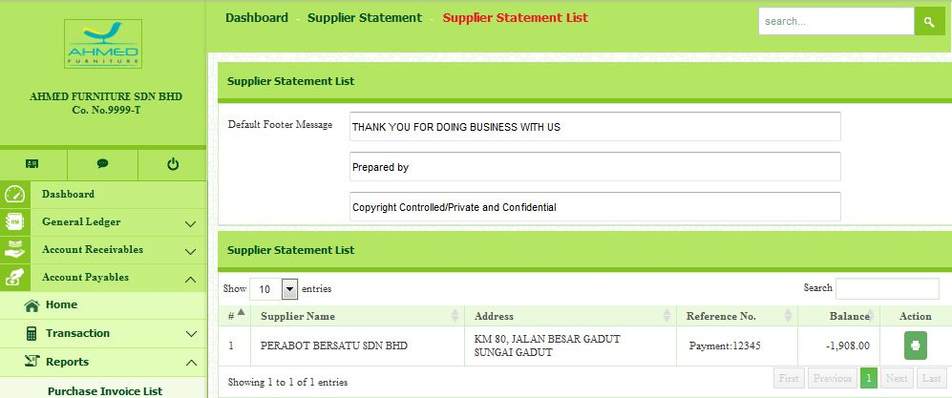

- Example of Purchase Credit Note List.

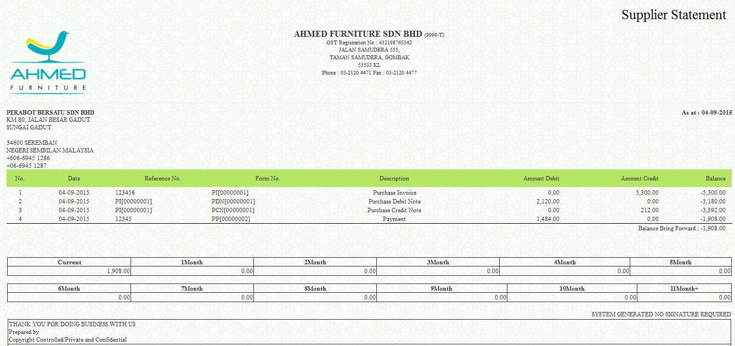

6) Cash Purchase List
- Go to Account Payables Reports Cash Purchase List.
- Select the Period.
- Click Submit.
- Click Action to review and print the report.

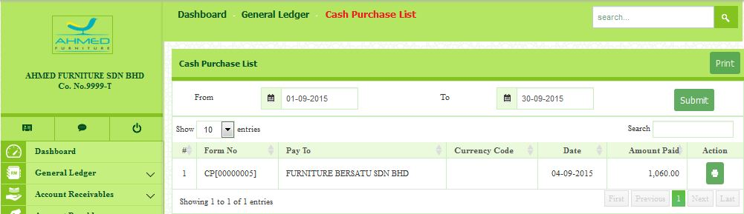

- Example of Purchase Credit Note List.

