Setup
There should be five major setups in the system.
- Company Setup
  - Company Information
Key Data Elements | Description
Business Name** | Company Name of business user  - Line 1  - Line 2
Business BRN** | Business Registration Number
GST No** | GST Registration Number of business user
Company Address** | - Line 1  - Line 2  - Line 3  - City  - Postal Code  - State  - Country
Telephone No** | Company contact no.
Fax No** | Company fax no.
Website** | Company website
Financial Year | Company financial year / financial period
Start Date | Company financial year start-date
End Date | Company financial year end-date
Currency Code | Functional currency used in accounting software (in 3 Char ISO). Empty means functional currency used in Malaysia Ringgit (MYR)
Product Version** | Accounting software name and version
GAF Version | GST Audit File (GAF) version number
** must be appeared on invoices.
- GST Setup
  - Tax Code Table
Key Data Elements |  |  | Description
TaxCodeTable | TaxCodeDetails | TaxCode | Tax code for lookup in tables
TaxCodeTable | TaxCodeDetails | TaxPercentage | Tax percentage
TaxCodeTable | TaxCodeDetails | Description | Description of tax code

  - Example Tax Code used by Swinburne
Tax Code | Tax Rate | Description
SR | 6% | Standard-rated supplies with GST charged.
ZRL | 0% | Local supply of goods or services which are subject to zero rated supplies.
OS | 0% | Out-of-scope supplies under GST legislations.
ES | 0% | Exempt supplies under GST legislations.
NS | 0% | Matters to be treated as neither a supply of goods nor a supply of services, and no GST chargeable.
*** Tax rate must be editable and the system should allow user to add new tax code

- Job Code Setup

  - Job Code Information
Key Data Elements | Description
Job Code | Job code for lookup in table
Item | Description of job code

- Item / Chart of Account Setup

  - Item / Chart of Account Information
Key Data Elements | Description
Account Code | Chart of Account code
Account Name | Chart of Account name
Job Code | Job code for lookup in table  *Based on Job Code Setup
Item | Description of job code
GST Setup | Tax code
Tax Rate | Tax rate based on the tax code used

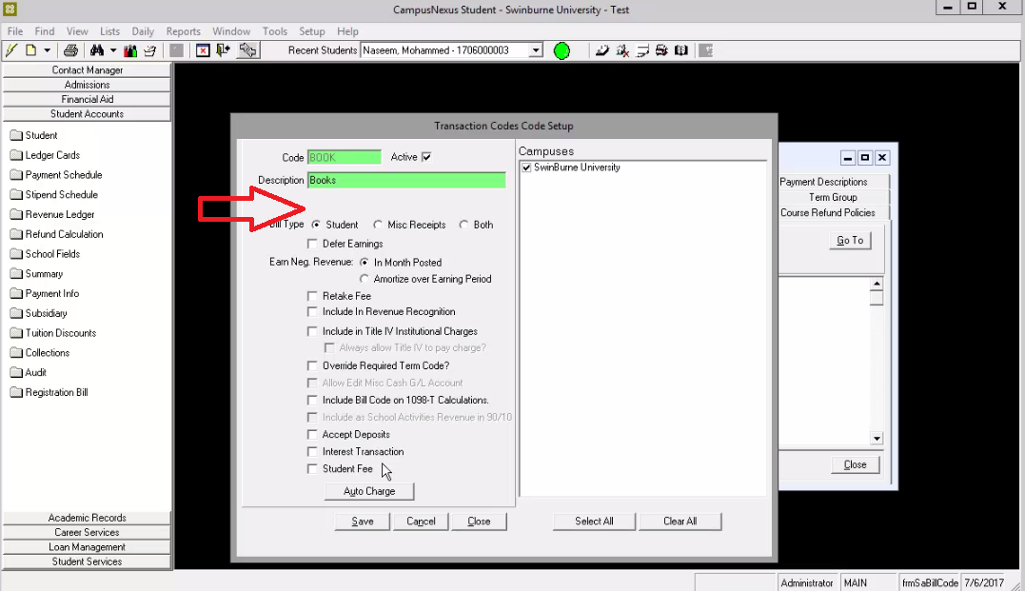
To setup Chart of Account, all key data elements for chart of account information must be added on this screen
(List > Student Account > Transaction Codes > Add / Edit).

- Customer / Student Setup

  - Student Information
Key Data Elements | Description
Customer ID** | Unique code for customer / student
Customer Name** | Customer / Student Name
Customer BRN | Business Registration Number of customer (if any)
Date GST Status Verified | Date GST status last checked (if any)
Customer GST No | GST Registration Number of customer (if any)
Customer Billing Address** | - Line 1  - Line 2  - Line 3  - City  - Postal Code  - State  - Country
Telephone** | Customer / Student contact no.
Fax** | Customer / Student fax no.
Email** | Customer / Student email
Website | Customer / Student website (if any)
** must be appeared on payment receipts.

