RECOMMENDATION AND SUGGESTIONS FOR

Campus Nexus Student System
GST Compliance Report

PREPARED FOR:-


PREPARED BY:-


SETUP

Setup
There should be five major setups in the system.
- Company Setup
  - Company Information
Key Data Elements | Description
Business Name** | Company Name of business user  - Line 1  - Line 2
Business BRN** | Business Registration Number
GST No** | GST Registration Number of business user
Company Address** | - Line 1  - Line 2  - Line 3  - City  - Postal Code  - State  - Country
Telephone No** | Company contact no.
Fax No** | Company fax no.
Website** | Company website
Upload Logo** | Company Logo
Currency Code | Functional currency used in accounting software (in 3 Char ISO). Empty means functional currency used in Malaysia Ringgit (MYR)
Product Version | Accounting software name and version
GAF Version | GST Audit File (GAF) version number

** must be appeared on tax invoice.
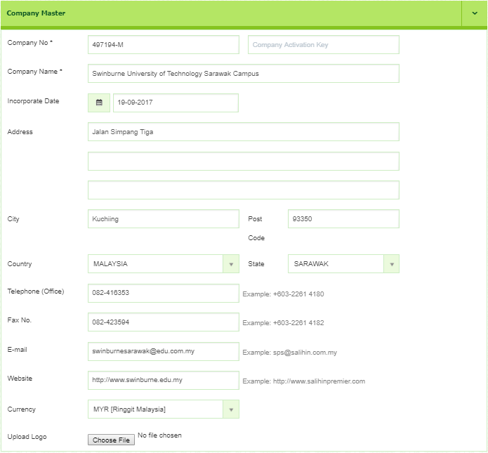
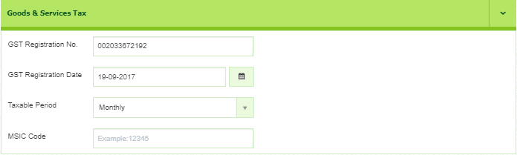
Example of Company Setup screen.

- GST Setup
  - Tax Code Table
Key Data Elements |  |  | Description
TaxCodeTable | TaxCodeDetails | TaxCode | Tax code for lookup in tables
TaxCodeTable | TaxCodeDetails | TaxPercentage | Tax percentage
TaxCodeTable | TaxCodeDetails | Description | Description of tax code

  - Example Tax Code used by Swinburne
Tax Code | Tax Rate | Description
SR | 6% | Standard-rated supplies with GST charged.
ZRL | 0% | Local supply of goods or services which are subject to zero rated supplies.
OS | 0% | Out-of-scope supplies under GST legislations.
ES | 0% | Exempt supplies under GST legislations.
NS | 0% | Matters to be treated as neither a supply of goods nor a supply of services, and no GST chargeable.
*** Tax rate must be editable and the system should allow user to add new tax code

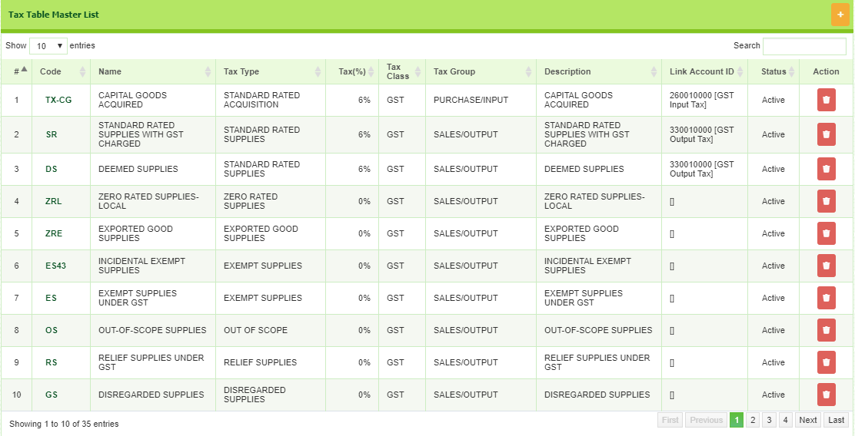
Example of GST Code List screen.

- Job Code Setup

  - Job Code Information
Key Data Elements | Description
Job Code | Job code for lookup in table
Item | Description of job code

- Item / Transction Code Setup

  - Item / Transaction Code Information
Existing Key Data Elements | New Name | Description
Code | Account Code | Chart of Account code
Description | Account Name | Chart of Account name

Add New Key Data Elements | Description
Job Code | Job code for lookup in table  *Based on Job Code Setup
Item | Description of job code
GST Setup | Tax code
Tax Rate | Tax rate based on the tax code used

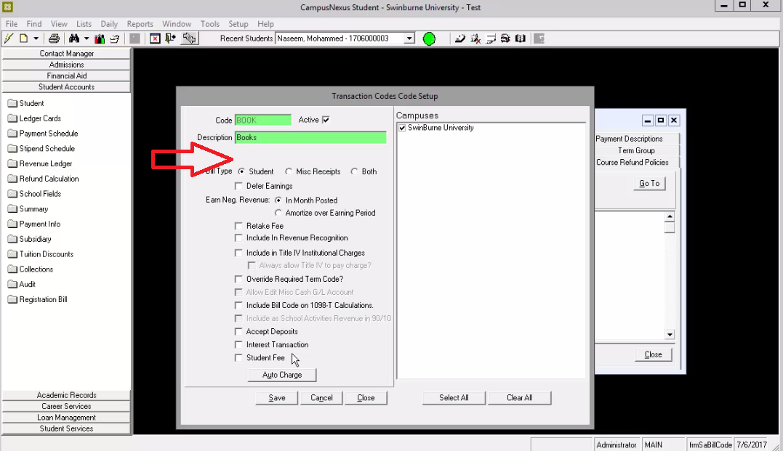
To setup Chart of Account, all new key data elements for chart of account information must be added on this screen
(List > Student Account > Transaction Codes > Add / Edit).
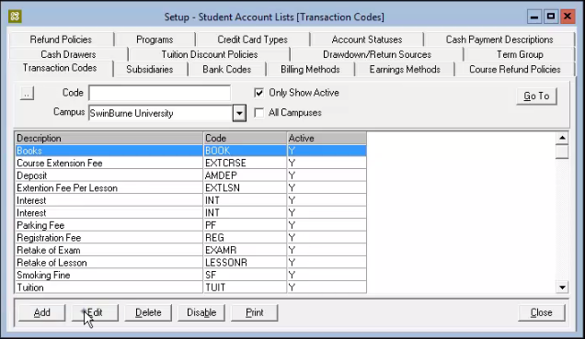
Old Transaction Codes

Example of New Transaction Code List Table :-
Account Code | Account Name | Job Code | Item | GST Code | Tax Rate
8-1300 | Graduation Ceremony | P0063 | -Bachelor gown | SR | 6%
8-1300 | Graduation Ceremony | P0063 | -Deposit | OS | 0%

GST for each Account Code will be setup on this screen. User need to fill in the GST Code and the Tax Rate for each Account Code.

- Customer / Student Setup

  - Student Information
Key Data Elements | Description
Customer ID** | Unique code for customer / student
Customer Name** | Customer / Student Name
Customer BRN | Business Registration Number of customer (if any)
Date GST Status Verified | Date GST status last checked (if any)
Customer GST No | GST Registration Number of customer (if any)
Customer Billing Address** | - Line 1  - Line 2  - Line 3  - City  - Postal Code  - State  - Country
Telephone | Customer / Student contact no.
Fax | Customer / Student fax no.
Email | Customer / Student email
Website | Customer / Student website (if any)
** must be appeared on payment receipts.

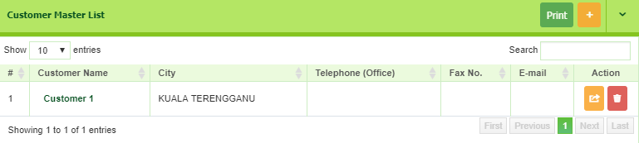
Example of Customer List Screen

TRANSACTION

GST Elements in Accounting System
Key Data Elements | Description
Tax Invoice | Words of Tax Invoice Appeared on the right top of the document
Debit Note | Words of Credit Note Appeared on the right top of the document
Credit Note | Words of Credit Note Appeared on the right top of the document
Form No | Each transaction creates must produce the form number
GST Code (%) | Each transaction creates must be labeled with the selected GST Code
GST Amount | Each transaction creates must show the GST Amount
Amount included GST | Each transaction creates must show the total amount included GST tax

6. Student Ledger Card
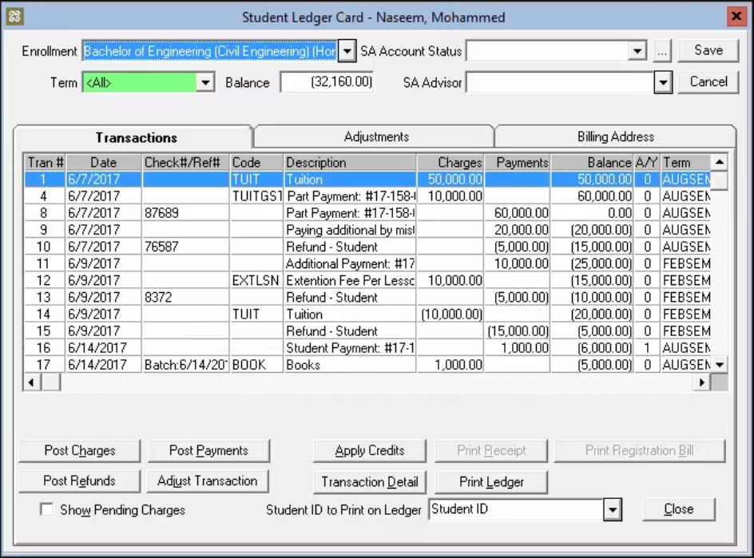
Credit Note
5
4
3
2
1
6.1 Requirement of changes
No. | Button | Table | Process | Description
1 | Post Charges |  | Invoice | When Post Button Charges are clicked, 2 boxes will appear either to create new invoice or debit note
1 | Post Charges |  | Debit Note
2 |  | Transactions | Account Code | In the transaction table, these 2 columns must be added to ease user to check.
2 |  | Transactions | Account Name
3 |  | Transaction Description | Print Transaction | Each transaction can be view and print by individually by clicking the description of the transaction.
4 | Post Refund  Credit Note Transaction |  | Post Refund | Post Refund button change to Credit Note Transaction and when a Credit Note Transaction is clicked, 2 boxes will appear either to Post Refund or Tuition Discount
4 | Post Refund  Credit Note Transaction |  | Tuition Discount
5 |  | Transactions | Auto-fill Form Number | Add a column to list all the transaction form number (Running number)
6.2 Transaction list on Ledger Card
Trans # | Date | Form No.  5  2  2  3 | Account Name | Account Code | Description | Charges | Payments | Balance | A/Y | Term
1 | 6/7/2017 | T.Inv001 | Ancillary Fee | 8-0300 | Books | 350 |  | 50 | 0 | AUGSEM
2 | 6/7/2017 | T.Inv002 | Ancillary Fee | 8-0300 | Academic Fee | 5000 |  | 1500 | 0 | AUGSEM
3 | 6/7/2017 | PP001 | Processing Fee | 4-8400 | Part Payment |  | 300 | 0.00 | 0 | AUGSEM
4 | 6/7/2017 | REF001 | Processing Fee | 4-8400 | Part Payment |  | 3500 | 0.00 | 0 | AUGSEM
5 | 6/7/2017 | DIS001 | A055 Business | 4-1100 | Tuition Discount | 500 |  | 0.00 | 0 | AUGSEM

7. Post Charges

Please Select
Tax Invoice
Debit Note

When user click Post Charges button, above message box will appear and user need to choose either to create Tax Invoice or Debit Note.
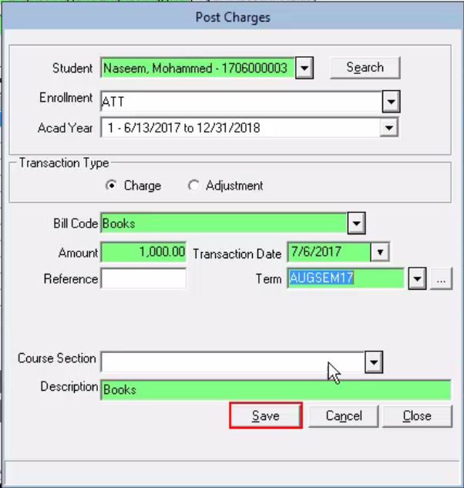
T1707-16
SR
30,952.00
Form No
GST Code
GST Amount
2
3
5
Amount Included GST
4
1,752.00

Debit Note
7.1 Additional requirements
No. | Key Data Elements | Description
1 | Tax Invoice | Words of Tax Invoice Appeared on the right top of the document
2 | Auto-fill Form Number | Each transaction creates must be produce the form number (Running number)
3 | GST Code (%) | Each transaction creates must be labeled with selected GST Code
4 | GST Amount | Each transaction creates must show the GST Amount
5 | Amount included GST | Each transaction creates must show the total amount included GST tax

7.2 Transaction list on Ledger Card
Trans # | Date | Form No. | Account Name | Account Code | Description | Charges | Payments | Balance | A/Y | Term
1 | 6/7/2017 | T.Inv001 | Ancillary Fee | 8-0300 | Books | 350 |  | 50 | 0 | AUGSEM
2 | 6/7/2017 | T.Inv002 | Ancillary Fee | 8-0300 | Academic Fee | 5000 |  | 1500 | 0 | AUGSEM
3 | 6/7/2017 | PP001 | Processing Fee | 4-8400 | Part Payment |  | 300 | 0.00 | 0 | AUGSEM
4 | 6/7/2017 | REF001 | Processing Fee | 4-8400 | Part Payment |  | 3500 | 0.00 | 0 | AUGSEM
5 | 6/7/2017 | DIS001 | A055 Business | 4-1100 | Tuition Discount | 500 |  | 0.00 | 0 | AUGSEM
6 | 18/7/2017 | T1707-16  Each time user clicks here, it will display the invoice to be viewed or print. | Professional Accounting Course | 4-5206 | ACCA Tuition | 30952 |  | 30952 | 0 | AUGSEM

7.3 Example of Complete Tax Invoice
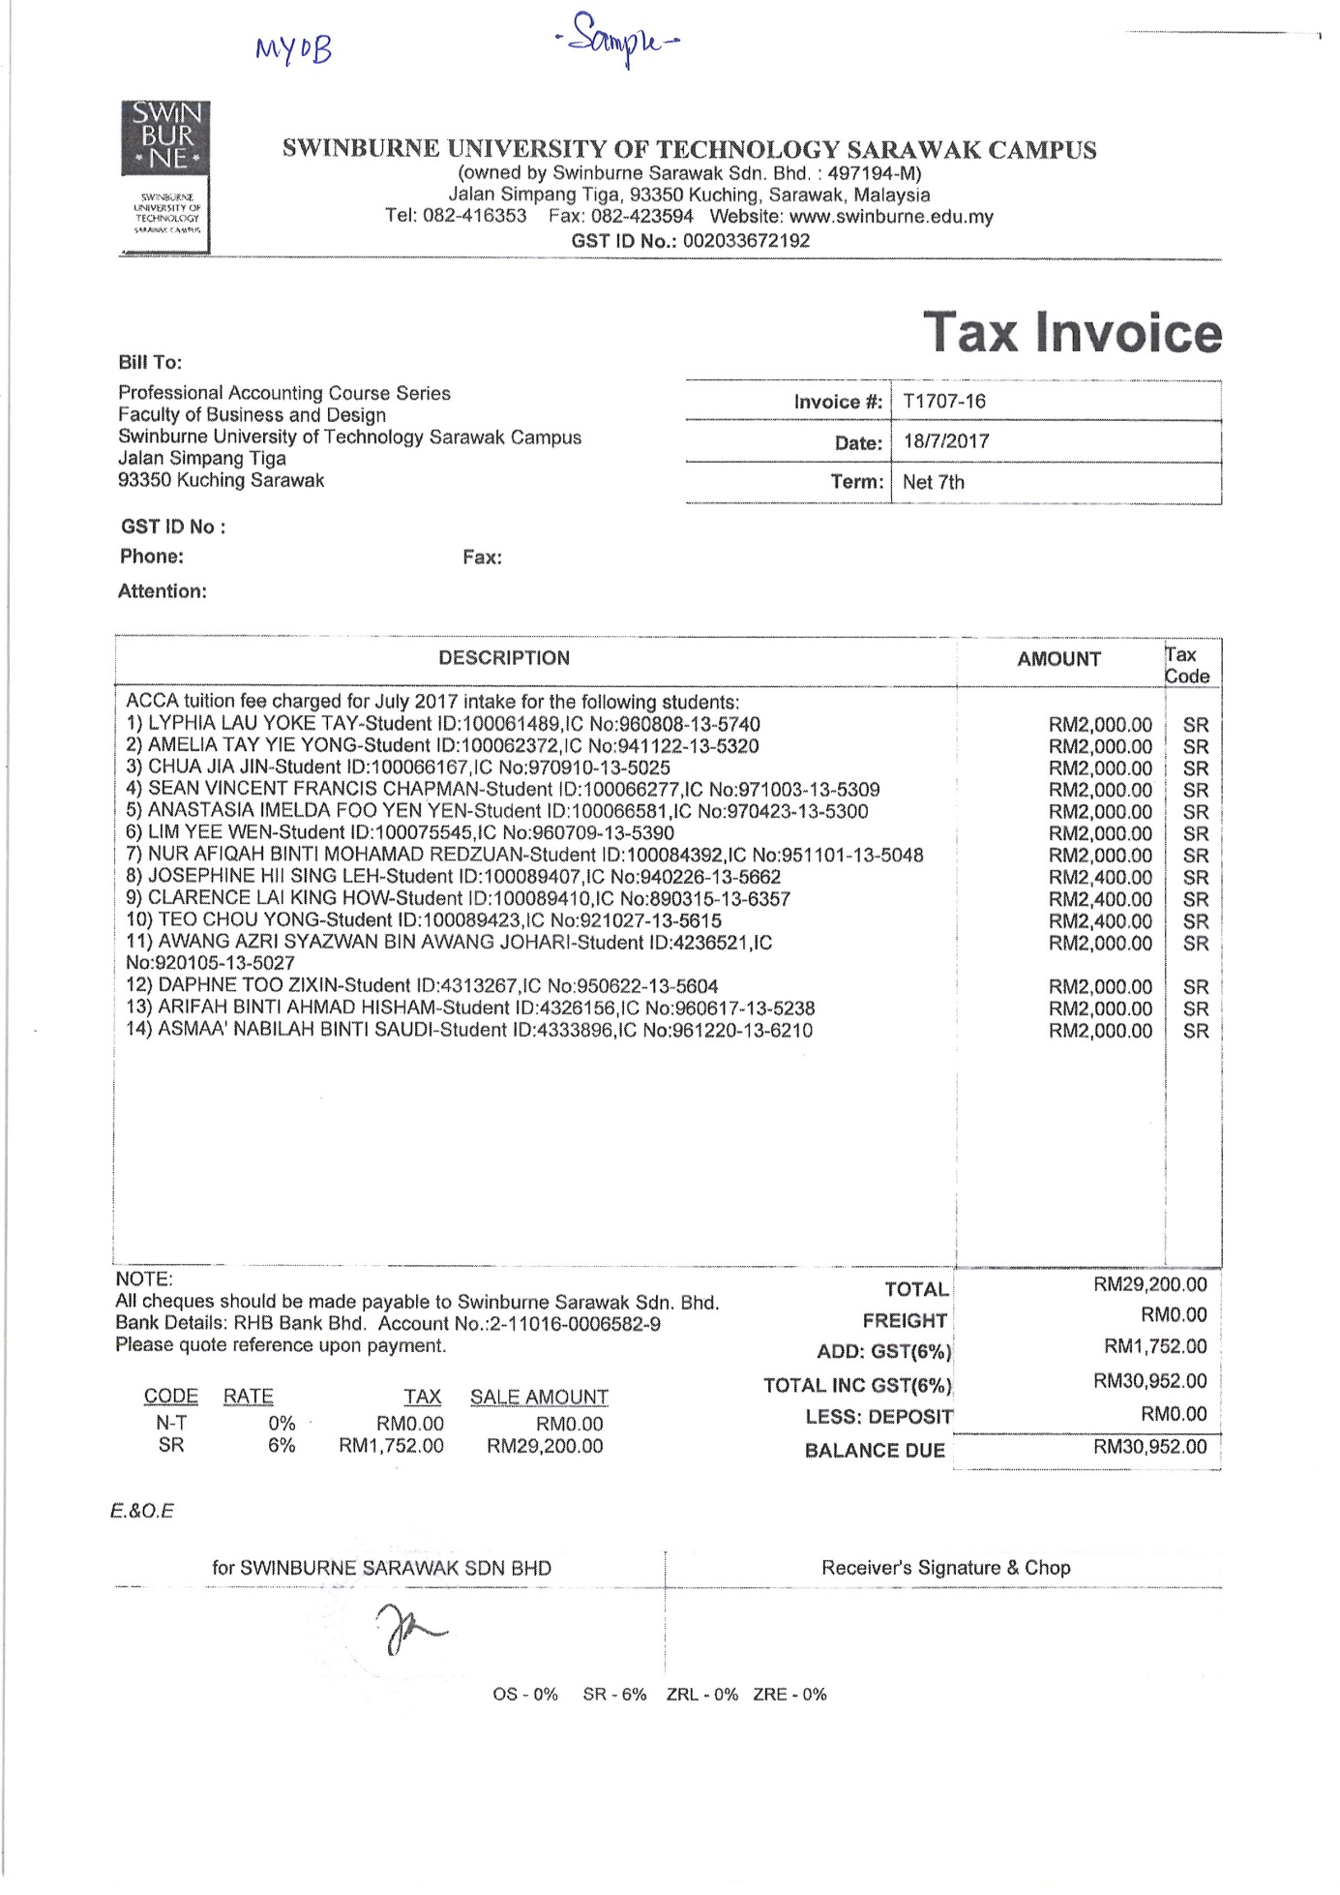

8. Post Charges (Debit Note)
Tax Invoice
Debit Note

When user click Post Charges button, above message box will appear and user need to choose either to create Tax Invoice or Debit Note.
Debit Note created
Comment
DN06/001
OS
18378.95
Form No
GST Code
GST Amount
2
3
5
Amount Included GST
4
0.00
6
7
8
Tax Invoice List
Debit Note
TINV000100
8.1 Additional requirements
No. | Key Data Elements | Description
1 | Debit Note | Words of Tax Invoice Appeared on the right top of the document
2 | Auto-fill Form Number | Each transaction creates must produce the form number (Running number)
3 | GST Code (%) | Each transaction creates must be labeled with the selected GST Code
4 | GST Amount | Each transaction creates must show the GST Amount
5 | Amount included GST | Each transaction creates must show the total amount included GST tax
6 | Debit Note Radio Button | This button has to be ticked to create the Debit Note, if not, it will be considered as New Tax Invoice.
7 | Tax Invoice List | This box will be enable once Debit Note has been ticked.
8 | Comment | Any comment or reason of the Debit Note has to be recorded in this space.

8.2 Transaction list on Ledger Card
Trains # | Date | Form No. | Account Name | Account Code | Description | Charges | Payments | Balance | A/Y | Term
1 | 6/7/2017 | T.Inv001 | Ancillary Fee | 8-0300 | Books | 350 |  | 50 | 0 | AUGSEM
2 | 6/7/2017 | T.Inv002 | Ancillary Fee | 8-0300 | Academic Fee | 5000 |  | 1500 | 0 | AUGSEM
3 | 6/7/2017 | PP001 | Processing Fee | 4-8400 | Part Payment |  | 300 | 0.00 | 0 | AUGSEM
4 | 6/7/2017 | REF001 | Processing Fee | 4-8400 | Part Payment |  | 3500 | 0.00 | 0 | AUGSEM
5 | 6/7/2017 | DIS001 | A055 Business | 4-1100 | Tuition Discount | 500 |  | 0.00 | 0 | AUGSEM
6 | 18/7/2017 | T1707-16 | Professional Accounting Course | 4-5206 | ACCA Tuition | 30952 |  | 30952 | 0 | AUGSEM
7 | 20/6/2017 | DN06/001  Each time user clicks here, it will display the Debit Note to be viewed or print. | Short Courses | 4-5200 | Overpayment | 18378.95 |  | 18378.95 | 0 | AUGSEM

8.3 Example of Complete Tax Invoice
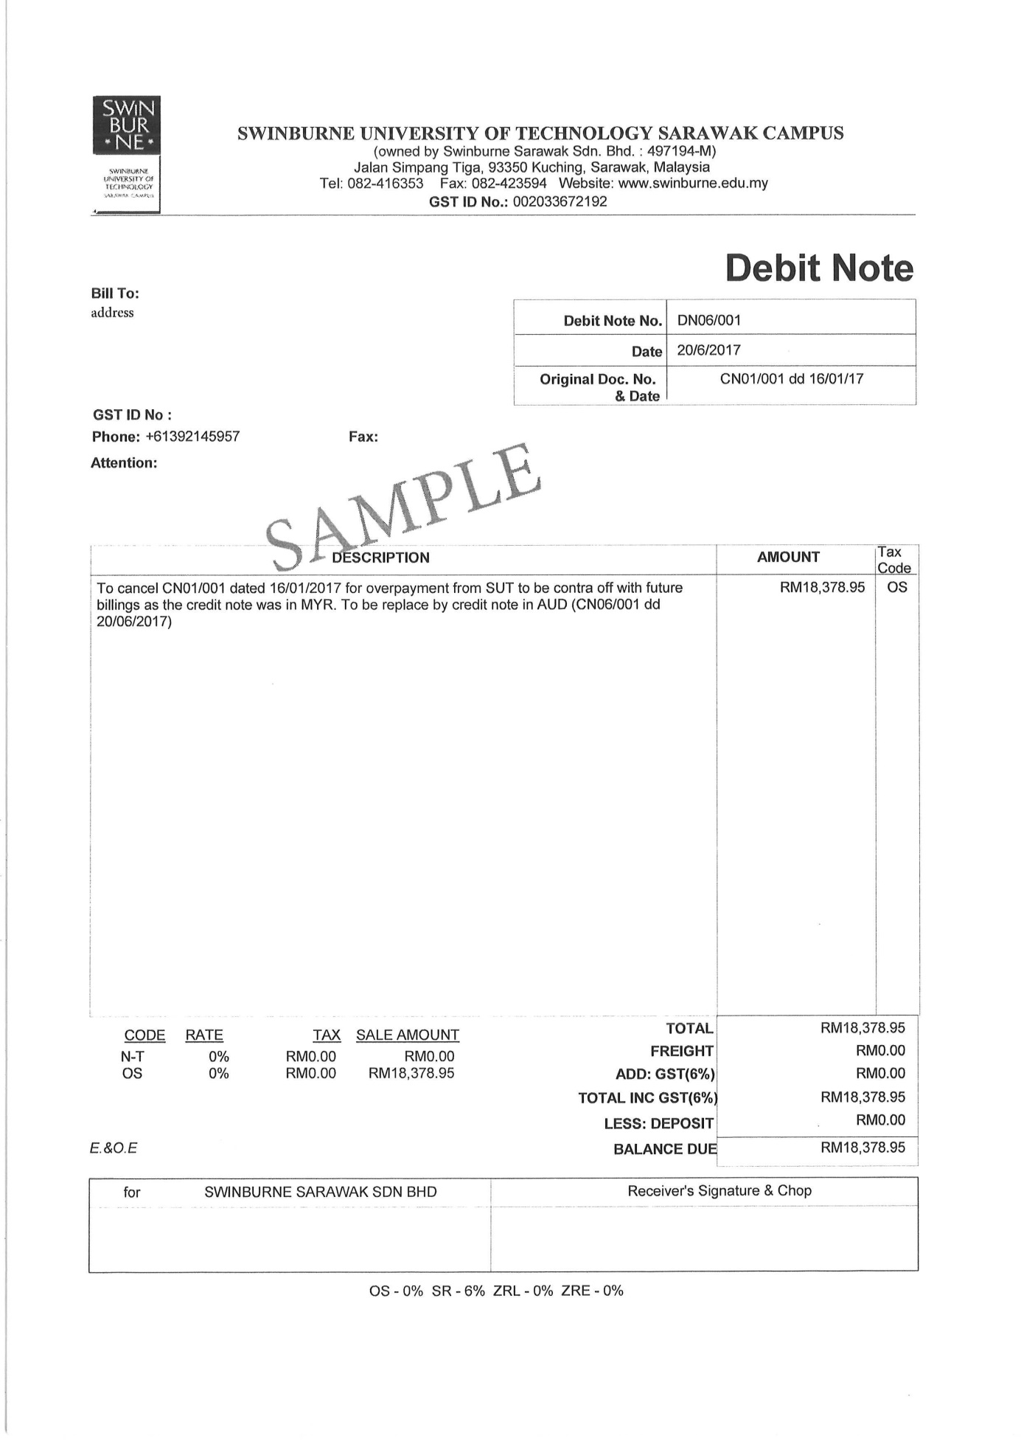

9. Adjustment Transaction
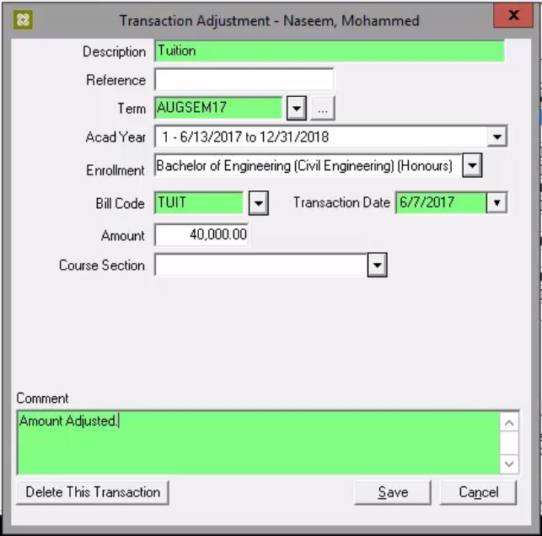
T1707-16
SR
28,832.00
Form No
GST Code
GST Amount
2
3
5
Amount Included GST
4
1,632.00

9.1 Additional requirements
No. | Key Data Elements | Description
1 | Tax Invoice / Debit Note / Credit Note | Words of Tax Invoice / Debit Note / Credit Note appeared on the right top of the document
2 | Auto-fill Form Number | Each transaction creates must be produce the form number (Running number)
3 | GST Code (%) | Each transaction creates must be labeled with selected GST Code
4 | GST Amount | Each transaction creates must show the GST Amount
5 | Amount included GST | Each transaction creates must show the total amount included GST tax

9.2 Transaction list in Ledger Card
Trans # | Date | Form No. | Account Name | Account Code | Description | Charges | Payments | Balance | A/Y | Term
1 | 6/7/2017 | T.Inv001 | Ancillary Fee | 8-0300 | Books | 350 |  | 50 | 0 | AUGSEM
2 | 6/7/2017 | T.Inv002 | Ancillary Fee | 8-0300 | Academic Fee | 5000 |  | 1500 | 0 | AUGSEM
3 | 6/7/2017 | PP001 | Processing Fee | 4-8400 | Part Payment |  | 300 | 0.00 | 0 | AUGSEM
4 | 6/7/2017 | REF001 | Processing Fee | 4-8400 | Part Payment |  | 3500 | 0.00 | 0 | AUGSEM
5 | 6/7/2017 | DIS001 | A055 Business | 4-1100 | Tuition Discount | 500 |  | 0.00 | 0 | AUGSEM
6 | 18/7/2017  Each time user clicks here, it will display the Adjustment Transaction to be viewed or print. | T1707-16 | Professional Accounting Course | 4-5206 | ACCA Tuition | 28,832 |  | 28,832 | 0 | AUGSEM
7 | 20/6/2017 | CN01/001 dd 16/01/17 | Short Courses | 4-5200 | Overpayment | 18378.95 |  | 18378.95 | 0 | AUGSEM

9.3 Example of Complete Tax Invoice
28,832.00
28,832.00
27,200.00
27,200.00
1,632.00
1,632.00

10. Post Refunds
Post Refund
Students Tuition Discounts

When user click Credit Note button, above message box will appear and user need to choose either to create Post Refund or Students Tuition Discounts.

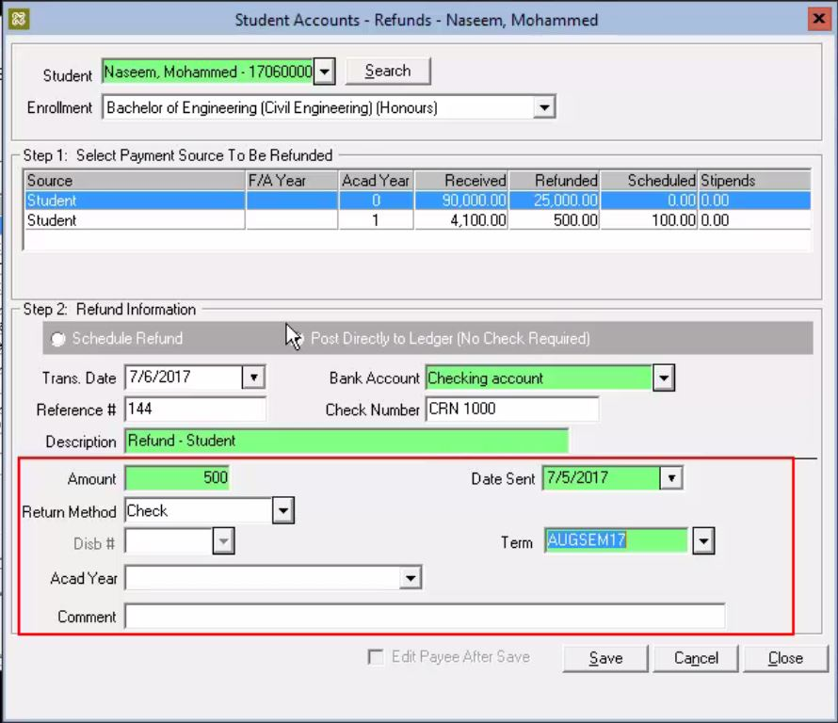
Amount Included GST
3
4
5
2
6
GST Amount
GST Code
1,886.79
113.21
SR
Form No
TCN08/04
Tax Invoice List
TINV000100

10.1 Additional requirements
No. | Key Data Elements | Description
1 | Credit Note | Words of Credit Note Appeared on the right top of the document
2 | Auto-fill Form Number | Each transaction creates must produce the form number (Running number)
3 | GST Code (%) | Each transaction creates must be labeled with the selected GST Code
4 | GST Amount | Each transaction creates must show the GST Amount
5 | Amount included GST | Each transaction creates must show the total amount included GST tax
6 | Tax Invoice List | One invoice must be selected in order to create the Credit Note

10.2 Transaction list on Ledger Card
Trans # | Date | Form No. | Account Name | Account Code | Description | Charges | Payments | Balance | A/Y | Term
1 | 6/7/2017 | T.Inv001 | Ancillary Fee | 8-0300 | Books | 350 |  | 50 | 0 | AUGSEM
2 | 6/7/2017 | T.Inv002 | Ancillary Fee | 8-0300 | Academic Fee | 5000 |  | 1500 | 0 | AUGSEM
3 | 6/7/2017 | PP001 | Processing Fee | 4-8400 | Part Payment |  | 300 | 0.00 | 0 | AUGSEM
4 | 6/7/2017 | REF001 | Processing Fee | 4-8400 | Part Payment |  | 3500 | 0.00 | 0 | AUGSEM
5 | 6/7/2017 | DIS001 | A055 Business | 4-1100 | Tuition Discount | 500 |  | 0.00 | 0 | AUGSEM
6 | 18/7/2017 | T1707-16 | Professional Accounting Course | 4-5206 | ACCA Tuition | 30952 |  | 30952 | 0 | AUGSEM
7 | 20/6/2017 | DN06/001 | Short Courses | 4-5200 | Overpayment | 18378.95 |  | 18378.95 | 0 | AUGSEM
8 | 4/8/2017 | TCN08/04  Each time user clicks here, it will display the Credit Note to be viewed or print. | A046 Business - IS | 4-1101 | Cancellation of Training | 1886.79 |  | 0 | 0 | AUGSEM

10.3 Example of Complete Tax Invoice
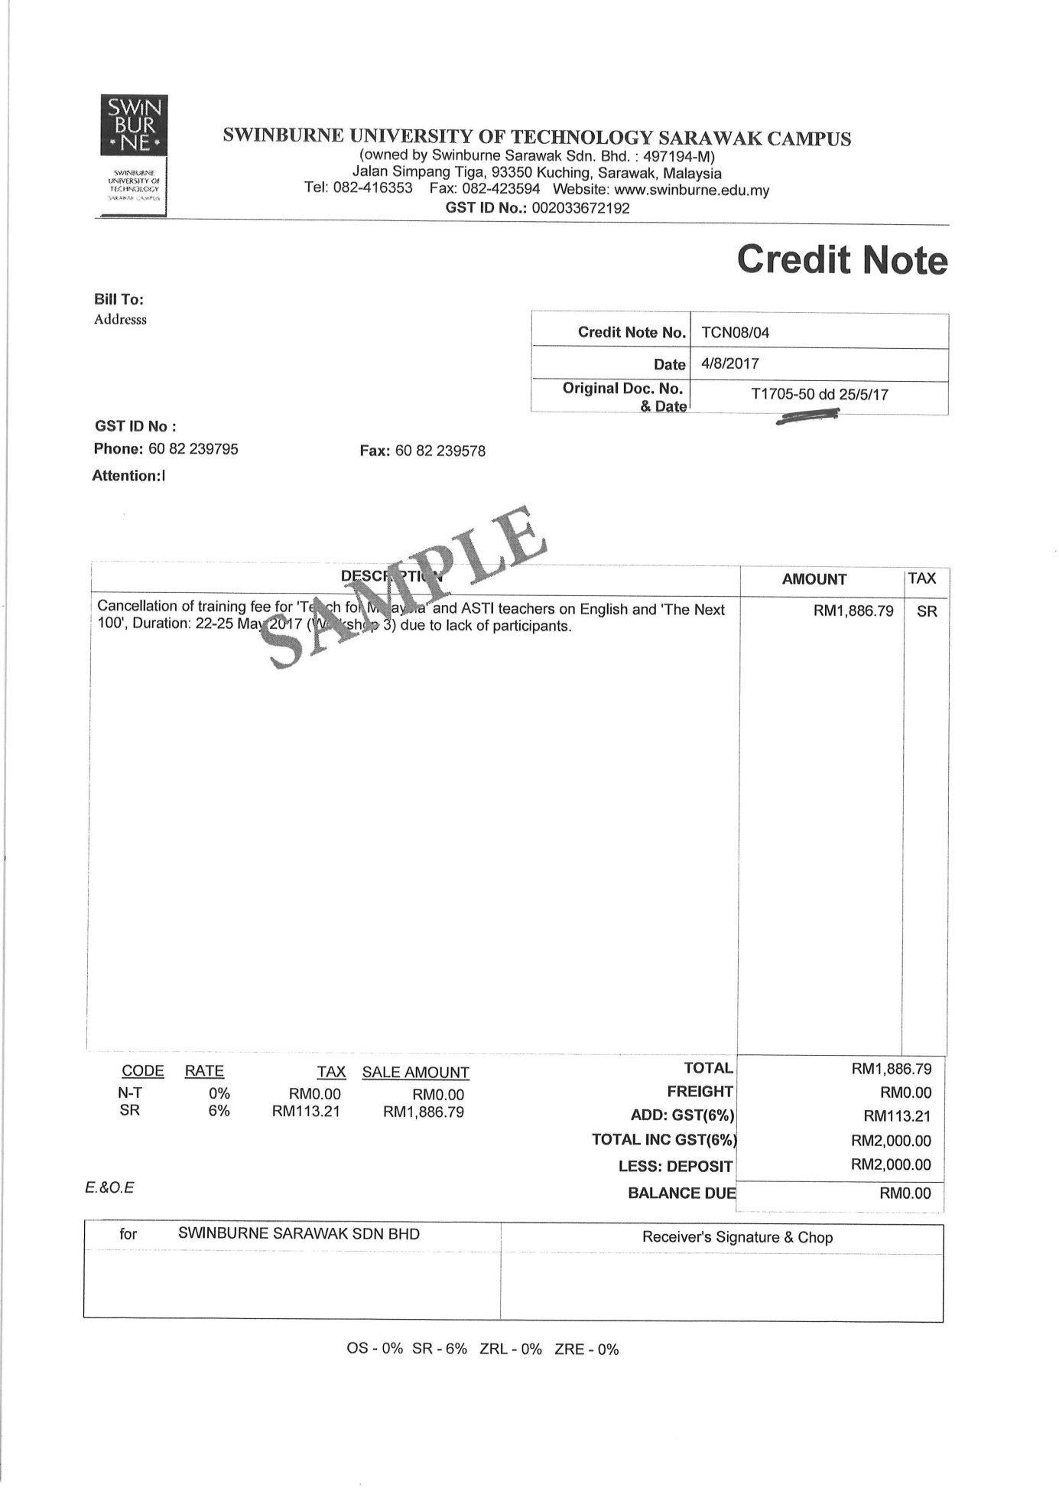

11. Students Tuition Discounts

Post Refund
Students Tuition Discounts

When user click Credit Note button, above message box will appear and user need to choose either to create Post Refund or Students Tuition Discounts.

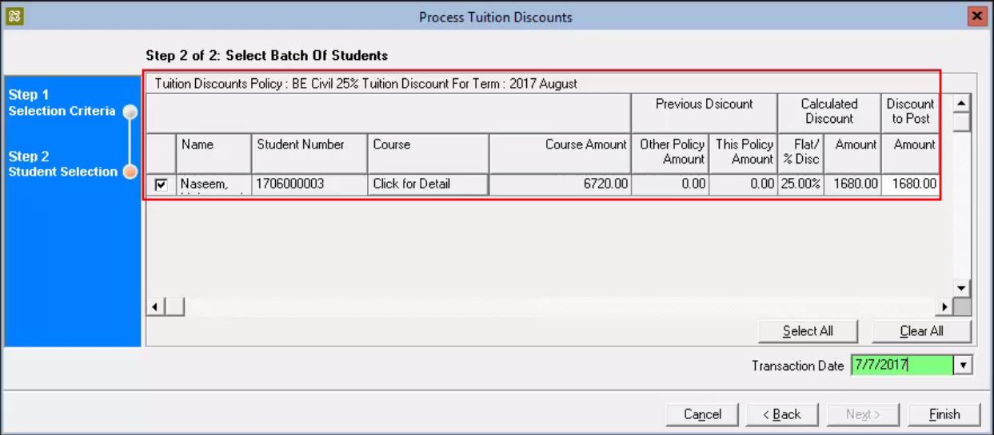
2  3  4  5 |  |  |  |  |  |  | Previous Discount |  | Calculated Discount |  |  |  | Discount To Post
No. | Form No. | Invoice No | Name | Student Number | Course | Course Amount | Other Policy Discount | This Policy Amount | Flat/% Disc | Tax Code | Tax Amount | Amount Included GST | Amount
1 | DCN08/05 | TCN08/05 | Naseem | 1706000003 |  | 6720.00 | 0.00 | 0.00 | 25.00% | EX | 0.00 | 1680.00 | 1680.00
2 |  |  |  |  |  |  |  |  |  |  |  | 6
Step 2 of 2: Select Batch Of Students

11.1 Additional requirements
No. | Key Data Elements | Description
1 | Credit Note | Words of Credit Note Appeared on the right top of the document
2 | Auto-fill Form Number | Each transaction creates must be produce the form number (Running number)
3 | Invoice Number | Each refund to be made, user has to select the invoice they want to refund
4 | GST Code (%) | Each transaction creates must be labeled with selected GST Code
5 | GST Amount | Each transaction creates must show the GST Amount
6 | Amount included GST | Each transaction creates must show the total amount included GST tax

11.2 Transaction list on Ledger Card
Trans # | Date | Form No. | Account Name | Account Code | Description | Charges | Payments | Balance | A/Y | Term
1 | 6/7/2017 | T.Inv001 | Ancillary Fee | 8-0300 | Books | 350 |  | 50 | 0 | AUGSEM
2 | 6/7/2017 | T.Inv002 | Ancillary Fee | 8-0300 | Academic Fee | 5000 |  | 1500 | 0 | AUGSEM
3 | 6/7/2017 | PP001 | Processing Fee | 4-8400 | Part Payment |  | 300 | 0.00 | 0 | AUGSEM
4 | 6/7/2017 | REF001 | Processing Fee | 4-8400 | Part Payment |  | 3500 | 0.00 | 0 | AUGSEM
5 | 6/7/2017 | DIS001 | A055 Business | 4-1100 | Tuition Discount | 500 |  | 0.00 | 0 | AUGSEM
6 | 18/7/2017 | T1707-16 | Professional Accounting Course | 4-5206 | ACCA Tuition | 30952 |  | 30952 | 0 | AUGSEM
7 | 20/6/2017 | DN06/001 | Short Courses | 4-5200 | Overpayment | 18378.95 |  | 18378.95 | 0 | AUGSEM
8 | 4/8/2017 | TCN08/04 | A046 Business - IS | 4-1101 | Cancellation of Training | 1886.79 |  | 0 | 0 | AUGSEM
9 | 5/8/2017 | TCN08/05 | A046 Business - IS | 4-1101 | Cancellation of Training | 2012.89 |  | 0 | 0 | AUGSEM
Each time user clicks here, it will display the Crebit Note to be viewed or print.

11.3 Example of Complete Tax Invoice
1,680.00
0.00
0.00
0.00
EX
1,680.00
1,680.00
1,680.00
5
5

STUDENT PORTAL

Student portal is a platform that only can be access by registered student of Swinburne. Student can easily access and view the information needed. In this section student can: -
- Check student mailbox (E-mail)
- Register semester subject
- Access online classroom
- Manage student enrolment
- Student Statement

- STUDENT STATEMENT
We are recommended on improvements of student summary statement section. Sample new screen layout as below: -

- Sample New Screen Layout
The screen below a sample of new main screen for student statement. We recommend
to create a sorting button that will make easier for student to sort/search transaction history by date.
STUDENT STATEMENT
PRINT

Date From
Date To

Transaction Date | Account Name | Form Number | Amount | Balance
1/1/2017 | Invoice | R205925 | (RM1,000.00) | RM12,440.00
1/1/2017 | Payment |  | (RM3,360.00) | RM8,580.00
8/1/2017 | Credit Note | TCN08/04
1/1/2017 | Debit Note | DN05/001

2.0 Field Description
BIL | Field | Description
1 | Account Name | It will be referred to the account name. Click the link to see details.
2 | Form Number | This will be generated automatically. Basically, it will be as a Reference Number.
3 | Amount | Payment is charged to the student according to semester subject
4 | Balance | The remaining balance will be displayed
Once submitted, all the listing on the selected date will be listed. Too see the details, student need to click the link of account name. Once click, it will be direct to the details pages.

From the details page, you can simply click the button to print or save the details.
Transaction Date | Account Name | Form Number | Amount | Balance
1/1/2017 | Invoice | R205925 | (RM1,000.00) | RM12,440.00
1/1/2017 | Invoice 2
1/1/2017 | Invoice 3
1/1/2017 | Payment |  | (RM3,360.00) | RM8,580.00
1/1/2017 | Credit Note | TCN08/04
1/1/2017 | Debit Note | DN05/001

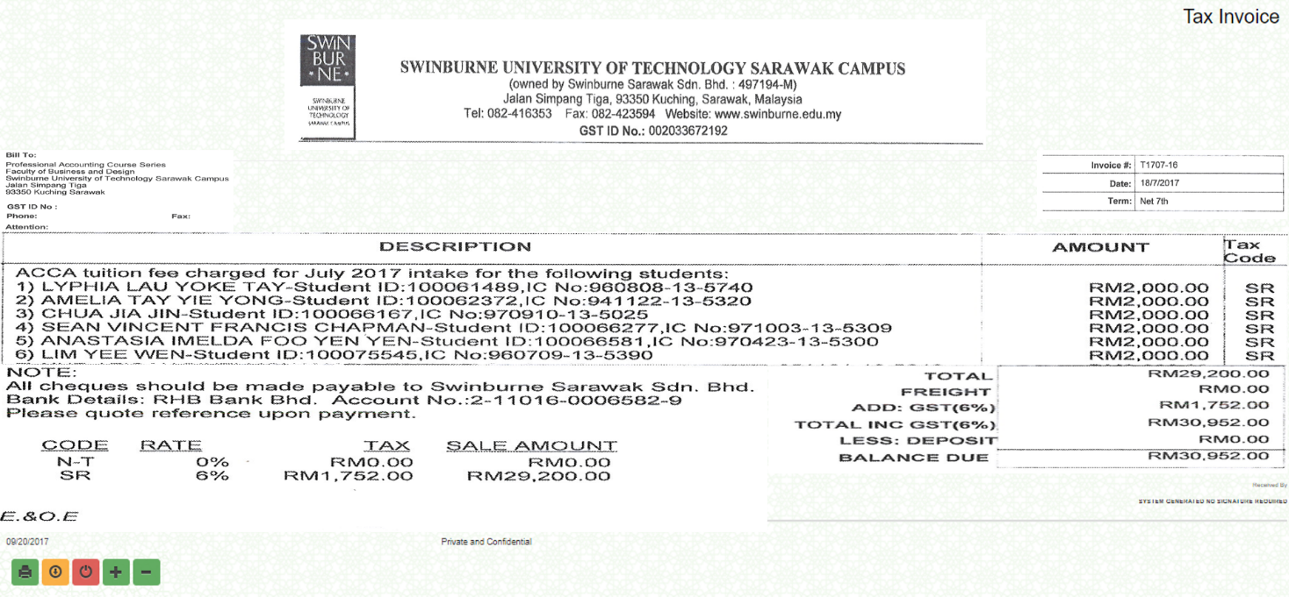
You can simply click the button to print or save report as PDF, Excel or CSV.

Sample : Tax Invoice
