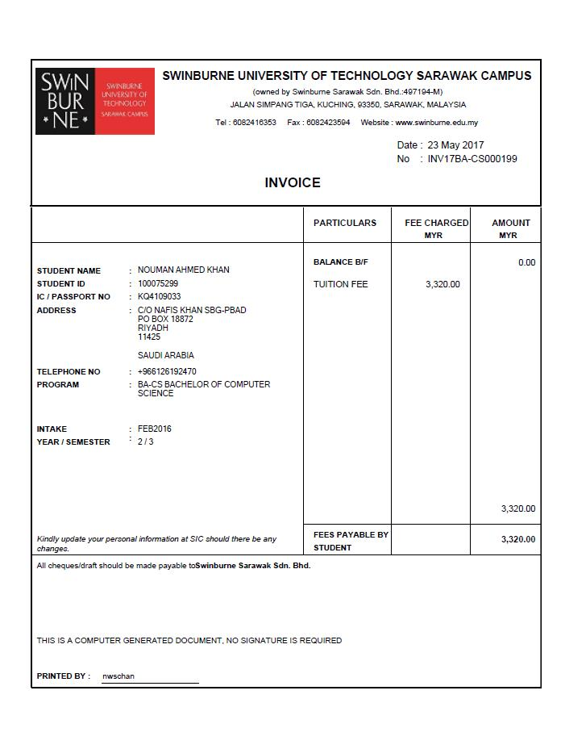
TAX INVOICE
FEES PAYABLE BY STUDENT

TUITION FEE
2,400.00
PARTICULARS
FEE CHARGED MYR
TAX CODE

Bhd.

SR

TOTAL

ADD: GST(6%)
144.00
TOTAL INC GST(6%)
2,544.00
LESS: DEPOSIT
0.00
CODE
SR
RATE
6%
TAX
MYR144.00
SALE AMOUNT
MYR2,400.00
MEMO:
GST ID NO. : 02033672192
TAXI NVOICE NO. : TI17BA-C000199
2,400.00

2,544.00

FEE CHARGED MYR
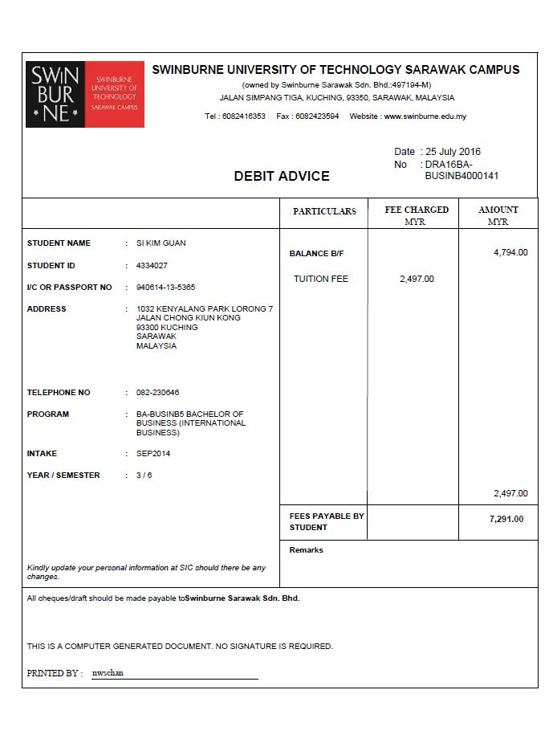
GST ID NO. : 02033672192
TAX INVOICE NO. : TDN17ACCA00001
TAX DEBIT NOTE

FEE CHARGED MYR
TAX CODE

TAX CODE
FEE CHARGED MYR
PARTICULARS
TUITION FEE-ADD SUBJECT
2,400.00
SR
CODE
RATE
TAX
SALE AMOUNT
ES
0%
RM0.00
RM2,497.00
MEMO:
TOTAL
ADD: GST(6%)
TOTAL INC GST(6%)
LESS: DEPOSIT
FEES PAYABLE BY STUDENT
2,544.00
144.00
0.00
2,400.00
2,544.00

CODE
EX
RATE
0%
TAX
RM0.00
SALE AMOUNT
RM3,320.00
MEMO:
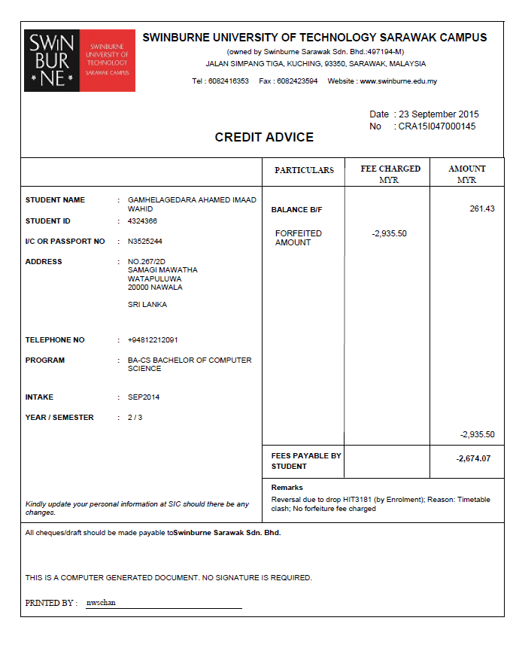

GST ID NO. : 02033672192
TAX CREDIT NOTE

FEE CHARGED MYR
TAX CODE

TAX CODE
FEE CHARGED MYR
PARTICULARS
TUITION FEE-DISCOUNT
1,200.00
SR
CODE
RATE
TAX
SALE AMOUNT
SR
6%
RM72.00
RM1,200.00
MEMO:
TOTAL
ADD: GST(6%)
TOTAL INC GST(6%)
LESS: DEPOSIT
FEES PAYABLE BY STUDENT
1,272.00
72.00
0.00
1,272.00
1,200.00
TAX INVOICE NO. : TCN17ACCA00001

MYR100.00
MYR0.00
0%
ZRL
736.00
FEES PAYABLE BY STUDENT

SOUVENIRS
600.00
PARTICULARS
FEE CHARGED MYR
TAX CODE

Bhd.

SR

TOTAL

ADD: GST(6%)
36.00
TOTAL INC GST(6%)
736.00
LESS: DEPOSIT
0.00
CODE
SR
RATE
6%
TAX
MYR144.00
SALE AMOUNT
MYR2,400.00
MEMO:
SALES OF TEXTBOOKS
ZRL
100.00
MISCELLANOUS INVOICE
700.00

GST ID NO. : 02033672192
TAXI NVOICE NO. : MTI000001

FEE CHARGED MYR
GST ID NO. : 02033672192
TAX INVOICE NO. : MDN00001
MISCELLANOUS DEBIT NOTE

FEE CHARGED MYR
TAX CODE

TAX CODE
FEE CHARGED MYR
PARTICULARS
SALES OF TEXTBOOKS – ADD TEXTBOOK
200.00
ZRL
CODE
RATE
TAX
SALE AMOUNT
ZRL
0%
RM0.00
RM200.00
MEMO:
TOTAL
ADD: GST(6%)
TOTAL INC GST(6%)
LESS: DEPOSIT
FEES PAYABLE BY STUDENT
200.00
0.00
0.00
200.00
200.00

CODE
EX
RATE
0%
TAX
RM0.00
SALE AMOUNT
RM3,320.00
MEMO:

GST ID NO. : 02033672192

FEE CHARGED MYR
TAX CODE

TAX CODE
FEE CHARGED MYR
PARTICULARS
RETURN OF SOUVENIRS
50.00
SR
CODE
RATE
TAX
SALE AMOUNT
SR
6%
RM3.00
RM50.00
MEMO:
TOTAL
ADD: GST(6%)
TOTAL INC GST(6%)
LESS: DEPOSIT
FEES PAYABLE BY STUDENT
53.00
3.00
0.00
53.00
50.00
TAX INVOICE NO. : MCN00001
MISCELLANOUS CREDIT NOTE

RM250.00
RM0.00
0%
ES
GST ID NO. : 02033672192
TAX INVOICE NO. : STI000001
SIMPLIFIED TAX INVOICE

FEE CHARGED MYR
TAX CODE

TAX CODE
FEE CHARGED MYR
PARTICULARS
GRADUATION FEE – EXTRA TICKET
100.00
SR
CODE
RATE
TAX
SALE AMOUNT
SR
6%
RM6.00
RM100.00
MEMO:
TOTAL
ADD: GST(6%)
TOTAL INC GST(6%)
LESS: DEPOSIT
FEES PAYABLE BY STUDENT
256.00
6.00
0.00
250.00
256.00
ES
250.00
GRADUATION FEE

CODE
EX
RATE
0%
TAX
RM0.00
SALE AMOUNT
RM3,320.00
MEMO:

