This section will guide you through the basic general setup for user, company, entrepreneurs and generate report. This guide restricted for administrative use only.

- HOW TO LOG IN TO SYSTEM

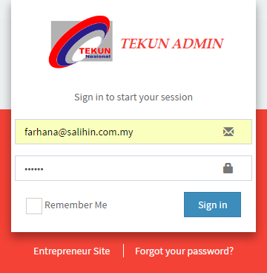

- Insert your full email address. (As shown in image)
- Insert your password.
- Click Sign In button. Then, you will be direct to the main page of the system.

- HOW TO SETTING UP USER
In this part, admin need to determine user for granted permission to access Admin Site or Salihin Site.

- Go to Setup > List User
- Click + button to add new user

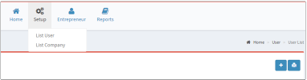

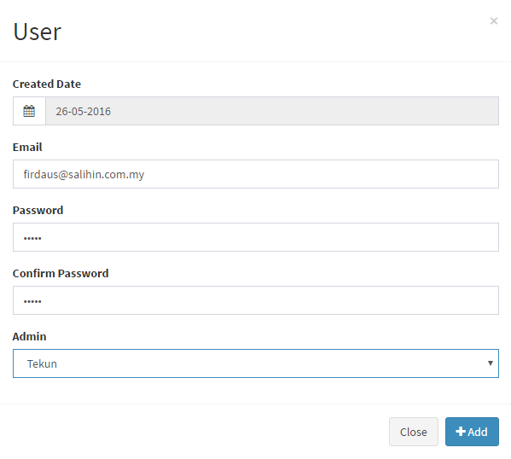
- Enter full e-mail address of user
- Enter the password. Re-enter the same password for confirmation
- Select option from the list for granted permission access.
- Once completed, click Add button to saved data.

2.0.1 HOW TO EDIT USER
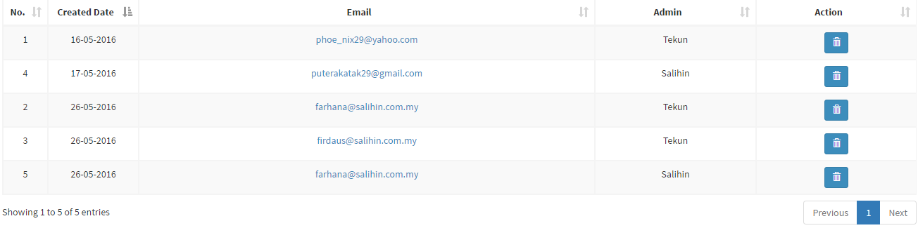
- Go to Setup > List User
- Click the link of selected email.
- Once click, you will direct to editing page.
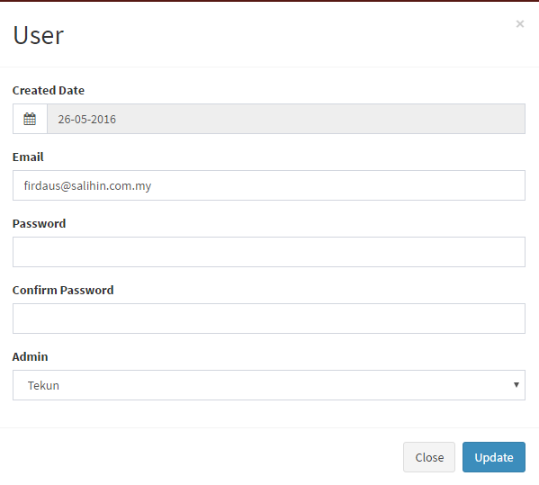
- Enter your new password. Re-enter password for confirmation.
- Select option from the drop-down list.
- Once completed, click Update button to saved data.

2.0.2 HOW TO DELETE USER
- Go to Setup > List User
- Select which user you want to deleted. Next, click the delete button.
- To proceed, you need to enter admin password
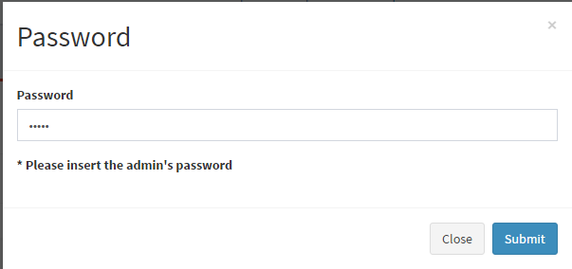

WARNING! YOU ARE NOT ALLOWED TO DELETE THE USER WITHOUT PERMISSION.
PLEASE CONTACT YOUR SUPER ADMIN.

- HOW TO SETTING UP COMPANY
- Go to Setup > List Company
- Click + button to add new user
- Once click, you will be direct to Add Company page
- Insert your company details.
- Once completed, click Submit button to saved data.

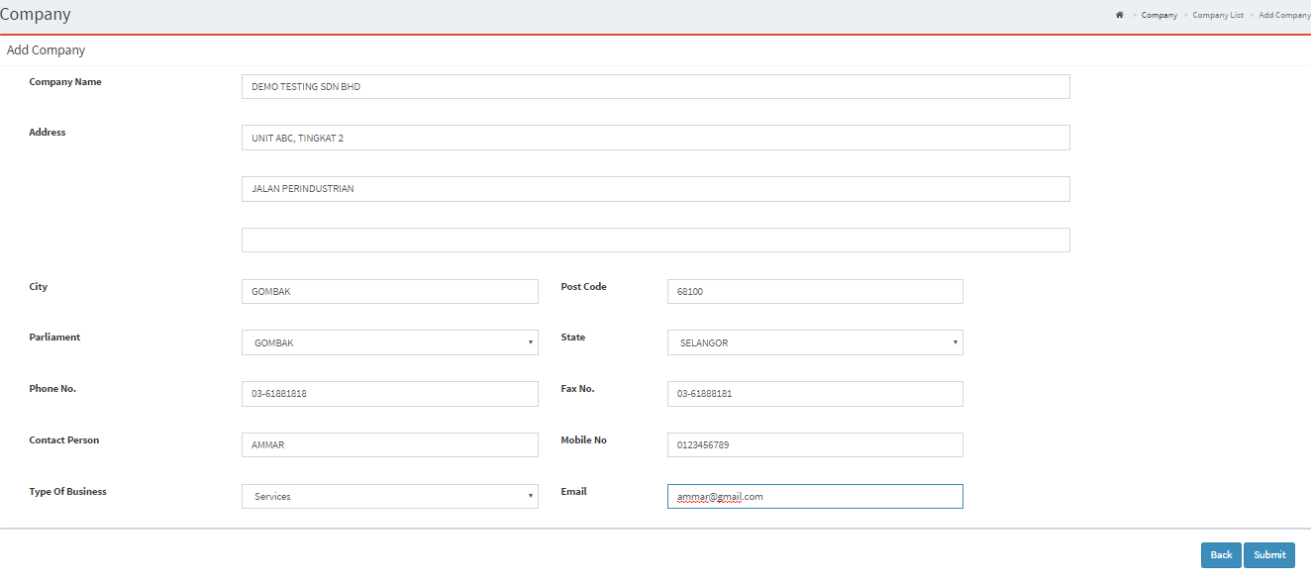

3.0.1 HOW TO EDIT COMPANY
- Go to Setup > List Company
- Click the selected company that need to re-edit.
- You will be direct to editing page.
- Once editing completed, click Update button to saved data.
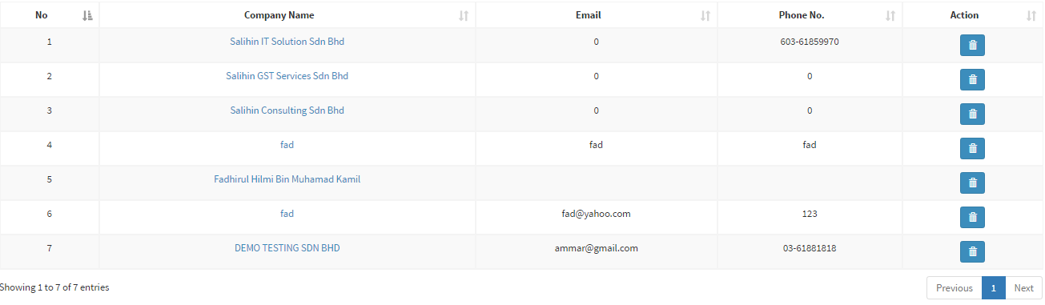
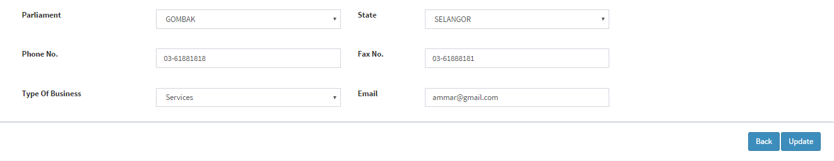

3.0.2 HOW TO DELETE COMPANY
- Go to Setup > List Company
- Select which company you want to deleted. Next, click the delete button.

4.0 HOW TO SETUP BANK
- Go to Setup > Bank
- Click the selected Account Name that need to re-edit.
- Insert Maybank as the bank account name.
- You will be direct to editing page
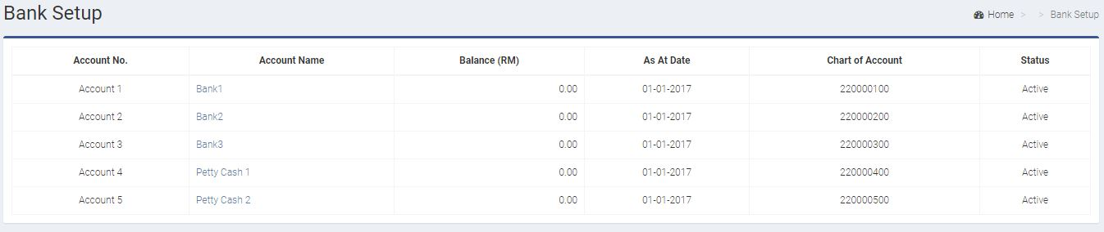
- Insert amount RM15000 in Balance (RM)
- Once editing completed, click Update button to saved data.
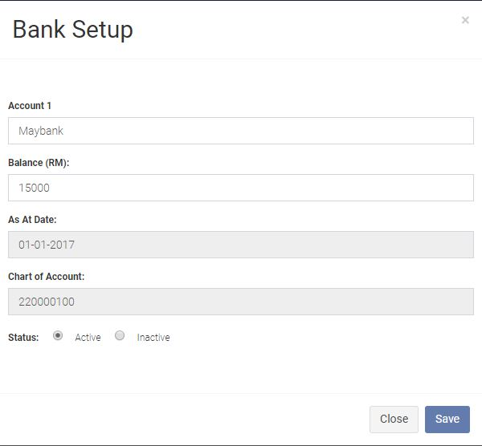

4.0.1 HOW TO DO BANK TRANSFER
- Go to General > Bank Transfer > Add New
- Date: 2/1/2017
- Transfer From: Maybank
- Transfer To: Petty Cash
- Amount: 1000
- Description: Cost 6/1/2017
- Click Save button once Bank Transfer confirm.
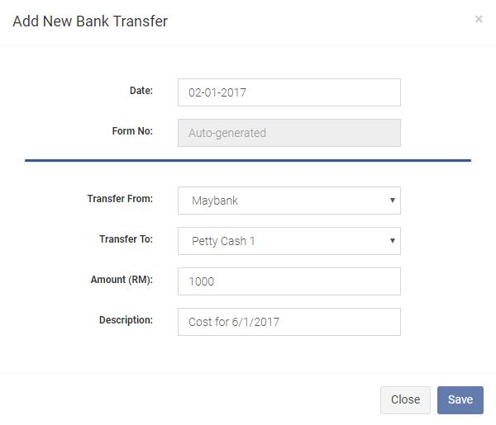
Then, try to do another money transfer using bank transfer module. The detail as follow:
Date: 9/1/2017
From: Maybank
To: Petty Cash 1
Amount: 900
Description: Cost for a banquet on 14/1/2017

5.0 HOW TO CREATE COST OF GOODS SOLD
- Go to Expenses > Cost of Goods Sold > Add New
- Key in all the information required in Add COGS as follow.
- Date: 3/1/2017
- Bank: Petty Cash1
- Pay To: Ah Leng Pasar Borong
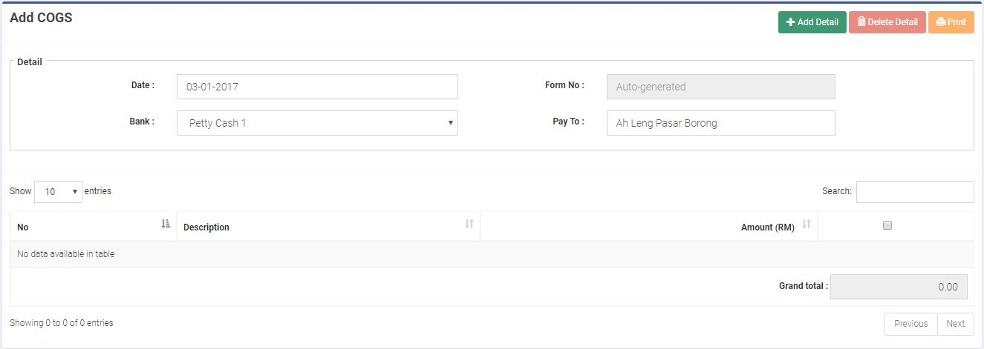
- Click Add Detail
- In Add New Cost of Goods Sold section, insert:
- Item Description: Ayam
- Amount: RM300
- Click Save button once details are confirm.
- Click Save button once again in the main page of the Add Sales.
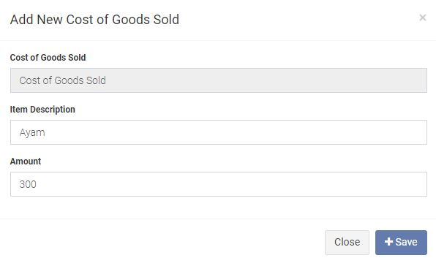

Then, try to do another cost of goods sold using cost of goods sold module. The detail as follow:
Date: 11/1/2017
Bank: Petty Cash 1
Pay To: NSK Selayang
Amount: 785
Description: 1. Beras RM200 2. Minyak RM50 3. Ayam RM400
4. Kacang RM20 5. Ikan Bilis RM20 6. Santan RM20
7. Garam RM5 8. Serbuk Kunyit RM10 9. Timun RM10
10. Telur RM50

6.0 HOW TO CREATE OPERATING EXPENSES
- Go to Expenses > Operating Expenses > Add New
- Key in all the information required in Add COGS as follow.
- Date: 3/1/2017
- Bank: Petty Cash
- Pay To: Travelling Expenses
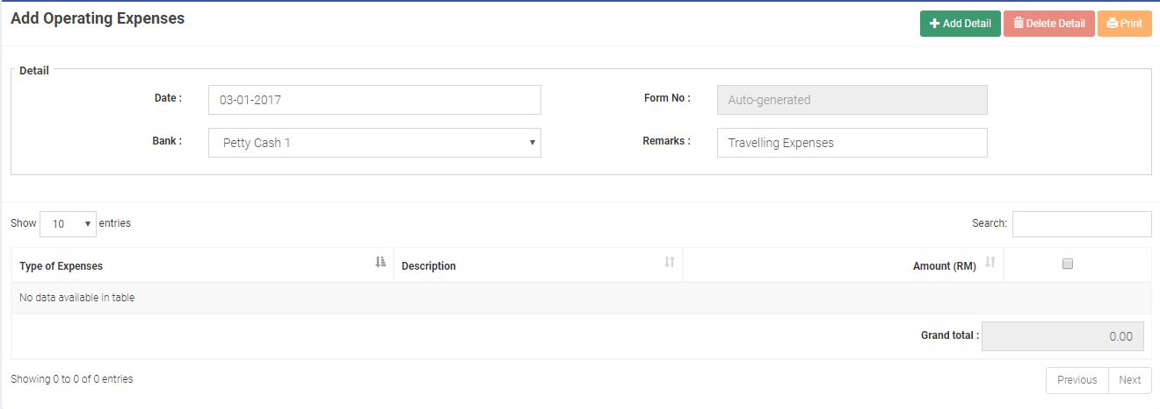
- Click Add Detail
- In Add New Operating Expenses section, insert:
- Type of Expenses: Petrol, Parking & Toll
- Item Description: Minyak
- Amount: RM50
- Click Save button once details are confirm.
- Click Save button once again in the main page of the Add Sales.
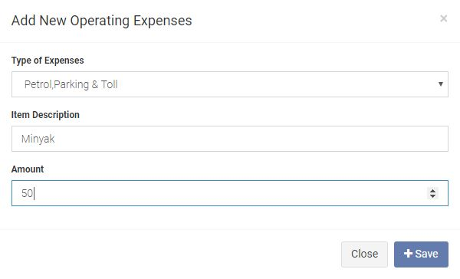

Then, try to do another operating expenses using operating expenses module. The detail as follow:
Date: 11/1/2017
Bank: Petty Cash 1
Pay To: Traveliing Expenses
Amount: 70
Description: 1. Petrol RM50 2. TouchnGo RM20

7.0 HOW TO CREATE PURCHASE OF FIXED ASSET
- Go to Expenses > Purchase of Fixed Asset > Add New
- Key in all the information required in Add COGS as follow.
- Date: 2/1/2017
- Bank: Petty Cash
- Remarks: Ah Cheng Supply
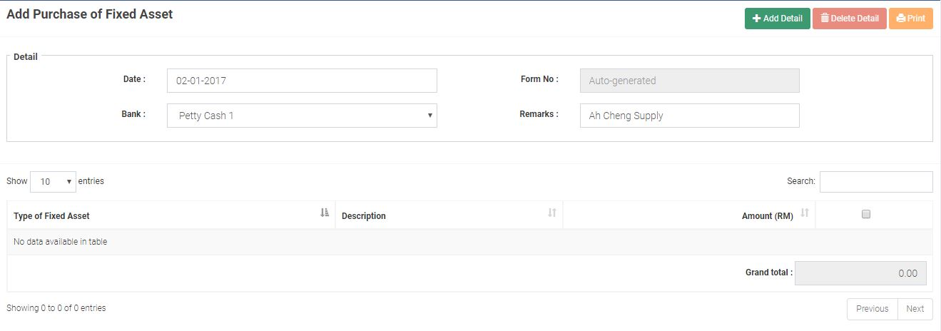
- Click Add Detail
- In Add New Purchase of Fixed Asset section, insert:
- Type of Fixed Asset: Furniture & Fixtures
- Item Description: Dorm Table
- Amount: RM500
- Click Save button once details are confirm.
- Click Save button once again in the main page of the Add Sales.
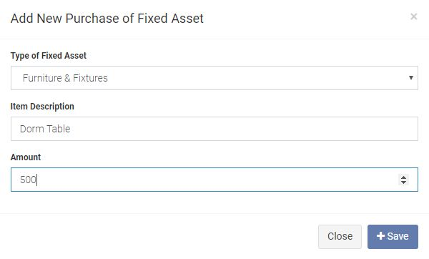
8.0 HOW TO CREATE SALES
- Go to Sales > Add New.
- Key in all the information required in Add Sales as follow.
- Date: 6/1/2017
- Bank: Petty Cash
- Receive From: Al-Amin Resources
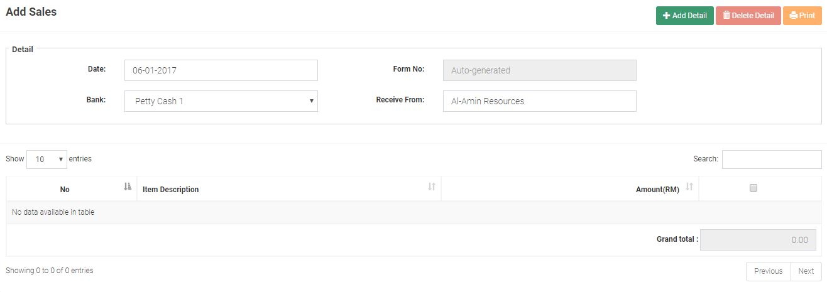
- Click Add Detail
- In Sales Add Detail section, insert
- Item Description: Jamuan Bacaan Yaasin
- Amount: RM700
- Click Save button once details are confirm.
- Click Save button once again in the main page of the Add Sales.
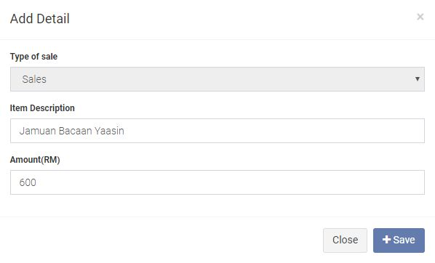

Then, try to do another sales using sales module. The detail as follow:
Date: 13/1/2017
Bank: Petty Cash 1
Receive From: Mega Jaya Sdn. Bhd.
Amount: 1570
Description: 1. Nasi Lemak & The Tarik Panas RM1270
2. Kuih Koci RM100
3. Kuih Lapis RM100
4. Transportation RM100

9.0 HOW TO SETUP Loan
- Go to Setup > Loan
- Click the selected Loan Name that need to re-edit
- You will be direct to editing page
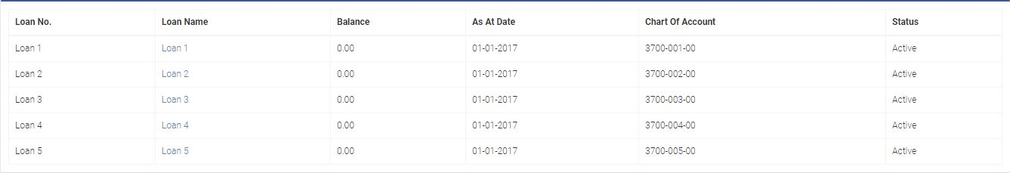
- Insert Business Loan as the loan name.
- Insert amount RM50000 in Balance (RM)
- Once editing completed, click Update button to saved data.
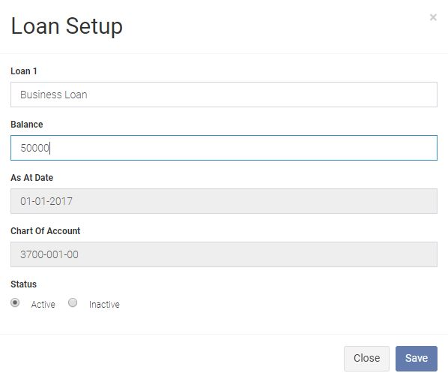
9.0.1 HOW TO CREATE LOAN REPAYMENT
- Go to General > Loan Repayment > Add New
- Key in all the information required in Add Loan Repayment as follow.
- Date: 29/1/2017
- Bank: Maybank
- Remarks: SME Loan Installment (1923131920933321)
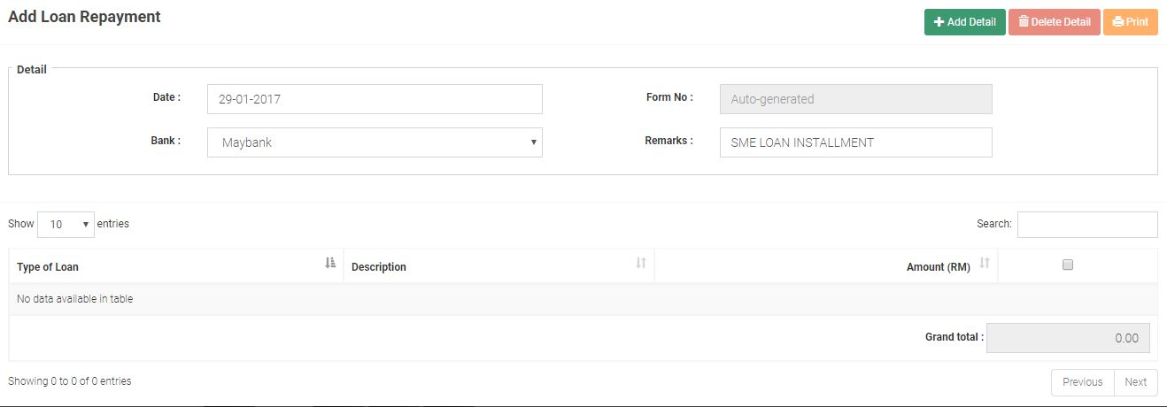
- Click Add Detail
- In Add New Cost of Goods Sold section, insert
- Type of Loan: Business Loan
- Item Description: January 2017 Installment
- Amount: RM550
- Click Save button once details are confirm.
- Click Save button once again in the main page of the Add Sales.
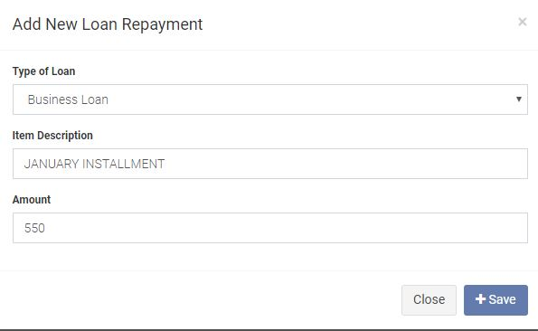
10.0 HOW TO CREATE LOAN RECEIVED
- Go to General > Loan Received > Add New
- Key in all the information required in Add COGS as follow.
- Date: 1/7/2017
- Type of Loan: Loan 2
- Type of Bank: Bank2
- Amount: 30000
- Description: Office Renovation
- Click Save button once details are confirm.
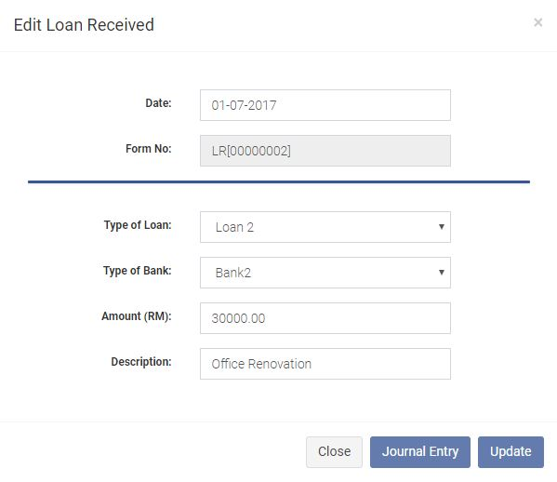

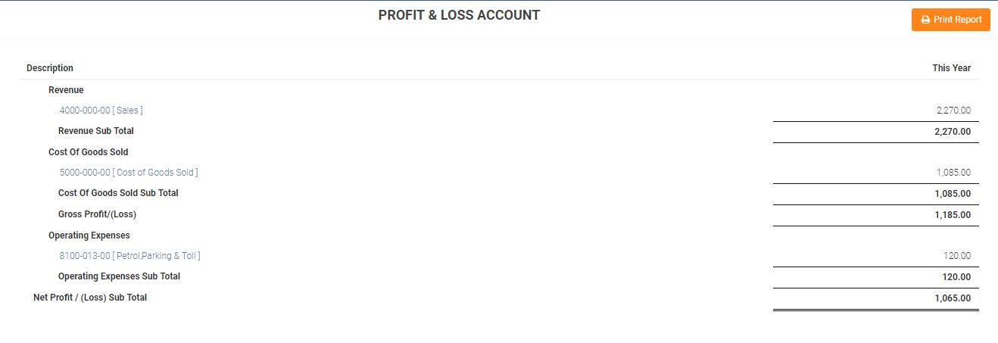
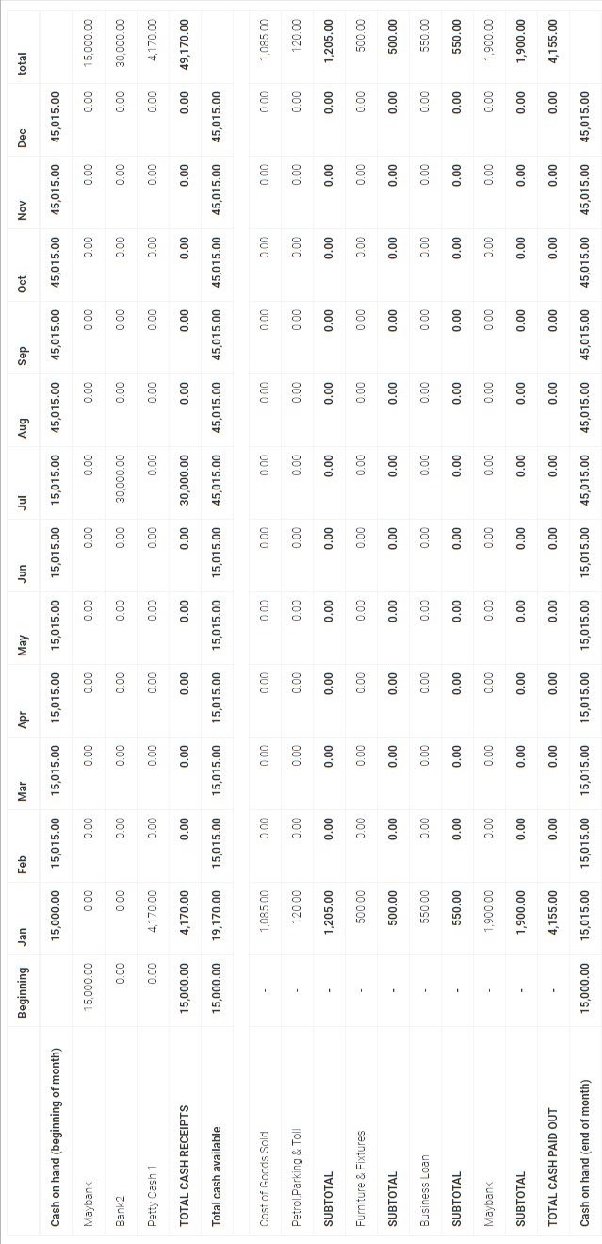
EXERCISE

- Transfer money from Petty Cash1 to Maybank with amount RM2270.
Date: 16/1/2017
From: Petty Cash 1
To: Maybank
Amount: 2270
Description: Sales Collection as at 15 January 2017

- Record a transaction of COGS with amount RM1495
Date: 18/1/2017
Bank: Petty Cash 1
Pay To: Segi Fresh Batu Caves
Amount: 1495
Description: 1. Beras RM300 2. Minyak RM70 3. Ayam RM500
4. Tomato RM20 5. Sos Cili RM40 6. Bawang2 RM50
7. Garam RM5 8. Serbuk Kunyit RM10
9. Ikan Bawal RM500

3. Record a transaction of Operating Expenses with amount RM50
Date: 18/1/2017
Bank: Petty Cash 1
Pay To: Traveliing Expenses
Amount: 50
Description: 1. Petrol RM50

- Prepare an invoice/receipt of sale on 20/1/2017 with amount RM3100
Date: 20/1/2017
Bank: Petty Cash 1
Receive From: Alam Gamma Sdn. Bhd.
Amount: 3100
Description: 1. Nasi Tomato Ayam, Ikan Bawal & Ice Lemon Tea RM3000
4. Transportation RM100

- Record a transaction of Operating Expenses with amount RM50
Date: 20/1/2017
Bank: Maybank
Pay To: Telekom Malaysia
Amount: 250
Description: 1. Wifi & Calls RM250

- Record a loan payment made on 1/2/2017 with amount RM550
Date: 1/2/2017
Bank: Maybank
Remarks: SME Loan Installment (1923131920933321)
Type of Loan: Business Loan
Item Description: February 2017 Installment
Amount: RM550

