INTRODUCTION

The Salihin Premier Solution (SPS), the first intelligent software in the world that can manage numerous aspects of accounting including Goods and Services Tax (GST), Zakat calculation, and Waqf customized specially for Small and Medium Enterprises (SMEs).

SPS is an efficient and effective accounting software that accommodates changes affecting invoicing and billing system of the business process. The software is powered by the latest security features to secure data or information for optimal integrity and confidentiality. It is tailor made for small and medium industries by professional accountants. Timely accurate and complete returns, reports and forms can be generated without hassle to facilitate payments and refunds, audits and timely submissions of GST. SPS has innovative checking and auditing system to ensure that GST returns meet all the statutory requirements.

The Zakat module makes SPS the first comprehensive accounting software with Zakat solution. It will make it easier than ever for Muslim businesses, corporations and organizations to determine the amount payable of Zakat. With Zakat feature built in, it is simply the best accounting software yet.

SYSTEM REQUIREMENTS
Minimum System Requirements

- Operating system must be Windows 7 and above
- Important note: Win XP and Win 2003 are not supported
- 1 GHz processor or higher
- 1GB or higher for RAM
- 10GB of hard disk space
- Microsoft Office 2010 and above
- A broadband internet connection will be required only for WAN environment and usage within an office will require a basic LAN configuration

LESSON ONE
MODULE: GENERAL SETUP

This module provide users the steps to setup the software in the user’s machine.

- How to Setup Company
After system installation, the first thing you have to set up is your company details. Company should function as the foundation of an accounting system that the business will use during future years.
    - Create/Add New Company
- Go to General Setup > Company Setup > List
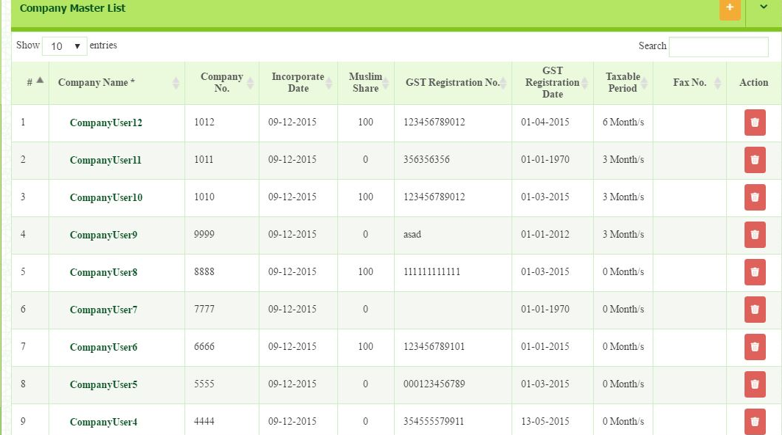
- Click button that located on top right page.

Once click, you will be directed to company master pages. In this section, you need to fill in all the required information needed.

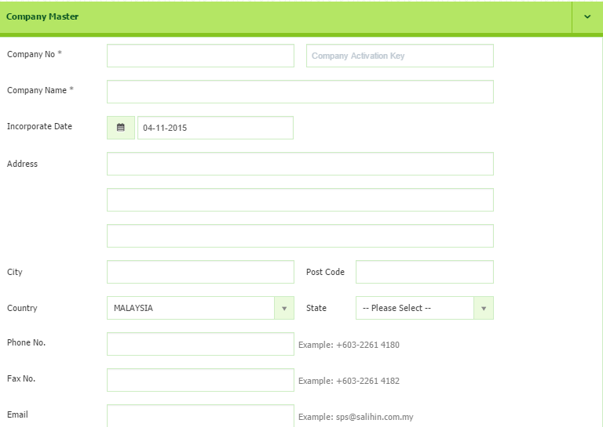

Before you continue to fill in all the required information, you need to get the Company Activation Key first.
Step 1.0.1 and 1.0.2 below are for commercial version. Please ignore the steps for student version. Key in any number for student version.

    - How to get Company Activation Key
- Open new browser and type demo.salihinpremier.com/ss-ss/customerlogin
- Enter your username and password. (Please check your email or contact SPS Support Team to get the details)
- Once login, you will be directed to Customer Login page.
Below is the main interface of Customer Login page. Continue the following steps:-
- Click the SPS License from the menu
- Then, click the SPS Serial No.

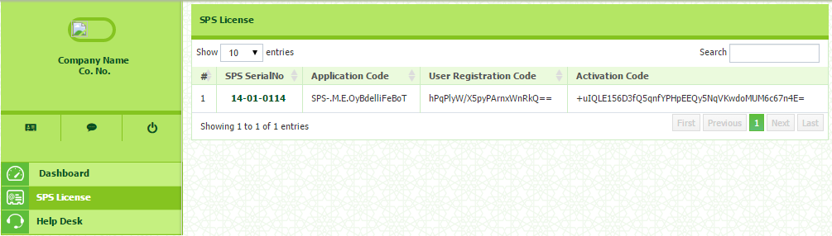

Below is the main interface of your License and Company Registration details.
- Proceed to the SPS Registered Company Key
- Click Add Company button
- Once click, you need to entered Company No. , Activation Date.
- Then click the button.
- Once click, the Activation Key will be automatically appear.
- Next copy the Activation Key as appeared
- Then, open your Company Master page in SPS. Paste your Activation Key and paste the code into Company Activation Key column besides Company No. (Please refer Company Master Interface)

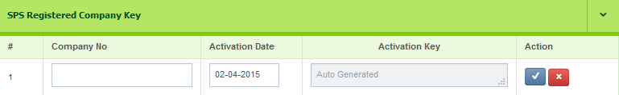

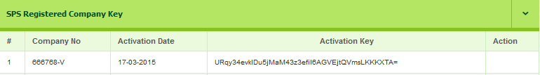

 WARNING!

- Make sure there is no SPACE when you copy and paste. IF you are failed to validate, please contact your Dealer.
- Please be careful before you remove the registered company. Charge may be implied for data recovery.

    - Failed to Add New Company
If you having this problem to adding new company registration, kindly please check again your company license that you already purchased. If you purchased for 1 Company, you are unable to proceed for any new company registration.

If you are wish to have more than 1 company license, do call your dealer or SPS Support Team to consult you on the volume of licensing according to your business activities.
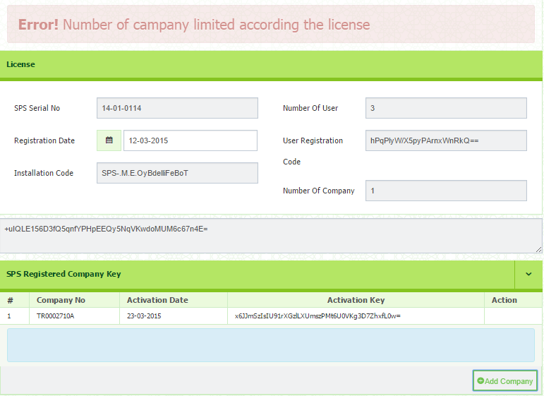

    - How to Upload Image/Company Logo
- Click the Choose File button
- Select images from your drive , where the logo is located and stored
- Images can be BMP, PNG, JPEG or GIF files and should measure 120 x 120.
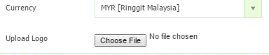

    - Goods & Services Tax
Information of your GST No, GST Registration Date, Taxable Period and MSIC
Code.
- GST Registration No – Must be 12 digits
- GST Registration Date – Refer your references copy from Customs.
- Taxable Period – Only appeared when you select the Registration Date. You can select taxable period from the drop down menu, either as Monthly, Every 3 Months, Every 6 Months or Yearly.
- MSIC Code – Refer your references copy from Customs. This MSIC Code will take effect in your GST 03.
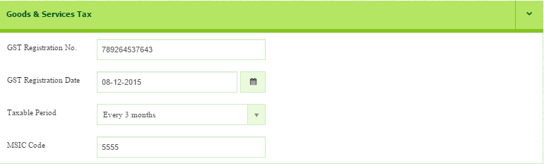

    - Zakat & Wakaf
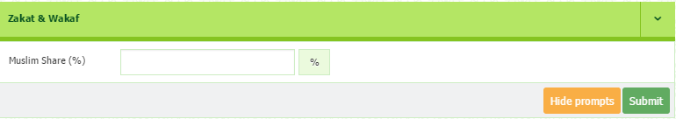
Enter the amount (%) of your zakat & wakaf

After Company Activation Key has been updated, you may proceed to click Submit button to save all the information.

- How to Create New User
In this section, you can create your new user. The user can be one or more depends to the pattern of your business type. You are also enabled to set the User Access Right to control and prevent data from unauthorized user.
2.0.1 Create/Add New User
To create new user, please follow the following steps:-
- Go to Admin > User Master
- Click button that located on the top right page.

- Once click, you will be directed to the User Master page (as shown below).
- In this section you need to setup your user details.
- Once completed, click Submit button to save.
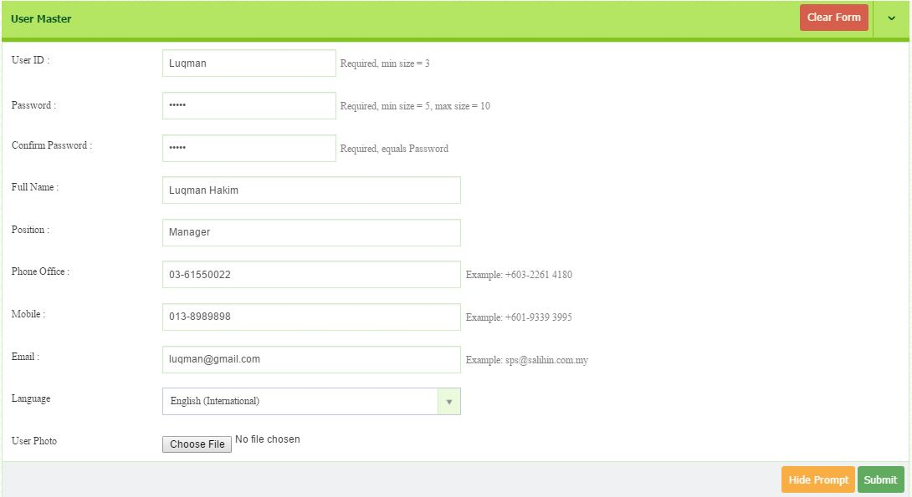
- Click Clear Form button to reset all the information.

2.0.2 How to View/Edit User
To view the listing of User:-
- Go to Admin > User Master
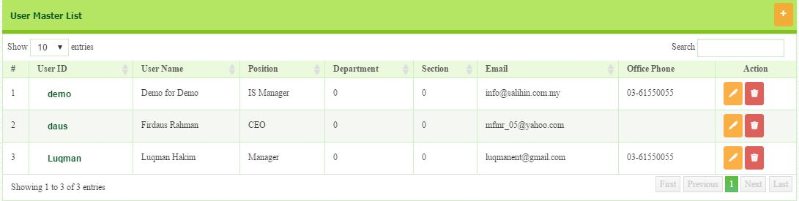
- To edit, click button that located in Action column.

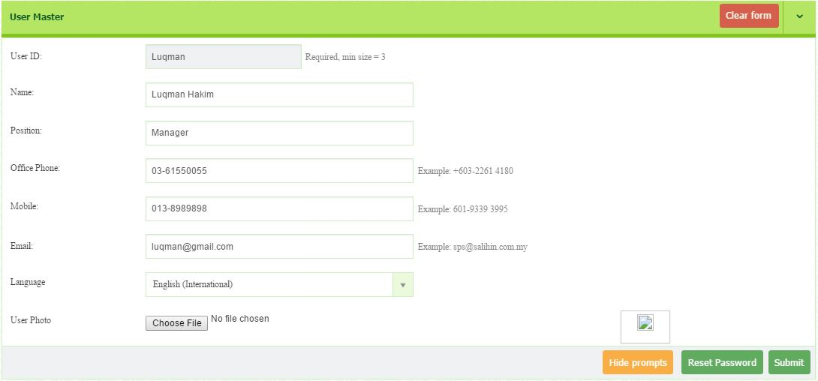
- You will be directed to the editing page.

- After editing user information, click button.

2.0.3 How to Delete User
To delete the listing of User:-
- Go to Admin > User Master > User Master List
- Select the identified user
- To delete, click button that located in Action column.
WARNING!
Please be careful before you remove the registered user. Charge may be implied for data recovery.

- How to Grant User Access Right
This section is to guide you as admin to set the user access right. It will help you to control and prevent the data/information from unauthorized user. Please follow the following step:
- Go to Admin > User Master
- Click the identified User ID
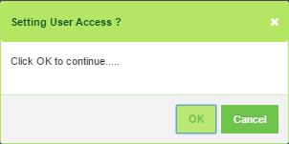
- You will be directed to User Access for the user you have selected. The Setting User Access dialog box will appear. Click OK to continue

- You will be directed to User Access Right page.

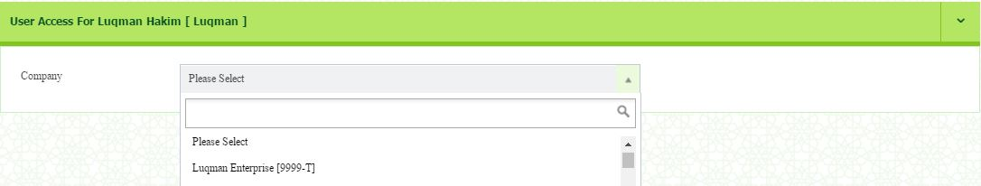
- In this section, you need to select the company (Luqman Enterprise) from the drop down menu.

- Once selected, the User Access will be listed.
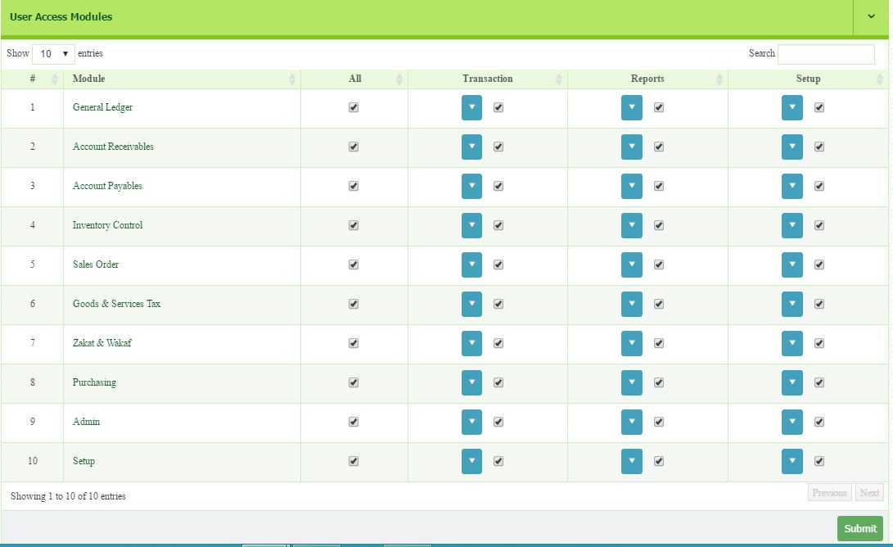
- In this part, you may choose which modules you want to grant a permission. If you wish to grant permission to all modules, tick the box under ALL column.

- Then, click submit button
- Please wait for a while, until the message box is prompt. (as shown below)
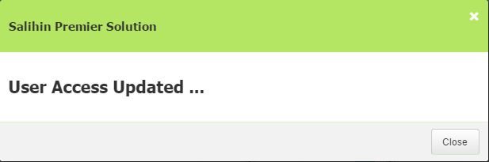
Example 1
For example, if you want the user to access only the Goods & Services Tax and can execute transactions, you have to tick the box under Transaction menu.
- Next, click the drop down button. You can see all the menus under Transaction.
- In this section you can choose which menu to allow them to access.
- Once selected, click button to save.
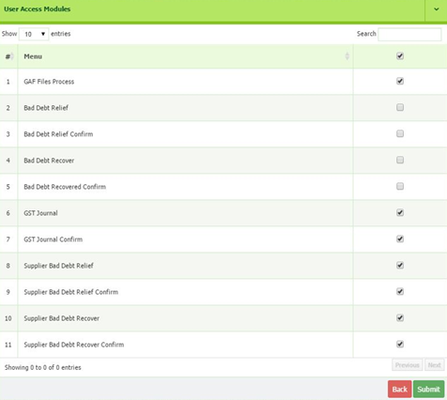
WARNING!
1) Please make sure to limit the access right for User Demo. This is required after you already successful registered new company and assigned user.
2) If you are super admin for that selected company, please be careful and confirmed on which modules you want to give privilege.

Once you click submit button, you need to log out from the system.
Then, use your new ID and select the company you have assigned just now.

- How to Reset Password
If you are the user, you need to contact your admin to request for Reset Password. Reset password is needed when, for example, the user no longer working at your company, so you need to set a new password to prevent from the unauthorized person or you forget the password.

Please follow the steps below:-
- Go to Admin > User Master > User Master List
- Select the identified user (Luqman) and click button that located in action column.
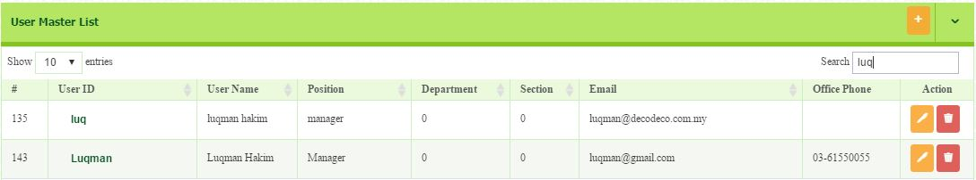

- You will be directed to the User Master page.
- Click the button.

- Once click, you will be directed to Forget Password page
- Insert your new password, then click Submit
- Once submitted, there is a message to prompt that reset password is success.
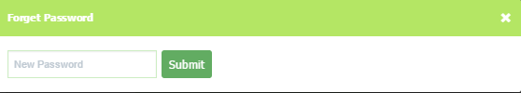
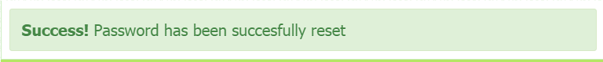
WARNING!
Super Administrator need to keep a copies of username and password of the registered user.

- How to Setup Chart of Account
After you have registered your company and user master, next step is to setup your Chart of Account. In this part, you need to identify your Industry Classification and Type of Business.
- Go to General Setup > Company Setup > Chart of Account Setup
- You will be directed to page as shown below.
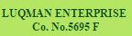
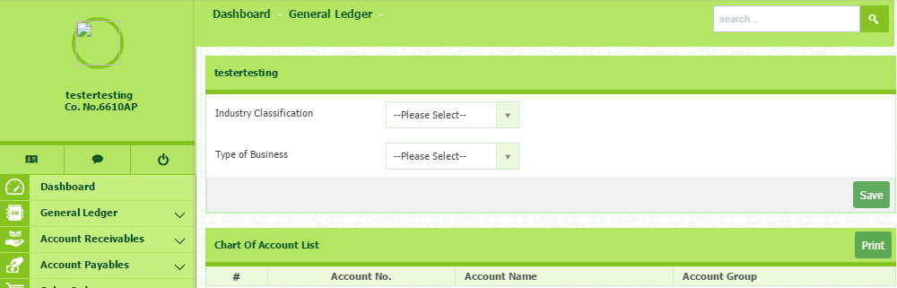
- Next, select your Industry Classification and Type of Business from the dropdown menu.
- Choose General for both. Chart of Account List will be listed automatically.
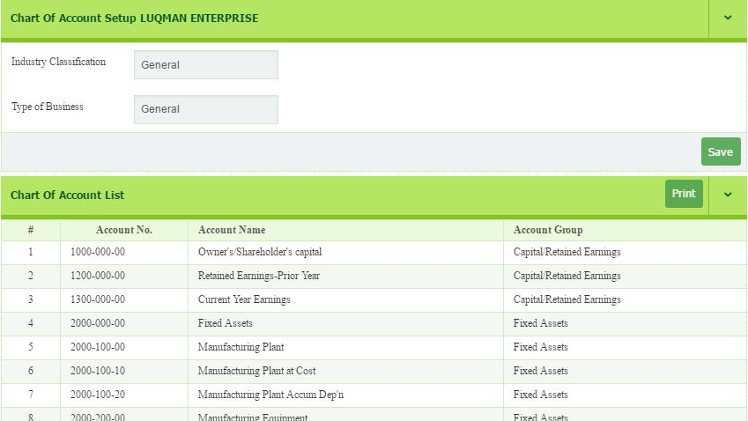
- Then, click button.
- Once you click button, you will be directed to the System & General Setup.
- In this section, the system set the default for all setup and customizes according to your company’s suitability and needs.

Account No. | Related Amount
1xxx/xxx/xx | - Retailed earning  - Current year earning  - Owners/shareholders capital
2xxx/xxx/xx | - Fixed asset  - Trade receivable  - Cash & bank balance  - Inventories  - Other receivable  - Prepayment & deposit  - Tax claimable
3xxx/xxx/xx | - Trade payable  - Invoice/Good not receive  - Other payable  - Accruals  - Client deposit  - Deffered tax liabilities  - Borrowing
4xxx/xxx/xx | - Sales  - Wholesale  - Consignment  - Miscellaneous income
5xxx/xxx/xx | - Cost of goods sold  - Purchase price variance  - Purchases  - Wholesale cost of sales  - Consignment cost of sales  - Materials & supplier  - Freight  - Commission expenses  - Inventory adjust account
7xxx/xxx/xx | - Other operating income
8xxx/xxx/xx | - Administration expenses  - Employment expenses  - Finance cost  - Income tax expenses  - Other comprehensive income
9xxx/xxx/xx | - Finance income  - Interest income
- The main function of this section is to create the auto journal (the information are available by default).

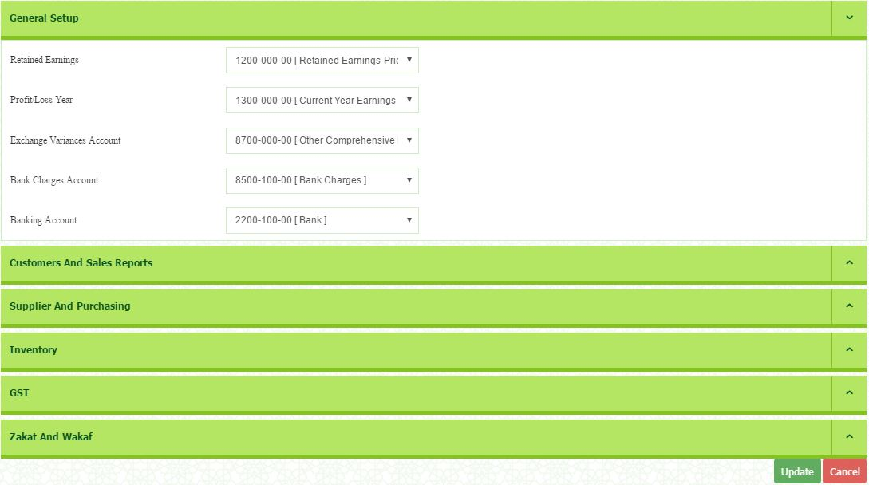
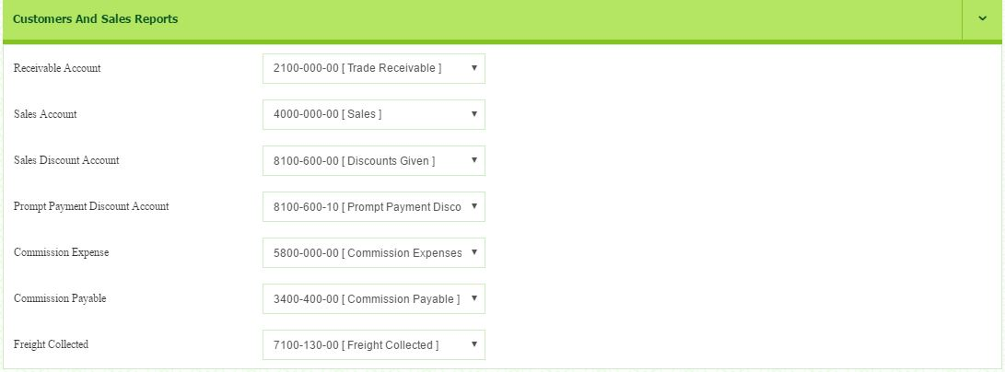
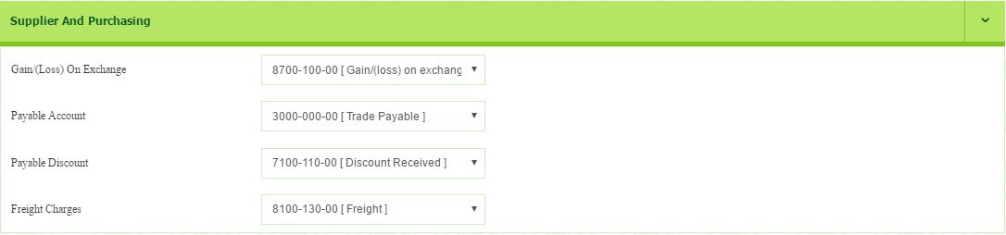
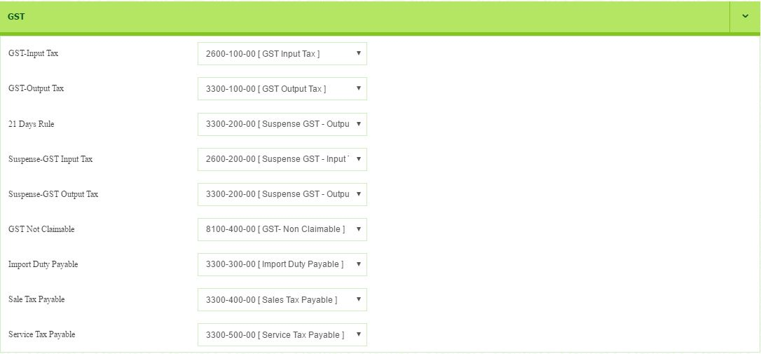
- Example as below:
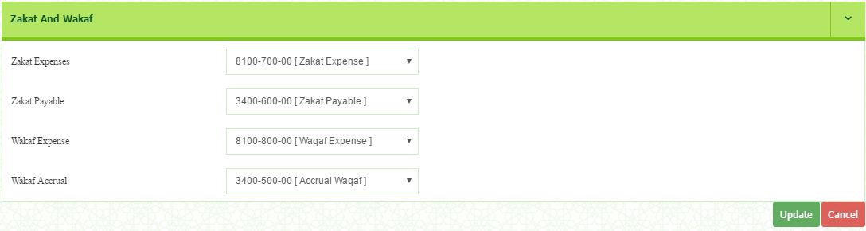
- Then, click button.
- You will be directed to Form Setup page.

- How to Set Form Setup
- Go To General Setup > Company Setup > Form Setup. The Form Setup List window appears.
- In this section, you can set your Serial Startup No.
- You also can set your Special Coding for each form type.
- To insert your special coding and serial startup number, double click at the selected field.
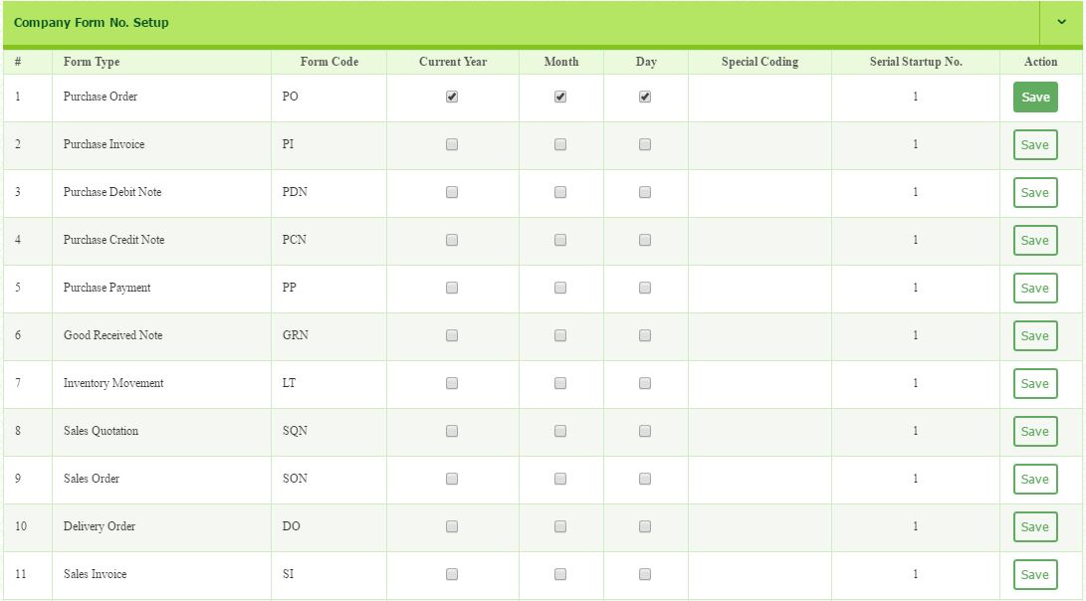
- Press Enter and click button to save the data.

How to add new chart of account
- Go to General ledger > Setup > Chart of Account.
- Click button to add account master.
Please add new the following chart of account:
Section: SOFP | Section: SOCI
Account Group: Current Assets | Account Group: Finance income
Account Code: 2200-100-01 | Account Code: 9000-000-01
Account Name: Maybank Berhad | Account Name: Hibah

- How to Setup Financial Year Calendar

- Go to General ledger > Setup > Financial Year Calendar List.
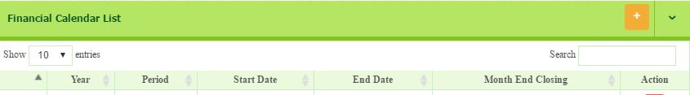
- Click button on the top of right corner to add New Financial Calendar List.

- You will be directed to Financial Year Calendar page.
- Select Year 2017.
- Start period = 1, No of period = 12
- Start date 01-01-2017
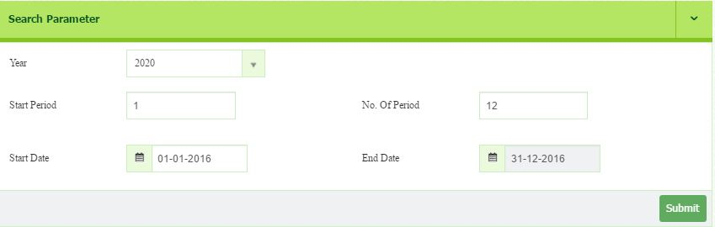
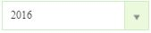
- Then, click button.
- The list of financial year calendar will be listed once you click button.
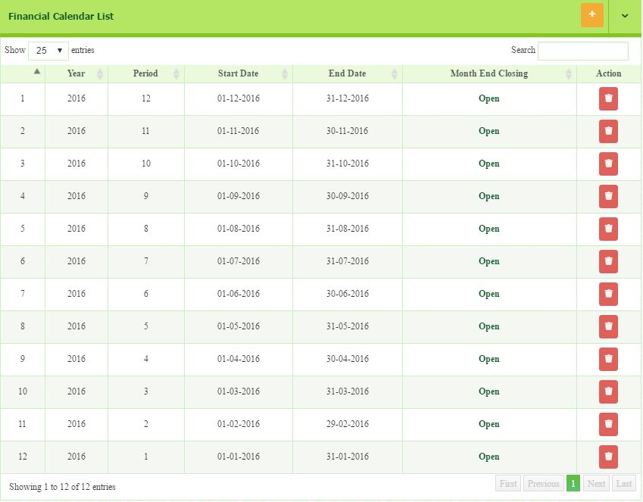

- How to Setup Opening Balance
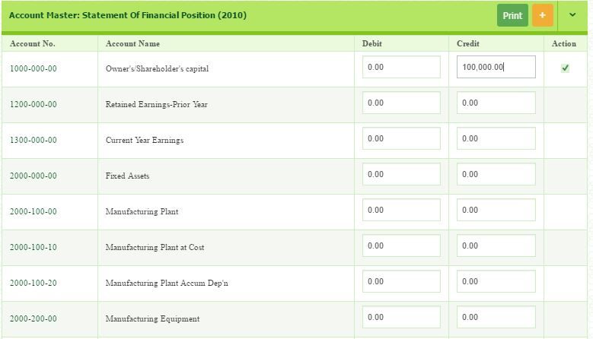
  - Go to General ledger > Setup > Opening Balance. Key in the amount under Debit and Credit column.

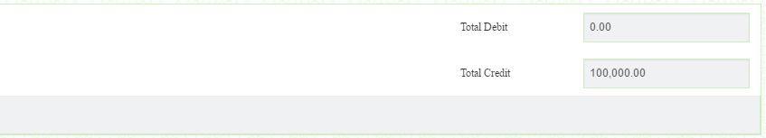
  - Amount under Debit and Credit must be balance. The total is shown at the bottom side.

- If the total is not balance, the warning message will appear.

Please setup opening balance as follow:
Account Name | Debit | Credit
Owner’s shareholder |  | 100,000
Furniture & Fixtures at cost | 20,000
Furniture & Fixtures Acc Depn |  | 3,000
Office Equipment at Cost | 10,000
Office Equipment Acc Depn |  | 1,000
Motor Vehicle at cost | 35,000
Motor Vehicle Acc Depn |  | 3,500
Maybank Berhad | 80,000
Cash in Hand | 12,500
Bank Loan |  | 50,000
Total | 157,500 | 157,500

- How to Setup Terms
You need to set your Credit Terms and Condition List. It will appear when you create an invoice.
- Go to General Setup > Terms Setup
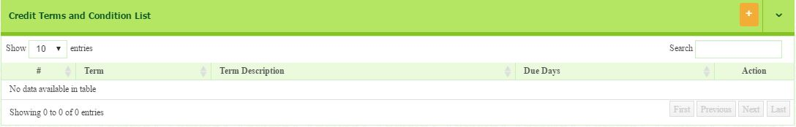
- To Add New, click button on top right of page

- In this section, all the particulars must be filled in.
  - Term Name: 30 days ( the period/time frame given )
  - Description: Payment within 30 Days (based on user preference)
  - Due days: 30 (dateline given for the term to be completed)
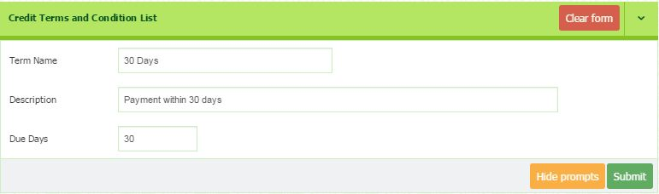
- Once completed, then click button to save.
9.0.1 How to View/Edit Terms
- Go to General Setup > Terms Setup
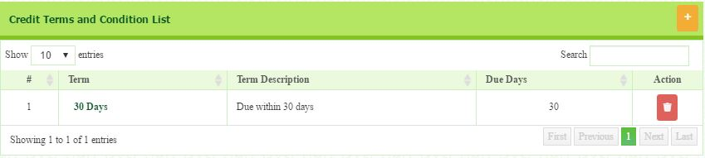
- To Edit, click the link of identified Terms
- You will be directed to the editing page. Once completed, click button to save.
9.0.2 How to Delete Terms List
- Go to General Setup > Terms Setup
- You will be directed to the Credit Terms and Condition List page.
- Identify the Terms that you want to remove.
- Click the button that located in Action column to delete.

- How to Setup Bank
Before setup Bank, you must ensure how many bank your company may use. If you have only one bank, then you can proceed to setup Bank. However, if more than one, you need to add new account code for each bank. It is because you require to each bank to each account code.
How to Add New Account Code
SPS have already set up Chart of Account by default. However, you can change chart of account as you prefer. For example, when you have a new customer, you need to create a new ledger for his/her account. Any related transaction to that customer will be recorded into the ledger that you have created.

You can see the different of this account ledger in Statement of Financial Position Report and Statement of Comprehensive Income Report.

- Go to General Ledger > Setup > Chart of Account.
- There are two sections of Company Master Group.
  - Statement of financial position (SOFP)
  - Statement of comprehensive income (SOCI)

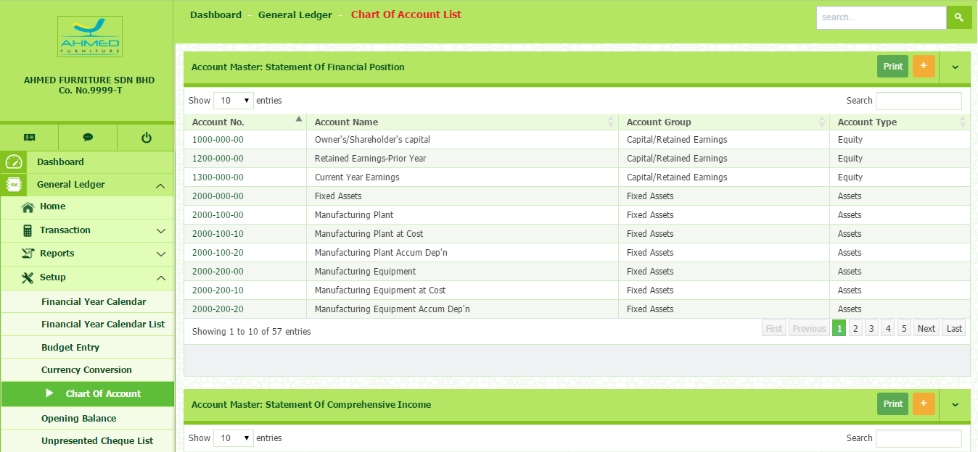
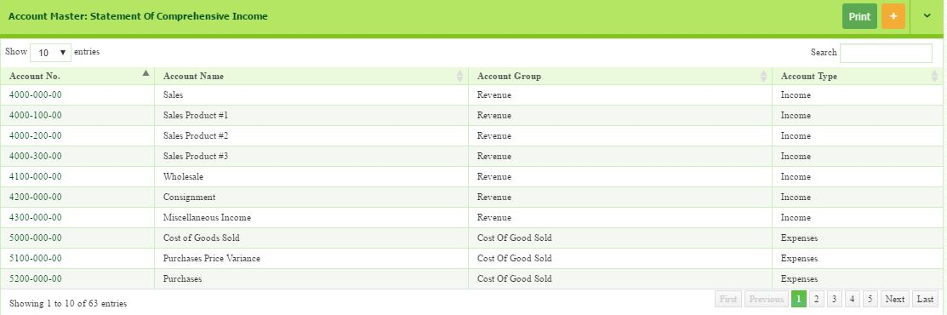
- To add new account master, click button that located on top right of page either under SOFP or SOCI section.
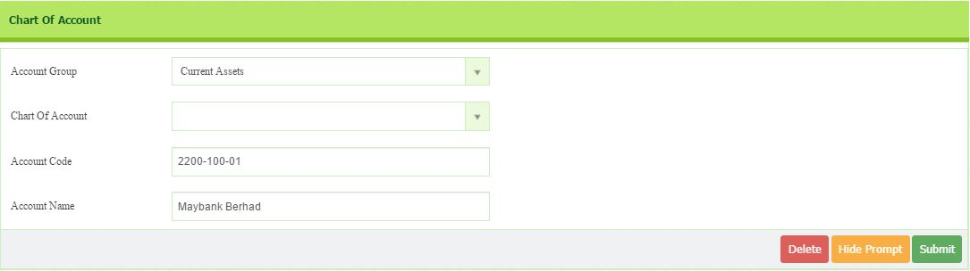
- You will be directed to the page as shown below.

- Next, select Account Group (Current Asset)
- Type your Account Code (2200-100-01)
- Account Name (Maybank Berhad)
- Then click Submit button to save
- To delete, click button.
If you have three banks, you need to add two more new account codes. Then you can proceed to bank setup.
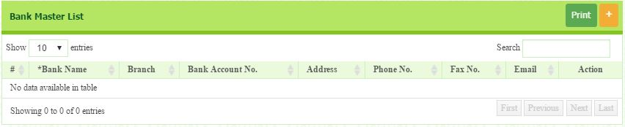
- Go To General Setup > Bank Setup. The Bank Master List window appears.
- Click on Button on the top right-side of the page to add New Bank.

- You will be directed to the page where you can enter all the required information.
  - Bank Name: Maybank Berhad
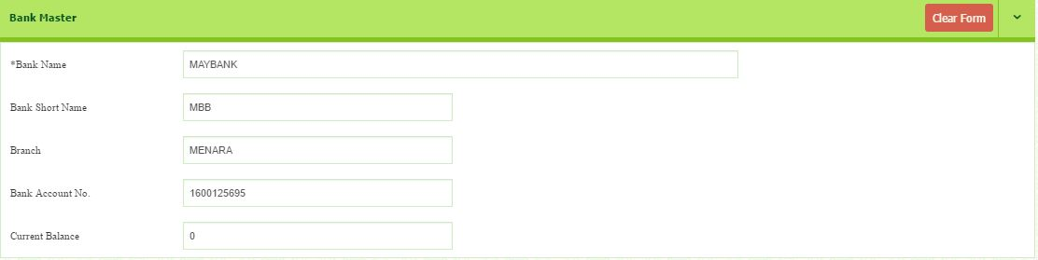
  - Bank Short Name: MBB
- Once completed, click button to save.
- Under others information section, user needs to choose linked account ID with the related chart of account.
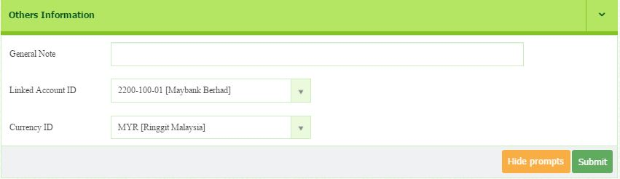

Please add Cash using similar step you setup Bank as detail below:
Bank name: Cash in Hand
Bank short name: Cash in Hand
Branch: HQ
Account Bank: 1
Current Balance: RM12, 500
Linked Account ID: 2200-200-00 [Cash in Hand]

10.0.1 How to View/Edit Bank Listing
- Go To General Setup > Bank Setup. The Bank Master List window appears.
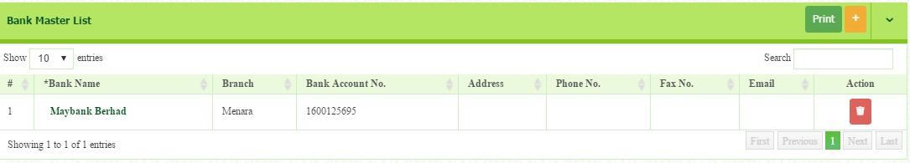
- In the search field, you can search any particular bank by entering the bank name.

- In the Bank Name field, identify the bank and select the particular bank name.
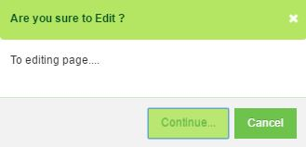
- The Edit dialog box appears.

- Click Continue, the Bank Master window appears. Edit the relevant information.
- Once completed, click button to save.

10.0.2 How to Delete Bank Listing
- Go To General Setup > Bank Setup. The Bank Master List window appears.
- To remove the existing bank, identify the bank row.
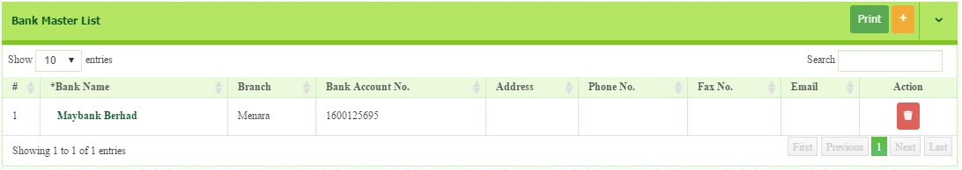
- In the Action field on the right-side of the row, click button.
- Dialog box of deletion confirmation appears, then click button.
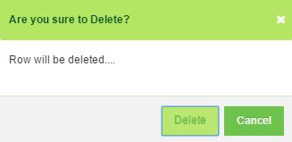

LESSON TWO

MODULE: GENERAL LEDGER

(Other Payment/Other Receive/Journal Entry)

General ledger allow users to create Journal entry, record the payment made or received, produce various report and summary of the transaction. This modules need to be setup carefully as it will result in the financial reporting statement.

  - How to Create Other Payment

- Go to General ledger > Transaction > Other Payment.
- Key in all the information required in New Other Payment Section as follow.
  - Date: 29/1/2017
  - Bank: MBB
  - Pay to: TNB
  - Payment method: cheque
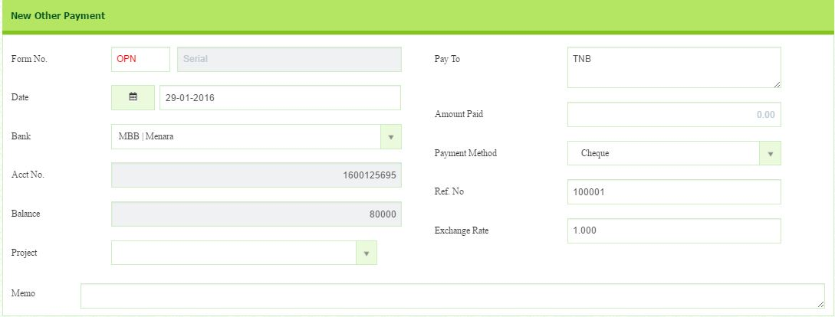
  - Ref no: 100001

- In Payment Details section, click Add New Payment to create payment voucher.
- Select account group (Electricity) and tax code (TX) from drop down button.
- Insert description (January) and amount (RM300)
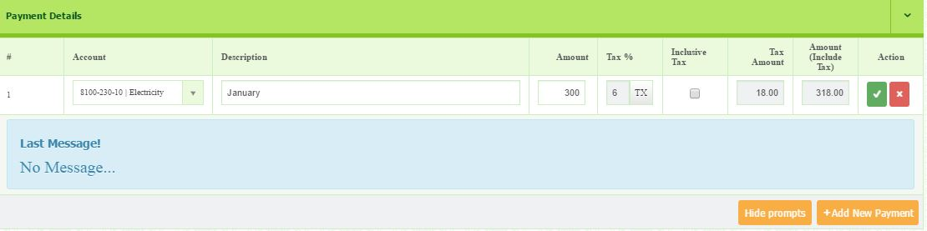
- Click button in the action column to save.

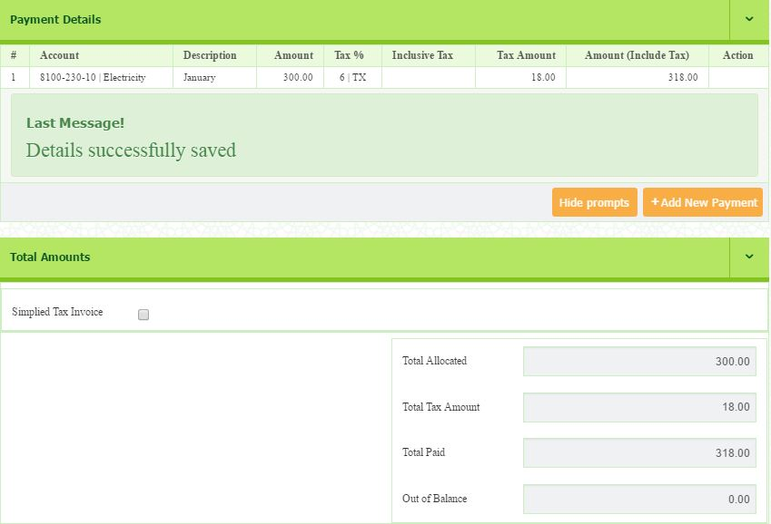
- After saved, message will appear. Total amount will be shown.

Then, try to do another payment by using other payment module. The detail as follow:
  - Date: 29/1/2017
  - Bank: MBB
  - Pay to: Syabas
  - Payment method: cheque
  - Ref no: 100002
- Account Group: Water
- Description: January
- Amount: RM200
- GST: RM12
- Tax Code: TX

  - How to Confirm Other Payment

- Go to General ledger > Transaction > Other Payment Confirm
- Select Year (2017) and Period (1)
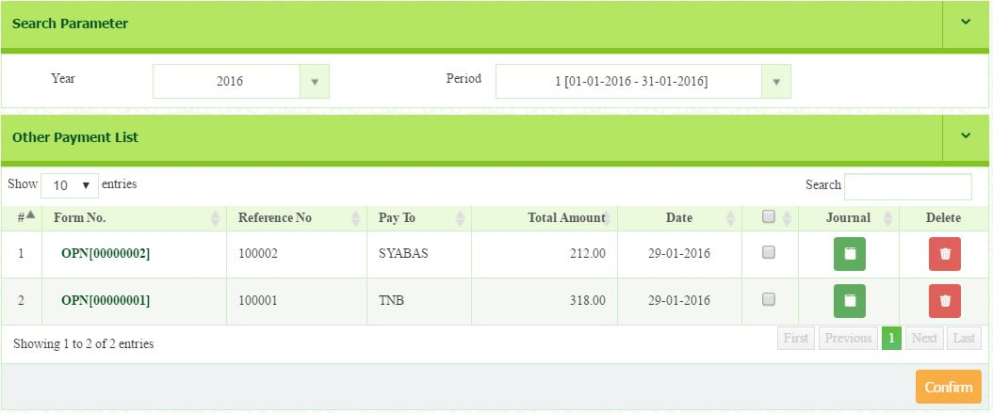
- The list of other payment will appear.

- You can click button to show pre journal.
- To edit, click on the Form No.

- You will be directed to the payment detail page.
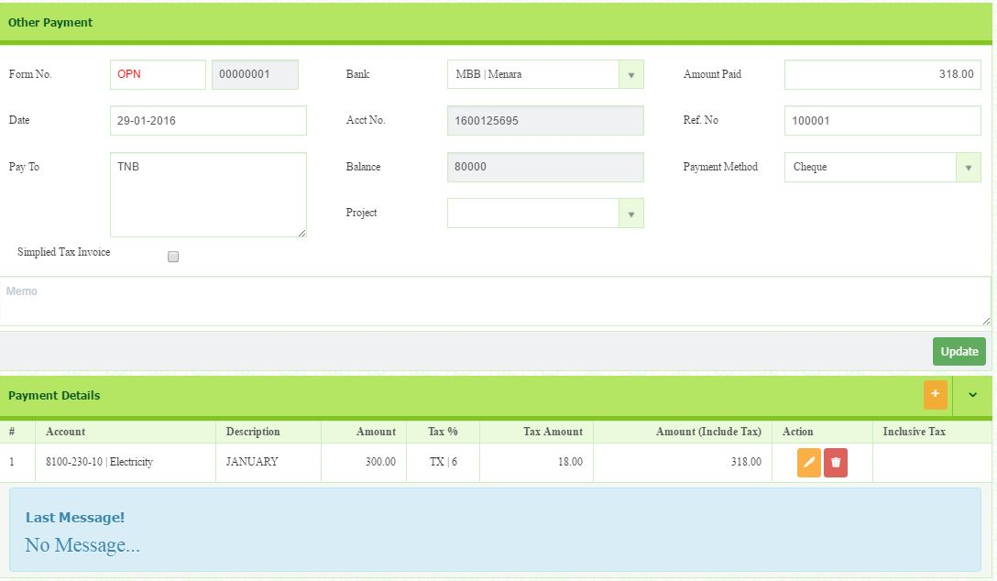
- You can change all information in other payment section except Form No, Account No and Balance.

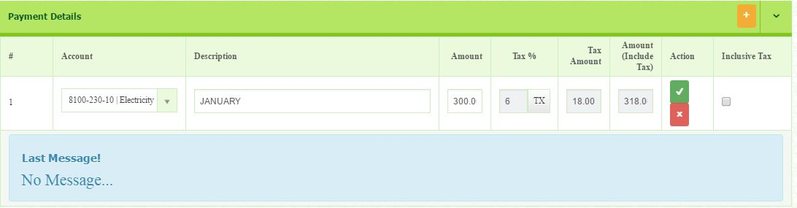
- Click button to edit Payment Detail information.

- After edit payment detail, click button.
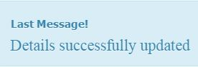
- Go back to General ledger > Transaction > Other Payment Confirm
- Select Year (2017) and Period (1)
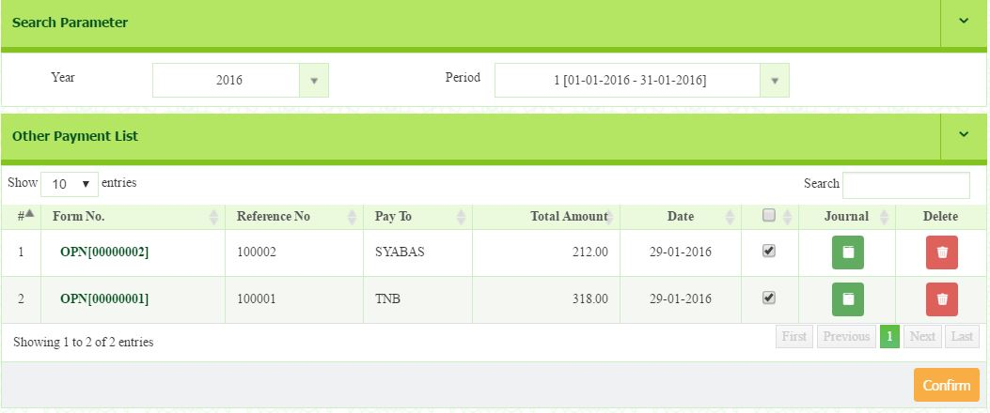
- The list of other payment will appear, tick the box and click button.

  - How to Create Other Receive

- Go to General ledger > Transaction > Other Receive
- You will be directed to the Other receive page
- Fill in all the information required in the New Other Receive section as follow:
  - Date: 31/1/2017
  - Bank: MBB
  - Receive Type: Other Receive
  - Receive From: Maybank
  - Payment Method: online
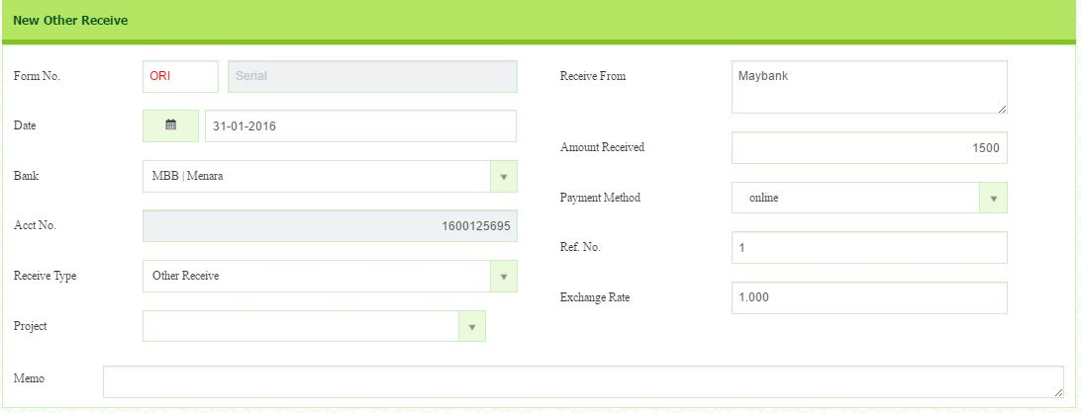
  - Amount received: 1500

- In Other Receive Details section, click Add New Payment to record any payment received.
- Select account group (HIBAH) and tax code (OS) from drop down button. Insert description (2015) and amount (RM1500).
- Tick the box in column inclusive tax to represent the amount inserted is inclusive of GST.
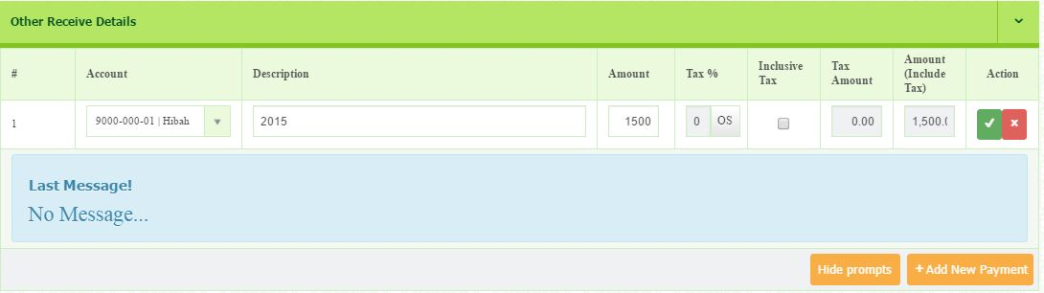
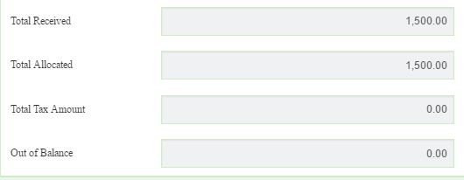
- Click button in the action column to save.

Please add one more transaction in other receive as follow:
  - Date: 31/1/2017
  - Bank: MBB
  - Receive Type: Other Receive
  - Receive From: Maybank
  - Payment Method: online
  - Amount received: 2000
  - Account: Interest income
  - Description: Fixed Deposit
  - Amount: RM2 000
  - Tax code: OS

  - How to Confirm Other Receive

- Go to General ledger > Transaction > Other Receive Confirm
- Select Year (2017) and Period (1). The list of Other receive will appear.
- Select Form No that wants to be confirmed and tick the box.
- Then click button.
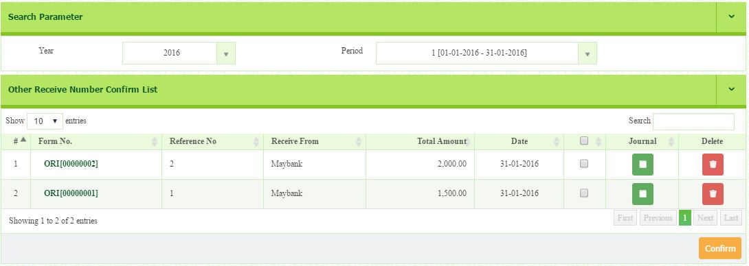
- You can click button to show pre journal.
  - How to Create Journal Entry

- Go to General ledger > Transaction > Journal Entry
- Enter all the information as follow:
  - Date: 4/1/2017
  - Description: Transfer to cash
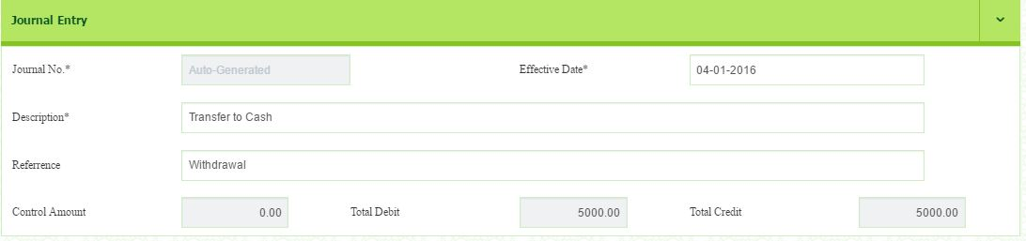
  - Reference: withdrawal

- Click on button on the top of right corner of the journal details to add transaction.
- Select the Account Number (Dr: cash in hand) and (Cr: Maybank Bhd)
- Insert the description (withdrawal) and the amount of debit or credit (RM5000)
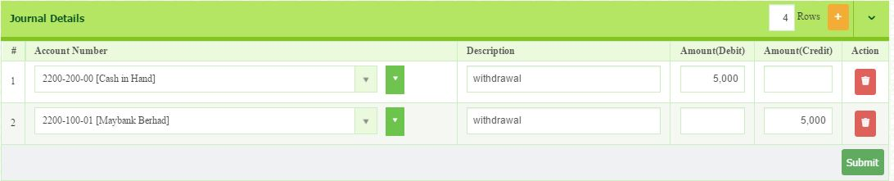
- Click Submit button to save.
- Journal No. will be automatically generated once the user click button.
- The transaction will be appeared in the Posting Journal.

  - How to do Posting Journal

- Go to General ledger > Transaction > Posting Journal
- Select Year (2017) and Period 1[01-01-2017 – 31-1-2017]
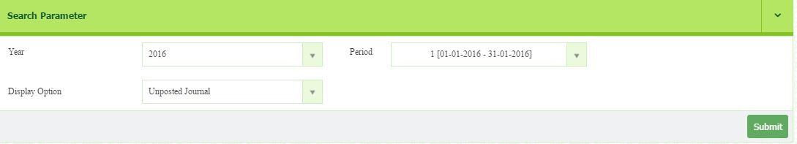
- Then click button.

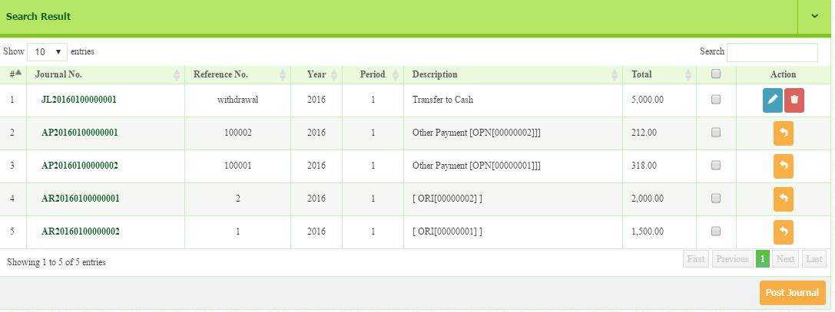
- All transactions that already confirmed will be listed in search result below


- Tick the box to post the intended transaction.
- Then, click button.
- You may see the journal details by clicking on the Journal No.

  - How to edit/delete transaction

- This function enable users to edit or delete any transaction that already confirmed or posted which mistakenly recorded.
- There are some conditions applied due to the logics.
Unconfirmed
-Can edit & delete
Posted
-Not allowed to edit & delete

Confirmed/Unposted
- Not allowed to edit & delete

figure: confirming & Posting transaction process flow

- Figure above shows that the normal process that must be done by users in order to produce accounting reports. If there are problem occurred to the transaction, figure below will explain you how to pull out the transaction back from the reports and fix it.
Unconfirmed
-Can edit & delete
Posted
-Not allowed to edit & delete

Confirmed/Unposted
- Not allowed to edit & delete

- There are certain situation to edit or delete the transaction which include the following:-

  - The transaction already posted. You need to unpost and unconfirm the transaction to allow you to edit the transaction.
  - The transaction already confirmed but no posting made. You need to unconfirm the transaction to allow you to edit.
  - The transaction not confirm yet. You may edit the transaction in the confirm menu.

PROCESS FLOW OF UNPOST THE TRANSACTION
- Go to General Ledger > Transaction > Posting Journal
- Select Year and Period
- Select Posted Journal in display option
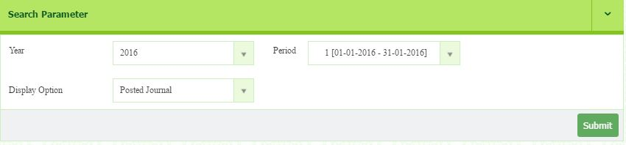
- Click Submit button.

- The list of posted transaction will appear.
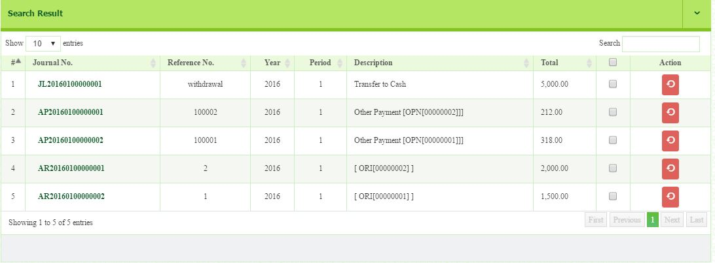
- Find the journal that need to unpost then click button.
When the posted journal already unpost, it will pull out the transaction to the unposted journal.

PROCESS FLOW OF UNCONFIRM THE TRANSACTION
- Go to General Ledger > Transaction > Posting Journal
- Select Year and Period
- Select Unposted Journal display option
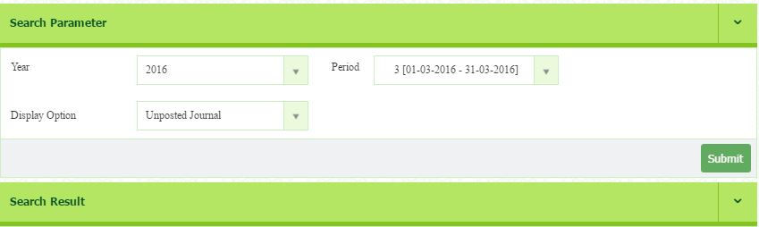
- Click Submit button


- The list of unposted transaction will appear.
- Find the journal that need to unconfirm then click button.
- There is exception for Journal entry transaction. You may edit the transaction at the posting journal menu. It does not require user to unconfirm the transaction but just unpost and click button to edit
- When the unposted journal is unconfirm, the unconfirm invoice/ credit note/ debit note/ payment will be listed in the invoice confirm/ credit note confirm/ debit note confirm/ payment advice confirm.

PROCESS FLOW OF EDIT/DELETE THE TRANSACTION
- Go to confirm menu of every module to delete the transaction. The confirm menu include the following:-
  - Other Payment confirm
  - Other Receive Confirm
  - Sales Invoice Confirm
  - Debit Note Confirm
  - Credit Note Confirm
  - Payment Received Confirm
  - Purchase Receive Confirm

- For example, go to other payment confirm.
- Select Year and Period
- Find and select the transactions that need to edit/delete.
- Follow the step of editing mentioned earlier.

Exercise
Add some of the other payment, other receive, and journal entry transactions.
Journal Entry:
- Date: 30-12-2017
- Description: Depreciation
- Reference: 2017
- Journal detail

Account No. | Dr | Cr
Depreciation | 7,500
Motor Vehicles Accum Depn |  | 3,500
Office Equipment Accum Depn |  | 1,000
Furniture & fixtures Accum Depn |  | 3,000

Other Payment:

- Date: 30.12.2017
- Bank: MBB
- Pay To: Luqman
- Payment Method: Cheque
- Ref No: 100004
- Account: Wages & salary
- Amount: RM18,000
- GST Code: OP

Other Receive
- Date: 30.12.2017
- Bank: MBB
- Receive From: Maybank
- Amount receive: RM5,000
- Payment Method: online
- Receive type: Other receive
- Ref No: 567890
- Account: Hibah
- Amount: RM5,000
- GST Code: OS

2.0 How to Generate Trial Balance
- Go to General ledger > Report > Trial Balance

- Select Year and Period
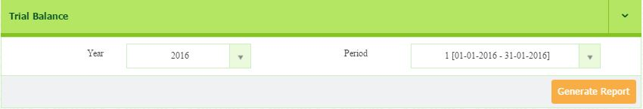
- Click to generate the report.

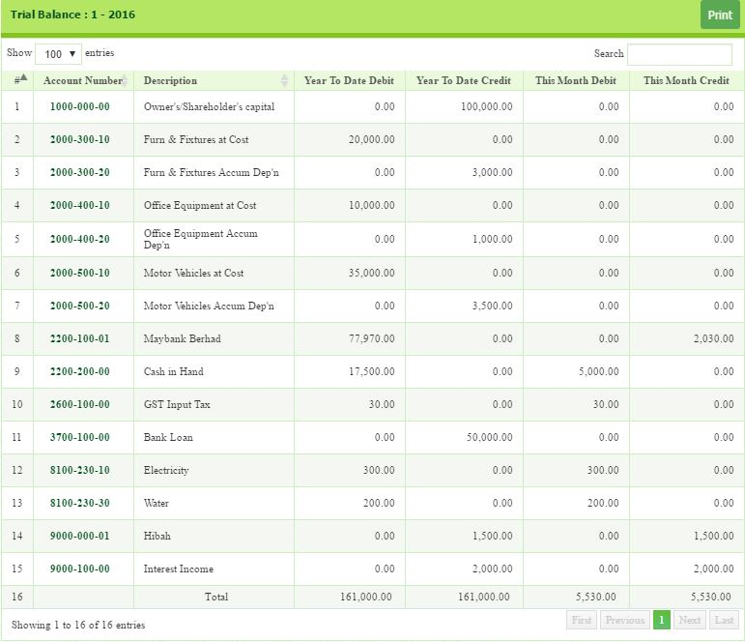
- The report will appear based on the period you have chosen.

- You can print the report by clicking button.

  - How to Generate Trial Balance Fiscal Year
- Go to General ledger > Report > Trial Balance Fiscal Year
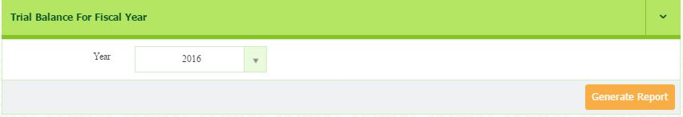
- Select Year. Then, click button.

- The report will appear as follows.
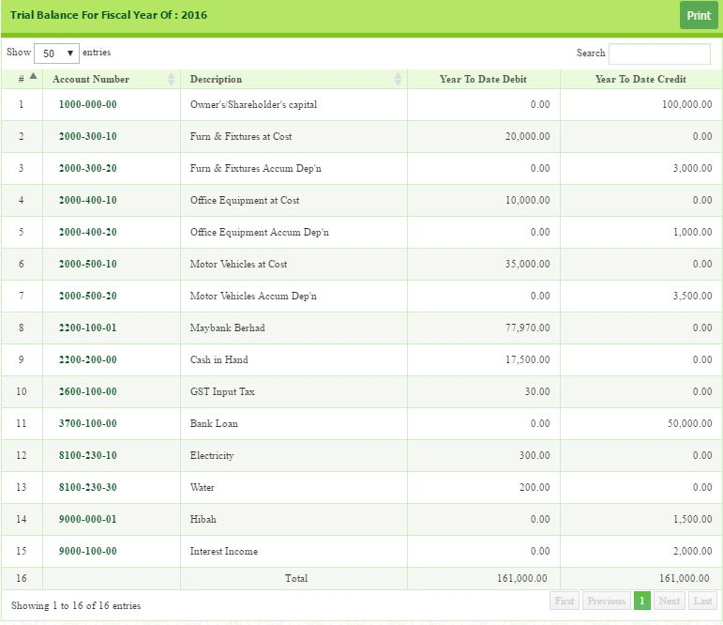
- Once report is generated, you can print the report by clicking button
  - How to generate Account Balance Summary
In this section, you can generate report for each ledger by select account number. You can ensure each ledger is recorded correctly.
- Go to General ledger > Report > Account Balance Summary
- Select Year (2017), Period 1 and Account Number (Maybank)
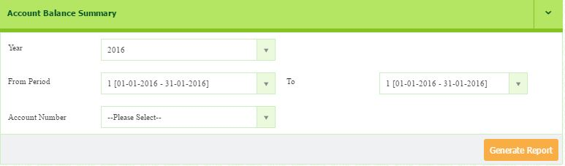
- Click button to generate the report.

- Once the report is generated, you can print by clicking button.
- You will be directed to printing page.
- To print, click button.
- You may convert into excel by clicking button.

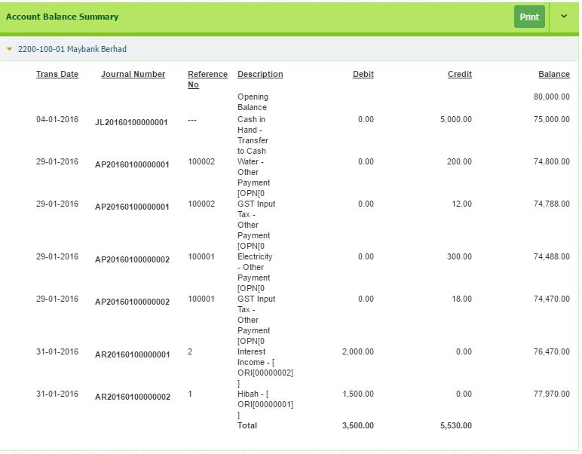
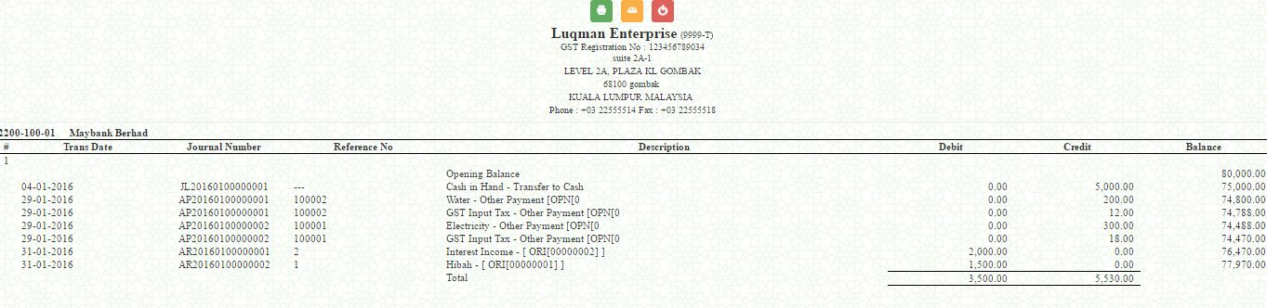

  - How to generate Statement of Financial Position
  - Go to General ledger > Report > Statement of Financial Position
  - You may choose the format of the report: standard, yearly or monthly on the top of right corner.
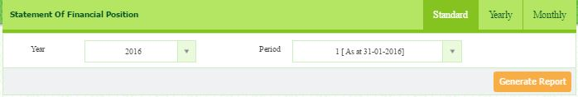
  - For standard, select Year (2017) and Period (1) and click button.

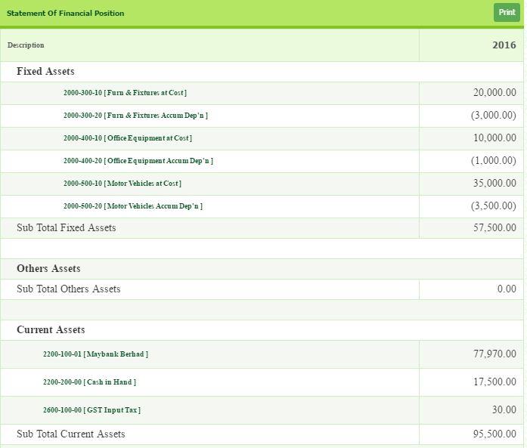
  - You can print the report by clicking button.
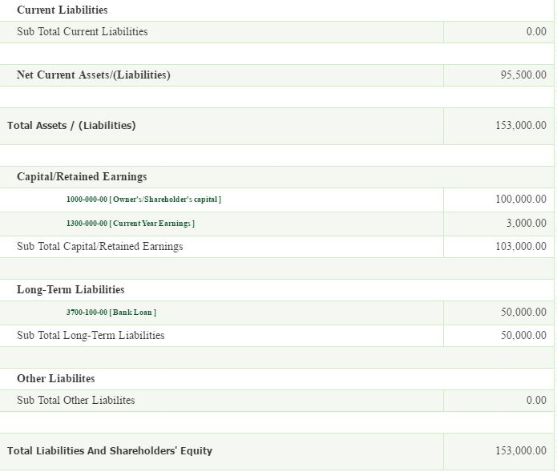

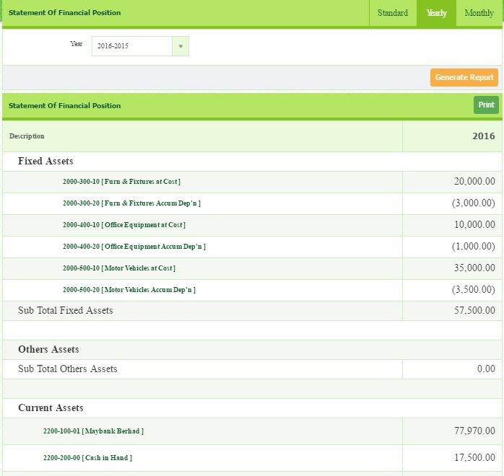
- If filter by Yearly, select Year and click button.

  - You can print the report by clicking button.

- If filter by Monthly, select Year, Period From (1) and Period To (3)
- Click button.

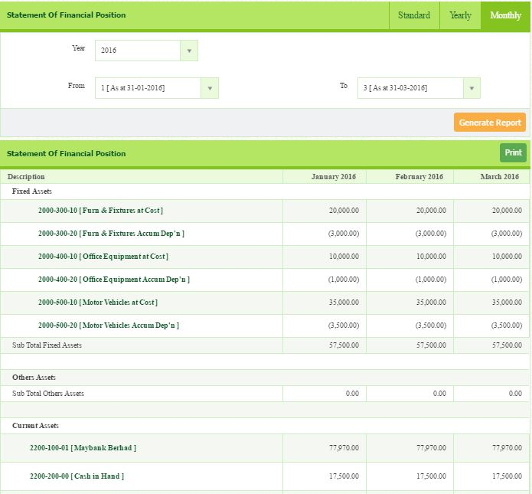

  - How to Generate Statement of Comprehensive Income Report
  - Go to General ledger > Report > Statement of Comprehensive Income
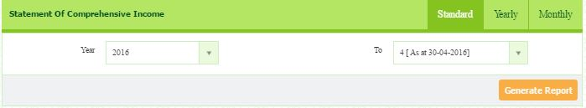
  - You may choose the format of the report: standard, yearly or monthly on the top of right corner.
  - If standard, select Year and Period and click Generate Report button.
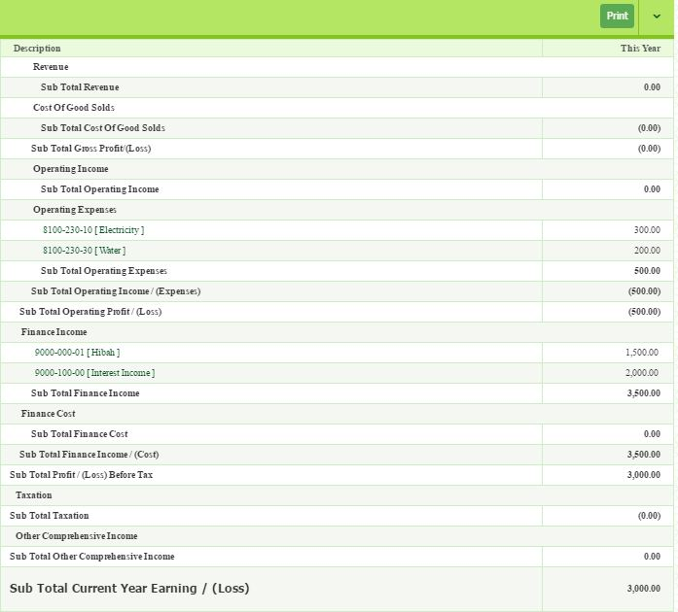
  - You can print the report by clicking button.

  - If filter by Yearly, select Year and click Generate Report button.
  - You can print the report by clicking button.
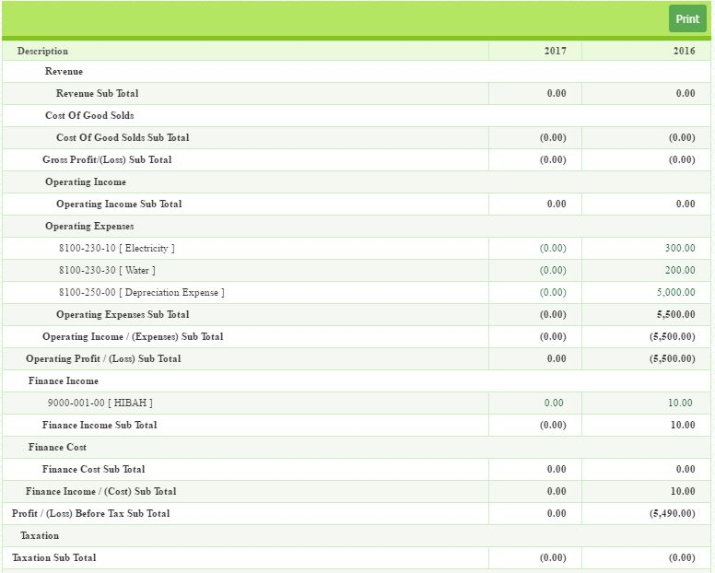
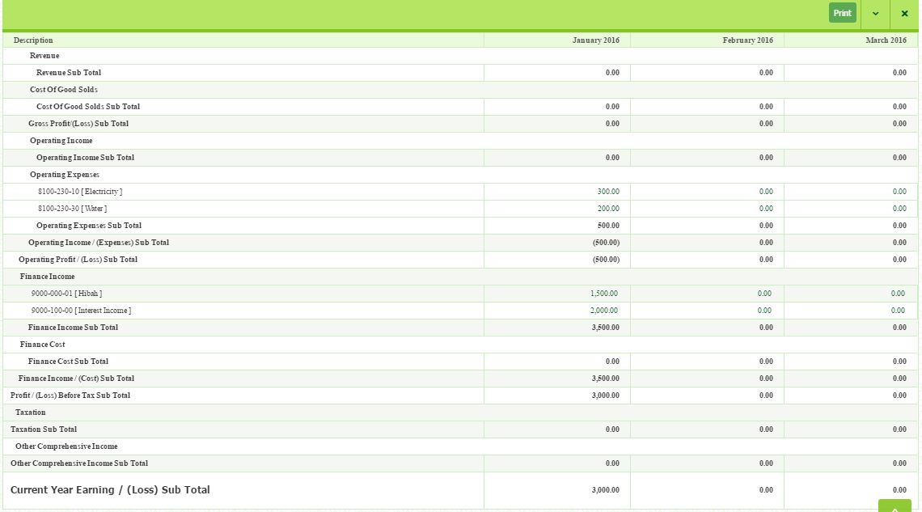
- If filter by Monthly, select Year, Period From and Period To and click
button.
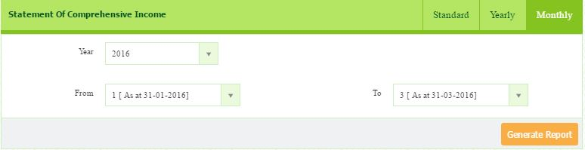
- You can print the report by clicking button.

How to Generate Unpost Journal List
This page shows the listing of the journal which are not post to the ledger yet. User can check the journal detail before post to the ledger. It can minimize the error after posted to the ledger. It apply the concept of segregation of duties.
- Go to General ledger > Report > Unpost Journal List
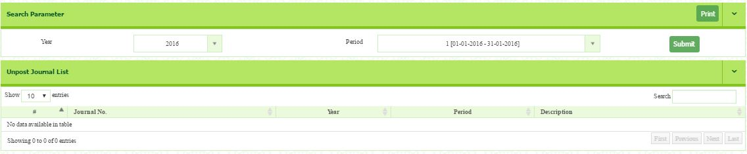
- Select Year and Period and Click button. The list will appear. If all transaction have been posted, therefore, no list will appear.

  - How to Review Posted Journal List
This page shows the listing of the journal which are already posted to ledger and have been included in the report.
- Go to General ledger > Report > Posted Journal List
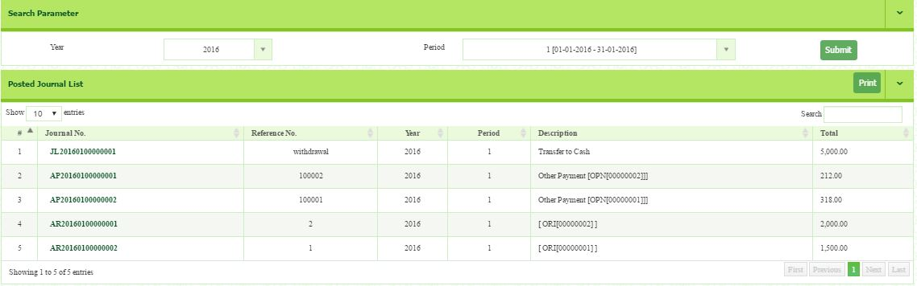
- Select Year (2017) and Period (1), then click button. The list will appear.

- You can get the journal detail by clicking at the Journal No.

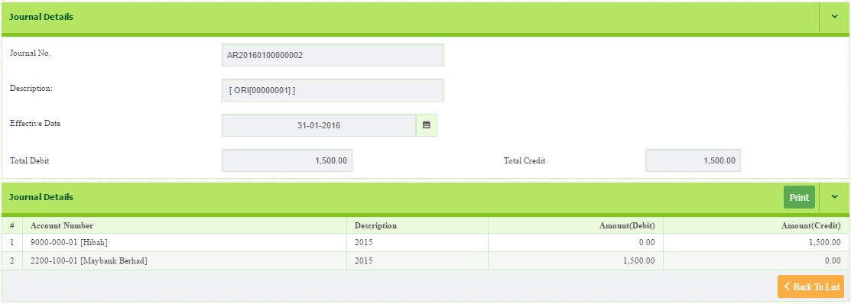
  - How to Generate Other Payment List

- Go to General ledger > Report > Other Payment List
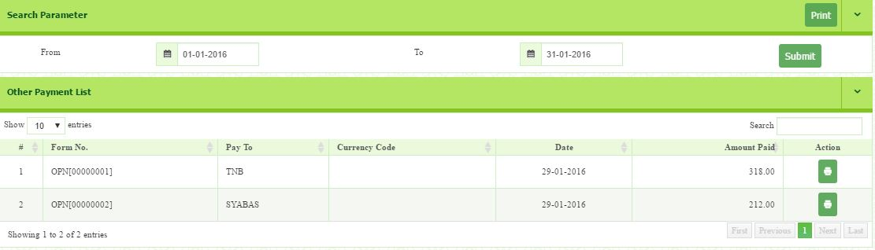
- Select From [01-01-2017] and To [31-01-2017]. Then, click button.

- The list of other payment will appear.
- You can print the report by clicking button.

  - How to Generate Other Receive List

- Go to General ledger > Report > Other Receive List.
- Select From [01-01-2017] and To [31-01-2017].
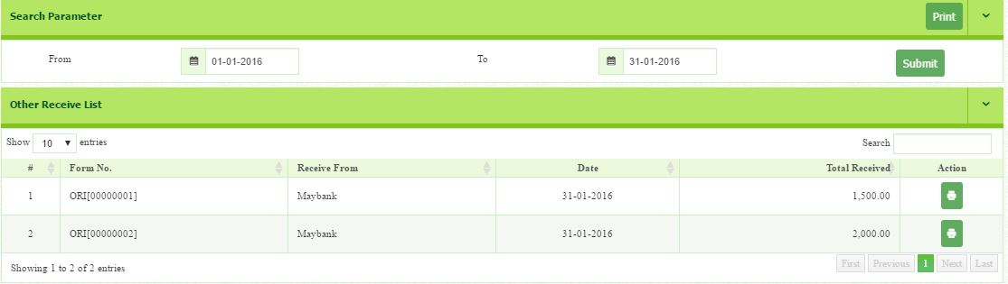

- The list of other receive will appear.
- You can print the report by clicking button.

LESSON THREE

MODULE 1: ACCOUNT PAYABLE (SERVICES)

Account Payable is money which a company owes to Supplier for goods and services purchased on credit. This item appears on the company Statement of Financial Position as a current liability, since the expectation is that the liability will be fulfilled in less than a year.

MODULE 2: ACCOUNT RECEIVABLE (SERVICES)

Account Receivable is money which a customer owes to company for goods and services sold on credit. This item appears on the company Statement of Financial Position as a current asset, since the expectation is that the asset will be fulfilled in less than a year.

MODULE 1: ACCOUNT PAYABLE (SERVICES)
  - How to Setup Supplier

- Go to Account Payable > Setup > Supplier Setup
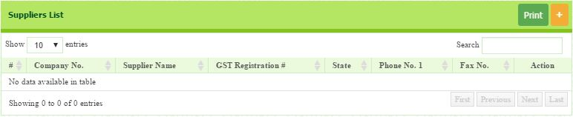
- Click button on the right top of the pages, to setup a New Supplier.

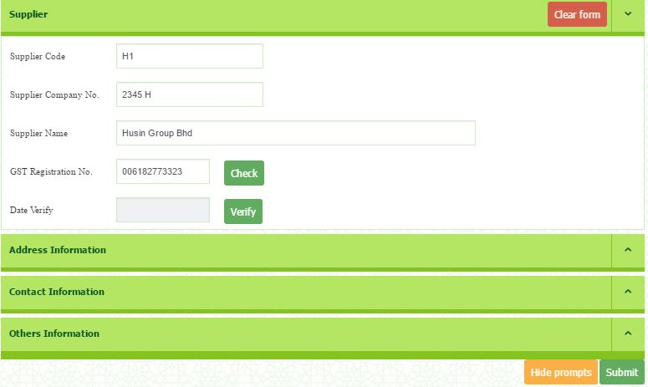
- You will be directed to the Supplier information page.

- Enter:
  - Supplier Code (H01)
  - Supplier Company No (2345 H) and
  - Supplier Name (Husin Group Berhad)
- If your Supplier is GST registrant, enter the GST Registration No. If not, just leave it blank.
- You must verify your supplier whether they register with Customs or not.

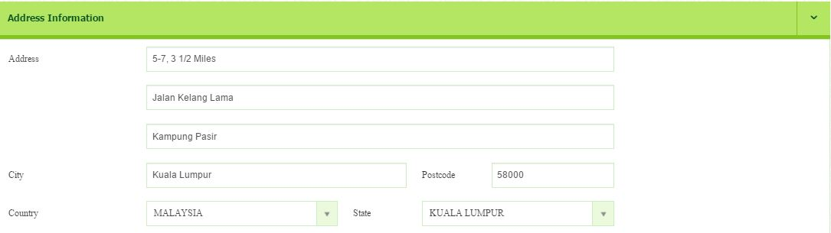
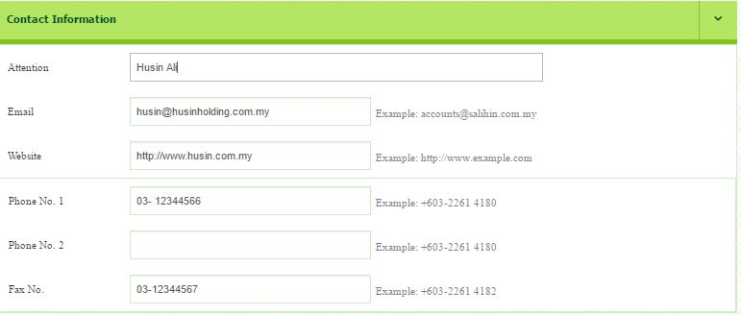
- Enter address information.

- Enter contact information.

- The most important thing is to choose Supplier Linked A/P Account. You can create new supplier chart of account by click dropdown button. Your supplier will be distinguished by linked A/P account in the Statement of Financial Position.
Please setup supplier chart of account as follow:
- Account Group: Current Liabilities
- Account Code: 3000-001-00
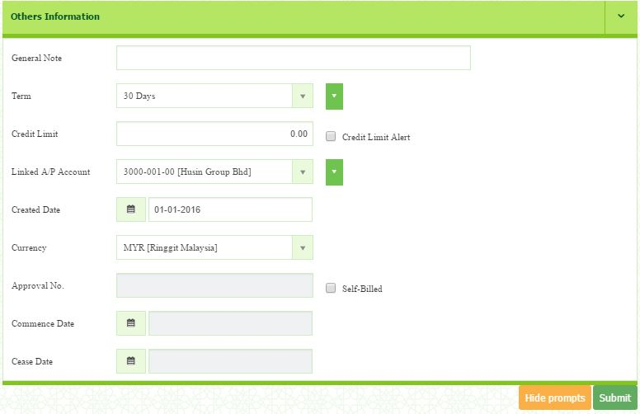
- Account Name: Husin Group Bhd

  - How to Create Direct Supplier Invoice

- By using direct purchase invoice, you are enables to create a purchase invoice and receipt at the same time.
- Certain companies does not want to maintain Inventory. The quantity of the stock does not record in the system by the company. Therefore, they should use Service/Other Charges function.

SERVICES (DOES NOT MAINTAIN INVENTORY)
- Go to Account Payables > Transaction > Direct Purchases Invoice
- Enter Form Number if necessary but the serial number will generate automatically
- Select Date (11-01-2017). If you do not change the date, it will record the current date.
- Select the Supplier (Husin Group)
- Enter Supplier Invoice No. (1001)
- Select Purchaser (Luqman)
- Select Location (HQ), Shipping Method (Freight) and Ships To (Gombak) from the drop down list.
- Any description or reminder can be included in the Memo.
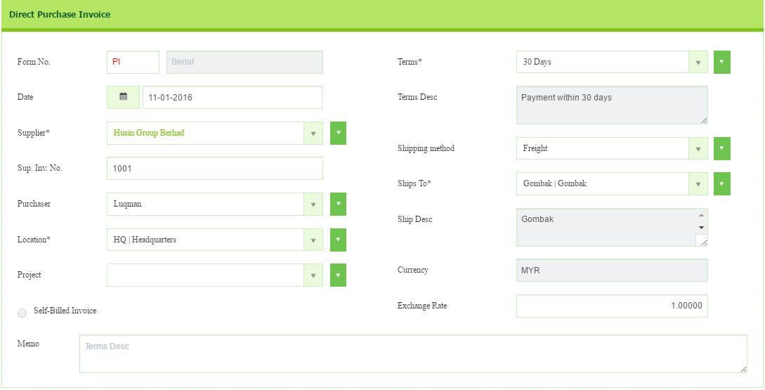

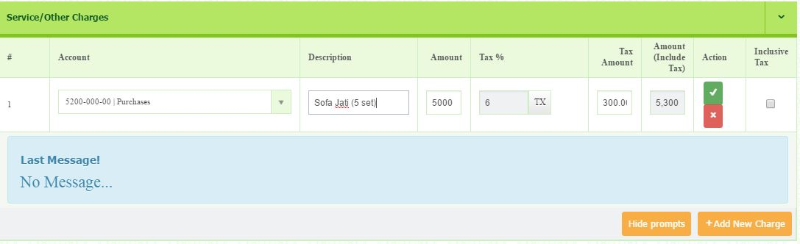
- Use Service/Other Charges section, click button to add new line for Other Charges

- Select the Account (Purchases) from the dropdown list.
- Enter the Description as Sofa Jati 5 sets.
- Enter the Amount RM5,000 (exclusive of GST)
- Select GST Tax Code (TX)
- To save, click the button.

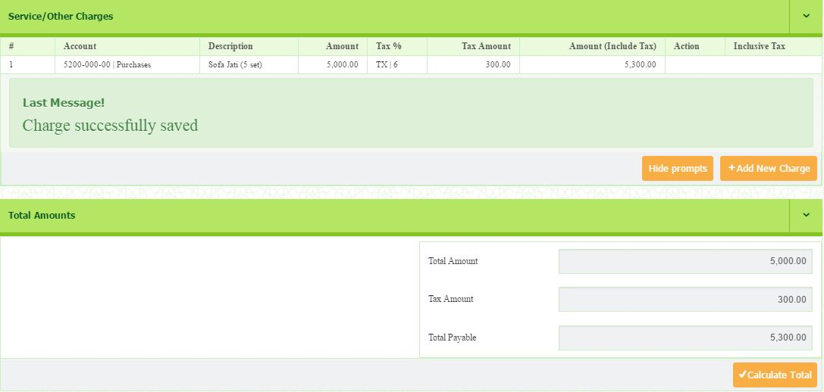
- Once you have save, the message will appear and the total of invoice will be calculated.

  - How to Confirm the Purchase Invoice
- Go to Account Payables > Transaction > Purchase Invoice Confirm
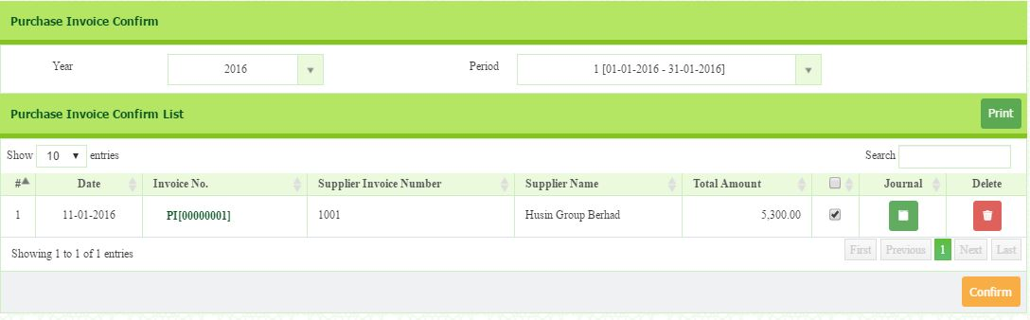
- Select Year (2017) and Period (1). The list will appear.

- From the list, identify the invoice you want to confirm.
- Then, tick small box and click button.

Edit invoice
- In this section, before you proceed to confirm, you need to double check all the information of your invoice. You are allowed to reedit.
- From the Purchase Invoice Confirm list, identify the invoice you want to reedit.
- Click the link of Direct Purchase Invoice No.
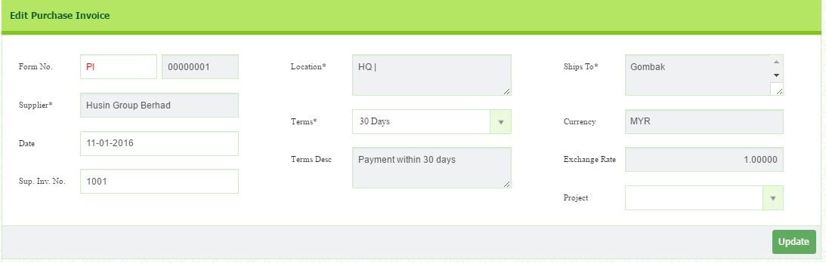
- You will be directed to the Edit Purchase Invoice page.
- Once you edited this section, click the button.
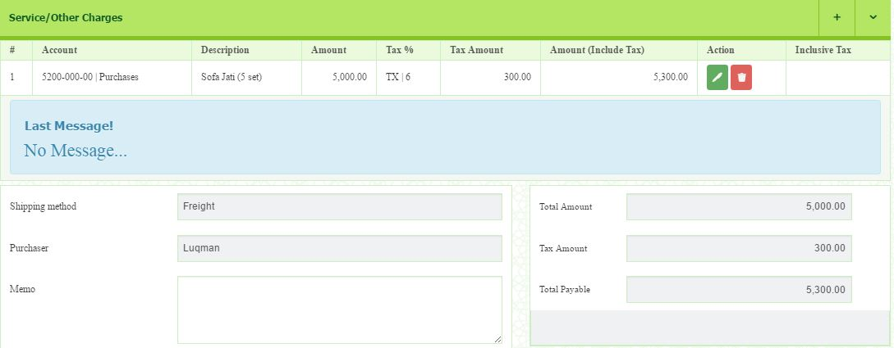
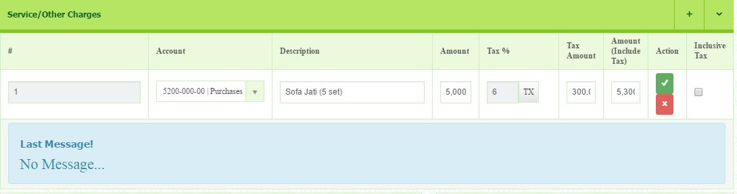
- Click button to edit. You will be directed to editing page.
- Then, after edit this section, click button.
- Wait until the message prompt as shown below.

  - How to Create Purchase Debit Note

In this section, the purchase debit note is issued as an adjustment to the invoice you received from the supplier to decrease the value of goods.
- Go to Account Payables > Transaction > Purchase Debit Note
- Select the date.
- If you do not change the date, it will record the current date
- Select the Supplier.
- Any new addition/ registration and refresh list, can be done by clicking the Green button
- Select the Invoice Number that created in Purchase invoice or Direct Purchase Invoice.
- Any description or reminder can be included in the Memo.
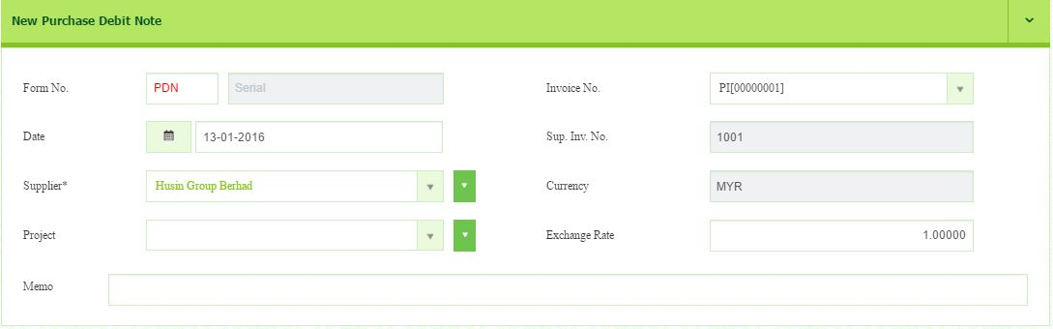

Under Service/Other Charges
- Click the Add New Charge button.
- Select the Account.
- You MUST select the same item that used in Direct Purchase Invoice or Purchase Invoice.
- Enter the Description.
- Enter the Amount.
- Select GST Tax Code.
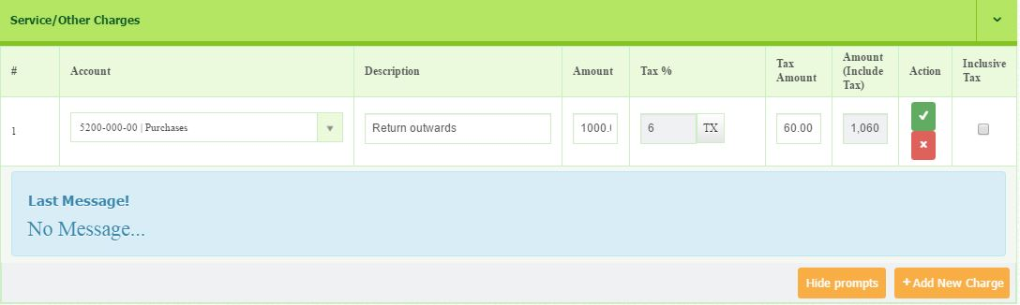
- To save, click the button.

  - How to Confirm the Purchase Debit Note

- Go to Account Payable > Transaction > Purchase Debit Note Confirm
- Select Year and Period.
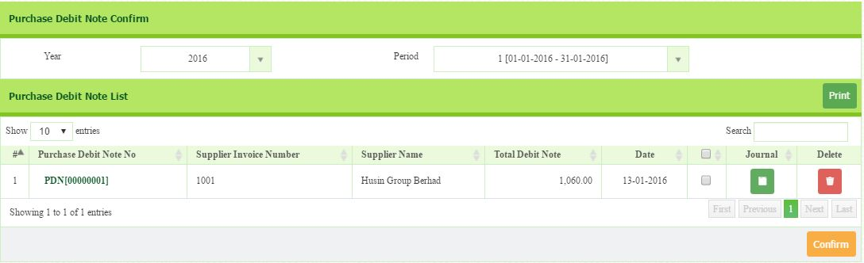
- The list of debit note will appear.

- Click the Invoice Number to re-check the details of the invoice created
- Tick the Purchase Debit Note List that you want to confirm.
- Then, click button.

  - How to Create Purchase Credit Note

In this section, the purchase credit note is issued as an adjustment to the invoice received from supplier to increase the value of the goods.
- Go to Account Payable > Transaction > New Purchase Credit Note
- Select the Supplier (Husin Group)
- Enter the date (15.1.2017)
  - If you do not change the date, it will record the current date
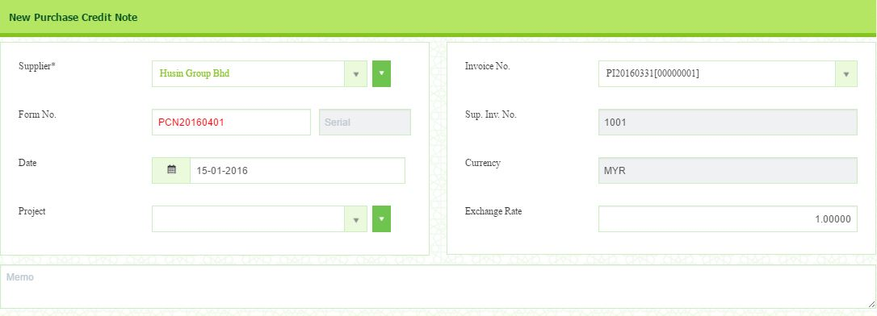
- Select the Invoice Number that created in Purchase invoice or Direct Purchase Invoice.

Under Service/Other Charges
- Click the Add New Charge button.
- Select the Account.
- You MUST select the same item that used in Direct Purchase Invoice or Purchase Invoice.
- Enter the Description.
- Enter the Amount.
- Select GST Tax Code (TX)
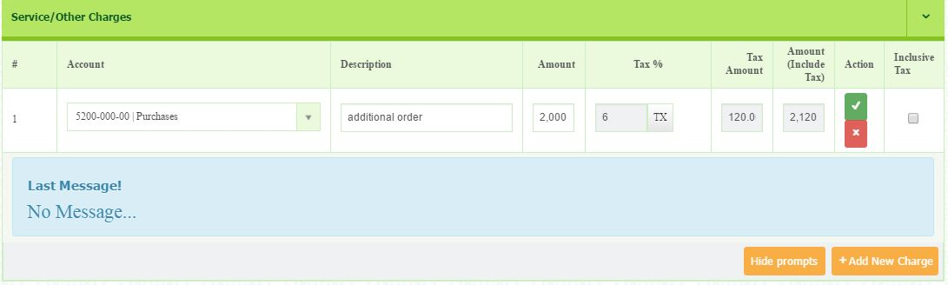
- To save, click the button.

  - How to Confirm Purchase Credit Note

- Go to Account Payable > Transaction > Purchase Credit Note Confirm
- Select Year (2017) and Period (1)
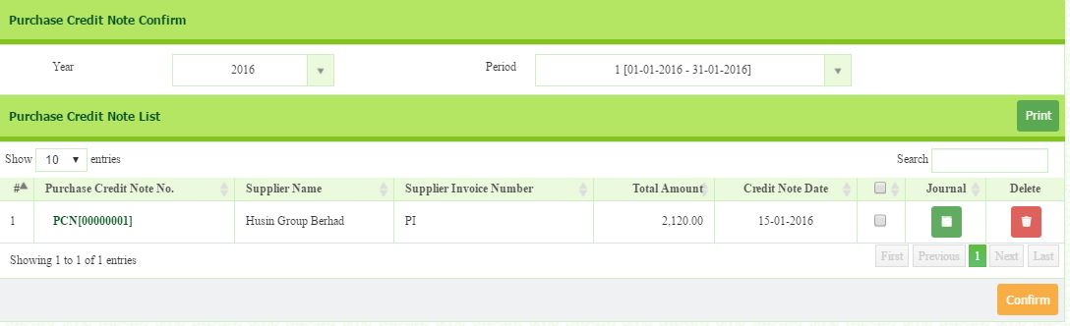
- The list will appear.

- Click the Invoice Number to check the details of the invoice created
- Tick the Purchase Credit Note List that you want to confirm.
- Then, click button.

  - How to Create Supplier Payment Advice

In this section, you will record payment made to suppliers.
- Go to Account Payables > Transaction > Supplier Payment Advice
- Select Supplier (Husin)
- Select Payment Method (Cheque)
- Enter Reference No (100003)
- Enter Description. (Part of Payment)
- Select Payment Date. (18.1.2017)
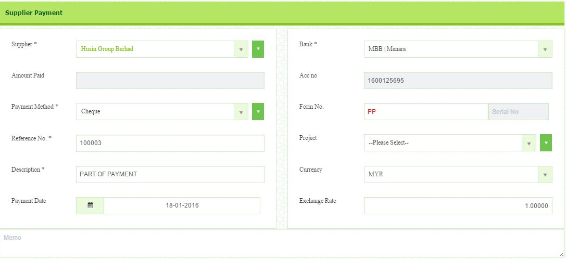
- Select Bank. (MBB)

- Enter Form Number if necessary but the serial number will generate automatically.
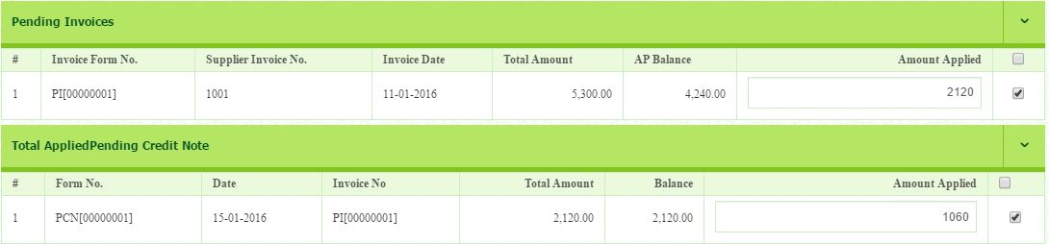
- Once you select the supplier, all invoices, debit notes and credit notes related to the supplier will be appear.

- As you can see, the total of the AP balance is RM4, 240. It is because the amount is already set off with the debit note.
- Select invoice/credit note as you want to pay. Click the box.
- Half of the invoice is paid. RM2, 120 for invoice, RM1, 060 for credit note.
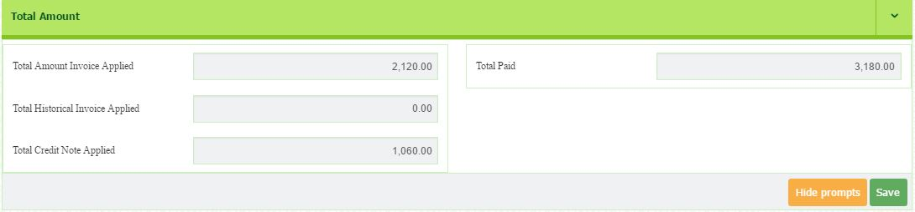
- Once you have select, click button.

LIST(S) OF INVOICES
- In the List of Invoice section, it will display all the listing of pending invoices.
- By selecting the particular row, you can decide amount of discount and amount applied.
- Once the row has been selected, you will see the summary of Total Discount, Bank Charges, Total Other Charges, Total Received, Total Applied, Total Other Charges and Out of Balance.
- Click Save button to save it.

LIST(S) OF DEBIT NOTES
- In the List of Debit Note section, it will display all the listing of debit note.
- You may tick the related debit note that associated with the invoice.
- It will not automatically add into the total amount of an invoice.

LIST(S) OF CREDIT NOTES
- In the List of Credit Note section, it will display all the listing of credit note.
- You may tick the related credit note that associated with the invoice.
- It will not automatically add into the total amount of an invoice.

  - How to Confirm Supplier Payment Advice

- Go to Account Payables > Transaction > Supplier Payment Confirm
- Select Year (2017) and Period (1)
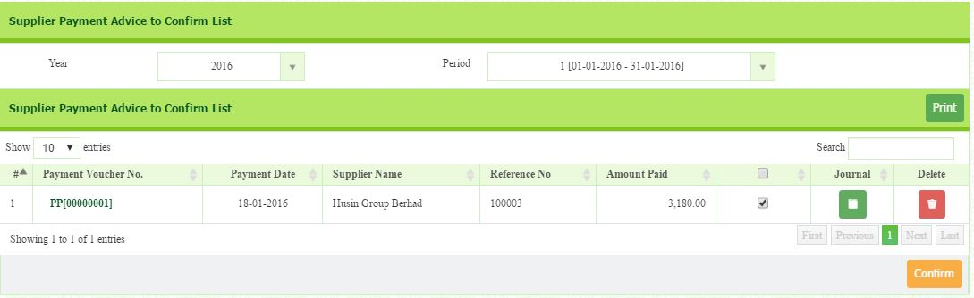
- The list will appear.

- Select Supplier Payment Advice To Confirm List.
- Then, Click button.
- You may edit the header and Item(s) details by clicking the Payment Voucher No.
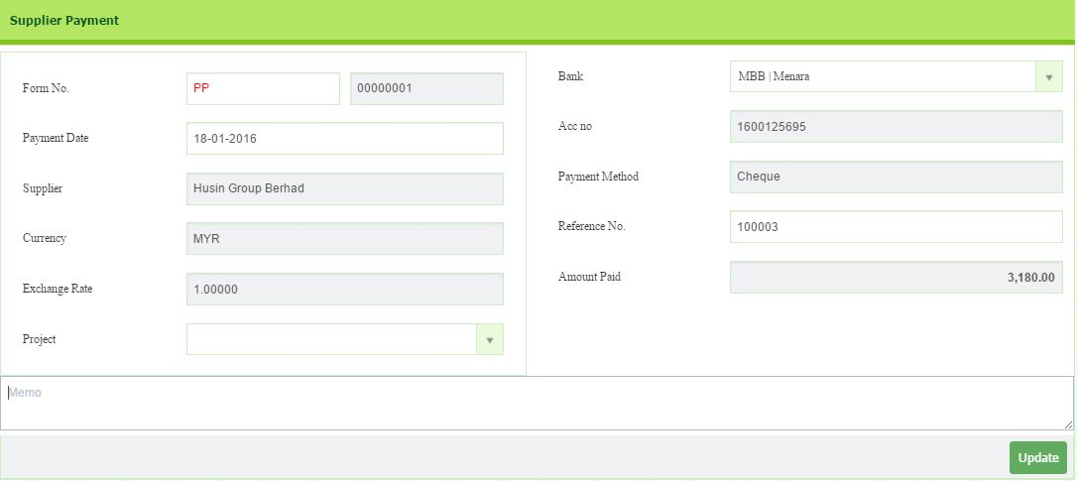
- You will be directed to editing page.
- Once complete, click button.

  - How to Generate Report?

In this section, you will generate all the report related to supplier. The reports include purchase invoice, purchase debit note, purchase credit note, supplier payment, and supplier statement.

  - How to Generate Purchase Invoice List

- Go to Account Payables > Reports > Purchase Invoice List
- Select the Period (1.1.2017 – 31.1.2017)
- Select the Status either open or closed
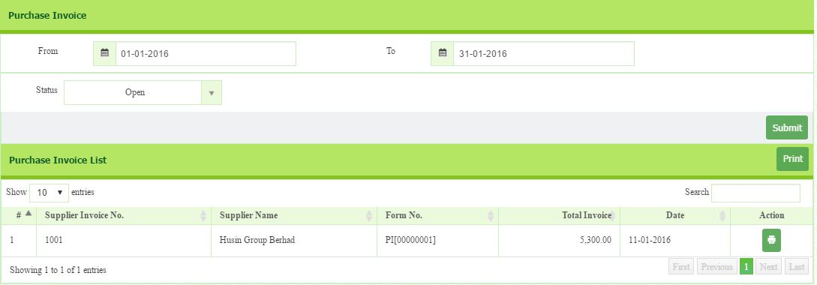
- Click button.
- Click button to review and print the report.
- Example of Purchase Invoice Receipt
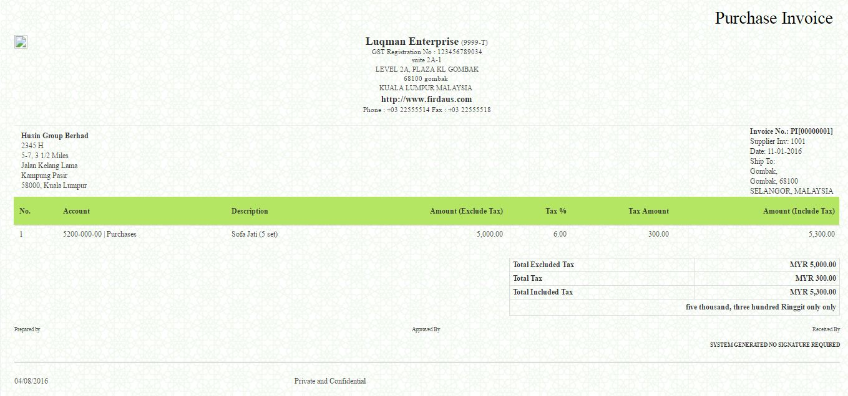

  - How to Generate Purchase Debit Note

- Go to Account Payables > Reports > Purchase Debit Note List.
- Select the Period (1.1.2017 – 31.1.2017)
- Click button.
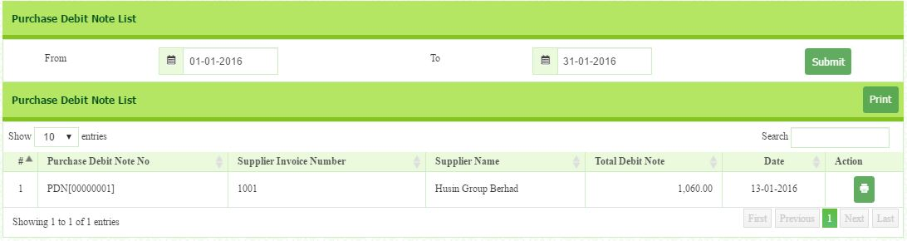
- The list of debit note will appear.

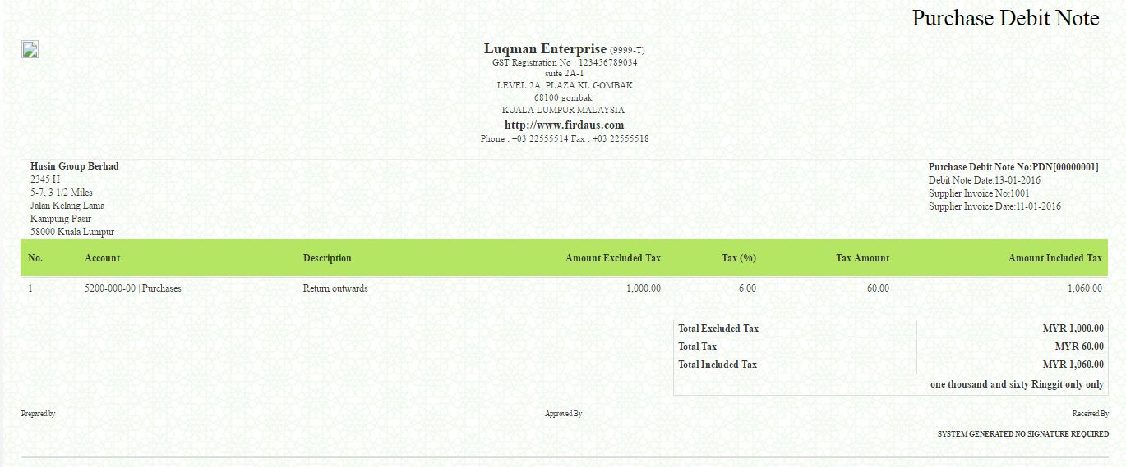
- Click to review and print the purchase debit note.

  - How to Generate Purchase Credit Note

- Go to Account Payables > Reports > Purchase Credit Note List.
- Select the Period (1.1.2017 – 31.1.2017)
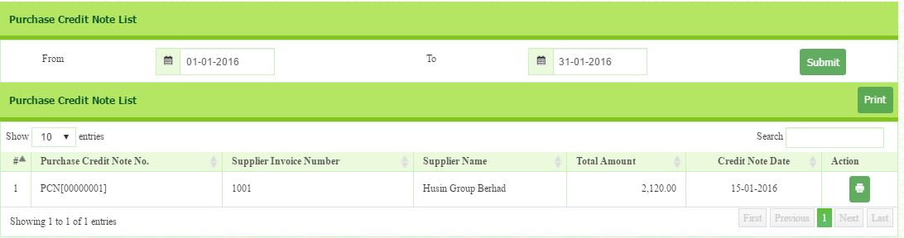
- Click button. The list of credit note will appear.

- Click to review and print the report.
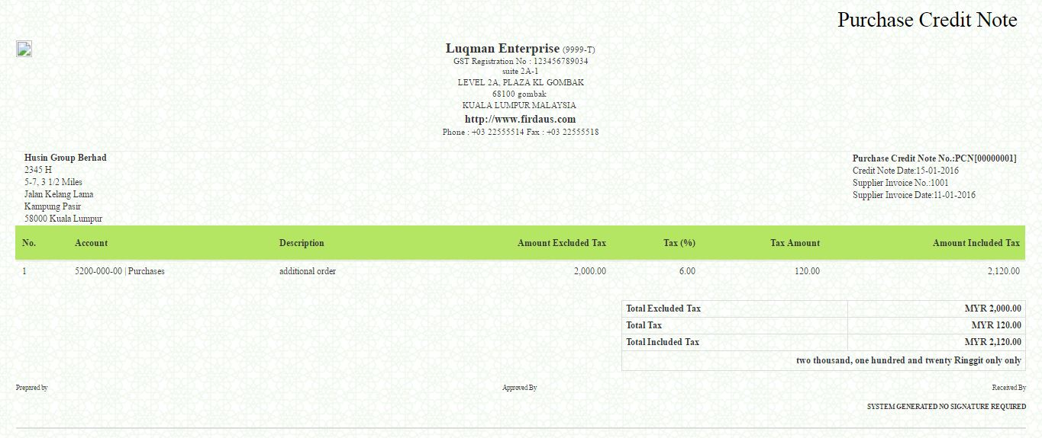
- Example of Purchase Credit Note.

  - How to Generate Supplier Payment

- Go to Account Payables > Reports > Supplier Payment List.
- Select the Period (1.1.2017 – 31.1.2017)
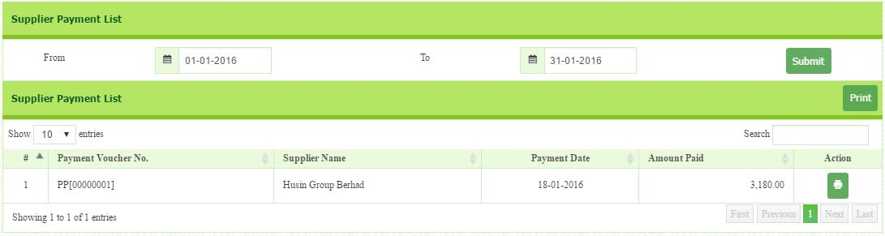
- Click button.

- Click to review and print payment advice/voucher.
- Example of Payment Advice/Voucher
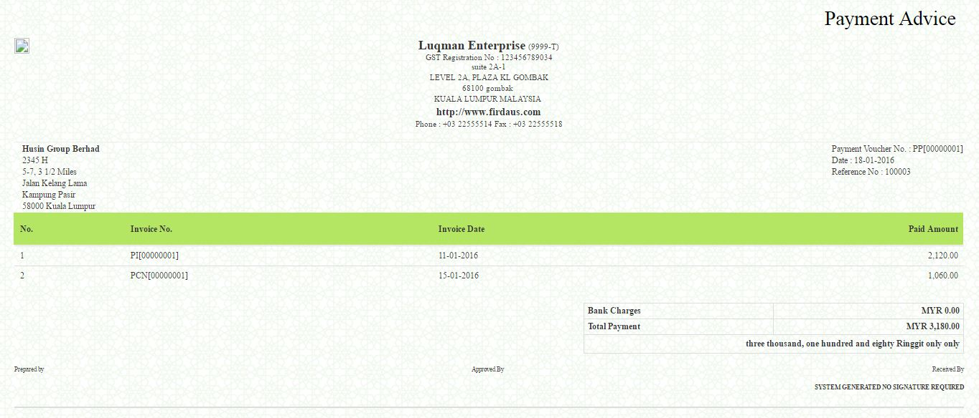

  - How to Generate Supplier Statement List

- Go to Account Payables > Reports > Supplier Statement List
- Enter Default Footer Message.
- Select the Supplier name.
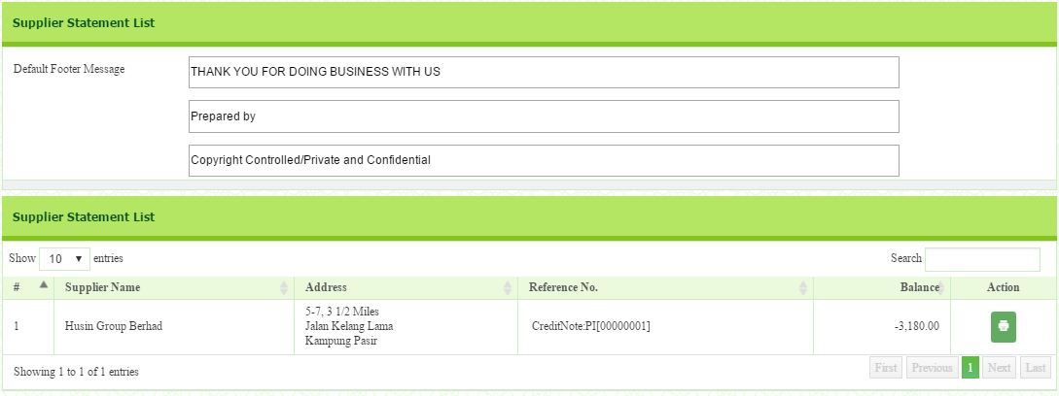
- Click button to review and print the report.

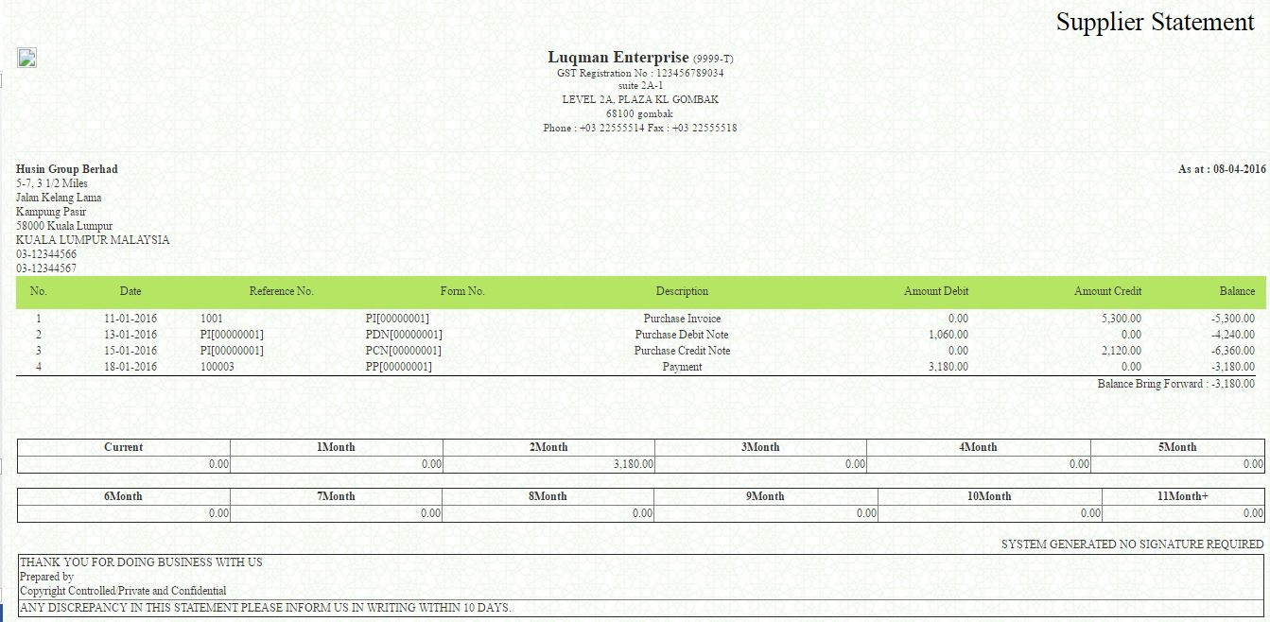
- Click button to print the report.

Exercise
Add some of the purchase invoice. Use direct purchase invoice.
- Date: 4-4-2017
- Supplier: Husin Group
- Supplier Invoice No: 0002
- Purchaser: Luqman
- Location: HQ
- Shipping Method: Freight
- Ships To: Gombak
- Account: Purchases
- Description: Sofa Jati 50 sets.
- Amount RM50,000 (exclusive of GST)
- GST Tax Code: TX

Payment made to supplier.

- Supplier: Husin
- Payment Method: Cheque
- Reference No: 100003
- Description: Part of Payment
- Payment Date: 11.4.2017
- Bank: MBB
- Amount: RM27,000

MODULE 2: ACCOUNT RECEIVABLE (SERVICES)

  - How to Setup Customer

- Go to Account Receivable > Setup > Customer Setup
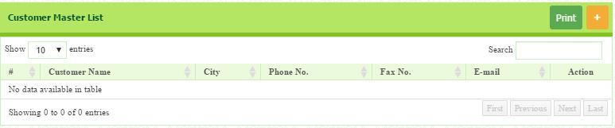
- To add customer, click button that located at the top right page.

- You will be directed to customer master page.
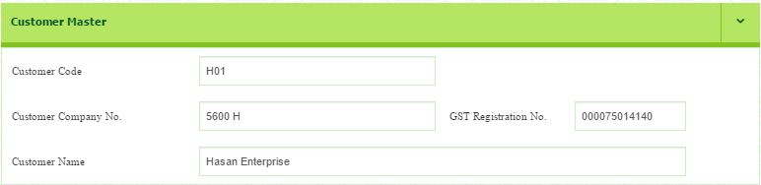
- Enter your customer information

- Enter address information
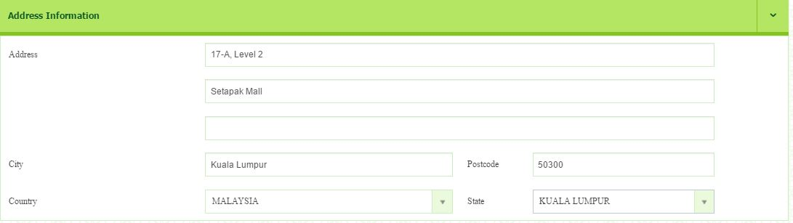

- The most important thing is to choose Supplier Linked A/R Account. You can create new supplier chart of account by click dropdown button. Your supplier will be distinguished by linked A/P account in the Statement of Financial Position
Please setup customer chart of account as follow:
- Account Group: Current Asset
- Account Code: 2100-001-00
- Account Name: Hasan Enterprise
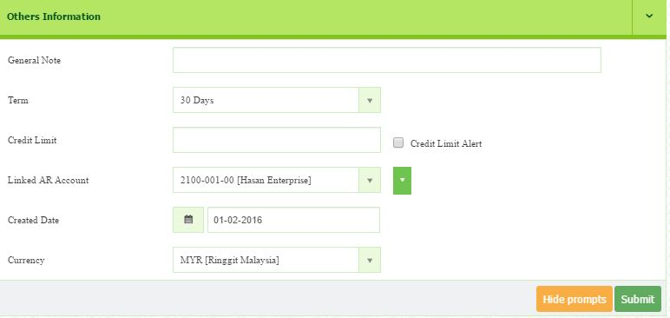
- Once completed, click button to save.

  - How to Create Direct Sales Invoice

SERVICES (DOES NOT MAINTAIN INVENTORY)

- Go to Account Receivables > Transaction > Direct Sales Invoice
- Enter Form Number if necessary but the serial number will generate automatically.
- Select Date (1.2.2017)
  - If you did not change the date, it will record the current date
- Select the Customer (Hasan)
- Insert the Customer PO Number (1001)
- Terms (30 Days), and Shipping Method (Freight) from the drop down list.
- Any description or reminder can be included in the Memo.
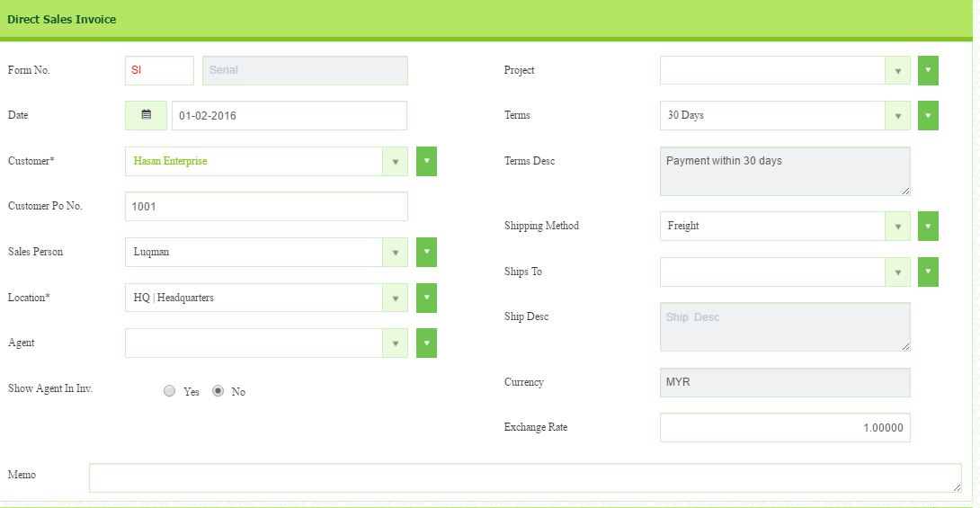

- Use Service/Other Charges section.
- Click Add New Charges button to add new line for Other Charges.
- Select the Sales account.
- Fill in the Description as (Two Sets of Sofa Jati)
- Amount (RM8,000 for 2 sets)
- GST Code (SR)
- Once completed, click the button to save.
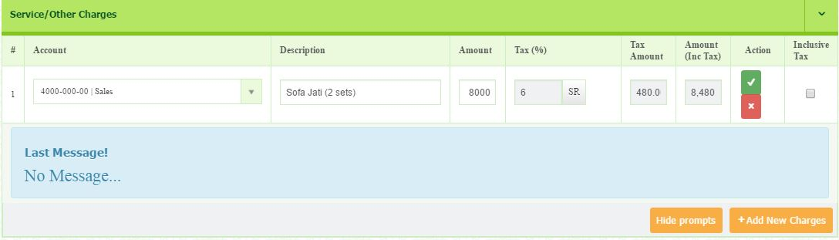

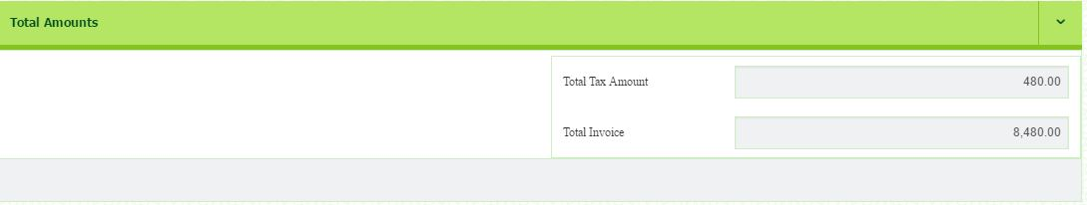
- Once you have save, the message will appear and the total of invoice will be calculated.

  - How to Confirm Sales Invoice

- Go to Account Receivables > Transaction > Sales Invoice Confirm
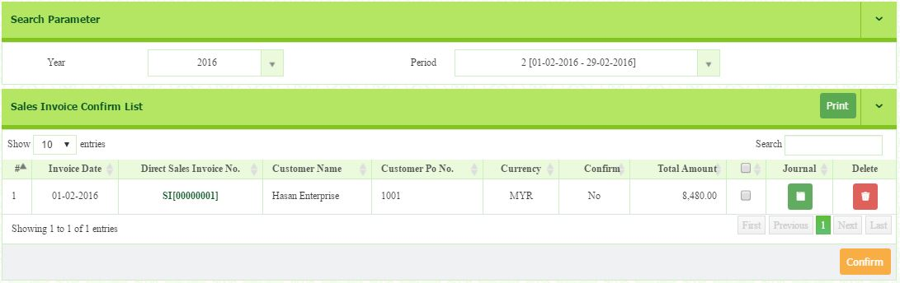
- Select Year (2017) and Period (2).The list will appear.

- From the list, identify the invoice you want to confirm.
- Then, tick small box and click button.

Edit invoice
- In this section, before you proceed to confirm, you need to double check all the information of your invoice. You are allowed to edit.
- From the Sales Invoice Confirm list, identify the invoice you want to reedit.
- Click the link of Direct Sales Invoice No.
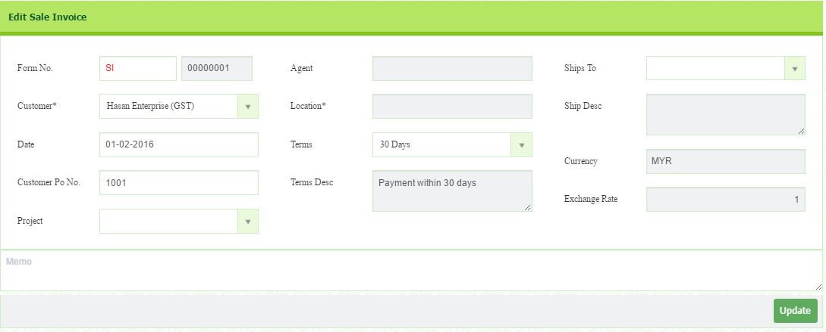
- You will be directed to the Edit Sales Invoice page.
- Once you completed edit, click the button.

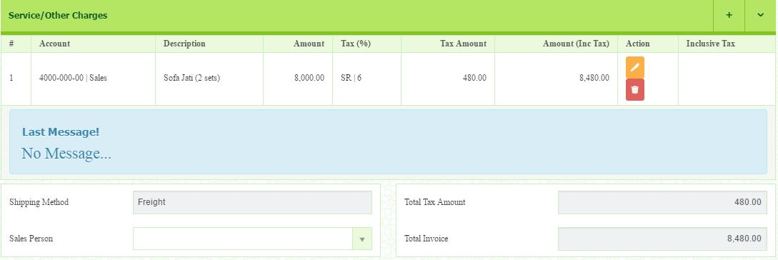
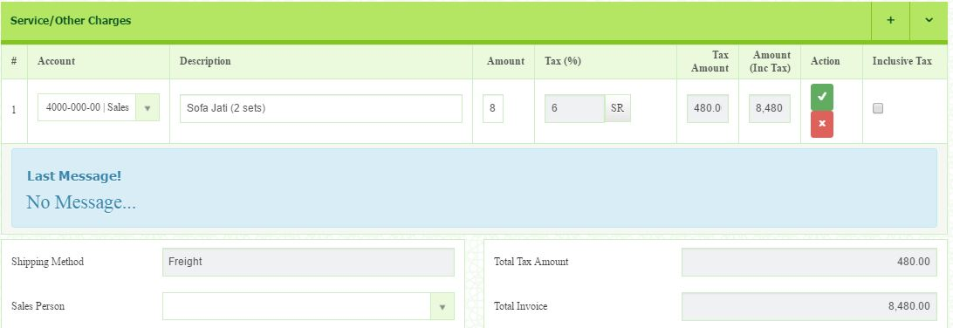
- Click button to edit. You will be directed to editing page.
- After edit, click button.
- Wait until prompt message appear.
  - How to Create Sales Debit Note

The Sales Debit Notes is issued as an adjustment to the invoice that you have previously created to increase the value of goods.

- Go to Account Receivables > Transaction > Sales Debit Note
- Select Date. (4.2.2017)
  - If you do not change the date, it will record the current date.
- Select the Customer (Hasan Enterprise)
- Select the intended Invoice Number that created in Direct Sales Invoice or Sales Invoice.
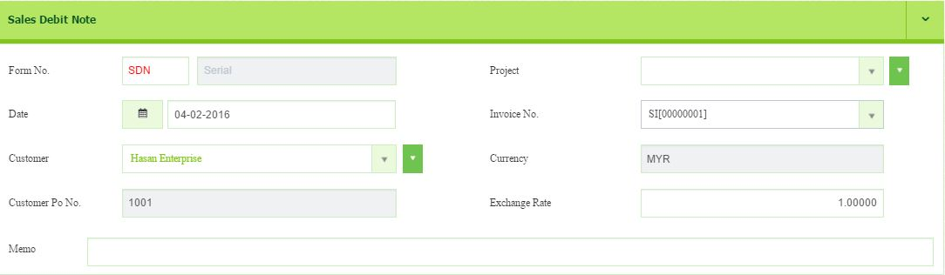
- Any description or reminder can be insert in the Memo.

Under service/other charges,
- Click (Add New Charges) button to add new line for Other Charges.
- Select the Account (Sales).
- Fill in the Description as (additional order by customer)
- Amount (RM4000)
- Tax Code: SR
- Click the button in the Action column to record the data.
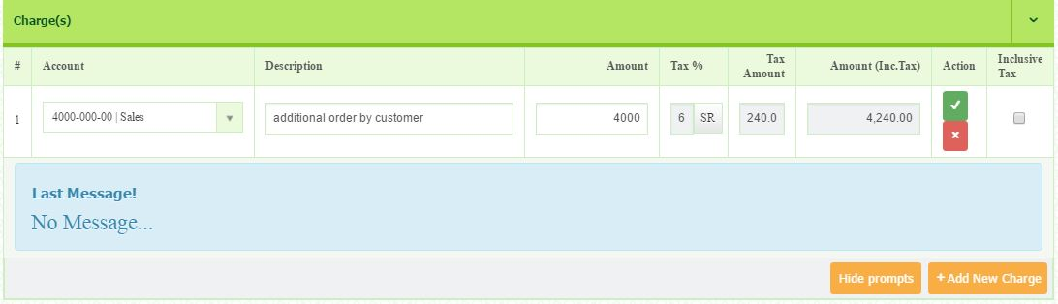
- The total amount will be automatically calculate and appear in Total Amounts section.
  - How to Confirm Sales Debit Note

- Go to Account Receivables > Transaction > Sales Debit Note Confirm
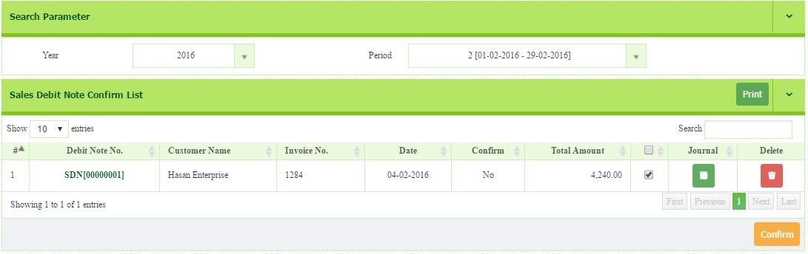
- Select Year (2017) and Period (2). The list will appear.

- Click the Invoice Number to re-check the details of the invoice.
- Tick small box if you are sure to do the confirmation.
- Once completed, click button

  - How to Create Sales Credit Note

The Sales Credit Note is issued as an adjustment to the invoice that you have previously created to decrease the value of the goods. For example, goods that returned from customer and also discounts given on that goods.

- Go to Account Receivables > Transaction > Sales Credit Note
- Select Date (8.2.2017)
  - If you do not change the date, it will record the current date
- Select the Customer (Hasan Enterprise)
- Select the Invoice Number (000000001)
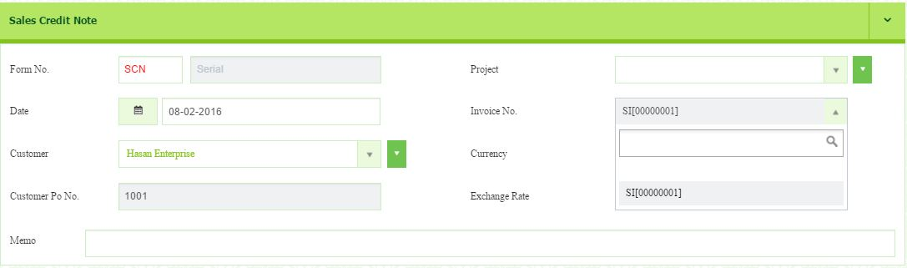
- Any description or reminder can be insert in the Memo.

Under service/other charges section

- Click button to add new line for Other Charges.
- Select the Account (Sales).
  - You MUST select the same chart of account that used in Direct Sales Invoice
- Fill in the Description as (return one set of Sofa Jati)
- Amount (RM4,000)
- Tax (SR)
- Click the button in the Action column to record the data.
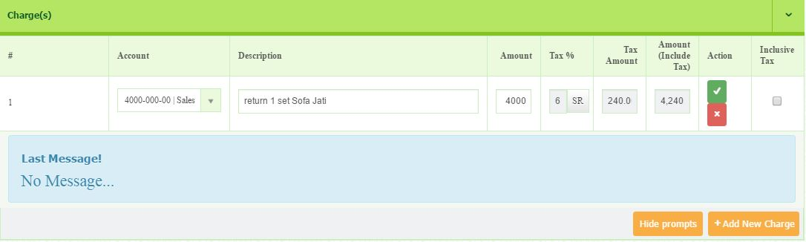
- The total amount will be automatically calculate and appear in Total Amounts section.

  - How to Confirm Sales Credit Note

- Go to Account Receivables > Transaction > Sales Credit Note Confirm
- Select Year (2017) and Period (2).
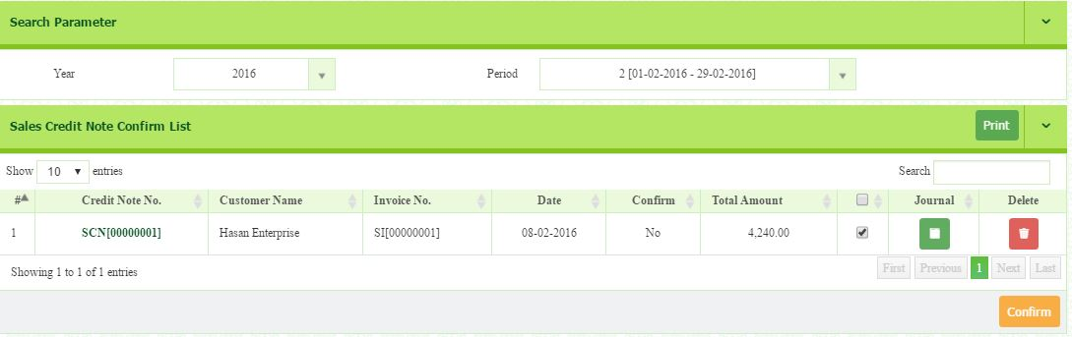
- The list will appear.

- Click the Invoice Number to re-check the details of the invoice created.
- Tick small box in if you are sure to do the confirmation.
- Once completed, click button

  - How to Create Customer Payment Received

- Go to Account Receivables > Transaction > Customer Payment Received
- Select Date (12.2.2017)
- Select name of bank (MBB).
- Select name of the Payer (Hasan Enterprise)
- You have to enter the Reference No (9090)
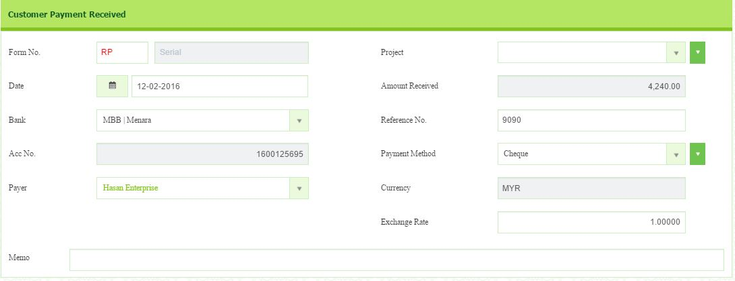
- Select the payment method (Cheque)

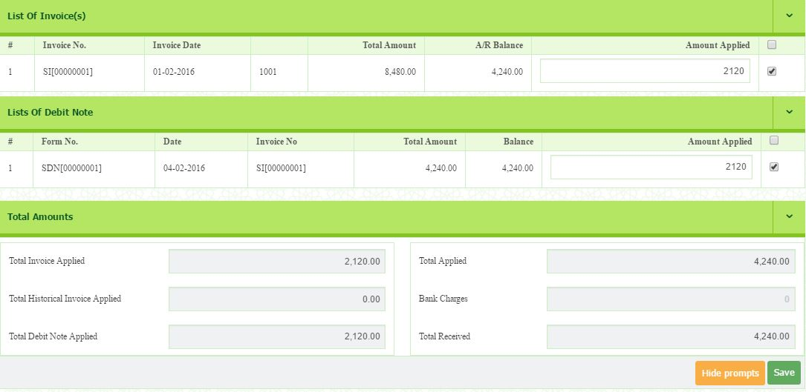
- Once you select the customer, all invoices, debit notes and credit notes related to the customer will appear.
- As you can see, the total of the AR balance is RM 4,240. It is because the amount is already set off with the sales credit note.
- Select invoice/debit note as customer has paid. Click the box

- Then, click button.
LIST(S) OF INVOICES
- In the List of Invoice section, it will display all the listing of invoices.
- By selecting the particular row, you can decide amount of discount and amount applied.
- Once the row has been selected, you will see the summary of Total Discount, Bank Charges, Total Other Charges, Total Received, Total Applied, Total Other Charges and Out of Balance.
- Click Save button to save it.

LIST(S) OF DEBIT NOTE
- In the List of Debit Note section, it will display all the listing of debit note.
- You may tick the related debit note that associated with the invoice.
- It will not automatically add into the total amount of an invoice.

LIST(S) OF CREDIT NOTE
- In the List of Credit Note section, it will display all the listing of credit note.
- You may tick the related credit note that associated with the invoice.
- It will not automatically add into the total amount of an invoice.

  - How to Confirm Customer Payment Received

    - Go to Account Receivables > Transaction > Customer Payment Received Confirm
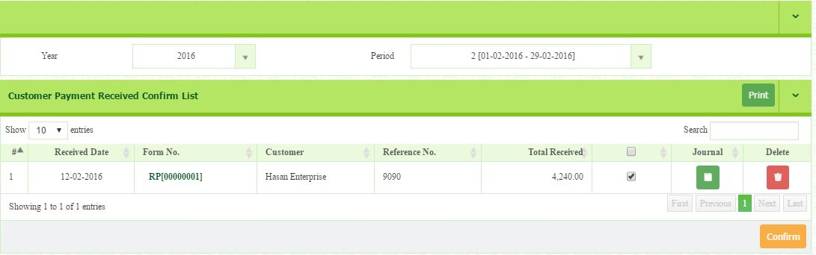
    - Select Year (2017) and Period (2). The list will appear.

    - Tick (√) small box if you are sure to do the confirmation.
    - Then, click button.
    - You may edit the header and Item(s) details by clicking at the Form No.
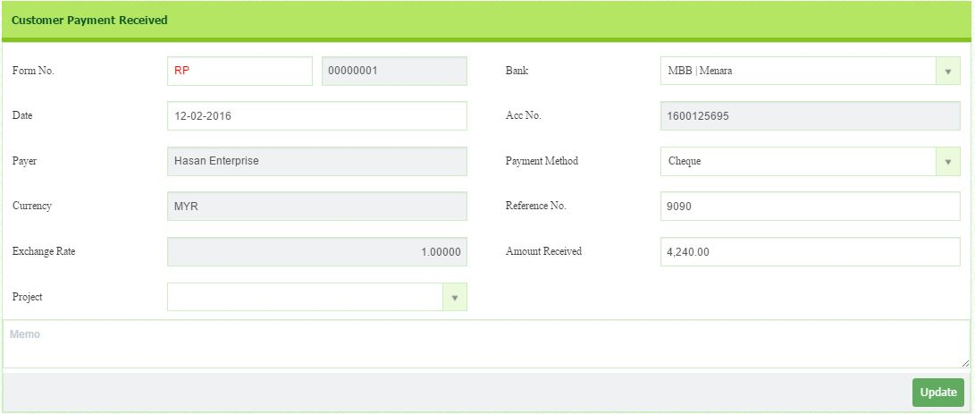
    - You will be directed to editing page.
    - Click button to save this section.

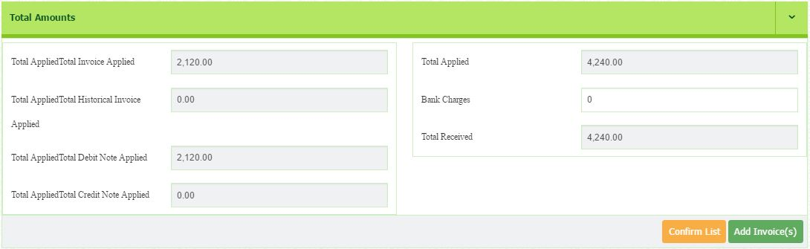
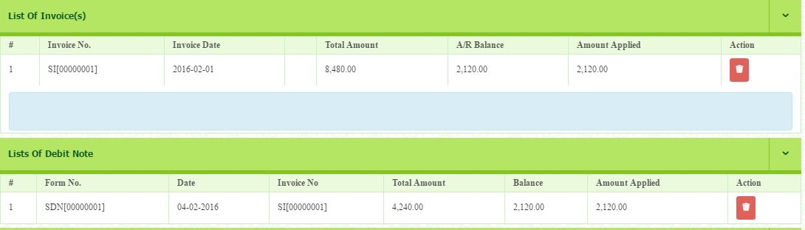
- Once complete, click button.

  - How to Generate Report?

In this section, you will generate all the report related to customer. The reports include sales invoice, sales debit note, sales credit note, customer payment, customer statement.

  - How to Generate Sales Invoice list

- Go to Account Receivables > Reports > Sales Invoice List
- Select the Date From (1.2.2017) and Date To (29.2.2017)
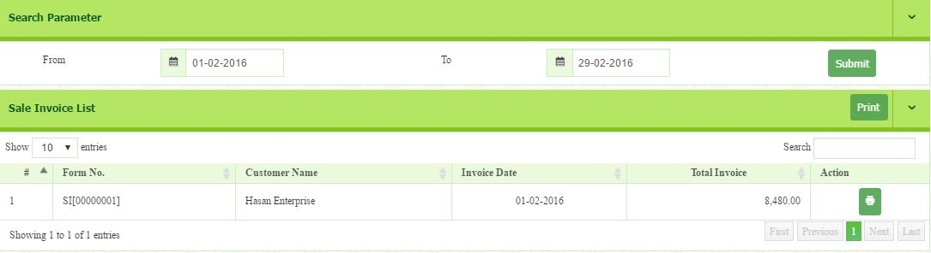
- Then, click button. The sales invoice list will appear.
- Click button to review and print the selected customer invoice.
- Example of sales tax invoice
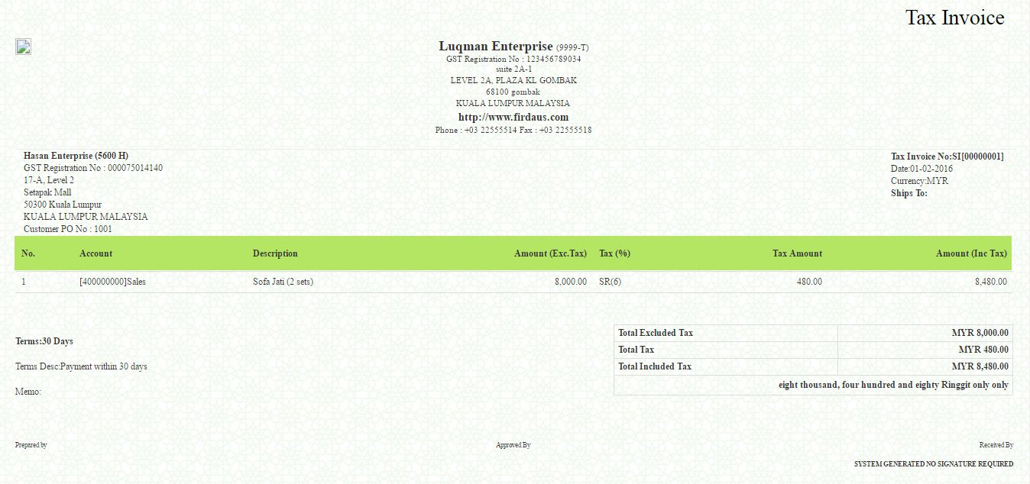
  - How to Generate Sales Debit Note List

- Go to Account Receivables > Reports > Sales Debit Note List
- Select the Date From (1.2.2017) and Date To (29.2.2017)
- Then, click button. The list will appear.
- To print, click the button that located in the same row of Form No.
- Click the button to print all the list of the invoices.
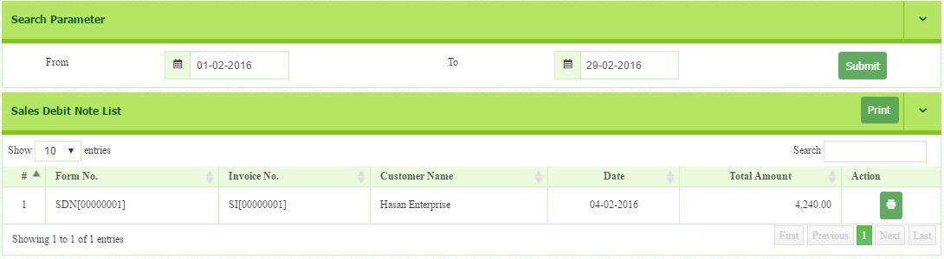
  - All the invoice list will appear if you have made the Sales Debit Note Confirm.
.
- Click button to review and print the selected customer sales debit note
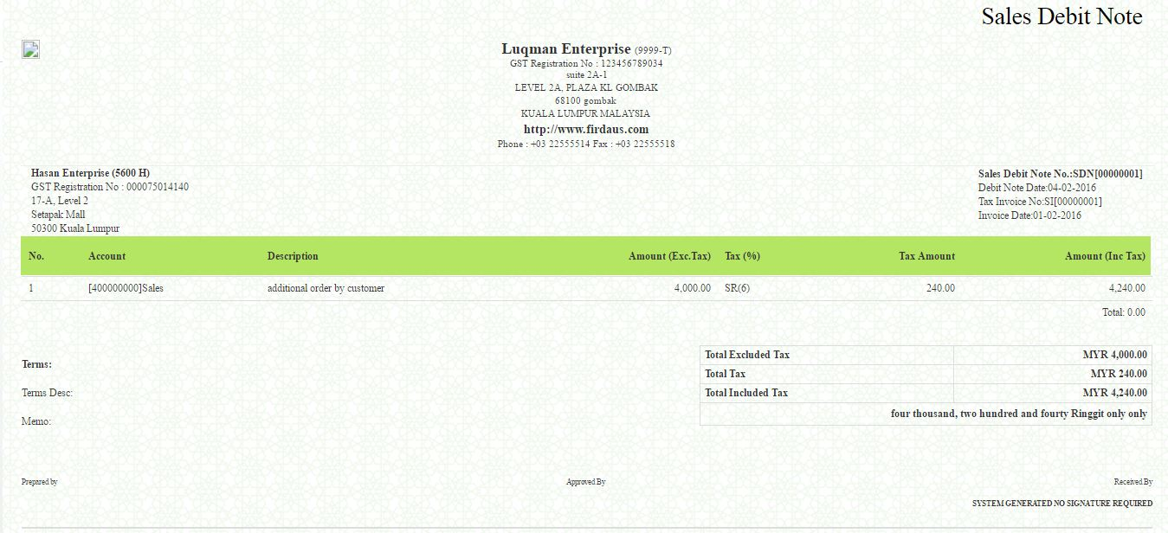
- Example of Debit Note of Hasan Enterprise.

  - How to Generate Sales Credit Note List

- Go to Account Receivables > Reports > Sales Credit Note List
- Select the Date From (1.2.2017) and Date To (29.2.2017)
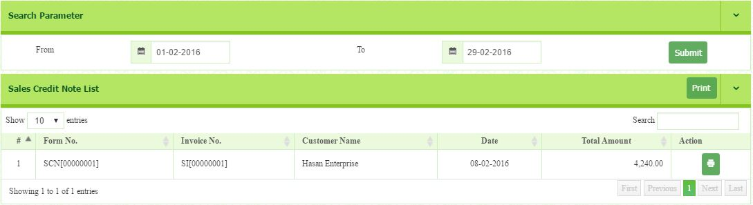
- Then click button. The list will appear.
- Click button to review and print the selected customer sales debit note
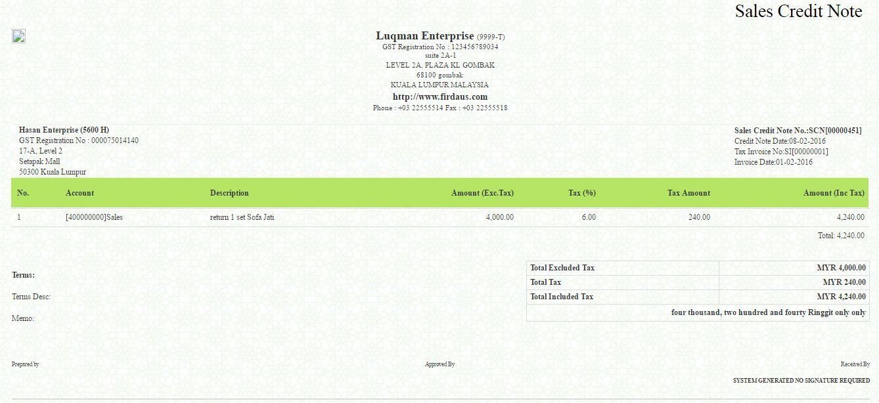
- Example of Credit note list

  - How to Generate Payment Receive List

- Go to Account Receivables > Reports > Payment Receive List
- Select the Date From (1.2.2017) and Date To (29.2.2017)
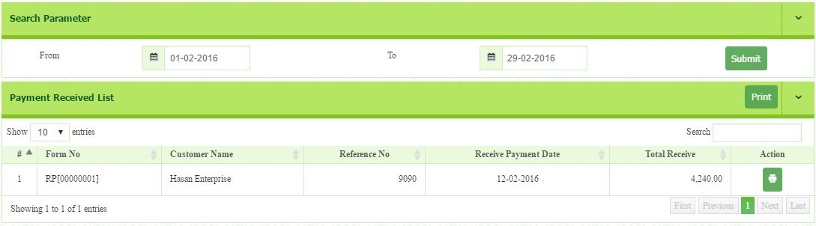
- Then click button. The list will appear.
- Click button to review and print the selected customer payment receive.
- Official receipt will be produced.
- Example of Official Receipt.
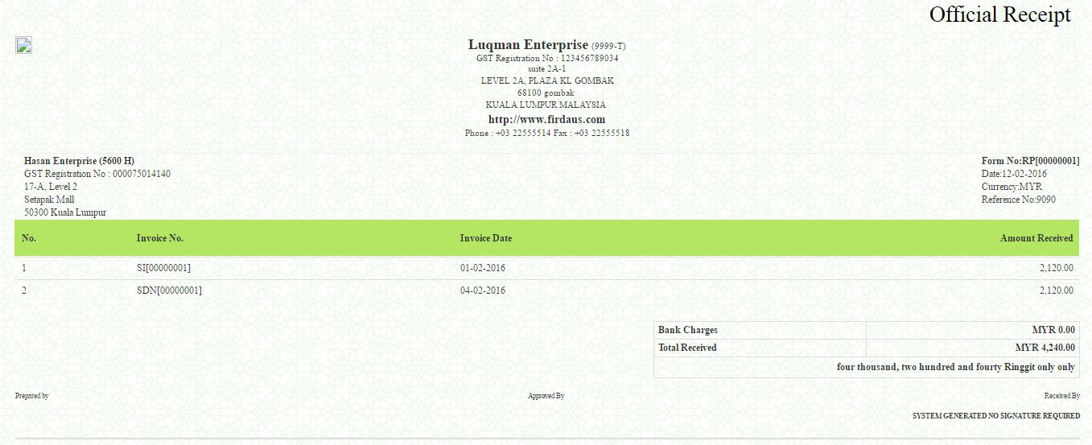

  - How to Generate Customer Statement

- Go to Account Receivables > Reports > Customer Statement
- Enter Default Footer Message in the Footer Customization section.
- To print, click button in the action column.
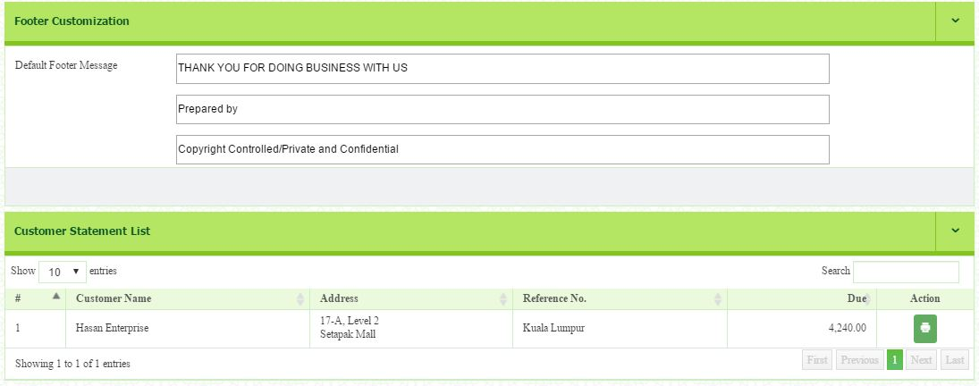
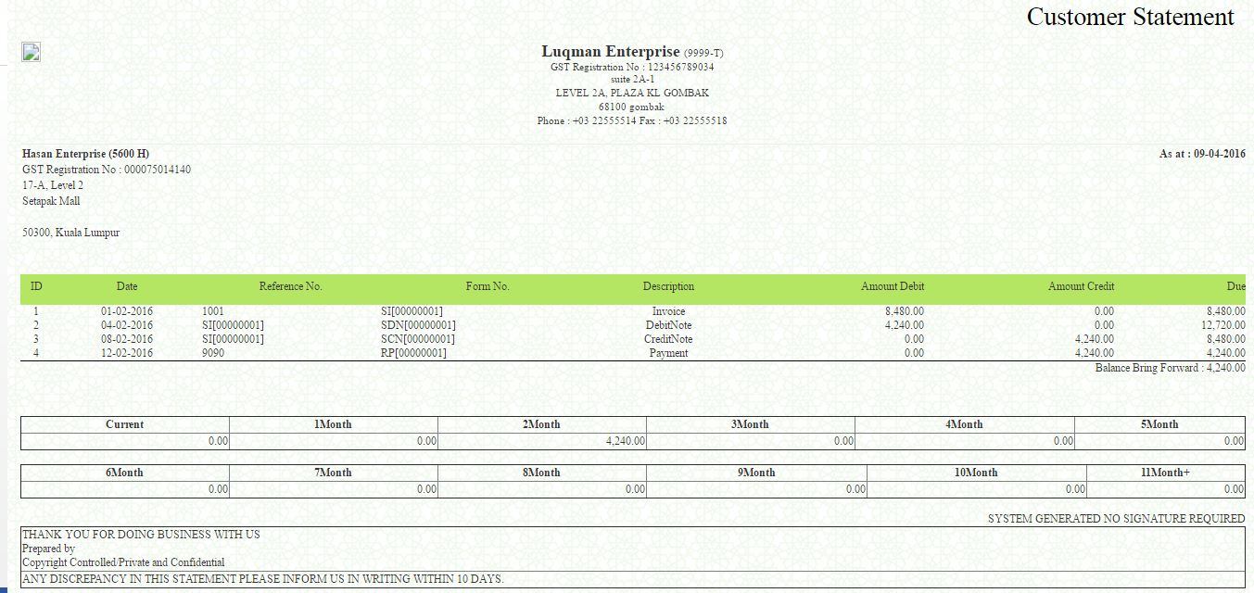
- Example of Hasan Enterprise Statement.

  - How to Generate AR Summary

- Go to Account Receivables > Reports > AR Summary
- Click the Period or Month.
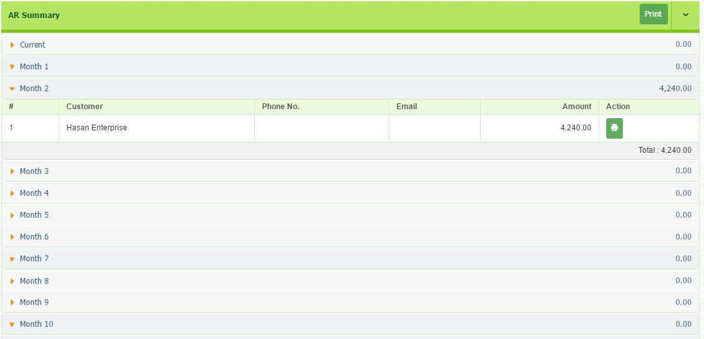
- It will list all the AR transaction by recording it by monthly.
- You can print the report, details of each transaction by clicking the button.

Exercise
Add some of the Sales invoice. Use direct sales invoice.
- Date: 3.5.2017
- Customer: Hasan Enterprise
- Customer PO Number: 1002
- Terms: 30 Days
- Shipping Method: Freight
- Account: Sales (4000-000-00)
- Description: Sofa Jati 40 Sets
- Amount: RM150,000
- GST Code (SR)

Payment received from customer.

- Date: 31.5.2017
- Bank: MBB
- Payer: Hasan
- Ref no: 707070
- Payment Method: Cheque
- Amount: RM106,000

LESSON FOUR
MODULE: GOODS AND SERVICES TAX
This module provide user with the GST transaction and reports required by Customs in GST submission.

- How to Setup Tax Table List
We have already put this setup under default setting. You need to know there are 23 GST codes as suggested by Customs. However, you may select the codes that applicable to your business only. You can also add some codes if you think it is appropriate to do so. You may study the codes attached in appendix 1.
To add, follow the steps below:
- Go to Goods & Services Tax > Setup > Tax Table List
- Click button to add tax table list. Then, you will be directed to the following page.
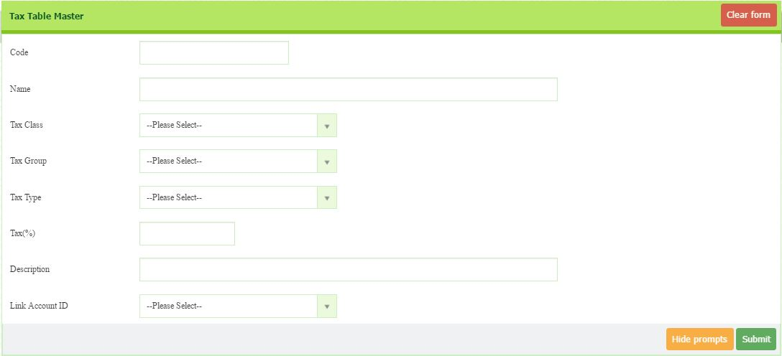
- Enter Code, Name, Tax (%) and Description.
- Select Tax Class, Tax Group, Tax Type and Link Account ID
- Then, click button.

- To modify, click on the tax code in Code column.
- You will be directed to the Tax Table Master page. Then, click button.
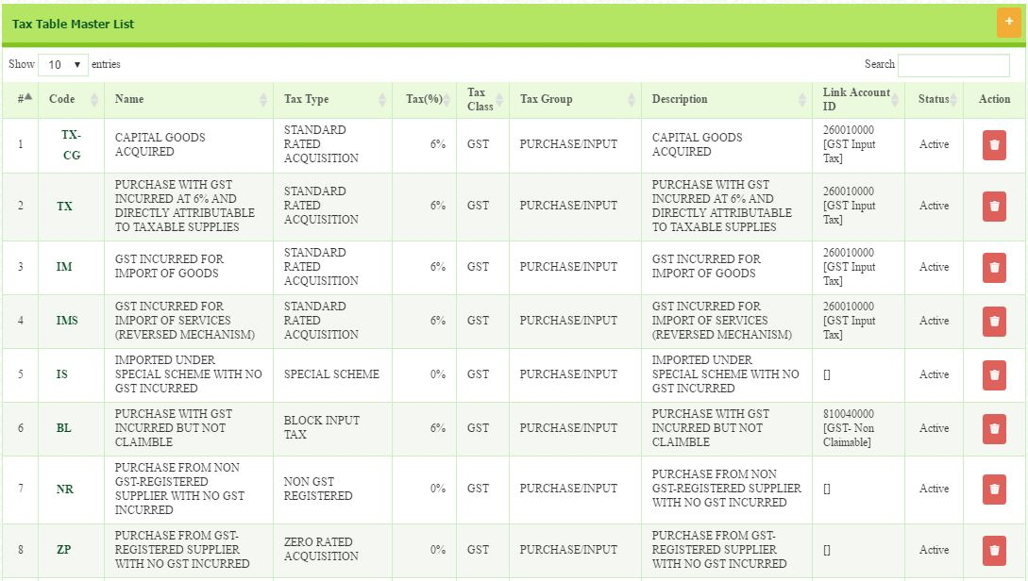

  - How to Setup Tax Class List
There are two different classes of tax. GST and Other Tax.
- Go to Goods & Services Tax > Setup > Tax Class List.
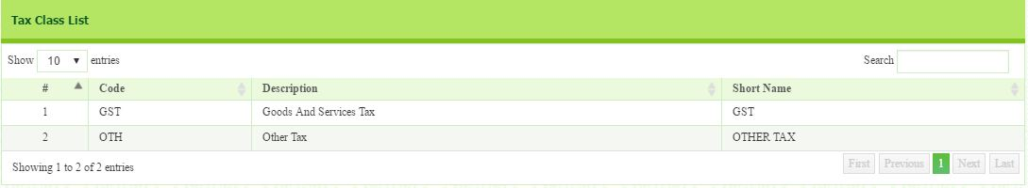
- You cannot edit Tax Class as it is default setting.

  - How to Set Tax Group List
- Go to Goods & Services Tax > Setup > Tax Group List.
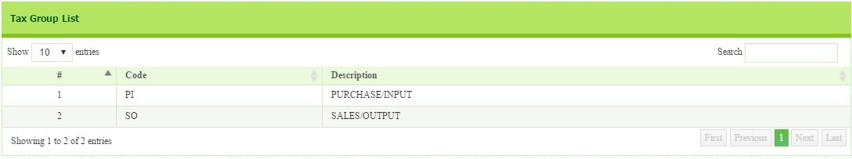
- There are two groups which are input and output. You cannot edit Tax Group as it is default setting.

  - How to Set Tax Type List
This section shows you type of the tax code. You need to know every single type of GST as you will use it when you want to enter the transaction.
- Go to Goods & Services Tax > Setup > Tax Type List.
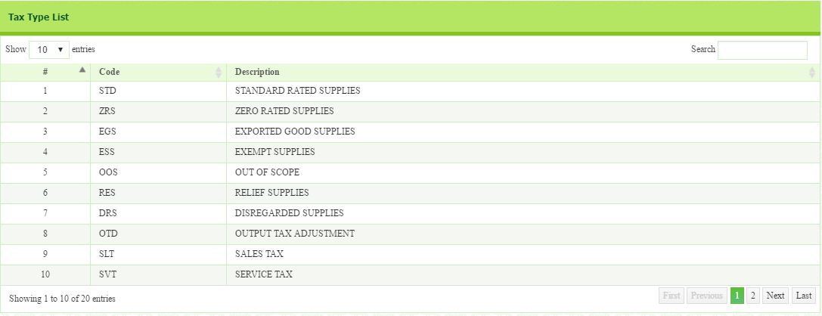
- You cannot edit Tax Type as it is default setting.

  - How to Setup GST Preference
In this section, you need to do financial setting regarding the GST matters. These matters, however, can affect your cash flow. The matters are include:
- Bad debt Relief (you may claim bad debt relief for at least after six month)
- Days Limit (days limit for issuing invoice)
- Maximum Input Tax Claim (the maximum amount you want to claim for each submission)
- Verification of Supplier GST registration (how frequent you verify the GST registration)
To setup GST Preference, follow the step below:
- Go to Goods & Services Tax > Setup > GST Preference
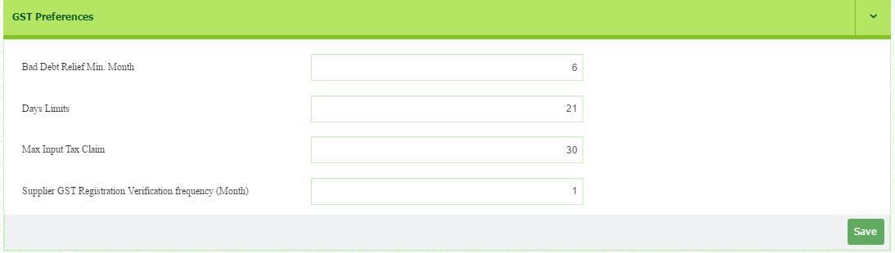
- Enter the information required in the box. Then, click button.

  - How to Set GST Tax Mapping
In this section, it is important for you to know where the GST code will be mapping to GST-03 Form. If you are not certain with the direction, you may ask our support team. This section as recommended by Customs Department may be changing in the future. Thus, you may edit the tax code to map with GST-03.
To setup GST Tax mapping, follow the step below:
- Go to Goods & Services Tax > Setup > GST Tax Mapping
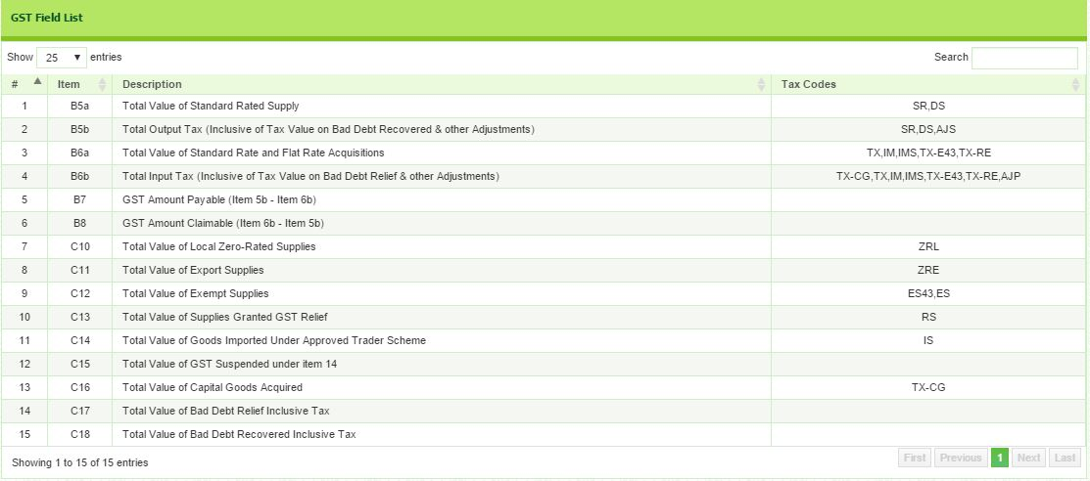

- To edit, click on the tax codes at the right column.
- The list will appear. Tick on the box to choose the Tax Code.
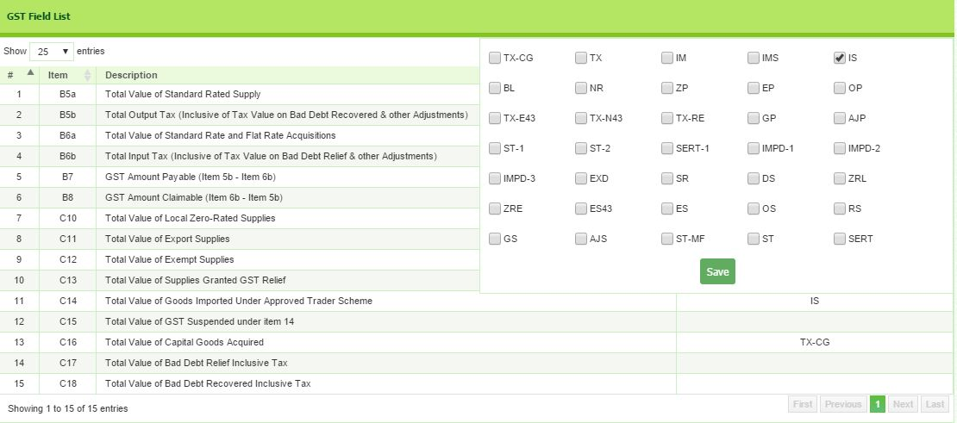
- Then, click button.

- Transaction
2.0.1 GAF File Process
- GST Audit Files (GAF) is required by RMCD during audit works. This GAF Files is being used for recording all the transactions regarding to GST. From this file, RMCD will know all the company’s transactions.
- To generate this file, follow the step below:
- Go to Goods & Services Tax > Transaction > GAF Files Process
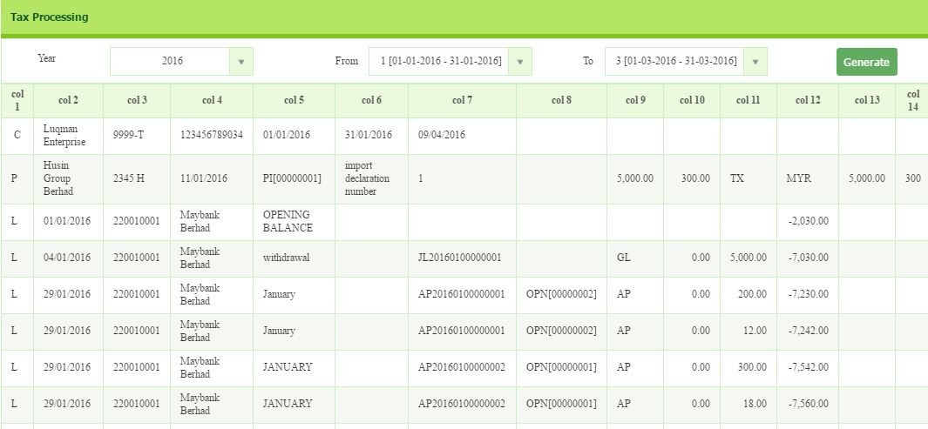
- Select Year, period From and Period To. Then, click button.

- To export file into GAF format, click button at the bottom.

2.0.2 Bad Debt Relief
- Under paragraph 143 & 144 of the General Guide issued by RMCD, “A taxable person is entitled to a relief for bad debt on the whole or any part of the tax paid by him in respect of a taxable supply if:-
  - the person has not received any payment in respect of the taxable supply from the debtor six months from the date of supply or the debtor has become insolvent before the period of six months has elapsed; and
  - Sufficient efforts have been made by him to recover the debt.
  - The date of supply refers to the date of invoice issued. A person is entitled to claim bad debt relief even though the bad debt is not written off from his books.

- Go to Goods & Services Tax > Transaction > Bad Debt Relief
- Select Customer Name (Hasan Enterprise) and Date (1.9.2017),
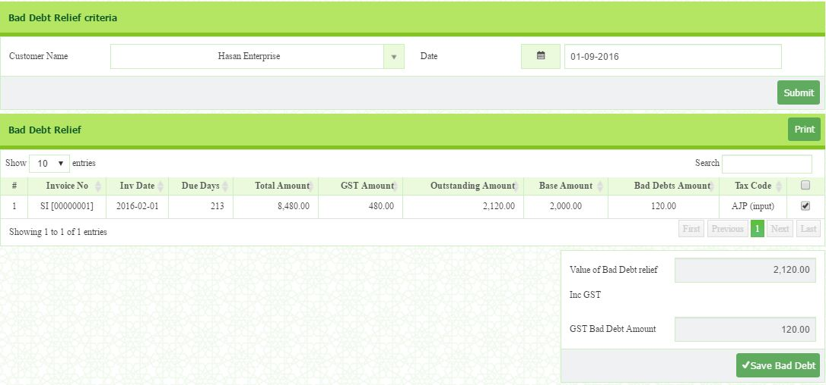
- Then click button.

- Then, tick on the box of selected invoice to add. Once you have tick, the value of bad debt relief will automatically be shown at the bottom side.
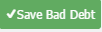
- Then, click to save.

2.0.3 Bad Debt Relief Confirm
- In this section, you need to confirm the bad debt relief before post to Journal. To confirm the bad debt, you need to follow the steps below:
- Go to Goods & Services Tax > Transaction > Bad Debt Relief Confirm
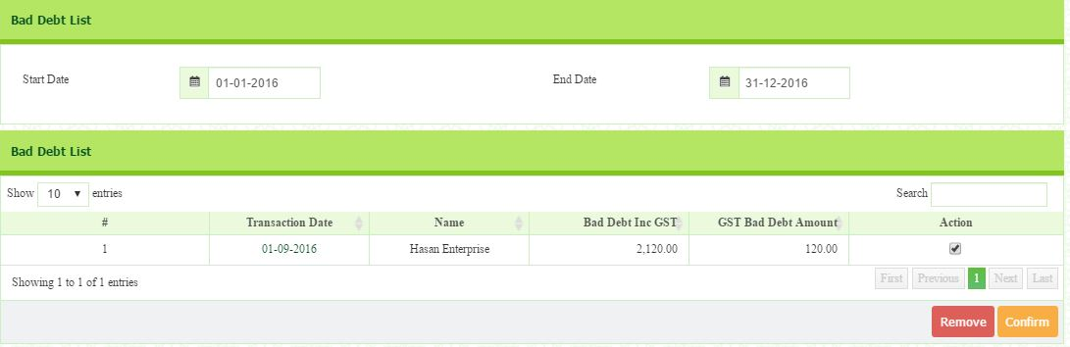
- Select Start Date (1.1.16) and End Date (1.12.2017). The list will be appear.


- Tick on the box under Action column. Then click button to post to journal.
- To remove, click on button.

2.0.4 Bad Debt Recover
In this section, you receive payment from customer after you include them in the customer bad debt. Thus, you need to record as bad debt recover.

- Go to Goods & Services Tax > Transaction > Bad Debt Recover
- Select Customer Name (Hasan Enterprise) and End Date (31.10.2017).
- The list will appear.
- Tick on the box
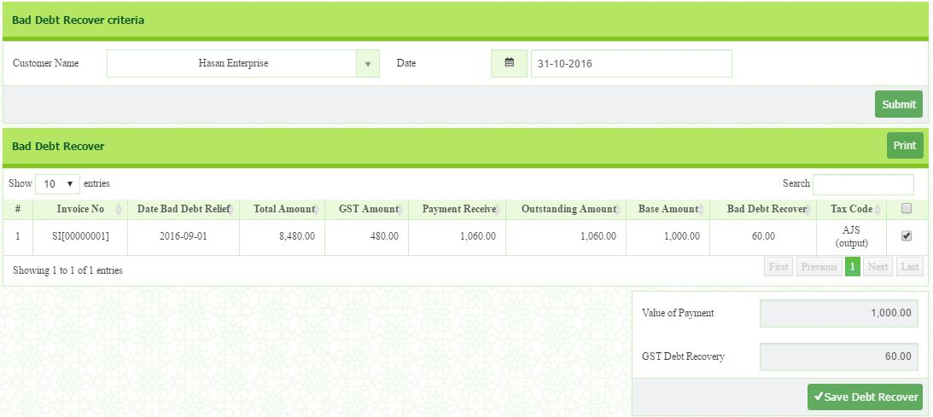
- Click button.

2.0.5 Bad Debt Recover Confirm
- You need to confirm the bad debt recover before post to Journal. To confirm the bad debt recover, you need to follow the steps below:
- Go to Goods & Services Tax > Transaction > Bad Debt Recover Confirm
- Select Start Date (1.1.2017) and End Date (31.12.2017),
- Then the list will appear.
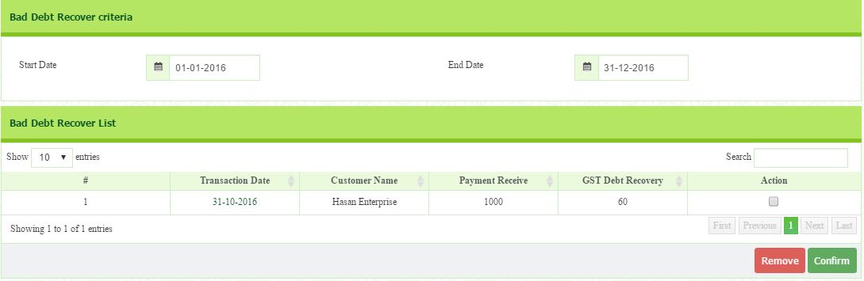
- Tick the box under Action column. Then, click button.

- To remove, click on button.

2.0.6 GST Journal
- There are certain transactions that need special treatment in GST. These transactions include:
- Deemed Supplies
- Imported Services
- Imported Goods and
- Apportionment
- The supply of goods without consideration under GST Act 2014 is deemed to be a supply called “deemed supplies”. The rationale behind this is that if supplies were not deemed, the goods are being enjoyed by the recipient tax free, while input tax incurred on the purchase of the goods would have been claimed by the business.
Examples of deemed supply
- Gifts to customers
- Goods taken for private use
- Disposal of assets for free

- Go to Goods & Services Tax > Transaction > GST Journal
- Select Type and enter Form No, Customer/Vendor Name, GST Number, Description and Based Amount.
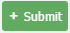
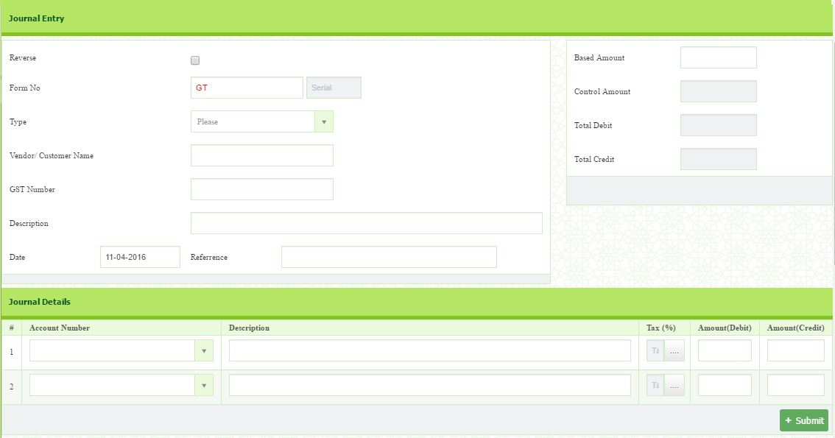
- In Journal Details section, select Account Number and Tax Code, enter the description and the amount. Then, click button.

2.0.7 GST Journal Confirm
- Go to Goods & Services Tax > Transaction > GST Journal Confirm
- Select Year and Period, then click Submit button.
- Tick on the box at the selected transaction and then click on button.
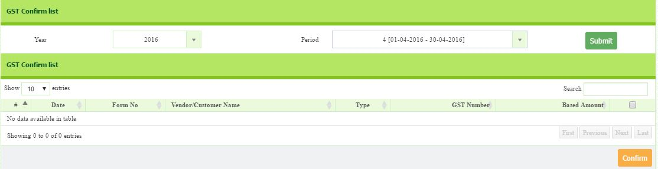

2.0.8 Supplier Bad Debt Relief
- A registered person who has claimed input tax but failed to pay the supplier within six months from the date of supply has to pay back the input tax as his output tax. Subsequently, when payment is made for the supply of the goods or services, a registered person is entitled to claim back the said output tax as input tax for the taxable period in which he made his payment.

- Go to Goods & Services Tax > Transaction > Supplier Bad Debt Relief
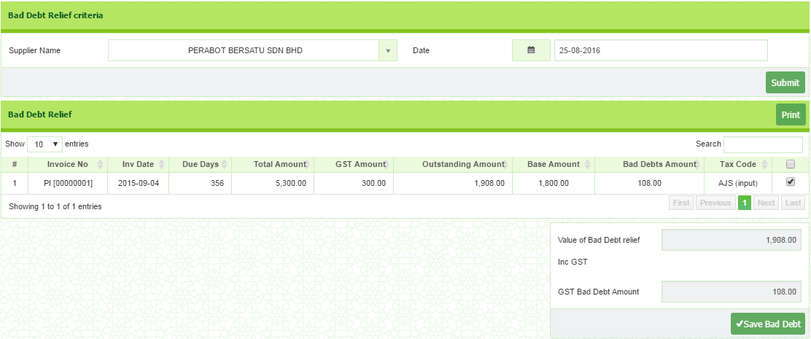
- Select Supplier and Date. Then, click button.

- Tick on the box at the selected transaction and then click on button.

2.0.9 Supplier Bad Debt Relief Confirm
- Go to Goods & Services Tax > Transaction > Supplier Bad Debt Relief Confirm
- Select Start Date and End Date.
- Then tick on the box and click button.
- To remove, click button.

2.0.10 Supplier Bad Debt Recover
- Where a registered person fails to pay the consideration for the supply of any goods or services made by his supplier within six months from the date of supply and he has claimed input tax on that supply, the taxable person is required to pay back the input tax by accounting an amount equal to the input tax as his output tax. He is required to account the output tax in the taxable period covering the month after the six months period.
- Go to Goods & Services Tax > Transaction > Supplier Bad Debt Recover
- Select Supplier Name and Date. Then, click on button.
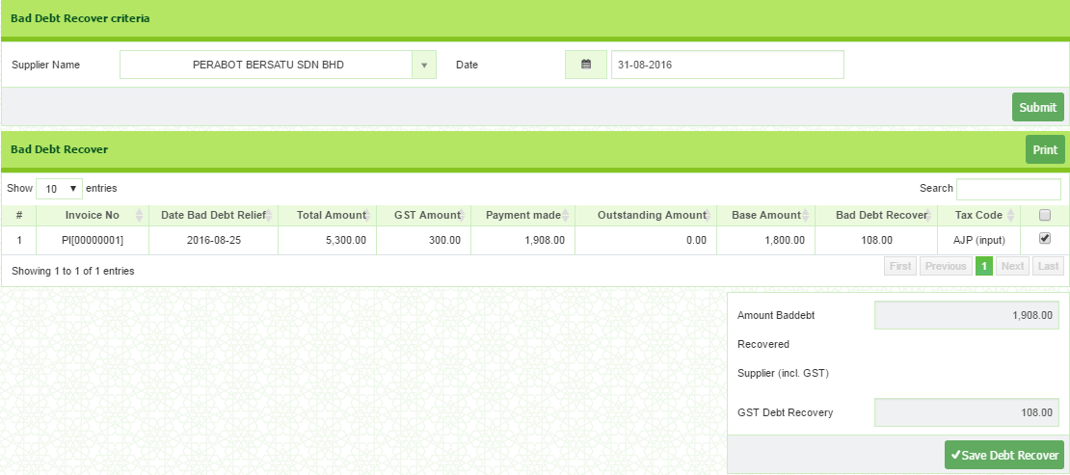
- The list will appear if there is an outstanding balance. Then, tick the box and click on button.

2.0.11 Supplier Bad Debt Recover Confirm
- Go to Goods & Services Tax > Transaction > Supplier Bad Debt Recover Confirm
- Select Start Date and End Date. The list will appear under Bad Debt Recover List.
- Tick the box at the selected Supplier.
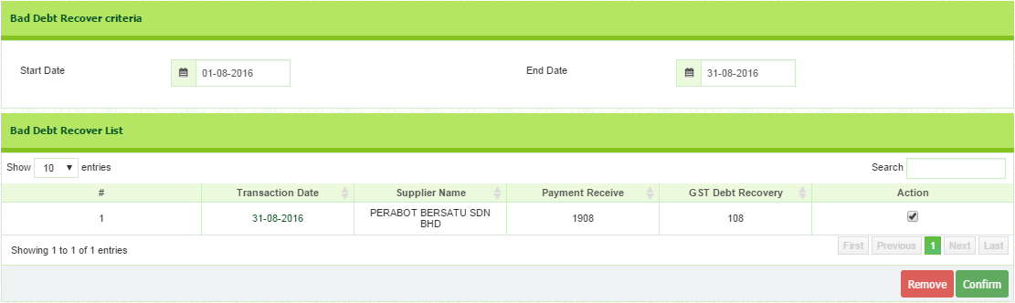
- Then, click button.
- Report
  - How to Generate GST Report
- The purpose of this report is to provide user with all the GST transaction. User can generate the report based on the GST Group (Input/Output) or GST Code (eg: SR/ES/TX/IM)
- To generate the report, follow the steps below:
- Go to Goods & Services Tax > Reports > GST Report.
- Select Year (2017) Period from (1) and Period To (12),
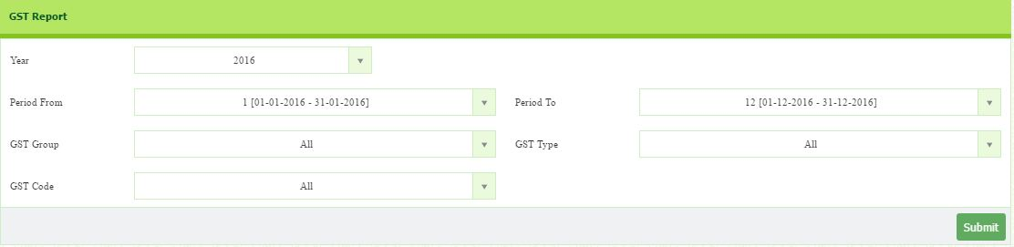
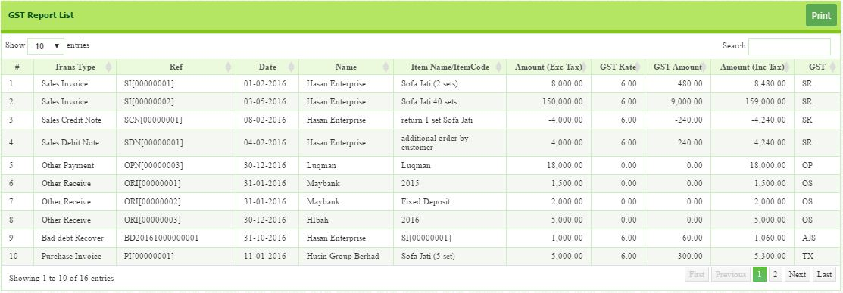
- GST Group (All), GST Code (All) and GST Type (All). Then, click button.
- To print, click button.

  - How to Generate GST Report Summary

- This report provide the total amount of GST based on its Code.
- To generate this report, follow the steps below:
- Go to Goods & Services Tax > Reports > GST Report Summary.
- Select Date From (1.1.2017) To (31.12.2017)
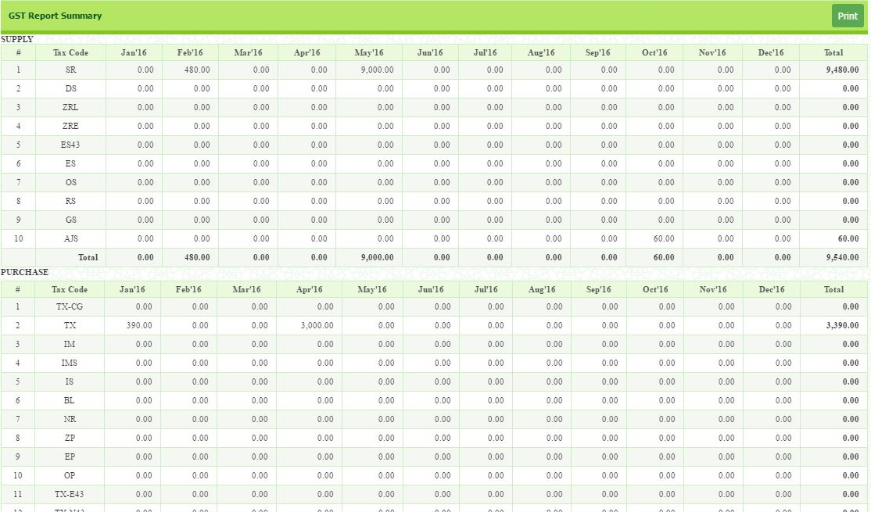
- Then, click button.
- To print, click button.

  - How to Generate GST 03

- GST 03 need to be submitted to RMCD as required by GST Act 2014. It depends on the revenue of the company. If total taxable supply is more than RM5 million, the submission is monthly otherwise, it is quarterly.
- To generate GST 03 report, follow the steps below:
- Go to Goods & Services Tax > Reports > GST 03.
- Select period From (1.1.2017) and period To (31.3.2017)
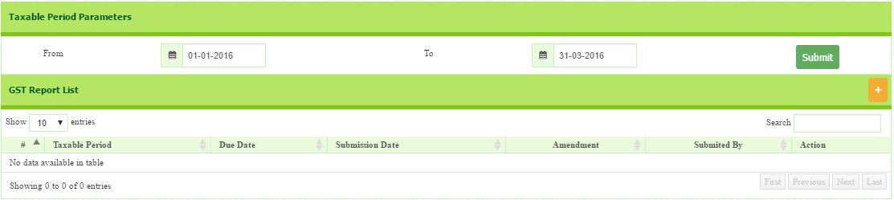
- Then, click button.
- Click button. The transaction summary will appear.
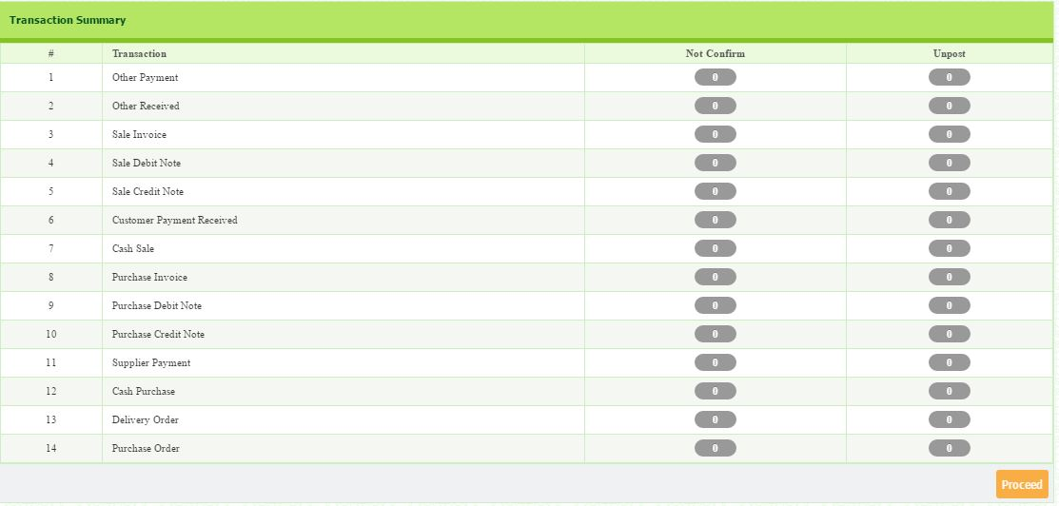
- If there are no transactions that are not confirm and unpost, you may click button.

- Then, message box will appear.
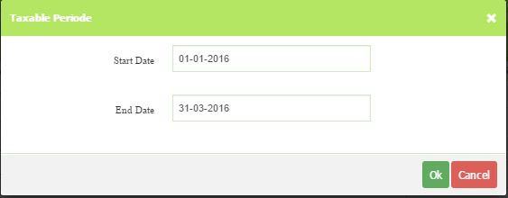
- Select start date and end date of GST 03 submissions. Then, click Ok.

- Once click Ok, you will be directed to GST Report Generation.
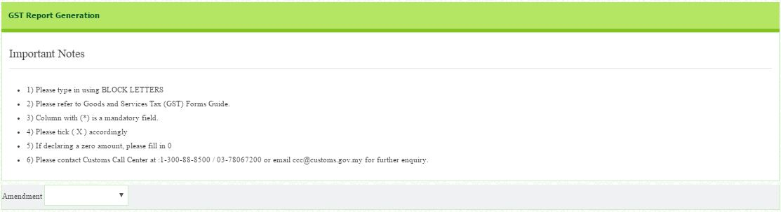
- Fill in Form GST-03 and click save button.

- In this section, choose either the submission is for amendment or not.
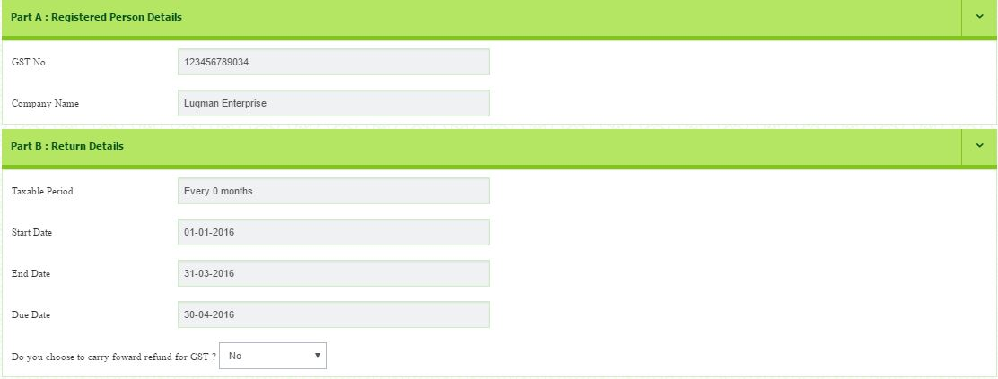
- In this section, Choose either you want to carry forward input tax claim for the period or not.

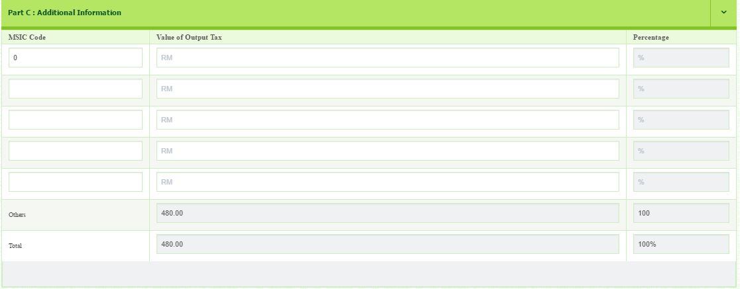
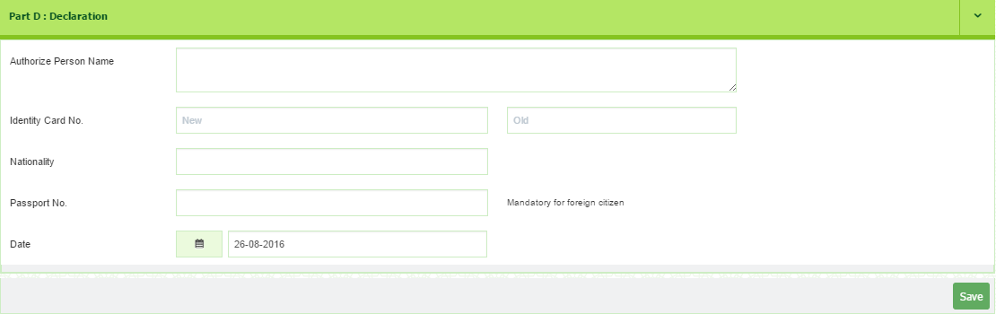
- Enter MSIC Code and the value of output tax. The total must equal to the total at the bottom.

- In this section, enter required information.
- Then, click button.
  - GST 03 Summary

- Go to Goods & Services Tax > Reports > GST 03 Summary
- Select period From (1.1.2017) and period To (31.12.2017).
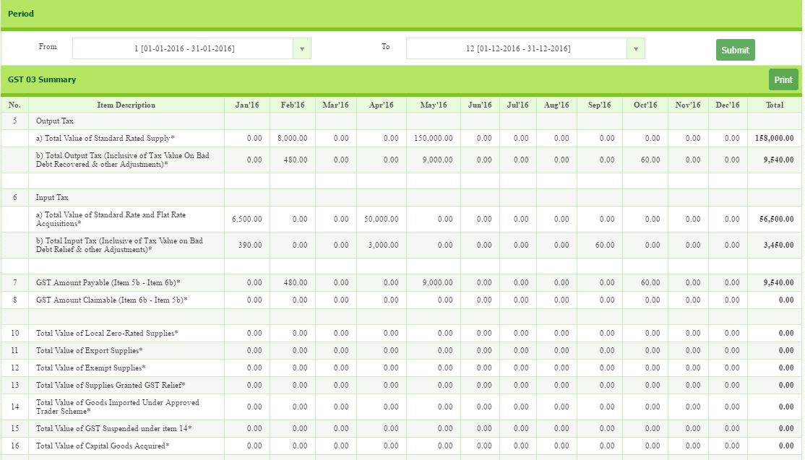
- Then, click button.
- To print, click button.

  - How to Generate Bad Debt Relief List

- This report shows the list of customer who have outstanding balance after six months from the Invoice date.
- Go to Goods & Services Tax > Reports > Bad Debt Relief List
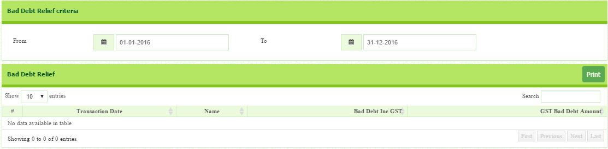
- Select period From (1.1.2017) and period To (31.12.2017).
- The list will appear at the bottom side.

- To print, click button.

  - Bad Debt Recovered List
- This report shows the list of the customer who are already recovered their bad debts.
- Go to Goods & Services Tax > Reports > Bad Debt Recovered List
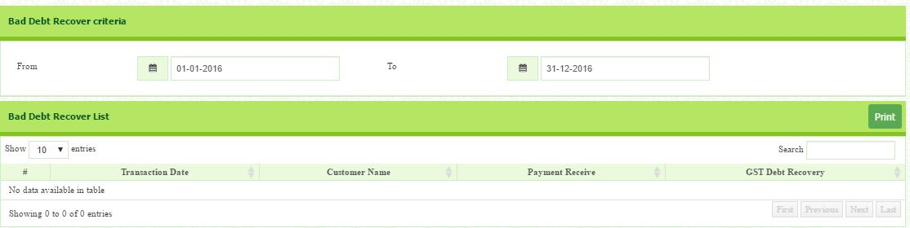
- Select period From (1.1.2017) and period To (31.12.2017).
- Then, click button.

LESSON FIVE
MODULE: ZAKAT & WAKAF
This module provide user with the Zakat and Waqaf transaction and reports.

1.0 How to setup Zakat Nisab
- Go to Zakat & Wakaf > Setup > Zakat Nisab.
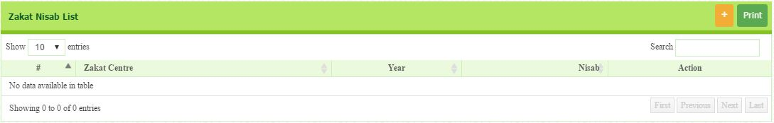
- The Zakat Nisab window will appear.
- Click button at the top right corner of Zakat Nisab List header.

- Zakat Nisab page will appear.
- Select the Zakat Centre (Lembaga Zakat Selangor) and Year (2017)
- Enter Nisab amount (RM12,680).
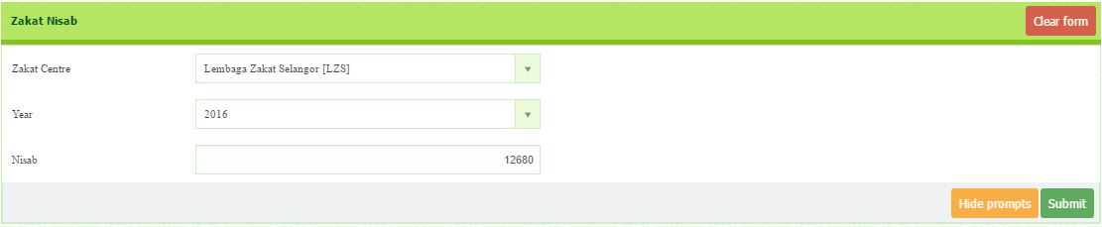
- Click button.

- How to Setup Zakat Centre

- Go to Zakat & Wakaf > Setup > Zakat Centre.
- The Zakat Centre List will appear. Some lists are already setup in the software.
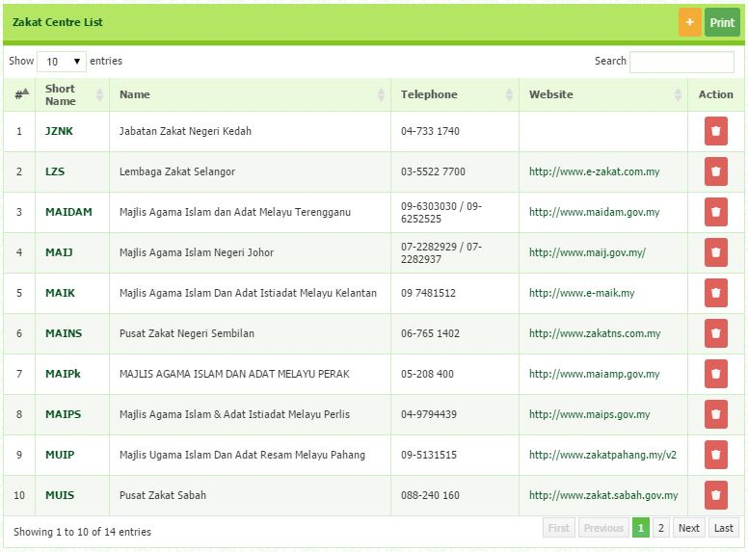
- To add, click button at the top right corner of Zakat Centre List header.

- Enter all information such as Short Name, Name, Address, City, Postcode, Country, State, Phone No, and Fax No.
- Enter Email and Website.
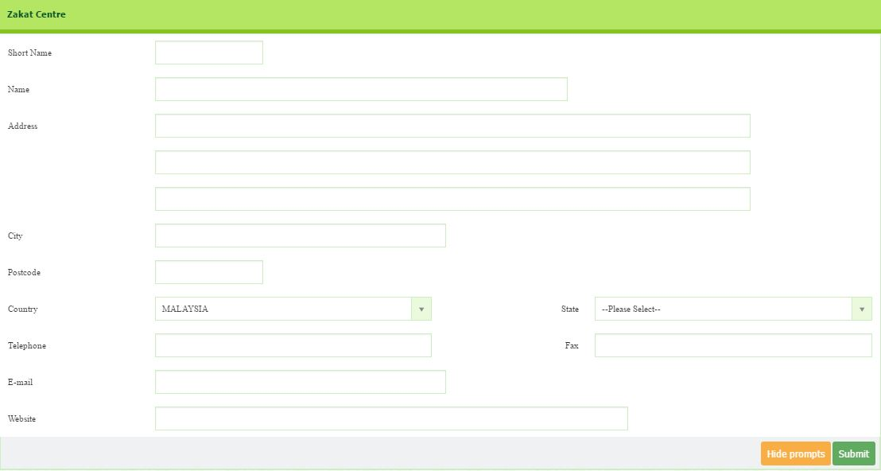
- Then, click button to save.

- How to Setup Wakaf Centre
  - Go to Zakat & Wakaf > Setup > Wakaf Centre.
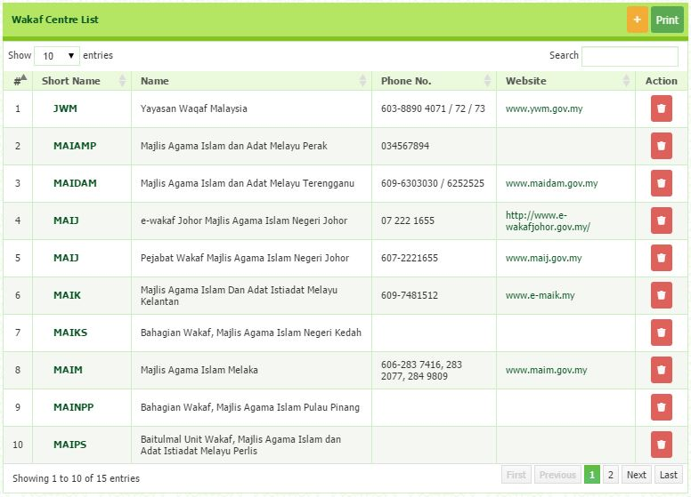
  - Click button that situated on the top right page to add new waqaf centre.

  - Enter all the required information.
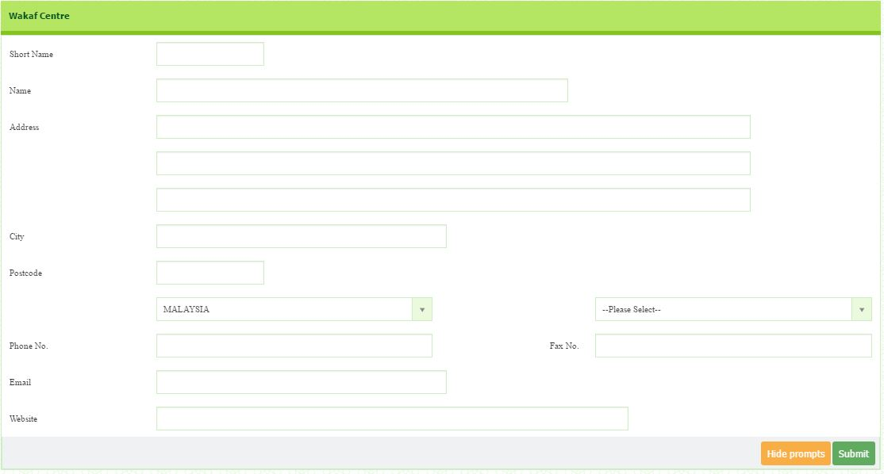
  - Click to save data.
- Zakat Calculation
  - Go to Zakat & Wakaf > Transaction > Zakat Calculation. The Zakat Calculation window appears.
  - Select Zakat Centre (LZS)
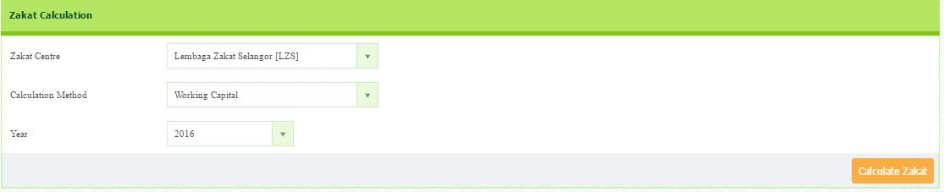
  - Method (Working Capital)
  - Year (2017) and click button.

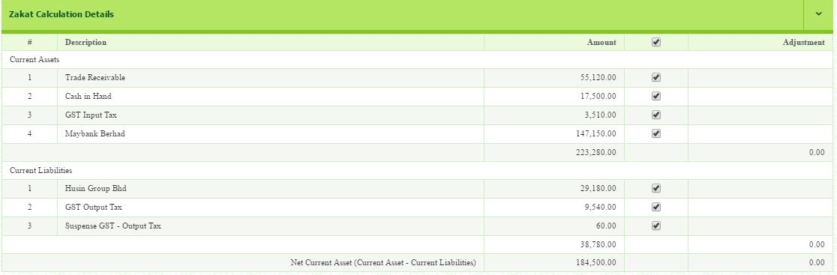
- Zakat Calculation Details will appears. You can see the details of Current Liabilities, Current Assets and the Amount. Tick relevant account to be included in the calculation of Zakat.

- All the calculation summary such as Zakat Rate, Muslim Ownership Share, Nisab, Monthly Zakat Payable, Net Current Asset, Adjustment, Adjusted Net Current Assets, Total Net Asset Due for Zakat, and Zakat Payable for The Year will be display under Zakat Calculation Summary.
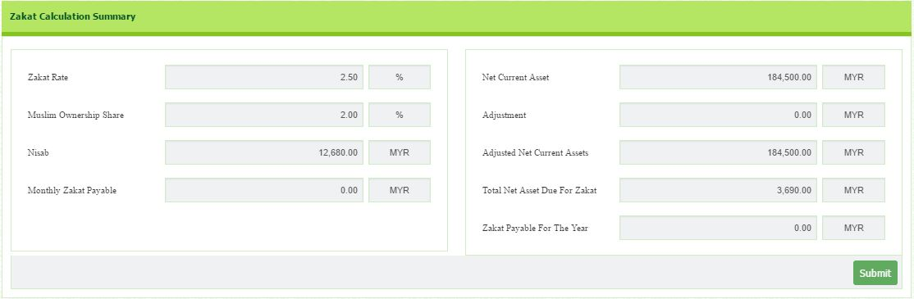
- Then click button.

- Wakaf Calculation
  - Go to Zakat & Wakaf > Transaction > Wakaf Calculation. The Wakaf Calculation window appears.
  - Select Wakif (Directors)
  - Select the Wakaf Institution (yayasan Waqaf Malaysia).
  - Select the Allocation Basis. (Lump Sum Amount).
  - Amount (RM10, 000). Then, you may assign to your beneficiaries by clicking button.
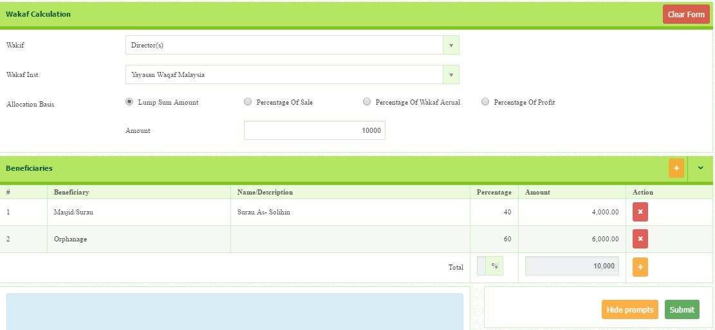
  - Then, click button.
- Zakat Nisab Report
- Go to Zakat & Wakaf > Reports > Zakat Nisab. The Zakat Nisab List window appears.
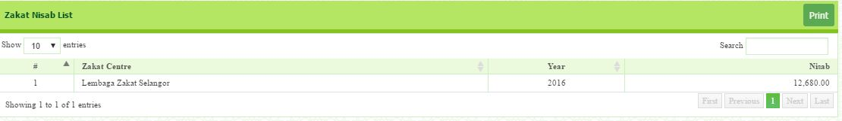
- All the Zakat Nisab will be listed.
- To print, click the button that situated on the top right of page.

- Zakat Centre Report

- Go to Zakat & Wakaf > Reports > Zakat Centre. Zakat Centre List appears.
- All the Zakat Centre will be listed.
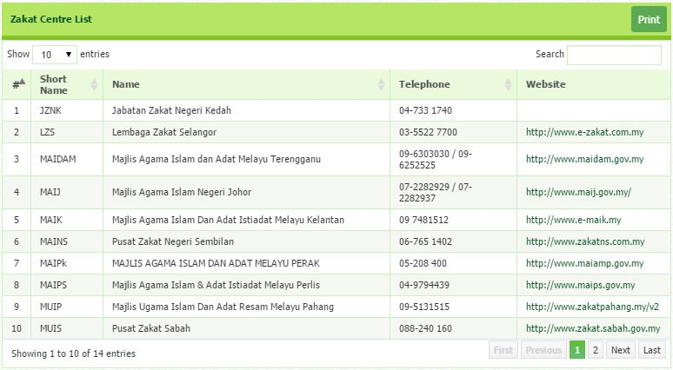
- To print, click the button that situated on the top right of page.

- Wakaf List

- Go to Zakat & Wakaf > Reports > Wakaf List.
- Select Date From (1.1.2017) and Date To. (31.12.2017)

- All the Wakaf List will be listed.
- To print the Wakaf Letter, click the button that under action column.
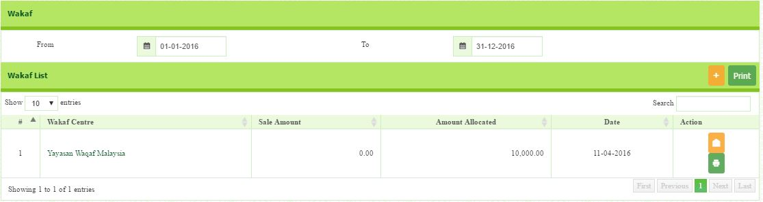
- To print the Wakaf List, click the button at the top right corner of the page.

LESSON SIX

MODULE: BANK RECONCILIATION

General ledger allow users to create Journal entry, record the payment made or received, produce various report and summary of the transaction. This modules need to be setup carefully as it will result in the financial reporting statement.

1.0 How to do Bank Reconciliation
Bank reconciliation is a process that explains the difference between the bank balance shown in an organization's bank statement, as supplied by the bank, and the corresponding amount shown in the organization's own accounting records at a particular point in time
- Go to General ledger > Report > Bank Reconciliation List
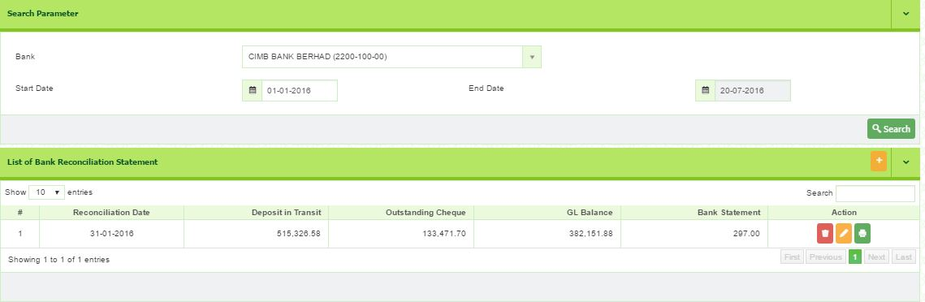
- Select Bank, Start Date and End Date. Click button.

- The screen will show the list of previous bank reconciliation list, if any.
- You may edit previous reconciliation before start new reconciliation.
- Click button to perform next reconciliation. You will be directed to the bank reconciliation page.
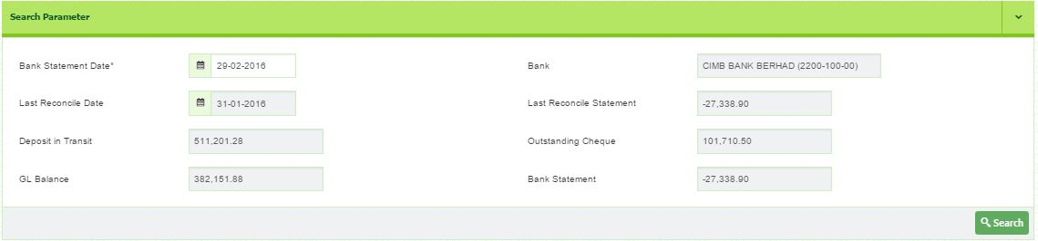
- To reconcile,
  - Select Bank Statement Date. E.g. 29th February 2017
  - Click button.
  - The list of transaction will appear as follow:

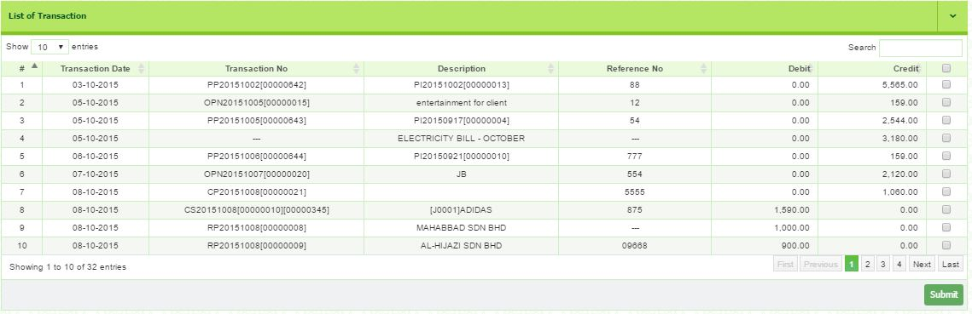

  - Tick √ in small box any related transaction existed in bank statement.
  - Click button.

2.0 How to Review Bank Reconciliation List
- Go to General ledger > Report > Bank Reconciliation List
- Select Bank, Start Date and End Date.
- Click Search.
- Click button to print. To edit click button.

CONCLUSION
This user guide provides an overview of your SPS and outlined the principal features, functionalities and capabilities, tools and resources to use and manage the SPS easily and efficiently. It is developed to be used as a reference for daily transaction entry and regular task activities such as creating purchase orders, receive payments, journals posting and end-of-period processing. It provides comprehensive information and step-by-step guidelines to assist you learn and to support as you start using the software.

SPS is a comprehensive and flexible accounting software that allow user to maintain its financial reports. SPS is designed and developed by pool of professional accountants for accountants that is easy to use. All tools, command bars, drop down and pop-up tips menus are organised in a very systematic manner that help user to operate smoothly.

The User Guide covers all the functions of your software from installation, getting started guide, software setup and detailed guidelines of each module. For each module, we provide step-by-step guidelines on how to create transaction, printing reports and how to setup. It also includes window descriptions, report samples and tips for assisting solve common problems may encountered by users.

