GENERAL LEDGER
Setup > Financial Year Calendar

You need to setup Financial Year Calendar before start doing any transaction. This refers to the 12-month time frame used to define your accounting year. For example, if a company’s financial year starts on 1 January 2015 and ends on 31 December, this will be Financial Year 2015. If a company’s financial year starts on 1 July 2015 and ends on 30 June 2016, this will be Financial Year 2016.
Start Period refer to the period you want to start the transaction. Basically, if start period is 1, system will assume a company just started its operation and there is no opening balance yet. You will unable to enter the opening balance in Statement of Comprehensive Income.
No of period normally will be 12. However, if your start period is 2, you need to add 1 from 12 period which means the number of period will be 13.
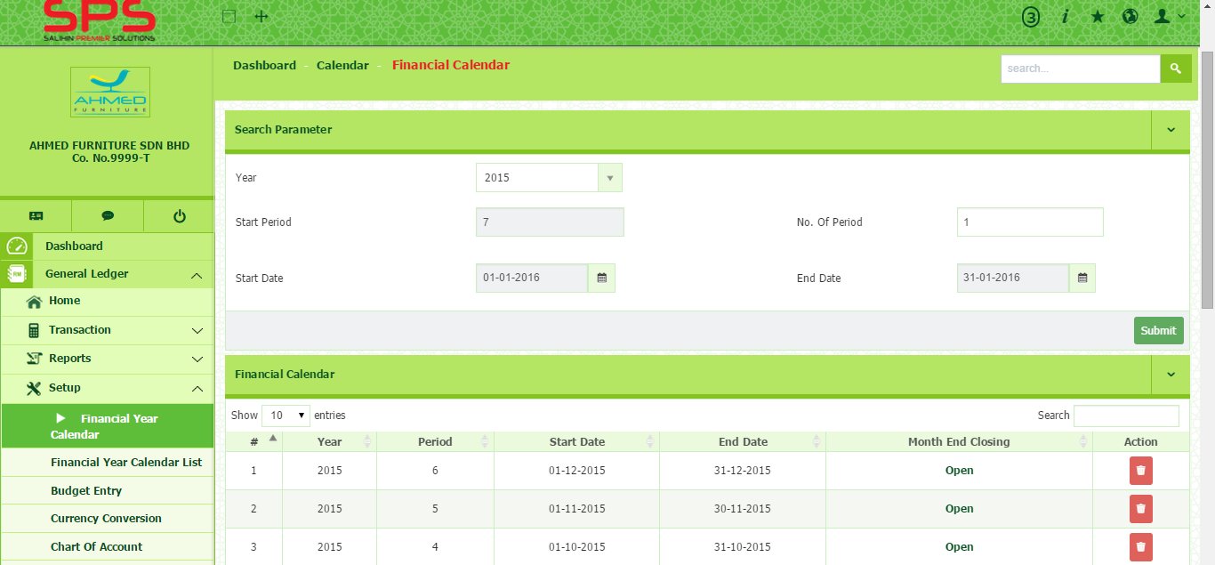
- Go to General ledger Setup Financial Year Calendar.
1
1

- Select Year, Start period, No. of Period and Start Date. The end date will be automatically appeared.
2
2
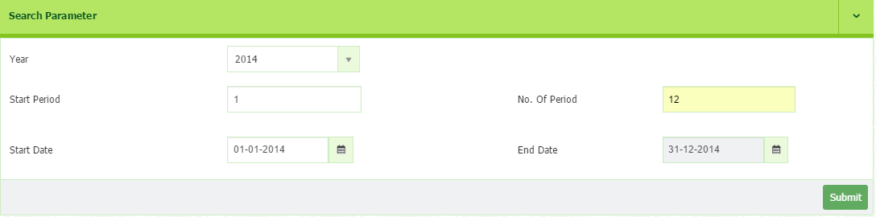
- Click Submit button to save.
- The list of Financial Year Calendar will be appeared.
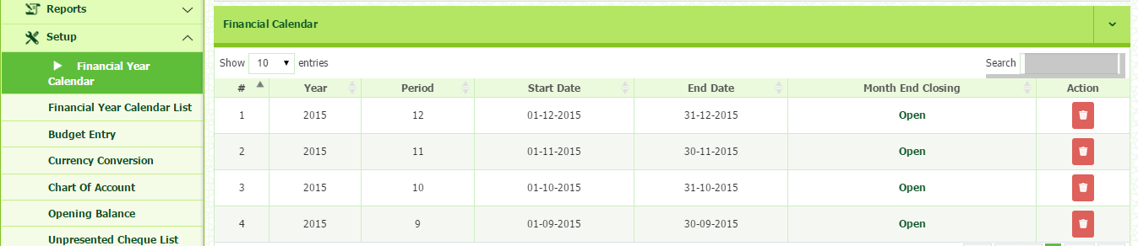

- To change status in the column of month end closing, click at the status “open” or “Close” to modify.
3
3
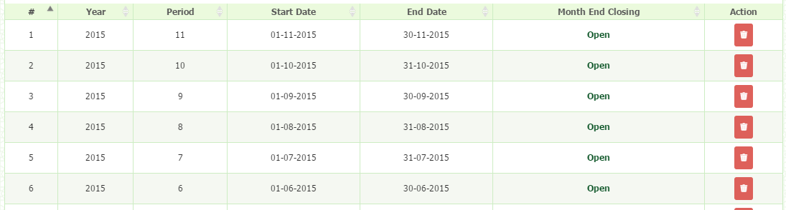
- Click Continue.

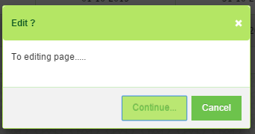

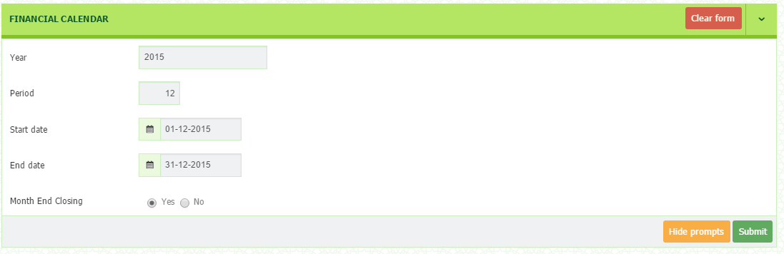
- Change the status at the month end closing row.

- Then, click Submit button to save.

Setup > Financial Year Calendar List
This section will show the list of the Financial Year Calendar.
1
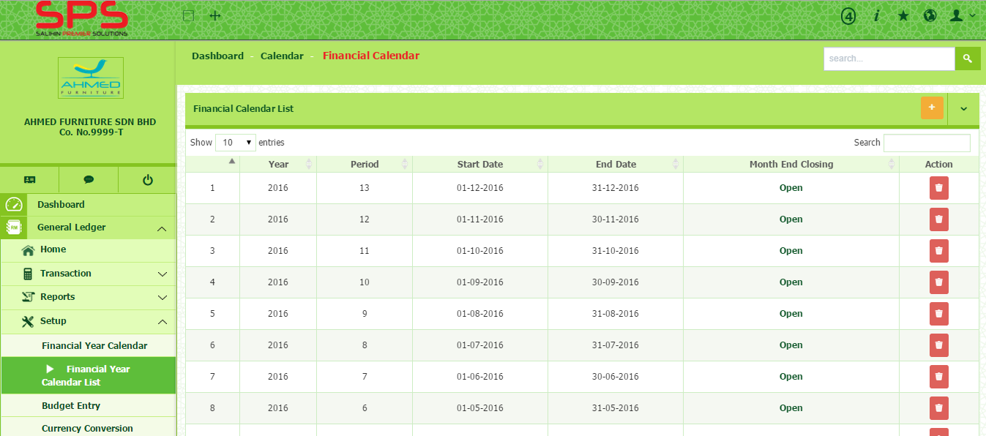
- Go to General ledger Setup Financial Year Calendar List
1

- Click + button on the top of right corner to add New Financial Calendar List
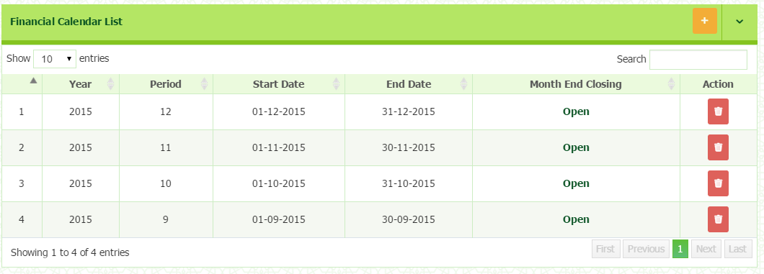

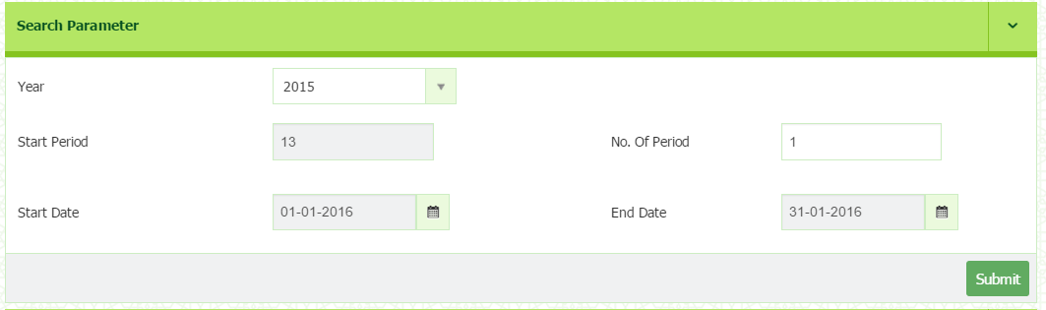
- You will be directed to Financial Year Calendar. Select Year and No of Period correctly.

- Click Submit button to save.
Setup > Budget Entry

1
- Go to General ledger Setup Budget Entry.
2
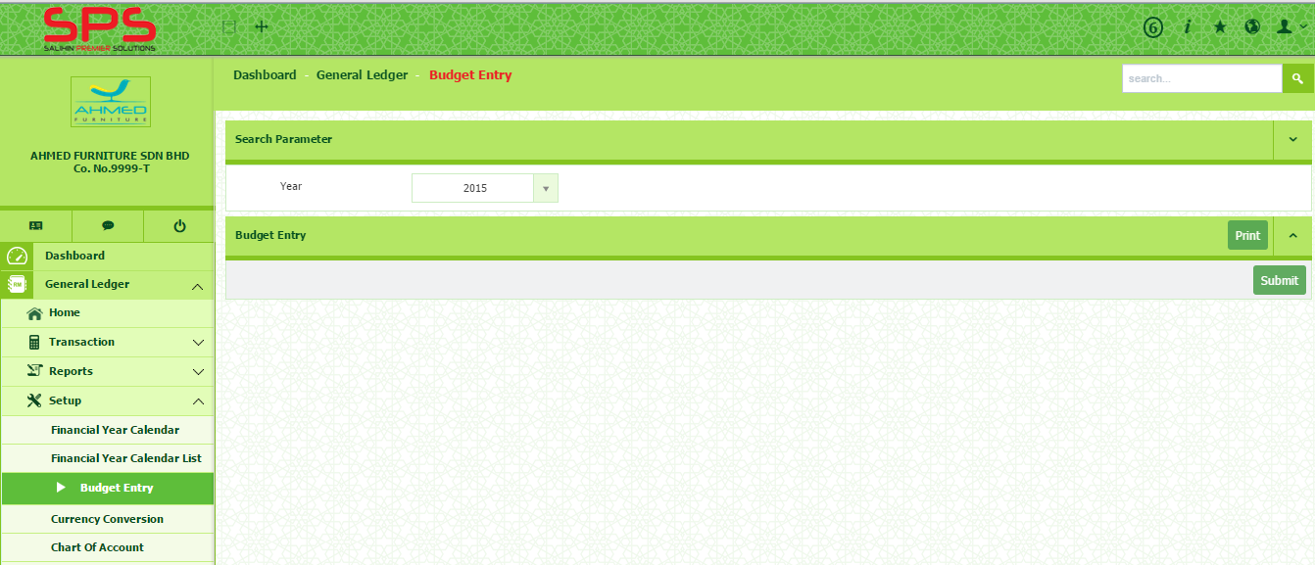
- Select Year
2
1
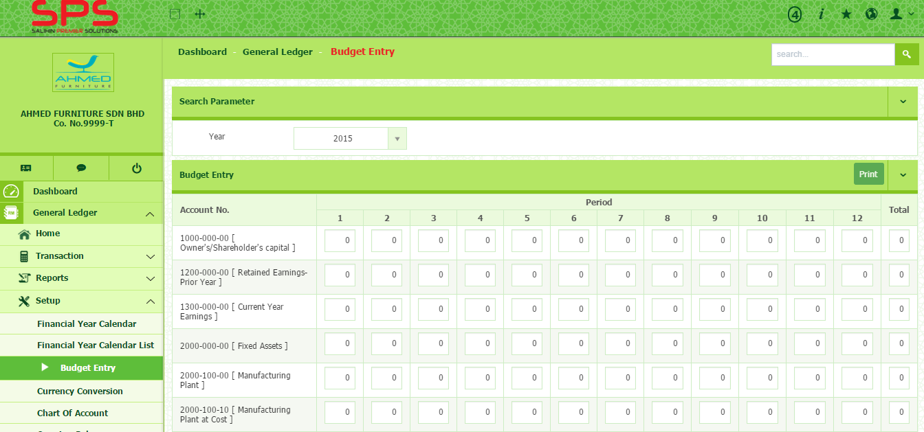
- Enter the budget amount inside the box.
3
3

- Click button.
- Click button to print.

Setup > Currency Conversion
Currency Conversion is a tool that converts the value or quantity of one currency into the relative values or quantities of other currencies.
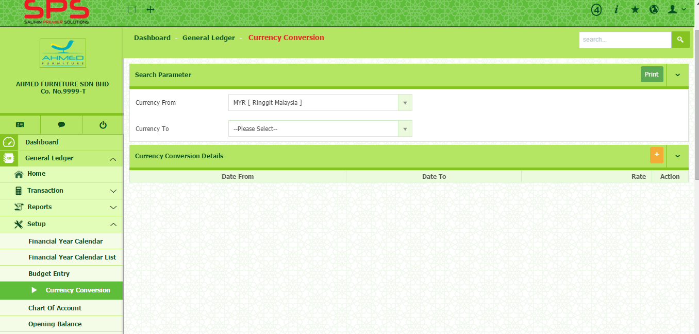
- Go to General ledger Setup Currency Conversion
1
1

- Select which currency you want to convert by clicking Currency From and Currency To.
2
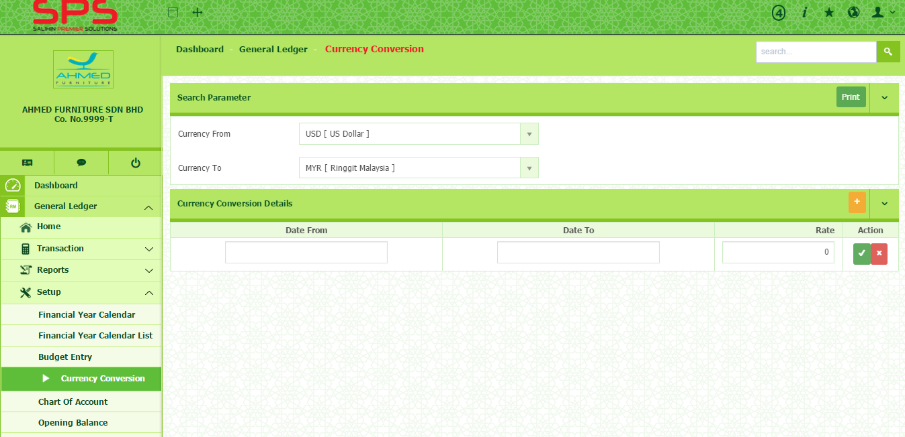
- Click + button on the top of right corner to add currency conversion.
2
- Enter Date From, Date To and Rate. Then click button.

Setup > Chart of Account

SPS have already set up Chart of Account by default. However, you can change chart of account as you prefer.
- Go to General ledger Setup Chart of Account.
1
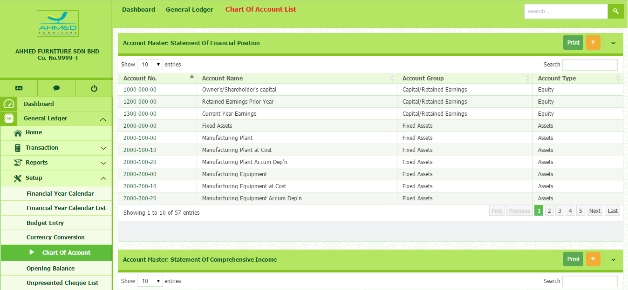
- Click + button to add account master.
1

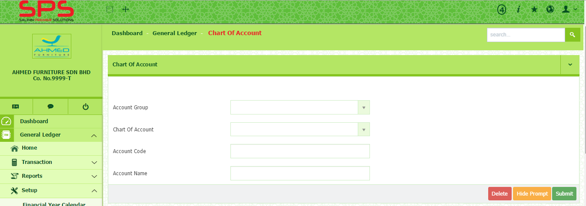
- Select Account Group and Chart of Account.
2
2

- Type account Code and Account Name.
- Click Submit button.
- To delete, click Delete button.

1
Setup > Opening Balance
- Go to General ledger Setup Opening Balance.
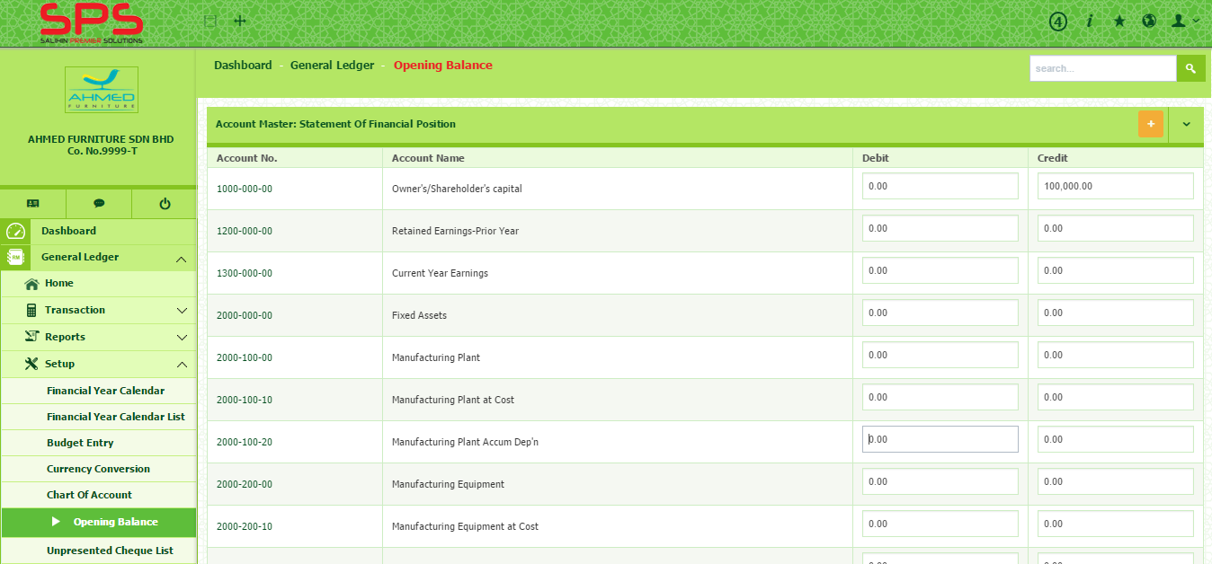
- Key in the amount under Debit and Credit column.
1

Setup > Unpresented Cheque List
1
- Go to General ledger Setup Unpresented Cheque List
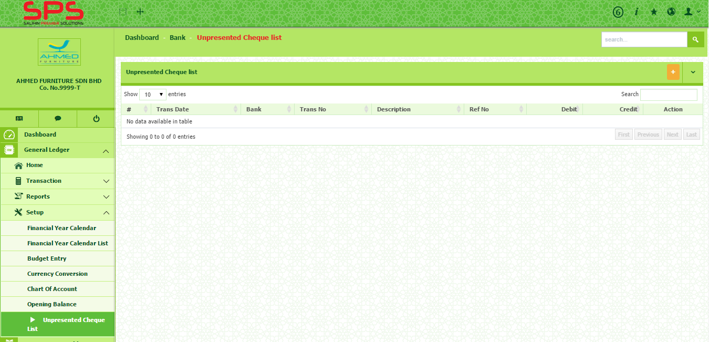
- Click + button to add.
1

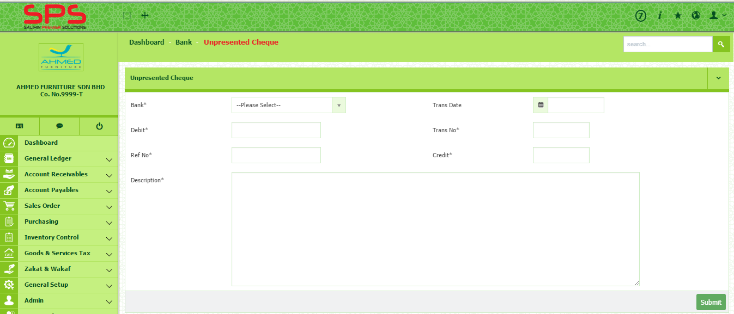
- You will be directed to the Unpresented Cheque List page. Insert all the information required.
2
2

- Then, click Submit button.
Transaction: Journal Entry
General Ledger: How to Setup a Transaction

1
- Go to General ledger Transaction Journal Entry
2
- Enter all the information required.
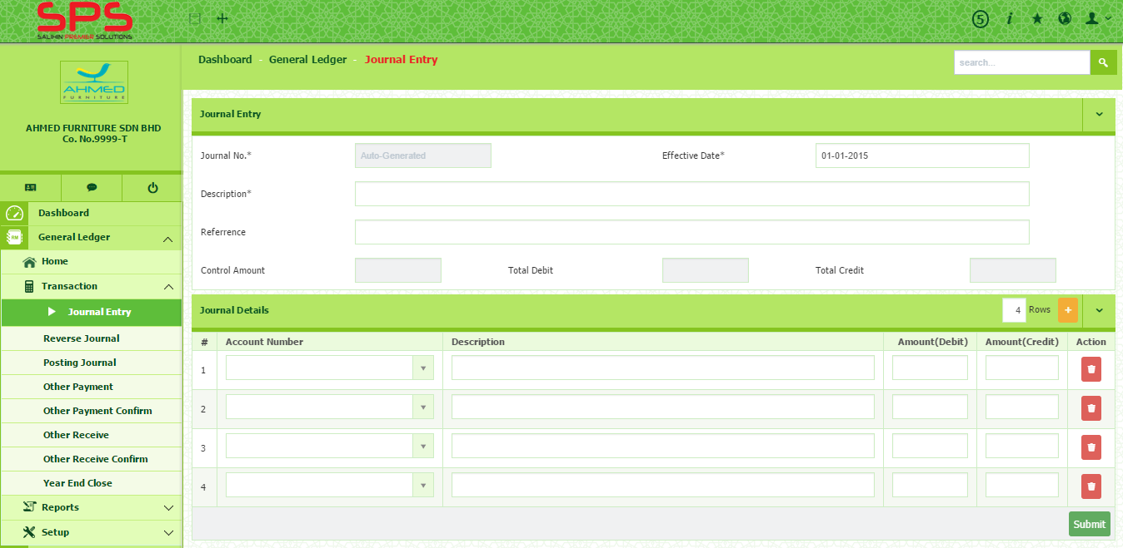
- Click on + button on the top of right corner of the journal details to add transaction.
3
3
2
1

- Select the Account Number from the drop down list. Insert the description and the amount of debit or credit.
- Click Submit button to save.
- Journal No. will be automatically generated once the user click Submit button.
- The transaction will be appeared in the Posting Journal.

Transaction: Posting Journal
1
- Go to General ledger Transaction Posting Journal
2
1
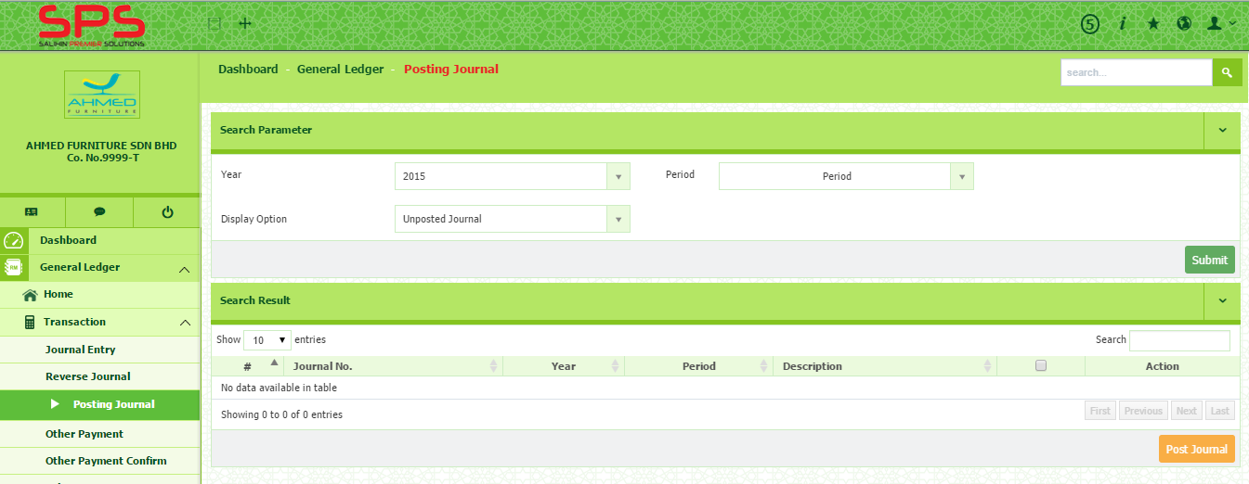
- Select Year and Period then click Submit button.
2
1
- You may see the journal details by clicking on the Journal No.
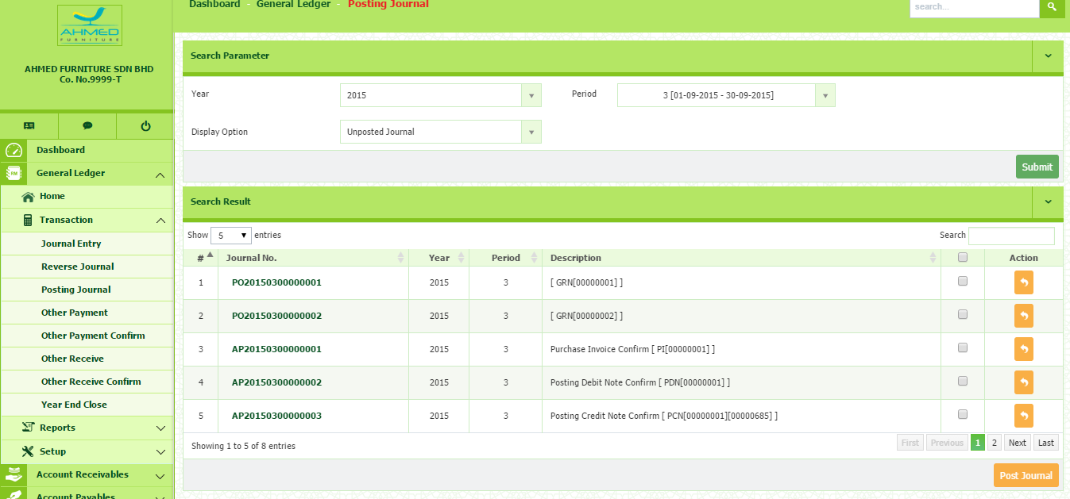
- You need to tick the box before post the journal.
1

- Click Post Journal button to post the journal.
- Please be noted, once the Journal has been posted, you are unable to reedit the details.
Transaction: Other Payment

1
- Go to General ledger Transaction Other Payment
- Key in all the information required in New Other Payment Section. You may type or select from drop down list.
2
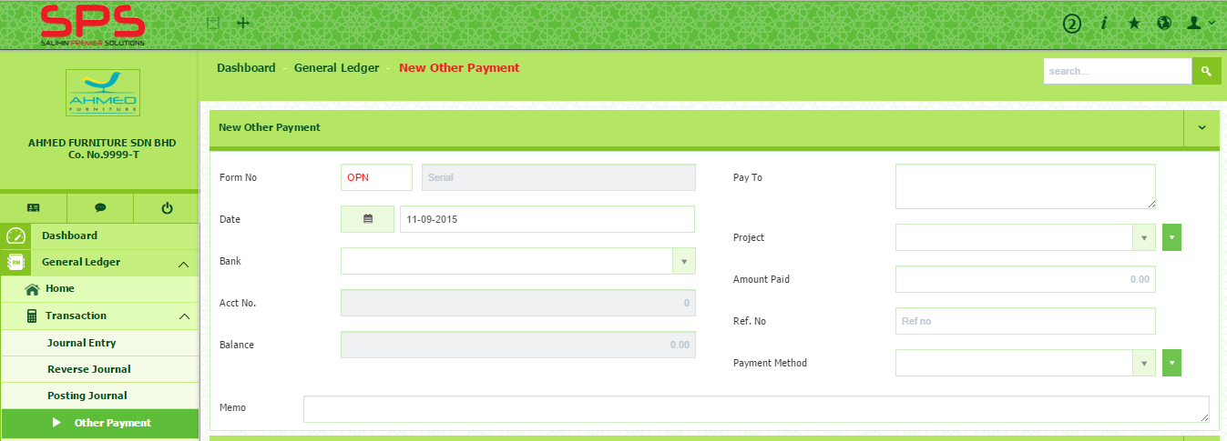
2
1
- In Payment Details section, click Add New Payment to create payment voucher.
1
- Select account group and tax code from drop down button. Insert transaction and amount.
2
- Tick the box in column inclusive tax to represent the amount inserted is inclusive of GST.
4
3
- Click button in the action column to save.
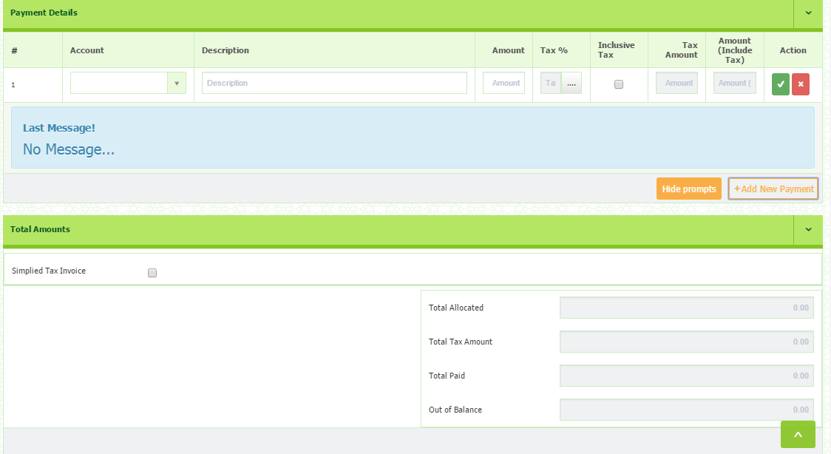
1
4
3
2
1
Transaction: Other Payment Confirm
- Go to General ledger Transaction Other Payment Confirm
2
- Select Year and Period.
3
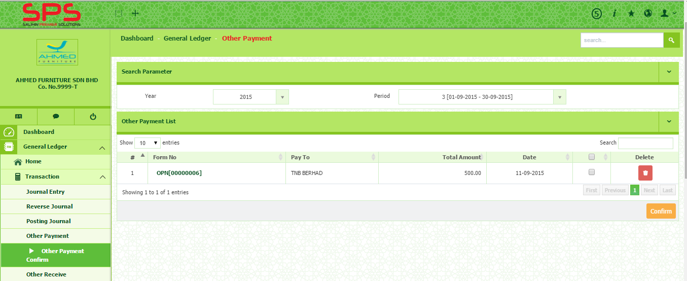
- Tick the box and click Confirm button.
3
3
1
2

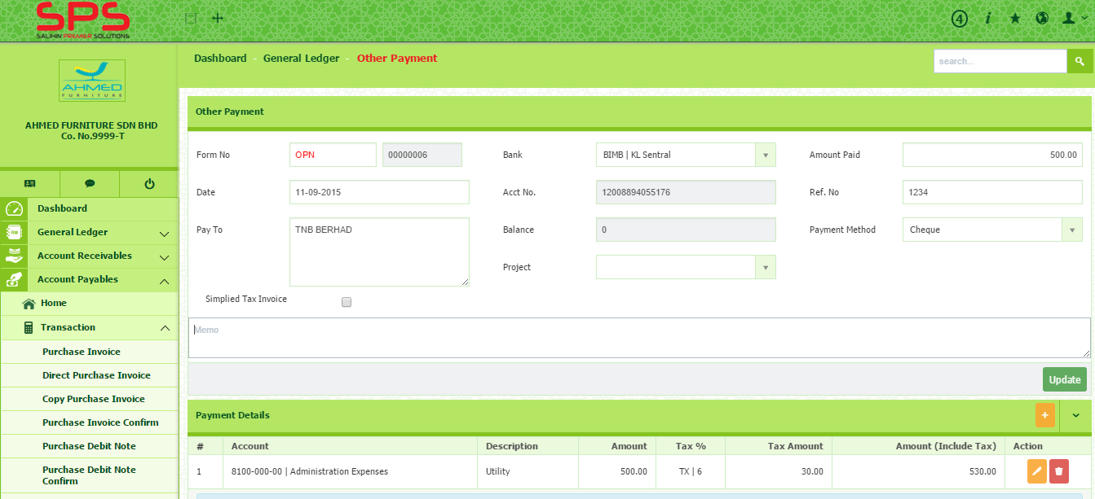
- To edit, click on the Form No. You will be directed to the payment detail page.
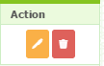
- Click on the in the action column.
- After edit, click on button.
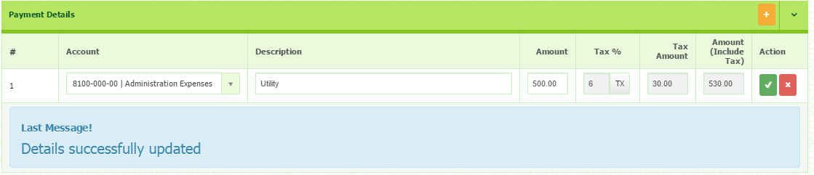

Transaction: Other Receive
1
- Go to General ledger Transaction Other Receive
2
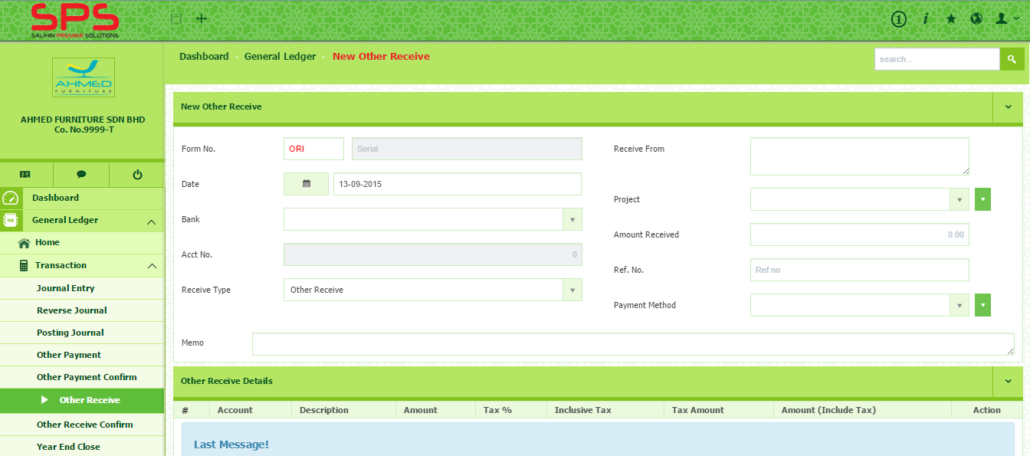
- Fill in all the information required in the New Other Receive section
2
1

- In Other Receive Details section, click Add New Payment to record any payment received.
3
- Select account group and tax code from drop down button. Insert transaction and amount.
4
- Tick the box in column inclusive tax to represent the amount inserted is inclusive of GST.
5
- Click button in the action column to save.
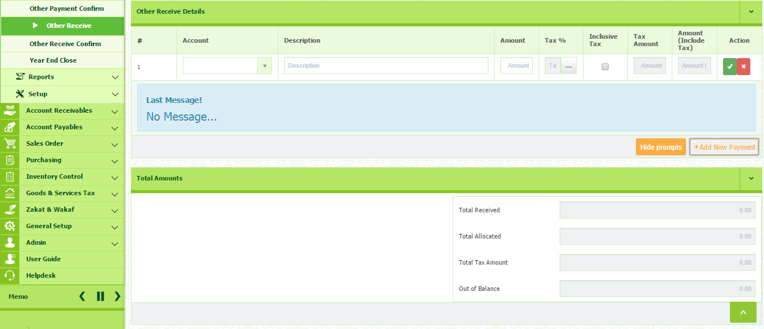
4
5
3

Transaction: Other Receive Confirm
You need to confirm other receive by confirming at Other Receive Confirm
1
- Go to General ledger Transaction Other Receive Confirm
2
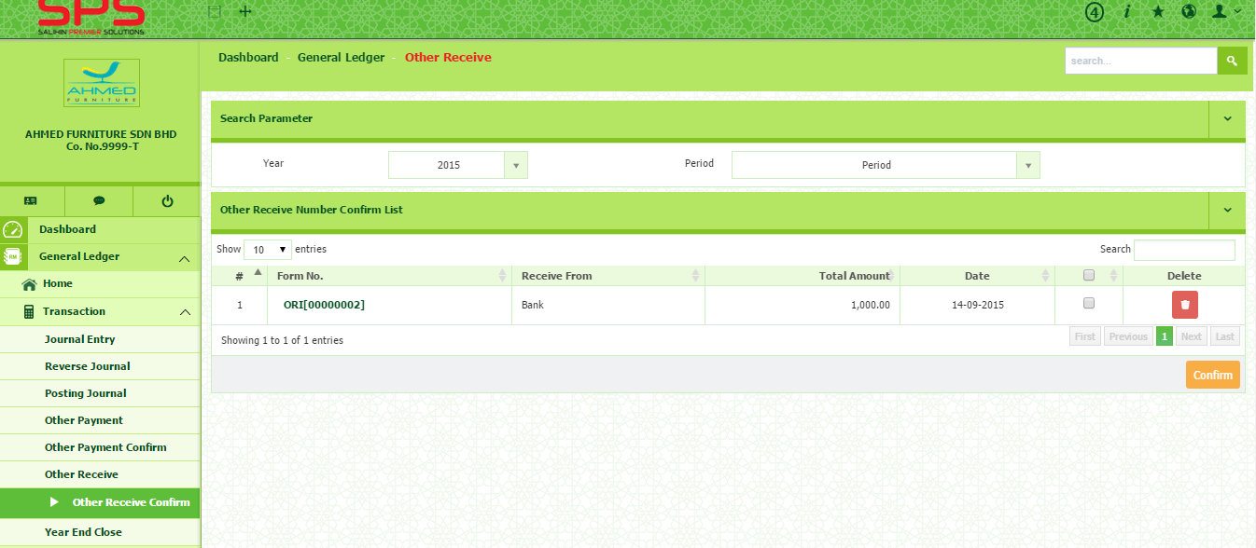
- Select Year and Period.
2
1

- Select Form No that want to be confirmed and tick the box. Then click Confirm.

Transaction: Year End Closing
1
- Go to General ledger Transaction Year End Close
2
- Select Year
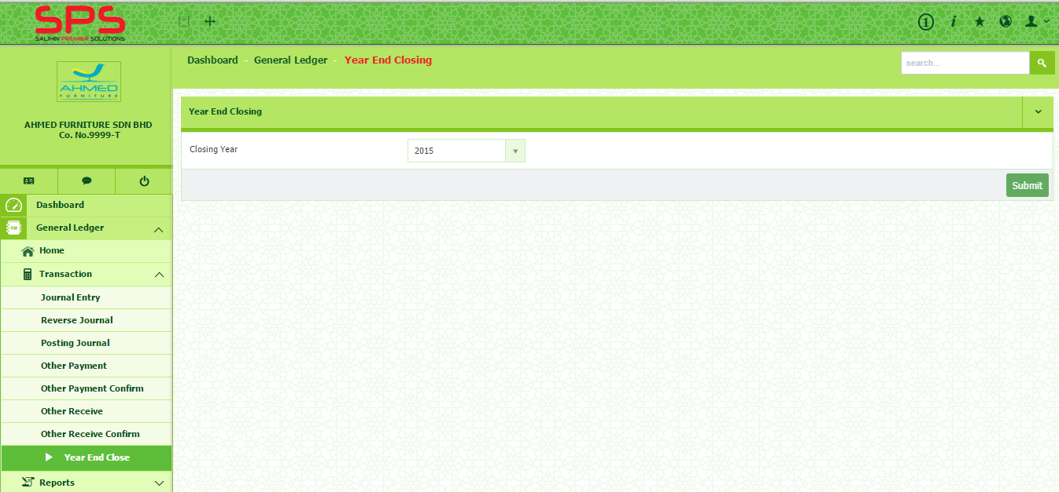
- Click Submit.
2
1
General Ledger: How to Setup a Report
Report: Account Balance Summary
1

- Go to General ledger Report Account Balance Summary
2
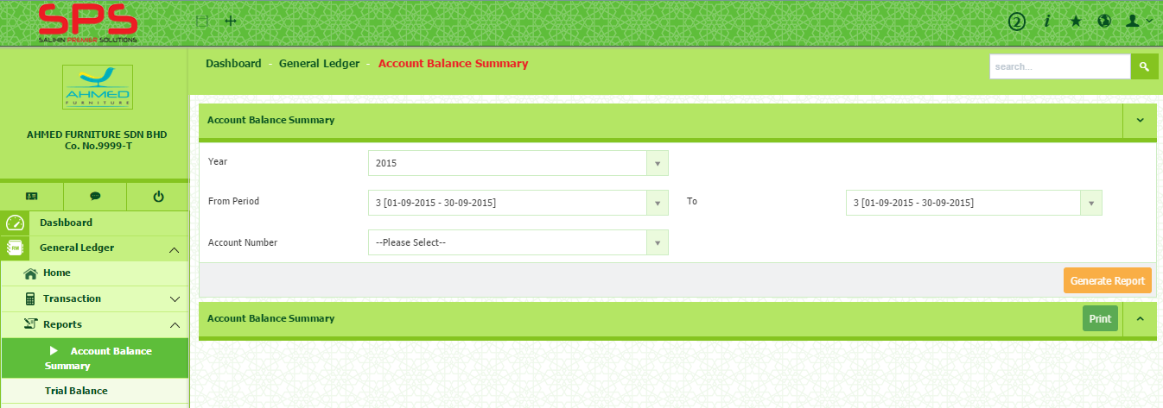
- Select Year, Period and Account Number
2
1

- Click Generate Report button to generate the report.
- You can print the report by clicking Print button

1
Report: Trial Balance
- Go to General ledger Report Trial Balance
2
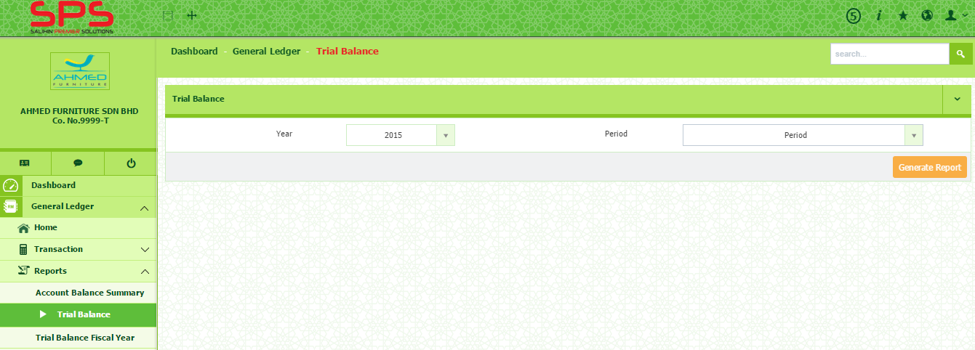
- Select Year and Period
2
1

- Click Generate Report button to generate the report.
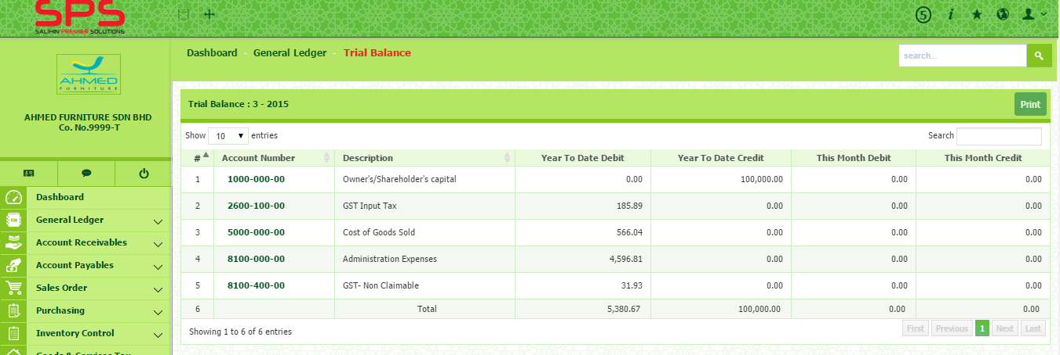
- You can print the report by clicking Print button

1
Report: Trial Balance Fiscal Year
- Go to General ledger Report Trial Balance Fiscal Year
2
- Select Year.
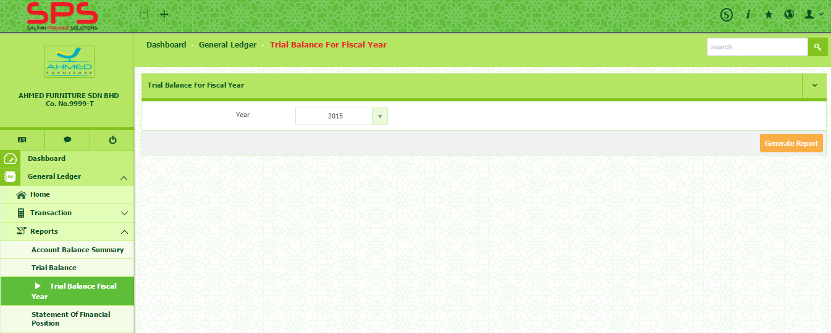
- Click Generate Report button to generate the report.
2
1

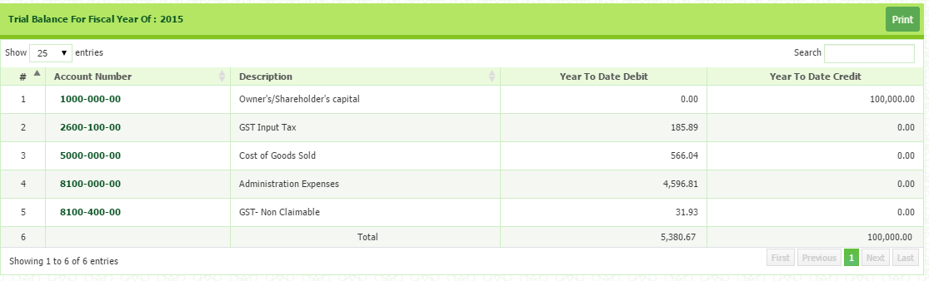
- Once report is generated, you can print the report by clicking Print button

1
Report: Statement of Financial Position
- Go to General ledger Report Statement of Financial Position
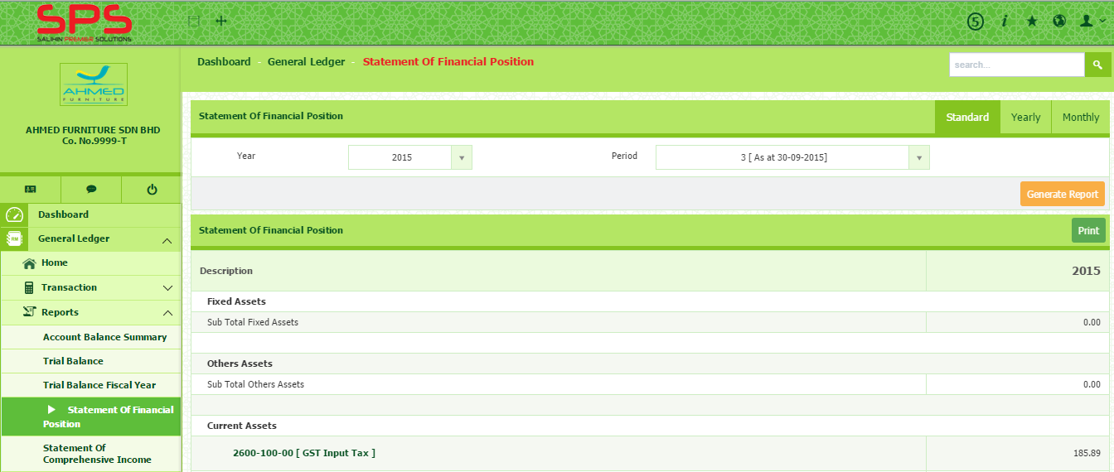
- You may choose the format of the report: standard, yearly or monthly on the top of right corner.
2
2
1

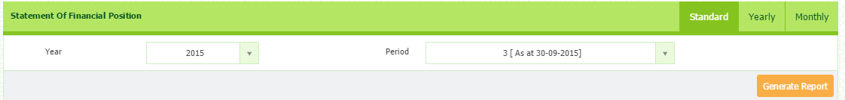
- For standard, select Year and Period and click Generate Report button

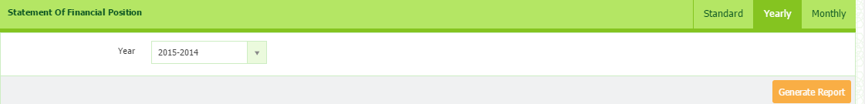
- For Yearly, select Year and click Generate Report button

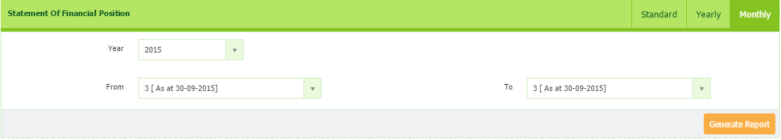
- For Monthly, select Year, Period From and Period To and click Generate Report button.

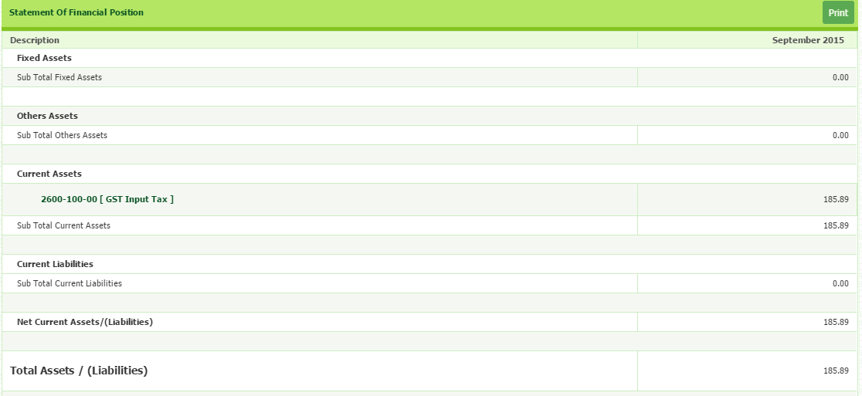
- You can print the report by clicking Print button

Report: Statement of Comprehensive Income
- Go to General ledger Report Statement of Comprehensive Income
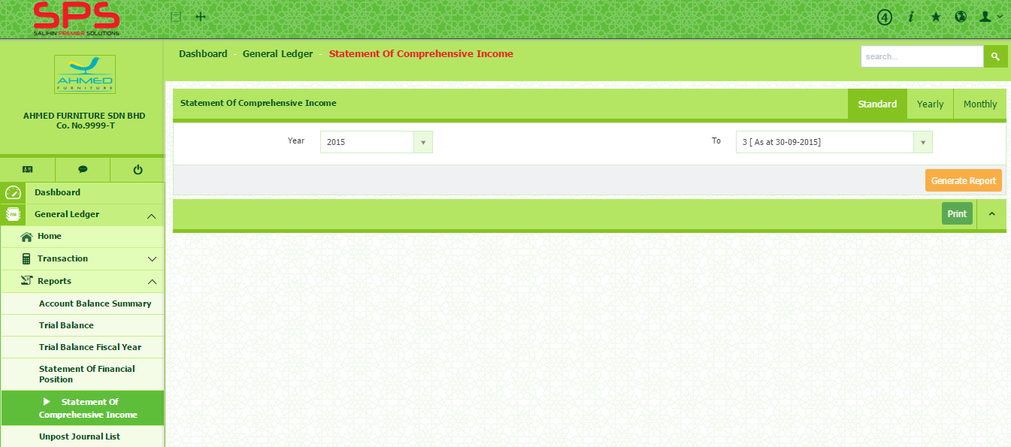
- You may choose the format of the report: standard, yearly or monthly on the top of right corner.
2
1

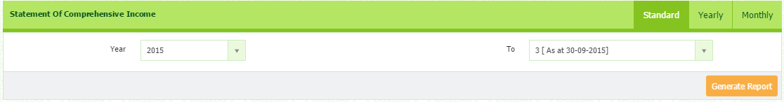
- For standard, select Year and Period and click Generate Report button

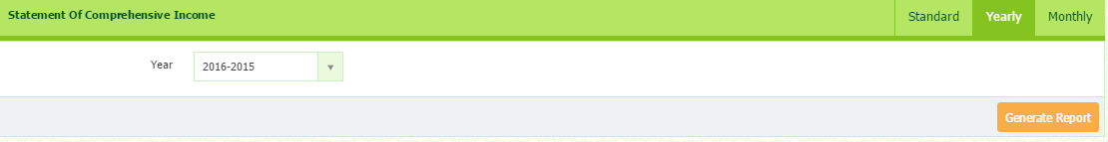
- For Yearly, select Year and click Generate Report button.

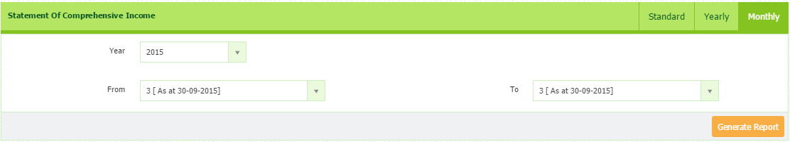
- For Monthly, select Year, Period From and Period To and click Generate Report button

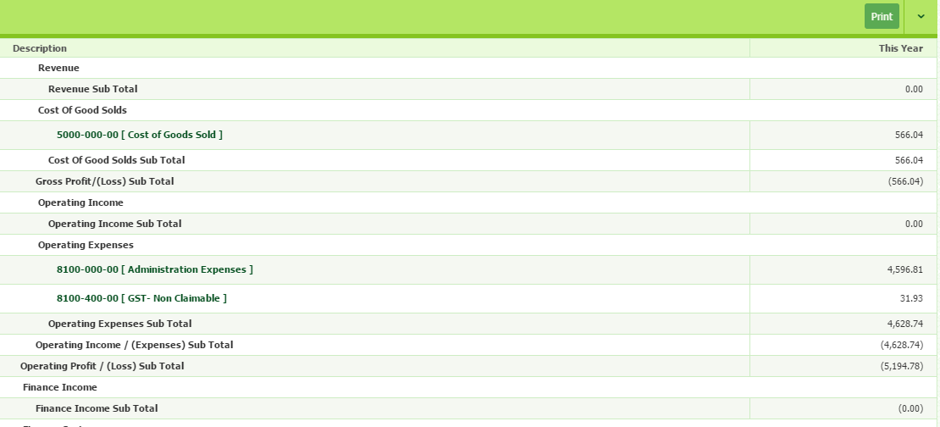
- You can print the report by clicking Print button

Report: Unpost Journal List
1
- Go to General ledger Report Unpost Journal List
2
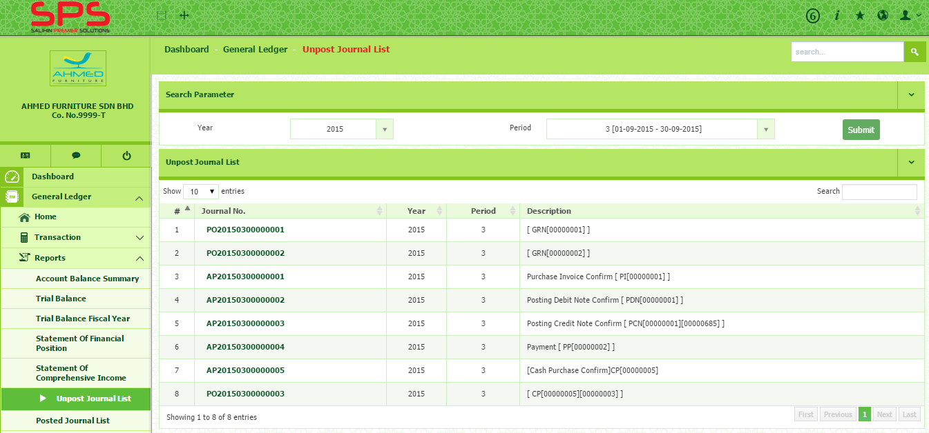
- Select Year and Period and Click Submit button. The list will appear at the bottom.
2
1

1
Report: Posted Journal List
- Go to General ledger Report Posted Journal List
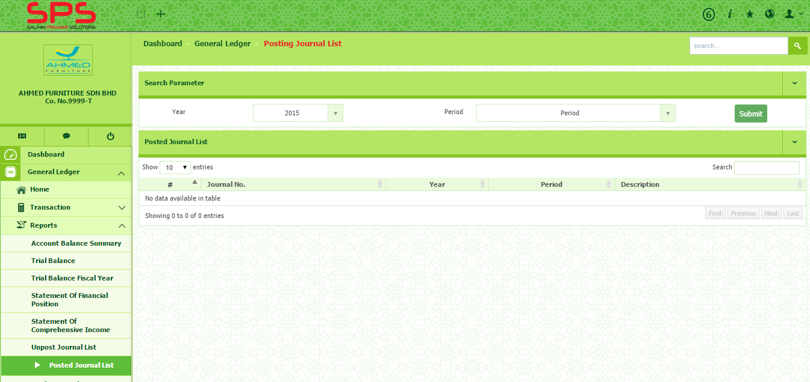
- Select Year and Period, then click Submit button. The list will appear at the bottom.
2
2
1

1
Report: Bank Reconciliation
- Go to General ledger Report Bank Reconciliation
2
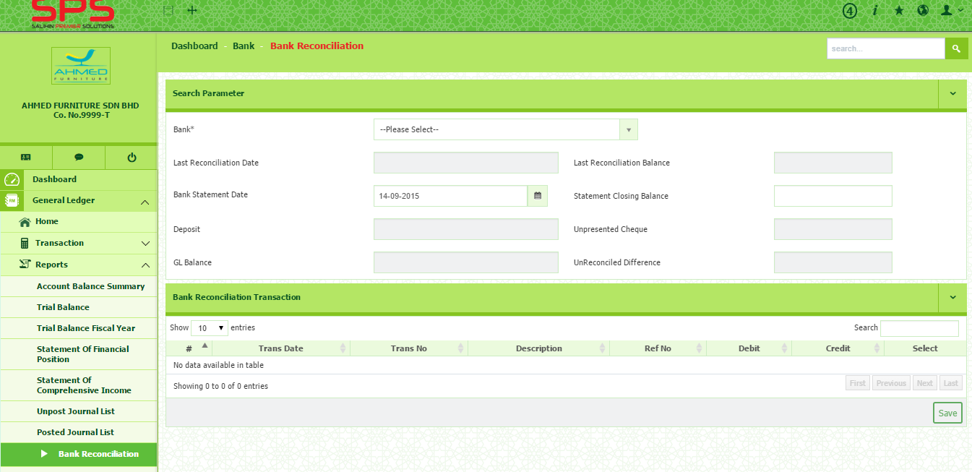
- Select Bank, Bank Statement Date and enter Statement Closing Balance.
2
1

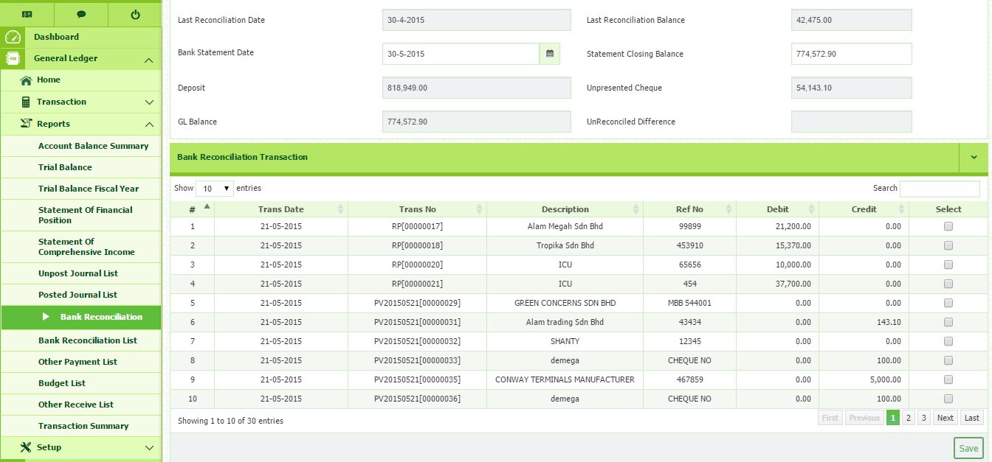
4
3
- The screen will show the last reconciliation balance, statement closing balance, unpresented cheque and unreconciled difference amount.
3
- Bank reconciliation transaction will be appeared at the bottom side. To reconcile, tick the box in Select column of each transaction that you intended to reconcile.
4
- Then, click Save button.

1
Report: Bank Reconciliation List
- Go to General ledger Report Bank Reconciliation List
2
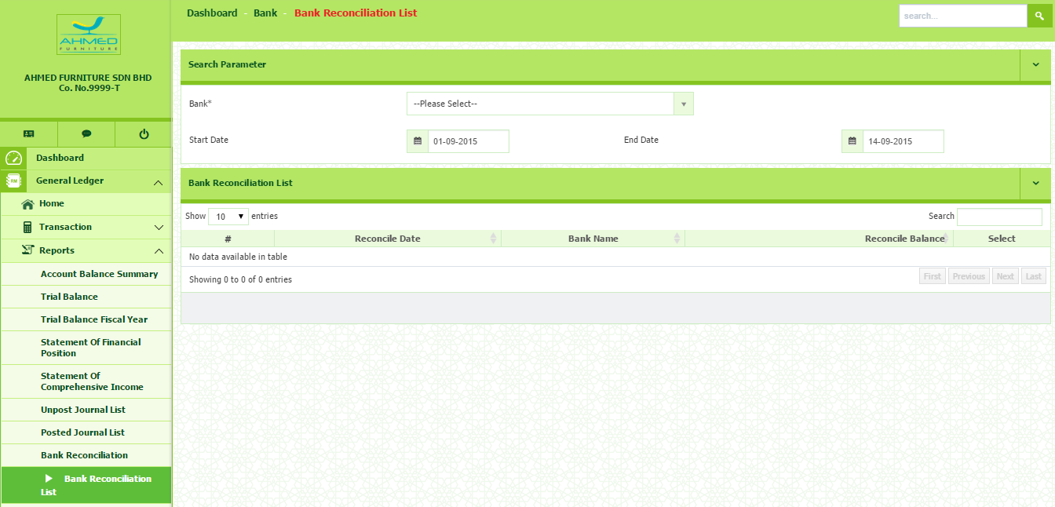
- Select Bank, Start Date and End Date
2
1

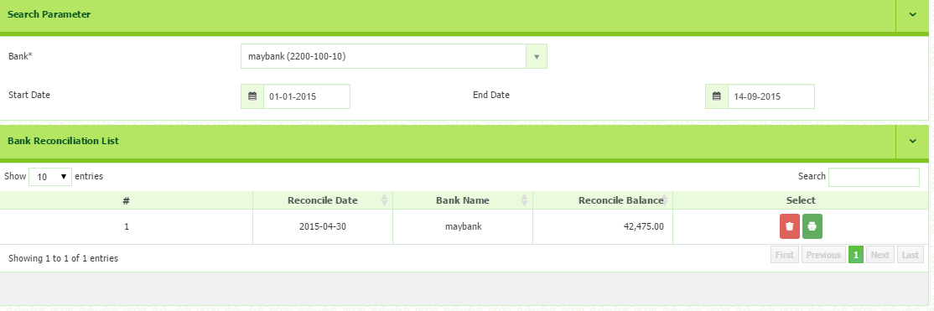
- Click button to print.

Report: Other Payment List
1
- Go to General ledger Report Other Payment List
2
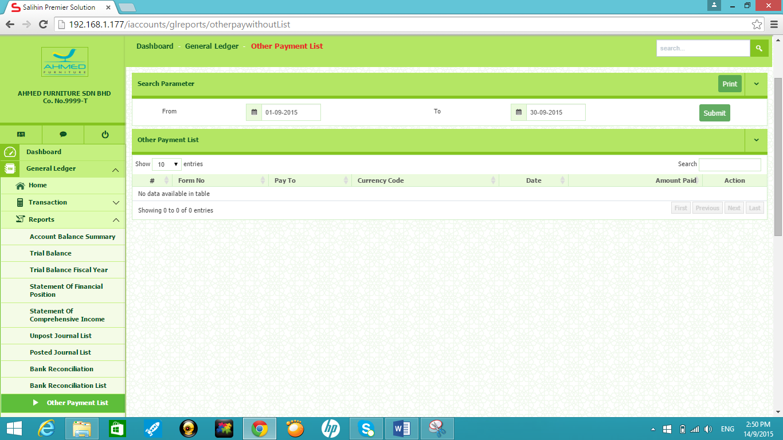
- Select From and To. Then, click Submit button.
2
1

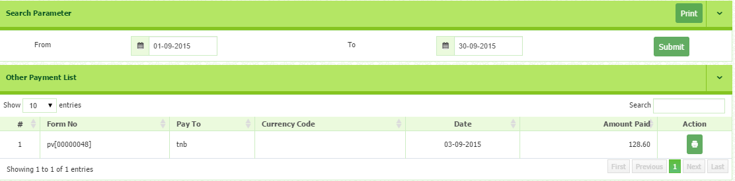
- You can print the report by clicking Print button

1
Report: Budget List
- Go to General ledger Report Budget List
2
- Select Year and click Generate Report button.
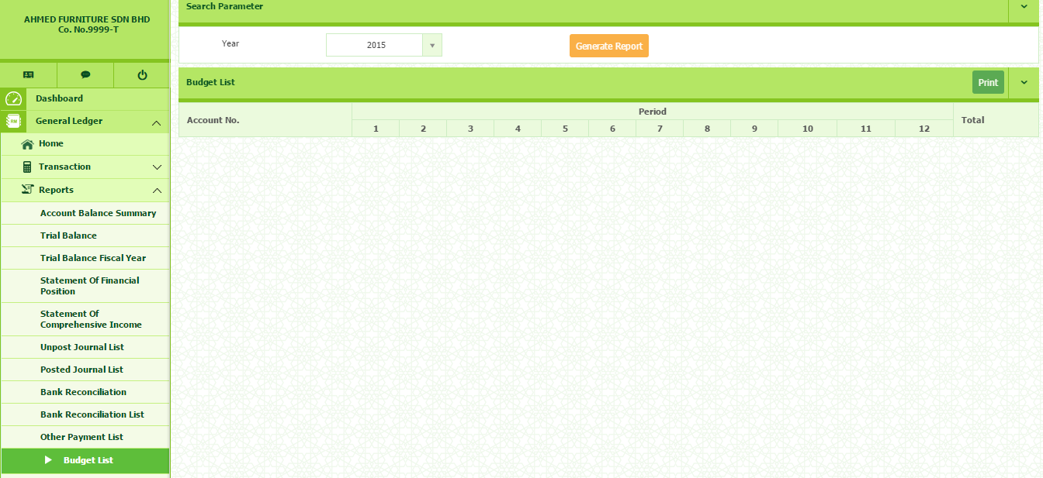
- Click Print button to print.
2
1
Report: Other Receive List

1
Report: Other Receive List
- Go to General ledger Report Other Receive List
2
- Select From and To, then click Submit button
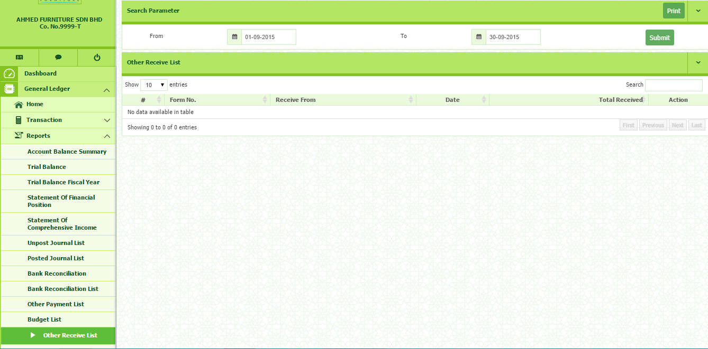
- Click Print button to print. It will print all the listed transactions under other received.
2
1

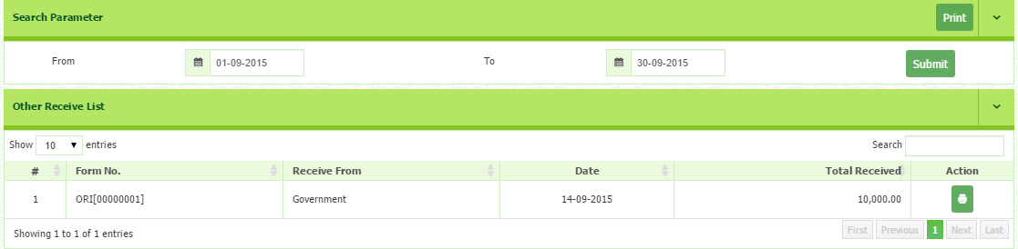
- Click Print button in the Action column to print.

1
Report: Transaction Summary
- Go to General ledger Report Transaction Summary
2
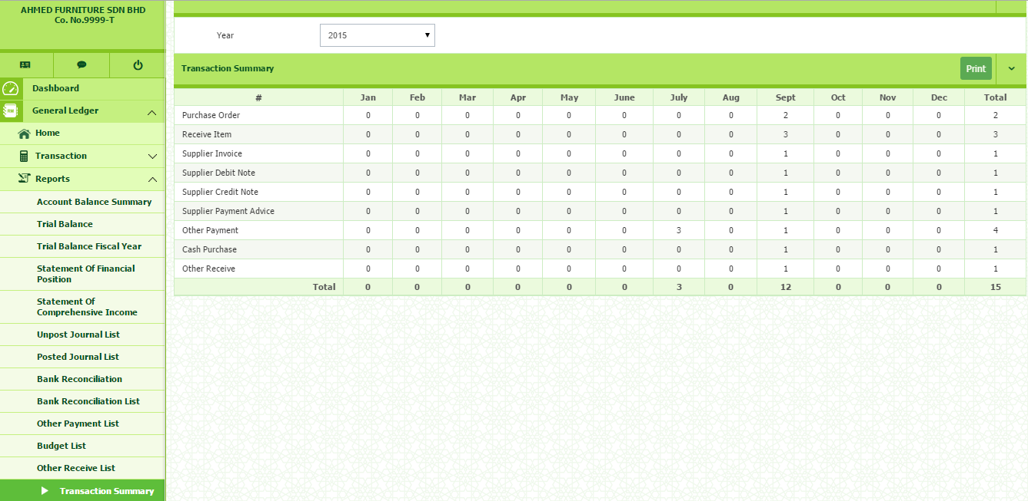
- Select Year and click Print button to print.
2
1

