CHAPTER 1
INTRODUCTION
1.1 INTRODUCTION AND BACKGROUND OF STUDY
Smartphone is viewed as an important communication tool and has become an integral part of the Malaysian society. The number of the people in Malaysia who are using the smartphone rather than the basic telephone as a way to keep in touch with their family, friends, colleagues and business associates are increasing. In Malaysia, some of the popular smartphone brands are Apple, Samsung, Sony, Oppo and others. Among these smartphone brands, Samsung Galaxy and Apple iPhone are among the competitors in the market based on advertisement and promotion.
The smartphone first appeared is in the late of 1990’s and was mainly used by a professionals. The first phone manufactured was Ericsson and the model was called R380 as shown Figure 1.1 and the smartphone was built with basic features which make it able to access an internet. In the third quarter of 2012, about one billion of smartphones have been used around the world.
Figure 1.1: The pictures of the smartphone
As mentioned earlier, during the first generation, when smartphone were released in the market, only the elitists could exclusively owned. However, nowadays, even average income people also can owned a smartphones. Nowadays, most of Malaysians are using a smartphones because they have many advanced functions or features such as e-mail communication, web-browsing, in-built cameras, with a HD touchscreen, countless apps and high-speed internet on the go. Qun et. al. (2012) claimed that, the society has slowly moved their cell phone purchasing decision to smartphone.
According to Woon et. al. (2013), Malaysia is one of the top country that contribute to the increasing of smartphone sales. From the research the penetration rate of Malaysia in Southeast Asia achieved 132.93 %, amongs the third highest penetration rate in Southeast Asia region.
Table 1.1: Penetration rate (%) in South East Asia
Country | Penetration Rate (%)
Vietnam | 166.76%
Singapore | 150.61%
Malaysia | 132.93%
Brunei Darussalam | 111.77%
Thailand | 105.05%
Indonesia | 104.25%
Philippines | 85.41%
Laos | 61.35%
Cambodia | 27.49%
Myanmar | 0.92%

The functionality having a smartphones is to help users in daily life, especially business people and university students is the key factor that most influences the increase in smartphone usage. Nowadays, peoples are searching information, checking e-mail, twitter status, whatsapp or other social networks by using smartphones with their constant web connection feature. According to Moscaritolo, smartphone is more accessible and mobile devices that can provide easy access. In addition, the highest rate of internet usage using a smartphone falls in the age group 25 to 34 years old (41%) and 18 to 24 years old (38%), the rest is those who in 40 an above.
There are many different factors on buying decision of smartphone for individuals. Some might look into the design, some might prefer user-friendliness of user interface, the price of the smartphone and so on that can makes a smartphone more interactive to be purchased. Therefore, this kind of factors are needed to determine that what factors that actually affecting consumer decision on buying a smartphone among staff in Universiti Teknologi Mara (UiTM) Negeri Sembilan, campus Seremban 3.

1.2 PROBLEM STATEMENT
Demands of a smartphone nowadays are increasing, typically in western countries (Kathy, 2012). According to the statistics that are made by Anson (2012), young adults are the higher amount of smartphone users, which means that they can adopt to new technology or product faster than older generations. It is clearly that the smartphone is getting popular among young adults in Malaysia and there are many factors that affecting this group of in buying smartphones. As numbers of manufacturers have entered the smartphone market, the competition in the smartphone market becomes more and more fierce.
As mentioned earlier, there are many different brands and operating system out there for smartphone users. The more the new brands or products, there more competative among the manufactures. This study will be helpful to every smartphone producers, designers and programmers gain more insights about how consumer made a decision in buying a smartphone. Now, smartphone as part of anyone live since it has many useful applications. People now are living in the highly developed and technologically advance society and depends greatly on smartphone. So the problem of this study is to identify which factors that most affecting consumer in making decision when buying smartphone.

1.3 THEORETICAL FRAMEWORK
The theoretical framework is a diagram that displays both dependent variable and independent variables and connects or links those variables to form a test in this study. A study conducted through a research to identify the major factors affecting consumers buying decision of smartphone among staffs at Universiti Teknologi Mara Negeri Sembilan, campus Seremban 3.
The purpose of this study is to determine the association between the six independent variables, such as friend and family influences, social influence, product features, brand name, and price, with buying decision of smartphone among staffs as the dependent variable.
Friend and Family Influences

Social Influence

Smartphone Buying Decision
Product Features

Brand Name

Price

Figure 1.2: The Theoretical Framework of the Study

1.4 RESEARCH QUESTION
The research questions of the study are:
- What is the profile information of smartphones’ buyers among staffs in UiTM Negeri Sembilan, campus Seremban 3?
- Are there any differences of smartphone buying decision among gender and department smartphone buying decision?
- Which are the factors that influence buying decision of smartphone?

1.5 RESEARCH OBJECTIVE
This study has looked into the familiarity of the users towards smartphones, choices of smartphone brand and service providers, and most importantly the determinants that influence their purchasing decision. A large number of studies attempted to identify the factor affecting consumer buying decision of smartphones device among staffs at the education organization. The independent variable are friend and family influence, social influence, product features, brand name, and price. There is evidence that male and female staffs perception differ and they not only influenced by price factors, but also by social and brand name. So, these studies focus on staff’s buying decision of smartphone. Below are the research objectives.
- To determine the profile information of smartphones’ buyers among staffs in UiTM Negeri Sembilan, campus Seremban 3.
- To test whether there is a difference of smartphone buying decision among gender on smartphone buying decision.
- To identify the factors that influence buying decision of smartphone.

1.6 RESEARCH HYPOTHESIS
- H1: The friend and family influences are affecting to the consumers’ smartphone buying decision.
- H2: The social influence affects the consumers’ smartphone buying decision.
- H3: There is a significant positive relationship between features of a product and the smartphone buying decision.
- H4: There is a significant positive relationship between branding and smartphone buying decision.
- H5: Price is related to the consumer’s smartphone buying decision.
- H6: There is no difference between genders in smartphone buying decision.

1.7 SIGNIFICANCE OF STUDY
The result will benefit to the staffs and an organization to comprehend the relationship between the family and friends influences, social influence, product features, brand name, and price in the smartphone market setting. These studies will provide evidence to support the relationship between the family and friends influences, social influence, product features, brand name, and price towards consumer buying decision among staff in Universiti Teknologi Mara (UiTM) Negeri Sembilan, campus Seremban 3.
Hence, it can help to improve the business growth for the marketers and increasing demand for smartphones. The companies of smartphone need to take actions that necessarily to improve their smartphone to be more and marketable to meet unlimited consumers expectations and needs (Norazah, 2013).

1.8 LIMITATION OF STUDY
The study is to investigate the factors affecting consumer buying decisions of smartphone devices among staff in Universiti Teknologi Mara (UiTM) Negeri Sembilan, campus Seremban 3. However, there are some restrictions throughout the study.
The limitation of the study is the research only conducted among the staff in UiTM Negeri Sembilan, campus Seremban 3 only. In this UiTM consists of three main faculties which are Faculty of Sport Science and Recreation (FSR), Faculty Computer and Mathematical Science (FSKM), and Faculty of Administrative Science and Policy Studies (FSPPP). Therefore, the result of this study cannot be generalized the purchasing decision of smartphone among Malaysian. In additional, there are no much variety of races of the staff.

1.9 DEFINITION OF TERM
Smartphone: A smartphone has more advanced computing capability and connectivity than a feature phone. Nowadays, smartphone include high-resolution touch screen and web browsers with a high-speed data access is provided by Wi-Fi and Mobile Broadband.
Consumer decision: Meaning that consumers identify their needs, collect information, evaluate alternatives, and make the purchase decision.
Friends and family influence: The influence of friends and family on buying a smartphone. Friends and family are related to an individual may cause another person to change the feelings, attitudes, and behavior, intentionally or unintentionally (Rashotte, 2007).
Social influence: Social influence may affect individuals on buying decision through daily observation, media, advertising and others’ perceptions. The result of study by Ying et. al. (n.d.) shows that consumer decision on buying smartphone may affect from celebrities connect the product value by transfer the feelings on a particular product that can give a strong recommendation to the consumer.
Product features: A feature is an attribute of a product that to meet with the satisfaction level of consumers’ needs and wants through the owning of the product, usage, and utilization of a product (Kotler et.al, 2007). Features of the products are including the larger and higher resolution screens and offer consumers a wide array of features which are mobile web browsing, applications, e-mail, messaging, social networks, games, video, camera and picture.
Brand Name: A name given by the maker to a product or range of products, especially a trademark.
Price: Price is an importantaspect before making any purchasing decision. There are two types of product price, which are high-price (expensive) products are market brands and low-price (cheap) products to be purchased for utilitarian value. Consumers typically look for low prices of brands or substitutes to get the best value (Swani and Yoo, 2010).

CHAPTER 2
LITERATURE REVIEW
2.1 INTRODUCTION
This chapter involved with discussion in the literature review and followed by discussion on relevant theoretical model, conceptual framework and developing hypotheses. Besides that, the purpose of the literature review is to understand and identified existing trends and relationships between variables. By referring relevant theoretical models, dependent and independents variables were defined. The main purpose of this study is to determine the important factors affecting consumer buying decision of smartphone. Other purposes of the literature review is to review the critical points of current knowledge including the factor findings as well as theoretical. Other than that, literature reviews also known as secondary sources, it only reports the past research and do not introduce any new or original research information.

2.2 LITERATURE REVIEW
2.2.1 CONSUMER DECISION MAKING
Consumer decision making is a process for consumers to identify their needs, collect information, evaluate alternatives and make the purchase decision. Consumer constantly make decisions regarding the choice, purchase and use of products and services (Payne et. al.,n.d.). They said that consumer decisions are of great important not only for the consumer themselves but also for marketers. According to Mohan (2014), marketers are extremely trying to research the consumer buying process to find out what consumers buy, where and how they buy, when and why they buy. It is easier for researchers to find the answers for what, how, where, when and how much consumers buy but it is not that much easy to find why they buy. Other than that, purchase intention can be used for future demand prediction too (Qun et. al., 2012).
A study by Lay-Yee et. al (2013) categorized the decision making into three different types which is nominal decision making, limited decision making and extended decision making. Lay-Yee explained that nominal decision making usually happen when costomers purchasing low involvement product, low cost and familiar product which is frequently purchased. Limited decision making is in the range of nominal and extended decision making, which involve limited external search. While extended decision making usually will be on the high involvement product; perhaps expensive products and unfamiliar products.
2.2.2 FRIEND AND FAMILY INFLUENCES
Peers and family are the important social factors that influence the consumer in helping them to make decision towards smartphone (Norazah and Norbayah, 2013) because family is one of the groups are that are close and interactions among relatives’ members and friend. Friends and family are the group was being a customer, so, they will give a little bit information to their friend about the smartphone that they are currently used to be a guideline whether they feel comfortable to buy the same smartphone. It supported by Shadan etc. al. (2014) from the research of a private university in Tehran are stated that the consumers who are more likely to interlock with and depend on positive so called opinions of important others on smartphones will in themselves augment their usage rate through either changing them into beliefs or by a process of imitation since they are more ambiguous about their potential uses. The consumers are depending on their friends or families because of this group are easily to change the consumer’s perception to buy or paid the products or services.
Other than that, consumers more like to have better communicating with their friends compared to their family when the was in the adolescence stage. It is because consumer often meet and spend time with their friends compared their family. According to Chow (2012) recognise from the survey, both female and male will find the opinion from their friends based on fashion and tend to purchase the similar clothes with their friends wear even in an adult stage. The study also mention that smartphone users decide to use smartphone to still contacting with their friends, colleagues or others persons in social network sites because of most smartphone application category they used is social media application for an example Twitter, Facebook and other. This shows that friends may influent people’s decision making.
2.2.3 SOCIAL INFLUENCE
From the word, someone can easier to influence other person’s decision (Chow et. al. (2012). Every person have a natural desire to ask other persons, find information from the internet or others about the advantages and disadvantages of the product before buying something. It is to prevent they will regret after buy that things. According to Norazah (2013), social factor related to the individual that can make other persons change their decision directly or indirectly. Social influence also can be interpreted as someone feels it so important for the others people need to use the new system (Chow et. al. 2012) such as smartphone. According to Norazah (2013), stated that the users worried whether the suggestion about the brand of the smartphone they are currently using will attract their friends to buy a smartphone if it helped them to fit in with their social group. Based on her previous study, the results of the study showed that social influence is the factor highly influenced on smartphone buying decision. It supported by Qun et. al. (2012), they found that factor of social influence affect on consumer buying decision since the p-value was less than significant level 0.05.
Another study towards Malaysian young adult of age 19 to 25 shows that direct role model refers to parents and vicarious role model refer to celebrities in which both direct and vicarious role models have an impact on the consumer’s purchase intention (Lay-Yee et. al. 2013). The study also interpreted that social influence indeed plays a significant role and it is the most influential to student’s dependency on smartphone. Someone’s past experience will affect the expectation for the purchase behavior is really dependent on smartphones because of the underlying motives (Norazah, 2013). According to Ilma et.al, (2013), stated that to argue that styling or changing the appearance and presentation of products could encourage customer demand, in an increasingly competitive market, advertisers and manufacturers have begun to argue that styling or changing the appearance and presentation of products could encourage customer demand.
When an application is good, it will fit in better social groups because of the knowledge. People who have used the product would share their experience with others, and consequently more people would be willing to buy the product like “Word of mouth” made Nokia succeed in all kinds of customer satisfaction surveys or interviews (Na and Gergana, 2011). While Orose and Bronchai (2012) discovered that to have access an unprecedented amount of information, and in this way knowledgeable consumers can make more informed decisions customer enables to connect with Internet in their smartphones such as fashion, healthcare and others. Consumers does not know without hear the others’ perception towards brands to prevent regret.
2.2.4 PRODUCT FEATURES
Product features is hypothesized to have positive impact with the quantity demanded. Product features is related to the attributes of a product that help to meet the satisfaction level of consumers’ needs and wants through owning the product, use, and utilization of the product (Norazah, 2013). The mobile phone features are basically the set of competencies, services and applications that are offered to the users (Khan and Rohi, 2013) including a personal digital assistant, a media player, Bluetooth, Wi-Fi, camera, touchscreen, GPS navigation unit, applications and many more features of smartphones. These type of application can saving time of the customers to find the information.

Nowadays, comparing basic phone, smartphone has more application because Google’s Android operating system has propelled Samsung to the top of global smartphone sales in 2011 in Southeast Asia (Norazah, 2013). According to her research study, users largely value the smartphone features such as full-screen viewing for images and video and larger text and buttons with stylish design. Another research study conducted by Mohan (2014), factor affecting ones to acquire a smartphone due to software consists of 33 % whereas hardware has only 17.6%. It shows that hardware is less important than software on buying decision of smartphone. In the same research, smartphone’s design gain the most importance of the device specification, it consists of 56% exceed the importance of Wi-Fi (38.5%), computing power (34.2%), price (30.2%) and others.
Based on Leelakulthani & Hongcharu (2012), the results of the multiple regression analysis according to the standardized beta coefficients, product features were positive determinants of the smartphone repurchase. However, product features not give the highest score for beta. It supported by Sata (2013) that product features be the second higher for beta after price. The two articles proved that product features is the factors that most important when consumers making decisions when buying a smartphone devices.
2.2.5 BRAND NAME
Brands play a very important role in the consumer decision making processes. To purchase a specific product, customers always follow a sequences of steps in decision making. The study also define that young people make decision to buy smartphones by three important factor which is price, brand name and product features. They start realizing a requirement of product, get information, identify & evaluate alternative products and finally decide to purchase a product from a specific brand. Besides that, brand also label as a trademark. (Chow et. al, 2012) has proposed three definitions: ‘‘trademark’’ is a logo with associated visual elements, ‘‘brand’’ is a trademark with associated intellectual property rights, and ‘‘branded business’’ covers the whole organization. Comolis (2010) agreed that more and more companies realize that one of their most priceless assets is the brand name related to their products or services
According to (Chow et. al, 2012) they stated that oneof the major objectives of a brand name is to provide information on the quality of a product and the value of a brand name adds to the product is named as brand equity. (Keller, 1998) highlight that developing brand equity is thought to be an important component of brand building and brand equity is assumed to convey several benefits to a firm. Brands might develop as competitive advantage for firms to differentiate them from those of competition which make them more unique. As a result, if consumers perceive a particular brand favourably, then the firm may have a competitive advantage (Chow, et. al, 2012). It is supported by Forsido, (2012) that the brand image can be brand uniqueness when it comes to competing brands because of almost all competitive brands have unique dimensions to differentiate themselves from the competitor’s brand. He also said that, the brand can be differentiated by the texture, sound, the color, packaging, weight, design, whereas other more abstract dimensions can be brand uniqueness.
The results of the multiple regression analysis based on Leelakulthani & Hongcharu (2012), according to the standardized beta coefficients, brand name were positive determinants of the smartphone repurchase. In other words, brand name tended to most influence smartphone repurchase in a positive way. Leelakulthani & Hongcharu (2012) also said that brand name give the highest score for beta and brand name is the factors that influence consumers making decision when purchase a smartphone.

2.2.6 PRICE
Price can be an income for the seller when they can sell their product to the customer. Therefore, price is one of the important factors that can affect customer make a decision (Leelakulthani & Hongcharu, 2012) because of their worry towards price of the product. It is supported by S. Monica (2014), price is no longer an element that can be ignore in the investigation whether or not it is an crucial factor that can be affected consumers’ behavior in products and services.
Yang (2013) stated that the level of price can create the image of the brand for the customer. According to Chow et. al. (2012), customers usually fell and think that the good quality just for the high price and the lower price shows the low quality. However, the perception of the product will increase when the performance or the quality of the product more than customer expectation and the level of price are affordable, then they will choose the same product (Leelakulthani & Hongcharu, 2012). It happens usually because of the consumers have a lot of experience when buying the lower and higher price. The lower price usually easy to damage or the services are not good.
Besides that, Xie, and Chaipoopirutana (2014) stated that customer less confident towards the products’ quality when the price less than the suitable price range and purchase intension can be reduced if the actual price is higher than the suitable price range on the product. Ima et. al. (2013) was agreed with Xie and Chaipoopirutana which from Jacoby’s model prove that price standard is estimated by perceived quality and perceived sacrifice which is high price in the high products’ quality can increase purchase intention directly. From the Monroe’s concept, purchase intention was not only includes perceived quality but also perceived sacrifice will be influenced by role of price (Ima et. al., 2013).
Other than that, price basically is the monetary value that consumers willing to pay to get the products and services that are valueable. It supported by Lay-Yee (2013) which is some of customer preferred high quality and willing to pay high price and some of them are not because of consumer has different tastes, needs, motivation lifestyle when they want to purchase a product. However, some of the customer uncertain which the brands of the smartphone provide suitable price in term of product quality.
The results of the multiple regression analysis according to Sata (2013) stated that the standardized beta coefficients, price were positive determinants of the smartphone repurchase. Sata (2012) also said that price give the highest score for beta. Other than that, pice is the most factors that affecting consumers making decision when buying a smartphones. However, ilma ilyani et. al (2013) do not agreed with the Sata (2012) because of ilma ilyani et. al. (2013) believed that in multiple regression analysis, the standardized beta coefficients, even price were positive determinants of the smartphone repurchase but it is the lowest beta and price do not influence consumers’ decision when buying a smartphone.

2.3 CONCLUSIONS
In this chapter, the consumer buying decision is important to examine the selection of smartphones among the Universiti Teknologi Mara (UiTM) Negeri Sembilan, campus Seremban 3. The dependent variable is consumer decision making and the independent variable that have discussed in the literature review are family and friend influences, social influence, product features, brand name and price factors from the previous research. The more understanding about the factors related to buying decision the more insight information about consumer’s preference will be known.

CHAPTER 3
METHODOLOGY
3.1 INTRODUCTION
In this chapter the research design, sampling, instrument, software used and statistical data analysis will be discussed. To achieve the purpose of the research which is to investigate the factors affecting the consumer, there are several methods can applied and the method must be suitable. In doing so, the type of the research must be identified and the method of data must be proper. The research is composed of two major parts of analyses. One is descriptive analysis to investigate demographic pattern and the another one is multiple linear regression.

3.2 RESPONDENT
The respondent of this research will be target on the UiTM Negeri Sembilan, campus Seremban 3 staff which are the individual groups consists of male and female staff, respondents in age start from 20 and above. This group of individual representatives on consumers’ decision on buying smartphone during this ages periods. The questionnaires will be randomly distributed and administered to Universiti Teknologi Mara (UiTM) Negeri Sembilan, campus Seremban 3.

3.3 INSTRUMENTATION
This research will be used a questionnaire to obtain the data. The purpose of the questionnaire is to acquire useful data from the staff Universiti Teknologi Mara (UiTM) Negeri Sembilan, campus Seremban 3. The questionnaires are generally less expensive and time consuming than interviews and observation.
The questionnaire is designed in English and Malay language as it is the suitable for communication with the respondents. The questionnaire will be seperated into two major section, which are Section A and Section B. Section A will contain a question about the respondents’ profile information, while Section B examining on the dependent variable and independent variables. The questionnaire has 11 items in Section A and 33 items in Section B. In section B will be on a five-point Likert scale ranging where 1 represents ‘strongly disagree’ to 5 represents ‘strongly agree’. Every element has five or six questions.
Table 3.1: Summary of Questionnaire
Section | Questions | Type of Questions
A | 11 | This section consists of respondents’ demographic background
B | 33 | This section focuses on question about factor that affect consumer decision on buying smartphone

3.4 SAMPLING METHOD AND SAMPLE SIZE
Since the population is known and the sample size is small, stratified sampling is suitable for this research. Besides that, there is no information about the variances and costs, then it will be assumed that the stratum variances and costs are equal, so proportional allocation will be used to calculate the number for each categories. The benefits of this method are most efficient among all probability designs, and all groups are adequately sampled and comparisons among groups are possible.
A population size of 317 respondesnts is chosen from staff with different department in Universiti Teknologi Mara (UiTM) Negeri Sembilan, campus Seremban 3. The staffs are chosen to be the samples as their decision on buying smartphone. The campus has two staff catogories which are an academician and administrative. The total staff from academician is 214 and the total of staff from administrative is 103. Since there is no information about cost and variance, to determine the sample size for this research will be referring the textbook.
Table 3.2: Sample size for a given population size
N | S | N | S
10 | 10 | 120 | 92
15 | 14 | 130 | 97
20 | 19 | 140 | 103
25 | 24 | 150 | 108
30 | 28 | 160 | 113
35 | 32 | 170 | 118
40 | 36 | 180 | 123
45 | 40 | 190 | 127
50 | 44 | 200 | 132
55 | 48 | 210 | 136
60 | 52 | 220 | 140
65 | 56 | 230 | 144
70 | 59 | 240 | 148
75 | 63 | 250 | 152
80 | 66 | 260 | 155
85 | 70 | 270 | 159
90 | 73 | 280 | 162
95 | 76 | 290 | 165
100 | 80 | 300 | 175
110 | 86 | 320 | 181

Since the number of the population is 317, so the sample size of research is 181. Below are calculated for each categories by using proportional allocation:
For academician: For supportive staff:
By using the stratified sampling, sample from the academician category is 122 and the sample from supportive category is 59. In addition, staff category have many departments which are Faculty of Administrative Science and Policy Studies (FSPPP), Faculty of Computer and Mathematical Science (FSKM), Faculty of Sport Science and Recreation (FSR), Policy Department, Medical Unit, Service Department, Library Department, Administrative Department and College Department.

3.5 DATA COLLECTION METHOD
The data was a primary data. In this study, the whole research will be conducted by using a survey questionnaire to collect the data from the staff in UiTM Negeri Sembilan, campus Seremban 3. The questionnaires will be distributed to the respondents by hand. The responses from the respondents will be obtained through structured questionnaire and thus to be further analyzed. In both user and non-user instances, pains were taken to explain to respondents the purpose and objective of the survey.

3.7 VARIABLES OF THE STUDY
Table below shown the variables that will be used in this study.
Table 3.3: Summary of Variable Study
Variables | Scale of Measurement | Descriptions
Section A:  - Gender  - Age  - Staff Category  - Department  - Income Level  - Current phone (Brand)  - Preferred Brand (Samsung, HTC, Apple, Blackberry, Nokia, Sony Ericson, LG, Lenovo, ASUS, OPPO, Others)  - Get Information about smartphone (Television, Family&Friends, Magazine, Promotion, Social Media, Blogger, Internet, Others)  - Connection at home  - Access from other places | - Nominal  - Nominal  - Nominal  - Nominal  - Ordinal  - Scale  - Scale  - Nominal  - Nominal  - Nominal | 0= Male; 1 = Female  1= age 20-30 years old;  2= age 31-40 years old;  3= age 41-50 years old;  4= greater than age 50 years old  1= Academician;  2= Administrative/Supporting Service  1= FSPPP; 2= FSKM; 3= FSR;  4= Police Department;  5= Medical Unit;  6=Administration;  7= Librarian;  8= Other  1= Below RM1,000;  2= RM1,001 – RM2,000;  3= RM2,001 – RM3,000;  4= RM3,001 – RM4,000;  5= RM4,000 and above  1= Samsung; 2= HTC; 3= Apple;  4= Blackberry; 5= Nokia;  6= Sony Ericson; 7= LG;  8= Lenovo; 9= ASUS;  10= OPPO; 11= Others  0= Not choosing;  1= Very Important;  2= Important;  3= Average;  4= Not Important;  5= Very Not Important  0= Not tick;  1= Tick  0= No;  1= Yes  0= No;  1= Yes
Section B:  - Friends and Family  - Social Influence  - Product Features  - Brand  - Price  - Buying Decision | Scale | 1= Strongly Disagree;  2= Disagree;  3= Neutral;  4= Agree;  5= Strongly Agree

3.8 SOFTWARE USES
IBM SPSS statistics 20 software will be used to analyze data from the research respondents, to gain the result from the methods. Data analysis begins after the data have been collected and processed. Besides that, usually researcher uses simple data to calculate the mean, percentage distribution, frequency distribution, and others. Furthermore, we will use the Microsoft word and Microsoft excel.
- Statistical Package for Social Science (SPSS)
IBM SPSS is also used to analyze quantitative data in a way that produces the result that was intended.
- Microsoft Excel
Microsoft Office Excel 2010 is a powerful tool can use to create and format spreadsheet.

3.8 METHOD OF DATA ANALYSIS
In this chapter use several types of analysis to analyze the findings such as a pilot test, frequency distribution, examining the reliability and Multiple Regression Analysis.
3.8.1 Examining Reliability
The reliability of a measure indicates the important to which it is without error free and reliability also an indication of the stability and consistency with instrument measures. In other word, reliability helps to affect the good of measure. Interitem consistency reliability or Cronbach’s alpha is the one of the popular test measure that people always use. If the coefficient is high, then the instrument measure is good. In table 3.4 below shows the reliability of Cronbach’s alpha.
Table 3.4: Cronbach’s alpha
Cronbach’s Alpha | Conclusion
Below 0.6 | The reliability is weak
In the range of 0.6 to 0.8 | The reliability is strong
Above 0.8 | The reliability is very strong

3.8.2 Descriptive Analysis
Descriptive analysis is often used to collect data that describe the characteristics of persons, events, or situations. This research does not gather the causes behind a situation. Descriptive analysis is easy to interpret and understand. From Section A of the questionnaire such as age, gender, faculty, family income level and etc, to describe the measurement using percentage, frequency, pie chart, bar chart and graphics.

3.8.3 Test of Normality
In this research, to check whether the error terms are normally distribute, the method will be used are Skewness, Kurtosis and P-P Plot of Residuals. All these plots are to check either the error terms are normally distributed or not. When P-P Plot of Residuals are run, if the dotted point lies close on the 45 degree line and nearly on the straight line, a researcher can directly conclude that the error terms are normally distributed, but if dotted point show some pattern, the error terms are not normally distributed. Besides that, to check normality by using skewness, it will be normally distributed if the range for the values of skewness are between -2 and 2, while for kurtosis the range are between -3 and 3.

3.8.4 Independent Sample t-test
Independent Sample t-test used to determine whether or not there is a difference in the mean for two groups in variable of interest. If the data showed normality distributed in the normality test earlier, so it will use Independent Sample t-test in order to know whether differences exist between male and female, and staff categories on decision on buying smartphone.

3.8.5 One-Way Analysis of Variance (ANOVA)
It is used to examine the significant mean differences among more than two groups on an interval or ratio-scale dependent variable. If the data showed normality distributed in the normality test earlier, so it will use Analysis of Variance (ANOVA) in order to examine whether the differences exist between gender, and staff category on decision on buying smartphone.

3.8.6 Multiple Linear Regression Analysis
Multiple linear regression is a method to analysis the effects of two or more independent variable. For this particular study, this method is used to determine the relationship between all variable on a single dependent variable.
Where:
${\text{β}}_{\text{0}}$ is the regression constant
${\text{β}}_{\text{i}}$ is the coefficient or multipliers that describe the size of the effect the independent variable are having on dependent variable.
${\text{X}}_{\text{1}}$ is friend and family influences variable
${\text{X}}_{\text{2}}$ is social influence variable
${\text{X}}_{\text{3}}$ is product features variable
${\text{X}}_{\text{4}}$ is brand name variable
${\text{X}}_{\text{5}}$ is price variable
In this research, backward elimination technique will be used to determine the best model and the most factor that influence consumer decision on buying smartphone. It starts from the full model, including all independent variables. The variables are dropped one by one until a stopping condition is satisfied. At each step, the variable that shows the smallest contribution to the model will be removed or deleted from the model.

3.9 DATA ANALYSIS TECHNIQUE
Table below shown the technique that will be used in this study.
Table 3.5: Summary of Data Analysis Technique
NO | ISSUES | QUESTION NO | DATA ANALYSIS TECHNIQUE
1. | Respondent Profile | Section A (1-5) | Tables, bar chart, pie chart
2. | Examining reliability | Section B | Cronbach Alpha coefficients
3. | Test of Normality | Section B | - Skewness and Kurtosis Coefficient  - Probability Plot
3. | Examining determinations of itention to use | Section B | - Bivariate Relationship  - Pearson correlation  - Modeling – Multiple Linear Regression  - Model Evaluation (Levene’s Test, Coefficient, backward elimination)
 | Model Evaluation |  | - Levene’s Test (equal variance and mean)  - One-Way of Variance  - Coefficient  - Backward Elimination

3.10 SUMMARY
In conclusion, chapter three described the methodology that will be used to carry out the research design and data collection methods, research design, sampling and research instrument. Data will be collected from the questionnaire and coded into IBM SPSS 20 for analysis and will be analyzed.

CHAPTER 4
ANALYSIS AND RESULTS
4.1 INTRODUCTION
In this chapter, the results of analysis are presented. The findings are derived from questionnaire where analysis has been carried out to get a full understanding about the research area. Four fundamental goals drove the collection of the data and the subsequent data analysis. These objectives were accomplished.

4.2 TEST OF RELIABILITY
The reliability of a measure indicates the importance to which it is without error free and reliability also an indication of the stability and consistency with instrument measures. In other word, reliability helps to affect the good of measure. Interiterm consistency reliability or Croncach’s alpha is the one of the popular test measures that people always use. If the coefficient is high, the instrument measure is good. Table 4.1 shows the reliability coefficients for the friend and family influences, social media influences, product features, brand name, price and purchasing decision.
As what is shown in the table, friend and family influences were measured by 6 items and the reliability coefficient (Cronbach’s alpha) of the measure was 0.807, follow by social influences measured by 5 items and the reliability coefficient (Cronbach’s alpha) of the measure 0.798. While the reliability coefficient of product features was measured by 6 items, the value of Cronbach’s alpha for product features is 0.712. In other hand, brand name and price measured by 6 items and the reliability coefficient for bith variable 0.824 and 0.793. Lastly, for purchasing decision the Cronbach’s alpha is 0.723 measured by 4 items. It can be concluded that the instruments are acceptable and strong reliability in the data because the value is more than 0.60.
Table 4.1 : Summary of Reliability
Factor | Cronbach’s alpha | Items
Friend and Family Influences | 0.807 | 6
Social Influences | 0.798 | 5
Product Features | 0.712 | 6
Brand Name | 0.824 | 6
Price | 0.793 | 6
Purchasing Decision | 0.723 | 4

4.3 OBJECTIVE 1: TO DETERMINE THE PROFILE INFORMATION OF SMARTPHONES’ BUYERS AMONG STAFFS

Figure 4.1: Percentage of Total Respondnets according to Gender
Figure 4.1 shows the percentage of total respondent according to gender for smartphone usage. From a total of 317 respondents in this study, it is clearly seen that the respondents are almost equally divided into male and female. Most of the respondents are female with 99 (54.70%) of respondents.

Figure 4.2: Percentage of Total Respondents according to Age
Figure 4.2 implies the percentage of total respondents according to age. For academician most of the respondent are age around 20 to 30 years old 49 (27.07%) of respondents, 31 to 40 years old 43 (23.76%) of respondents, followed by age 41 to 50 years old 24 (13.26%) of respondents, and age greater than 50 years old 6 (3.31%). Meanwhile, for administrative staff most of the total respondents are around 20 to 30 years old 32 (17.68%) of respondents, 31 to 40 years old 23 (12.71%) of respondents, followed by age 41 to 50 years old 3 (1.66%) of respondents, and age greater than 50 years old 1 (0.55%) of respondents.

Figure 4.3: Pie Chart according to Department
Figure 4.3 shows the percentage of total respondents according to the department. From 181 sample respondents mostly come from Faculty of Administrative Science and Policy Studies (FSPPP) which 27.07%, followed by Faculty of Computer Science and Mathematical (FSKM) is 22.65%, other department include Faculty of Business Study, ACIS, Facility and other is 22.10%, Faculty of Sport Science and Recreation (FSR) and Administration is 8.29% whilst respondents from police department 6.63%, librarian 2.76% and medical unit 2.21% are included on the lowest percentage.

Figure 4.4: Percentage of Income Level according to Academician
Figure 4.4 implies the percentage of respondents’ income level. The most staff in UiTMNegeri Sembilan, campus Seremban 3 income level RM 4,000 and above 87 respondents (48.07%) with income followed by earning between RM 3,001 to RM 4,000 33respondents (18.23%) per month and income level between RM 2,001 to RM 3,000 2 respondents (1.10%) per month lowest income level among academician staff. Furthermore, among administrative or supporting service is income between RM 2,001 to RM 3,000 (13.26%) per month are largest group of income, followed by RM 1,001 to RM 2,000 (9.94%) and RM 3,001 to RM 4,000 (7.73%). Below RM 1,000 are lowest income among administrative or supporting service.

Figure 4.5: Percentage of Brand of Smartphone currently using
Based on Figure 4.5 above, the most popular brand used among staff in UiTMNegeri Sembilan, campus Seremban 3 is Samsung with 35.91%, followed by Apple user which are 24.31% and Lenovo brand with 14.92%. While the less popular brand used among the respondents are OPPO, ASUS, Blackberry, HTC, Nokia and LG with percentage below 5%.

Figure 4.6: Percentage of Important smartphone brand
From the Figure 4.6, it shows that iPhone is the most important brand among the staff UiTM Negeri Sembilan, campus Seremban3 which is 39% and followed by Samsung which is 33%. The rest of the brand that staff in UiTM Negeri Sembilan, campus Seremban 3 are really not preferred are less than 10%. While the type of brand that staff in UiTM Negeri Sembilan, campus Seremban 3 are mostly not preferred is OPPO brand which is 17% and followed by Lenovo and ASUS that have shared the same percentage which is 16%.

Figure 4.7: Graph where did respondents get the information about the smartphone
We allow our respondent to able to choose more than one answer for this question as we want to see where our respondent gain their information about smartphone. The respondents get their information about their smartphone from internet with 71%. Followed by television and radio, friends and family and promotion are quite high alternative to get the information which is 49%, 59% and 51% respectively.

Figure 4.8: Internet connection at home
According to Figure 4.8, it shows that almost 80% of the staffs in UiTM Negeri Sembilan, campus Seremban 3 have their own Internet connection at home, which is 77.90%. However, only 22.10% of the staffs in UiTM Negeri Sembilan, campus Seremban 3 do not have any Internet connection at home.

Figure 4.9: Type of connection is used.
Based on Figure 4.9, Wifi is higher connection that staff in UiTM Negeri Sembilan, campus Seremban 3 used which comprises 79%, while only 4.97% of staffs in UiTM Negeri Sembilan, campus Seremban 3 are using dial-up. Meanwhile, 22.10% respondent no internet connection at home. Therefore, no in question 9 means that the staff in UiTM Negeri Sembilan, campus Seremban 3 do not need to answer this question.

Figure 4.10: An accessing Internet from other places
According to Figure 4.10, there are 95.03% will access an Internet from other places. However, only 4.97% does not access Internet from other places.

4.4 MODEL ADEQUACY CHECKING
4.4.1 Test Linearity of Independent
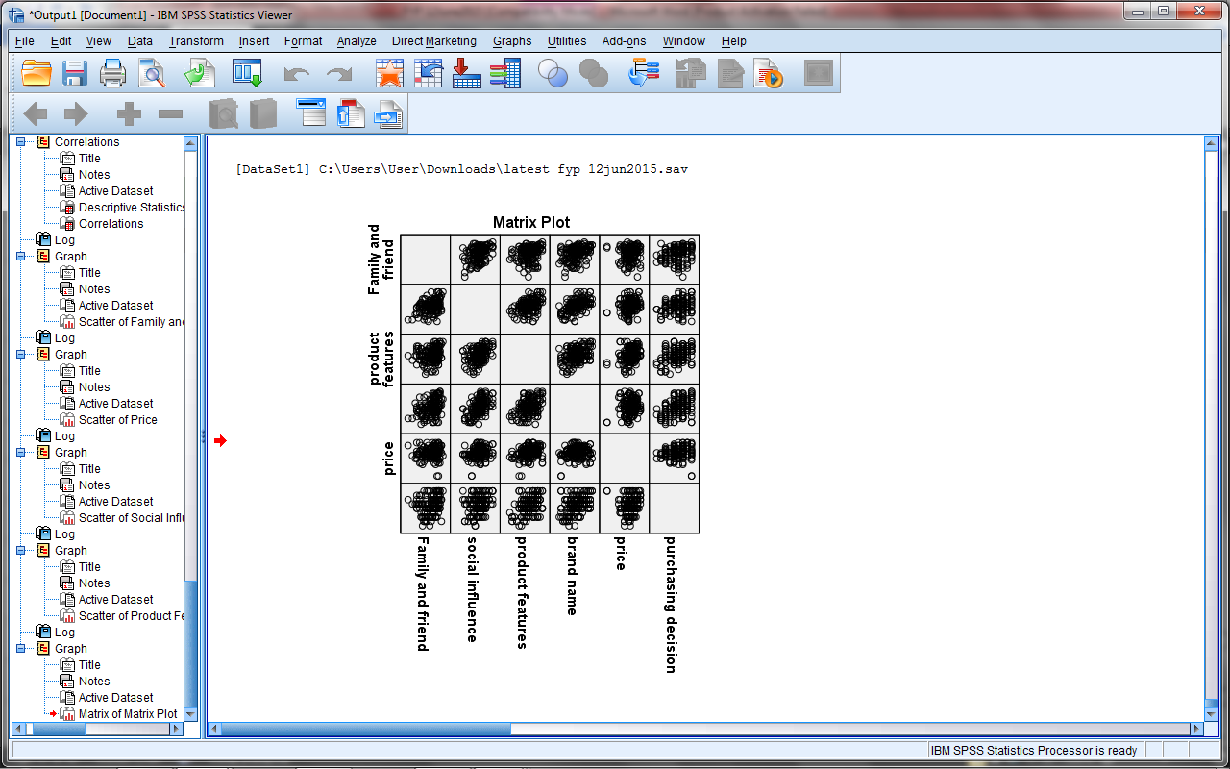
Figure 4.11: Matrix Plot
Table 4.2: Scatter plot Linearity for Dependent and Independent variable
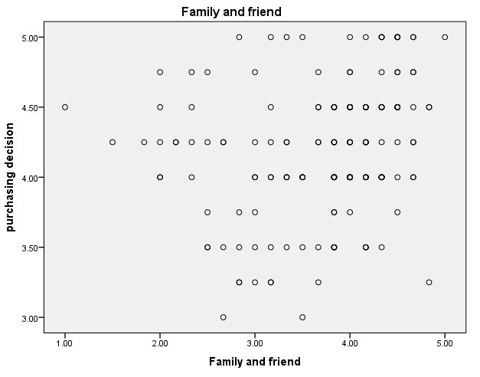 | 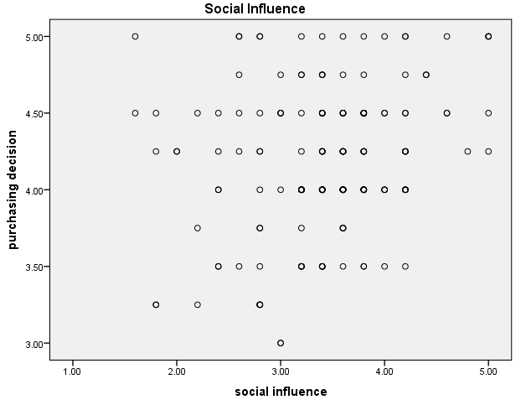
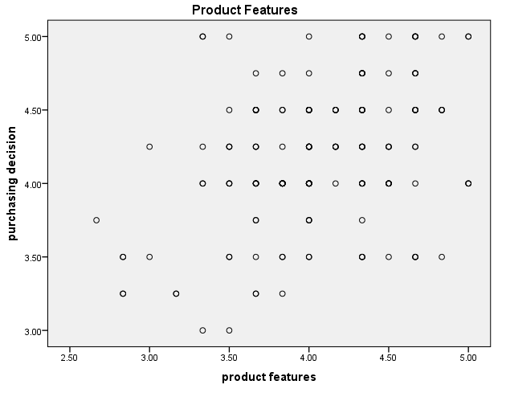 | 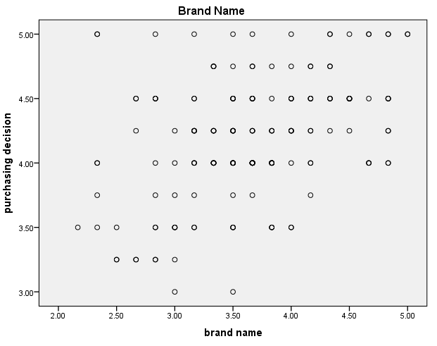
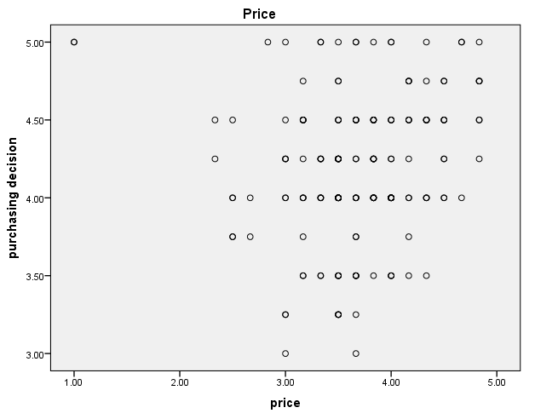

Since we are not confirmed using scattered-plot in Figure 4.11, we use partial plots to determine individual scatter-plots of dependent and independent variables. From Table 4.2, clearly see that between average purchase decision (dependent variable) and family and friend variable and social influence randomly scattered, multiple linear regression model does not seem appropriate and there is no linear relationship.

4.4.2 Test of Normality
Normality is important because all parametric tests require the variables analyzed to be normally distributed. Based on Table 4.3 below, the dotted plots lies close on the 45 degrees line and have some point nearly on the straight line, we can concluded that error terms are normally distributed. The value of skewness and kurtosis for purchasing decision are close to normality. Andy (2012) stated that the range for the values of skewness to be normality are between -2 and 2, while for kurtosis are between -3 and 3. Besides that, value skewess and kurtosis for all factors which is family and friend influence, social influence, product features, brand name and price also in the range so we can conclude variable are close to normality.
Table 4.3: Summary of Normality Test
 | Purchasing Decision
Skewness | -0.156
Kurtosis | -0.280
Normal P-P Plot | 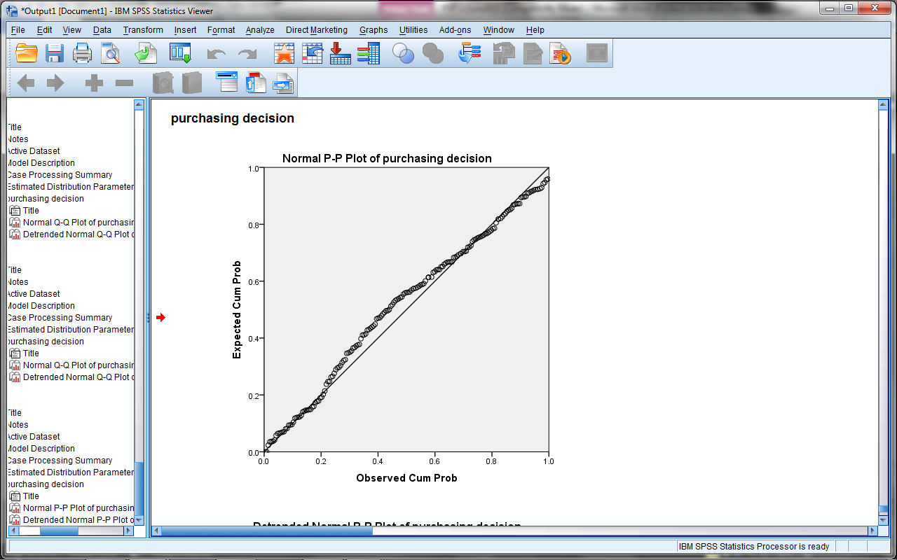

 | Family and Friend Influeces
Skewness | -1.038
Kurtosis | -0.725
Normal P-P Plot | 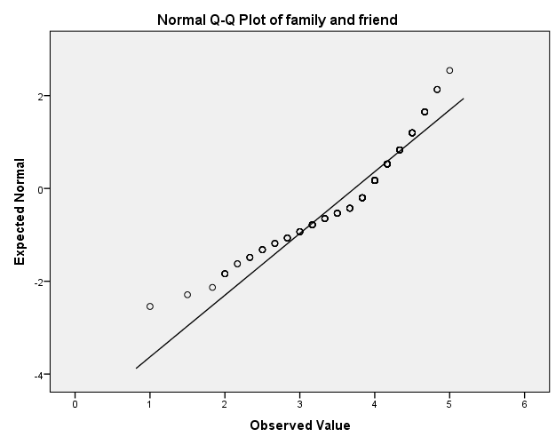

 | Social Influence
Skewness | -0.695
Kurtosis | 0.566
Normal P-P Plot | 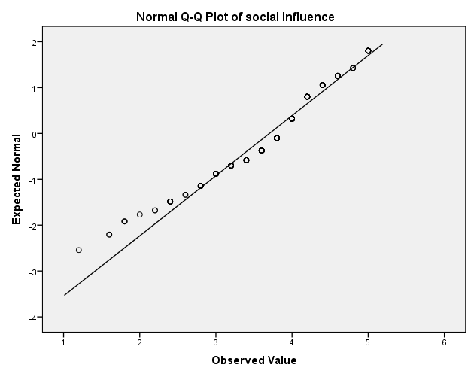

 | Product Features
Skewness | -0.732
Kurtosis | 1.455
Normal P-P Plot | 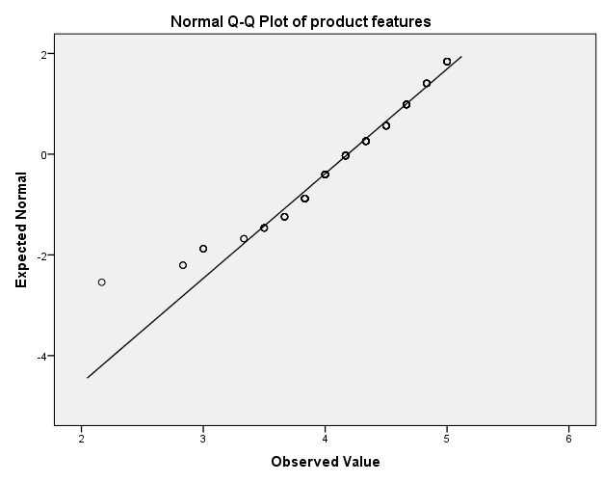

 | Brand Name
Skewness | -0.261
Kurtosis | -0.149
Normal P-P Plot | 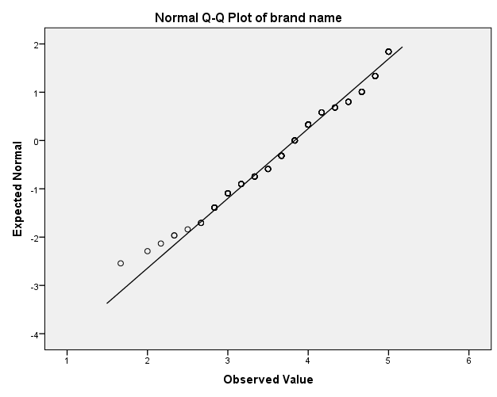

 | Price
Skewness | -0.896
Kurtosis | 1.969
Normal P-P Plot | 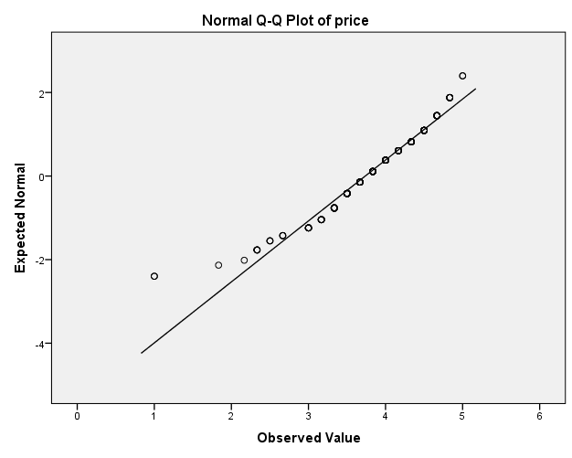

4.4.3 Homoscedasticity
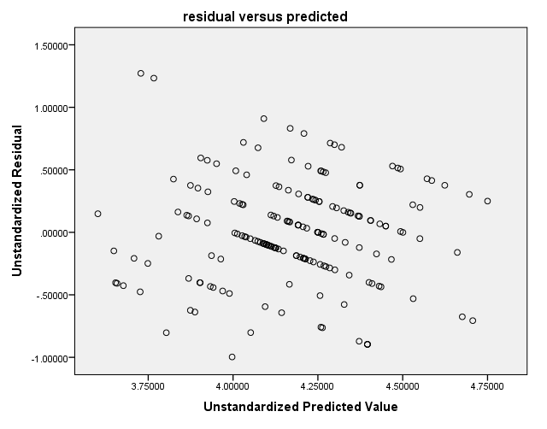
Figure 4.12: residual versus predicted
The residuals plot indicates that the variance of the error term is constant because the plot in Figure 4.12 shows randomly scattered and there is not reveal any obvious pattern.

4.4.4 Multicollinearity

Table 4.4: Coefficients table
Model |  | Collinearity Statistics
 |  | Tolerance | VIF
1 | family and friend | 0.828 | 1.208
1 | social influence | 0.579 | 1.728
1 | product features | 0.788 | 1.269
1 | brand name | 0.636 | 1.573
1 | Price | 0.879 | 1.138
a. Dependent Variable: purchasing decision
Table 4.4 shows there is no multicollinearity present, since the value for variance inflation factor (VIF) for all independent variables is lower than 10. Multicollinearity will give effect on the regression coefficients so to solve this problem we should drop the variable.

    - Presence of outliers
By checking using:
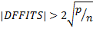 For large data sets
No observation should not remove from the data since the value for all observation DFFITS < 0.3324 it is not the presence of outliers.

  - OBJECTIVE 2: TO TEST WHETER THERE IS A DIFFERENCE BETWEEN GENDERS ON SMARTPHONE BUYING DECISION
It is the same for the One-Way Analysis of Variance to meet the assumptions of normality and equal variance before to run the result of One-Way Analysis of Variance. From Table 4.5 below, it can be concluded that the variance are equal for all variables since p-value of the Levene’s test are greater than 0.05.
Table 4.5: Levene’s test
Variables | Hypothesis | Result | Conclusion
Gender | H₀: The variance are equal  H₁: The variance are not equal | p-value = 0.599 | The variances are equal

Result of Levene’s Test in Table 4.6 shows that the p-value for the variable gender and staff category more than alpha value 0.05. Therefore, it can be concluded that buying decision are equal between the gender.
Table 4.6: Levene’s test
Variables | Hypothesis | Result | Conclusion
Gender | H₀: $μ_{1}=μ_{2}$  H₁: $μ_{1}≠μ_{2}$  Note:  $μ_{1}$ is male  $μ_{2}$ is female | p-value = 0.244 | There is no different between the average male and female on smartphone buying decision.
4.6 OBJECTIVE 3: TO IDENTIFY THE FACTORS THAT INFLUENCE BUYING DECISION OF SMARTPHONE
In this study, F-test will be used to determine factor affecting student buying decision of smartphones have significantly different or insignificantly differ. Since the p-value less than 5% significant level, the model is significant different at least one variable not equal zero.
Table 4.7: Summary of ANOVA
Hypothesis | Significant Value | Conclusion
$H_{0}: β_{1}{=β}_{2}=β_{3}=β_{4}=β_{5}=0$  $H_{1}: {at least one β}_{i}≠0$ | p-value = .000^{b} | The model is significant different at least one variable not equal zero.

Based on Table 4.8, the following equation is formed:
Purchasing Decision = 1.954 + 0.058X₁ – 0.076X₂ + 0.367X₃ + 0.193X₄ + 0.003X₅
Where X₁ is family and friend influences
X₂ is social influence
X₃ is product features
X₄ is brand name
X₅ is price
From the linear equation, it revealed that there is significant positive relationship between family and friend influences, product features, brand name and price with decision buying smartphone. The product features has the most significant influence on decison buying smartphone. It has proven by the Unstandardized Coefficients value beta is 0.367. It also can be explained by a unit increases in product features enable increase of 0.367 unit in buying decision of smartphone.
However, there is negative relationship between social influence with decision buying smartphone as its unstandardized coefficients value beta is -0.076. it will cause a unit increase in social influence enable decrease of 0.076 unit in buying decision of smartphone.

Table 4.8: Coefficientsª
Model |  | Unstandardized Coefficients |  | Standardized Coefficients | T | Sig.
 |  | B | Std. Error | Beta | T | Sig.
1 | (Constant) | 1.954 | .295 |  | 6.625 | .000
1 | family and friend influences | .058 | .043 | .094 | 1.341 | .182
1 | social influence | -.076 | .051 | -.125 | -1.490 | .138
1 | product features | .367 | .069 | .382 | 5.313 | .000
1 | brand name | .193 | .053 | .290 | 3.624 | .000
1 | price | .003 | .046 | .004 | .064 | .949
a. Dependent Variable: purchasing decision

There are two factors that have influence on purcahse decision of smartphone among UiTM Negeri Sembilan, campus Seremban 3 staffs. There are product features and brand name. P-value of the 2 factors are less than significant level 0.05. According to table 4.7 product features has the highest score in beta. Thus, product features has the most significant influence on purchase decision of smartphone.
The result from Table 4.9 shows that model 4 is the best model because it has parsimonious characteristics. Initially all variables considered were included in the Model 1. Since the model have insignificant value the variable must drop from the model. Price variable will become the first variable to be dropped from the current model since highly insignificant when the probability 0.949 larger that the 5% level of significant. Followed by Model 2, family and friend influences must be dropped first from the model since the probability exceeding the 5% significant level. While, in Model 3 social influences insignificant and shoud be dropped from the model. On the positive note, Model 4 shows product features and brand name significant and the best model.
Table 4.9: Coefficientsª
Model |  | Unstandardized Coefficients |  | Standardized Coefficients | T | Sig.
 |  | B | Std. Error | Beta | T | Sig.
1 | (Constant) | 1.954 | .295 |  | 6.625 | .000
1 | family and friend (X₁) | .058 | .043 | .094 | 1.341 | .182
1 | social influence (X₂) | -.076 | .051 | -.125 | -1.490 | .138
1 | product features (X₃) | .367 | .069 | .382 | 5.313 | .000
1 | brand name (X₄) | .193 | .053 | .290 | 3.624 | .000
1 | Price (X₅) | .003 | .046 | .004 | .064 | .949
Equation Model 1:
$\hat{Y}$ = 1.954 + 0.058X₁ – 0.076X₂ + 0.367X₃ + 0.193X₄ + 0.003X₅

2 | (Constant) | 1.960 | .277 |  | 7.066 | .000
2 | family and friend (X₁) | .058 | .043 | .094 | 1.343 | .181
2 | social influence (X₂) | -.075 | .049 | -.124 | -1.524 | .129
2 | product features (X₃) | .368 | .067 | .382 | 5.455 | .000
2 | brand name (X₄) | .193 | .053 | .289 | 3.643 | .000
Equation Model 2:
$\hat{Y}$ = 1.960 + 0.058X₁ – 0.075X₂ + 0.368X₃ + 0.193X₄
3 | (Constant) | 2.055 | .269 |  | 7.650 | .000
3 | social influence (X₂) | -.057 | .047 | -.093 | -1.195 | .234
3 | product features (X₃) | .376 | .067 | .391 | 5.590 | .000
3 | brand name (X₄) | .197 | .053 | .295 | 3.720 | .000
Equation Model 3:
$\hat{Y}$ = 2.055 – 0.057 X₂ + 0.376X₃ + 0.197X₄
4 | (Constant) | 2.023 | .268 |  | 7.559 | .000
4 | product features (X₃) | .362 | .066 | .377 | 5.461 | .000
4 | brand name (X₄) | .166 | .046 | .248 | 3.597 | .000
Equation Model 4:
$\hat{Y}$ = 2.023 + 0.362X₃ + 0.166X₄

a. Dependent Variable: purchasing decision

CHAPTER 5

CONCLUSIONS AND RECOMMENDATIONS

5.1 INTRODUCTION
This chapter will explain in detail about the result and discussion from the previous chapter. In addition, this chapter will also discuss several suggestions in order to generate the better research in the future.

5.2 CONCLUSIONS
In this study, from a total sample 181 staff, it was clearly seen that the respondents are almost equally divided into male and female where most of them academician category. It can also be seen that Faculty of Administrative Science and Policy Studies (FSPPP) the highest sample respondents. Moreover, the majority of the respondents were 20 to 30 years old for both category academician staff and administrative staff. This had been classified as an adult generation. In addition, most of smartphone users among academician were specified RM 4,000 above income per month and among administrative or supporting service is income between RM 2,001 to RM 3,000 per month. The most popular brand among staff in UiTM Negeri Sembilan, campus Seremban 3 are Samsung and Apple.

Result of One-Way Analysis of Variance shows that the p-value for the variable gender and staff category more than alpha value 0.05. Therefore, it can be concluded that buying decision are equal between gender and staff category.
From this study, the factor that contributes to the affect purchasing decision were all variable family and friend influences (X₁), social influeces (X₂), product features (X₃), brand name (X₄) and price (X₅). The product features has the most significant influence on decison buying smartphone. It has proven by the Unstandardized Coefficients value beta is 0.367. It also can be explained by a unit increases in product features enable increase of 0.367 unit in buying decision of smartphone. To determine the best model in this study, backward step is used. The result shows that model 4 is the best model because it has parsimonious characteristics include brand name factor and product features factor.

5.3 RECOMMENDATIONS
The next recommendation is to enhance some predictor variables in this study so that the relationship between these variables can be identified and the result that we will get can be more accurate and precise. The other researcher also can use another method such as Factor Analysis to find out the most factor affect the purchasing decision of a smartphone. These methods can be used for researcher want to know more detail because this factor analyses use for multiple choice answer.

REFERENCES
A study of factors affecting towards young customers’ purchase Intention of Domestic-branded smartphone in Shanghai, Republic of China. (2014). doi: 10.15242/icehm.ed1014036

Chew and others, (August, 2012). ‘Exploring The Factors Affecting Purchase
Intention Of Smartphone: A Study Of Young Adults In Universiti Tunku Abdul Rahman’ Perak, Malaysia.

Chow, M.M., Chen, L.H.,Yeow, J.A.,& Wong, P.W. (2012). Factor affecting
the demand ofsmartphone among the young adults. International Journal on Social Science Economics & Art, 2(2), 44-49.

Dr. Monica Sainy, (2014) “Buying behavior of smartphone among B school students”,
Acropolis faculty of Management & Research Indore, Vol. 5 Iss:1, pp 24-35

Eng, K (2010, August, 19). Hand Phone Users Survey 2009, Malaysia. Aisa-Pacific
Internet Research Alliance 7th International Conference, New Delhi, India, 1-23.

Forsido, M.Z., (2012, August), Brand loyalty in Smartphone. Master Thesis of Uppsala Universitet

Ilma Ilyani Ibrahim, Khairul Anwar Subari, & Siti Khairul Bariah Mohamood, (2013,

December). Antecedent Stirring Purchase Intention of Smartphone among Adolescents inPerlis. International Journal of Academic Research in Business and Social Sciences, 3(12). doi: 10.6007/IJARBSS/v3-i12/415

Larson, M. (2011, September, 27). Statistical Primer for Cardiovascular Research
Descriptive Statistics and Graphical Displays,from htto://circ.ahajournals.org/content/114.176.full

Lay-Yee, K.L., Siew, H.K., & Yin-Fah, B.C.(2013). Factors Affecting Smartphone
Purchase Decision Among Malaysian Generation Y. International Journal of Asian Social Science, 3(12), 2426-2440.

Leelakulthanit, O. & Hongcharu, B. (2012, November). Factors Influencing
Smartphone Repurchase. Journal of Business & Economics Research, 10(11), Retrieved from http://www.cluteinstitute.com/.

Liao, Chun-Hsiung, & Hsieh, I. Yu.(2012). Determinants of Consumer’s Willingness to Purchase Gray-Market Smartphones.Journal of Business Ethics, 114(3), 409-424. doi: 10.1007/s10551-012-1358-7

Norazah Mohd Suki, (2013) "Students’ demand for smartphones: Structural
relationships of product features, brand name, product price and social influence", Campus-Wide Information Systems, Vol. 30 Iss: 4, pp.236 – 248

Norazah Mohd Suki & Norbayah Mohd Suki, (2013), Dependency on Smartphones: An Analysis of Structural Equation Modelling.

Orose Leelakulthanit & Boonchai Hongcharu (2012, November). Factor Influencing smartphone repurchase, Journal of Business & Economics Research, Vol.10 Iss: 11, pp. 623 - 628

Shadan Vahabzadeh, Soheila Saedar Duneghe & Tahareh Ataei Khachoei (2014, February). A Study of the Factors Influencing Dependency, and Its Effect on the Purchase Behavior of the Iranian Consumers of Smartphones, Nationalpark-Forschung In Der Schweiz : Switzerland Research Park Journal, Vol. 103 Iss: 2, pp.1120 - 1132

Smura, Timo, Kivi, Antero, & Töyli, Juuso. (2009). A framework for analysing the usage of mobile services.info, 11(4), 53-67. doi:10.1108/14636690910970973

Xie, X., & Chaipoopirutana, S. (2014, October 1-2). A Study of Factors Affecting
Towards Young Customers’ Purchase Intension of Domestic-Branded Smartphone in Shanghai, Republic of China.

Woon, C.K.T., Mee, L.F, S.M. Shahidul Alam & Marjan Samooty (2013, November 30). Factors Affecting The Consumer Choice of Smartphone Among The Youth Adults in Urban Area Of Kuching, Sarawak, Malaysia.

Yangil Park, Jengchung V. Chen, (2007) "Acceptance and adoption of the innovative use of smartphone", Industrial Management & Data Systems, Vol. 107 Iss: 9, pp.1349 – 1365.

Yang, V., (2013, June). A Study on Probing into The Relationship Between College Students’Perception and Willingness Of Purchasing Smartphones.

APPENDICES

QUESTIONNAIRE

UNIVERSITI TEKNOLOGI MARA

FACULTY OF COMPUTER AND MATHEMATICAL SCIENCE
Bachelor of Science (Hons.) Statistics
Survey Questionnaire
We are students of Bachelor of Science (Hons) at the Faculty of Computer and Mathematical Science (FSKM) at Universiti Teknologi Mara. We are currently conducting a survey on factors affecting consumer buying decision of smartphone devices.
First of all, we would like to thank you for sparing your time to fill up the questionnaire. The purpose of this survey is to find out does friend and family,social reference group product feature or branding affecting purchasing decision on smartphone among staffs. This would only take you approximately about 10 minutes to complete.
Please take note all information obtained will be analyzed and to be written into a report which is used solely for academic purpose. We would like to assure you that all the information collected will remain private and confidential.
Once again, we would like to thank you for your participation in completing this questionnaire. Thank you for your cooperation.
DATE : MARCH 2015

Section A. Profile Information / Bahagian A. Maklumat Peribadi
Please place a ‘/’ on the blank boxes provided / Sila tanda ‘/’ pada ruangan yang disediakan

- Gender/ Jantina
Male / Lelaki
Female / Perempuan

- Age / Umur
20 - 30 years old / 20 - 30 tahun
31 - 40 years old / 31 - 40 tahun
41 - 50 years old / 41 - 50 tahun
Above 50 years old / 50 tahun ke atas

- Staff Category / KategoriStaf
Academician / Akademik
Administrative/Supporting Service
Unit Pentadbiran/Perkhidmatan Sokongan

- Department / Jabatan
Faculty of Administrative Science and Policy Studies (FSPPP)
Fakulti Sains Pentadbiran dan Pengajian Polisi (FSPPP)
Faculty of Computer Science and Mathematical (FSKM)
Fakulti Sains Komputer dan Mathematics (FSKM)
Faculty of Sport Science and Recreation (FSR)
Fakulti SainsSukan dan Rekreasi (FSR)
Police Department / Jabatan Polis
Medical Unit / Unit Perubatan
Administration / Unit Pentadbiran
Librarian / Pustakawan
Other / Lain-lain: _________________

- Income level / Pendapatan
Below RM 1,000 / Bawah RM 1,000
RM 1,001 – RM 2,000
RM 2,001 – RM 3,000
RM 3,001 – RM 4,000
RM 4,001 and above / RM 4,001 and above

- Which brand of smartphone are you currently using?
Apakah jenama telefon pintar yang sedang anda gunakan?

Samsung
HTC
Apple
Blackberry
Nokia
Sony Ericsson
LG
Lenovo
ASUS
OPPO
Others, please specify / Lain-lain, nyatakan: _____________________

- Which do you choose the preferred smartphone brand? / Jenamatelefonbimbit yang manakahsatu yang menjadipilihananda?

Please rate question 7 accordingly with the rank of 1 to 5; 1 means most important, continue to 5 which is least important /
Sila nilaikan soalan 7 sewajarnya dengan pangkat 1 hingga 5; 1 bermakna paling penting, terus 5 yang kurang penting.

Samsung
HTC
Apple
Blackberry
Nokia
Sony Ericsson
LG
Lenovo
ASUS
OPPO
Others, please specify / Lain-lain, sila nyatakan: _____________________

- Where did you get the information about smartphone? / Dimanakahandamendapatmaklumatmengenaitelefonbimbit?

You can thick more than one. / Anda boleh tanda lebih dari satu.

Television/Radio
Televisyen/Radio
Family/Friends
Ahli Keluarga / Rakan-Rakan
Magazine / Newspaper
Majalah / Surat khabar
Promotion
Promosi
Social Media (Facebook, Twitter, Youtube, Google+)
Media Sosial (Facebook, Twitter, Youtube, Google+)
Blogger
Internet
Others, please specify / Lain-lain, nyatakan: ___________________

- Speaking of the Internet, do you have an Internet connection at home? If ‘NO’, ignore question 10.
Berceritamengenai Internet, adakahandamempunyai Internet di rumah? Jika ‘TIDAK’, abaikansoalan 10.
 | Yes / Ya |  |  | No / Tidak

- And this Internet is… / Dan Internet iniadalah….
Dial-up
Broadband
Wifi

- Do you access Internet from other places?
Adakahandamelayari Internet daritempat lain?
 | Yes / Ya |  |  | No / Tidak

Section B. Please indicate the extent to which you agree or disagree with the following statements
Bahagian B. Sila nyatakan sejauh mana anda bersetuju atau tidak bersetuju dengan kenyataan berikut

1 | 2 | 3 | 4 | 5
Strongly Disagree (SD) | Disagree (D) | Neutral (N) | Agree (A) | Strongly Agree (SA)

- FAMILY AND FRIENDS / AHLI KELUARGA DAN RAKAN-RAKAN
No | Question Items | SD | D | N | A | SA
1 | My friends’ evaluation will influence my choice in purchasing smartphone.  Penilaian rakan-rakan saya akan mempengaruhi keputusan saya memembeli telefon pintar | 1 | 2 | 3 | 4 | 5
2 | My friends’ preference will influence my choice in purchasing smartphone.  Pilihan utama rakan-rakan saya akan mempengaruhi pilihan saya untuk membeli telefon pintar. | 1 | 2 | 3 | 4 | 5
3 | It is important that my friends like the brand of smartphone I’m using.  Ia adalah penting bila rakan-rakan saya menyukai jenama telefon pintar yang sedang saya gunakan. | 1 | 2 | 3 | 4 | 5
4 | My friends do not influence my decision in buying smartphone.  Rakan-rakan saya tidak mempengaruhi keputusan saya untuk membeli telefon pintar. | 1 | 2 | 3 | 4 | 5
5 | I would not collect smartphone information from family members.  Saya tidak akan mengumpul maklumat mengenai telefon pintar dari ahli keluarga. | 1 | 2 | 3 | 4 | 5
6 | Family recommendation may influence my buying decision of smartphone.  Cadangan keluarga boleh mempengaruhi keputusan saya membeli telefon pintar. | 1 | 2 | 3 | 4 | 5

- SOCIAL INFLUENCE / PENGARUH SOSIAL
No | Question Items | SD | D | N | A | SA
7 | Social influences affect my choice on smartphone.  Pengaruh sosial mempengaruhi pilihan saya pada telefon pintar. | 1 | 2 | 3 | 4 | 5
8 | Advertising will influence my choice in purchasing smartphone.  Pengiklanan akan mempengaruhi pilihan saya untuk membeli telefon pintar. | 1 | 2 | 3 | 4 | 5
9 | Advertising endorsers (like concerts, sports events, drama series, through celebrities) will not affecting me to buy a smartphone.  Penyokong-penyokong Pengiklanan (seperti konsert, acara sukan, siri drama, melalui selebriti) tidak akan memberi kesan kepada saya untuk membeli telefon pintar. | 1 | 2 | 3 | 4 | 5
10 | I would buy a smartphone if it helped me to fit in with my social group better.  Saya akan membeli telefon pintar jika ia membantu saya untuk menyesuaikan diri dengan kumpulan sosial saya lebih baik. | 1 | 2 | 3 | 4 | 5
11 | My choice of smartphone is influenced by other consumers’ word-of-mouth.  Pilihan saya terhadap telefon pintar dipengaruhi oleh kata-kata pengguna lain . | 1 | 2 | 3 | 4 | 5

- PRODUCT FEATURES / CIRI-CIRI PRODUK
No | Question Items | SD | D | N | A | SA
12 | Smartphone has more applications than basic handphone.  Telefon pintar mempunyai lebih banyak aplikasi daripada telefon bimbit asas. | 1 | 2 | 3 | 4 | 5
13 | Smartphone do not provide high quality of games.  Telefon pintar tidak menyediakan permainan yang berkualiti tinggi. | 1 | 2 | 3 | 4 | 5
14 | Smartphone’s internet accessibility is speedier than basic hand phone.  Melayari Internet di telefon pintar adalah lebih cepat daripada telefon bimbit asas. | 1 | 2 | 3 | 4 | 5
15 | Smartphone saves my time and effort of my work. I would prefer carrying my smartphone rather than my laptop.  Telefon pintar menjimatkan masa saya dan usaha kerja saya. Saya lebih suka membawa telefon pintar saya berbanding komputer riba saya. | 1 | 2 | 3 | 4 | 5
16 | Having a smartphone is like having both a mobile phone and a computer together.  Mempunyai sebuah telefon pintar adalah seperti mempunyai telefon bimbit dan komputer riba dalam masa yang sama. | 1 | 2 | 3 | 4 | 5
17 | Smartphone provides bigger size of display screen compared basic hand phone.  Telefon pintar menyediakan skrin paparan yang lebih besar berbanding telefon bimbit asas. | 1 | 2 | 3 | 4 | 5

- BRAND NAME /JENAMA
No | Question Items | SD | D | N | A | SA
18 | I prefer to buy an international recognized smartphone.  Saya lebih suka untuk membeli sebuah telefon pintar antarabangsa yang diiktiraf. | 1 | 2 | 3 | 4 | 5
19 | Brand name is a major factor that will influence my decision towards buying a smartphone.  Jenama adalah satu faktor utama yang akan mempengaruhi keputusan saya ke arah membeli telefon pintar. | 1 | 2 | 3 | 4 | 5
20 | I make my purchase according to my favorite smartphone brand, regardless of price.  Saya membuat pembelian mengikut jenama telefon pintar kegemaran saya tanpa mengira harga. | 1 | 2 | 3 | 4 | 5
21 | I choose my brand because it has a good reputation.  Saya memilih jenama saya kerana ia mempunyai reputasi yang baik. | 1 | 2 | 3 | 4 | 5
22 | My choice of brand is not influenced by promotions.  Keputusan saya memilih jenama tidak dipengaruhi oleh promosi. | 1 | 2 | 3 | 4 | 5
23 | My choice of brand says something about me as a person.  Keputusan saya memilih jenama mengatakan sesuatu tentang personaliti saya. | 1 | 2 | 3 | 4 | 5

- PRICE / HARGA
No | Question Items | SD | D | N | A | SA
24 | Price is my main consideration when deciding whether to buy a smartphone.  Harga adalah pertimbangan utama saya apabila membuat keputusan samaada untuk membeli sebuah telefon pintar ataupun tidak. | 1 | 2 | 3 | 4 | 5
25 | Price is the most important factor when purchasing Smartphone.  Harga adalah faktor yang paling penting apabila membeli telefon pintar. | 1 | 2 | 3 | 4 | 5
26 | I compare prices of other Smartphone‘s brands and store brands before I choose one.  Saya bandingkan harga jenama telefon pintar yang lain denganjenama kedai sebelum saya memilihnya. | 1 | 2 | 3 | 4 | 5
27 | I buy Smartphone because they are worth to used regarding between with their price and usage quality.  Saya membeli telefon pintar kerana mereka lebih bernilai untuk digunakan berbanding harga dan kualiti penggunaan. | 1 | 2 | 3 | 4 | 5
28 | I am uncertain which Smartphone‘s brands provide real value for money in terms of product quality.  Saya tidak pasti yang jenama telefon pintar ini menyediakan harga yang bertepatan dengan kualiti produk. | 1 | 2 | 3 | 4 | 5
29 | The cheapness of some Smartphone‘s brand suggests to me that they may have some risks, such as low quality.  Murahnya jenama beberapa telefon pintar ini menunjukkan kepada saya bahawa telefon pintar ini mungkin mempunyai beberapa risiko, seperti kualiti rendah. | 1 | 2 | 3 | 4 | 5

- PURCHASING DECISION / KEPUTUSAN MEMBELI
No | Question Items | SD | D | N | A | SA
30 | On the whole, I’m satisfied with the smartphone experience.  Secara keseluruhan, saya berpuas hati dengan pengalaman telefon pintar. | 1 | 2 | 3 | 4 | 5
31 | Overall, my positive experience outweighs my negative experience with smartphone.  Secara keseluruhan, pengalaman positif saya mengatasi pengalaman negatif saya mengenai telefon pintar. | 1 | 2 | 3 | 4 | 5
32 | I intend to keep continuing use smartphone in the future.  Saya berhasrat untuk terus menggunakan telefon pintar pada masa akan datang. | 1 | 2 | 3 | 4 | 5
33 | I intend to have a better purchase of smartphone in the future from my experience.  Saya berhasrat untuk mempunyai pembelian telefon pintar yang lebih baik pada masa akan datang melalui pengalaman saya. | 1 | 2 | 3 | 4 | 5

Thank you very much for your participation in this survey. Your time and opinions are deeply appreciated. / Terima kasih atas penyertaan anda dalam kajian ini, Masa dan pendapat anda adalah amat dihargai.

TEST OF RELIABILITY

Case Processing Summary
 |  | N | %
Cases | Valid | 181 | 100.0
Cases | Excludedª | 0 | .0
Cases | Total | 181 | 100.0
a. Listwise deletion based on all variables in the procedure.

Reliability Statistics
Cronbach's Alpha | N of Items
.868 | 29

FAMILY AND FRIENDS INFLUENCE
Item-Total Statistics
 | Scale Mean if Item Deleted | Scale Variance if Item Deleted | Corrected Item-Total Correlation | Cronbach's Alpha if Item Deleted
My friends’ evaluation will influence my choice in purchasing smartphone. | 107.51 | 149.240 | .480 | .862
My friends’ preference will influence my choice in purchasing smartphone. | 107.67 | 151.354 | .453 | .862
It is important that my friends like the brand of smartphone I’m using. | 107.88 | 148.581 | .486 | .861
My friends do not influence my decision in buying smartphone. (RECODE) | 107.75 | 150.310 | .423 | .863
I would not collect smartphone information from family members.  (RECODE) | 107.66 | 157.847 | .178 | .870
Family recommendation may influence my buying decision of smartphone. | 107.54 | 156.461 | .255 | .867

SOCIAL INFLUENCE
Item-Total Statistics
 | Scale Mean if Item Deleted | Scale Variance if Item Deleted | Corrected Item-Total Correlation | Cronbach's Alpha if Item Deleted
Social influences affect my choice on smartphone. | 107.90 | 146.750 | .555 | .859
Advertising will influence my choice in purchasing smartphone. | 107.66 | 147.438 | .591 | .858
Advertising endorsers (like concerts, sports events, drama series, through celebrities) will not affecting me to buy a smartphone.  (RECODE) | 107.57 | 148.524 | .554 | .860
I would buy a smartphone if it helped me to fit in with my social group better. | 107.80 | 150.675 | .448 | .863
My choice of smartphone is influenced by other consumers’ word-of-mouth. | 107.56 | 151.859 | .505 | .861

PRODUCT FEATURES
Item-Total Statistics
 | Scale Mean if Item Deleted | Scale Variance if Item Deleted | Corrected Item-Total Correlation | Cronbach's Alpha if Item Deleted
Smartphone has more applications than basic handphone. | 106.88 | 157.770 | .372 | .865
Smartphone do not provide high quality of games (RECODE) | 106.93 | 158.078 | .343 | .866
Smartphone’s internet accessibility is speedier than basic hand phone. | 107.18 | 157.202 | .290 | .866
Smartphone saves my time and effort of my work. I would prefer carrying my smartphone rather than my laptop. | 107.46 | 154.783 | .339 | .865
Having a smartphone is like having both a mobile phone and a computer together. | 107.51 | 155.751 | .330 | .865
Smartphone provides bigger size of display screen compared basic hand phone. | 107.30 | 154.368 | .428 | .863
BRAND NAME
Item-Total Statistics
 | Scale Mean if Item Deleted | Scale Variance if Item Deleted | Corrected Item-Total Correlation | Cronbach's Alpha if Item Deleted
I prefer to buy an international recognized smartphone. | 107.55 | 150.738 | .515 | .861
Brand name is a major factor that will influence my decision towards buying a smartphone. | 107.43 | 147.801 | .629 | .858
I make my purchase according to my favorite smartphone brand, regardless of price. | 107.93 | 149.967 | .414 | .864
I choose my brand because it has a good reputation. | 107.29 | 152.984 | .495 | .862
My choice of brand is not influenced by promotions. (RECODE) | 107.22 | 154.540 | .450 | .863
My choice of brand says something about me as a person. | 107.99 | 153.161 | .360 | .865

PRICE

Item-Total Statistics
 | Scale Mean if Item Deleted | Scale Variance if Item Deleted | Corrected Item-Total Correlation | Cronbach's Alpha if Item Deleted
Price is the most important factor when purchasing Smartphone. | 107.64 | 152.822 | .342 | .866
I compare prices of other Smartphone‘s brands and store brands before I choose one. | 107.59 | 155.910 | .270 | .867
I buy Smartphone because they are worth to used regarding between with their price and usage quality. | 107.35 | 154.450 | .367 | .865
I am uncertain which Smartphone‘s brands provide real value for money in terms of product quality. | 108.24 | 160.563 | .070 | .873
The cheapness of some Smartphone‘s brand suggests to me that they may have some risks, such as low quality. | 107.76 | 152.838 | .401 | .864

DESCRIPTIVE ANALYSIS

Gender
 |  | Frequency | Percent | Valid Percent | Cumulative Percent
Valid | Male | 82 | 45.3 | 45.3 | 45.3
Valid | Female | 99 | 54.7 | 54.7 | 100.0
Valid | Total | 181 | 100.0 | 100.0

Age
 |  | Frequency | Percent | Valid Percent | Cumulative Percent
Valid | age 20-30 years old | 81 | 44.8 | 44.8 | 44.8
Valid | age 31-40 years old | 66 | 36.5 | 36.5 | 81.2
Valid | age 41-50 years old | 27 | 14.9 | 14.9 | 96.1
Valid | greater than age 50 years old | 7 | 3.9 | 3.9 | 100.0
Valid | Total | 181 | 100.0 | 100.0

Staff Category
 |  | Frequency | Percent | Valid Percent | Cumulative Percent
Valid | Academician | 122 | 67.4 | 67.4 | 67.4
Valid | Administrative/ Supporting Service | 59 | 32.6 | 32.6 | 100.0
Valid | Total | 181 | 100.0 | 100.0

Department
 |  | Frequency | Percent | Valid Percent | Cumulative Percent
Valid | FSPPP | 49 | 27.1 | 27.1 | 27.1
Valid | FSKM | 41 | 22.7 | 22.7 | 49.7
Valid | FSR | 15 | 8.3 | 8.3 | 58.0
Valid | Police Department | 12 | 6.6 | 6.6 | 64.6
Valid | Medical Unit | 4 | 2.2 | 2.2 | 66.9
Valid | Administration | 15 | 8.3 | 8.3 | 75.1
Valid | Librarian | 5 | 2.8 | 2.8 | 77.9
Valid | Other | 40 | 22.1 | 22.1 | 100.0
Valid | Total | 181 | 100.0 | 100.0

Department ( If others)
 |  |  |  | Frequency |  | Percent |  | Valid Percent |  | Cumulative Percent
Valid |  | Not choose others |  | 141 |  | 77.9 |  | 77.9 |  | 77.9
 |  | FPP (Faculty in Business Study) |  | 6 |  | 3.3 |  | 3.3 |  | 81.2
 |  | ACIS |  | 6 |  | 3.3 |  | 3.3 |  | 84.5
 |  | APB |  | 8 |  | 4.4 |  | 4.4 |  | 89.0
 |  | FPN |  | 1 |  | .6 |  | .6 |  | 89.5
 |  | Faculty of Accountancy |  | 3 |  | 1.7 |  | 1.7 |  | 91.2
 |  | Faculty of Law |  | 1 |  | .6 |  | .6 |  | 91.7
 |  | Facility |  | 3 |  | 1.7 |  | 1.7 |  | 93.4
 |  | HEA |  | 5 |  | 2.8 |  | 2.8 |  | 96.1
 |  | HEP |  | 7 |  | 3.9 |  | 3.9 |  | 100.0
 |  | Total |  | 181 |  | 100.0 |  | 100.0
 | Income Level
 |  |  | Frequency |  | Percent |  | Valid Percent |  | Cumulative Percent
 | Valid | Below RM1,000 | 2 |  | 1.1 |  | 1.1 |  | 1.1
 | Valid | RM1,001 - RM 2,000 | 18 |  | 9.9 |  | 9.9 |  | 11.0
 | Valid | RM2,001 - RM3,000 | 26 |  | 14.4 |  | 14.4 |  | 25.4
 | Valid | RM3,001 - RM4,000 | 47 |  | 26.0 |  | 26.0 |  | 51.4
 | Valid | RM4,000 and above | 88 |  | 48.6 |  | 48.6 |  | 100.0
 | Valid | Total | 181 |  | 100.0 |  | 100.0

Which brand of smartphone are you currently using?
 |  | Frequency | Percent | Valid Percent | Cumulative Percent
Valid | Samsung | 65 | 35.9 | 35.9 | 35.9
Valid | HTC | 5 | 2.8 | 2.8 | 38.7
Valid | Apple | 44 | 24.3 | 24.3 | 63.0
Valid | Blackberry | 7 | 3.9 | 3.9 | 66.9
Valid | Nokia | 3 | 1.7 | 1.7 | 68.5
Valid | Sony Ericson | 4 | 2.2 | 2.2 | 70.7
Valid | LG | 1 | .6 | .6 | 71.3
Valid | Lenovo | 27 | 14.9 | 14.9 | 86.2
Valid | ASUS | 14 | 7.7 | 7.7 | 93.9
Valid | OPPO | 8 | 4.4 | 4.4 | 98.3
Valid | Others | 3 | 1.7 | 1.7 | 100.0
Valid | Total | 181 | 100.0 | 100.0

Which brand of smartphone are you currently using? (If choose others)
 |  | Frequency | Percent | Valid Percent | Cumulative Percent
Valid | Not choose others | 177 | 97.8 | 97.8 | 97.8
Valid | SHARP | 3 | 1.7 | 1.7 | 99.4
Valid | VIVO | 1 | .6 | .6 | 100.0
Valid | Total | 181 | 100.0 | 100.0

Which do you choose the preferred smartphone brand? (SAMSUNG)
 |  | Frequency | Percent | Valid Percent | Cumulative Percent
Valid | Not choosing | 5 | 2.8 | 2.8 | 2.8
Valid | Very Important | 59 | 32.6 | 32.6 | 35.4
Valid | Important | 74 | 40.9 | 40.9 | 76.2
Valid | Average | 23 | 12.7 | 12.7 | 89.0
Valid | Not Important | 7 | 3.9 | 3.9 | 92.8
Valid | Very Not Important | 13 | 7.2 | 7.2 | 100.0
Valid | Total | 181 | 100.0 | 100.0

Which do you choose the preferred smartphone brand? (HTC)
 |  | Frequency | Percent | Valid Percent | Cumulative Percent
Valid | Not choosing | 116 | 64.1 | 64.1 | 64.1
Valid | Very Important | 5 | 2.8 | 2.8 | 66.9
Valid | Important | 6 | 3.3 | 3.3 | 70.2
Valid | Average | 25 | 13.8 | 13.8 | 84.0
Valid | Not Important | 19 | 10.5 | 10.5 | 94.5
Valid | Very Not Important | 10 | 5.5 | 5.5 | 100.0
Valid | Total | 181 | 100.0 | 100.0

Which do you choose the preferred smartphone brand? (Apple)
 |  | Frequency | Percent | Valid Percent | Cumulative Percent
Valid | Not choosing | 20 | 11.0 | 11.0 | 11.0
Valid | Very Important | 71 | 39.2 | 39.2 | 50.3
Valid | Important | 50 | 27.6 | 27.6 | 77.9
Valid | Average | 20 | 11.0 | 11.0 | 89.0
Valid | Not Important | 14 | 7.7 | 7.7 | 96.7
Valid | Very Not Important | 6 | 3.3 | 3.3 | 100.0
Valid | Total | 181 | 100.0 | 100.0

Which do you choose the preferred smartphone brand? (Blackberry)
 |  | Frequency | Percent | Valid Percent | Cumulative Percent
Valid | Not choosing | 108 | 59.7 | 59.7 | 59.7
Valid | Very Important | 4 | 2.2 | 2.2 | 61.9
Valid | Important | 11 | 6.1 | 6.1 | 68.0
Valid | Average | 18 | 9.9 | 9.9 | 77.9
Valid | Not Important | 15 | 8.3 | 8.3 | 86.2
Valid | Very Not Important | 25 | 13.8 | 13.8 | 100.0
Valid | Total | 181 | 100.0 | 100.0

Which do you choose the preferred smartphone brand? (Nokia)
 |  | Frequency | Percent | Valid Percent | Cumulative Percent
Valid | Not choosing | 115 | 63.5 | 63.5 | 63.5
Valid | Very Important | 7 | 3.9 | 3.9 | 67.4
Valid | Important | 9 | 5.0 | 5.0 | 72.4
Valid | Average | 18 | 9.9 | 9.9 | 82.3
Valid | Not Important | 17 | 9.4 | 9.4 | 91.7
Valid | Very Not Important | 15 | 8.3 | 8.3 | 100.0
Valid | Total | 181 | 100.0 | 100.0
Which do you choose the preferred smartphone brand? (Sony Ericson)
 |  | Frequency | Percent | Valid Percent | Cumulative Percent
Valid | Not choosing | 105 | 58.0 | 58.0 | 58.0
Valid | Very Important | 4 | 2.2 | 2.2 | 60.2
Valid | Important | 10 | 5.5 | 5.5 | 65.7
Valid | Average | 22 | 12.2 | 12.2 | 77.9
Valid | Not Important | 25 | 13.8 | 13.8 | 91.7
Valid | Very Not Important | 15 | 8.3 | 8.3 | 100.0
Valid | Total | 181 | 100.0 | 100.0

Which do you choose the preferred smartphone brand? (LG)
 |  | Frequency | Percent | Valid Percent | Cumulative Percent
Valid | Not choosing | 161 | 89.0 | 89.0 | 89.0
Valid | Important | 2 | 1.1 | 1.1 | 90.1
Valid | Average | 7 | 3.9 | 3.9 | 93.9
Valid | Not Important | 5 | 2.8 | 2.8 | 96.7
Valid | Very Not Important | 6 | 3.3 | 3.3 | 100.0
Valid | Total | 181 | 100.0 | 100.0
Which do you choose the preferred smartphone brand? (Lenovo)
 |  | Frequency | Percent | Valid Percent | Cumulative Percent
Valid | Not choosing | 71 | 39.2 | 39.2 | 39.2
Valid | Very Important | 15 | 8.3 | 8.3 | 47.5
Valid | Important | 12 | 6.6 | 6.6 | 54.1
Valid | Average | 22 | 12.2 | 12.2 | 66.3
Valid | Not Important | 32 | 17.7 | 17.7 | 84.0
Valid | Very Not Important | 29 | 16.0 | 16.0 | 100.0
Valid | Total | 181 | 100.0 | 100.0

Which do you choose the preferred smartphone brand? (ASUS)
 |  | Frequency | Percent | Valid Percent | Cumulative Percent
Valid | Not choosing | 110 | 60.8 | 60.8 | 60.8
Valid | Very Important | 5 | 2.8 | 2.8 | 63.5
Valid | Important | 5 | 2.8 | 2.8 | 66.3
Valid | Average | 11 | 6.1 | 6.1 | 72.4
Valid | Not Important | 21 | 11.6 | 11.6 | 84.0
Valid | Very Not Important | 29 | 16.0 | 16.0 | 100.0
Valid | Total | 181 | 100.0 | 100.0
Which do you choose the preferred smartphone brand? (OPPO)
 |  | Frequency | Percent | Valid Percent | Cumulative Percent
Valid | Not choosing | 100 | 55.2 | 55.2 | 55.2
Valid | Very Important | 8 | 4.4 | 4.4 | 59.7
Valid | Important | 3 | 1.7 | 1.7 | 61.3
Valid | Average | 14 | 7.7 | 7.7 | 69.1
Valid | Not Important | 25 | 13.8 | 13.8 | 82.9
Valid | Very Not Important | 31 | 17.1 | 17.1 | 100.0
Valid | Total | 181 | 100.0 | 100.0

Which do you choose the preferred smartphone brand? (OTHERS)
 |  | Frequency | Percent | Valid Percent | Cumulative Percent
Valid | Not choosing | 178 | 98.3 | 98.3 | 98.3
Valid | Very Important | 1 | .6 | .6 | 98.9
Valid | Very Not Important | 2 | 1.1 | 1.1 | 100.0
Valid | Total | 181 | 100.0 | 100.0

Where did you get the information about smartphone? (Television/Radio)
 |  | Frequency | Percent | Valid Percent | Cumulative Percent
Valid | Not thick | 93 | 51.4 | 51.4 | 51.4
Valid | Thick | 88 | 48.6 | 48.6 | 100.0
Valid | Total | 181 | 100.0 | 100.0

Where did you get the information about smartphone? (Family/Friends)
 |  | Frequency | Percent | Valid Percent | Cumulative Percent
Valid | Not thick | 75 | 41.4 | 41.4 | 41.4
Valid | Thick | 106 | 58.6 | 58.6 | 100.0
Valid | Total | 181 | 100.0 | 100.0

Where did you get the information about smartphone? (Magazine/Newspaper)
 |  | Frequency | Percent | Valid Percent | Cumulative Percent
Valid | Not thick | 137 | 75.7 | 75.7 | 75.7
Valid | Thick | 44 | 24.3 | 24.3 | 100.0
Valid | Total | 181 | 100.0 | 100.0

Where did you get the information about smartphone? (Promotion)
 |  | Frequency | Percent | Valid Percent | Cumulative Percent
Valid | Not thick | 88 | 48.6 | 48.6 | 48.6
Valid | Thick | 93 | 51.4 | 51.4 | 100.0
Valid | Total | 181 | 100.0 | 100.0

Where did you get the information about smartphone? (Social Media- Facebook, Twitter, Youtube, Google+)
 |  | Frequency | Percent | Valid Percent | Cumulative Percent
Valid | Not thick | 119 | 65.7 | 65.7 | 65.7
Valid | Thick | 62 | 34.3 | 34.3 | 100.0
Valid | Total | 181 | 100.0 | 100.0
Where did you get the information about smartphone? (Blogger)
 |  | Frequency | Percent | Valid Percent | Cumulative Percent
Valid | Not thick | 171 | 94.5 | 94.5 | 94.5
Valid | Thick | 10 | 5.5 | 5.5 | 100.0
Valid | Total | 181 | 100.0 | 100.0

Where did you get the information about smartphone? (Internet)
 |  | Frequency | Percent | Valid Percent | Cumulative Percent
Valid | Not thick | 52 | 28.7 | 28.7 | 28.7
Valid | Thick | 129 | 71.3 | 71.3 | 100.0
Valid | Total | 181 | 100.0 | 100.0

Where did you get the information about smartphone? (Others)
 |  | Frequency | Percent | Valid Percent | Cumulative Percent
Valid | Not thick | 181 | 100.0 | 100.0 | 100.0

Speaking of the Internet, do you have an Internet connection at home?
 |  | Frequency | Percent | Valid Percent | Cumulative Percent
Valid | No | 40 | 22.1 | 22.1 | 22.1
Valid | Yes | 141 | 77.9 | 77.9 | 100.0
Valid | Total | 181 | 100.0 | 100.0

And this Internet is…
 |  | Frequency | Percent | Valid Percent | Cumulative Percent
Valid | No in question 9 | 40 | 22.1 | 22.1 | 22.1
Valid | Dial-up | 9 | 5.0 | 5.0 | 27.1
Valid | Broadband | 53 | 29.3 | 29.3 | 56.4
Valid | Wifi | 79 | 43.6 | 43.6 | 100.0
Valid | Total | 181 | 100.0 | 100.0

Do you access Internet from other places?
 |  | Frequency | Percent | Valid Percent | Cumulative Percent
Valid | No | 9 | 5.0 | 5.0 | 5.0
Valid | Yes | 172 | 95.0 | 95.0 | 100.0
Valid | Total | 181 | 100.0 | 100.0

TEST OF NORMALITY

Descriptives
 |  |  | Statistic | Std. Error
purchasing decision | Mean |  | 4.1754 | .03437
purchasing decision | 95% Confidence Interval for Mean | Lower Bound | 4.1076
purchasing decision | 95% Confidence Interval for Mean | Upper Bound | 4.2432
purchasing decision | 5% Trimmed Mean |  | 4.1840
purchasing decision | Median |  | 4.2500
purchasing decision | Variance |  | .214
purchasing decision | Std. Deviation |  | .46244
purchasing decision | Minimum |  | 3.00
purchasing decision | Maximum |  | 5.00
purchasing decision | Range |  | 2.00
purchasing decision | Interquartile Range |  | .50
purchasing decision | Skewness |  | -.156 | .181
purchasing decision | Kurtosis |  | -.280 | .359

CORRELATION

Descriptive Statistics
 | Mean | Std. Deviation | N
purchasing decision | 4.1754 | .46244 | 181
family and friend | 3.7284 | .75156 | 181
social influence | 3.7028 | .76292 | 181
product features | 4.1860 | .48122 | 181
brand name | 3.8297 | .69232 | 181
Price | 3.7366 | .68562 | 181

Correlations
 |  | purchasing decision | family and friend | social influence | product features | brand name | price
purchasing decision | Pearson Correlation | 1 | .215** | .207** | .473** | .393** | .109
purchasing decision | Sig. (2-tailed) |  | .004 | .005 | .000 | .000 | .146
purchasing decision | N | 181 | 181 | 181 | 181 | 181 | 181
family and friend | Pearson Correlation | .215** | 1 | .393** | .230** | .285** | .058
family and friend | Sig. (2-tailed) | .004 |  | .000 | .002 | .000 | .440
family and friend | N | 181 | 181 | 181 | 181 | 181 | 181
social influence | Pearson Correlation | .207** | .393** | 1 | .343** | .562** | .280**
social influence | Sig. (2-tailed) | .005 | .000 |  | .000 | .000 | .000
social influence | N | 181 | 181 | 181 | 181 | 181 | 181
product features | Pearson Correlation | .473** | .230** | .343** | 1 | .384** | .258**
product features | Sig. (2-tailed) | .000 | .002 | .000 |  | .000 | .000
product features | N | 181 | 181 | 181 | 181 | 181 | 181
brand name | Pearson Correlation | .393** | .285** | .562** | .384** | 1 | .121
brand name | Sig. (2-tailed) | .000 | .000 | .000 | .000 |  | .103
brand name | N | 181 | 181 | 181 | 181 | 181 | 181
price | Pearson Correlation | .109 | .058 | .280** | .258** | .121 | 1
price | Sig. (2-tailed) | .146 | .440 | .000 | .000 | .103
price | N | 181 | 181 | 181 | 181 | 181 | 181
**. Correlation is significant at the 0.01 level (2-tailed).

LEVENE’S TEST
GENDER
 |  |  | purchasing decision (transform)
 |  |  | Equal variances assumed | Equal variances not assumed
equality of variance | F |  | 0.278
equality of variance | Sig |  | 0.559
t-test for equality of Means | t |  | 1.169 | 1.172
t-test for equality of Means | df |  | 179 | 174.677
t-test for equality of Means | Sig. (2-tailed) |  | 0.244 | 0.243
t-test for equality of Means | Mean Difference |  | 0.08062 | 0.08062
t-test for equality of Means | Std. Error Difference |  | 0.06898 | 0.06877
t-test for equality of Means | 95% Confidence Interval of the Difference | Lower | -0.05550 | -0.05510
t-test for equality of Means | 95% Confidence Interval of the Difference | Upper | 0.21674 | 0.21635

STAFF CATEGORY
 |  |  | purchasing decision (transform)
 |  |  | Equal variances assumed | Equal variances not assumed
equality of variance | F |  | 3.455
equality of variance | Sig |  | 0.065
t-test for equality of Means | t |  | 1.847 | 1.709
t-test for equality of Means | df |  | 179 | 94.992
t-test for equality of Means | Sig. (2-tailed) |  | 0.066 | 0.091
t-test for equality of Means | Mean Difference |  | 0.13452 | 0.13452
t-test for equality of Means | Std. Error Difference |  | 0.07285 | 0.07871
t-test for equality of Means | 95% Confidence Interval of the Difference | Lower | -0.00923 | -0.02175
t-test for equality of Means | 95% Confidence Interval of the Difference | Upper | 0.27826 | 0.29078

ANOVA
Table 4.3.4: Table of ANOVA
Model |  | Sum of Squares | df | Mean Square | F | Sig.
1 | Regression | 11.125 | 5 | 2.225 | 14.228 | .000^{b}
1 | Residual | 27.368 | 175 | .156
1 | Total | 38.493 | 180
a. Dependent Variable: purchasing decision
b. Predictors: (Constant), price, family and friend, brand name, product features, social influence

COEEFICIENT TABLE

Coefficientsª
Model |  | Unstandardized Coefficients |  | Standardized Coefficients | T | Sig.
 |  | B | Std. Error | Beta | T | Sig.
1 | (Constant) | 1.954 | .295 |  | 6.625 | .000
1 | family and friend | .058 | .043 | .094 | 1.341 | .182
1 | social influence | -.076 | .051 | -.125 | -1.490 | .138
1 | product features | .367 | .069 | .382 | 5.313 | .000
1 | brand name | .193 | .053 | .290 | 3.624 | .000
1 | price | .003 | .046 | .004 | .064 | .949
a. Dependent Variable: purchasing decision

BACKWARD STEP

Coefficientsª
Model |  | Unstandardized Coefficients |  | Standardized Coefficients | T | Sig.
 |  | B | Std. Error | Beta | T | Sig.
1 | (Constant) | 1.954 | .295 |  | 6.625 | .000
1 | family and friend | .058 | .043 | .094 | 1.341 | .182
1 | social influence | -.076 | .051 | -.125 | -1.490 | .138
1 | product features | .367 | .069 | .382 | 5.313 | .000
1 | brand name | .193 | .053 | .290 | 3.624 | .000
1 | price | .003 | .046 | .004 | .064 | .949
2 | (Constant) | 1.960 | .277 |  | 7.066 | .000
2 | family and friend | .058 | .043 | .094 | 1.343 | .181
2 | social influence | -.075 | .049 | -.124 | -1.524 | .129
2 | product features | .368 | .067 | .382 | 5.455 | .000
2 | brand name | .193 | .053 | .289 | 3.643 | .000
3 | (Constant) | 2.055 | .269 |  | 7.650 | .000
3 | social influence | -.057 | .047 | -.093 | -1.195 | .234
3 | product features | .376 | .067 | .391 | 5.590 | .000
3 | brand name | .197 | .053 | .295 | 3.720 | .000
4 | (Constant) | 2.023 | .268 |  | 7.559 | .000
4 | product features | .362 | .066 | .377 | 5.461 | .000
4 | brand name | .166 | .046 | .248 | 3.597 | .000
a. Dependent Variable: purchasing decision

