GOODS AND SERVICES TAX
You need to do GST setup before start doing transaction because in GST era you need to enter GST code for every transaction once company has registered as a GST registrant. There are certain setups under GST module.
Setup > Tax Table List

We have already put this setup under default setting. You need to know there are 23 GST codes as suggested by Customs. However, you may select the codes that applicable to your business only. You can also add some codes if you think it is appropriate to do so.
To add, follow the steps below:
1
- Go to Goods & Services Tax Setup Tax Table List
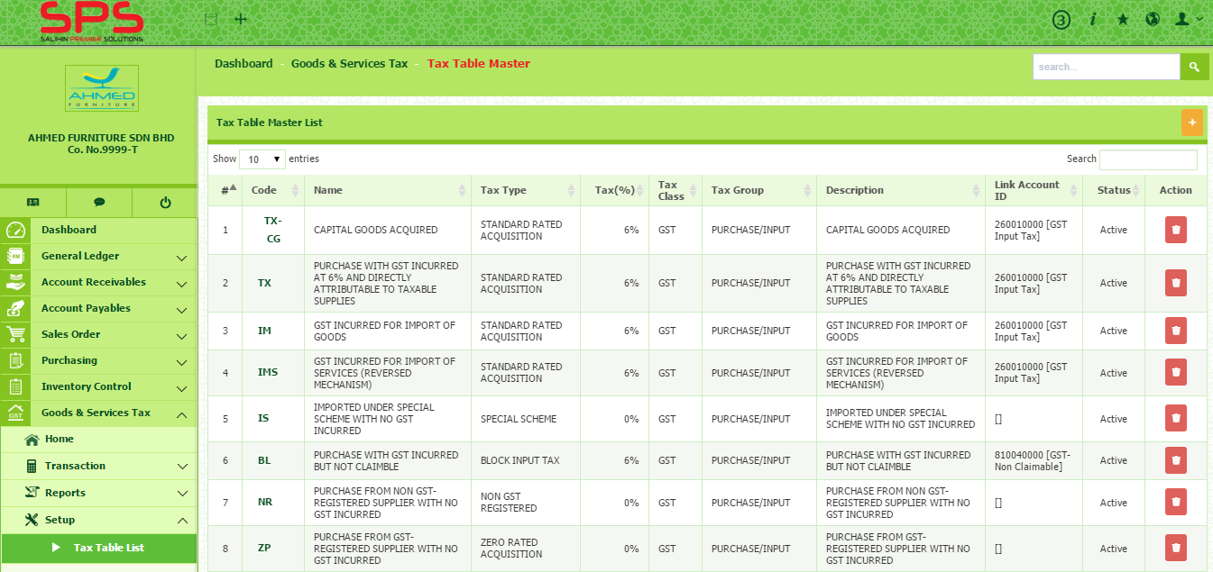
- Click + button to add tax table list.
1

- Enter Code, Name, Tax (%) and Description.
- Select Tax Class, Tax Group, Tax Type and Link Account ID
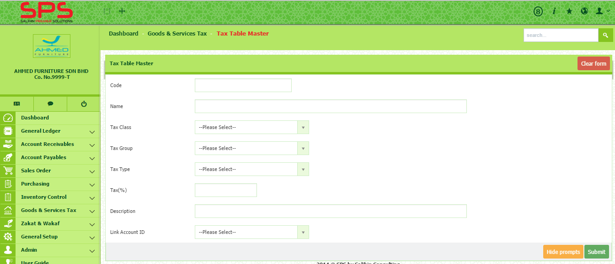
- Then, click Submit button.

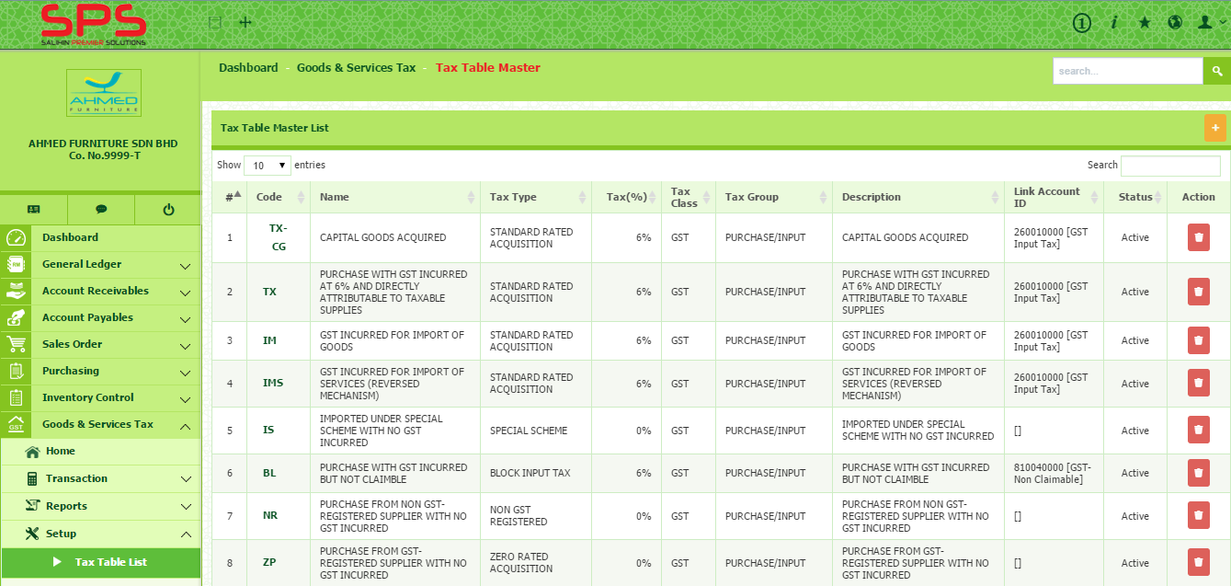
- To modify, click on the tax code in Code column. You will be directed to the Tax Table Master page. You can modify the information as you wish. Then, click Submit button.
- To delete, click on button under action column.
Setup > Tax Class List

There are two different classes of tax. GST and Other Tax.
1
- Go to Goods & Services Tax Setup Tax Class List.
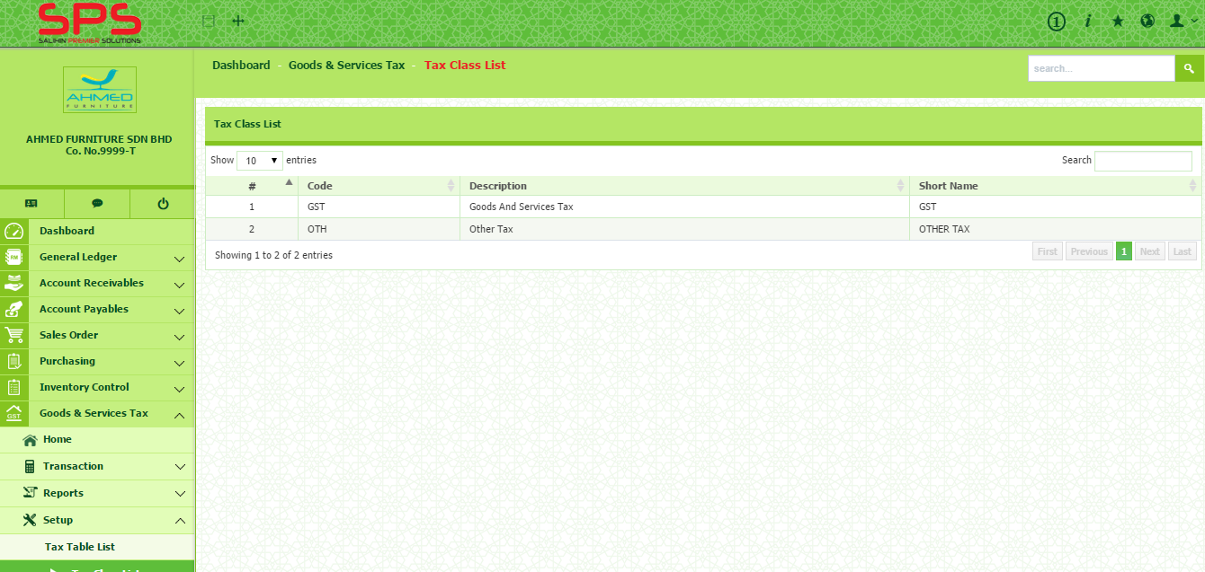
- You cannot edit Tax Class as it is default setting.
1

1
Setup > Tax Group List

- Go to Goods & Services Tax Setup Tax Group List.
- There are two group which are input and output. You cannot edit Tax Group as it is default setting.
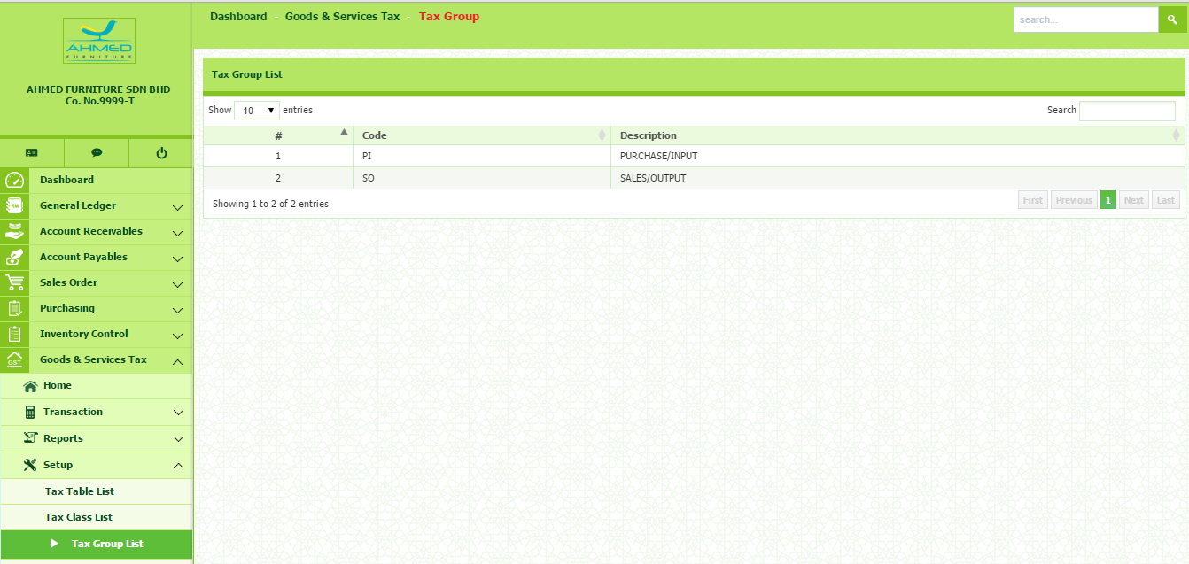
1

Setup > Tax Type List

This section shows you type of the tax code. You need to know every single type of GST as you will use it when you want to enter the transaction.
- Go to Goods & Services Tax Setup Tax Type List.
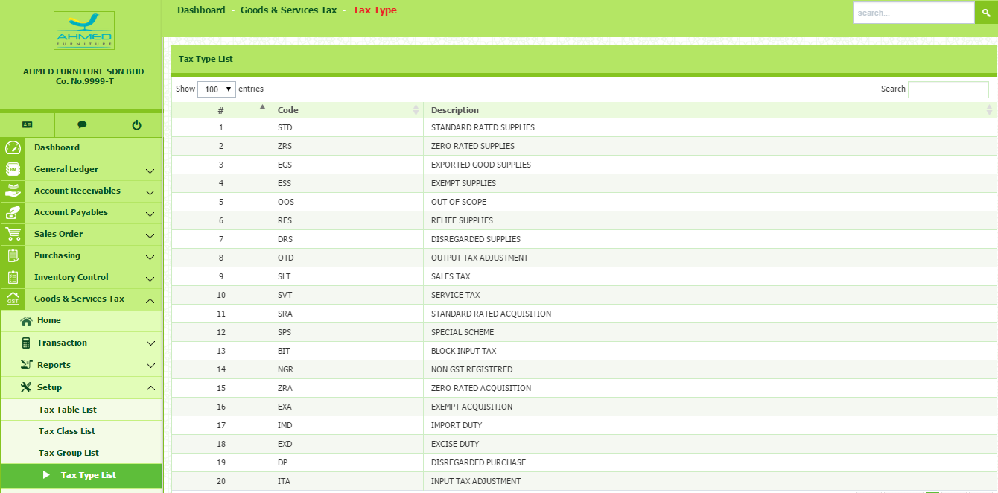
- You cannot edit Tax Type as it is default setting.
1

Setup > GST Preference

In this section, you need to do financial setting regarding the GST matters. These matters, however, can affect your cash flow. The matters are include:
- Bad debt Relief (you may claim bad debt relief for at least after six month)
- Input Tax Claim (the maximum amount you want to claim for each submission)
- Verification of Supplier GST registration (how frequent you verify the GST registration)
To do financial setting, follow the step below:
1
- Go to Goods & Services Tax Setup GST Preference
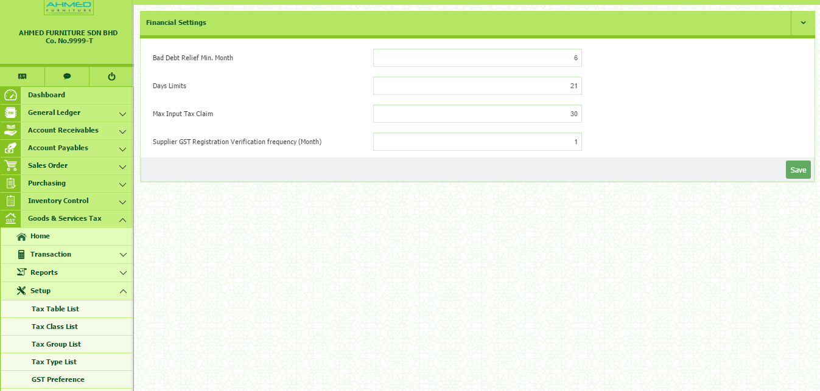
- Enter the information required in the box. Then, click Save button.
1

Setup > GST Tax Mapping

In this section, you need to know where the GST code will be mapping to GST-03 Form. However, this setting has been put under default setting as recommended by Royal Malaysian Customs Department (RMCD). Therefore, you cannot modify this setting.
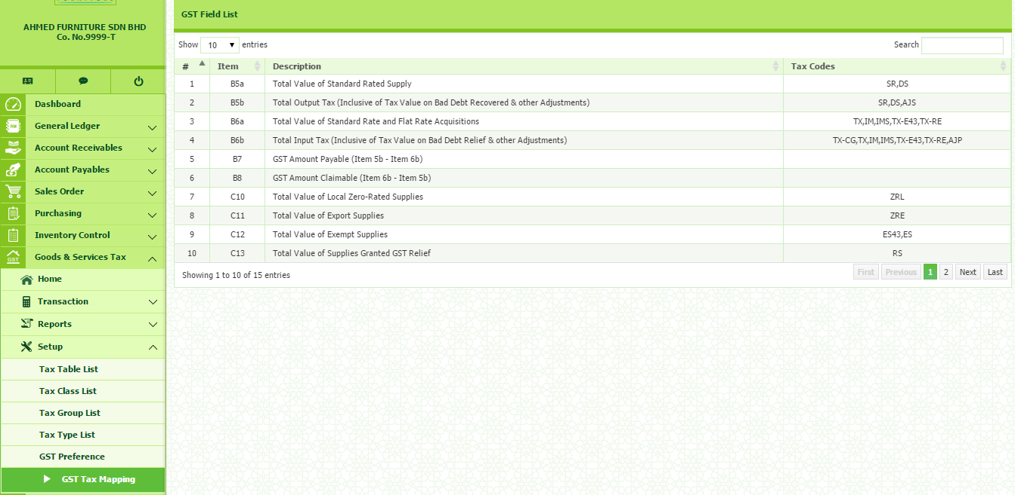
- Go to Goods & Services Tax Setup GST Tax Mapping

Transaction > GAF Files Process

Goods and Services Tax: How to Setup a Transaction

GST Audit Files (GAF) is required by RMCD during audit works. This GAF Files is being used for recording all the transactions regarding to GST. From this file, RMCD will know all the company’s transactions.
To generate this file, follow the step below:
- Go to Goods & Services Tax Transaction GAF Files Process
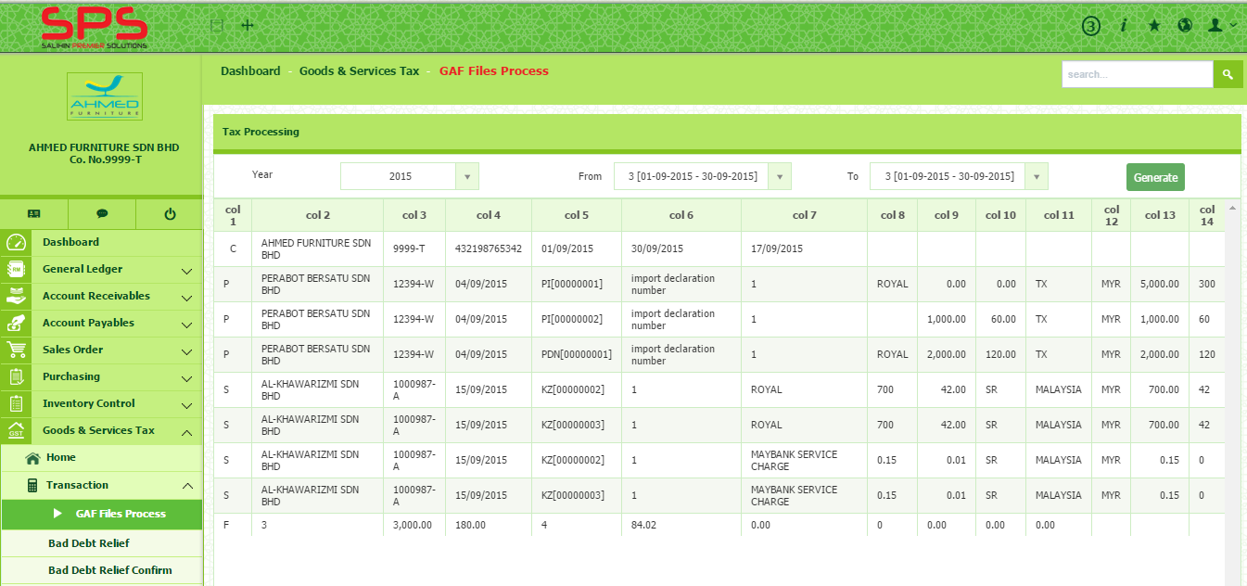
- Select Year, period From and Period To. Then, click Generate
To export file into GAF format, click button.

Transaction > Bad Debt Relief

Under paragraph 143 & 144 of the General Guide issued by RMCD, “A taxable person is entitled to a relief for bad debt on the whole or any part of the tax paid by him in respect of a taxable supply if:-
- the person has not received any payment in respect of the taxable supply from the debtor six months from the date of supply or the debtor has become insolvent before the period of six months has elapsed; and
- Sufficient efforts have been made by him to recover the debt.
The date of supply refers to the date of invoice issued. A person is entitled to claim bad debt relief even though the bad debt is not written off from his books.
1

- Go to Goods & Services Tax Transaction Bad Debt Relief
2
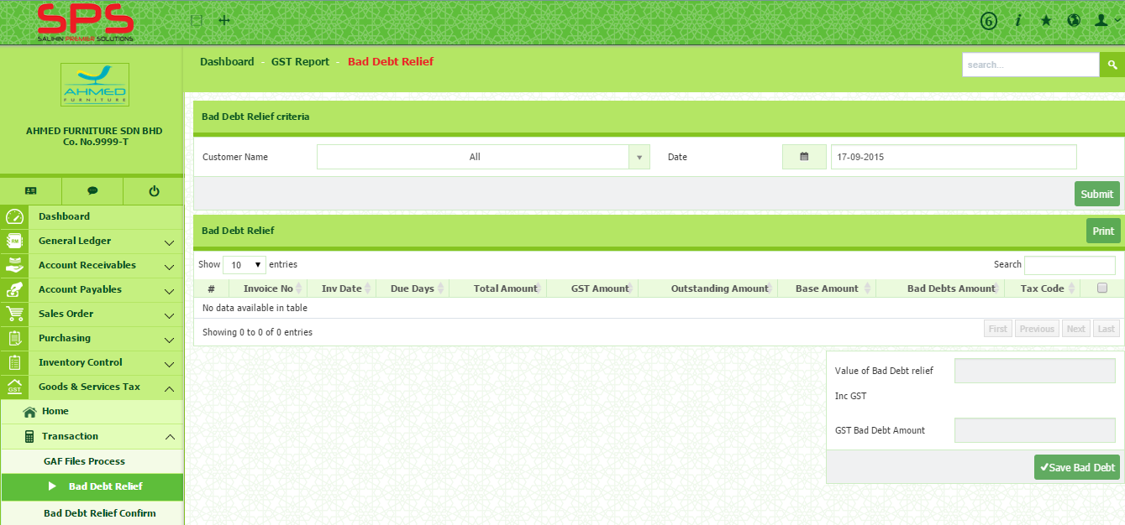
- Select Customer Name and Date, then click button.
- Then, tick on the box of selected invoice to add. Once you have tick, the value of bad debt relief will automatically be shown at the bottom side.
2
1

- Then, click to save.
Transaction > Bad Debt Relief Confirm

In this section, you need to confirm the bad debt relief before post to Journal. To confirm the bad debt, you need to follow the steps below:
1
- Go to Goods & Services Tax Transaction Bad Debt Relief Confirm
2
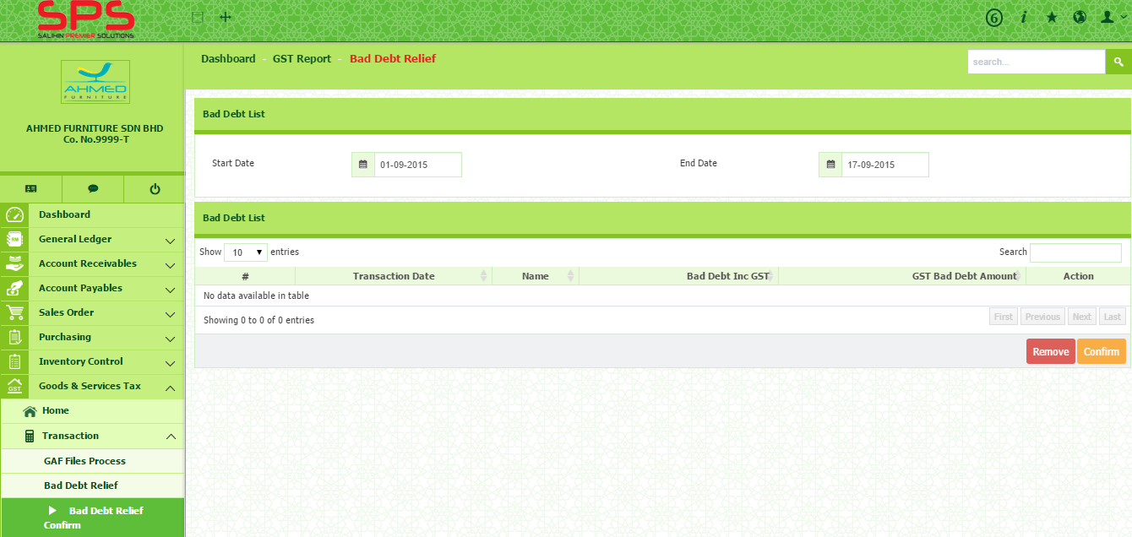
- Select Start Date and End Date. The list will be appeared under Bad Debt List.
2
1
- Tick on the box under Action column and then click button to post to journal.

- To remove, click on button.

Transaction > Bad Debt Recover

After running Bad Debt Relief process, any payment subsequently received from the debtors shall account for output tax under Bad Debt Recover.
Follow the steps below:
- Go to Goods & Services Tax Transaction Bad Debt Recover
- Select Customer Name and Date, then click button.
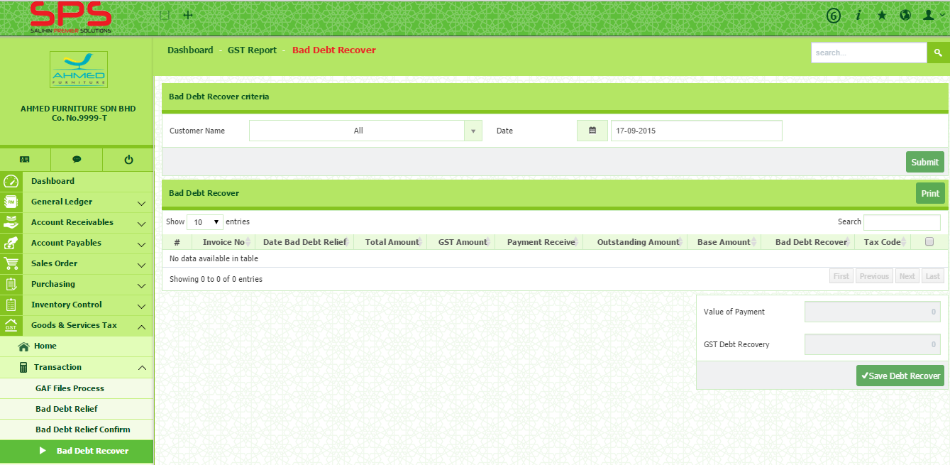
- The list will appear at the bottom side.
1

- Then tick the box and click button.
- Click button to print.

Transaction > Bad Debt Recover Confirm

You need to confirm the bad debt recover before post to Journal. To confirm the bad debt recover, you need to follow the steps below:
1
- Go to Goods & Services Tax Transaction Bad Debt Recover Confirm
2
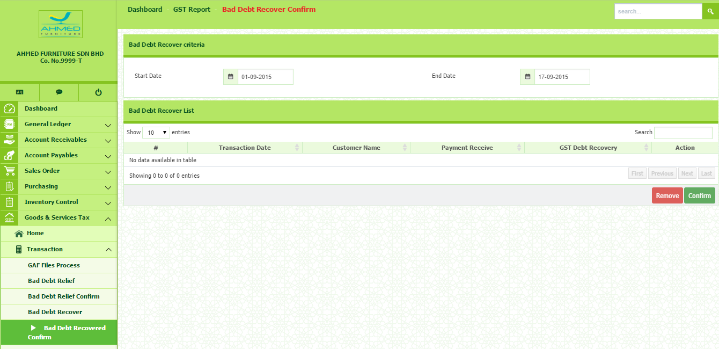
- Select Start Date and End Date, then the list will appear under bad debt recovered list.
1
2
- Tick the box under Action column. Then, click button.
- To remove, click on button.

Transaction > GST Journal

There are certain transactions that need special treatment in GST. These transactions include:
- Deemed Supplies
- Imported Services
- Imported Goods and
- Appportionment
The supply of goods without consideration under GST Act 2014 is deemed to be a supply called “deemed supplies”. The rationale behind this is that if supplies were not deemed, the goods are being enjoyed by the recipient tax free, while input tax incurred on the purchase of the goods would have been claimed by the business.
Examples of deemed supply
1. Gifts to customers
2. Goods taken for private use
3. Disposal of assets for free

- Go to Goods & Services Tax Transaction GST Journal
1
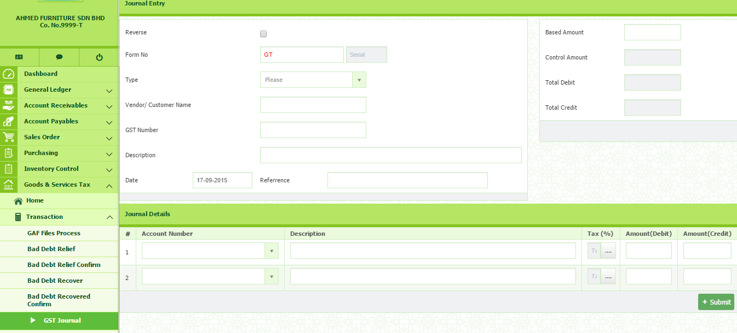
- Select Type and enter Form No, Customer/Vendor Name, GST Number, Description and Based Amount.
1
2
2


- In Journal Details section, select Account Number and Tax Code, enter the description and the amount. Then, click button.

Transaction > GST Journal Confirm

1
- Go to Goods & Services Tax Transaction GST Journal Confirm
2
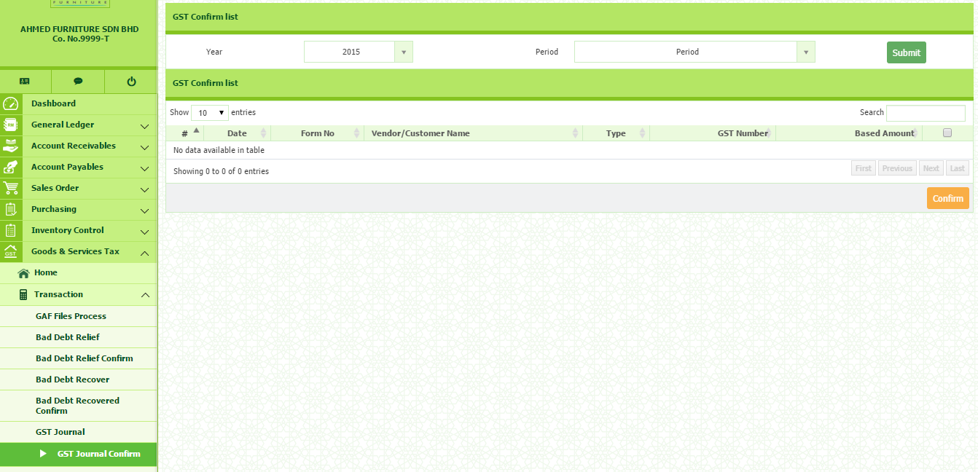
- Select Year and Period, then click button.
2
1
- Tick on the box at the selected transaction and then click on button.

Transaction > Supplier Bad Debt Relief

A registered person who has claimed input tax but failed to pay the supplier within six months from the date of supply has to pay back the input tax as his output tax. Subsequently, when payment is made for the supply of the goods or services, a registered person is entitled to claim back the said output tax as input tax for the taxable period in which he made his payment.
Please follow the following steps:
- Go to Goods & Services Tax Transaction Supplier Bad Debt Relief
1
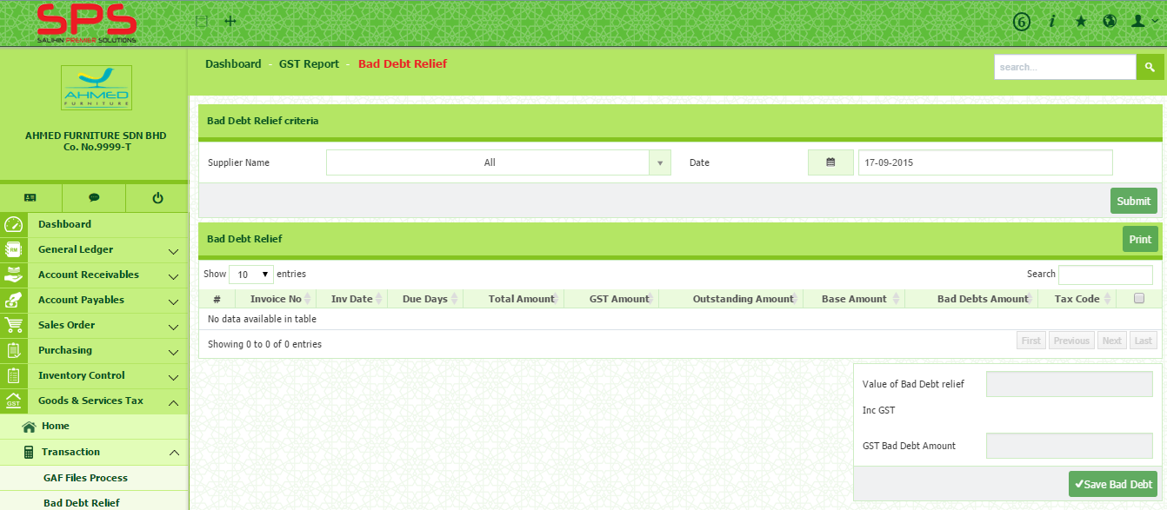
- Select Supplier and Date. Then, click button.
1
- Tick on the box at the selected transaction and then click on button.

Transaction > Supplier Bad Debt Relief Confirm

- Go to Goods & Services Tax Transaction Supplier Bad Debt Relief Confirm
1
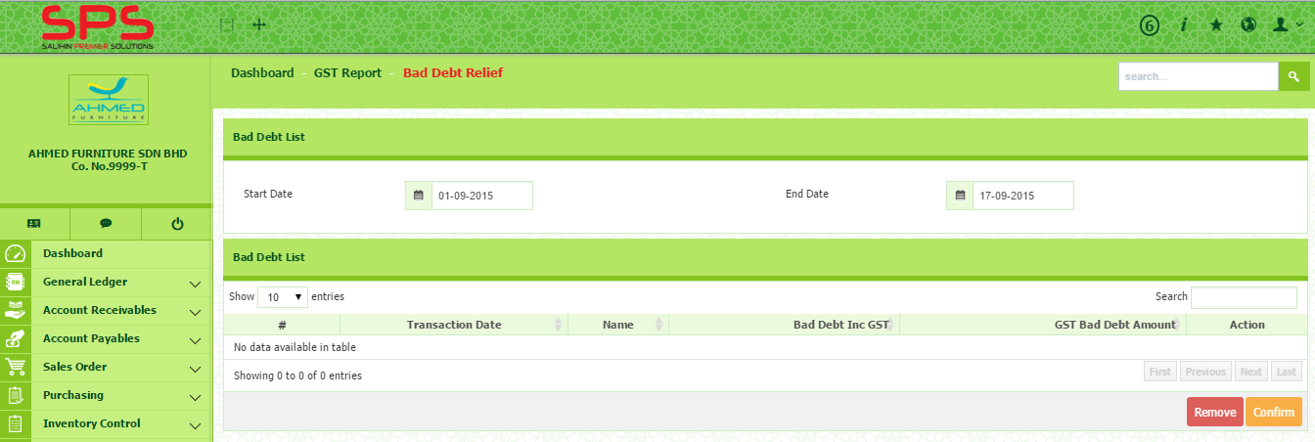
- Select Start Date and End Date.
1
- Then tick on the box and click button.
- To remove, click button.

Transaction > Supplier Bad Debt Recover

Where a registered person fails to pay the consideration for the supply of any goods or services made by his supplier within six months from the date of supply and he has claimed input tax on that supply, the taxable person is required to pay back the input tax by accounting an amount equal to the input tax as his output tax. He is required to account the output tax in the taxable period covering the month after the six months period.
- Go to Goods & Services Tax Transaction Supplier Bad Debt Recover
1
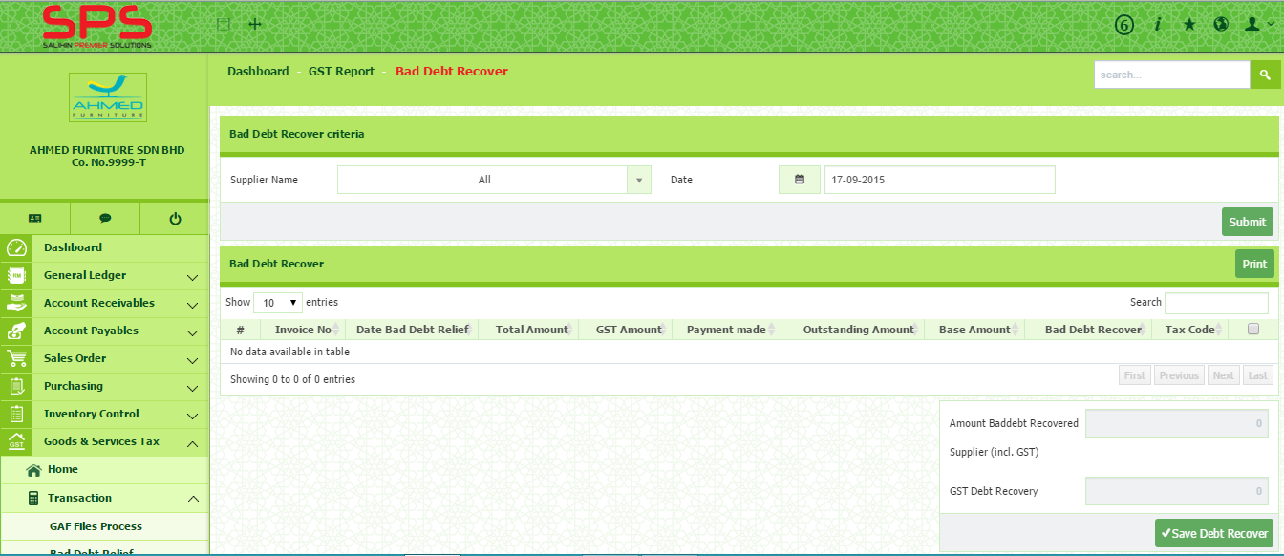
- Select Supplier Name and Date. Then, click on button.
1
- The list will appear. Then, tick the box and click on button.

Transaction > Supplier Bad Debt Recover Confirm

- Go to Goods & Services Tax Transaction Supplier Bad Debt Recover Confirm
1
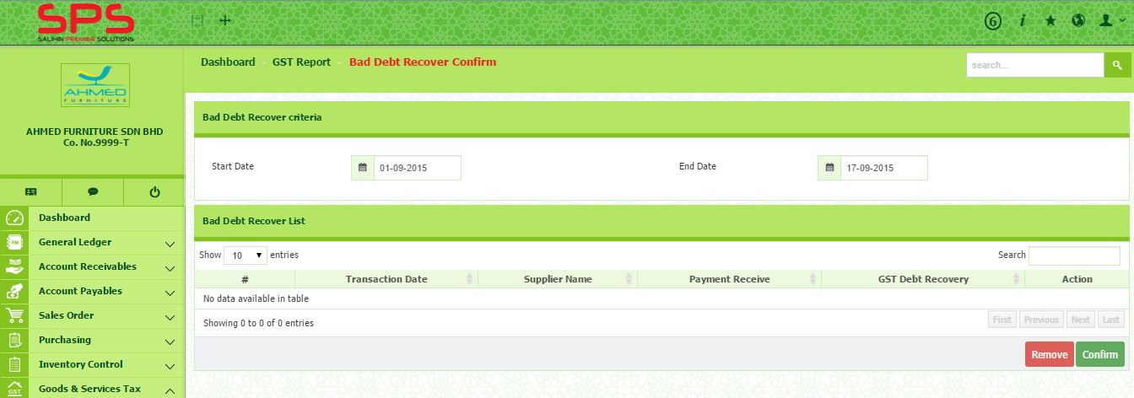
- Select Start Date and End Date. The list will appear under Bad Debt Recover List.
1
- Tick the box at the selected Supplier Name and click on button.

Goods and Services Tax: How to Setup Reports
There are few reports that can be used for internal purpose. It is important to keep tracking GST amount as management can forecast and manage its cash flow. It will very helpful to plan regarding GST matters.
Reports > GST Report
??
The purpose of this report is to provide user with all the GST transaction. User can generate the report based on the GST Group (Input/Output) or GST Code (eg: SR/ES/TX/IM)
To generate the report, follow the steps below:
- Go to Goods & Services Tax Reports GST Report.
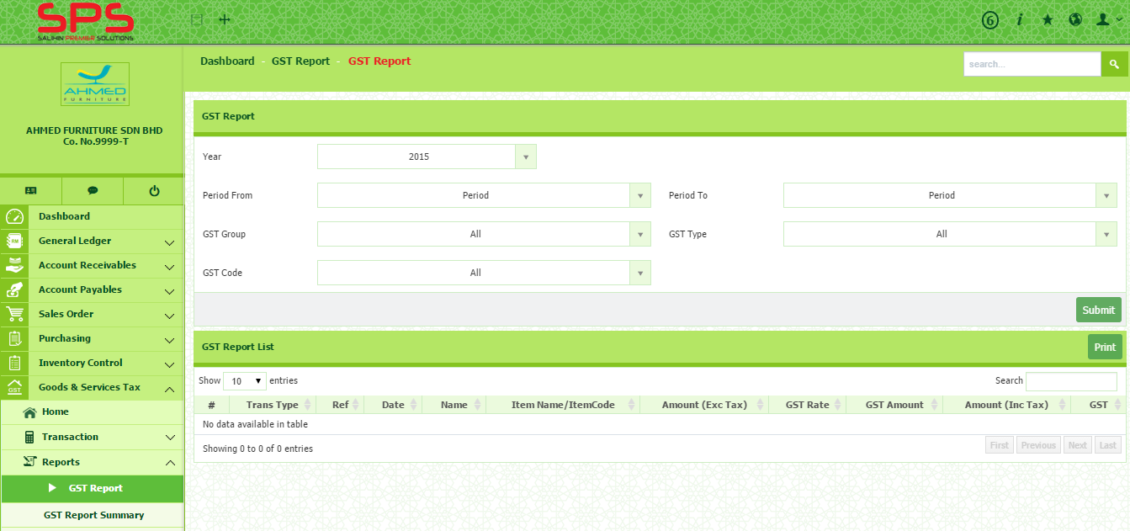
- Select Year, Period, GST Group, GST Code and GST Type. Then, click button.
1
1
- To print, click button.

Reports > GST Report Summary
??
This report provide the total amount of GST based on its Code.
To generate this report, follow the steps below:
- Go to Goods & Services Tax Reports GST Report Summary. Then, click button.
1
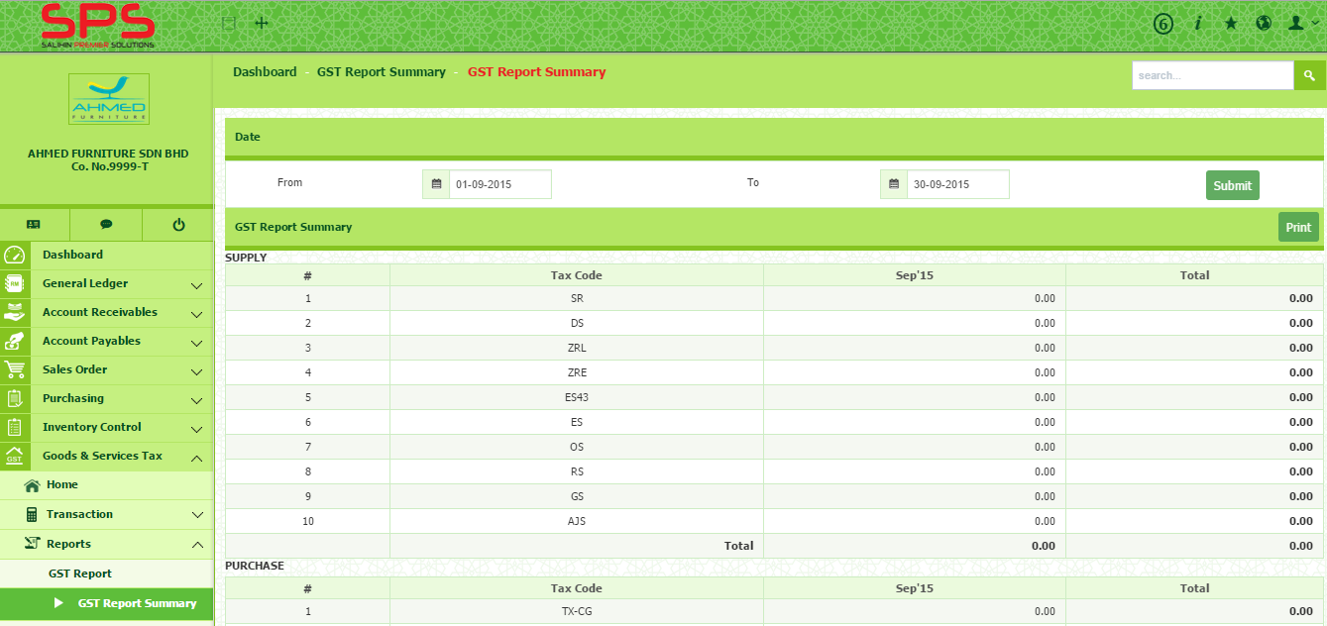
- To print, click button.
1

Reports > GST 03
??
GST 03 need to be submitted to RMCD as required by GST Act 2014. It depends on the revenue of the company. If total taxable supply is more than RM5 million, the submission is monthly otherwise, it is quarterly.
To generate GST 03 report, follow the steps below:
1
- Go to Goods & Services Tax Reports GST 03.
2
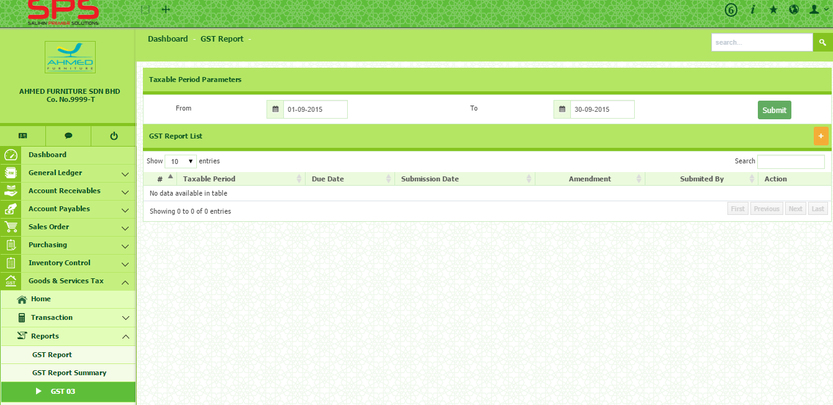
- Select period From and period To. Then, click button.
2
1

Reports > GST 03 Summary
??
- Go to Goods & Services Tax Reports GST 03 Summary
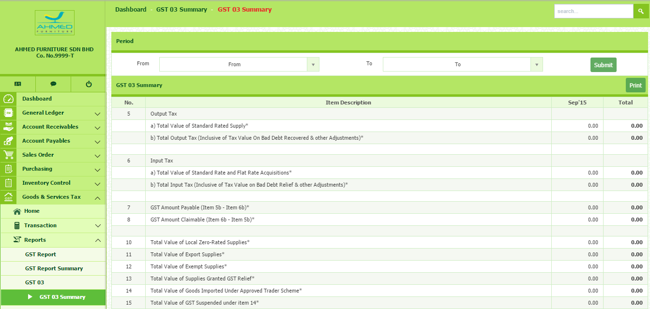
- Select period From and period To. Then, click button.
1

Reports > Bad Debt Relief List
??
This report shows the list of customer under
- Go to Goods & Services Tax Reports Bad Debt Relief List
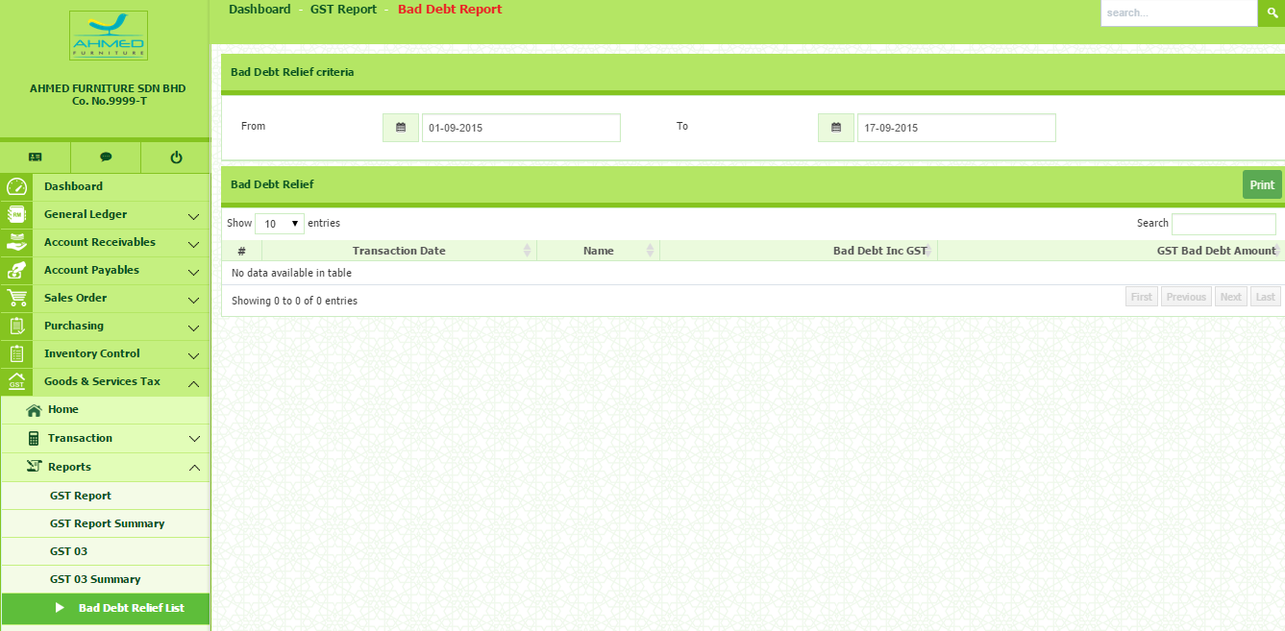
- Select period From and period To. The list will appear at the bottom side.
1

Reports > Bad Debt Recovered List
??
This report shows the list of the customer who are
- Go to Goods & Services Tax Reports Bad Debt Recovered List
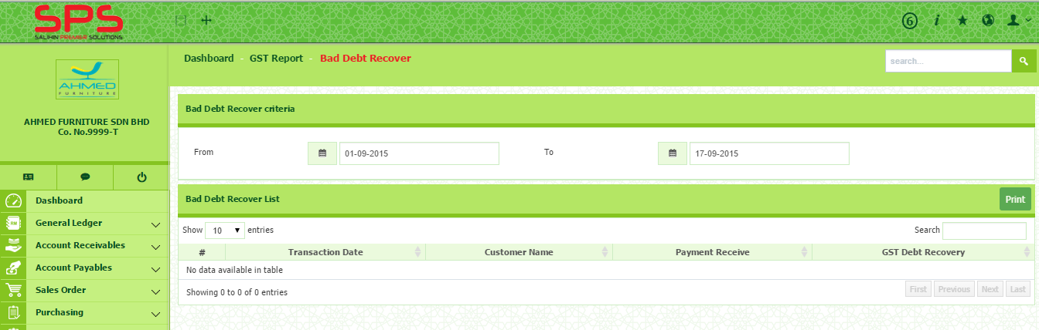
- Select period From and period To. Then, click button.
1

