Mohd Norhjirah bin Rahmat

Name: Mohd Norhijrah bin Rahmat  IC No: 910920-14-5951  Date of Birth: September 20, 1991  Gender: Male  Race: Malay  Religion: Islam  Marital Status: Single  Address: No.48, Lorong Kerayong 5A,  Taman Seri Kerayong,  42200 Kapar Klang,  Selangor Darul Ehsan.  Phone: (6012) 9020 146 (Mobile)  (603) 3250 9109 (Home)  Email: hijrahrahmat@gmail.com | 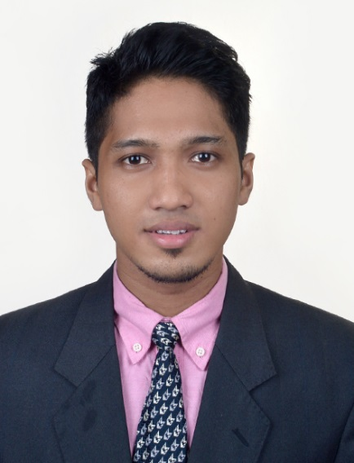

Objective | To continue to grow in leadership and knowledge, excel in innovative technology applications, interact and share with team members and colleagues, deal with real world challenges and develop world-class solutions. Willing to gain and learn new skills and experience to increase expertise and competencies.
Education  Working Experience | Universiti Teknologi Mara (UiTM) Segamat, Johor Darul Takzim  - Level: Diploma in Information Management  - CGPA: 2.88  Universiti Teknologi Mara (UiTM) Puncak Perdana, Shah Alam  - Level: Bachelor of Science (Hons) in Information System Management  - CGPA: 3.23  Sijil Pelajaran Malaysia (equivalent to O-Level) Sek. Men. Teknik Kuala Selangor, Selangor Darul Ehsan  Salihin Consulting Group Sdn Bhd  - Position: IT Trainee  - Duration: February 2015- August 2015  SJM Flex Sdn Bhd  - Position: Warehouse Assistant  - Duration: February 2014- August 2014
Technical / Other Related Skills and Knowledge | - Language programming: C++, PHP, HTML and Visual Basic  - Desktop applications: Microsoft Office, Adobe, SPSS, Macromedia and Sony Vegas Pro  - SPS Accounting Software  - Proficient in Malay and English
Extra-Curricular Activities and Interests | - Members of Jawatankuasa Perwakilan Kolej (UiTM)  - Facilitator of new students intake (UiTM)  - Participants of UiTM sports carnival (KARISMA)  - Chairman of Citrawarna event (UiTM)  - Participant of college open day (UiTM)  - Participant of Seminar Komunikasi dalam Perkhidmatan Perpustakaan (UiTM)  - Participant of Bengkel Pengurusan Rekod dan Perpustakaan (UiTM)  - Participant of Projek Pengurusan Maklumat, PEMUIS 2010 (UiTM)  - Chairman of Persatuan Pendidikan Islam (SMT Kuala Selangor)  - Participant of KAT (Kejohanan Antara Teknik)  - Participant of Kursus Pengurusan Organisasi Peringkat Daerah Kuala Selangor
Personal Traits | - Highly determined, motivated, resilient and success driven  - Able to work independently under minimum supervision  - Competent team player

