- How to setting Your Company?
After system installation, the first thing you have to setting up is your company details. Company should function as the foundation of an accounting system that the business will use during future years.
    - Create/Add New Company
- Go to General Setup > Company Setup > List
- Click + button that located on top right page
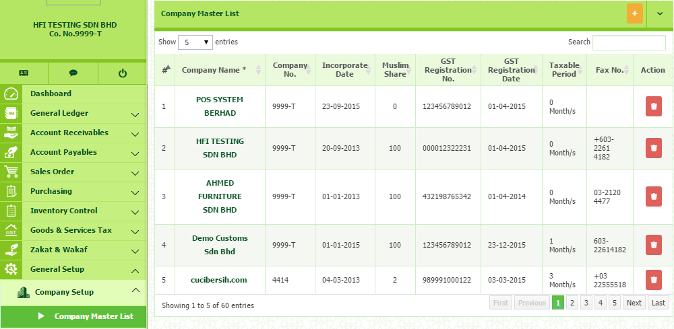
Once click, you will be direct to company master pages. In this section, you need to fill in all the required information needed.

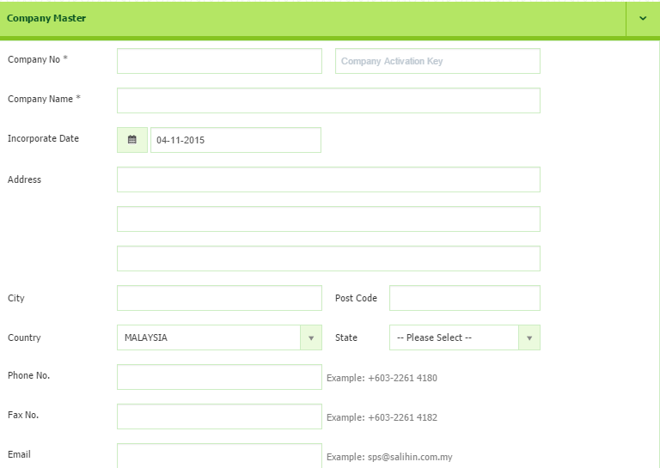

Before you continue to fill in all the required information, you need to get the Company Activation Key first. Please follows the following steps as below:-

    - How to get Company Activation Key
- Open new browser and type demo.salihinpremier.com/ss-ss/customerlogin
- Enter your username and password. (Please check your email OR contact SPS Support Team to get the details)
- Once login, you will be direct to Customer Login page.

Below is the main interface of Customer Login page. Continue the following steps:-
- Click the SPS License from the menu
- Then, click the SPS Serial No.

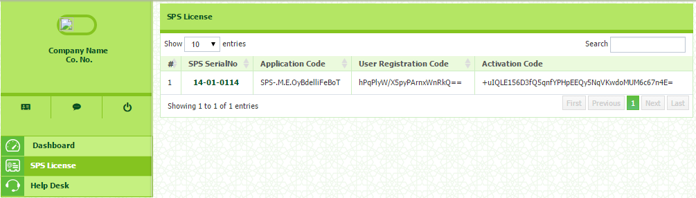

Below is the main interface of you License and Company Registration details.
- Proceed to the SPS Registered Company Key
- Click Add Company button
- Once click, you need to entered Company No. , Activation Date.
- Then click the button. Once click, the Activation Key will be automatically appear.
- Next copy the Activation Key as appeared
- Then, open your Company Master page in SPS. Paste your Activation Key and paste the code into Company Activation Key column besides Company No. (Please refer Company Master Interface)

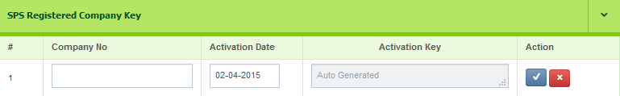

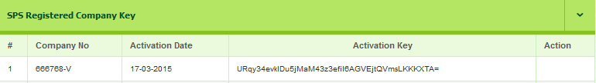

 WARNING!

- Make sure there is no SPACE when you copy and paste. IF you are failed to validate, please contact your Dealer.
- Please be careful before you remove the registered company. Charge may be implied for data recovery.

    - Failed to Add New Company
If you having this problem to adding new company registration, kindly please check again your company license that you already purchased. If you purchased for 1 Company, you are unable to proceed for any new company registration.

If you are wishing to have more than 1 company license, do call your dealer or SPS Support Team to consult you on the volume of licensing according to your business activities.
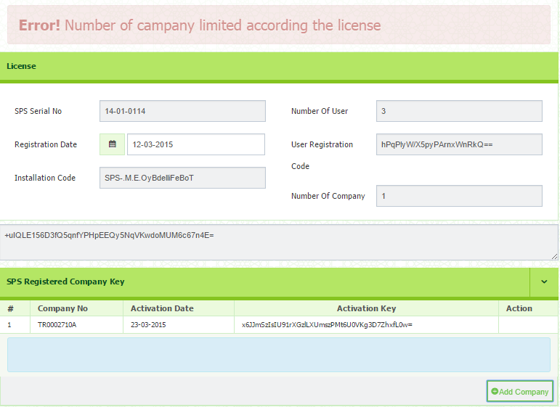

    - How to Upload Image/Company Logo
- Click the Choose File button
- Select images from your drive , where the logo is located and stored
- Images can be BMP, PNG, JPEG or GIF files and should measure 120 x 120.


    - Goods & Services Tax
Information of your GST No, GST Registration Date, Taxable Period and MSIC
Code.
- GST Registration No – Must be 14 digits
- GST Registration Date – Refer your references copy from Customs.
- Taxable Period – Only appeared when you select the Registration Date. You can select taxable period from the drop down menu, either as Monthly, Every 3 Months, Every 6 Months or Yearly.
- MSIC Code – Refer your references copy from Customs.

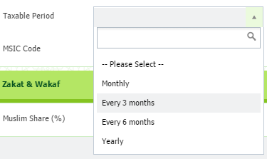
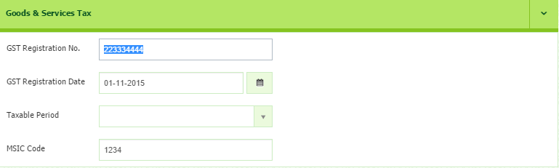

    - Zakat & Wakaf
Enter the amount (%) of your zakat & wakaf
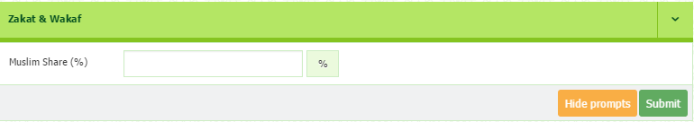
After Company Activation Key has been updated, you may proceed to click Submit button to save all the information.

