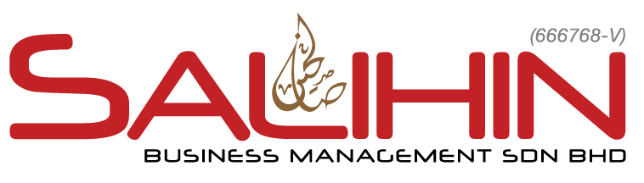    By Accountants for Accountants  www.salihin.com.my II www.salihinpremier.com | Corporate Centre  Unit 2A-1, Level 1 Tower 2A, Plaza Sentral, Jalan Stesen Sentral 5,  50470 KL Sentral, Kuala Lumpur.  Tel : +603-2261 4180 Fax : +603-2261 4182  Business Centre  555 Jalan Samudra Utara 1, Taman Samudra, 68100 Batu Caves, Selangor Darul Ehsan.  Tel : +603-6185 9970 Fax : +603-6184 2524

Commission Summary Form
Period From : | 01 JUNE 2015
Period To : | 30 JUNE 2015
Salesperson Name : | RTMA CONSULTING
Reference No. : | SPS-GST2015/TI/01

Date | Invoice | Client | Sale PricE (rm) | Commission  35% | AMOUNT  (include GST)
19/06/15 | SI 00000167 | NEDDY ENTERPRISE S/B | 2,880.00 | 1,008.00 | 1,008.00
19/06/15 | SI 00000167 | DAELECT ASIA S/B | 2,880.00 | 1,008.00 | 1,008.00
 |  |  |  | Total Invoiced (exclude GST) | 5,760.00
 |  |  |  | Gross Commissions Earned  (include GST) | 2,016.00
 |  |  |  | Less Advance | -
 |  |  |  | Other Deductions | -
 |  |  |  | Amount Payable | 2,016.00
Bank Name : | BMMB
Bank Account : | 0101 000 28 40 711
Prepared by | Date
Checked by | Date

Approved by | Date

