Setup
How to Setup Account Receivables

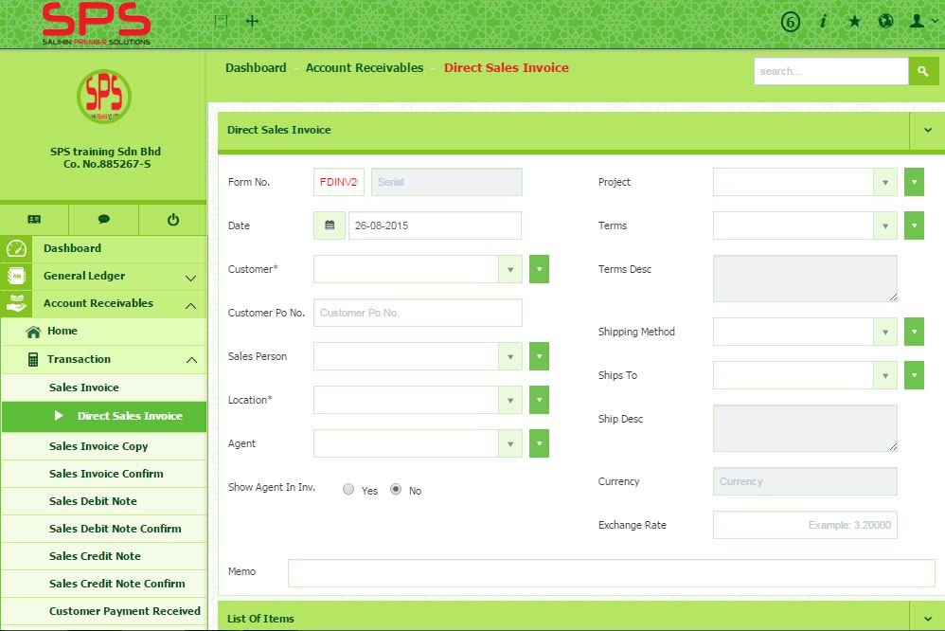Before you going to prepare an invoice for the sale items, you have to make sure that the following required information has been setup.
- Customer Setup
- Project Setup
- Location Setup
- Terms Setup
- Agent Setup
- Ship To
SETUP
- To setup Customer, go to Account Receivables Setup Customer Setup
- To setup Project, go to General Setup Project Setup
- To setup terms, go to General Setup Terms Setup
- To setup Location, go to Inventory Setup Location Master
- To setup Agent, go to General Setup Agent Setup

Transaction: Sales Invoice

Here you are going to prepare an invoice for the sale items. There are two methods:-
- Sales Invoice
- Direct Sales Invoice
- Go to Account Receivables Transaction Sales Invoice
- Select the Customer from the drop down list.
- Select the Agent, Project, Location, Terms, and Ships To from the drop down list.
- If the required information has not been setup yet, you can simply click the drop down button at each field. Click Add New to proceed.
- You may type Customer Po No according to customer format.
- You can select either to show agent or not in invoice.
- Once customer has been selected, the details of Item will be display in Item(s) section.
- Select the particular row of items.
- In Other Charges section, you can add new charges if needed and remove the other charges.
- Select the Shipping Method and Sale Person from the drop down button.
- Click Calculate Total to get the Total Amount, Total Tax Amount and Total Receivable.
- To save sales invoice, simply click Save Invoice.

Transaction: New Direct Sales Invoice

You can prepare the new direct sales invoice, if you want to proceed without sales order items.
- Go to Account Receivables Transaction New Direct Sales Invoice
- Select the Customer from the drop down list.
- Select the Agent, Project, Location, Terms, and Ships To from the drop down list.
- If the required information has not been setup yet, you can simply click the drop down button at each field. Click Add New to proceed.
- You may type Customer Po No according to your company standard.
- You can select either to display agent name or not in invoice.
- Once customer has been selected, the details of Item will be display in Item(s) section.
- Select the particular row of items.
- In Other Charges section, you can add new charges if needed and remove the other charges.
- Select the Shipping Method and Sale Person from the drop down button.
- Click Calculate Total to get the Total Amount, Total Tax Amount and Total Receivable.
- To save sales invoice, simply click Save Invoice.

Transaction: Copy Sales Invoice
- Go to Account Receivables Transaction Copy Sales Invoice
- Select the Customer from the drop down list.
- Select the Agent, Project, Location, Terms, and Ships To from the drop down list.
- If the required information has not been setup yet, you can simply click the drop down button at each field. Click Add New to proceed.
- You may type Customer Po No according to your company standard.
- You can select either to display agent name or not in invoice.
- Once customer has been selected, the details of Item will be display in Item(s) section.
- Select the particular row of items.
- In Other Charges section, you can add new charges if needed and remove the other charges.
- Select the Shipping Method and Sale Person from the drop down button.
- Click Calculate Total to get the Total Amount, Total Tax Amount and Total Receivable.
- To save sales invoice, simply click Save Invoice.

Transaction: Sales Invoice Confirm

Transaction: Sales Debit Note

The Sales Debit Notes is issues as an adjustment to the invoice that you have previously created to increase the value of goods.

- Go to Account Receivables Transaction Sales Debit Note
- Select the Customer from the drop down list or else you may simply click the drop down button to Add New Customer.
- Select the Project from the drop down list or else you may simply click the drop down button to Add New Project.
- Select Invoice No from the drop down list.
- Customer Po. No. will be appear automatically when you has selected Invoice No.
- You may entered the Exchange Rate.
- In the Item(s) section, you may change the type of Tax by clicking the Tax button.
- In Charges section, you can add new charges if needed and remove the other charges.
- By inserting the Item(s) details, you will get the Total Tax Amount and Total Debit Note.

- Go to Account Receivables Transaction Sales Debit Note Confirm
- Select Year and Period and click submit to get the Sales Debit Note List.
- You can edit the selected debit note by click the link of Debit Note No.
- You may edit the Item(s) details and charges only.
- Select the particular row that you are confirm to do a Posting. Click Posting button to proceed the posting.
- Please be noted, once the debit note has been posted, you are unable to reedit the details.

Transaction: Sales Debit Note Confirm

Transaction: Sales Credit Note

The Sales Credit Note is issued as an adjustment to the invoice that you have previously created to decrease the value of the goods. For example, goods that returned from customer and also discounts given on that goods.

- Go to Account Receivables Transaction Sales Credit Note
- Select the Customer from the drop down list or else you may simply click the drop down button to Add New Customer.
- Select the Project from the drop down list or else you may simply click the drop down button to Add New Project.
- Select Invoice No from the drop down list.
- Customer Po. No. will be appear automatically when you has selected Invoice No.
- You may entered the Exchange Rate.
- In the Item(s) section, you may change the type of Tax by clicking the Tax button.
- In Charges section, you can add new charges if needed and remove the other charges.
- By inserting the Item(s) details, you will get the Total Tax Amount and Total Credit Note.

Transaction: Sales Credit Note Confirm
- Go to Account Receivables Transaction Sales Credit Note Confirm
- Select Year and Period and click submit to get the Sales Credit Note List.
- You can edit the selected debit note by click the link of Credit Note No.
- You may edit the Item(s) details and charges only.
- Select the particular row that you are confirm to do a Posting. Click Posting button to proceed the posting.
- Please be noted, once the debit note has been posted, you are unable to reedit the details.

Transaction: Receive Payment
- Go to Account Receivables Transaction Receive Payment
- Select name of the Payer from the dropdown list. Payer is also known as Customer.
- Select name of the project from the dropdown list.
- Select name of bank from dropdown list. Account Number will be automatically appear only when bank has been selected.
- Select the payment method either Cash or Cheque from the dropdown list.
- You may entered Reference No for your reference or office use.
- Out of balance
- Amount Received
- In the List of Invoice section, it will display all the listing of invoices.
- By selecting the particular row, you can decide amount of discount and amount applied.
- Once the row has been selected, you will see the summary of Total Discount, Bank Charges, Total Other Charges, Total Received, Total Applied, Total Other Charges and Out of Balance.
- Click Save button to save it.
- Click Go to Conform Page after completion.

Transaction: Receive Payment Confirm
- Go to Account Receivables Transaction Sales Credit Note Confirm
- Select Year and Period and click submit to get the Sales Payment Confirm List.
- You can edit the selected Sales Payment by click the link of Credit Note No.
- You may edit the Item(s) details and charges only.
- Select the particular row that you are confirm to do a Posting. Click Posting button to proceed the posting.
- Please be noted, once the debit note has been posted, you are unable to reedit the details.
- All the posting will be listed in Unposted Journal.

- Go to Account Receivables Reports Direct Sales Invoice List
- You can print the report, details of each invoice by clicking the Print button.
- You also can print all the invoices listing.

Direct Sales Invoice List
Account Receivable: How to Setup a Report

Sales Debit Note List
- Go to Account Receivables Reports Direct Sales Invoice List
- You can print the report, details of each invoice by clicking the Print button.
- You also can print all the invoices listing.

- Go to Account Receivables Reports Receive Payment List
- You can print the report, details of each invoice by clicking the Print button.
- You also can print all the receive payment listing by click Print.

Receive Payment List
Sales Credit Note List
- Go to Account Receivables Reports Direct Sales Invoice List
- You can print the report, details of each invoice by clicking the Print button.
- You also can print all the invoices listing by click Print.

- Go to Account Receivables Reports AR Summary
- In this section, you can view summarizes of what the customer owes for the current billing period.

Account Receivable Summary
- Go to Account Receivables Reports Customer Statement
- You can search customer statement by Customer Name.
- You can print the report, details of each customer statement by clicking the Print button.
- You also can print all the customer statement list by click Print.

Customer Statement

