 | SALIHIN IT CURATION SDN BHD |  | Document No:  SITC-MGSV2-01
USER GUIDE
MANAGEMENT INFORMATION SYSTEM
MGS VER 2.0

MODULE:
USER/STAFF

Prepared by:  IT AND DIGITAL DEPARTMENT @ 2019 |  | Revision No:  Version 1.0 |  | Effective Date:  28 NOV 2019

- How to Access MGS
Let’s get started. You can simply click type the url link salihin.noip.me/mgs .Once clicked, you will be directed to the main page of MGS. Click Login button that located
on the top right corner of the page.

Notes : Login ID and password same as SPS ERP.

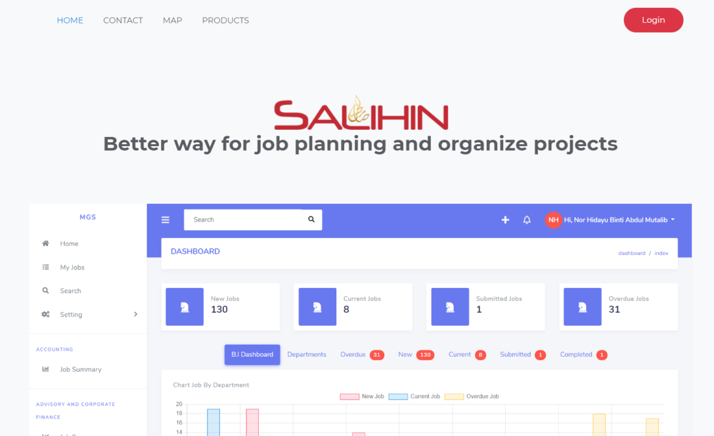

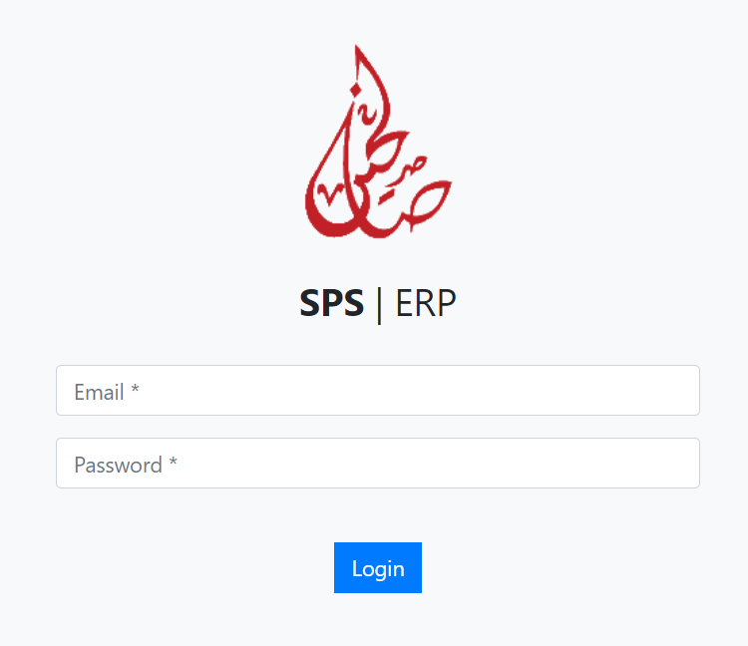

- View Dashboard
Once login, you will be directed to the Dashboard page. Staff enable to view own department only. From dashboard, you can see the total summary of:-

- New Jobs
- Current Jobs
- Submitted Jobs
- Overdue Jobs
- Completed Jobs

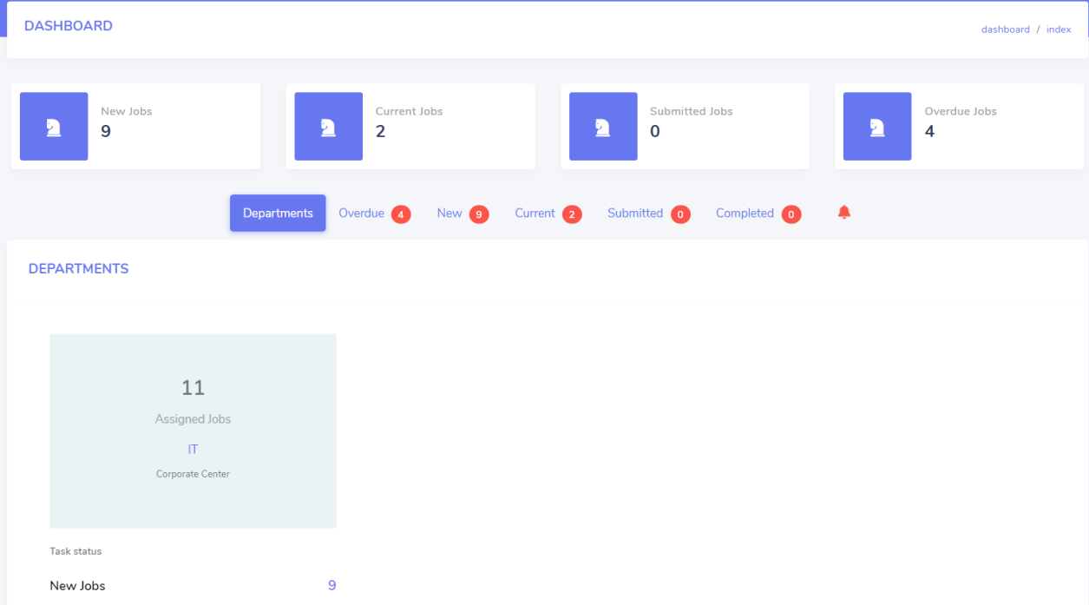

2.0.1 How to View Job Assigned
Once HODs/Supervisor has acknowledge job assign, you will see the new jobs list under new jobs. Normally, HODs or Supervisor will setup Person in Charge under working details.

2.0.2 Create Job Task
Once staff has been assigned as person in charge (PIC) for new job, he/she need to plan their own task schedule. In this part if will show the work in progress task status to meet the deadline.

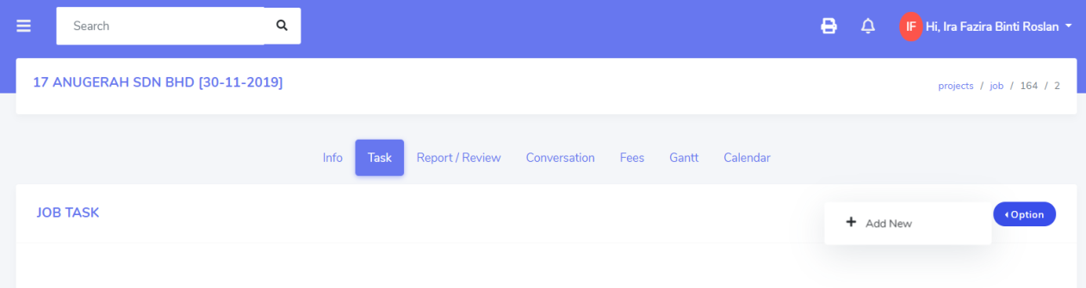

- Click Task from menu
- Click Option button, click +Add New
- Insert Task Name
- Insert Remarks
- Insert Due Date
- Insert Status – In Progress, Pending , Completed
- Click Save button to saved data

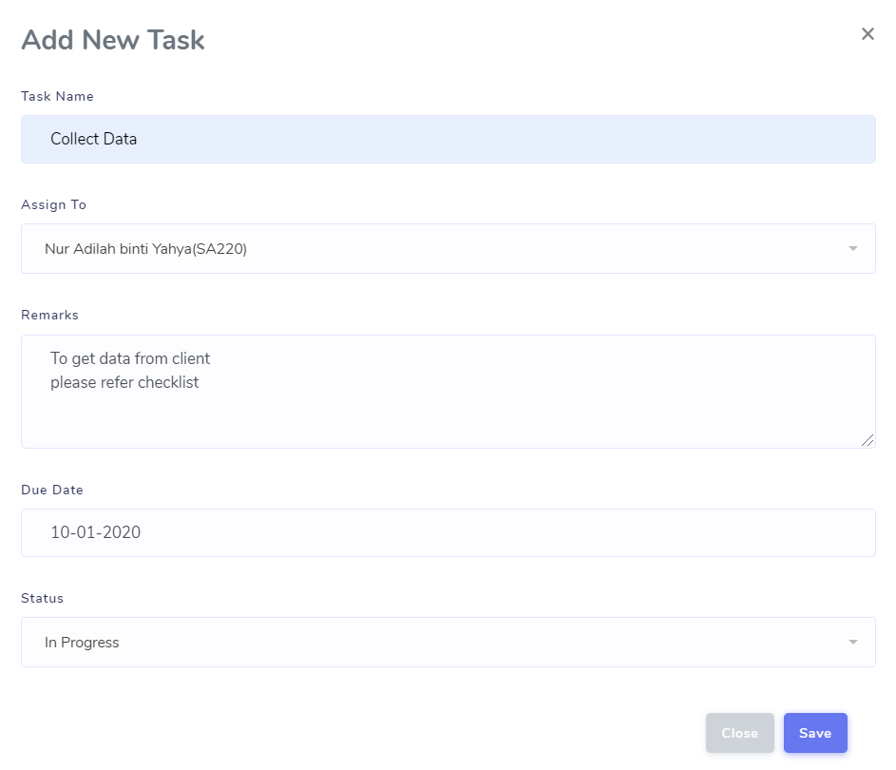

2.0.3 View Job Task
Staff can view he/she job task listing and update their task progress status. Status of task name can be update as
- In Progress
- Pending
- Completed

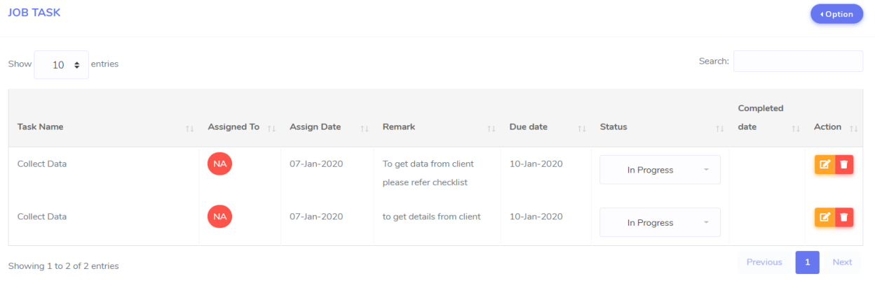

- Report/Review

3.0.1 Add New Report/Review
Staff can add new draft of report/review to be reviewed by their HODs or Supervisor.

- Click Report/Review from the tab menu
- Click Option button, click +Add New
- Insert Report Name
- Select Reviewer from the list
- Insert Description
- Insert Remark
- Select Submission Date
- Insert Status
- Click Save button

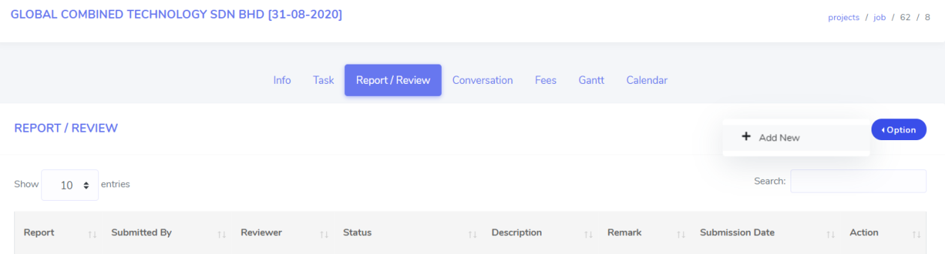

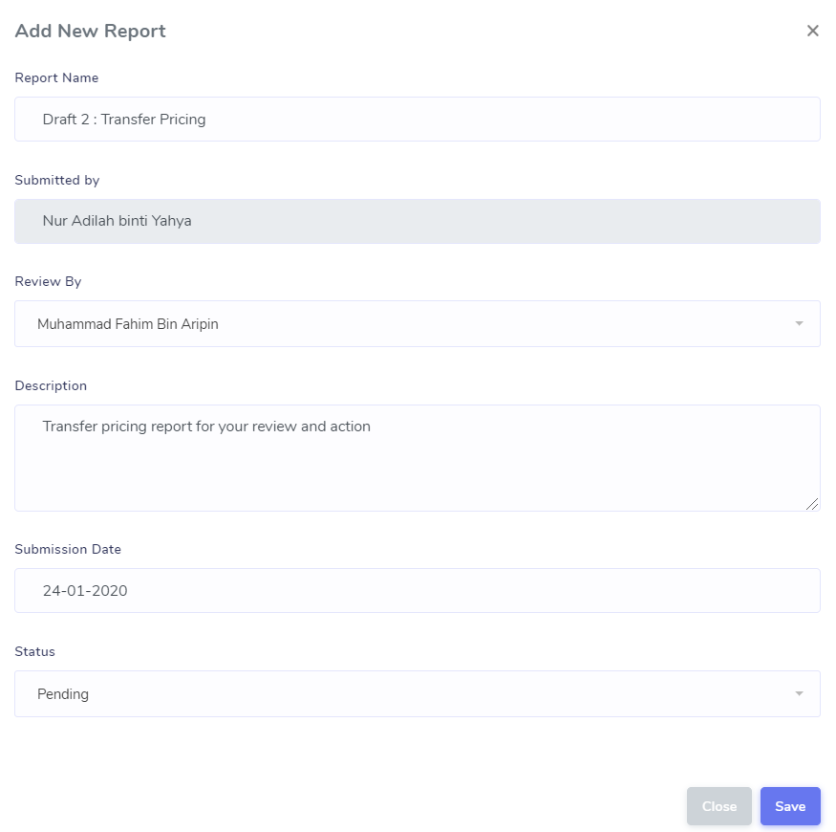

3.0.2 View, Edit and Delete Report

3.0.2.1 How to View List of Draft/Reporting
Staff can view he/she draft of report from the list as shown below.

  - Click Report/Review from the tab menu

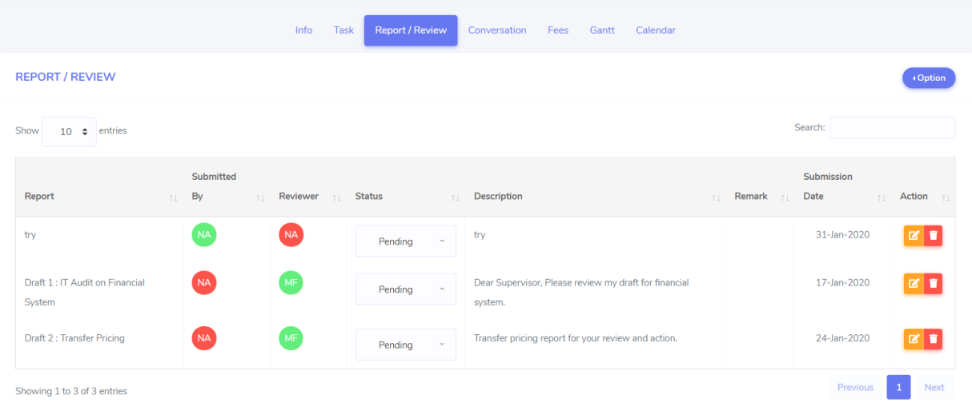

3.0.2.1 How to Edit List of Draft/Reporting
Staff enable to re-edit their added report. You can drag the description and
remarks field

  - Click Report/Review from the tab menu
  - Select report from the list
  - Click edit button that located in the same row of report name.
  - Once click, you will be directed to Draft/Reporting page.
  - Update the required information.
  - Once completed, click Save changes button to saved.

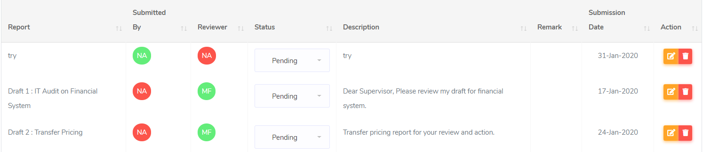

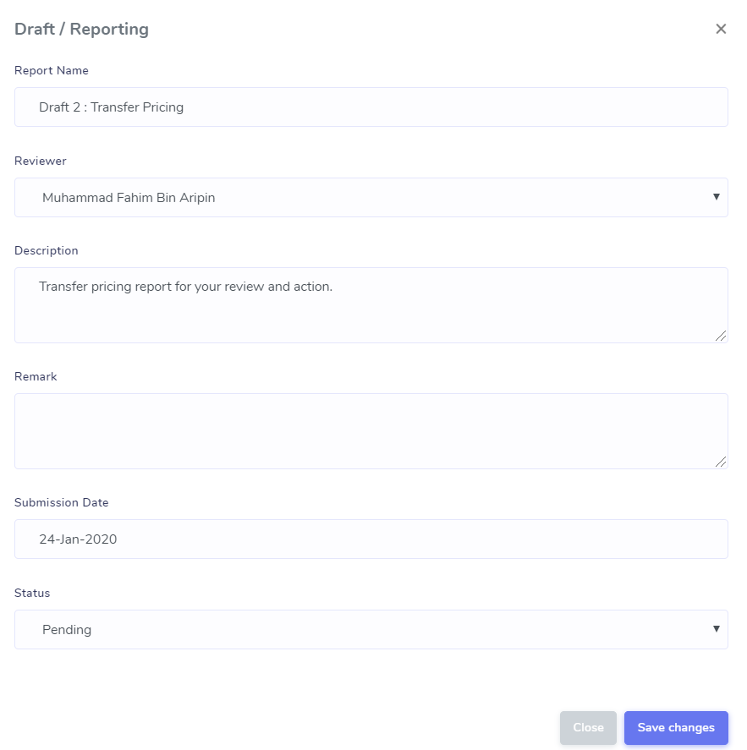

3.0.2.2 How to Delete Report
Staff enable to delete any report that no longer needed for review.

Notes : Please read report name carefully before you wish to click delete button.

  - Click Report/Review from the tab menu
  - Select report from the list
  - Click delete button that located in the same row of report name.
  - Once click, prompt message box will appear.
  - Click OK button

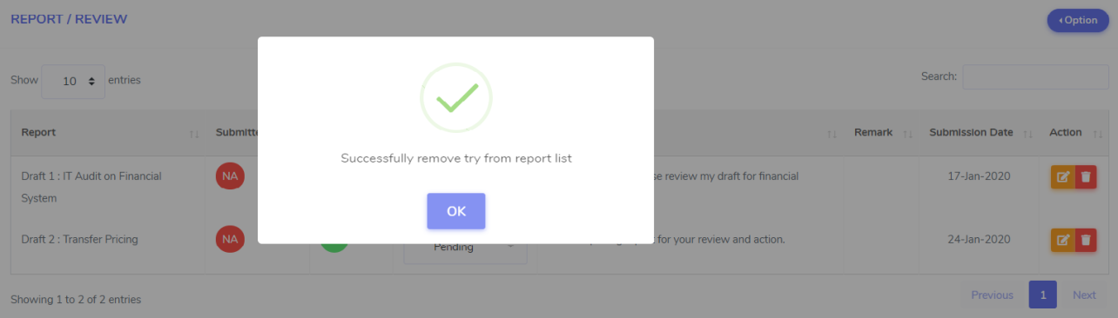

- Conversation
In this part there is two part of conversation which are Daily Updates and Job Discussion.

4.0.1 Daily Updates
Each staffs are required to update their daily progress everyday start from 5.30 pm.
Daily updates will be monitored by their HODs/Supervisor and teammate.

- Click Conversation from tab menu
- Insert your details in daily updates box
- Click Post button to insert daily updates
- Your daily message will be shown as below

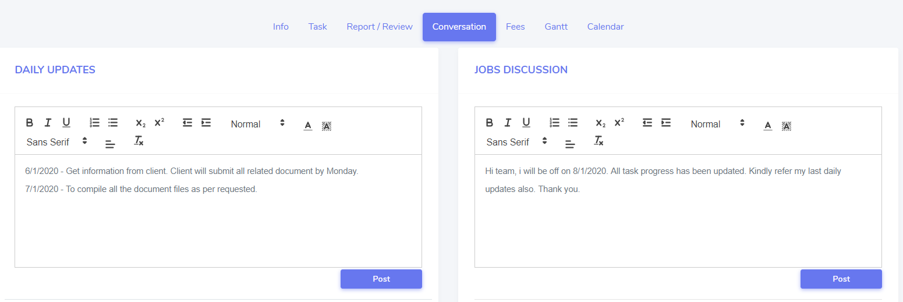

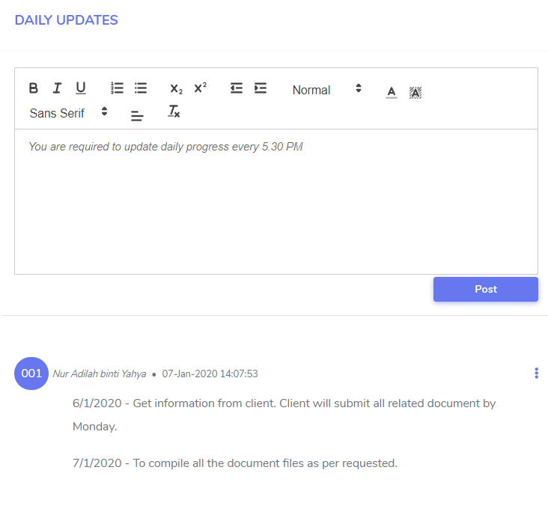

4.0.1.1 How to Edit Daily Updates
Staff are enable to edit their daily updates.

  - Click Conversation from tab menu
  - Click button on top right corner of the page
  - Click Edit and you will be directed to Edit Discussion page
  - Re-edit required information and click Save changes button.

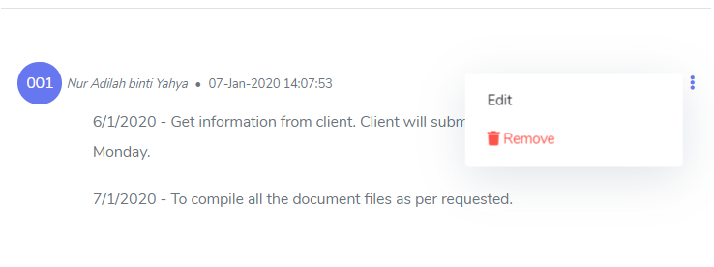

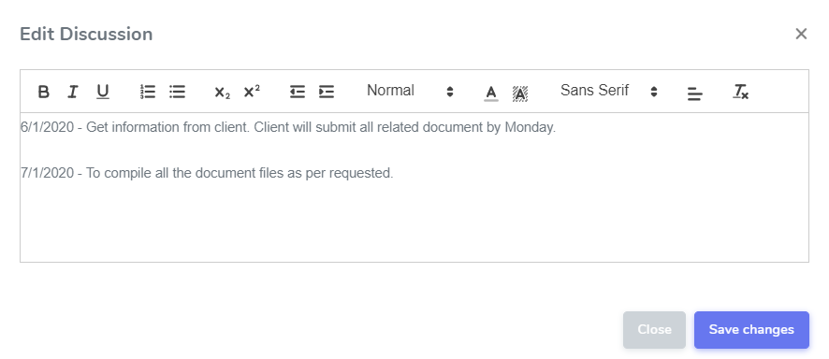

4.0.1.2 How to Remove Daily Updates
Staff are enable to delete their daily updates

  - Click Conversation from tab menu
  - Click button on top right corner of the page
  - Click Remove and prompt message box will be appear.
  - Click OK

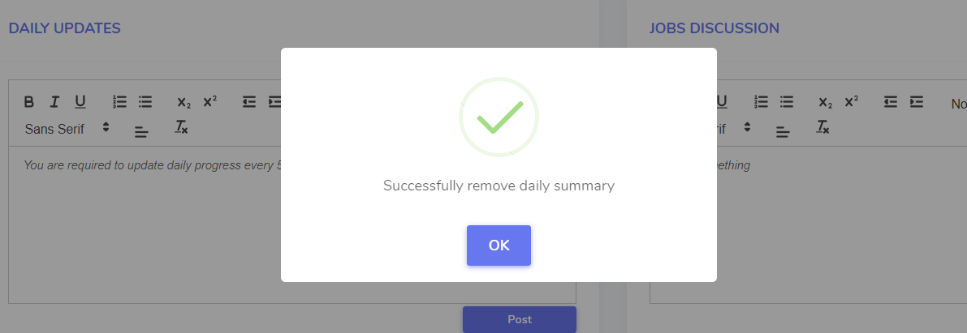

4.0.2 Job Discussion
Each staffs enable to use jobs discussion as a “chat forum” to update, to ask or informs their HODs, Supervisor and among teammates.

- Click Conversation from tab menu
- Insert your details in job discussion box
- Click Post button to insert job discussion
- Your job discussion message will be shown as below

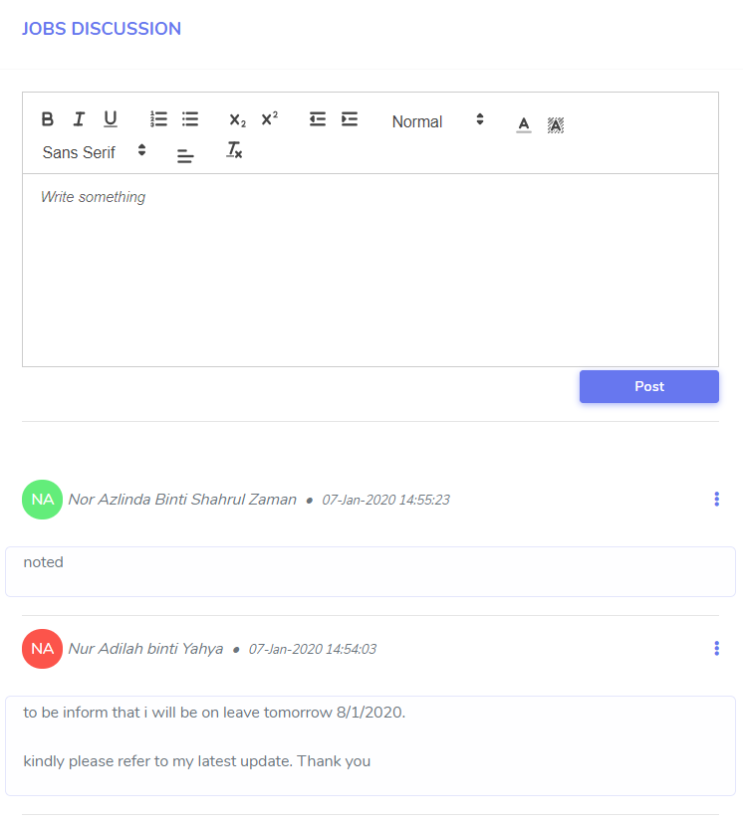

- JOB FEES
Staffs are enable to insert the details of invoice.

- Click Fees from the tab menu
- Click Option and click + Add New Invoice
- You will be directed to Add Invoice page
- Insert Date, Invoice Number, Representative Name and Amount.
- Click Save changes

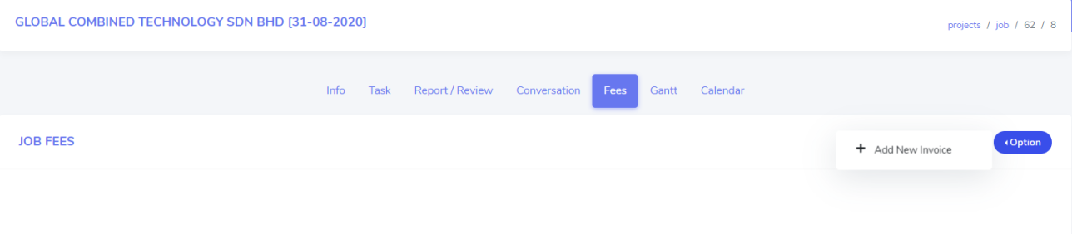
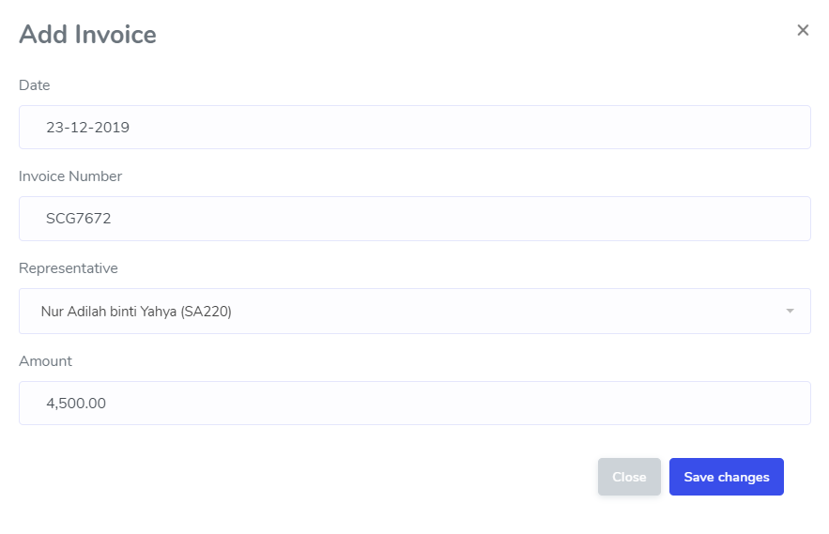

5.0.1 View List of Job Fees
All invoices will be listed as below.

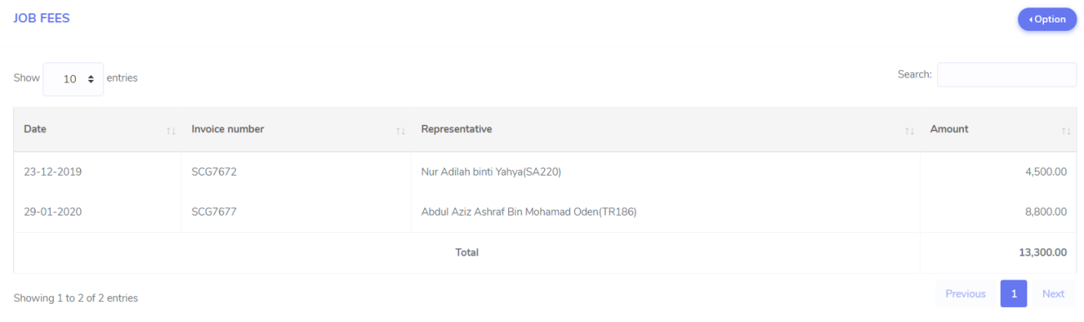

- JOB GANTT AND TIMELINE
Staffs are enable to monitor their job task timeline in job gantt format.

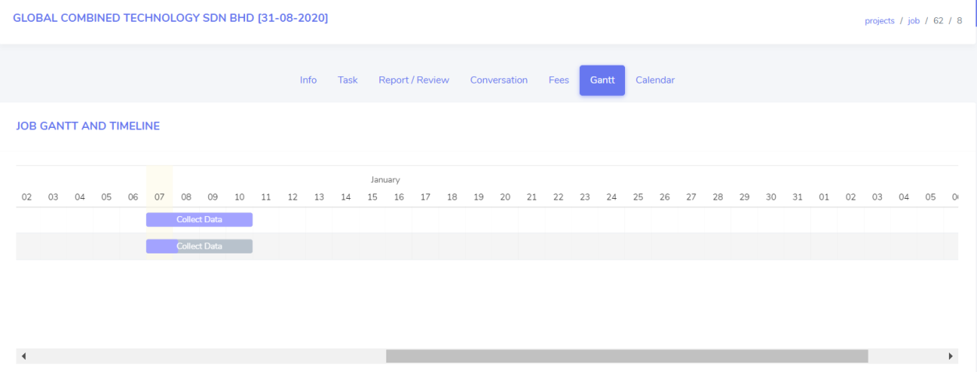

- CALENDAR
Staff are enable to monitor their job task timeline in calendar format. It can be view as month, week, day and list.

