 | SALIHIN IT CURATION SDN BHD |  | Document No:  SITC-MGSV2-01
USER GUIDE
MANAGEMENT INFORMATION SYSTEM
MGS VER 2.0

MODULE:
HOD/SUPERVISOR/MANAGER

Prepared by:  IT AND DIGITAL DEPARTMENT @ 2019 |  | Revision No:  Version 1.0 |  | Effective Date:  28 NOV 2019

- How to Access MGS
Let’s get started. You can simply click type the url link salihin.noip.me/mgs .Once clicked, you will be directed to the main page of MGS. Click Login button that located
on the top right corner of the page.

Notes: Login ID and password same as SPS ERP.

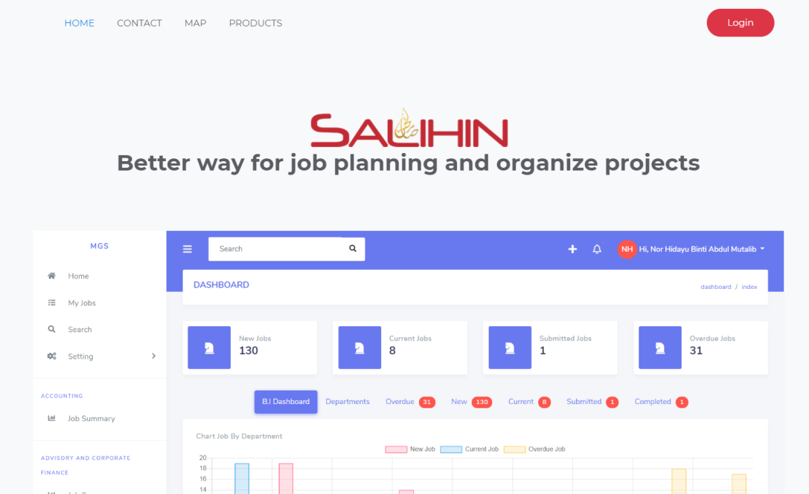

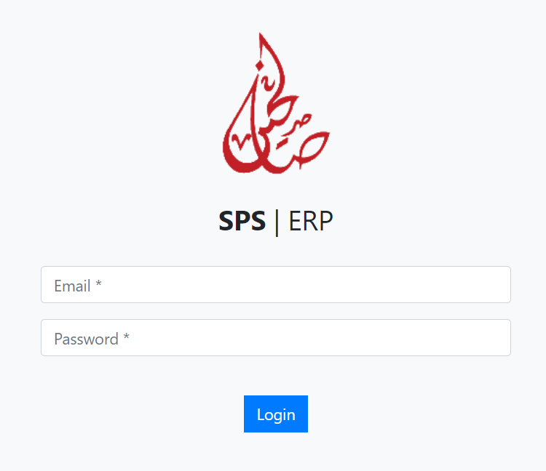

- How to View Department
Once login, you will be directed to the Dashboard page. HOD/Supervisor enable to view own department:-
- B.I Dashboard : chart that display amount of jobs for each department.
- Departments : list of every department at corporate center and branches.
- Overdue Job : jobs that have been acknowledge but already exceed dateline.
- New Job : jobs that is newly created and not yet being acknowledge.
- Current Job : jobs that have been acknowledge.
- Submitted Job : jobs that have been submitted.
- Completed Job : jobs that have been completed.
- Job Summary : list of jobs created for each department.

2.0.1 How to Create an Internal Job
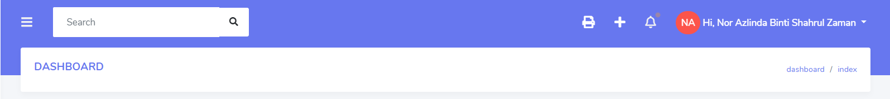

Click ‘+’ icon button:-
- You will be directed to Create an Internal Job page (as shown below)
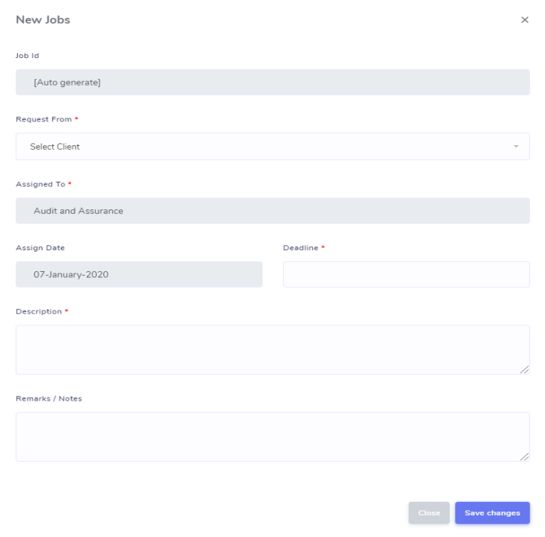

- Select Request From from the drop-down menu (compulsory). The Request From are based on which department who assigned the job to your department.
- Insert Deadline (compulsory).
- Insert Description (compulsory).
- Insert Remarks / Notes.
- Once completed, click Save changes button to save the job.
2.0.1.1 How to View Job Assigned
Once log on to system, dashboard will display the total of:-
- New Jobs.
- Current Jobs.
- Submitted Jobs.
- Overdue Jobs.
Then, click the New Jobs, Current Jobs, Submitted Jobs and Overdue Jobs to see the total of internal job, external job and all jobs.
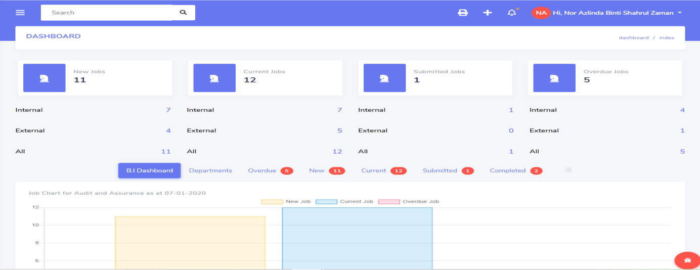

2.0.1.2 How to view New Jobs
- Click New button
- You will be directed to new jobs page.
- Click the link of Department.
- You will be directed to page Jobs Information tab.

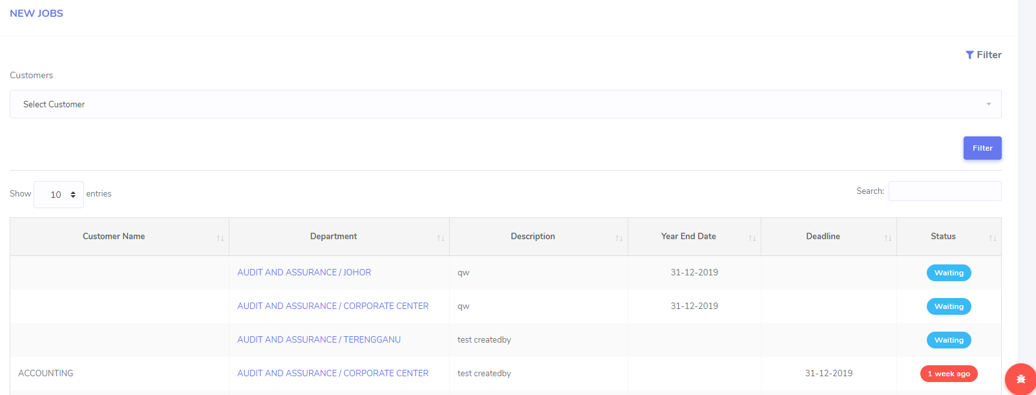

3.0 Job Information
3.0.1 Initial Setup
HOD/Supervisor need to complete the initial setup as follows:-
- Select Services from the drop-down menu.
- Select Type of Job from the drop-down menu (Not allowed to select until you selection of services is done).
- Insert File Number (Depends on department filing format).
- Insert Description.
- Insert Remarks / Notes.
- Insert Year End Date (If necessary).
- Insert Deadline.
- Click Save setup to save the data.

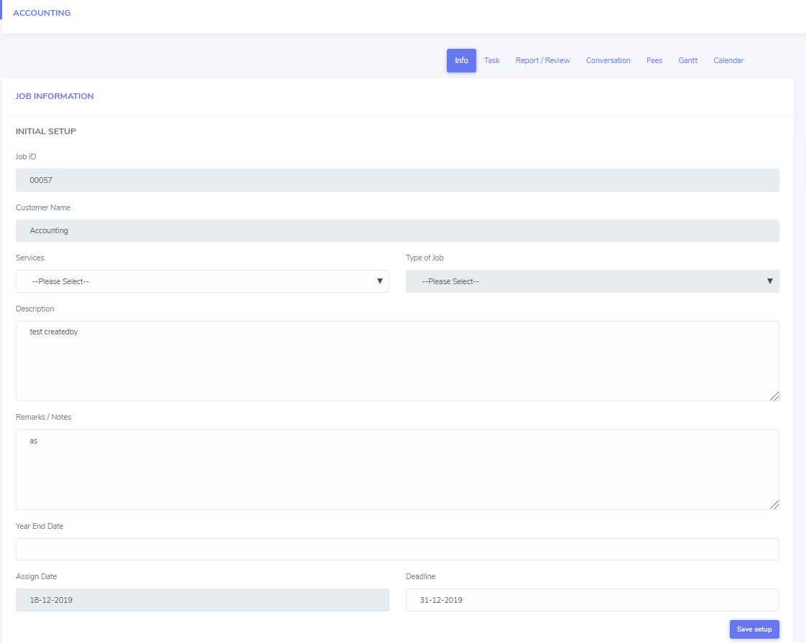

3.0.2 Working Details
HOD/Supervisor need to complete the working details as follows:-
- Select Person in Charge from the drop-down menu (staff involved can be multi-selected more than one person).
- Insert File Number (Depends on department filing format).
- Choose Compliance Type Calendar by clicking the check box.
- Insert Compliance Date.
- Insert Tax Submission Date.
- Click Save working details to save the data.

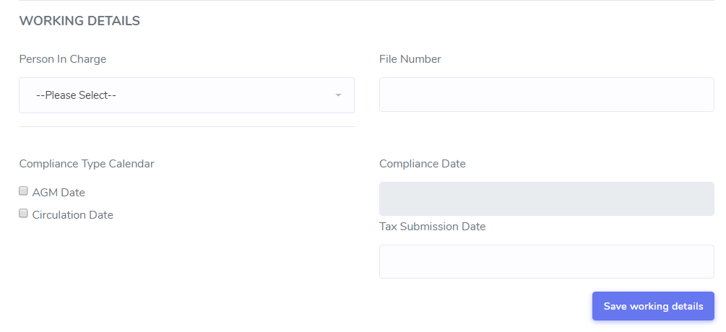

3.0.3 Team Setup
HOD/Supervisor need to select team leader as follows:-
- Choose Team Leader by clicking the check box (the name list based on person in charge of that job and only one person can be selected).
- Click Save team setup to save the data.

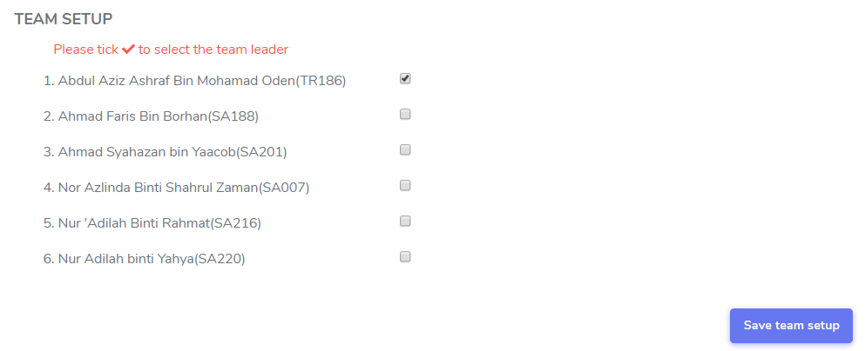

3.0.4 Job Acknowledgment
Assigned job will be displayed as “JOBS NOT ACKNOWLEDGE” until the job was acknowledged by HOD.

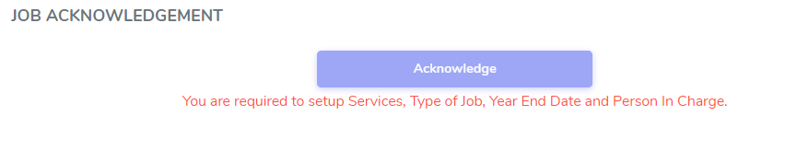
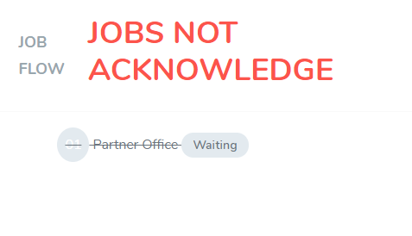

To accept, click Acknowledge button. Once clicked, status will be displayed as follows:-
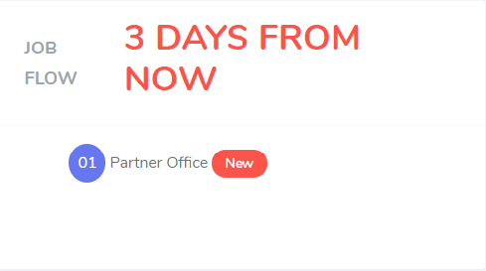


3.0.4.1 Job Status
HOD enables to change the job status to pending or complete.

3.0.4.1.1 Job Pending
To change job status to pending, click pending button and Pending Reason will be display.

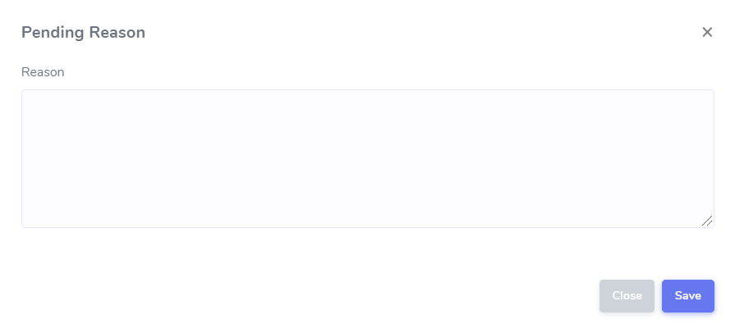

- Insert Reason.
- Click Save to save the reason.
- The pending reason will be displayed at Job Information page under Job Resume button and also will be added into Conversation.

3.0.4.1.1.1 Job Resume
To resume job, click Resume button and it will be displayed on Job Information page under Job Submission / Completion part.

- HOD/Supervisor can edit the reason pending in. Once completed, click Save button.

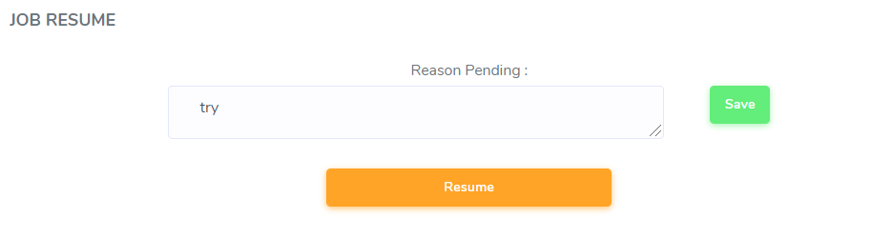

3.0.4.1.1.2 Job Completed
For job submission, click Submit button. Once clicked, status will be display as
follows:-

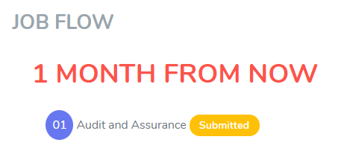


4.0 My Jobs
Once you click My Jobs, the job that assigned to us will be display based on:-
- New Job.
- In Progress.
- Overdue.
- Completed.
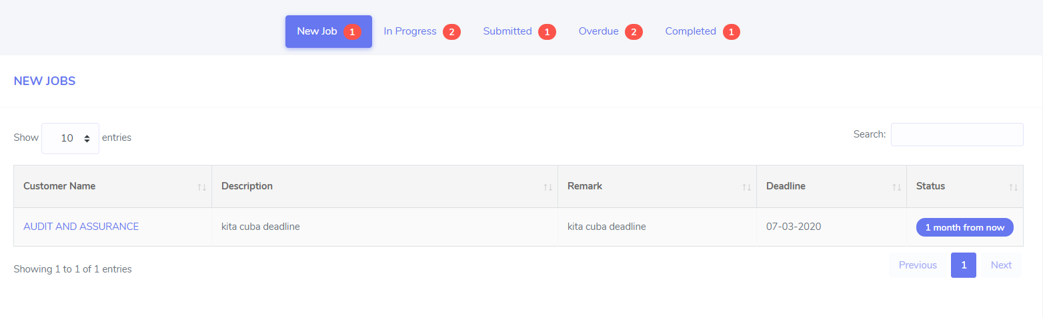

4.1 To view New Job
You can view the new job that has been assigned by:-
      - Click New Job button.
      - You will be directed to New Jobs page.
      - Click the link of Customer Name.
      - You will direct to page Jobs Information and tab info.

Once click the link of Customer Name, you can view:-
      - Info
      - Task
      - Report/Review
      - Conversation
      - Fees
      - Gantt.
      - Calendar

4.1.1 Job Task
4.1.1.1 Add New Job Task
Once HOD/Supervisor has been assigned as person in charge (PIC) for new job, he/she need to plan their own task schedule. In this part it will show the work in progress task status to meet the deadline.
            - Click Task from menu.
            - Click Option button, click +Add New.
            - Insert Task Name.
            - Insert Remarks.
            - Insert Due Date.
            - Insert Status – In Progress, Pending, Completed.
            - Click Save button to save data.
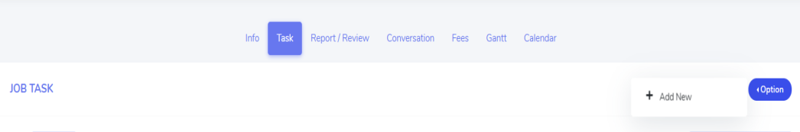

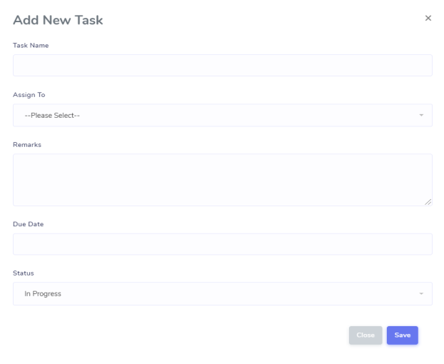

4.1.1.2 View Job Task
HOD/Supervisor can view their job task listing and update their task progress status. Status of task name can be update as
- In Progress
- Pending
- Completed

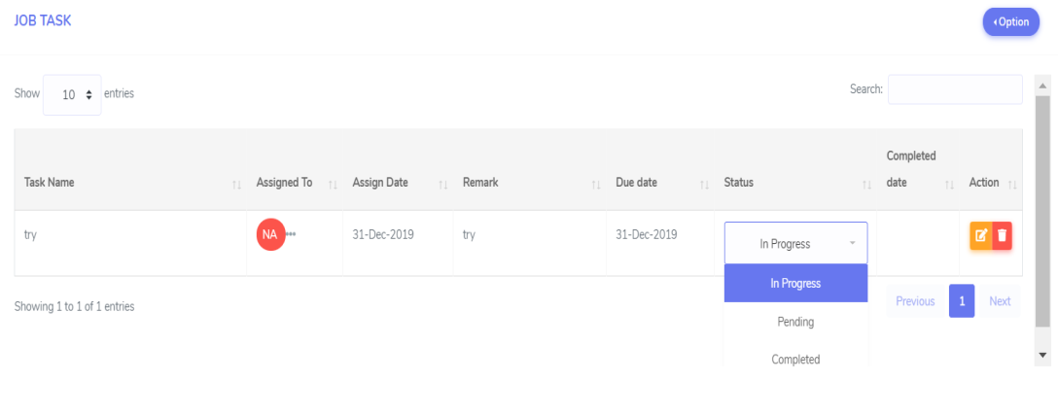

4.1.1.2 Edit Job Task
Only HOD/Supervisor and assigned person can edit the job task.
- Click edit button
- Edit Task page will be display as follows.
- Update the required information.
- Once completed, click Save changes button to save the data.
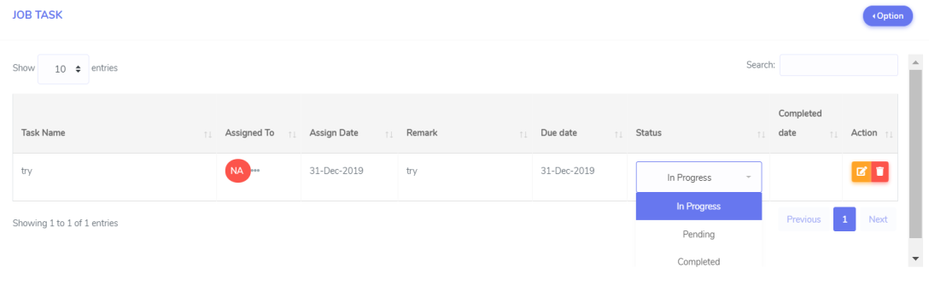

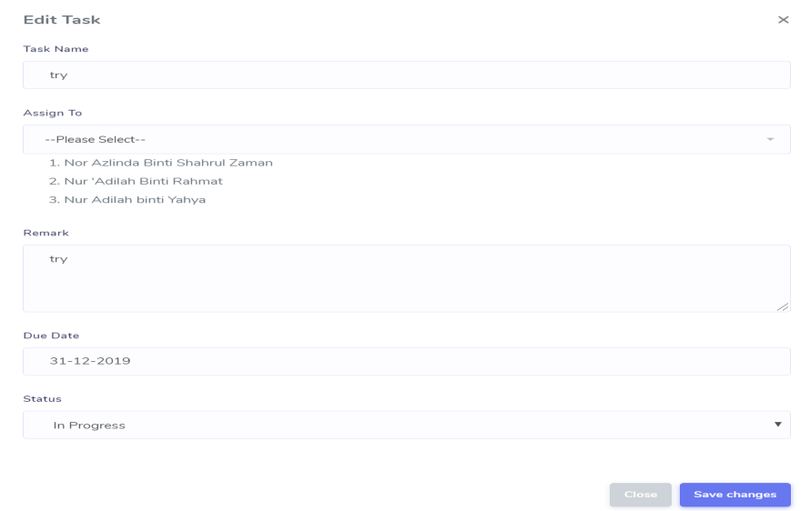

4.1.1.3 Delete Job Task
Only HOD/Supervisor and assigned person can edit the job task.
- Click delete button.
- The row of that task will be deleted.
- Click OK button.

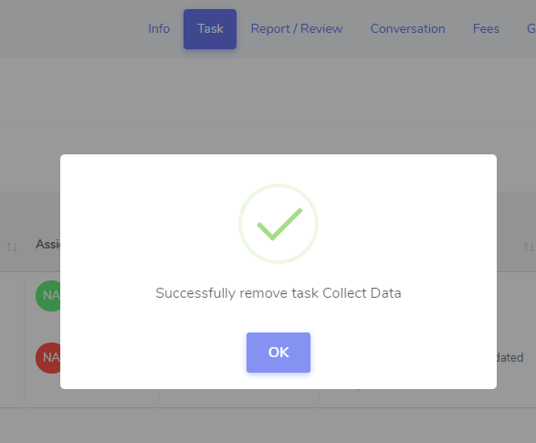

4.1.2 Report/Review
4.1.1.1 Add New Report/Review
HOD can add new draft of report/review to be reviewed by their staff.
- Click Report/Review from the tab menu.
- Click Option button, click +Add New.
- Insert Report Name.
- Select Review by from drop-down menu list.
- Insert Description.
- Insert Remark.
- Select Submission Date.
- Select Status from the drop-down menu.
- Click Save button to save the data.

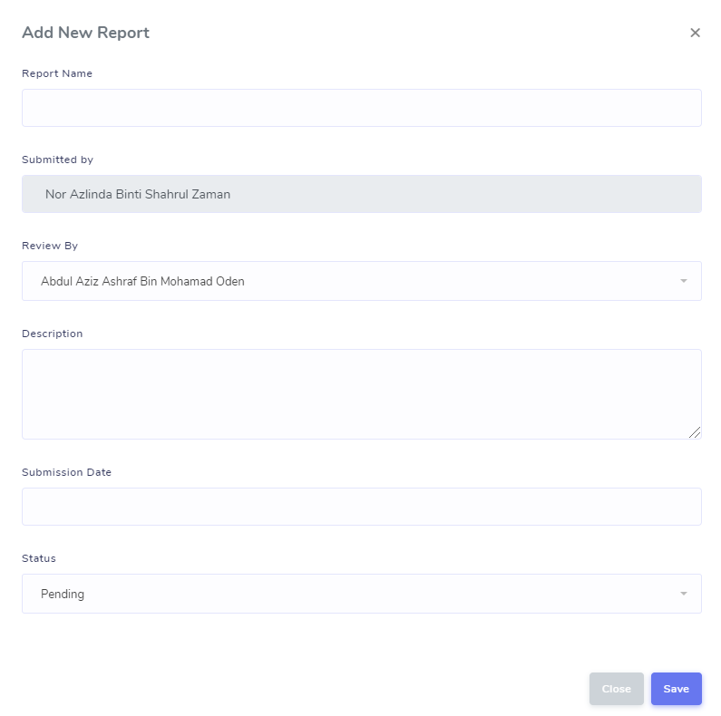

4.1.1.2 View, Edit and Delete Report
4.1.1.2.1 How to View List of Draft/Reporting
HOD/Supervisor can view their staff draft of report from the list as shown below.
    - Click Report/Review from the tab menu

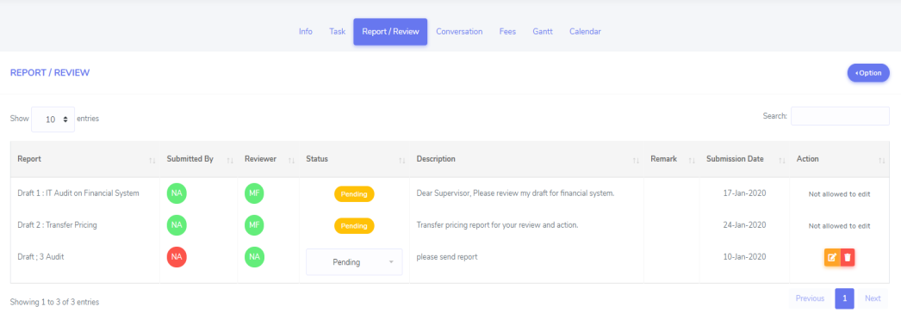

4.1.1.2.2 How to Edit List of Draft/Reporting
HOD/Supervisor is allowed to edit report added by staffs. You can simply drag the description and remarks field. HOD/Supervisor also is allowed to change the report /review status.

  - Click Report/Review from the tab menu
  - Select report from the list
  - Click edit button that located in the same row of report name.
  - Once click, you will be directed to Draft/Reporting page.
  - Update the required information.
  - Once completed, click Save changes button to saved.
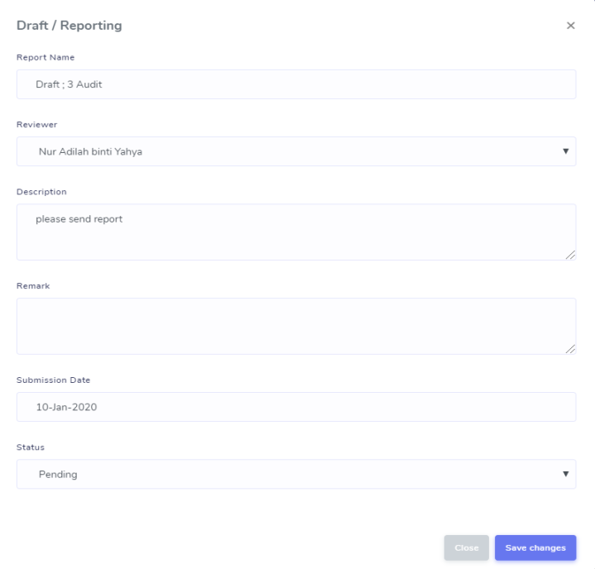

4.1.1.2.3 How to Delete Report
HOD/Supervisor is allowed to delete any report that no longer needed for review.

Notes: Please read report name carefully before you wish to click delete button.

  - Click Report/Review from the tab menu.
  - Select report from the list.
  - Click delete button that located in the same row of report name.
  - Once click, prompt message box will appear.
  - Click OK button.
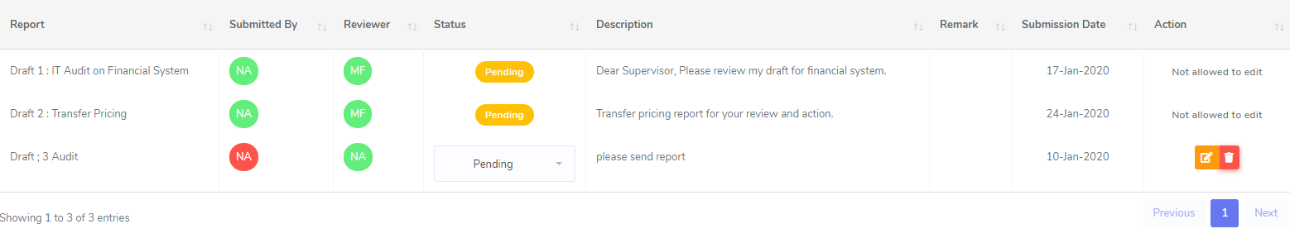

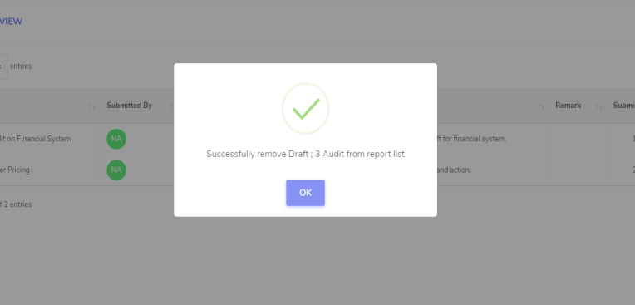

4.1.3 Conversation
In this part there is two part of conversation which is Daily Updates and Job Discussion.
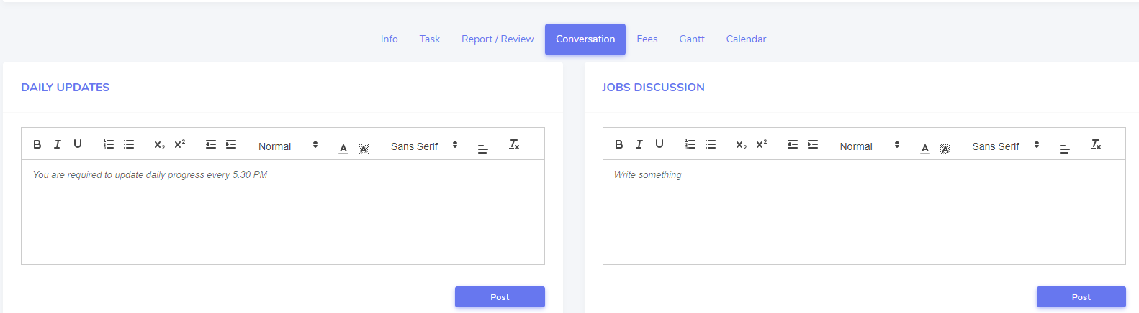

4.1.3.1 Daily Updates
Each staffs included HOD/Supervisor are required to update their daily progress every day before 5.30 pm. Daily updates will be monitored by their HODs/Supervisor and teammate.
- Click Conversation from tab menu
- Insert your details in daily updates box
- Click Post button to insert daily updates
- Your daily message will be shown as below
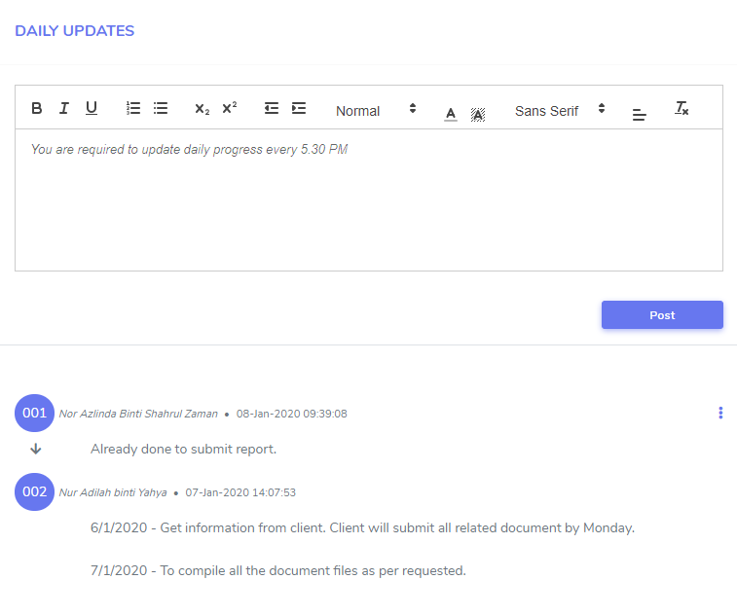

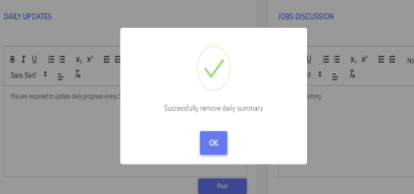

4.1.3.1.1 How to Edit Daily Updates
HOD is allowed to edit their daily updates.
  - Click Conversation from tab menu
  - Click button on top right corner of the page
  - Click Edit and you will be directed to Edit Discussion page
  - Re-edit required information and click Save changes button.
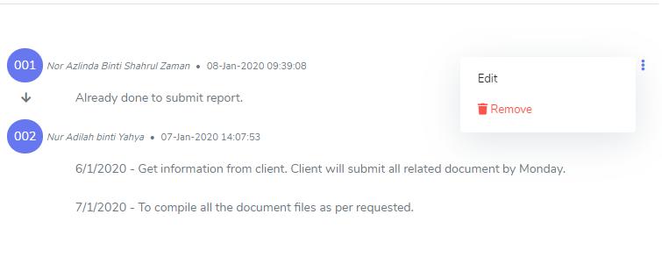

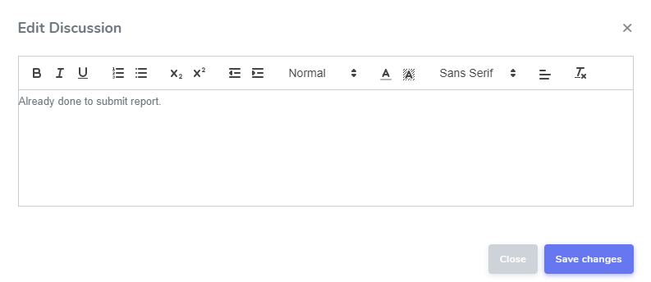

4.1.3.1.2 How to Remove Daily Updates
Staff is allowed to remove or delete their daily updates.
  - Click Conversation from tab menu
  - Click button on top right corner of the page
  - Click Remove and prompt message box will appear.
  - Click OK

4.1.3.2 Job Discussion
Each staffs including HOD/Supervisor can use jobs discussion as a “chat forum” to update, to personal in charge of the project ask or informs HODs, Supervisor and among teammates.
  - Click Conversation from tab menu
  - Insert your details in job discussion box
  - Click Post button to insert job discussion
  - Your job discussion message will be shown as below

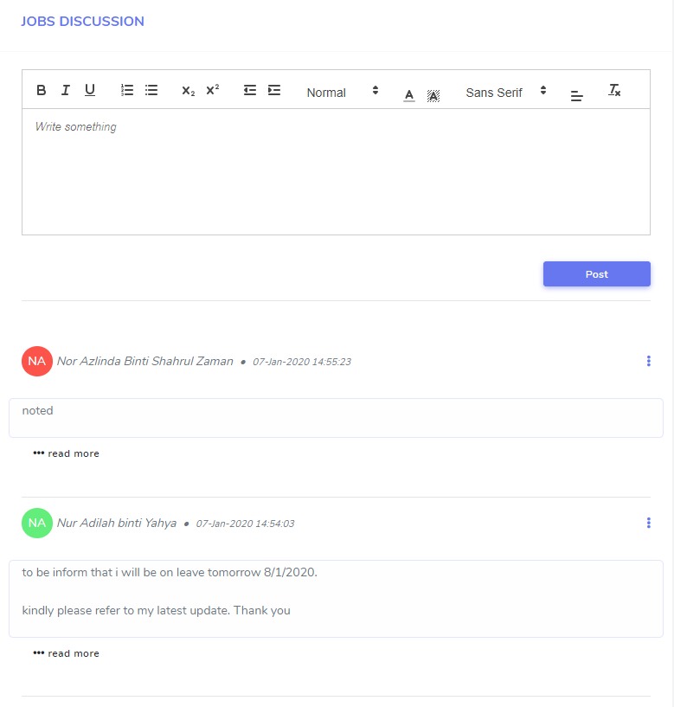

4.1.3.2.1 How to Pinned the Conversation
HOD can pinned any and move the selected conversation to be on top of message.
  - Click Conversation from tab menu
  - Click button on top right corner of the page
  - Click Pinned and prompt message box will be appear.
  - Click OK

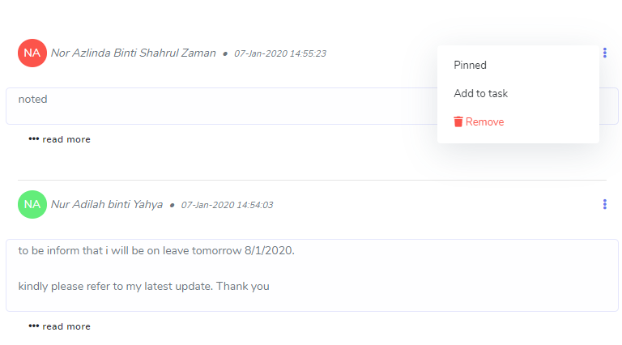

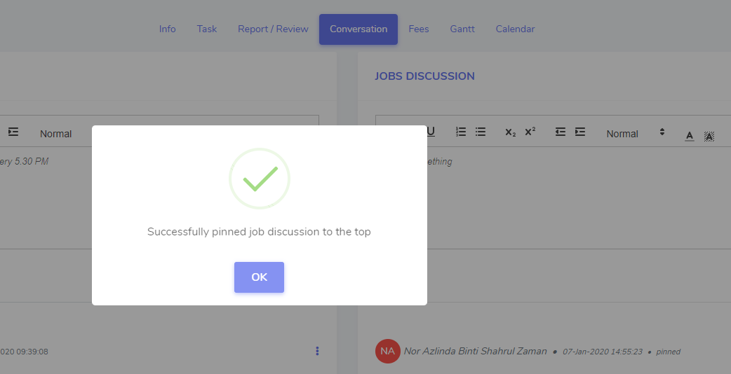

4.1.3.2.2 How to Add to Task at Conversation
While in conversation, if HOD gets any task, HOD just simply needs to click Add to Task.
  - Click button on top right corner of the page.
  - Click Add to Task.
  - Once click, you will be directed to Add New task page.
  - Insert Task Name.
  - Select assign to from the drop-down menu.
  - Click Remarks.
  - Click Due Date.
  - Select Status – In Progress, Pending, Completed.
  - Click Save button to saved data.
  - The new task will be display at task page.

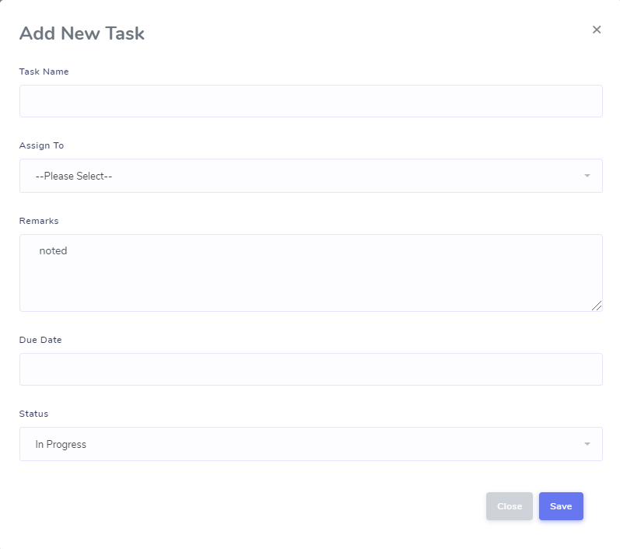

4.1.3.2.2 How to Remove Conversation
HOD is allowed to delete their own conversation text only.
  - Click Conversation from tab menu
  - Click button on top right corner of the page
  - Click Remove and prompt message box will appear.
  - Click OK button.

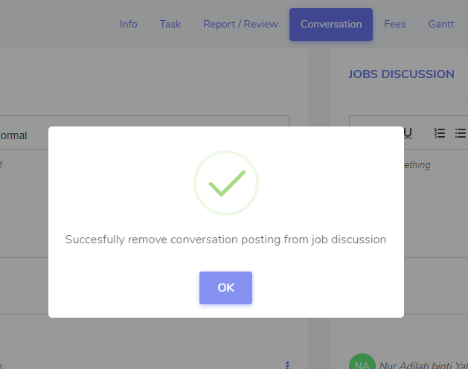

4.1.4 JOB FEES
HOD/Supervisor is allowed to insert the details of invoice.
- Click Fees from the tab menu.
- Click Option and click + Add New Invoice.
- You will be directed to Add Invoice page.
- Insert Date, Invoice Number, Representative Name and Amount.
- Click Save changes.

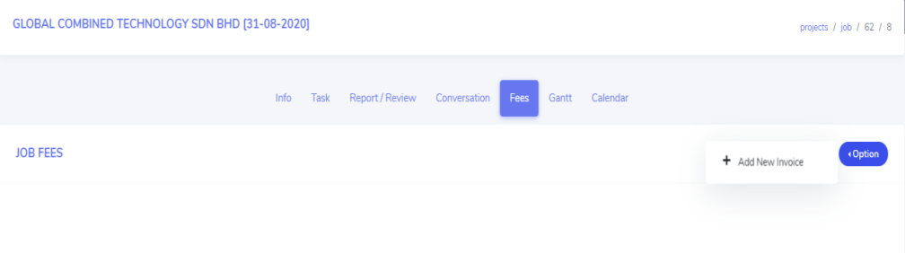

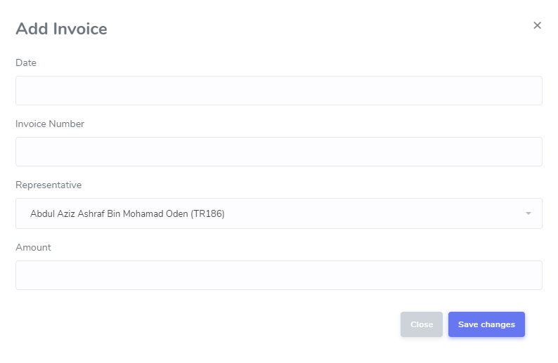

4.1.4.1 View List of Job Fees
All invoices will be listed as below.

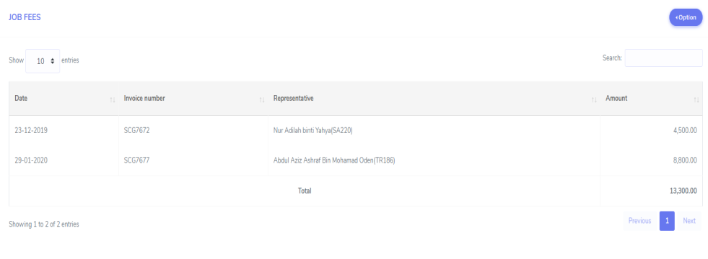

4.1.4 JOB GANTT AND TIMELINE
HOD/Supervisor is allowed to monitor their overall job task timeline from job Gantt chart timeline.

  - Click Gantt from the tab menu.
  - Your job Gantt chart and timeline will be shown as below :-

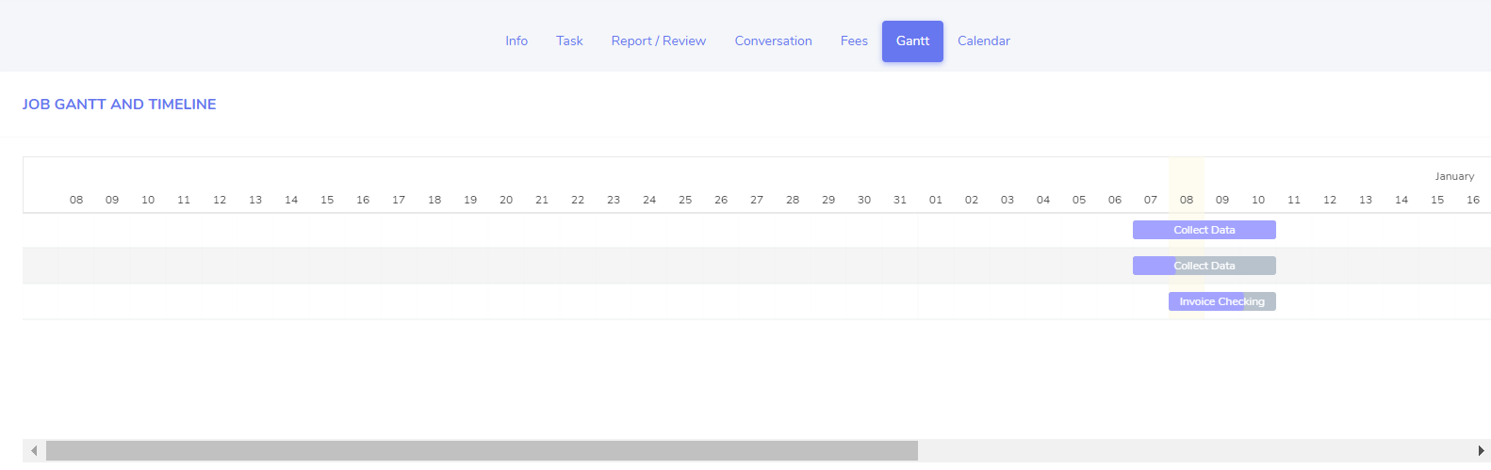

4.1.5 CALENDAR
HOD/ Supervisor is allowed to monitor their job task timeline in Calendar
Viewer. It can be view as month, week, day and list.
  - Click Calendar from the tab menu.
  - Your job calendar will be shown as below :-

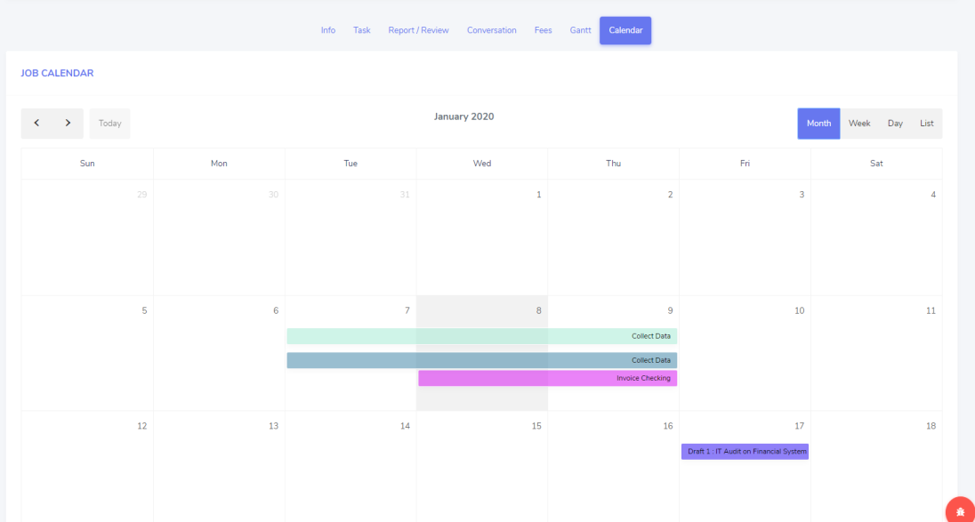

5.0 User Role
Admin and supervisor have a privilege to setup role for every user that login to the system in order to control the user access. There are three (3) types of roles which are ADMIN, SUPERVISOR and USER.
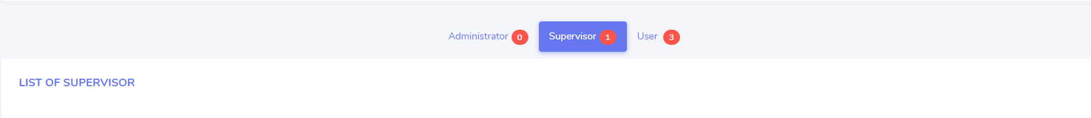

Click Setting > USER ROLE from sidebar of the page. The page will be display as shown below.
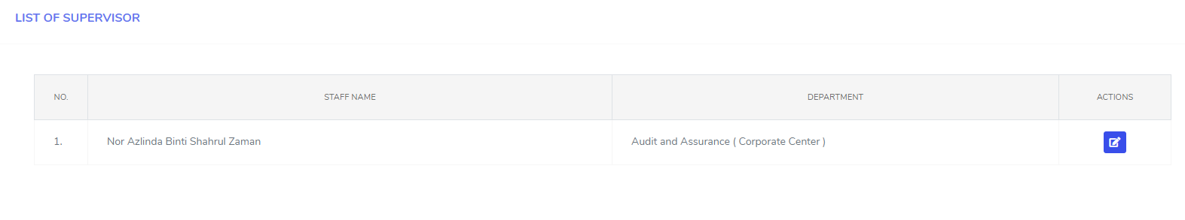

Notes: After successfully setup role, user needs to re-login to the system.

5.1 How to Setup Role
- Once click User Role, Setting page will be display.
- Click the Edit Button from the setting page.
- Edit Role page will be pop-up.
- Select Role from the drop-down menu
- Click the Save to save the data.
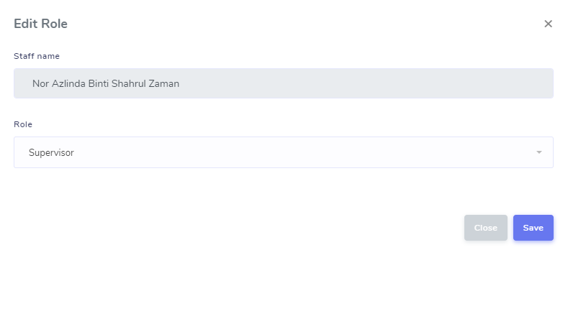

6.0 Job Summary
6.1 How to View Job Summary
HOD can view all jobs created and status by their own departments.
Once click job summary, you will be directed to the Dashboard page. HOD/Supervisor enable to view own department:
- Summary : list of jobs that HOD is not assigned personal in charge.
- Team : team list in their own department.
- Overdue Job : jobs that have been acknowledge but already exceed dateline.
- New Job : jobs that is newly created and not yet being acknowledge.
- Current Job : jobs that have been acknowledge.
- Submitted Job : jobs that have been submitted.
- Completed Job : jobs that have been completed.

Click the Job Summary from sidebar of the page. The page will be shown as below:-

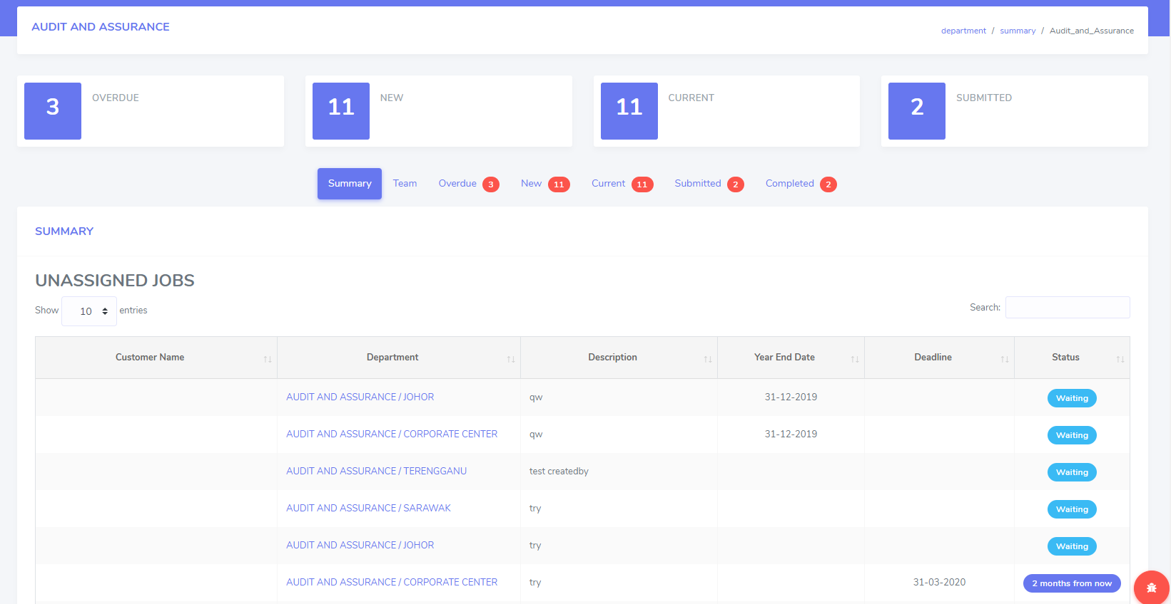

- Click link of department and it will direct to selected job.
- You will be directed to Job Information page.

7.0 Feature Request
Feature Request is for all of MGS users give an opinion to upgrade or improve the MGS system.

7.1 How to Add New Feature Request
Once user able to login into MGS system, they can request about system at Feature Request page.
      - Click Option button, click +Add New.
      - You will be directed to Add New Feature Request page.
      - Insert Feature Request.
      - Click Save button to saved data.

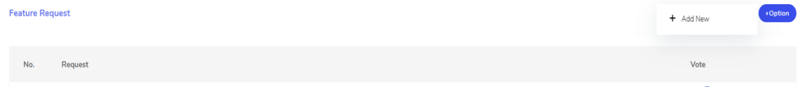

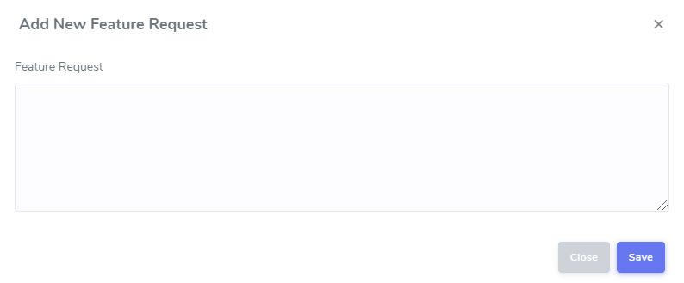

7.1 View and Vote Feature Request
      - Click Feature Request from sidebar menu.
- You will be directed to Feature Request page.
- To vote, click like or dislike icon at column Vote (everyone are allowed only once to vote).
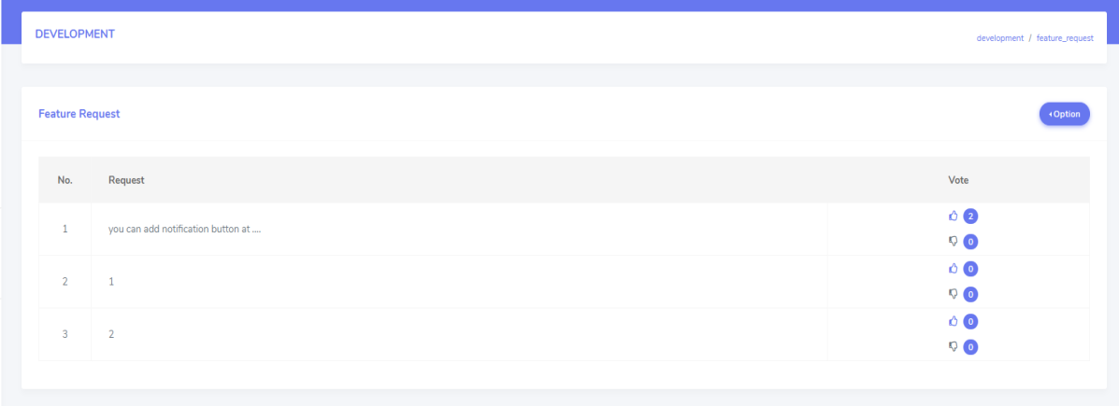

8.0 Bugs / Error Report
8.1 How to Add New Error Report
Once MGS user able to login, they can do any bugs / error report is MGS system.
- Click Option button, click +Add New.
- You will be directed to Add New Error Report page.
- Insert Description.
- Upload Picture (optional).
- Click Save button to saved data.

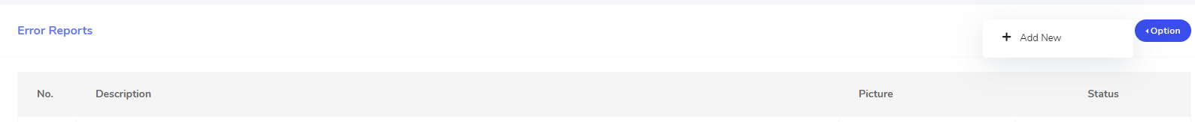

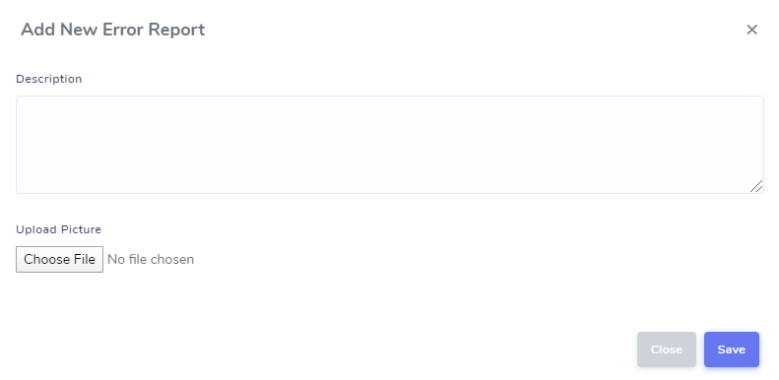

8.1.2 How to Add New Error Report by Screenshot
      - Click Bugs button at bottom left of every page in MGS.
      - Once you click the bugs’ button, it automatically will be display the screenshot screen in Error Reports page.
      - Insert Description.
      - Click Save button.
      - The error report will be display in Bugs / Error Report page.
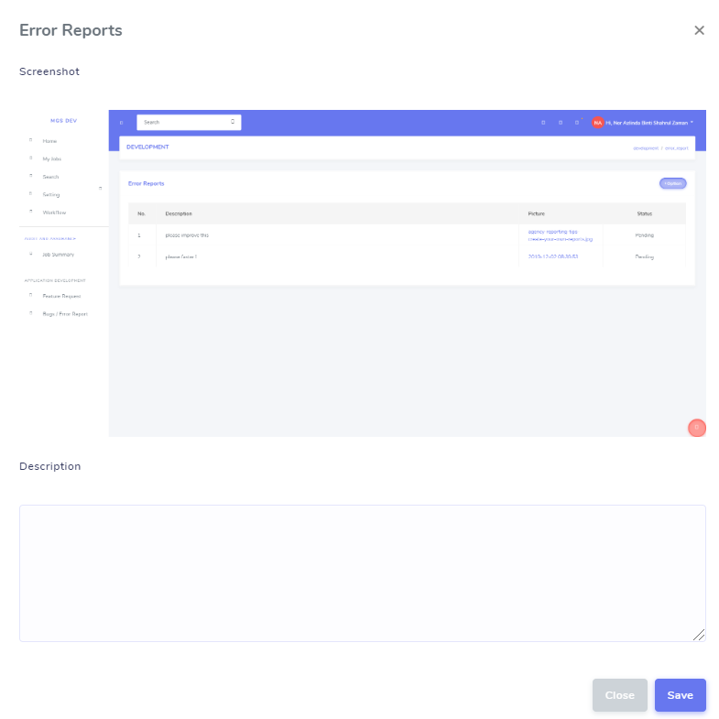

8.2 How to view Error Report
      - Click Bugs / Error Report from sidebar menu.
- You will be directed to Error Report page.

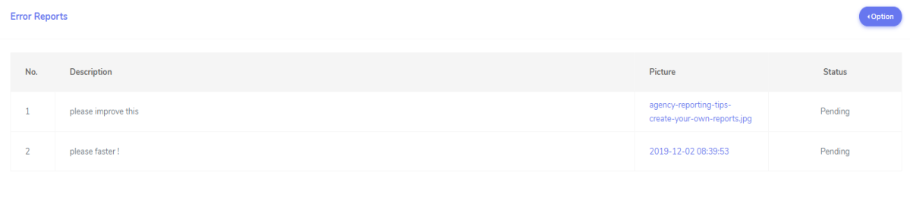

Note: You are disabled to download / view the picture that you have already uploaded.

