 | SALIHIN IT CURATION SDN BHD |  | Document No:  SITC-MGSV2-01
USER GUIDE
MANAGEMENT INFORMATION SYSTEM
MGS VER 2.0

MODULE:
DOCUMENT

Prepared by:  IT AND DIGITAL DEPARTMENT @ 2020 |  | Revision No:  Version 1.0 |  | Effective Date:  9 June 2020

- How to Access MGS
Let’s get started. You can simply click type the url link salihin.noip.me/mgs .Once clicked, you will be directed to the main page of MGS. Click Login button that located
on the top right corner of the page.

Notes : Login ID and password same as SPS ERP.

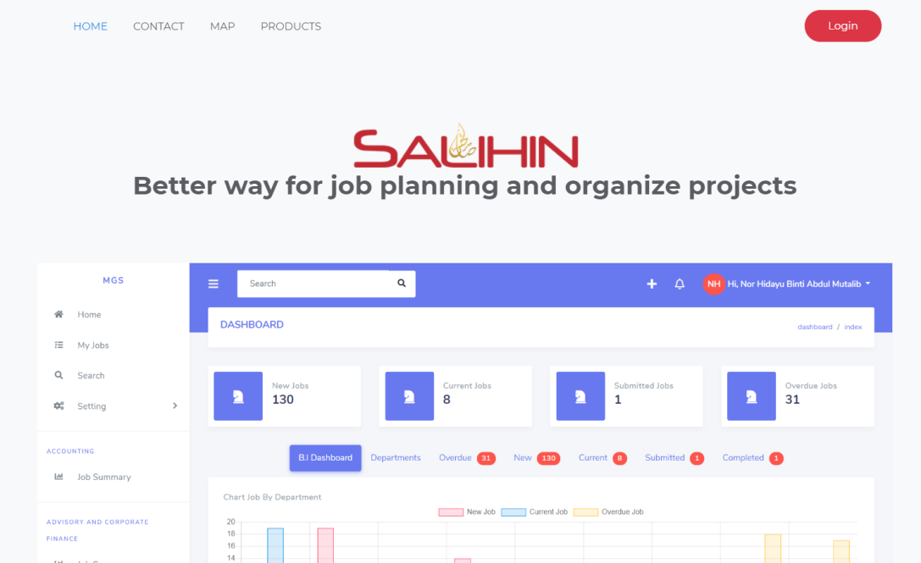

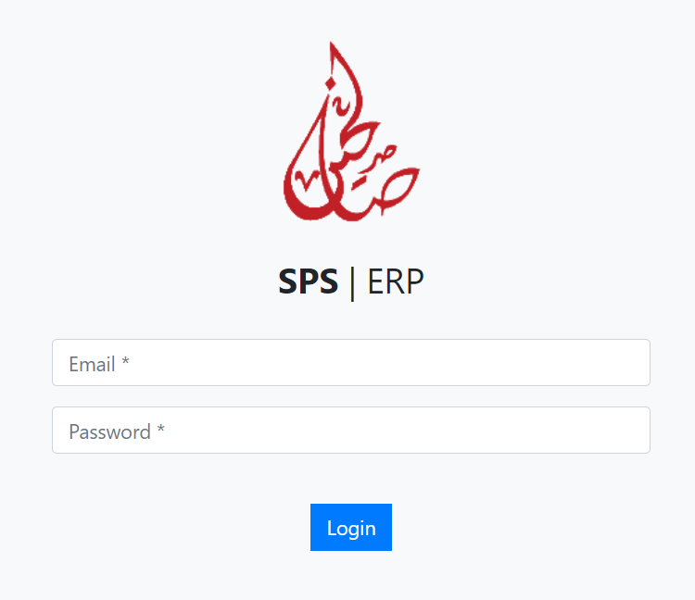

- How to View Client List
Once logon to MGS, you will be directed to the Dashboard page. In this page, you are enable to view all the clients listing.

- On the left menu, click Document
- You will be directed to Document Control > Client List page
- Select client from the list by click Choose button
- You will be directed to Document Type List page

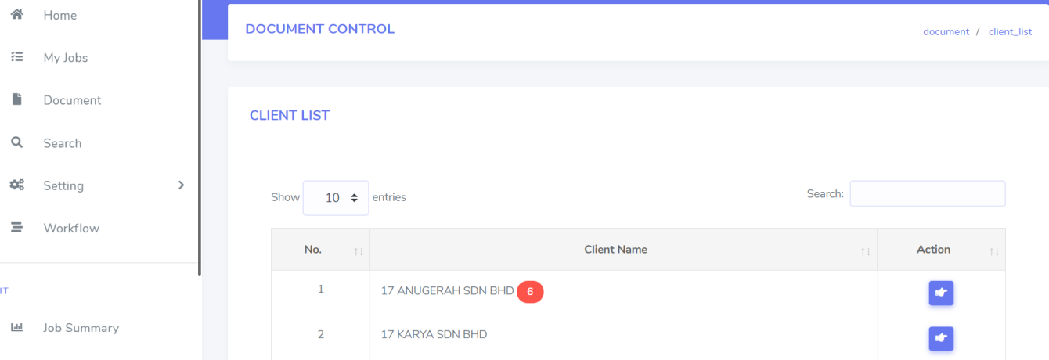

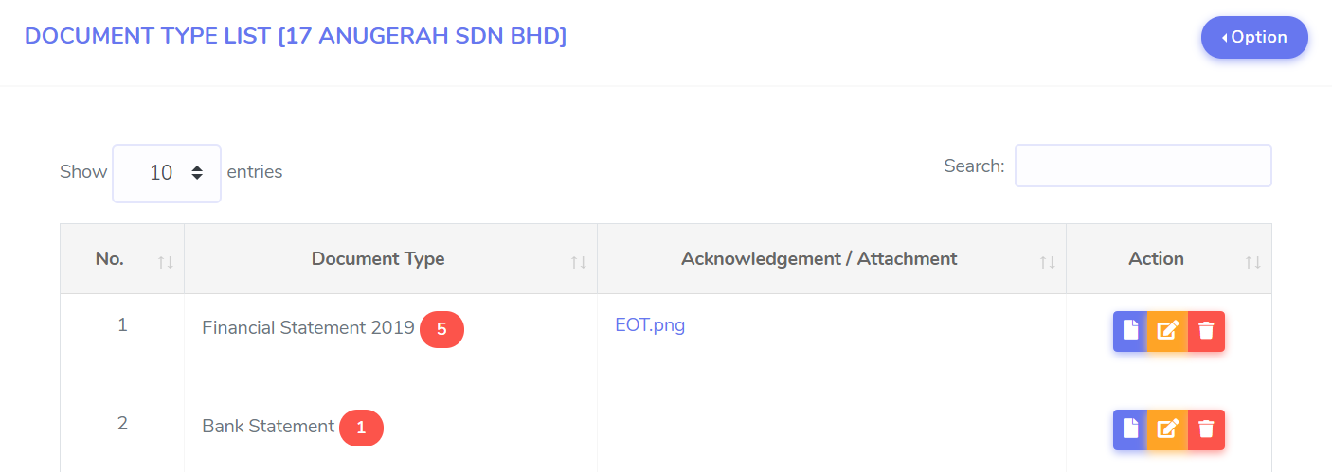

2.1 How to Add New Document Type List
In this part, staff required to record all the document received from clients. Staff is allowed to capture first cover page of document acknowledgement or attachment.

- Select Client (Please make sure your selected Client is CORRECT)
- Click Option button
- Click Add New button and you will be directed to Add New Document Type
- Insert document type name. (Please make sure the document type name MUST be CLEAR)
- Click Choose File to upload attachment. (Format .JPG, .PDF)
- Click Save button

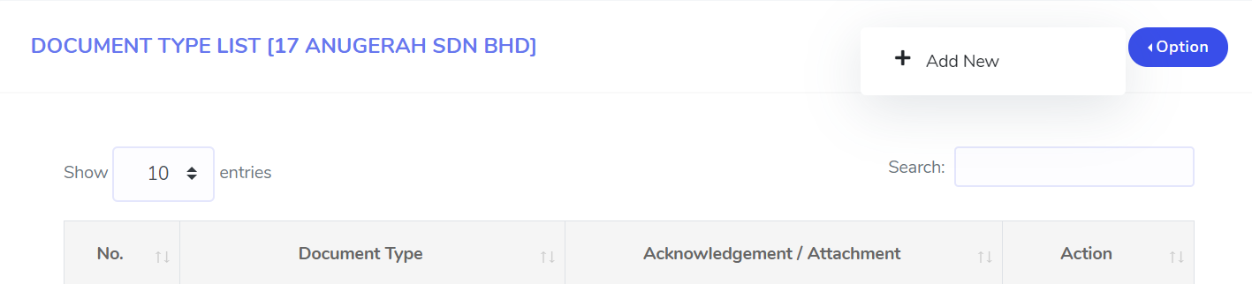

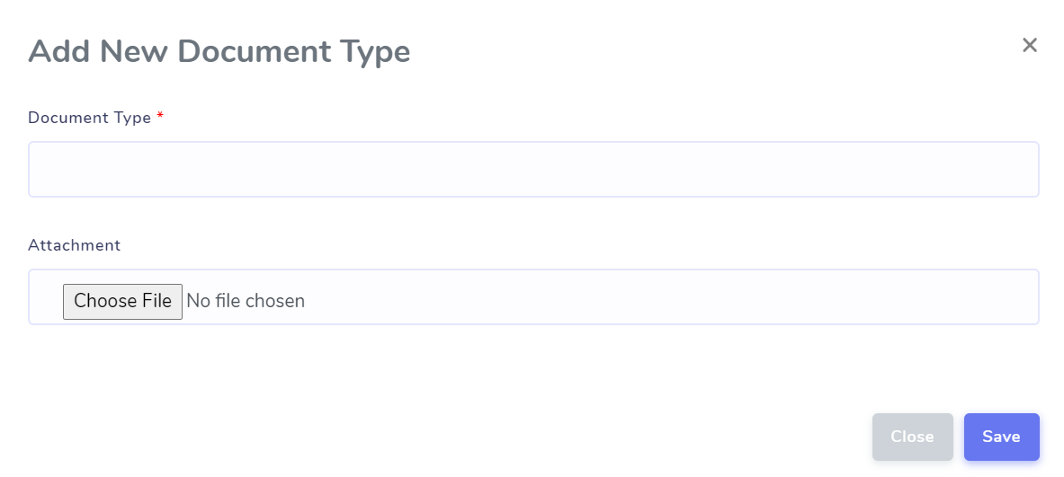

2.1.1 How to Edit Document
Staff is allowed to edit uploaded document when necessary.
- Click Edit button
- You will be directed to Edit Document Type page
- Edit related information
- Once confirm, click Save button
- Prompt message box will be appear, click Ok

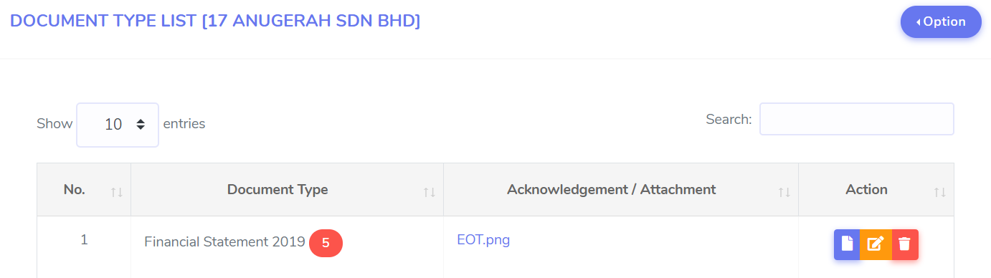

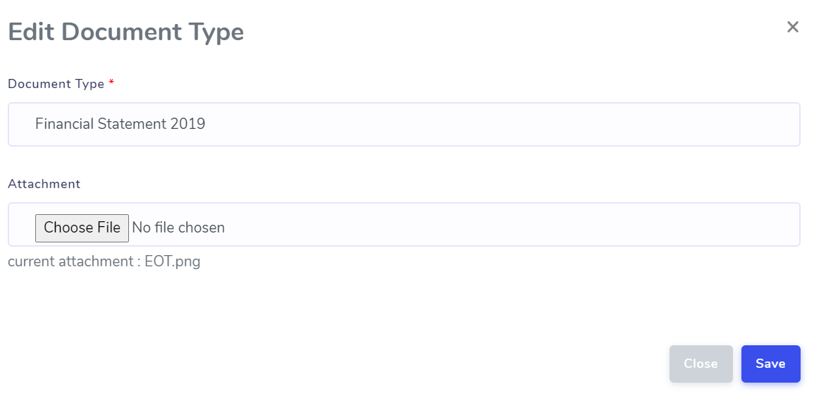

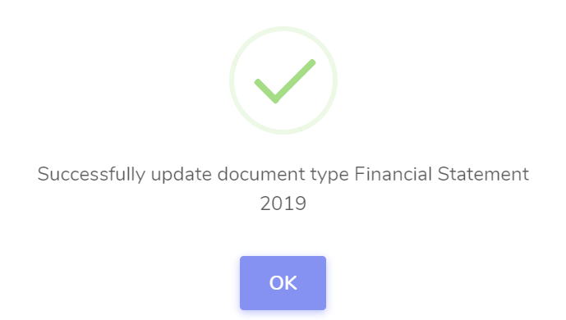

2.1.2 How to Delete Document
Staff is allowed to delete uploaded document when necessary.
- Click delete button
- Prompt message box will be appear, click Ok

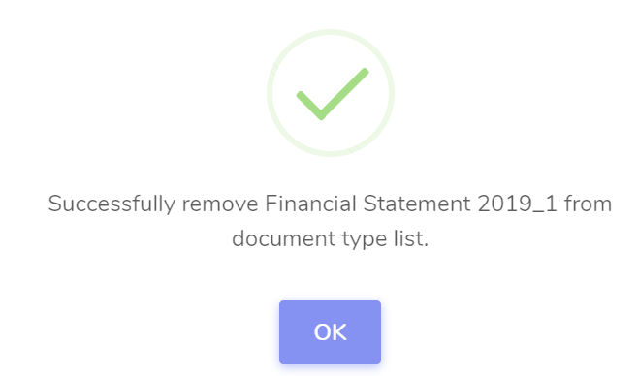

2.1.3 How to View Document
Staff is allowed to view the uploaded document by,
- Click Go To Document button
- You will be direct to document details page

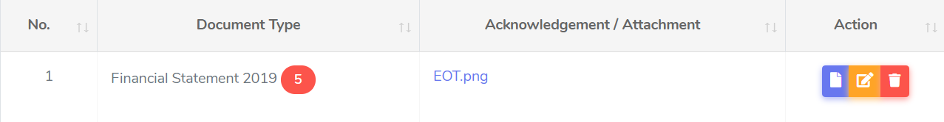

Once you click Go to Document button, you will direct to document details page. On this section, staff is allowed to add the details of uploaded document that has been created under document categories. As for example, let’s choose Financial Statement 2019 [17 Anugerah Sdn Bhd].

- How to Add Document Details
Staff is allowed to add document details of document type that has been created in previous step.
- Click Option button and Add New button
- You will be directed to Add New Document
- Insert Filename, Total Quantity
- Insert Remarks, Received Date
- Select Status
- Upload Document and Click Save
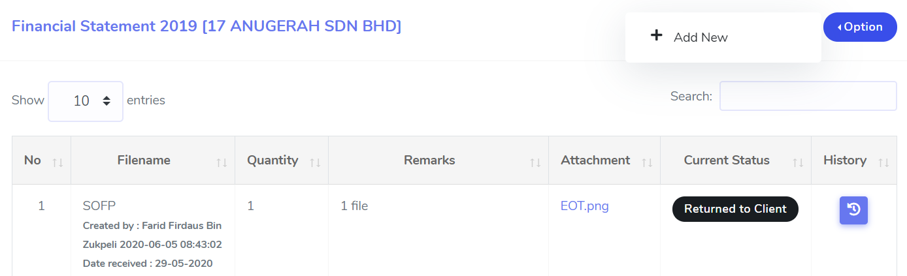
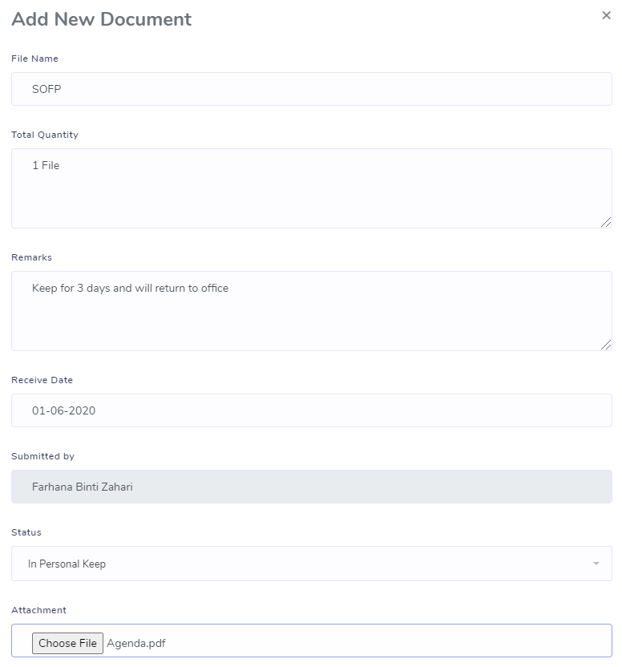

3.0.1 How to View Document Details
In this section, you may view all document details list that has been created by each staff under that document category.
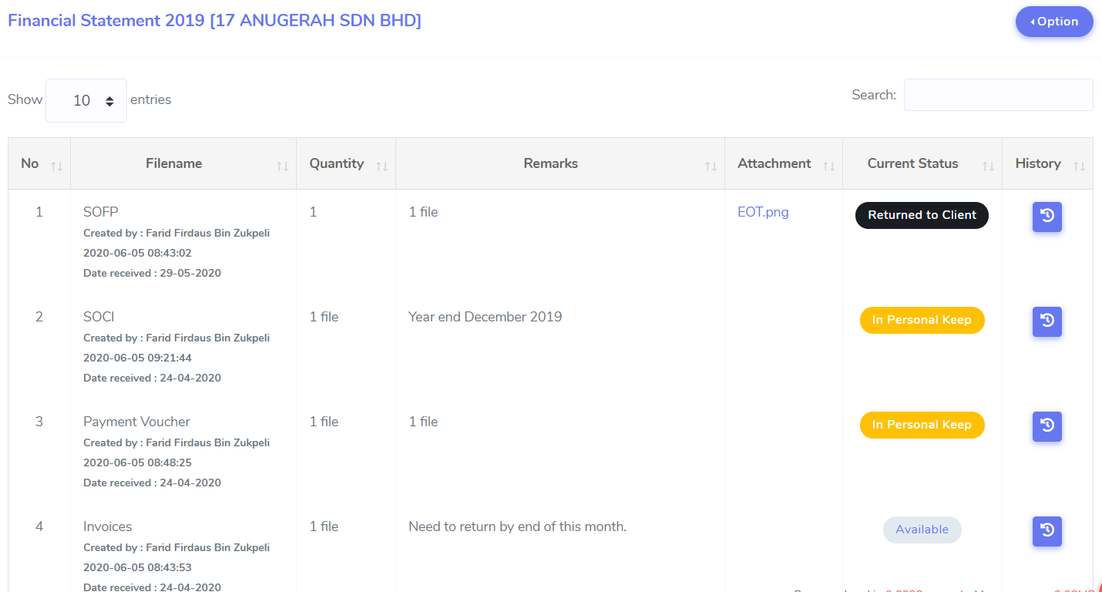

3.0.2 Document Current Status
You may see the current status of document as shown below. System will be display status such as:-
- Available
Document received and available at office. For this status, only can be change by admin or ownership / person in charge itself.

- In Personal Keep
Document taken out by staff for his/her personal keep. Staff required to record for any document movement. For this status, only can be change by the ownership / person in charge itself.

- Returned to Client
Document has been returned to client. For this status, only can be change by admin or ownership / person in charge itself.
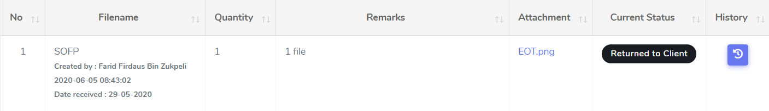

3.0.2.1 How to Change Current Status
To change on the current status, please ensure that the document is available and under your supervision/ownership. Staff who wants to use it will create the document movement.

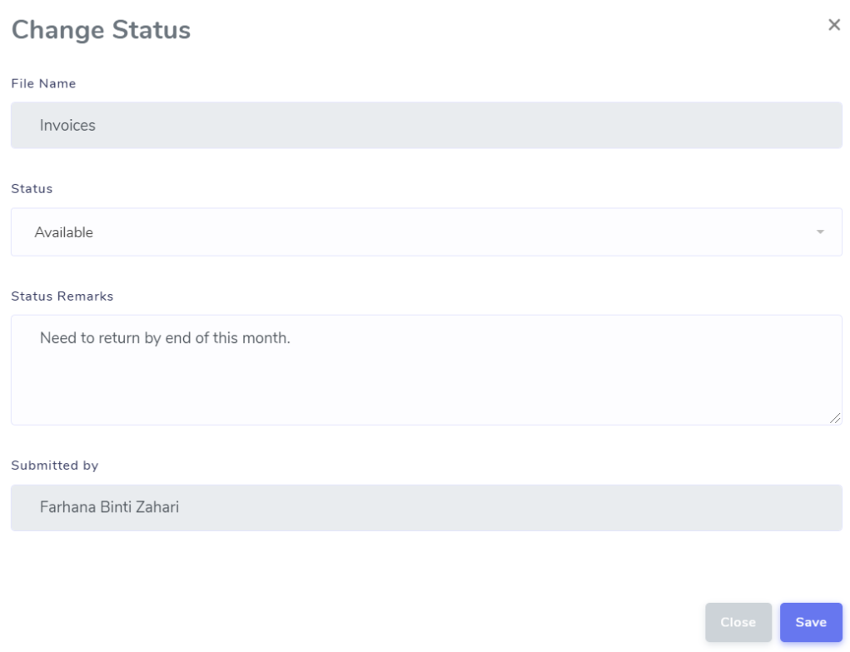

3.0.2.2 How to View Document Movement History
For monitoring, you can view the details of document movement history. You may simply click History button as shown below.

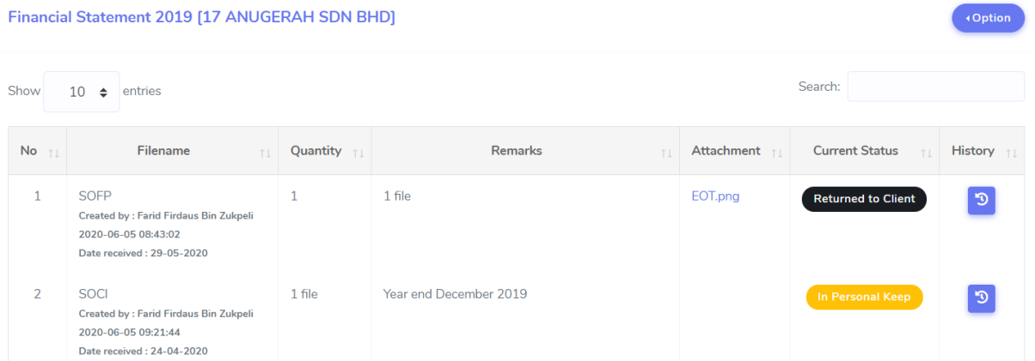

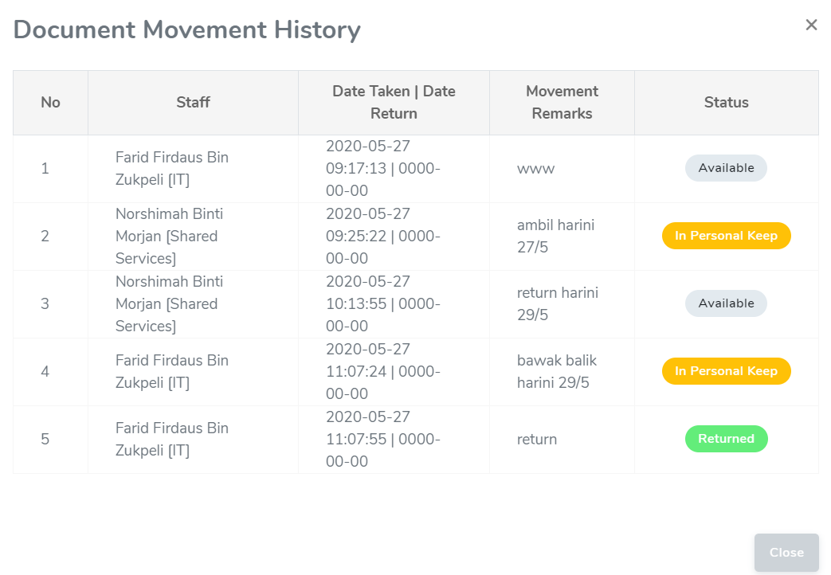

4.0 GENERAL FLOW PROCESS

