 | SALIHIN IT CURATION SDN BHD |  | Document No:  SITC-MGSV2-02
USER GUIDE
MANAGEMENT INFORMATION SYSTEM
MGS VER 2.0

MODULE:
ADMIN

Prepared by:  IT AND DIGITAL DEPARTMENT @ 2019 |  | Revision No:  Version 1.0 |  | Effective Date:  28 NOV 2019

- How to Access MGS
Let’s get started. You can simply click type the url link salihin.noip.me/mgs .Once clicked, you will be directed to the main page of MGS. Click Login button that located
on the top right corner of the page.

Notes : Login ID and password same as SPS ERP.

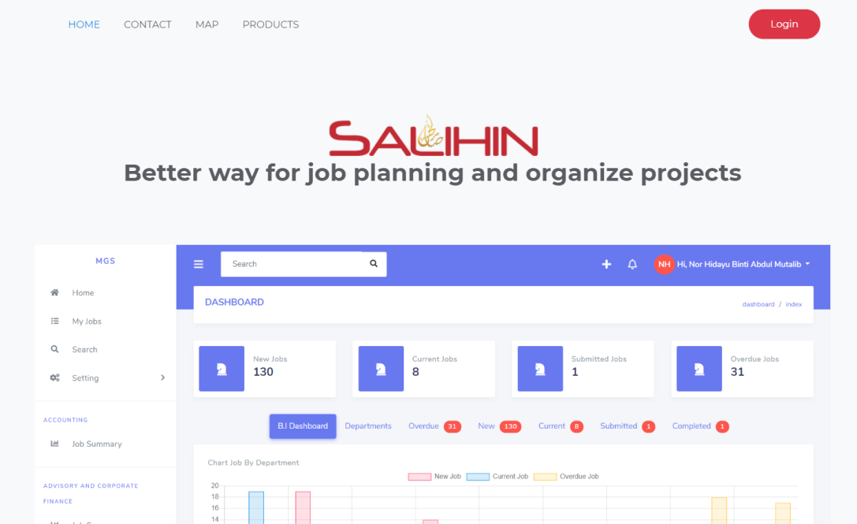

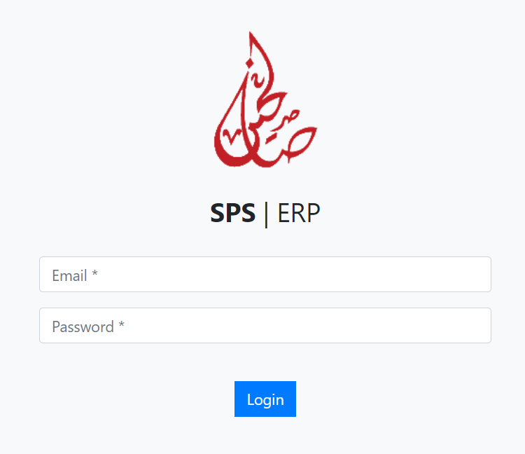

2.0 Dashboard
Admin are enables to view :-
- B.I Dashboard: Chart that display amount of jobs for each department.
- Departments: List of every departments at corporate center and branches.
- Overdue Job: Jobs that have been acknowledge but already exceed deadline.
- New Job: Jobs that is newly created and not yet being acknowledge.
- Current Job: Jobs that have been acknowledge.
- Submitted Job: Jobs that have been submitted.
- Completed Job: Jobs that have been completed.
- Job Summary: List of jobs created for each departments.

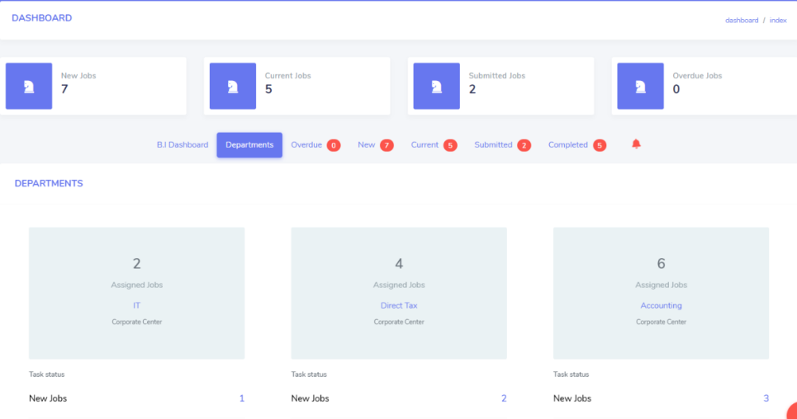

2.0.1 Create Job
Admin are representative that have a privilege to create new jobs for each department. There are two (2) types of jobs which is:-

2.0.1.1 Internal Jobs
If you are an Admin, you have a privilege to create job and assigned within inter-department.

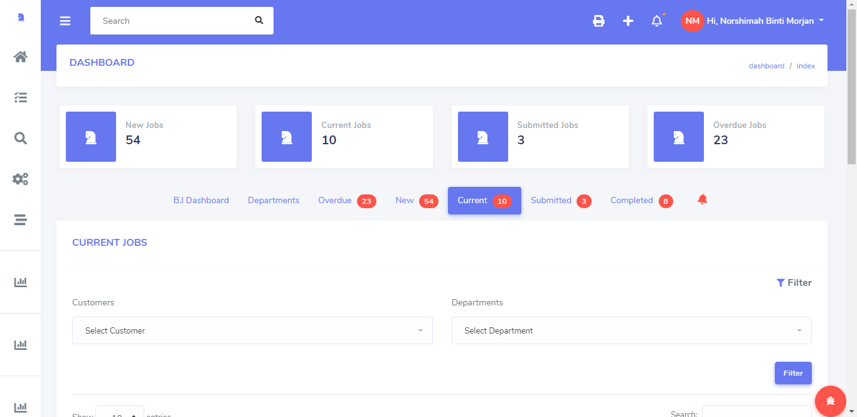

2.0.1.1.1 How to Create Internal Job
- Click the + icon from dashboard page.
- New page named New Jobs will appear.
- Click the Internal Job.
- Select the Request From.
- Select Assigned To which department.
- Insert Deadline.
- Insert Description.
- Insert Remarks.
- Then, click the Save changes to save.

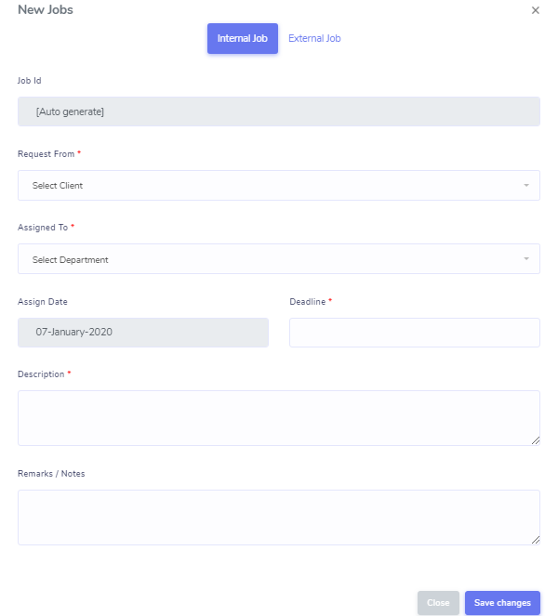

2.0.1.2 External Jobs
Only Admin have a privilege to create new job and assigned to specific deparments. Job created for External Job basically a job from external clients.

2.0.1.2.1 How to Create External Job
- Click the + icon from dashboard page.
- You will be directed to New Jobs page.
- Click the External Job.
- Select the Client Name.
- Select Assigned To which department.
- Insert Deadline.
- Insert Year End Date.
- Insert Description.
- Insert Remarks.
- Then, click the Save changes to save.

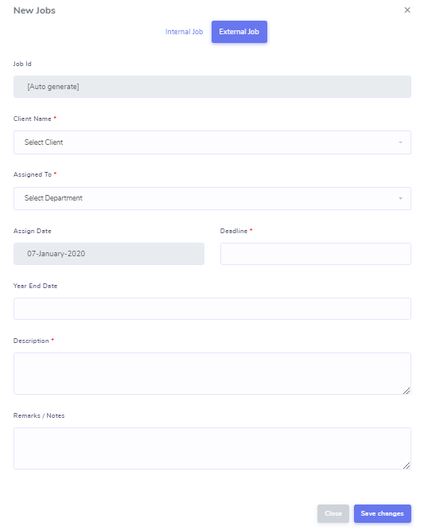

3.0 How to View Job Created
Once admin has created new job for each department, the job created list will be display in new jobs listing under new jobs.

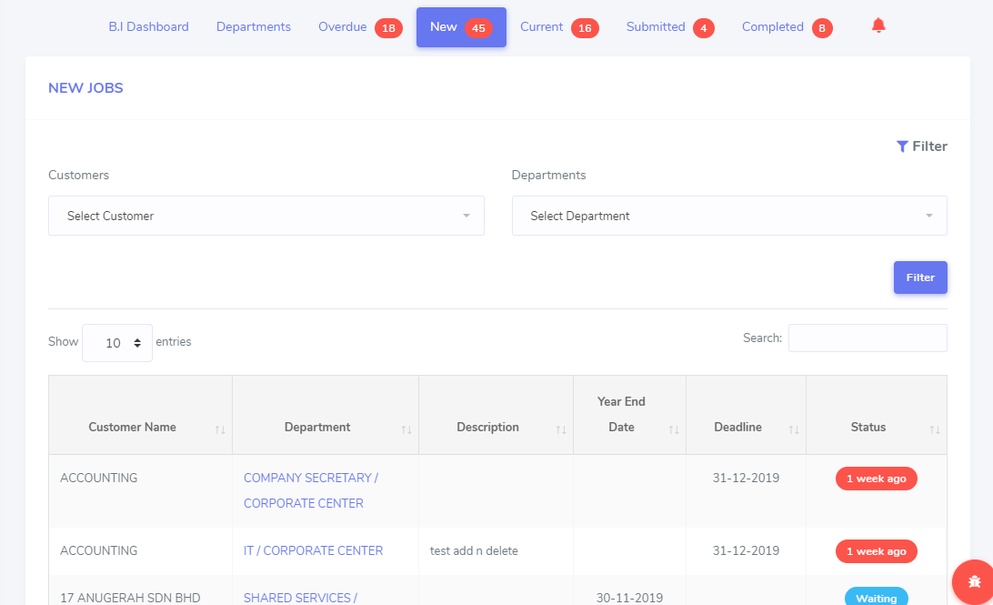

4.0 How to View Details of Job Created
Admin has a privilege to view all jobs details for each department. Click (Department Name) from dashboard page. Then, new page name (Client Name) will be shown.

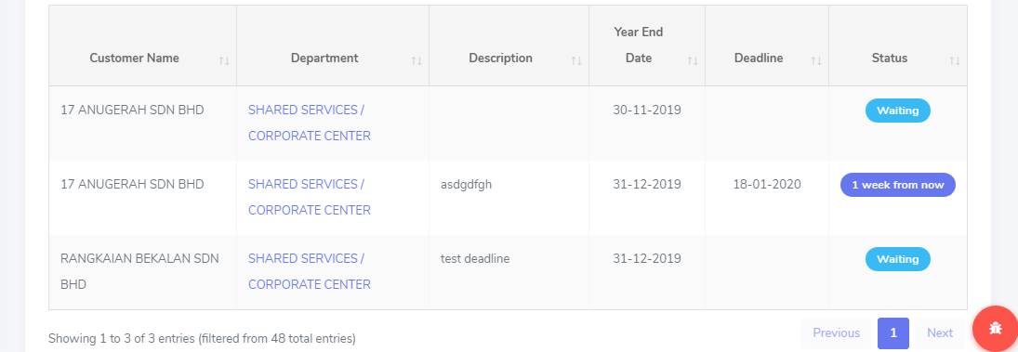

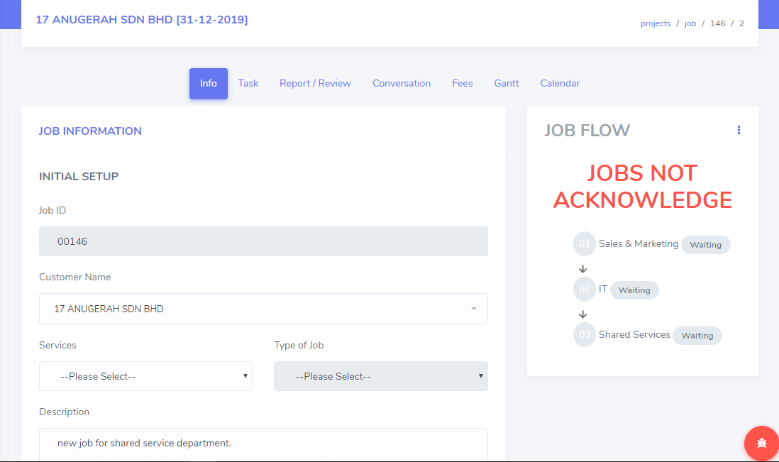

5.0 How to View Job Summary
Admin can view all jobs created and status for each departments. Click the Job Summary from sidebar of the page. The page will be shown as below.

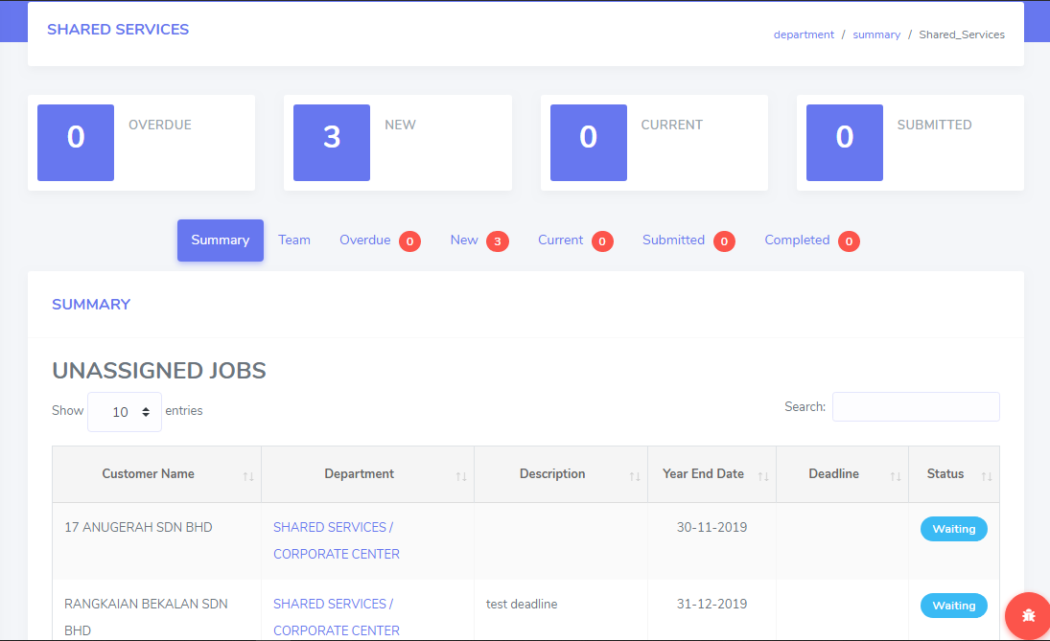

6.0 User Role
Admin and Supervisor have a privilege to setup role for every user that login to the system in order to control the user access. There are three (3) types of roles which is Admin, Supervisor and User.

Click Setting > User Role from sidebar of the page. The page will be display as shown below.

Notes : After successfully setup user role, user need to re-login to the system.

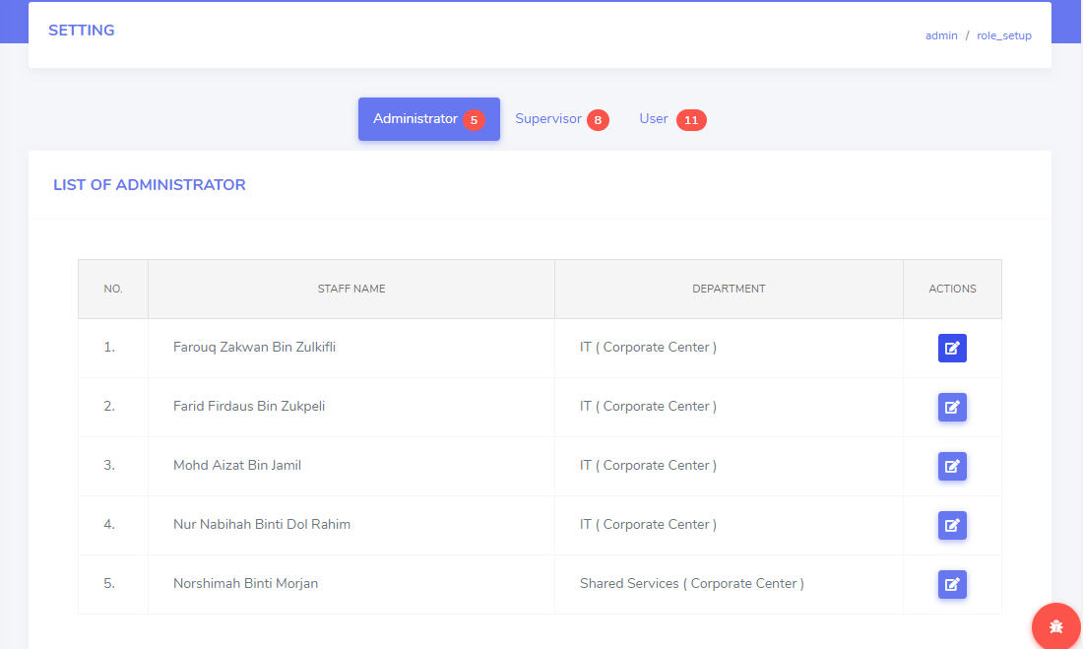

6.0.1 How to Setup User Role
- Click Setting > User Role from sidebar of the page.
- New page name Setting will be display.
- Click the Edit Button from the setting page.
- New page name Edit Role will be pop-up.
- Click the role box. Select which role to be set as.
- Then, click the Save.

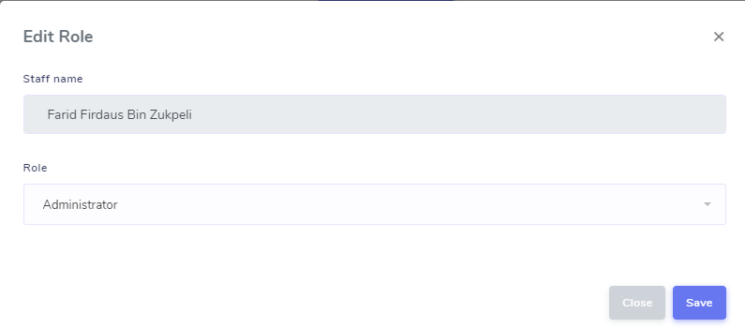

7.0 My Jobs
User can view the job that have been assigned if supervisor or admin have appointed you as person in charge.

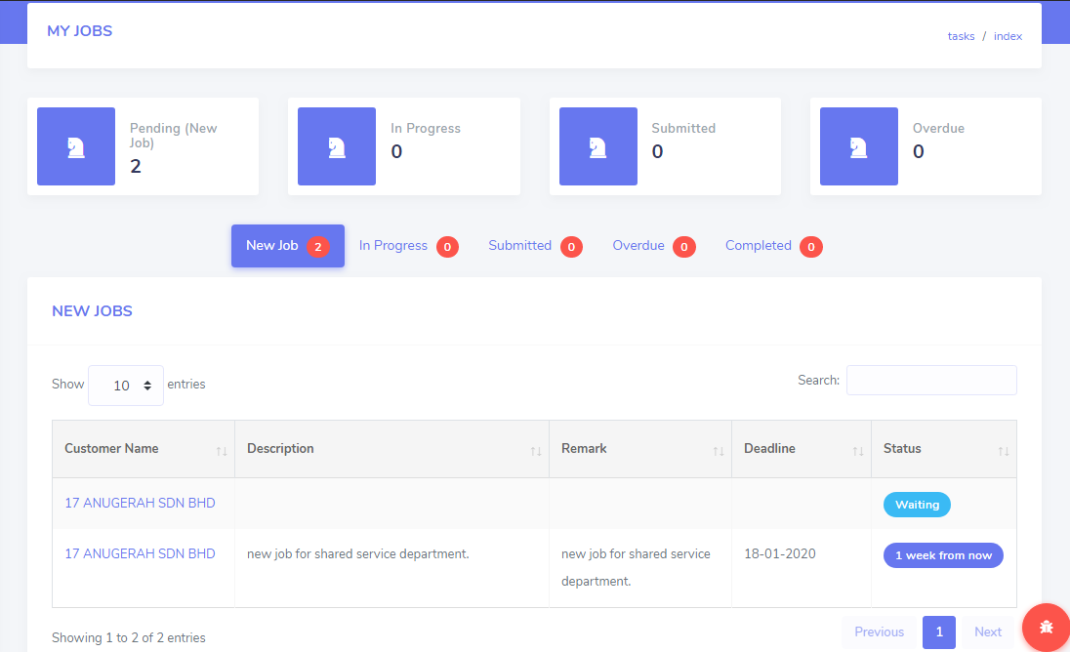

8.0 Change Job’s Deadline
Admin have a privilege to change the job’s deadline based on the request.

Notes : Supervisor also have a privilege to change job’s deadline. Once supervisor change the job’s deadline, admin will receive a notification.

8.0.1 How to Change Job’s Deadline
- Open details of the job (*refer 4.0)
- Click the deadline box. Select new date for the job.
- Then, click the Save setup to save.

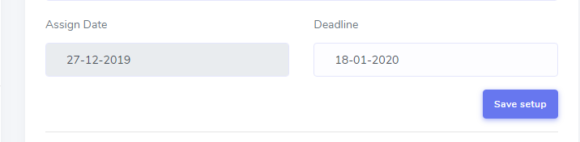

9.0 Add New Department
Only admin have a privilege to add new department for the selected job.

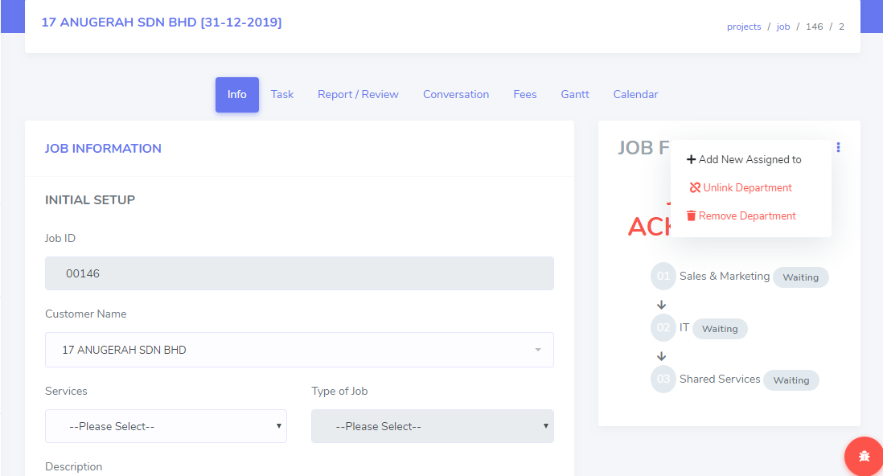

9.0.1 How to Add New Department
- Click the button that located right next to the Job Flow. Click Add New Assigned To.
- New page name Add New Assigned To will be pop-up.
- Select new department that admin want to add. Then, choose the job sequence for the new department either as the First Job or Next To the current department.

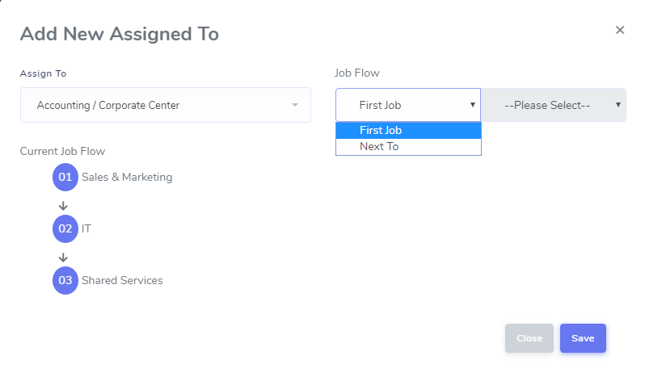

- If Next To is selected, admin need to decide the new department that will be in next to which current department.
- Then, click the Save.

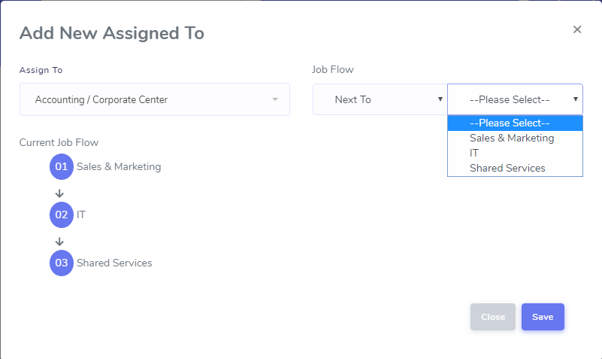

10.0 Unlink Department
Only admin has a privilege to remove or unlink the department from the job flow.

10.0.1 How to Unlink Department
- Click the button located right next to the Job Flow. Click Unlink Department.
- New page name Unlink Department will be pop-up.
- Click Unlink after admin select which department to be remove from the job flow.

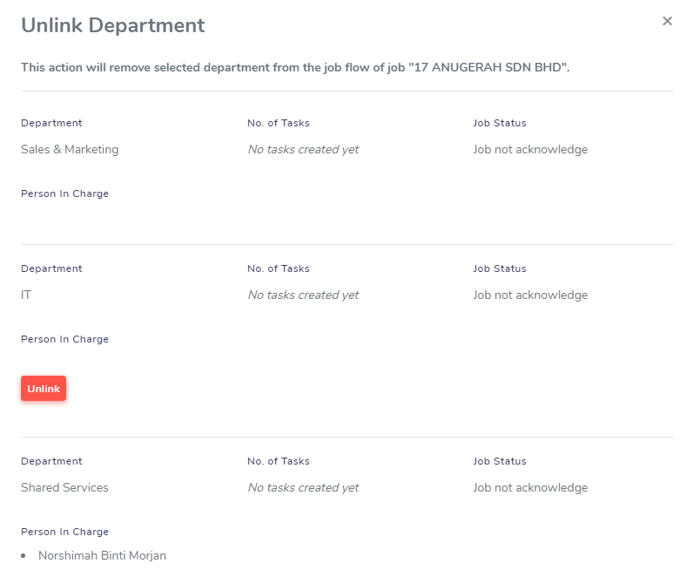

Notes : Only related job are able to be remove. This action only remove the department from the job flow. It will not delete the job from the system.
11.0 Remove Department
Only admin has a privilege to remove or delete the job for the selected department from the system.

11.0.1 How to Remove Department
- Click the button located right next to the Job Flow. Click Remove Department.
- New page name Remove Department will be pop-up.
- Click Remove to delete.

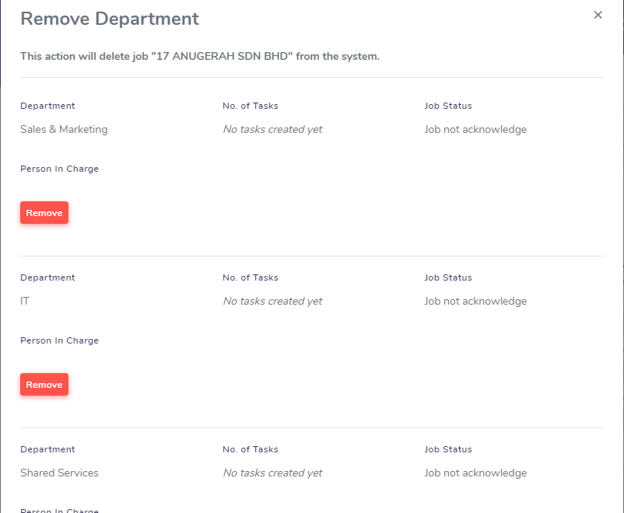

12.0 Job Task
Only admin have a privilege to create and view new tasks for all departments. He/She (Person in Charge) who have been assigned to the task will get notification. In this part it will show the work in progress task status until meet the deadline date.

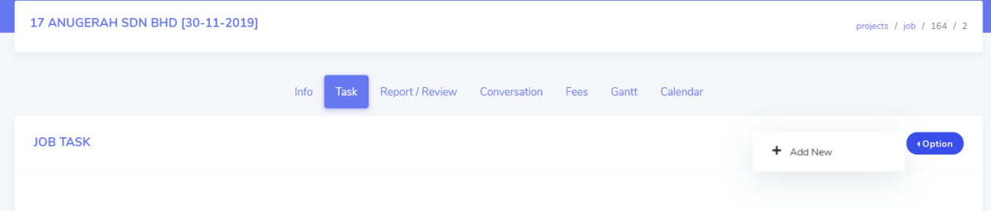

12.0.1 How to Create Job Task
- Open details of the job (*refer 4.0)
- Click the Task tab from menu.
- Click the Option button, click the + Add New.
- Insert the Task Name.
- Select the person in charge for the task at Assign To.
- Insert the Remarks.
- Insert the Due Date.
- Insert Status – In Progress, Pending , Completed
- Click Save button to saved data.

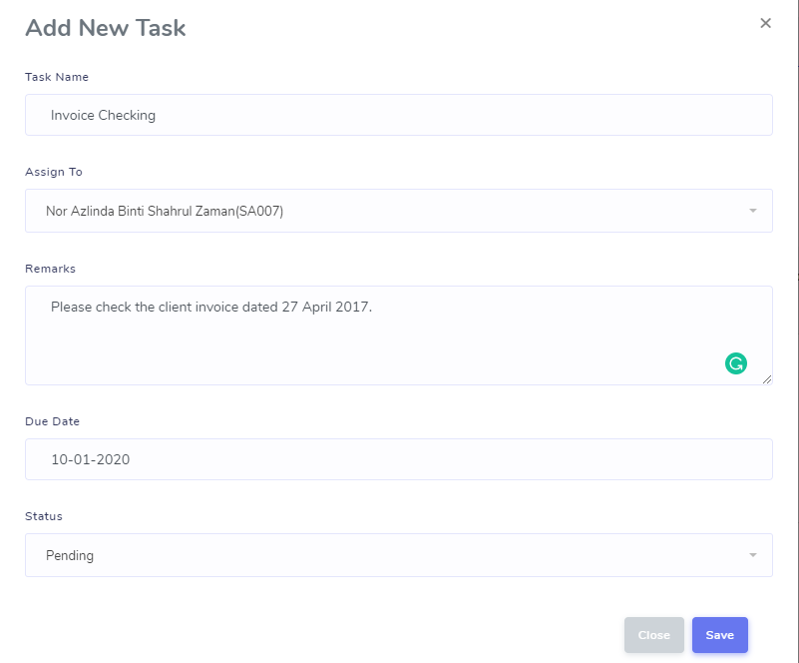

12.0.1 View Job Task
Admin can view list of task that have been created for each job of every departments.

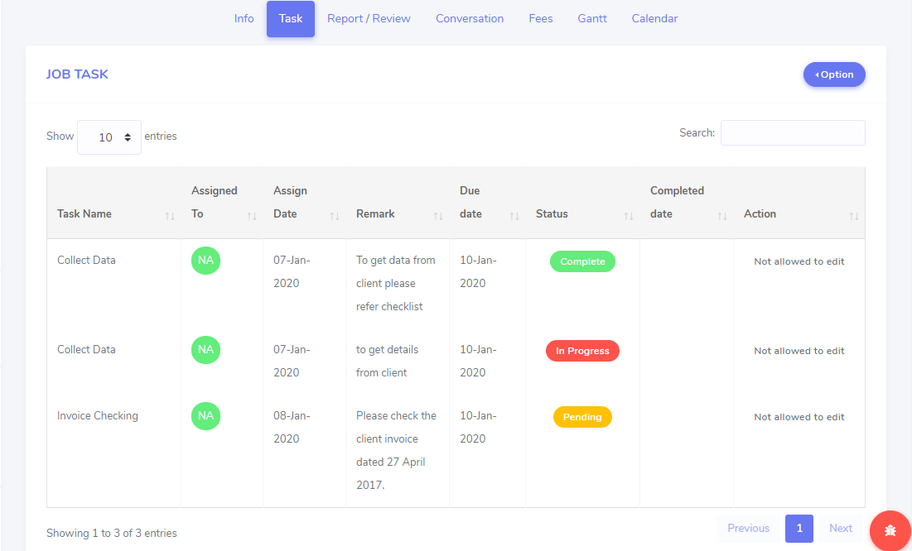

Note : Admin can only view all tasks created but not allowed to make any changes.

13.0 Report/Review

13.0.1 How to Add New Report/Review
Admin have a privilege to add new draft of report to be reviewed by the department’s HOD or Supervisor.
- Open details of the job (*refer 4.0)
- Click Report/Review tab from the menu.
- Click Option button, click the + Add New.
- Insert Report Name.
- Select Reviewer from the list.
- Insert Description of the report submitted.
- Insert Remark.
- Select Submission Date.
- Insert Status.
- Click Save button to save.

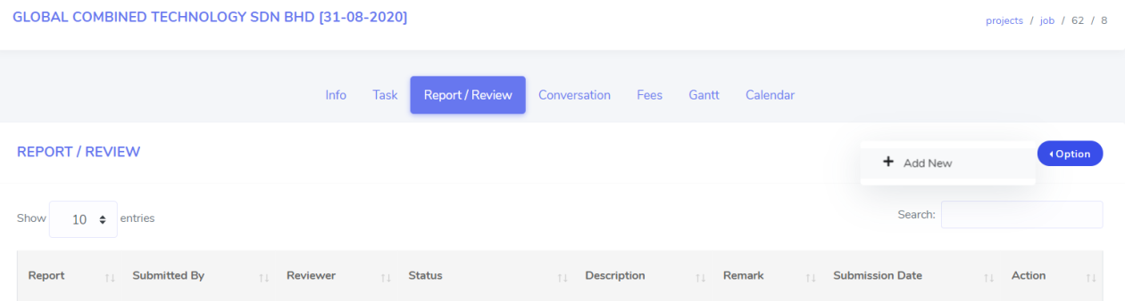
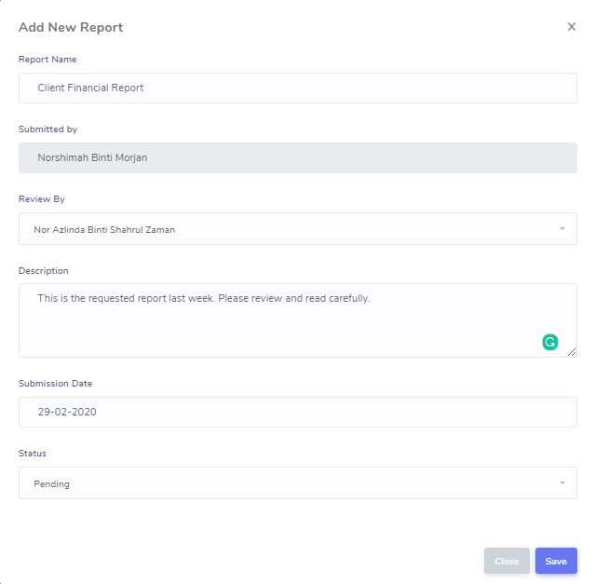

13.0.2 How to View Report
Admin can view draft of report created from the list as shown below.
  - Click Report/Review tab from the menu.

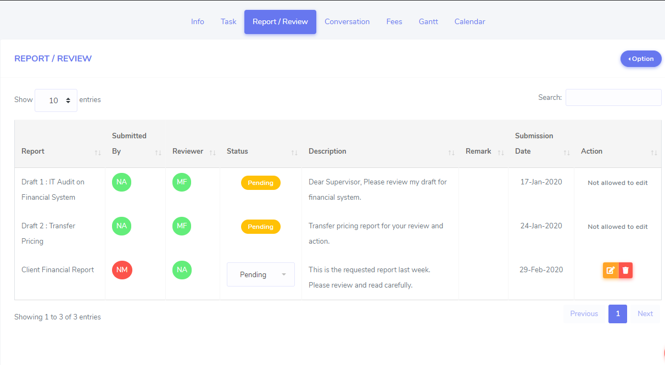

Note : Admin can only make a changes on the draft of report created by themselves. Otherwise, admin can only view the draft and not allowed to make any changes.

13.0.3 How to Edit List of Draft/Reporting
Admin is allow to edit their added report. You can simply drag the description and remarks field.
  - Click Report/Review tab from the menu.
  - Select report from the list.
  - Click Edit button that located in the same row of report name.
  - Once click, new page name Draft/Reporting will be pop-up.
  - Update the required information.
  - Once completed, click Save changes button to saved.

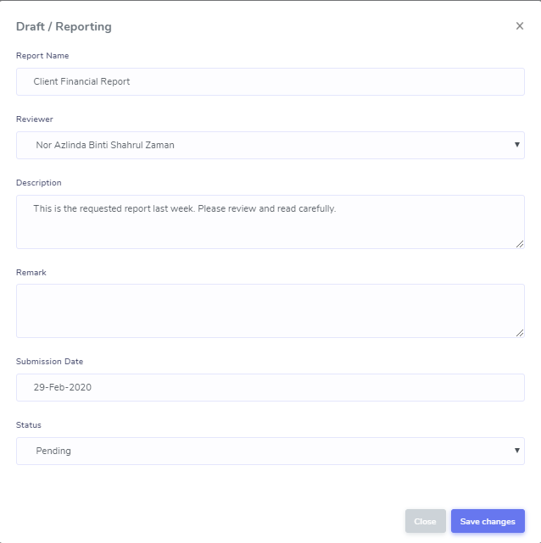

13.0.4 How to Delete Draft/Reporting
Admin is allow to edit their added report. You can simply drag the description and remarks field.

Notes : Please read report name carefully before you wish to click delete button.

  - Click Report/Review tab from the menu.
  - Select report from the list.
  - Click Delete button that located in the same row of report name.
  - Once click, prompt message box will appear.
  - Click OK button.

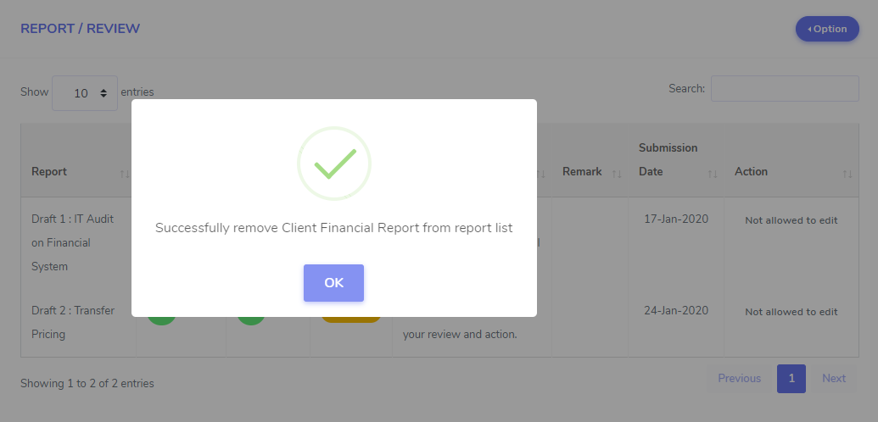

14.0 Conversation
In this part there is two part of conversation which are Daily Updates and Job Discussion. Admin can view all conversation created and can give respond if needed.

14.0.1 Daily Updates
Each staffs are required to update their daily progress everyday start from 5.30 pm.
Daily updates will be monitored by their HODs/Supervisor and teammate.

- Open details of the job (*refer 4.0)
- Click Conversation from tab menu
- Insert your details in Daily Updates box
- Click Post button to insert daily updates
- Your daily message will be shown as below

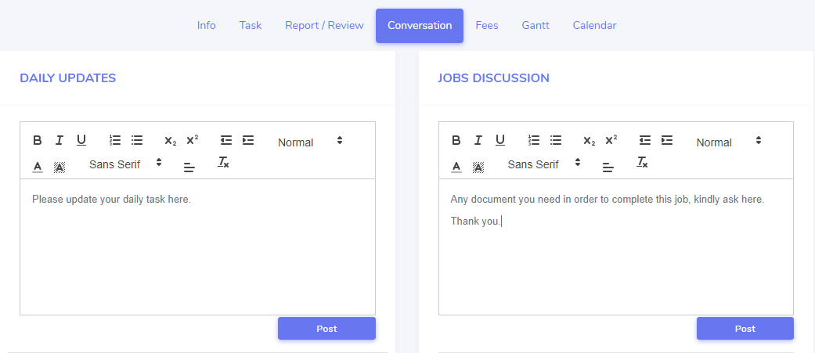

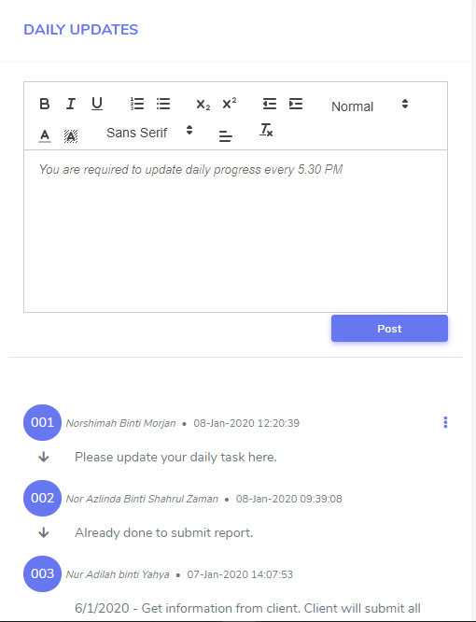

14.0.1.1 How to Edit Daily Updates
Staff are allow to edit their daily updates.
- Click Conversation tab from menu.
- Click button on top of right corner of the page.
- Click Edit button. New page name Edit Discussion will be pop-up.
- Re-edit the required information.
- Then, click Save changes to save.

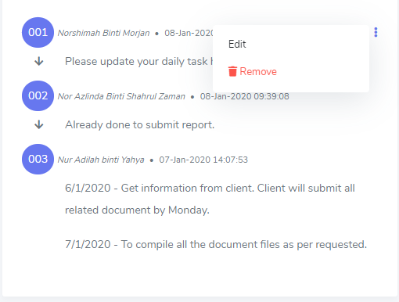

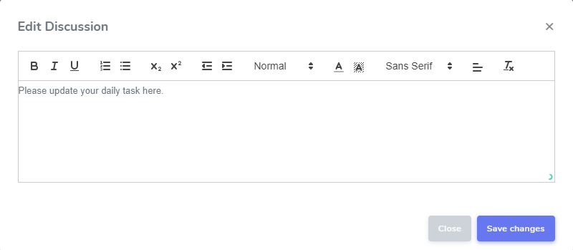

14.0.1.2 How to Remove Daily Updates
Staff are allow to delete their daily updates.
- Click Conversation tab from menu.
- Click button on top of right corner of the page.
- Click Remove button. Then, and prompt message box will be appear.
- Then, click OK.

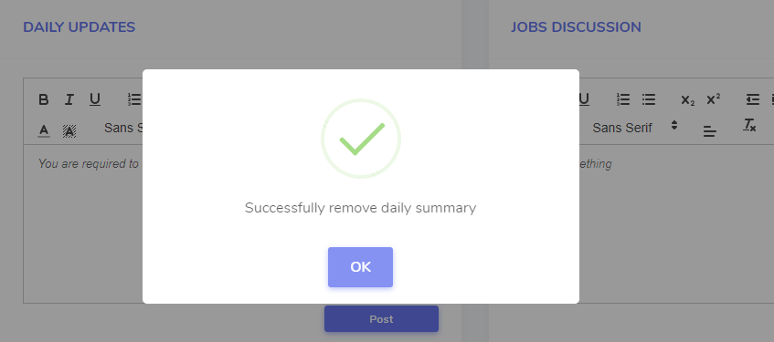

14.0.2 Jobs Discussion
Each staffs are allow to use jobs discussion as a “chat forum” to update, to ask or informs their HODs, Supervisor and among teammates.
- Open details of the job (*refer 4.0)
- Click Conversation tab from menu.
- Insert your details in Job Discussion box.
- Click Post button to insert job discussion.
- Your job discussion message will be shown as below.

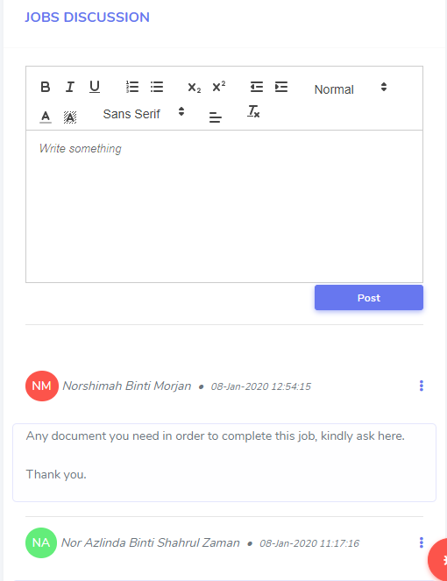

15.0 JOB FEES
Staffs are enable to insert the details of invoice. Admin have a privilege to view all job fees and create new job fees if needed.
- Open details of the job (*refer 4.0)
- Click Fees from the tab menu.
- Click Option and click + Add New Invoice.
- New page name Add Invoice will be pop-up.
- Insert Date, Invoice Number, Representative Name and Amount.
- Click Save changes to save.

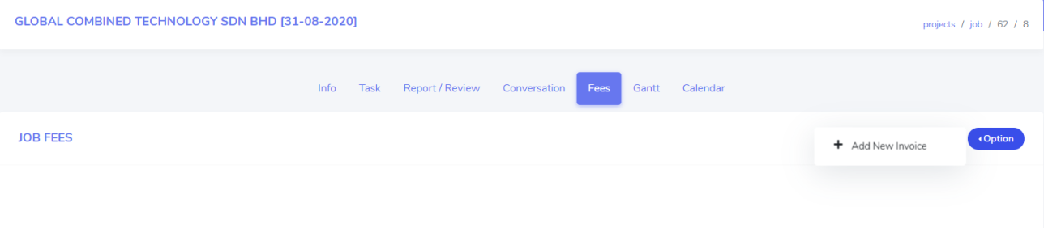
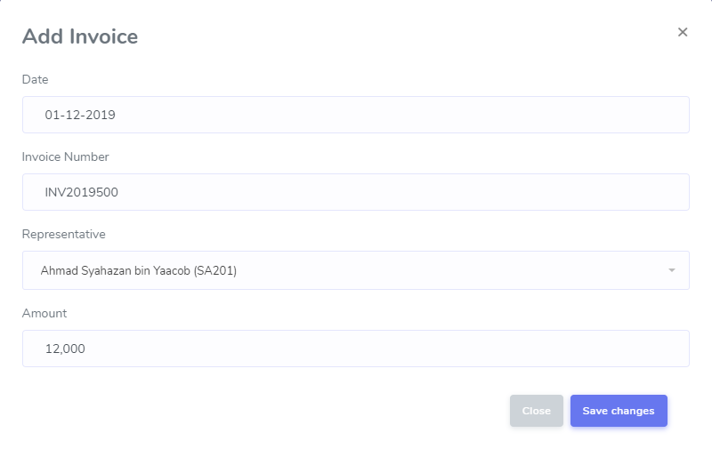

15.0.1 View List of Job Fees
All invoices will be listed as below.
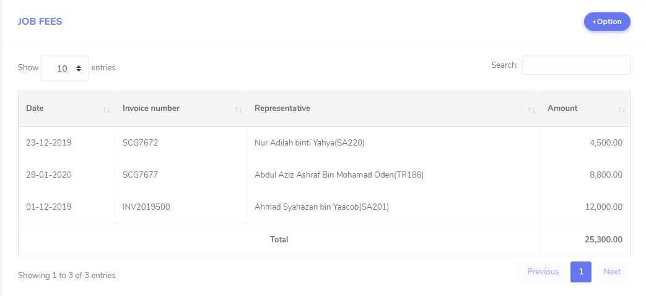

16.0 JOB GANTT AND TIMELINE
Admin are enable to monitor all job task timeline in job gantt format.

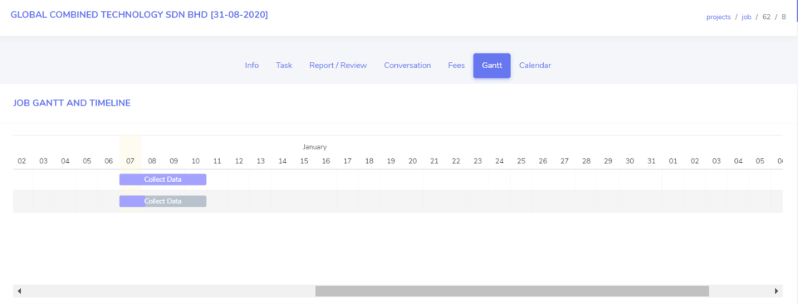

17.0 CALENDAR
Admin also are to monitor all job task timeline in calendar format. It can be view as month, week, day and list.

