Software Requirements Specification

MGS SYSTEM

Prepared by

SALIHIN IT CURATION SDN BHD

Table of Contents
Table of Contents
Product Revision History
Document Revision…………………………………………………………………………………………
Document Approval…………………………………………………………………………………………
1. Introduction 1
1.1 Purpose 1
1.2 Intended Audience and Reading Suggestions 1
1.3 Project Scope 1
1.4 References 1
2. Overall Description 2
2.1 Product Perspective 2
2.2 Product Features 2
2.3 User Classes and Characteristics 3
2.4 Operating Environment 3
2.5 Design and Implementation Constraints 3
2.6 User Documentation 3
2.7 Assumptions and Dependencies 4
3. System Features 3
3.1 Master Setting 3
3.2 Customer Relations Management 3
3.3 Human Resources Management 3
3.3.1 Pay Slip Module 3
3.3.2 Staff Leave Module 3
3.3.3 Staff Movement Module 3
3.3.4 Staff Profiling Module 3
3.3.2 Staff Overtime Management Module 3
3.3.2 Staff Claim Module 3
3.3.2 Training Module 3
3.3.2 Form, Terms and Conditions 3
4. External Interface Requirements 7
4.1 User Interfaces 7
4.2 Hardware Interfaces 7
4.3 Software Interfaces 7
4.4 Communication Interfaces 7
5. Functional Requirements 8
6. Other Nonfunctional Requirements 10
6.1 Performance Requirements 10
6.2 Safety Requirements 10
6.3 Security Requirements 10
6.4 Software Quality Attributes 10
Appendix A: Unified Modelling Language (UML) 11-15
Appendix B: Project Team Structure 16
Appendix C: Project Timeline 17
Appendix D: Glossary 18

Disclaimer…………………………………………………………………………………………... 19

Product Revision History
Name | Date | Reason of Changes | Version

Document Revision

Name | Title | Version | Date
Farhana Bt Zahari | Senior IT Executive | Draft MGS | 5/9/2019

Document Approval

Name | Title | Version | Date
En. Aizat Jamil
En.Akmaluddin

- INTRODUCTION

  - Purpose
The purpose of this document is to present a detailed description of the MGS SYSTEM (herein refers as MGS). This documentation explains the purpose and features of the system, the interfaces of the system, what the system will/can do, the constraints under which it must operate and how the system will react to external stimuli. This document is intended for both the stakeholders and the developers of the system.

Intended Audience and Reading Suggestions

This document is intended for developers, project managers, top management, system testers and document writers.

1.3 Project Scope

This objective of MGS system is to design, implement and streamlines all of the tasks and jobs that required to be completed successfully on time.

1.4 References

- MGS System v1.0

- OVERALL DESCRIPTION

  - Product Perspective
MGS system is a
System is functioning to help solve the manual processes and helps to save times and cost. Indirectly, it helps increase the quality and productivity of work.

  - Product Features

- Productive
System helps to save times and cost. Manage company easily.

- Reduce Operation Cost
Reduce miscellaneous expenses such as paper expenses.

- No Annual Commitment
No contract for any annual commitment.

- Increase Productivity

User Classes and Characteristics
The various user classes that will use the system are: -

Administrators – These are usually the System Administrators. Their responsibility includes configuring or set up the information of new task or jobs details. Has privilege to add, edit and delete.

Head of Department (HOD) – These are usually manager of department. Their responsibility is to viewing the draft and considers the approval final report submission by employees.

Employees – These are usually employees who will be the person in charge of the assigned tasks or job.

Operating Environment

Operating Environment | Details
Operating System | Win 7 and above
Hardware | Any laptops or smartphones
Software | Any latest internet (Microsoft Edge, Google Chrome, Firefox etc.)
Internet | Basic internet, preferably with higher bandwidth speeds

Design and Implementation Constraints
The software will be designed, developed and tested using the following technologies: -

- CodeIgniter Web Framework
- MySQL PHP 5.6
- JavaScript and JQuery library

User Documentation
- Inbuilt Help – Context specific help will be built into the application at all places.

Assumptions and Dependencies
- User Determination – User has their unique ID and password.
- Setup –
- Data Corruption – Functionalize to fix data corruptions/problems. Allow to add, edit and delete. (*Level of authority and module)
- Multi-language –will be operated in both English and Malay?
- Smart and User Friendly – Overall features/functions of MGS v1.0 must be “Smart and user Friendly”.
- Comprehensive Reporting – Generate report
- Real-time Tracking – Track records at real time.

System Features

The key features involved in MGS system are: -
  - General
Allow super to display and monitor job summary such as:-
    - Total of New Jobs
    - Total of Current Jobs
    - Total of Submitted Jobs
    - Total of Overdue Jobs
    - Total Completed Jobs

  - New Tasks
Allow super admin to create new tasks or jobs details and assigned to perspective department. Allow user to search

    - Job Number
    - Customer Name
    - Group
    - Description
    - Remarks
    - Associates
    - Head
    - Issue Date
    - Deadline
    - Year End Date
    - AGM Date
    - File Number
    - Job Type and Status
      - Company Secretary
      - Accounting
      - Audit
      - Tax
      - Consulting
      - GST Advisory & Consultancy
      - GST Training & Education
      - Corporate Finance
      - Transaction Service
      - IT Services

  - Current Tasks
To display the information of current tasks detail as follows:-

    - Job Number
    - Customer Name
    - Group
    - Associate
    - Head
    - Person in Charge
    - Department
    - Description
    - Current Report
    - Status
    - Issue Date
    - Dateline
    - Year End Date
    - AGM Date
    - Acknowledge Date
    - Pending Date
    - Completed Date
    - First Review
    - Head Review
    - Partner Review
    - Remarks
    - Submit First Draft
    - Submit Second Draft
    - Submit Third Draft
    - Submit Final Report

  - Submitted Tasks
To display the information of submitted tasks detail as follows:-

    - Job Number
    - Customer Name
    - Group
    - Associates
    - Head
    - Person in Charge
    - Department
    - Description
    - Current Report
    - Status
    - Issue Date
    - Dateline
    - Year End Date
    - AGM Date
    - File Number
    - Invoice Requested
    - Assign Date
    - Acknowledge Date
    - Pending Date
    - Completed Date
    - First Review
    - Head Review
    - Partner Review
    - Remarks
    - Submit First Draft
    - Submit Second Draft
    - Submit Third Draft
    - Submit Final Report

  - Completed Tasks
To display the information of submitted tasks detail as follows:-

    - Job Number
    - Customer Name
    - Group
    - Associates
    - Head
    - Person in Charge
    - Department
    - Description
    - Current Report
    - Status
    - Issue Date
    - Dateline
    - Year End Date
    - AGM Date
    - File Number
    - Invoice Requested
    - Assign Date
    - Acknowledge Date
    - Pending Date
    - Completed Date
    - First Review
    - Head Review
    - Partner Review
    - Remarks
    - Submit First Draft
    - Submit Second Draft
    - Submit Third Draft
    - Submit Final Report

  - Customer
To display the information of customer details as follows:-

    - Company
    - Address
    - Director
    - Contact Person
    - Contact No
    - Fax No
    - Email
    - Category
    - Year End Date
    - AGM Date
    - Associate
    - Group

  - User
To display the information of user details as follows:-

    - Identification Number
    - Username
    - Password
    - Confirm Password
    - Full Name
    - Designation
    - Contact No
    - Email
    - Department
    - Total Jobs
    - Pending Jobs
    - Completed Jobs
    - Availability
    - Note 1
    - Note 2

  - Associates
To display the information of associate’s details as follows:-

    - Associate Name
    - Address
    - Director
    - Contact Person 1
    - Contact Person 2
    - Contact Number 1
    - Contact Number 2
    - Fax No
    - Email Address
    - Valid License
    - Portion

  - Search
To display the information of associate’s details as follows:-

External Interface Requirements

User Interface

Specify the CSS being used – all things related to the look and feel, usability of the product. Sample screens attached.

Hardware Interfaces
- Printers
- Laptop/Personal Computer
- Ipad

Software Interfaces
- XAMPP
- PHP 5.5
- MySQL 5.6
- Ms Office – Ms.Excel

Communication Interfaces
- HTTP

Functional Requirements
(See Appendix for details)
ACTOR | PROCESS
Administrator | - Assign new user ID and password  - Add, Edit, Delete  - Search
Head | - Monitoring on going job progress status  - Assign person in charge for each task  - Review on the reporting
Partner | - Monitoring and review on the reporting
Employees | - To do the assigned job  - Submit draft of tasks reporting

Other Non-Functional Requirements

Performance Requirements
The system should be good in response time and should be able to handle large
data and user base.

Safety Requirements
The product is developed using PHP which is known as open source application. However the developer has to ensure the software developed must maintain high integrity and high quality.

Security Requirements
Projects are tied exclusively to the user meaning only its user can view, edit and use the project to the user’s desires.
All sensitive information (e-mail, phone number, address) will be stored and encrypted in our database.

Software Quality Attributes
The product is developed using PHP which is known as open source application. However the developer has to ensure the software developed must maintain high integrity and high quality.

APPENDIX 1: MSG FRAMEWORK

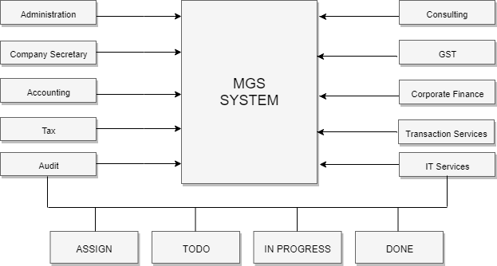

Appendix 3: Flowchart Summary Tasks Process

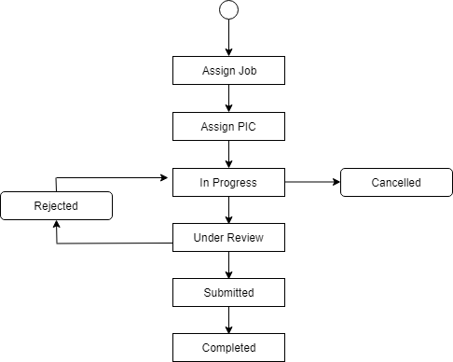

APPENDIX 2: ADMIN MODULE

<<ADMINISTRATOR>>
1.1 Login

1.2 Set up

1.3 Manage & Monitor
1.4 Update & Assign
ADMIN

1.5 Reporting

  - Login Requirement
- Valid email ID and password
- Must be admin person
- Have privilege to control, manage and configure

  - Setup Requirement
- Add new tasks or job
- Add new user

  - Manage and Monitor Requirement
- Manage and monitor tasks or job assigned
- Keep track on tasks progress (WIP)
- Monitor invoicing request

  - Update and Assign Requirement

  - Reporting Requirement
- Update new information details of tasks or job
- Update new

APPENDIX 3: MANAGER
MANAGER/HEAD

<<MANAGER>>
1.1 Login
1.2 Manage & Monitor

1.4 Review & Approval
1.5 Reporting

- Login Requirement
- Valid email ID and password
- Must be Head of Department
- Have privilege to access precise information about employees’ leave records, overtime claim and claim anywhere instantaneously.

  - Manage and Monitor Requirement
- Manage and monitor subordinate leave accordingly
- Manage and monitor subordinate Overtime and Miscellaneous Claim
- Monitor subordinate training

  - Update
- Update changes on requested leave
- Update change on training details

APPENDIX 4: EMPLOYEE
EMPLOYEE

<<EMPLOYEE>>

1.1 Login
1.2 Manage and Monitor
1.4 Submission

1.5 Reporting

- Login Requirement
- Valid email ID and password
- Must be registered employee under SALIHIN

  - Setup Requirement
- Update password

  - Update
- Update changes on requested leave
- Update change on training details

  - Reporting
- View report on employees’ record monthly or yearly
- View report on department details

APPENDIX B: Project Team Structure
HOD of Admin & HR , IT

System Development Team

System Testing Team

Admin &Human Resource Team

System Support & Testing Team
Project Team Structure

APPENDIX D: Glossary
Meaning of terms used in this document

- CSS – Custom Style Sheet
- HTTP – Hyper Text Transfer Protocol
- PHP – Hypertext Preprocessor
- UML – Unified Modelling Language

Interface: Main Page
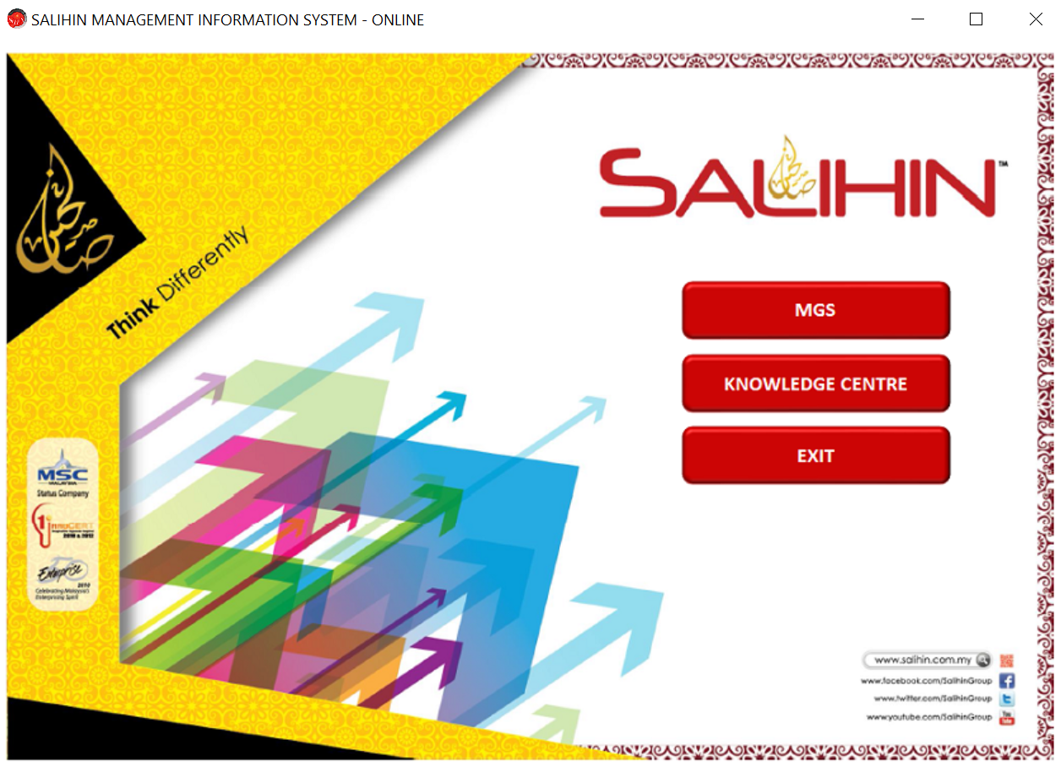

Interface: Login Page
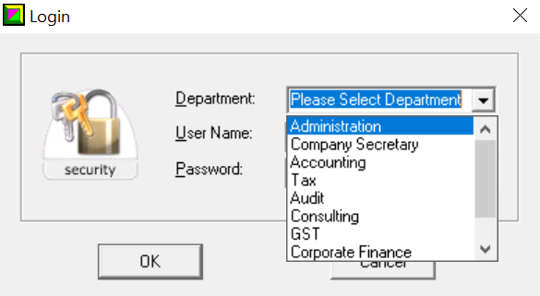

Interface: Main Page for Department
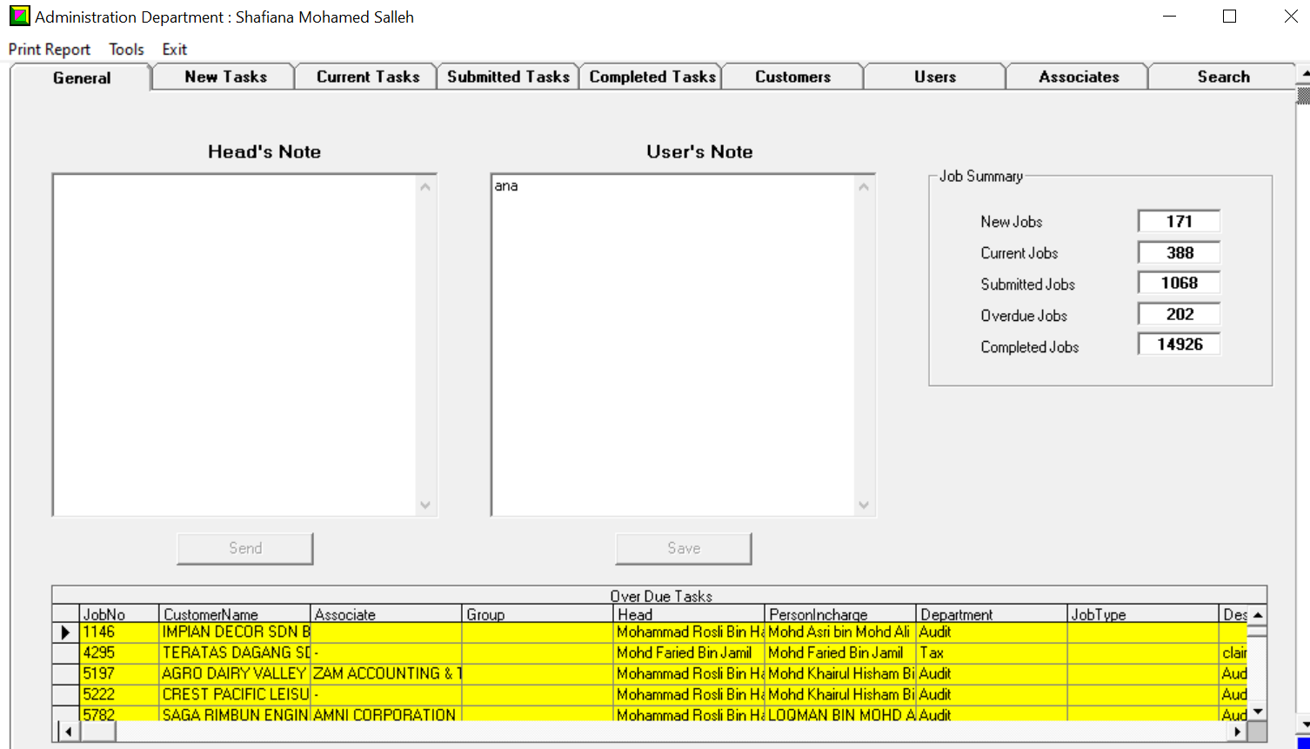

Interface: New Tasks
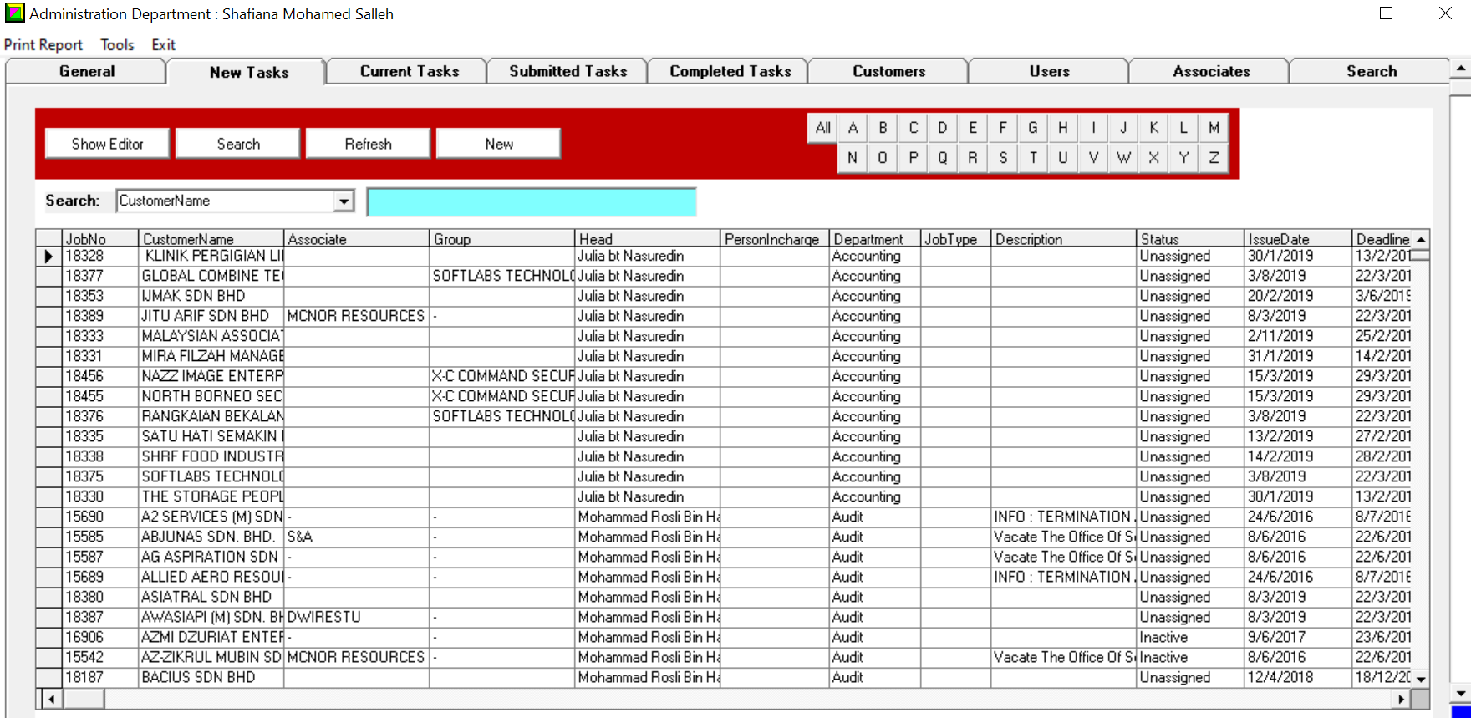

Interface: Show Editor > Task Editor
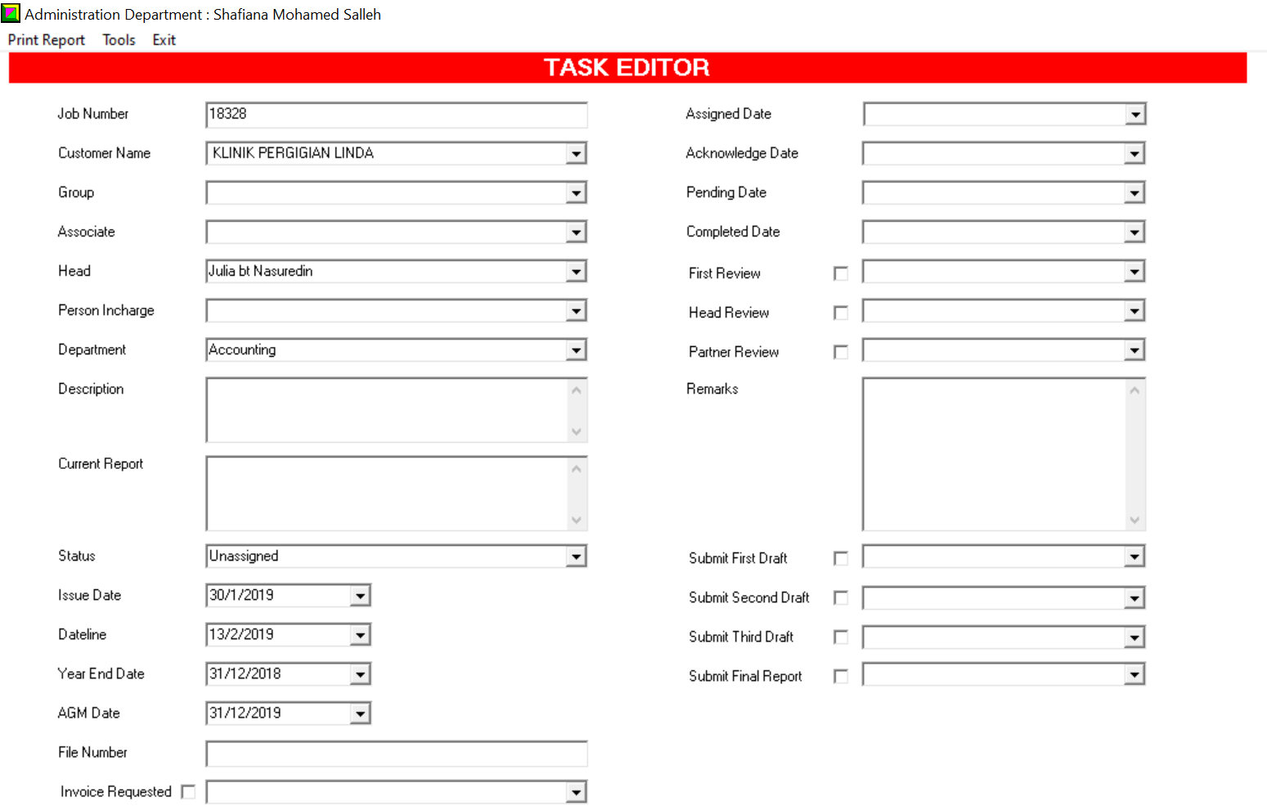
Notes: Same interface apply for Current Tasks, Submitted Tasks, Completed Tasks

Interface: Job Search Selection
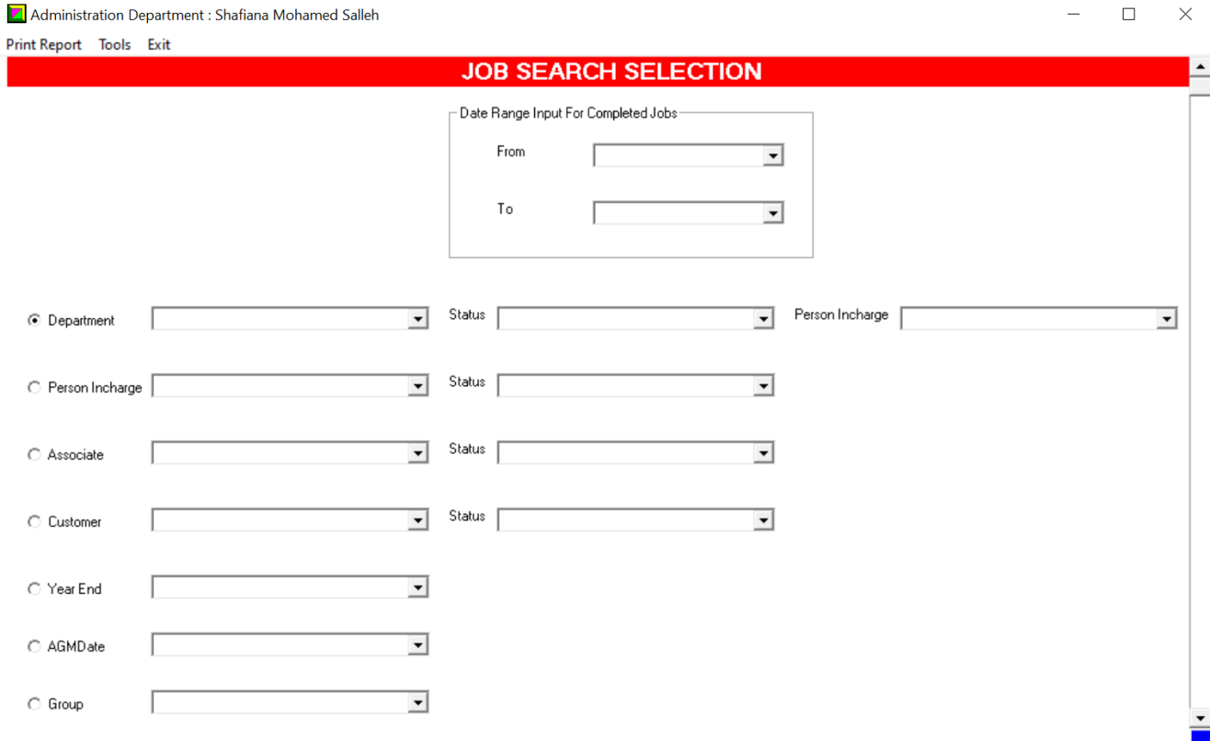

Interface: Customers Main Page
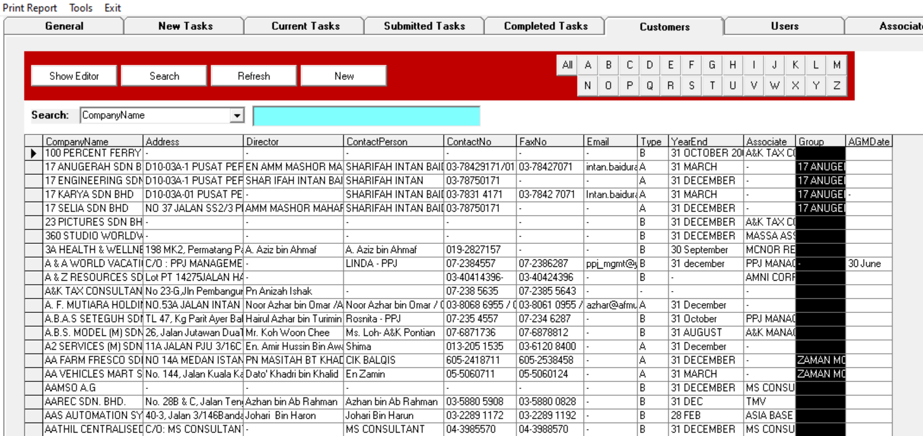

Interface: Show Editor > Customer Editor
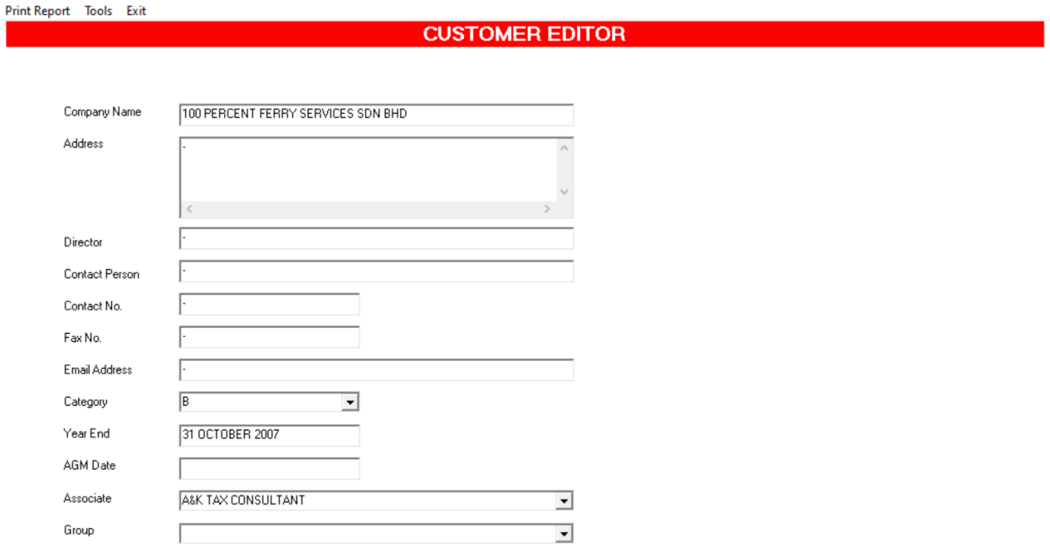

Interface: Users Main Page
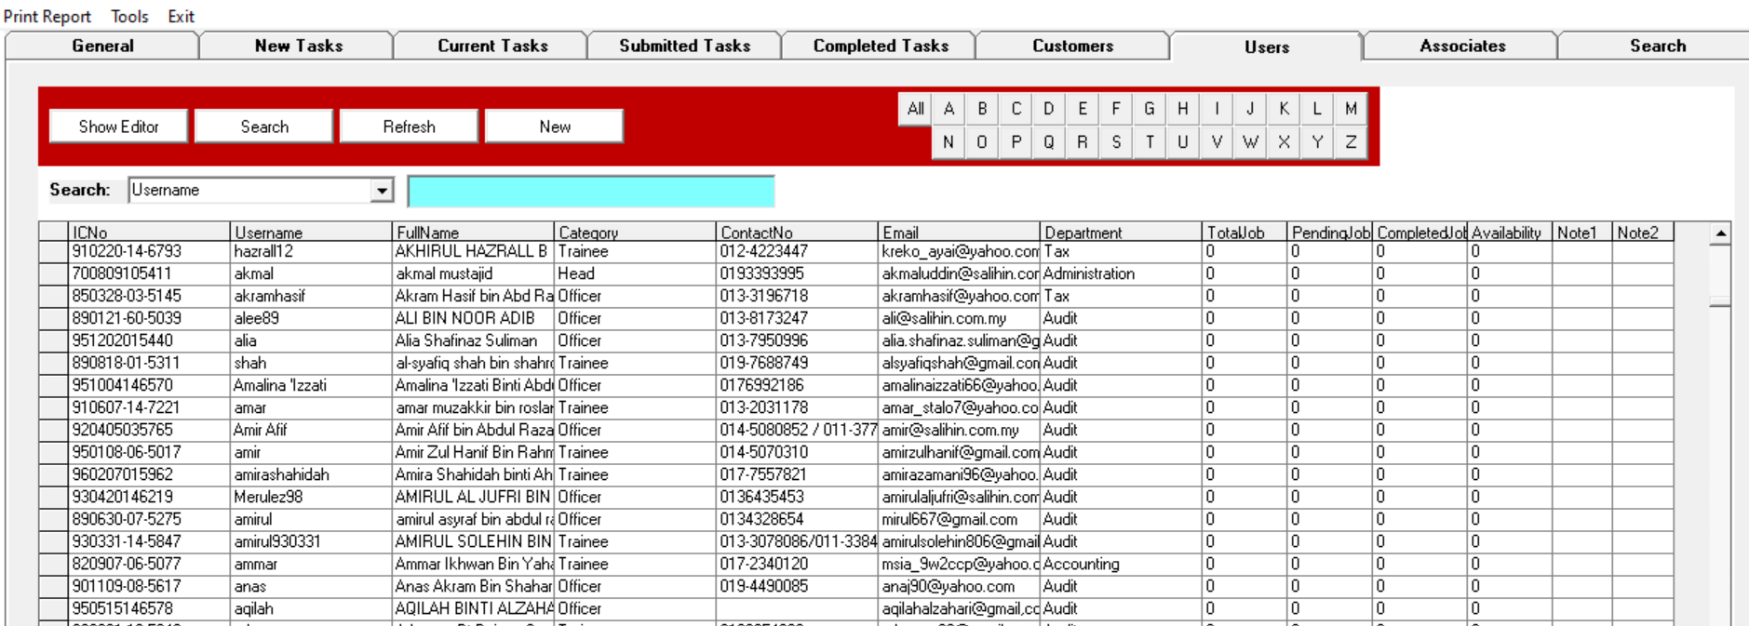

Interface: Users Editor
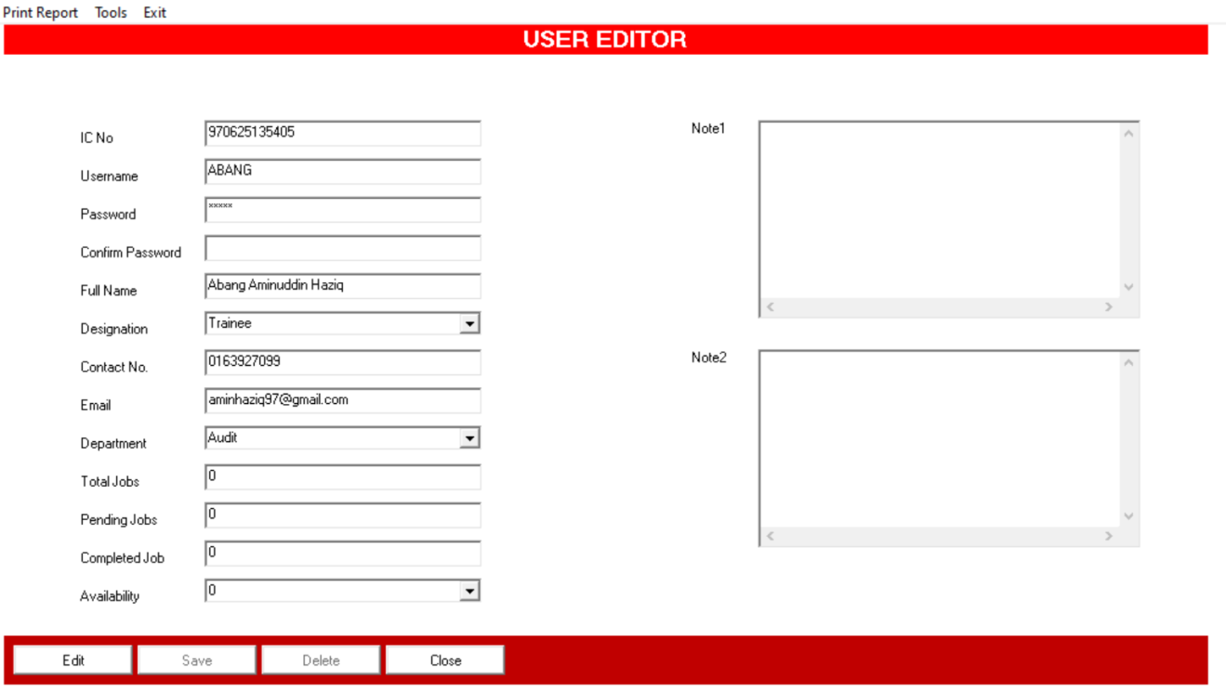
Notes: Once user click Edit button, automatically Save & Delete button enabled.

Interface: Associates Main Page
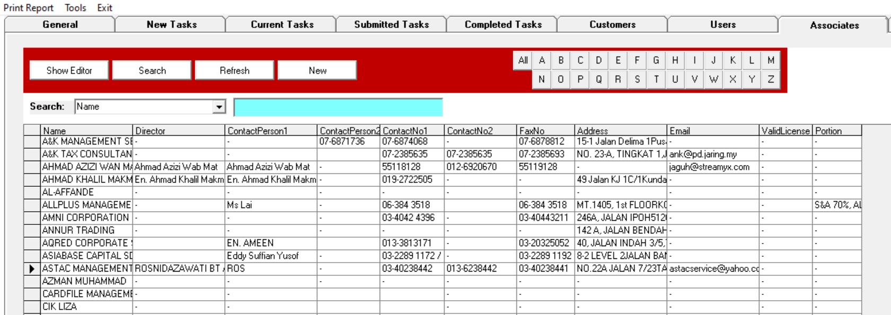

Interface: Associate Editor
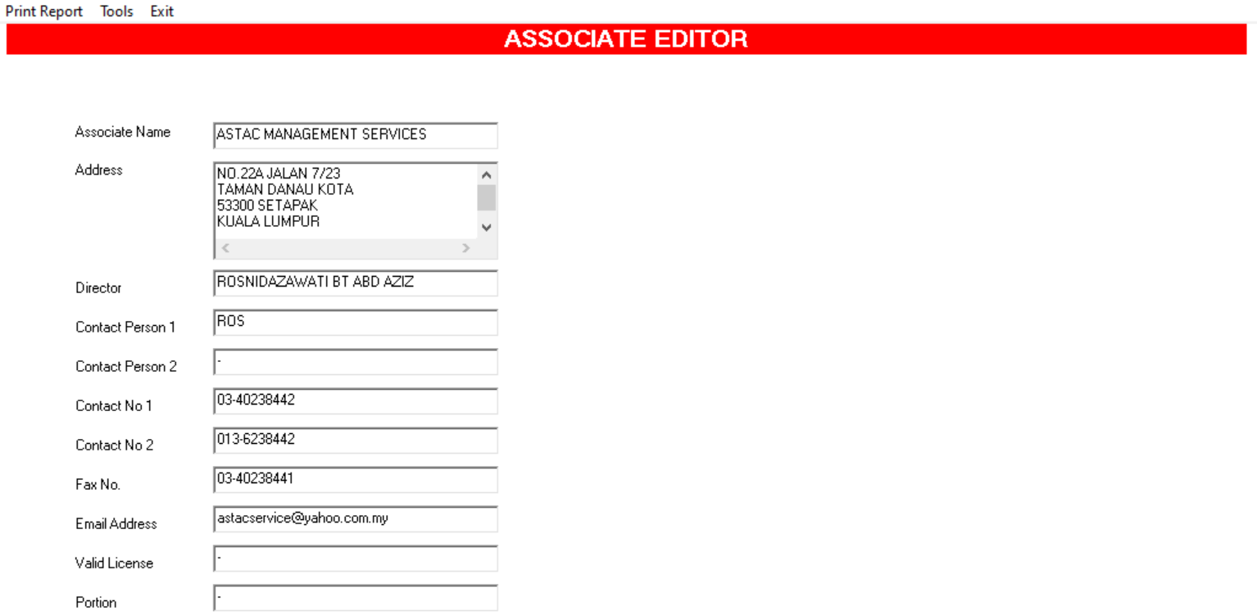

Interface: Print Report > List of User
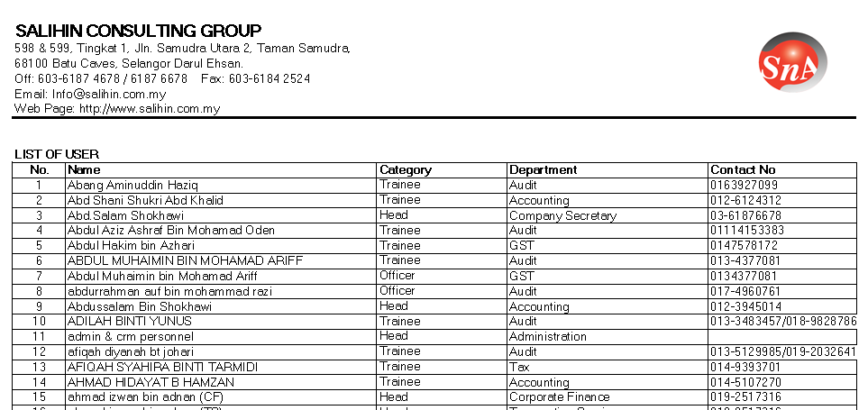
Notes: Address, Phone Number, Fax Number need to be update.

Interface: Print Report > List of Customer
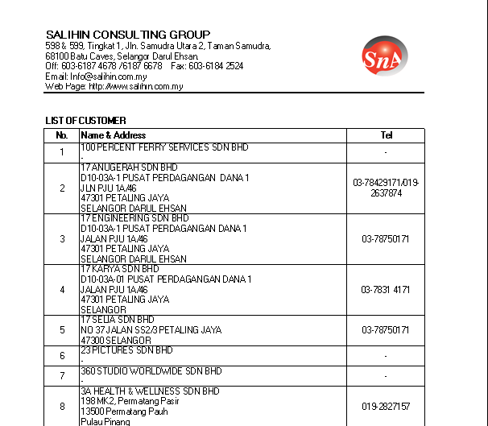
Notes: Address, Phone Number, Fax Number need to be update.

Interface: Print Report > List of Associate
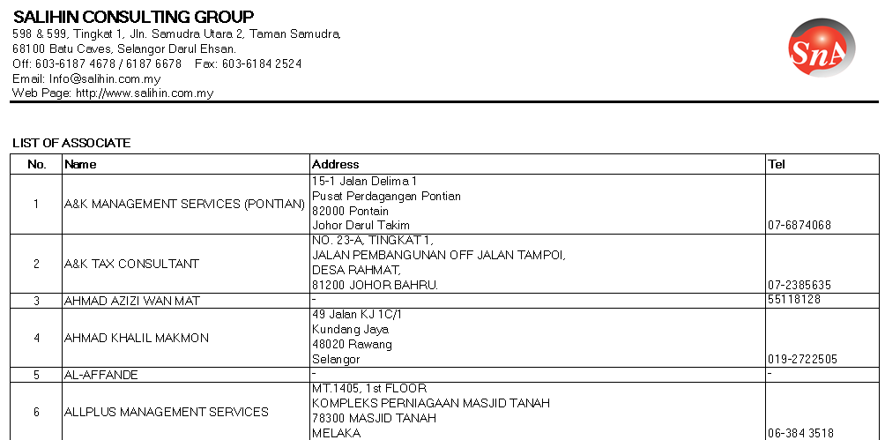
Notes: Address, Phone Number, Fax Number need to be update.

Interface: Print Report > Over Due Jobs – All Departments
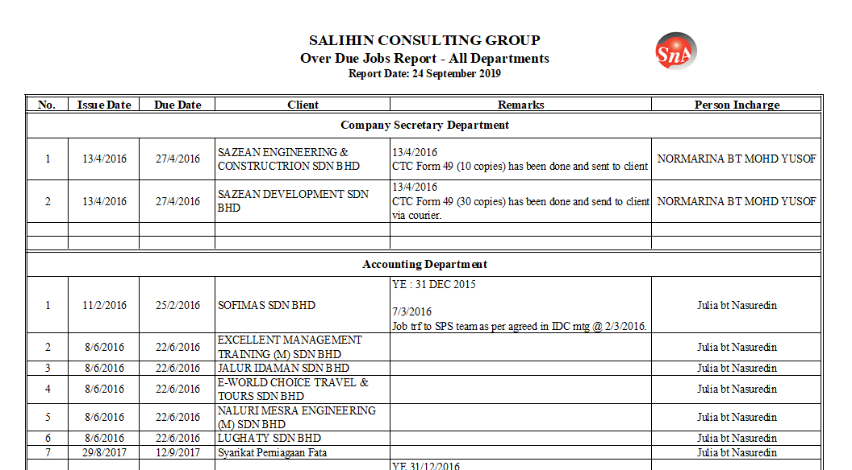

Interface: Print Report > List of Groups
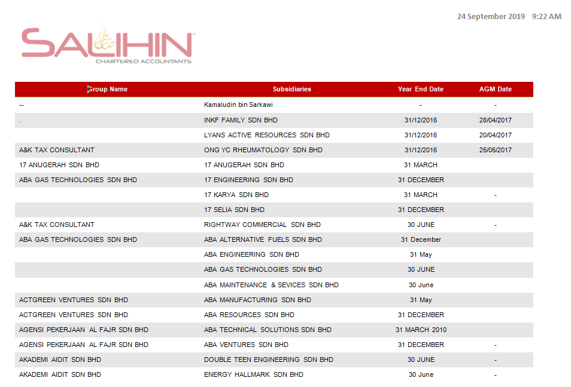

Disclaimer
The specifications or the requirements of MGS V1.0 as stated in this SRS should not be construed as exhaustive, other additions or changes could be made / required during and after the development stage of MGS V1.0

