

Pi1M COMMUNITY CONTENT ENHANCEMENT
BY ACCOUNTING SOLUTIONS

MONTHLY progress report-

REPORT
MONTH OF JANUARY 2017

CONTENT

ITEM

- PROJECT GLOSSARY
  - General Information
  - Pi1M Overview
  - Objective
- PROGRESS AND ACHIEVEMENT REPORT
  - Report Matrix
  - Works Reporting Agenda
    - Introduction – Previous minutes of meeting
    - Summary Progress report – Pre Development
    - Summary Progress report – Post Development
    - Summary of Acknowledgement day
    - MAINTENANCE SERVICE PERFORMANCES
    - PROGRAMME GALLERY
    - Any other matters
- AREA OF CONCERN
- ANY OTHER MATTERS

1.0 PROJECT GLOSSARY

  - GENERAL INFORMATION
With the current shift towards efficient taxation governance, the implementation of GST resulted in the requirement of further understanding of the tax structure in accounting. As one of the prestigious flagship for the rural development and agent of change, PI1M can lead the shift through utilization of SALIHIN Premier Solutions accounting (SPS) & SPS
Micro Accounting as a practical tool of tax structure knowledge in accounting.
SPS accounting solutions will provide the competitive edge for PI1M to enhance the learning experience and knowledge sharing of GST and financial edge for the business community within the PI1M circle.
As PI1M would play a vital role in strengthening and empowering rural business community and uphold Bumiputera agenda as outlined in the Government Transformation Program (GTP), FR MUTIARA SDN.BHD & SALIHIN GST SDN.BHD would like to propose our solutions in empowering and enhancing PI1M Centre utilizing SALIHIN range of Business Software Applications and Corporate Advisory & Services

1.2 PI1M OVERVIEW

- Pusat Internet 1 Malaysia (PI1M) is one of the earliest initiative under Universal Service Provision (USP), the first PI1M was built in 2007. It is an initiative to bring positive social and economic impact to the community in underserved areas.
- All PI1M centres are equipped with 20 units of computer and the centre provides basic internet access as well as ICT-related trainings that are conducted by full-time Manager and Assistant Manager.
- Focus of PI1M expanded from 2013 onwards to include the underserved groups in urban areas. PI1Ms in urban areas are built in low-cost housing areas such as at the People’s Housing Project (PPR) and the Government’s Support Staff housing areas.
- These PI1Ms are equipped with special facilities for people with disabilities (OKU) to browse the internet and there is special area for toddlers.

2.0 PROGRESS AND ACHIEVEMENT REPORT

2.1 INTRODUCTION

2.2 REPORT MATRIX
ZONE | DAILY REPORT | WEEKLY REPORT | MONTHLY REPORT | MAINTENANCE REPORT | PARTICIPANT PROGRESS REPORT
Steering Commitee Meeting (KKMM / MCMC / TELCO’S/ TELCO’S VENDOR / CPC)
Project Coordination Meeting (TELCO’S/ TELCO VENDOR / CPC)
Project Contractor Meeting (CPC)

2.3 PROGRESS REPORT – PRE DEVELOPMENT
Items | Month |  |  |  |  |  |  |  |  |  |  |  | Remarks
Items | 1 | 2 | 3 | 4 | 5 | 6 | 7 | 8 | 9 | 10 | 11 | 12
- Installation Hardware
Zone1
Zone 2
Zone 3
Zone 4
Zone 5
- Installation Software
Zone 1
Zone 2
Zone 3
Zone 4
Zone 5
Maintenance Support | `
Commisioning & handover PI1M

2.5 PROGRESS REPORT – POST DEVELOPMENT
Items | Month |  |  |  |  |  |  |  |  |  |  |  | Remarks
Items | 1 | 2 | 3 | 4 | 5 | 6 | 7 | 8 | 9 | 10 | 11 | 12
- Traning Class
Zone1
Zone 2
Zone 3
Zone 4
Zone 5
- Training Support
Webinar
Video Training & Tutorials
Online Training Material
Online Test & Examination
Online Certification
- Intensive Support | `
- Acknowledgement day

2.6 SUMMARY OF GRADUATION DAY EVENT
Passed Participation | Month |  |  |  |  |  |  |  |  |  |  |  | TOTAL PARTICIPANT GRADUATE (Blue Column)
Passed Participation | 1 | 2 | 3 | 4 | 5 | 6 | 7 | 8 | 9 | 10 | 11 | 12 | TOTAL PARTICIPANT GRADUATE (Blue Column)
Zone 1 | 5 | 6 | 9 | 20 |  |  |  |  |  |  |  |  | 20
Zone 2 | 4 | 4 | 2 | 10 |  |  |  |  |  |  |  |  | 10
Zone 3 | `3 | 5 | 3 | 11 |  |  |  |  |  |  |  |  | 11
Zone 4 | 5 | 5 | 5 | 15 |  |  |  |  |  |  |  |  | 15
Zone 5 | 6 | 5 | 5 | 16 |  |  |  |  |  |  |  |  | 16

Graduation day | location | Total Participant | Institute/ University Participation | Date | Name Participant Award | Total Estimated Visitor | Response Visitor
1st Batch
2nd Batch
3rd Batch
4th Batch
5th Batch
6th Batch
7th Batch
*Note;
- Survey form to be filled, recorded & save until 5 years

- CPC RESOURCES PERFORMANCES

Team Management | Name | Contact number | Staff performances
Team 1 | 1.
 | 2.
 | 3.
Team 2 | 1.
 | 2.
 | 3.
Team 3 | 1.
 | 2.
 | 3.
Team 4 | 1.
 | 2.
 | 3.
Team 5 | 1.
 | 2.
 | 3.
Helpdesk | Name | Contact number | Staff performances
 | 1.
 | 2.
 | 3.

Vehicle type | Model | Registration plate number | Condition Status

List of Training event tools , material & equipment | Quantity | Condition Status | Remarks

4.0 CPC ORGANIZATION CHART

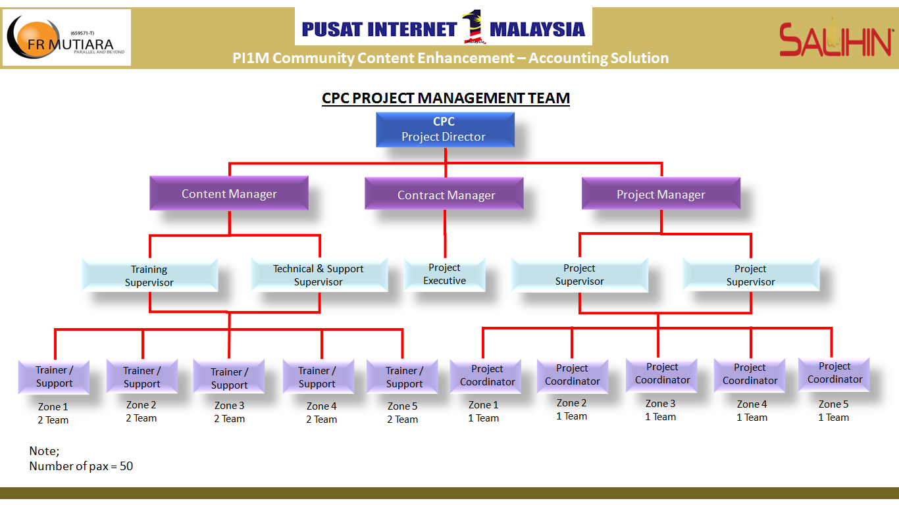

5.0 MAINTENANCE SERVICE PERFORMANCES

No | Date | Location Pi1M | Zone | Frequency | Site Problem

6.0 PROGRAMME GALLERY

7.0 ANY OTHER MATTERS

Prepared by Prepared by
FR MUTIARA (M) SDN. BHD SALIHIN GST SDN.BHD

_____________________________ _______________________________
Name: Name:
Designation: Designation:
Date: Date:

Checked by Checked by
*TELCO’s *TELCO’S VENDOR

_____________________________ _____________________________
Name: Name:
Designation: Designation:
Date: Date:

Approved by
*MCMC

_______________________________
Name:
Designation:
Date:

