  - Example GST-03 Return for Information

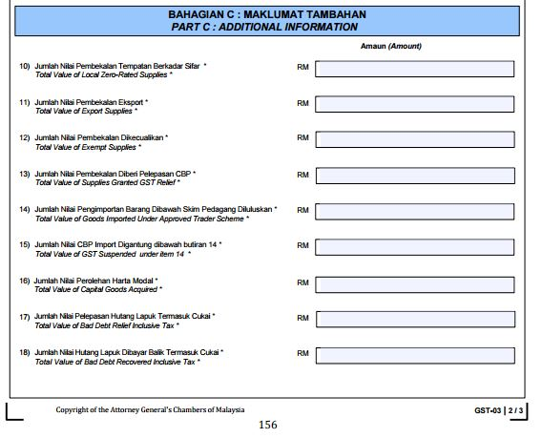

RS
ZRL

ZDA, ZRE

ES, IES

IS

OS, GS, OS-TXM, OS-NTX,SR-JWS
Jumlah Nilai Pembekalan Lain
Total Value of Other Supplies
TX-CG

AJP

AJS

