Main Interface: CampusNexus Student
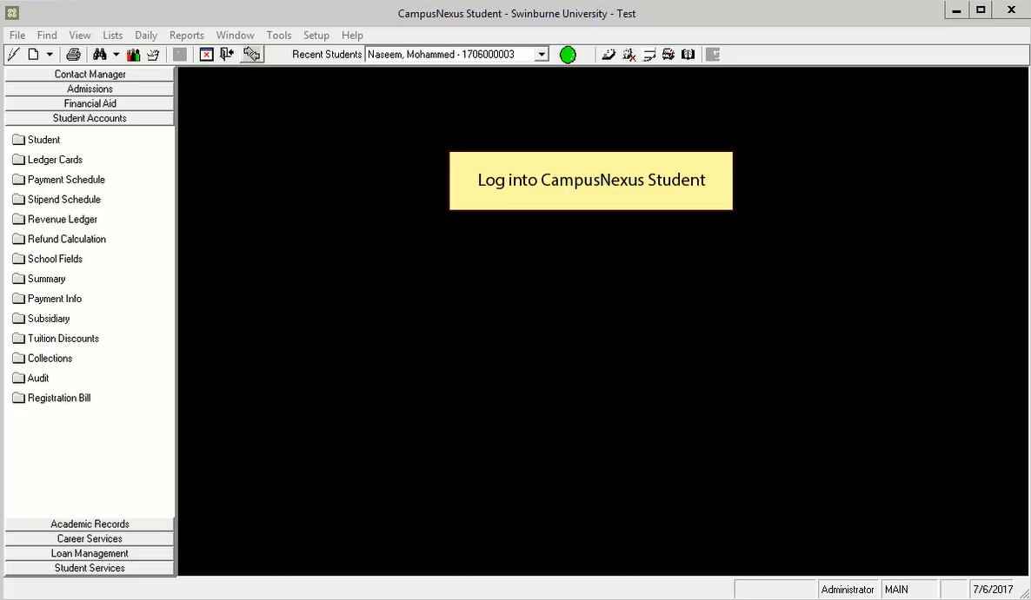
Interface: Transaction Codes > Lists
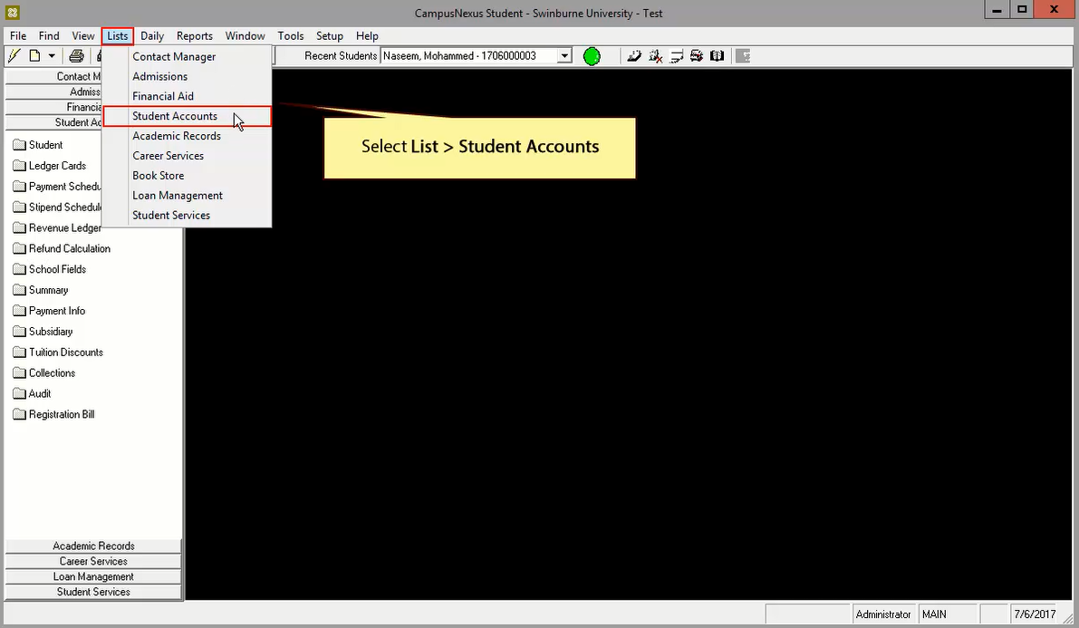
Interface: Transaction Codes
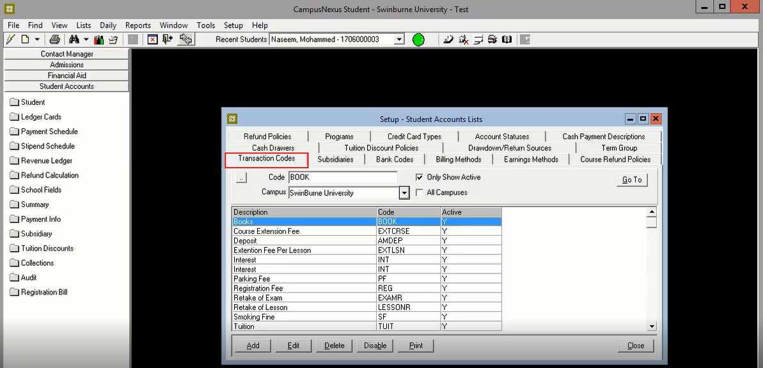
Click Add or Edit button, then transaction codes code setup will be displayed

Interface: Transaction Codes Code Setup
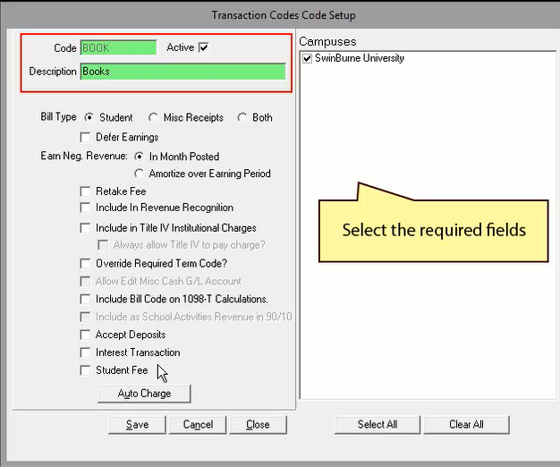

Interface: Billing Method
Interface: Setup > Billing Methods
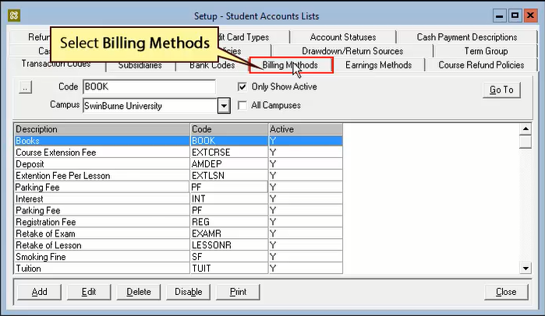
Click Add or Edit button, then transaction codes code setup will be displayed

Interface: Billing Methods Code Setup
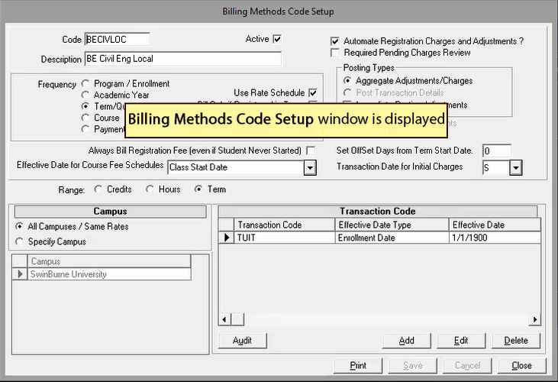

Every billing must have a separate billing method, which is specific to each term. For example: B.Tech in Civil Engineering, and a bachelors degree in Management will have separate billing methods.
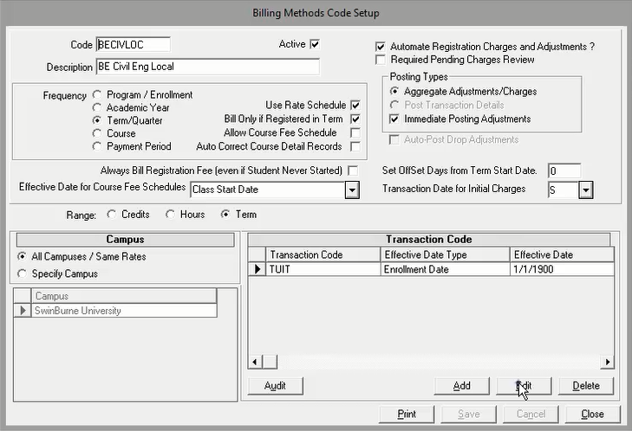
Click Edit button
Interface: Rate Schedule
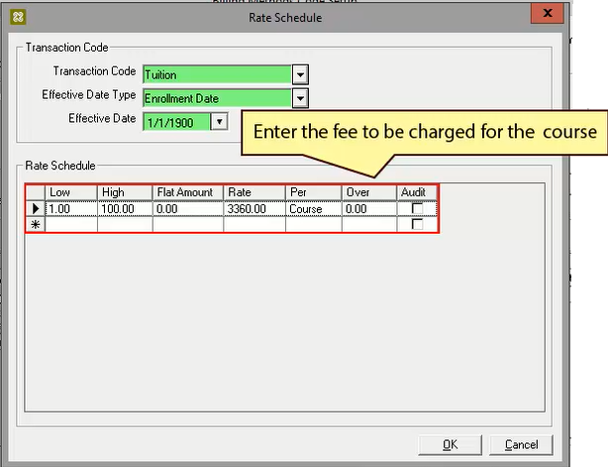

Interface: Ledger Card
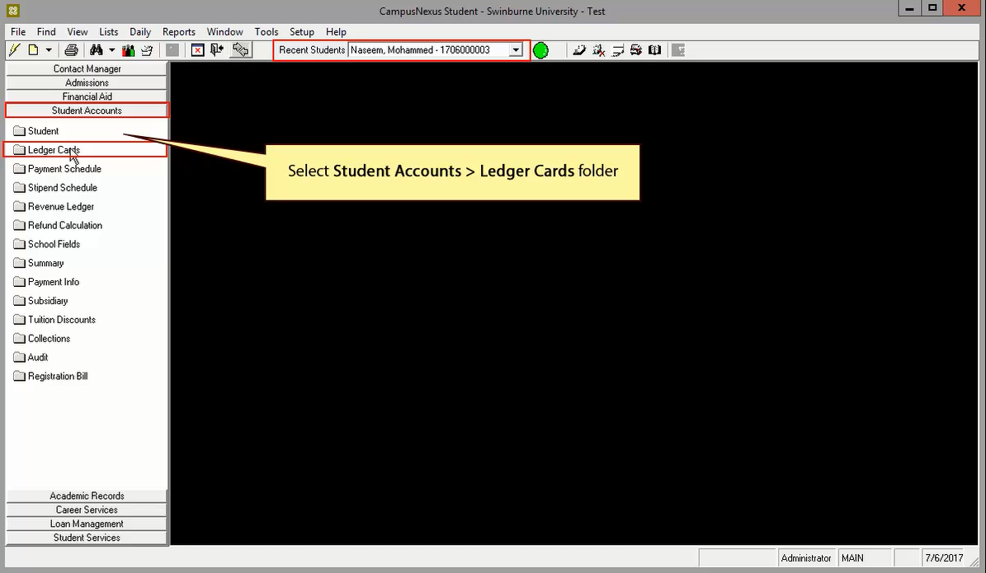
Interface: Student Ledger Card
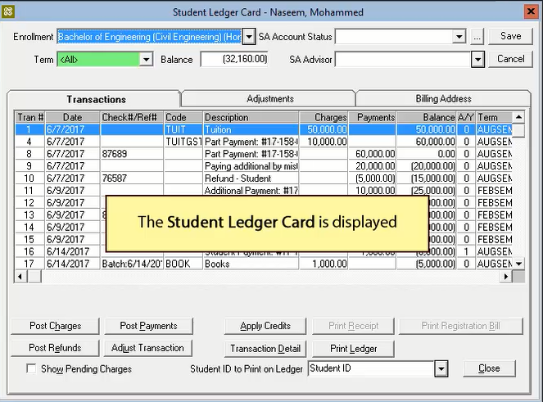

Interface:Post Charges
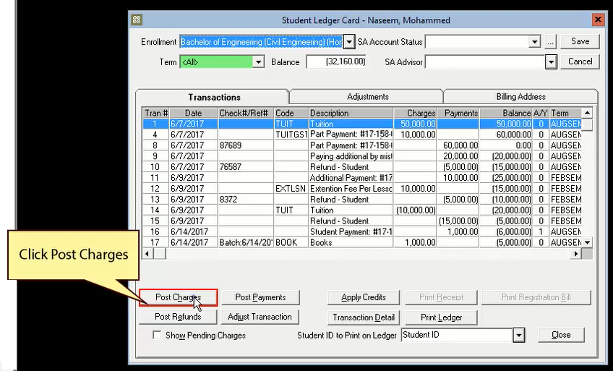

Interface:Post Charges
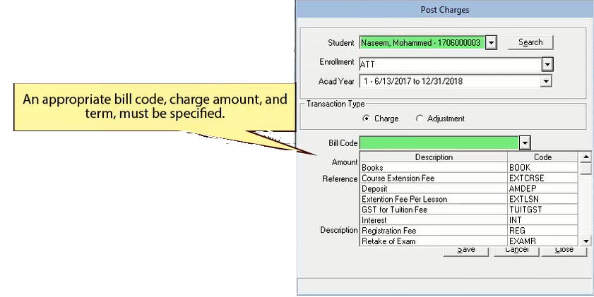

Interface:Post Charges > Enter Amount
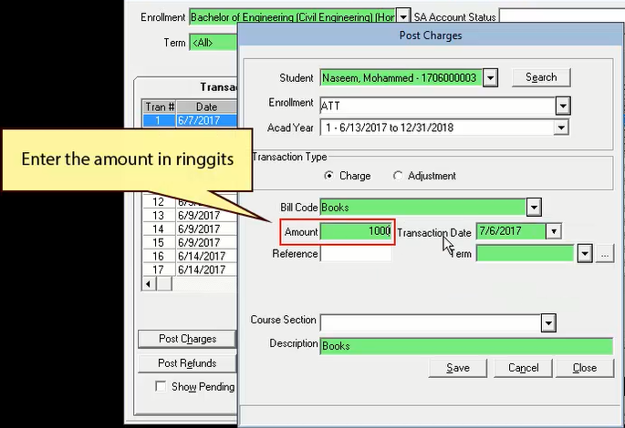

Interface:Post Charges : Select Term > Click Save
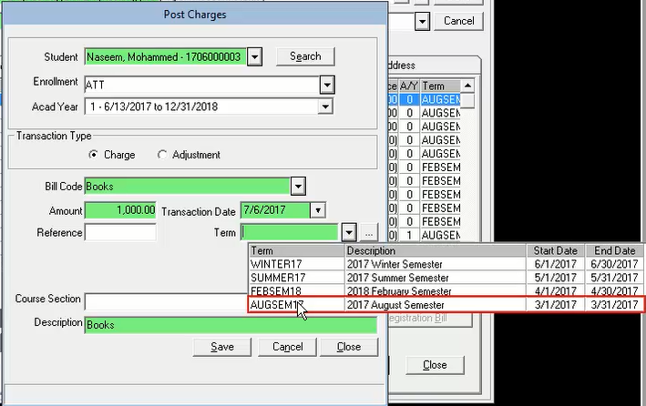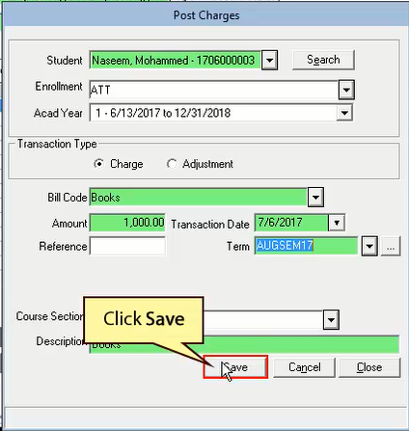

Interface:Posted charges displayed in row

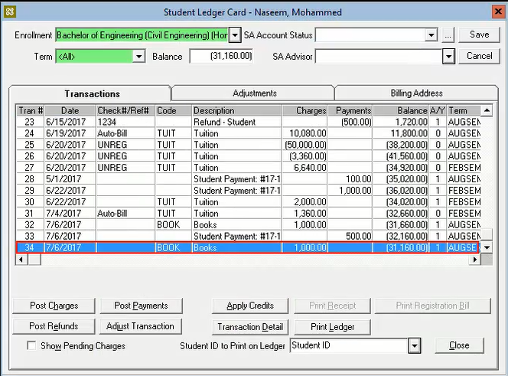

Interface:Posting Payments

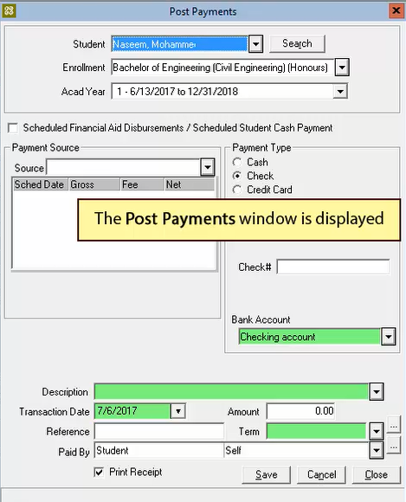
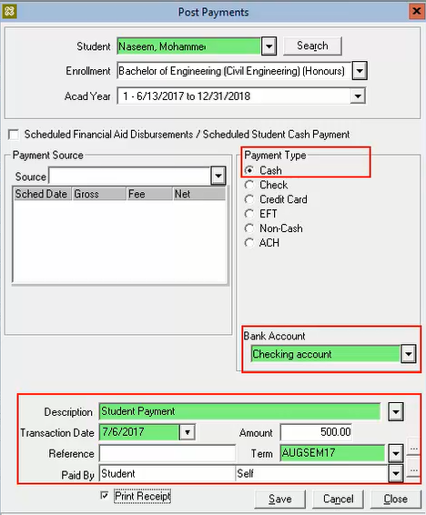
Interface:Posting Payments

*Payment Type, Bank Account must be specified

Interface: Typical Payment Receipt
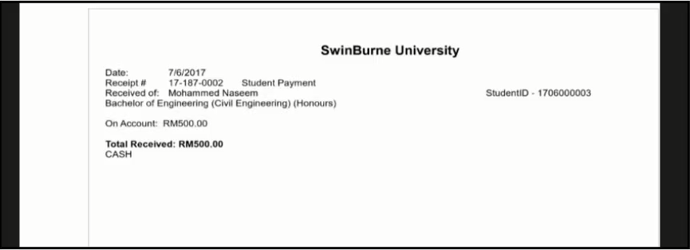

Interface: Posting Refund
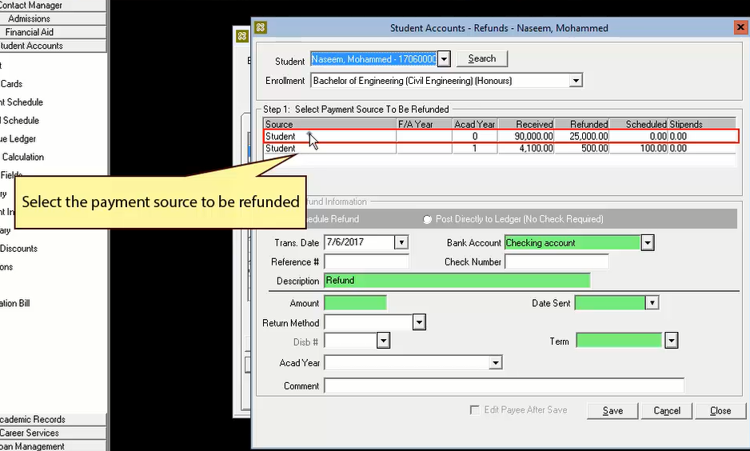

Interface: Posting Refund > Click Post Directly > Click Save > Message box displayed
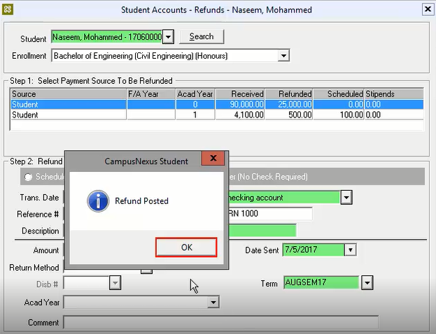
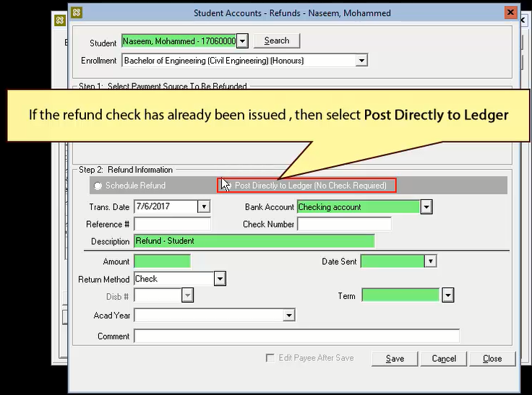

Interface : The refund that posted displayed in row
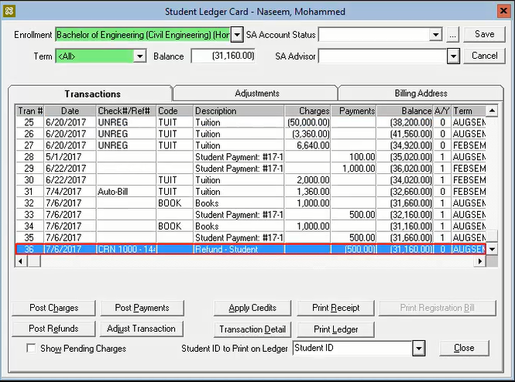

Interface: Adjusting Transactions
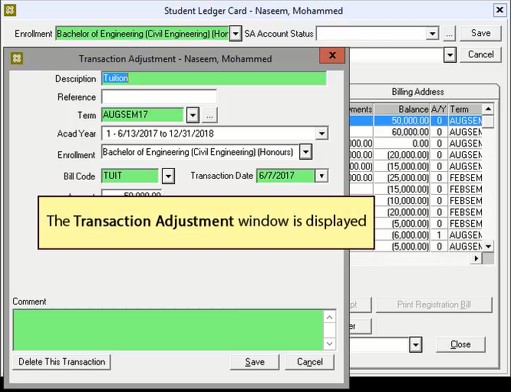

Interface: Scholarship Modules
Select the record and click Edit button.
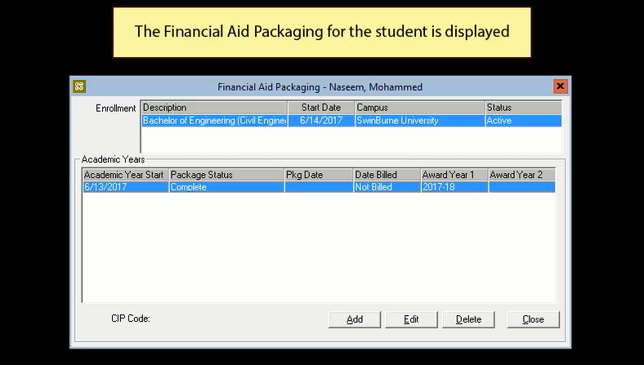

After specifying all the required details, click Save button.
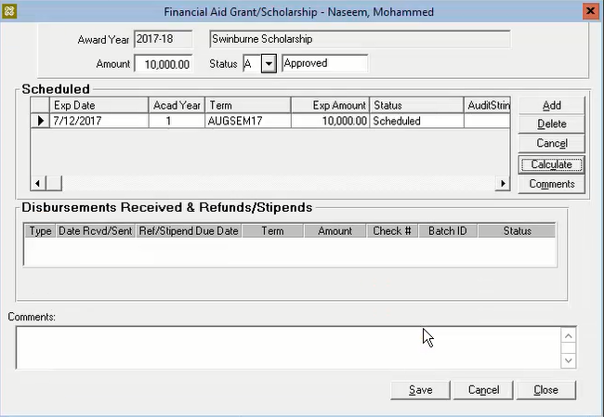
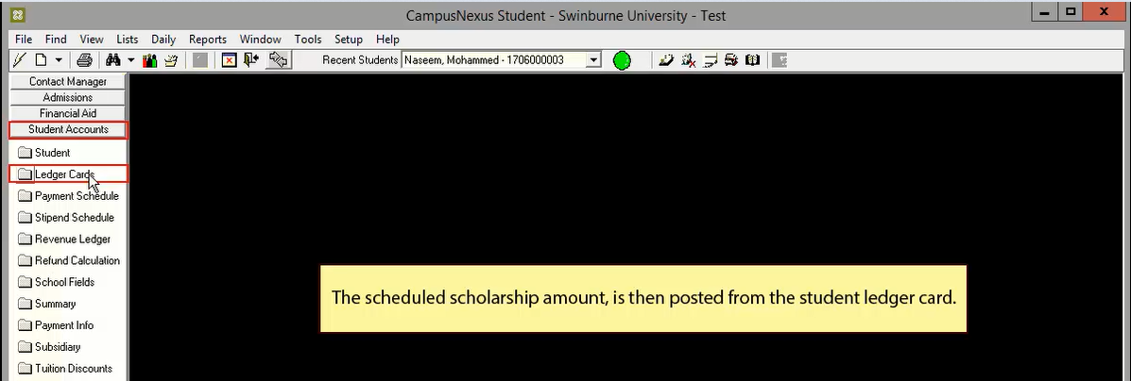

Interface: Ledger Card
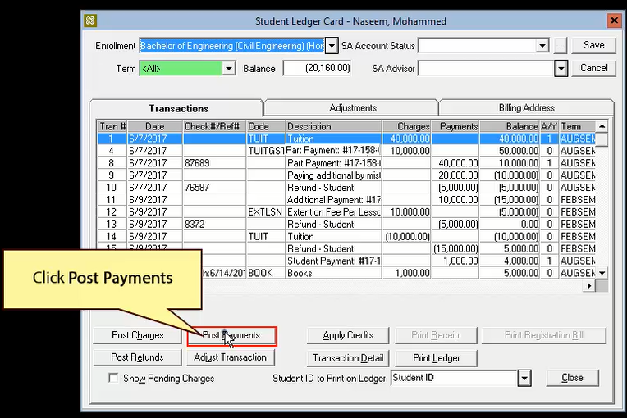

After specifying all the required details, click Save button.
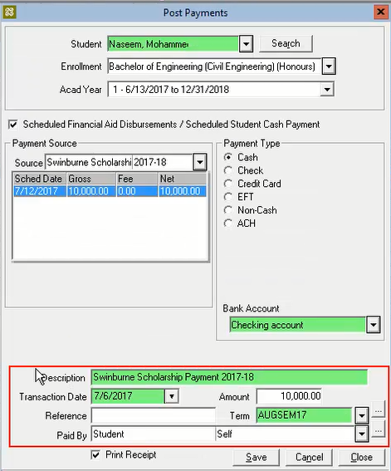

Installment: Posting scheduled fee payments
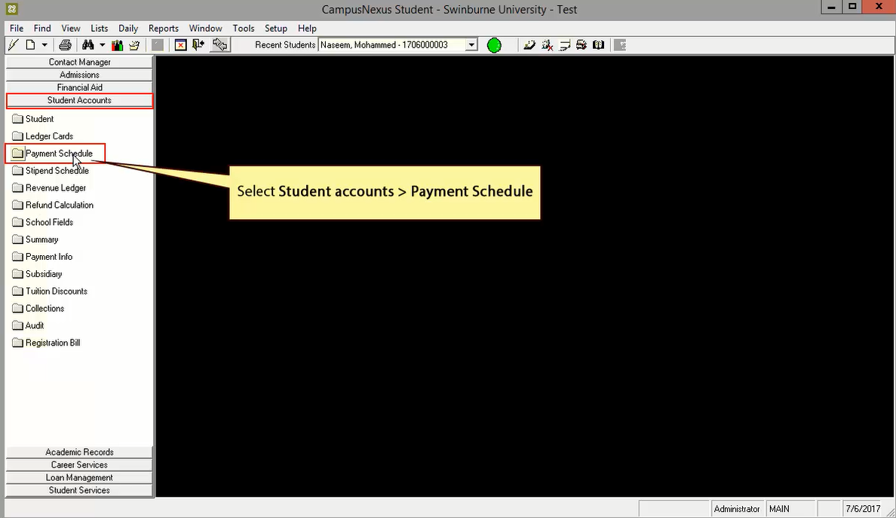

Installment: Posting scheduled fee payments
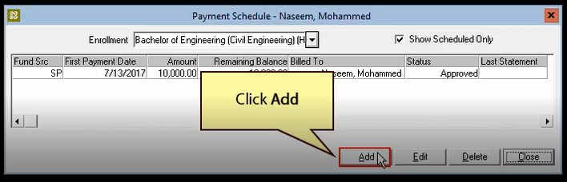
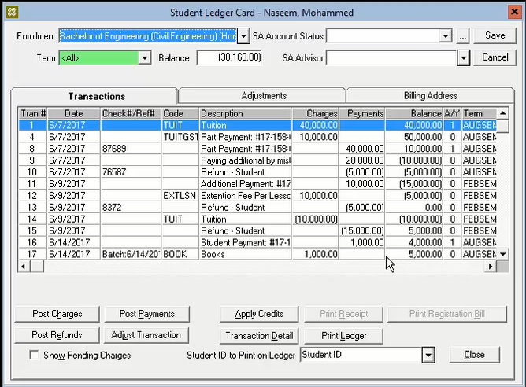
Tuition Discount
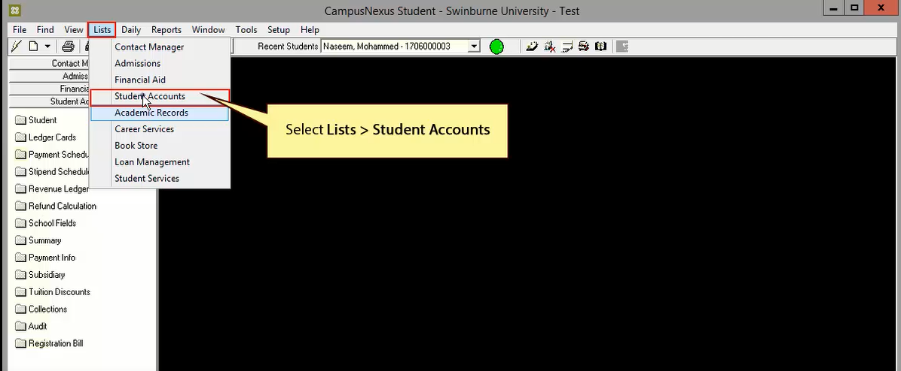
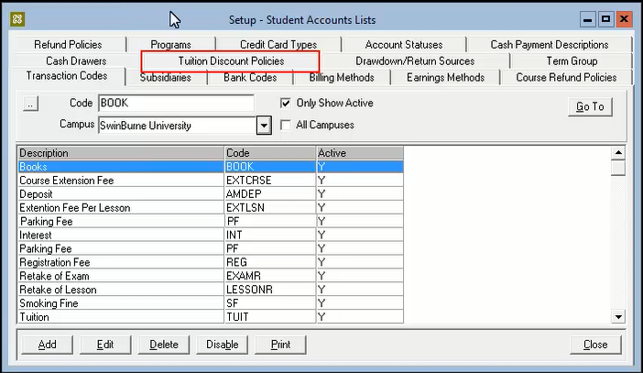
Click Add button. After specifying all the required details, click Save button.
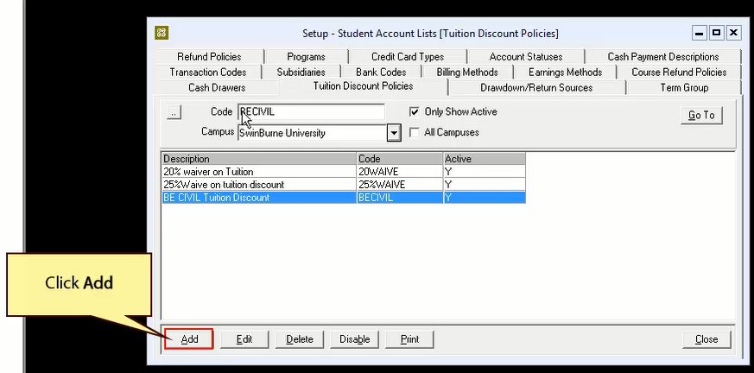
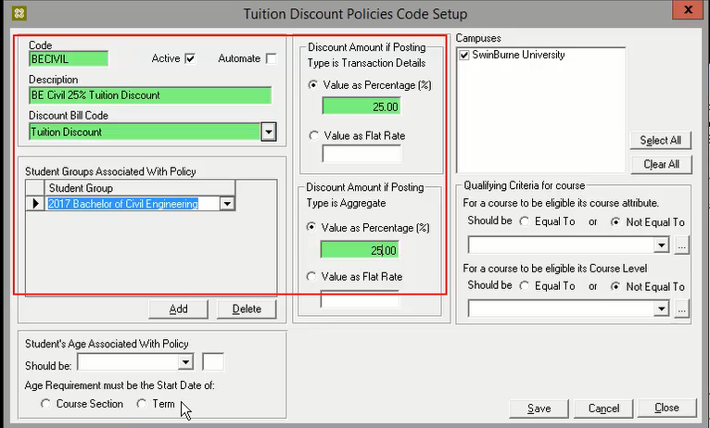
Interface: Daily>Student Accounts>Process Tuition Discounts
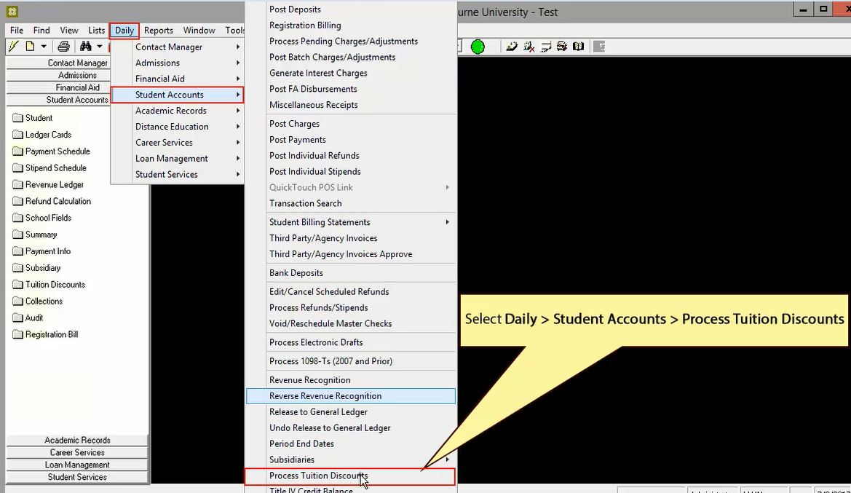

Interface: Process Tuition Discounts
