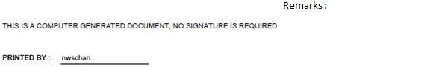
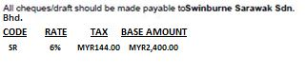
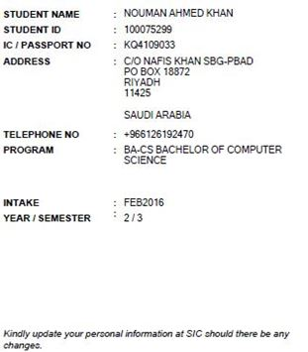
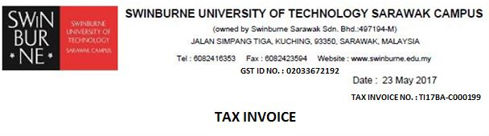
TUITION FEE SR 2,400.00 8,400.00
FEE CHARGED
MYR@3.50
FEE CHARGED
USD
TAX CODE
PARTICULARS
TOTAL 2,400.00 8,400.00
DISCOUNT (0.00) (0.00)
2,400.00 8,400.00
ADD: GST (6%) 144.00 504.00
GRAND TOTAL 3,544.00 8,904.00

E

