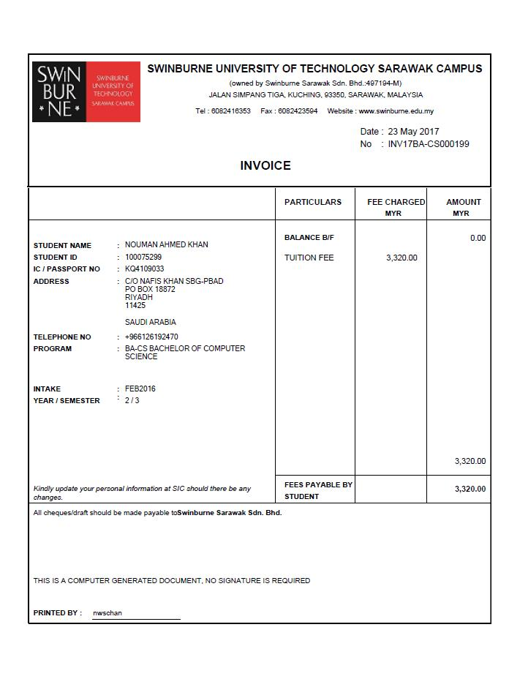
Remarks :
TAX INVOICE
GRAND TOTAL

TUITION FEE
2,400.00
PARTICULARS
FEE CHARGED MYR
TAX CODE

Bhd.

SR

TOTAL

ADD: GST(6%)
144.00
CODE
SR
RATE
6%
TAX
MYR144.00
BASE AMOUNT
MYR2,400.00
GST ID NO. : 02033672192
TAX INVOICE NO. : TI17BA-C000199
2,544.00
2,400.00
(0.00)
DISCOUNT
2,400.00

FEE CHARGED MYR
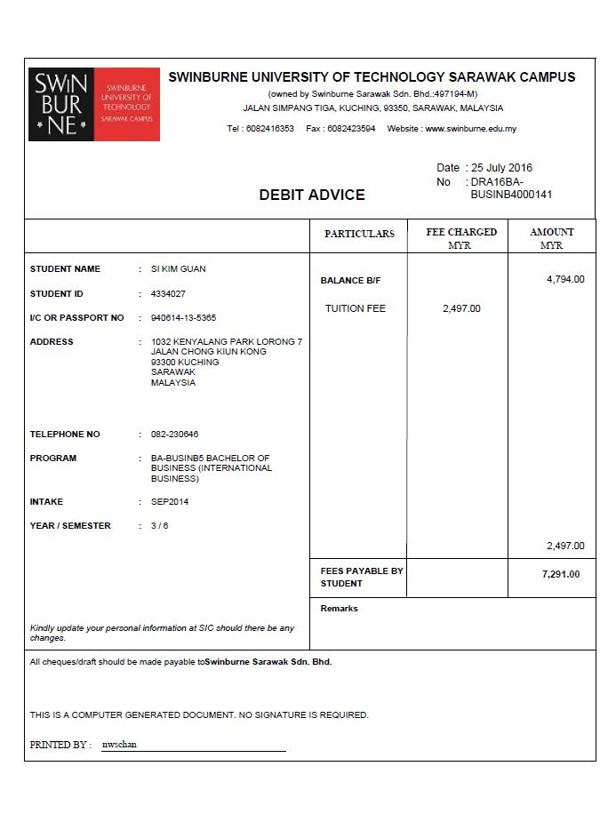
GST ID NO. : 02033672192
TAX DEBIT NOTE NO. : TDN17ACCA00001
TAX DEBIT NOTE

FEE CHARGED MYR
TAX CODE

TAX CODE
FEE CHARGED MYR
PARTICULARS
TUITION FEE-ADD SUBJECT
2,400.00
SR
CODE
RATE
TAX
BASE AMOUNT
SR
6%
RM144.00
RM2,400.00
REMARKS: ADD SUBJECT
TOTAL
ADD: GST(6%)
GRAND TOTAL
144.00
2,400.00
2,544.00
(0.00)
2,400.00
DISCOUNT
TAX INVOICE DATE. : 23 May 2016
TAX INVOICE NO. : TI17BA-C000199

CODE
EX
RATE
0%
TAX
RM0.00
SALE AMOUNT
RM3,320.00
MEMO:
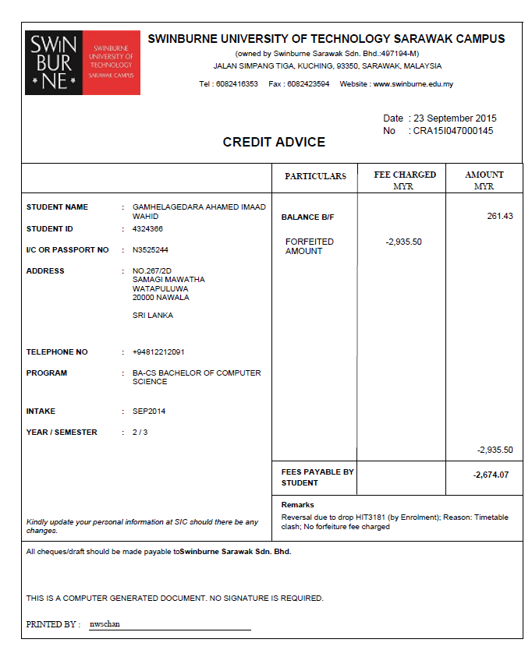

GST ID NO. : 02033672192
TAX CREDIT NOTE

FEE CHARGED MYR
TAX CODE

TAX CODE
FEE CHARGED MYR
PARTICULARS
TUITION FEE-DISCOUNT
1,200.00
SR
CODE
RATE
TAX
BASE AMOUNT
SR
6%
RM72.00
RM1,200.00
REMARKS: DISCOUNT
TOTAL
ADD: GST(6%)
GRAND TOTAL
72.00
1,272.00
1,200.00
TAX CREDIT NOTE NO. : TCN17ACCA00001
1,200.00
(0.00)
DISCOUNT
TAX INVOICE DATE. : 23 May 2016
TAX INVOICE NO. : TI17BA-C000199

REMARKS:
GRAND TOTAL

SOUVENIRS
600.00
PARTICULARS
FEE CHARGED MYR
TAX CODE

Bhd.

SR

TOTAL

ADD: GST(6%)
36.00
CODE
SR
RATE
6%
TAX
MYR36.00
BASE AMOUNT
MYR600.00
736.00
700.00
(0.00)
DISCOUNT
MISC. TAX NVOICE NO. : MTI000001
MISCELLANOUS TAX INVOICE
MYR100.00
MYR0.00
0%
ZRL
SALES OF TEXTBOOKS
ZRL
100.00
700.00

GST ID NO. : 02033672192

FEE CHARGED MYR
GST ID NO. : 02033672192
MISC. DEBIT NOTE NO. : MDN00001
MISCELLANOUS DEBIT NOTE

FEE CHARGED MYR
TAX CODE

TAX CODE
FEE CHARGED MYR
PARTICULARS
SALES OF TEXTBOOKS – ADD TEXTBOOK
200.00
ZRL
CODE
RATE
TAX
BASE AMOUNT
ZRL
0%
RM0.00
RM200.00
REMARKS: ADD TEXT BOOK
TOTAL
ADD: GST(6%)
GRAND TOTAL
0.00
200.00
200.00
MISC. TAX INVOICE NO. : MTI000001
200.00
(0.00)
DISCOUNT
MISC. TAX INVOICE DATE. : 23 May 2017

CODE
EX
RATE
0%
TAX
RM0.00
SALE AMOUNT
RM3,320.00
MEMO:

GST ID NO. : 02033672192

FEE CHARGED MYR
TAX CODE

TAX CODE
FEE CHARGED MYR
PARTICULARS
RETURN OF SOUVENIRS
50.00
SR
CODE
RATE
TAX
BASE AMOUNT
SR
6%
RM3.00
RM50.00
REMARKS : RETURN OF GOODS
TOTAL
ADD: GST(6%)
GRAND TOTAL
3.00
53.00
50.00
MISC. CREDIT NOTE NO. : MCN00001
MISC. TAX INVOICE NO. : MTI000001
50.00
(0.00)
DISCOUNT
MISC. TAX INVOICE DATE. : 23 May 2017
MISCELLANOUS CREDIT NOTE

GST ID NO. : 02033672192
SIMPL. TAX INVOICE NO. : STI000001
SIMPLIFIED TAX INVOICE

FEE CHARGED MYR
TAX CODE

TAX CODE
FEE CHARGED MYR
PARTICULARS
GRADUATION FEE – EXTRA TICKET
100.00
SR
CODE
RATE
TAX
BASE AMOUNT
SR
6%
RM6.00
RM100.00
REMARKS:
TOTAL
ADD: GST(6%)
GRAND TOTAL
6.00
250.00
256.00
250.00
(0.00)
DISCOUNT
RM250.00
RM0.00
0%
ES
ES
250.00
GRADUATION FEE

CODE
EX
RATE
0%
TAX
RM0.00
SALE AMOUNT
RM3,320.00
MEMO:

GRAND TOTAL

Bhd.

TOTAL

REMARKS:
3,320.00
DISCOUNT
(0.00)
3,320.00
3,320.00

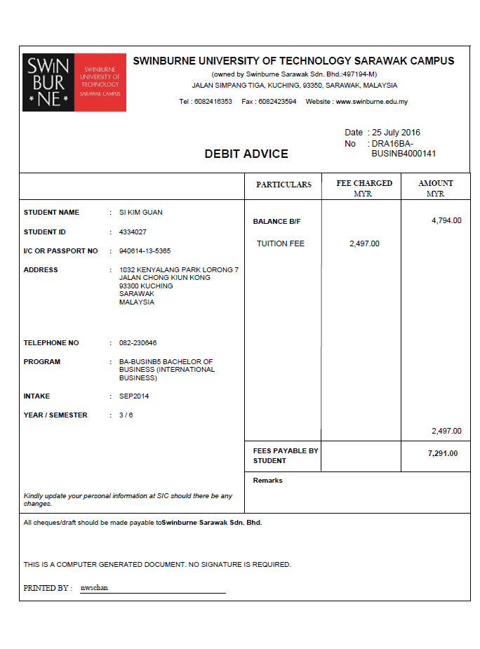
Date : 25 July 2017
Debit Note No. DRA16BA-
Invoice Date : 23 May 2017
Invoice No:INV17BA-CS0199
GRAND TOTAL

TOTAL

REMARKS: ADD SGUBJECT
(0.00)
DISCOUNT
2,497.00
DEBIT NOTE

2,497.00
2,497.00
Date : 27 July 2017
Debit Note No. CRA15104700
Invoice Date : 23 May 2017
Invoice No:INV17BA-CS0199
CRA15104700
0145
GRAND TOTAL

TOTAL

REMARKS:
Reverse due to drop HIT3181(by Enrolment)
Reason: Timeable clash; No forfeiture fee charges
2,935.50
2,935.50
(0.00)
DISCOUNT
2,935.50
FORFEITED
AMOUNT
CREDIT NOTE
2,935.50

