

Solution Design Document
(Sponsors – Student Accounts)

Version : 1.0

Document History
Document Name | Version
Solution Design Document - Sponsors | V1.0

Contributors
Name | Position
Srikanth Reddy Bala | Senior Implementation Engineer

Reviewers
Name | Position
Mohan Raj | Manager - Development

Revision History
Date | Author | Version | Change Reference
28/12/2018 | Srikanth Reddy Bala | V1.0

- Create Sponsor

- Navigate to Configuration tile – Student Accounts in the campus nexus student accounts system
- Click Sponsor from the left pane under the Student accounts

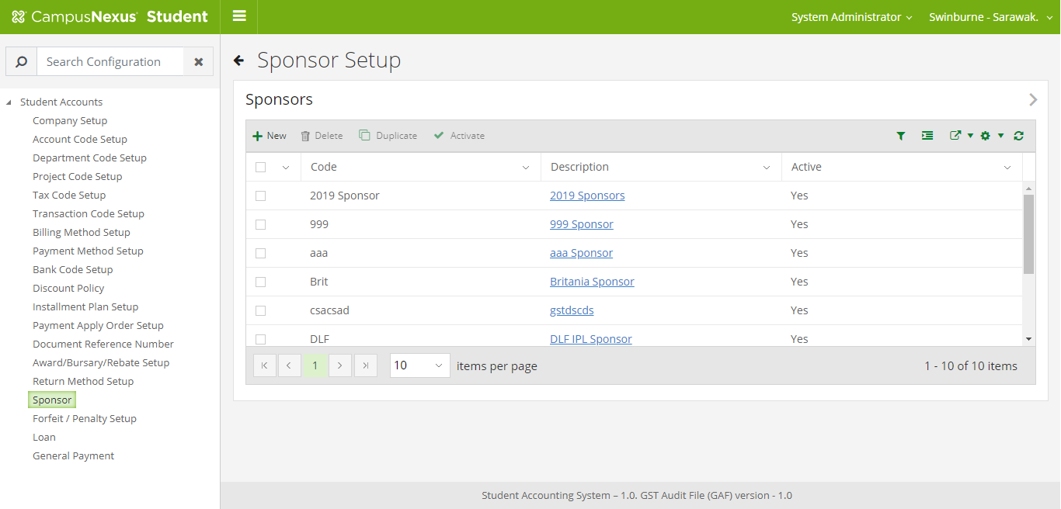

- Click New to create a New Sponsor
- Enter the Code and Description
- Click Save button to save the sponsor details

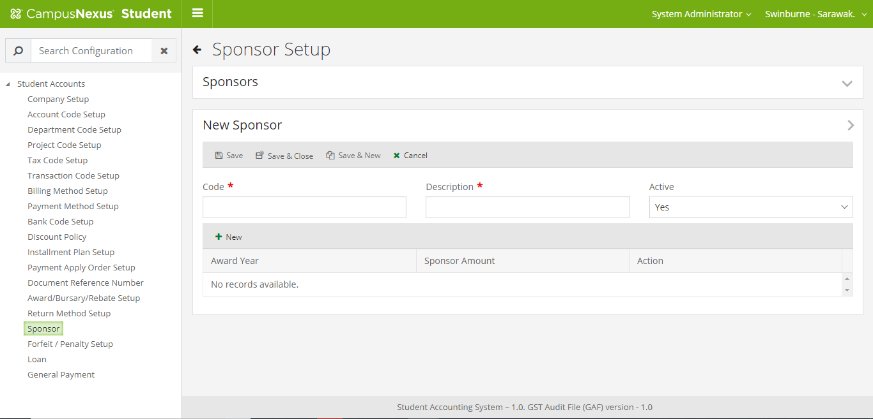

- Configure Sponsor Amount

- Click New button at the bottom grid
- Enter Award Year from the dropdown.
- Enter the Sponsor Amount and other details
- Click Save button

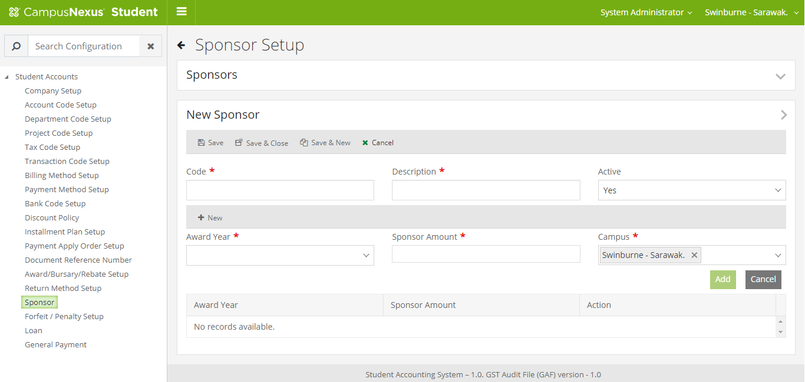

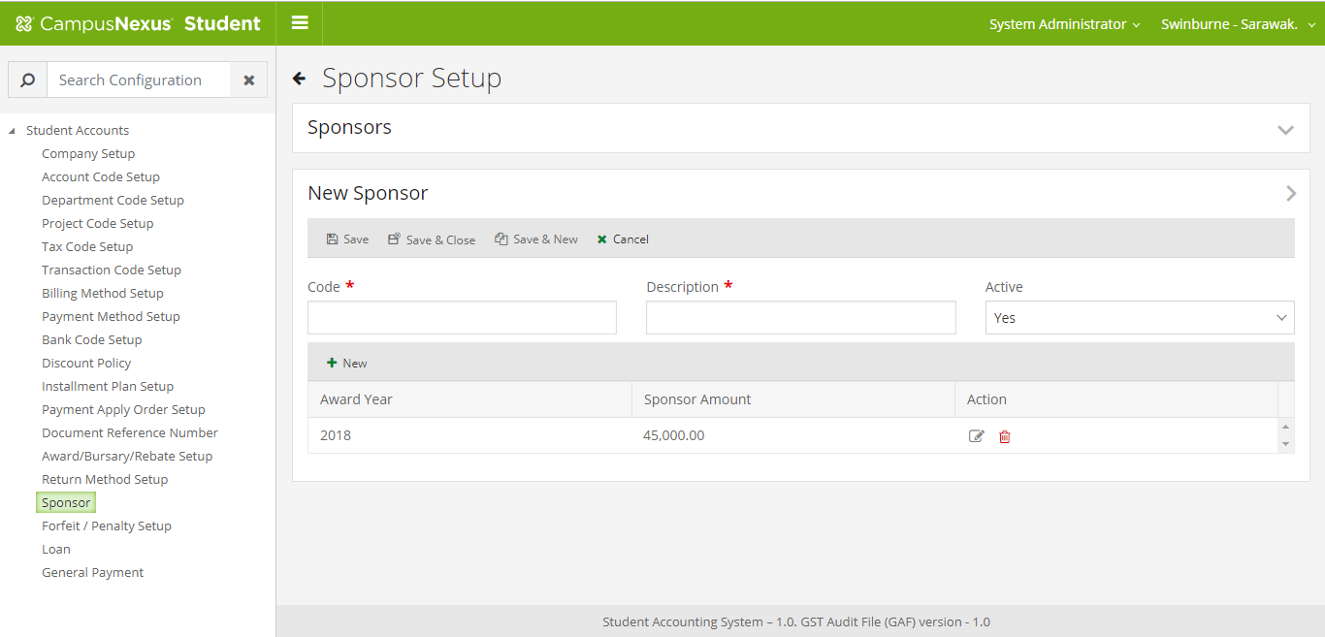

- Tag a Student to sponsor

  - Open a student record and Click Sponsors tile under the student accounts from the right panel

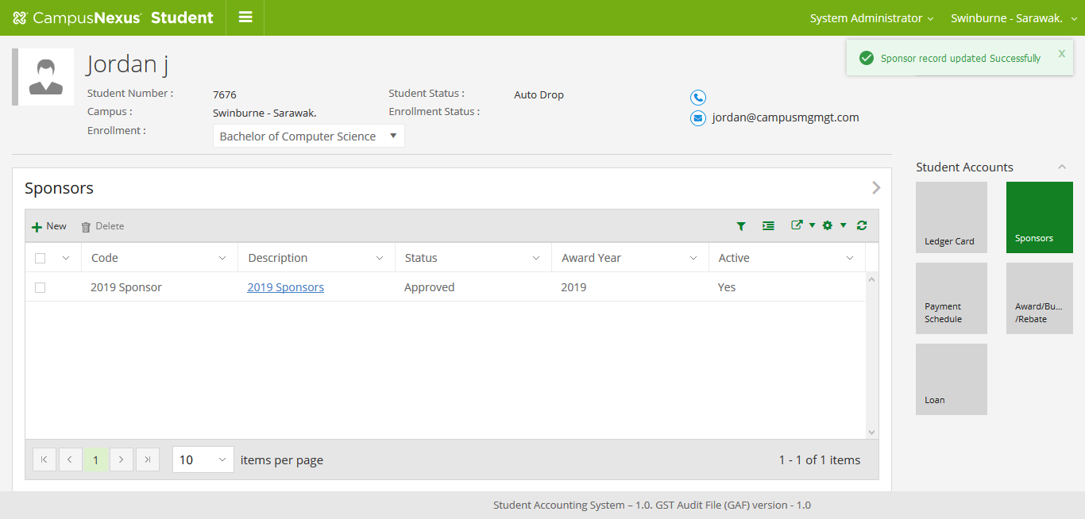

  - Click New button at sponsor grid
  - Select the Sponsor from the dropdown
  - Enter the Amount to be sponsored to the student in the sponsor amount field. (This amount should not be more than the sponsor amount entered in the configuration screen)
  - Remaining sponsor amount is a non-editable field, it will be updated automatically. (Remaining Sponsor Amount = Total sponsor amount entered in the configuration screen – Sum of the sponsor amount for all the students with the approved status)
  - Approved sponsor amount is a non-editable field, it will be updated automatically. (Approved Sponsor Amount is the sum of the amounts with the Approved status for all the students under the selected sponsor)
  - Estimated sponsor amount is a non-editable field, it will be updated automatically. (Estimated Sponsor Amount is the sum of the amounts with the Estimated status for all the students under the selected sponsor)
  - Click Save button

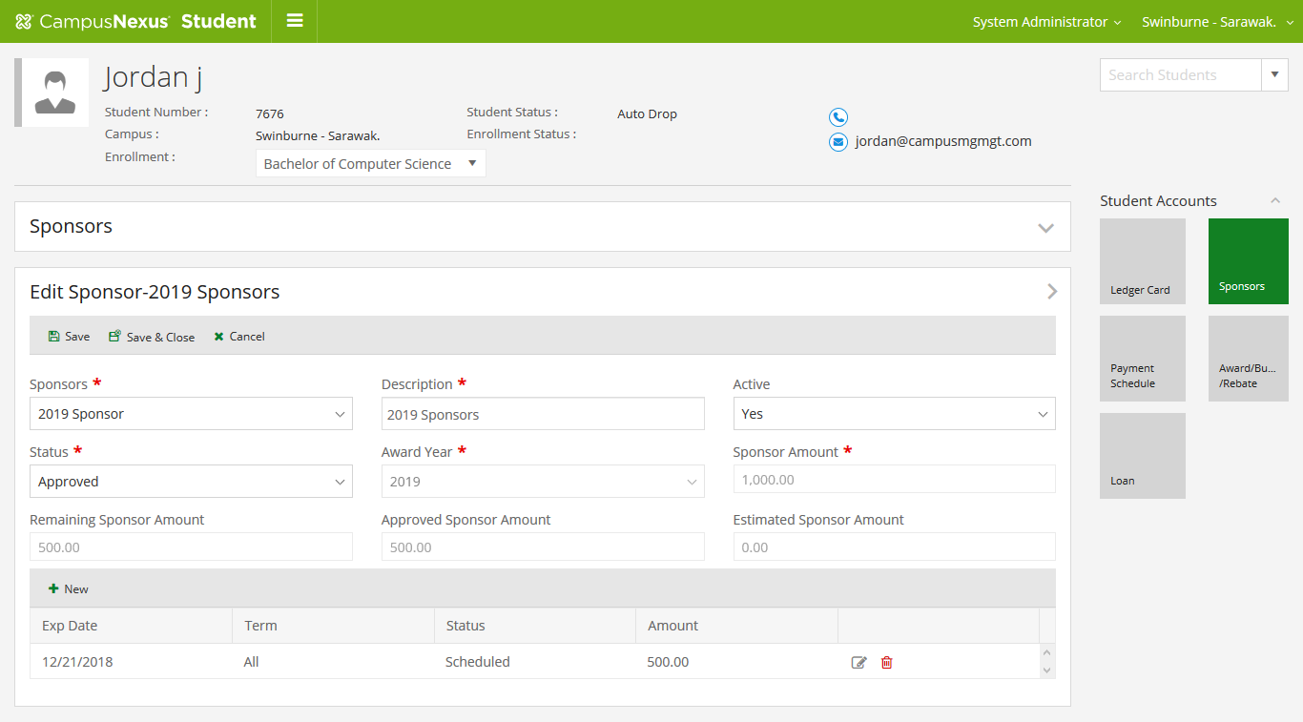

- Add schedule for the sponsor amount
  - Click New button in the bottom of the grid
  - Fill the date, term and amount fields
  - Click Save button to save the schedule

- Add sponsor Payment

  - Click Payment menu item in the student ledger screen
  - Select the payment type as scheduled FA disbursements
  - Select the Disbursement type as “Sponsor”
  - Select the schedule from the schedule disbursements dropdown
  - Enter the amount
  - Select Paid By as “Sponsor”
  - Click Save to make the payment

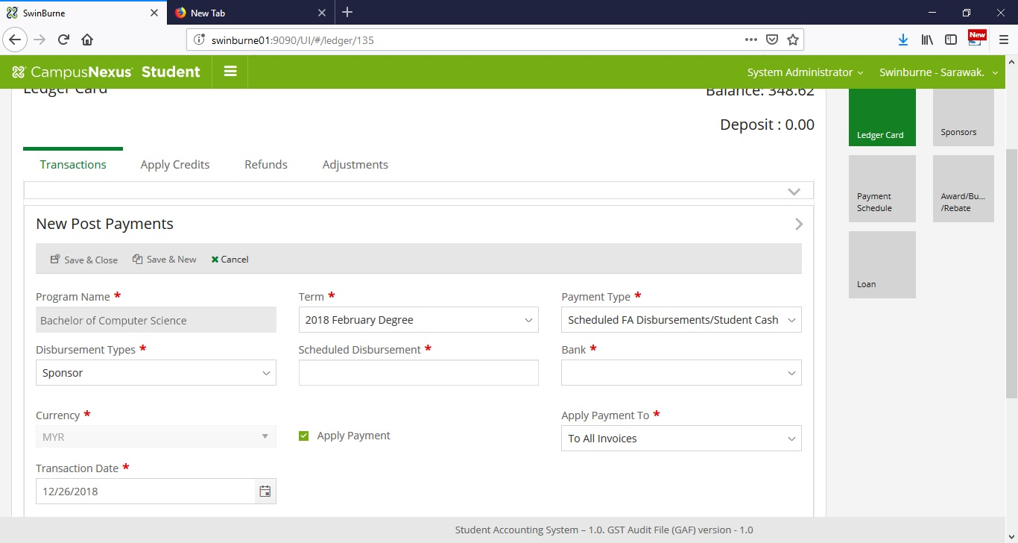

- Generate Group Invoice

  - Under the process menu, click “Sponsor Group Invoice” from left panel
  - A screen will appear the right side with sponsor dropdown, award year dropdown and the student list
  - Select the sponsor and the award year from the dropdowns

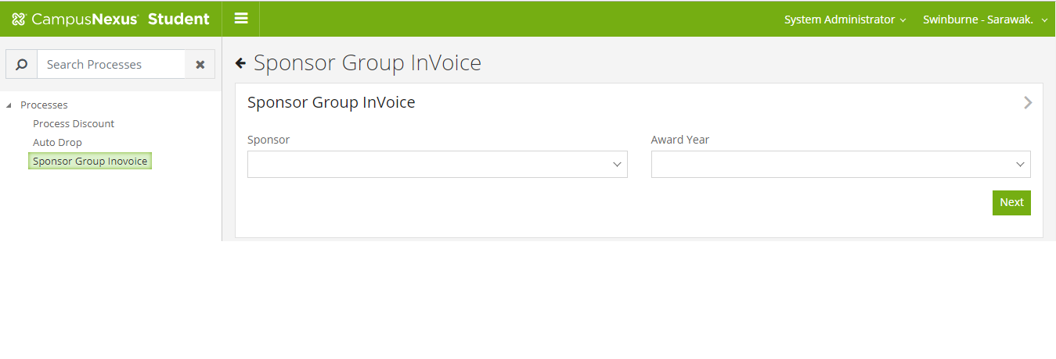

  - Click Next Button to open the grid to add /remove the students to the group invoice

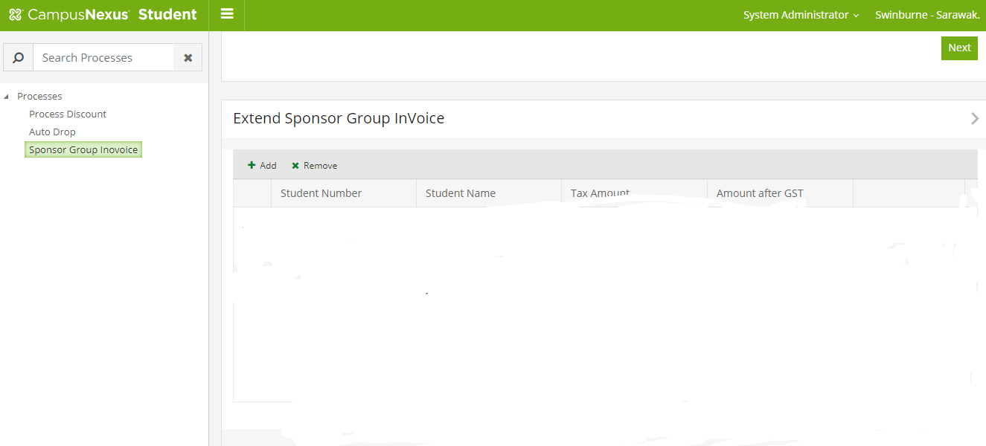

  - Click Add button at the top of the grid to open a popup window

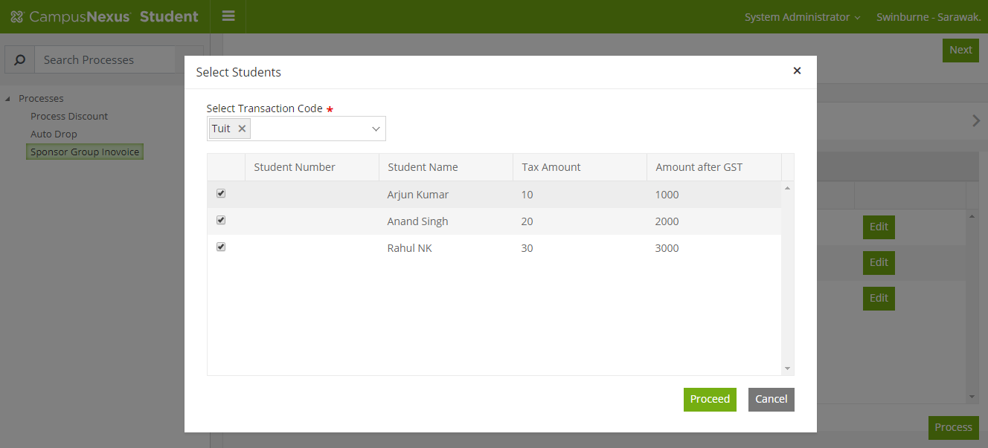

  - Select one or more transaction code to be included in the group invoice
  - Select one or more students from the grid
  - Click Proceed button to get back to previous screen
  - Click Edit button if required to edit the Amount and amount after GST
  - Click Edit button to edit the amount and tax before generating the group invoice
  - Click Process to generate group invoice
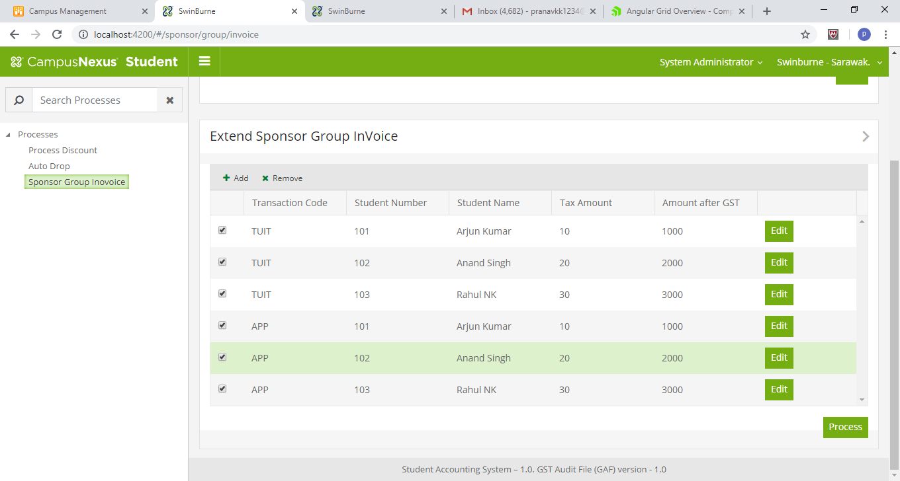
Sample Group Invoice

Group Invoice
Sponsor | Ranjith Singh
Award Year | 2018
Transaction Code | Student No | Student Name | Amount | Amount After GST
TUIT | 1 | Arjun Kumar | 1000 | 1100.00
TUIT | 2 | Anand Singh | 2000 | 2200.00
TUIT | 3 | Rahul NK | 3000 | 3300.00
Sub total |  |  |  | 6600.00
APP | 1 | Arjun Kumar | 100 | 110.00
APP | 2 | Anand Singh | 200 | 220.00
APP | 3 | Rahul NK | 300 | 330.00
Sub Total |  |  |  | 660.00
Grand Total |  |  |  | 7260.00

