
Student Accounts and GST Product screens

Introduction The purpose of this document is to showcase the UI design pattern we are going to follow for the development of the custom components and how it’s going to look finally. We have shown here the screenshots of major functionalities. We have created it based on the BRD we have signed. You can provide the feedback if needed.
Sr.No. | Functionality | UI Provided
1 | Company Set-up | Yes
2 | GST Setup - GST Code Table | Yes
3 | GST Setup -Tax Code used by Swinburne | Yes
4 | Mapping of GST Tax Codes with GST-03 Return | No
5 | Account Code Setup | No
6 | Department Code setup | No
7 | Project Code Setup | No
8 | Transaction Code setup | Yes
9 | Customer Setup | No
10 | Billing Method | Yes
11 | Student Ledger Setup | Yes
12 | Post Charges | Yes
13 | Post Payment | Yes
14 | Invoice | No
15 | Adjust Transaction | Yes
16 | Process Fee Discount | Yes
17 | Scholarship | Yes
18 | Reports | No
19 | Student Portal - Student Statement | No
20 | GAF Report | No
21 | Bad Debt | No
22 | Bad Debt Recovery | No
23 | Deposit / Advance Payment Received | No

Login Screen
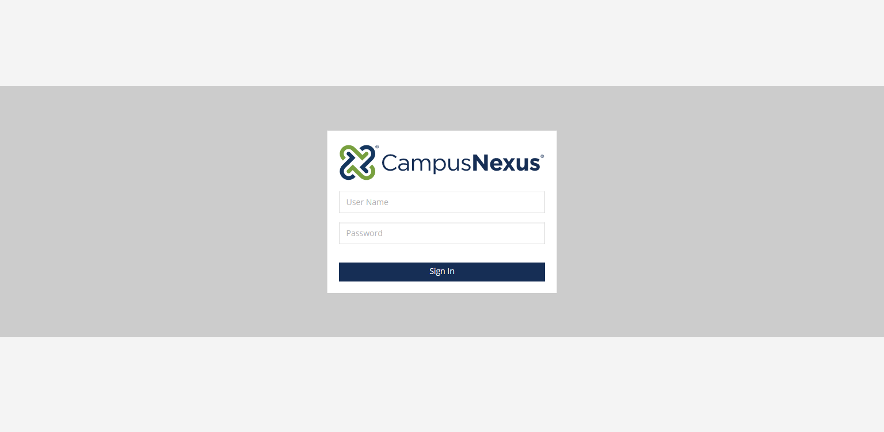
Student Accounts dashboard

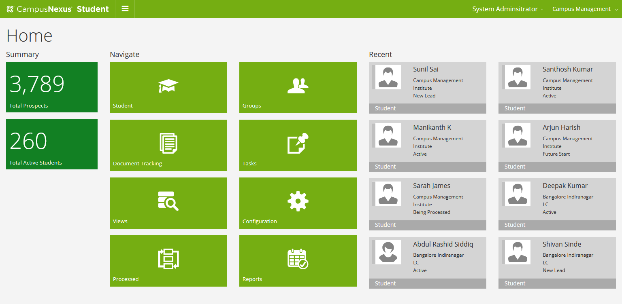

Configuration and Master data setting -->
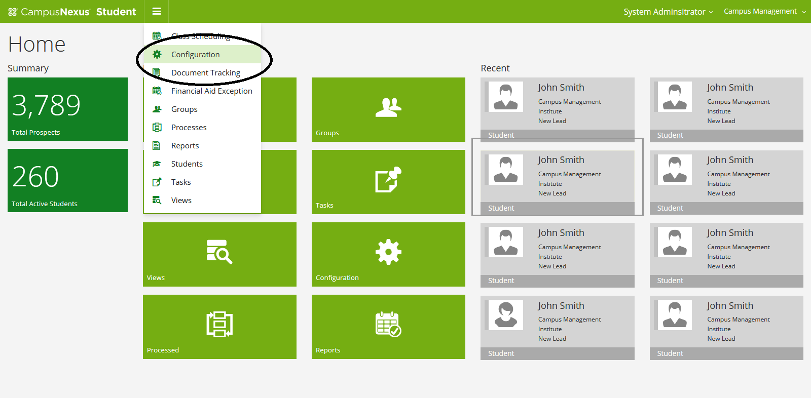

Company Setup
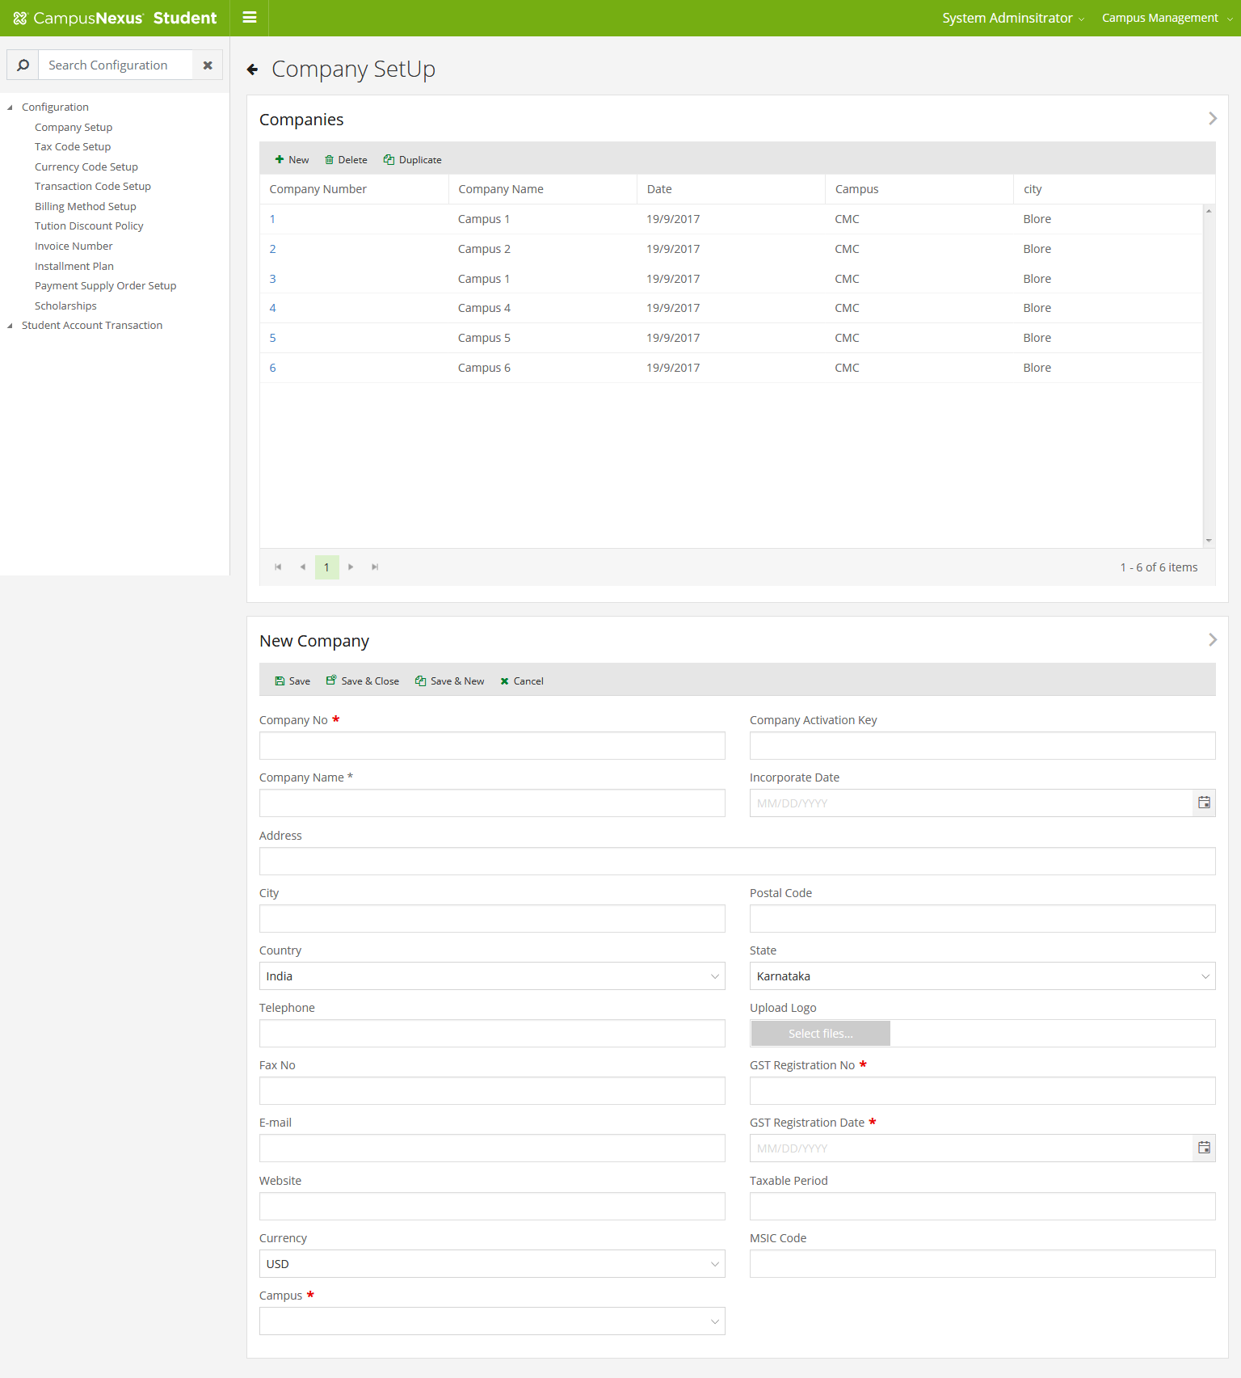

Tax Code set up
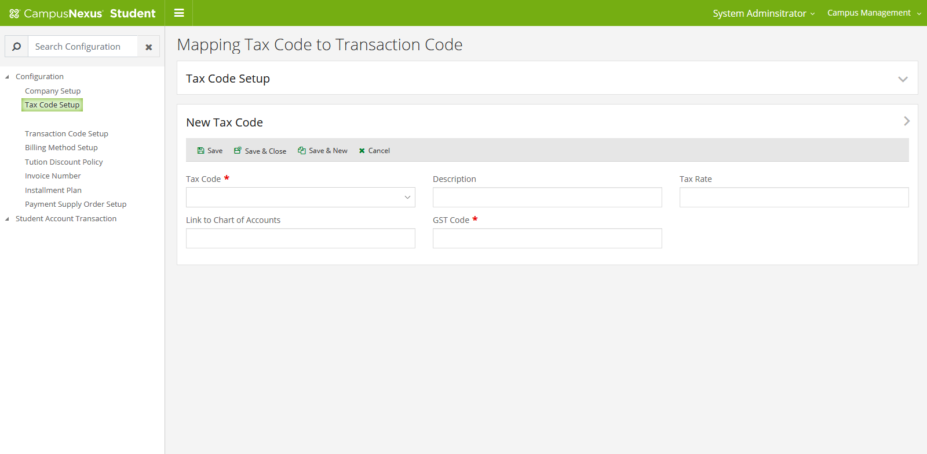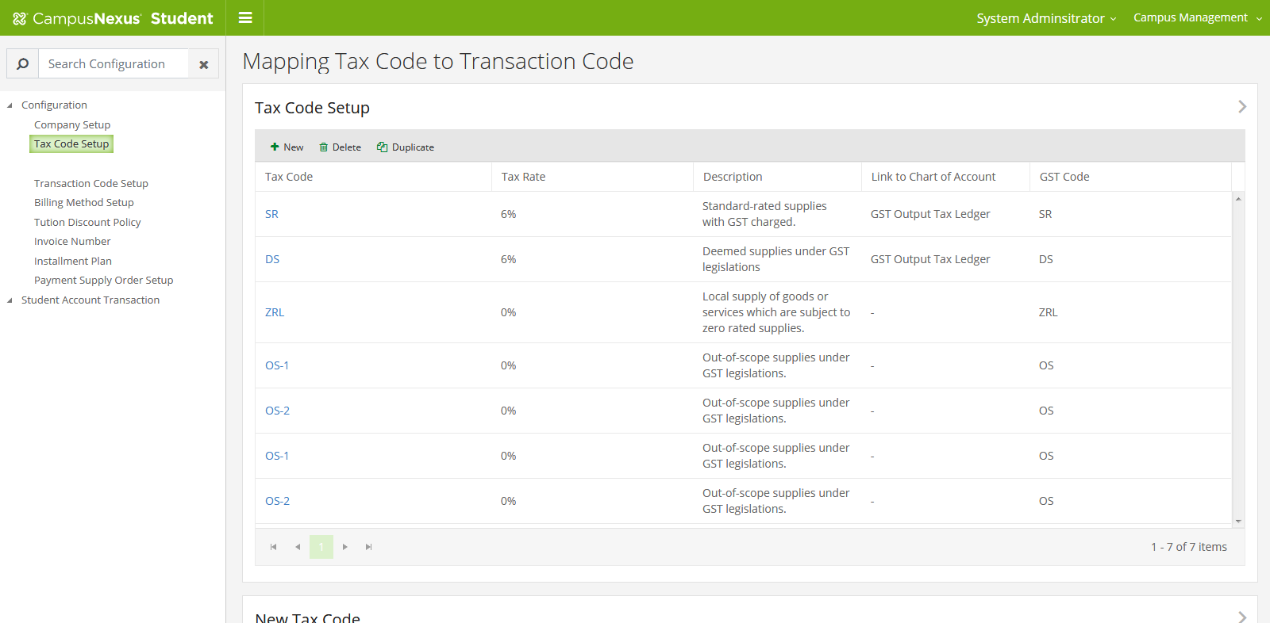

Transaction Code setup
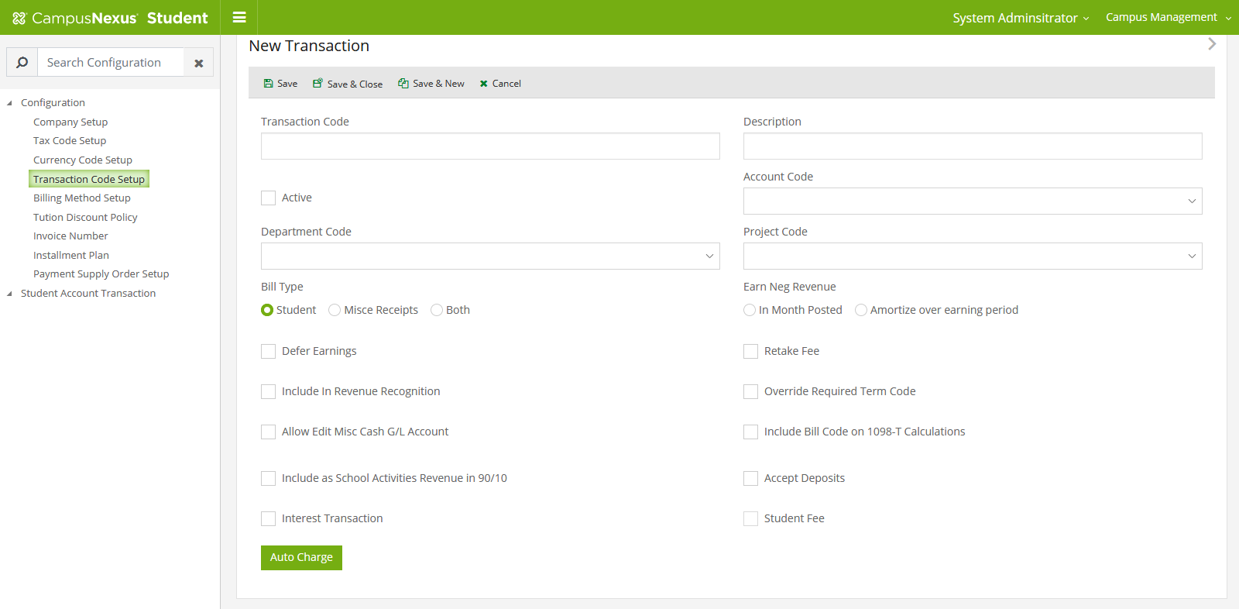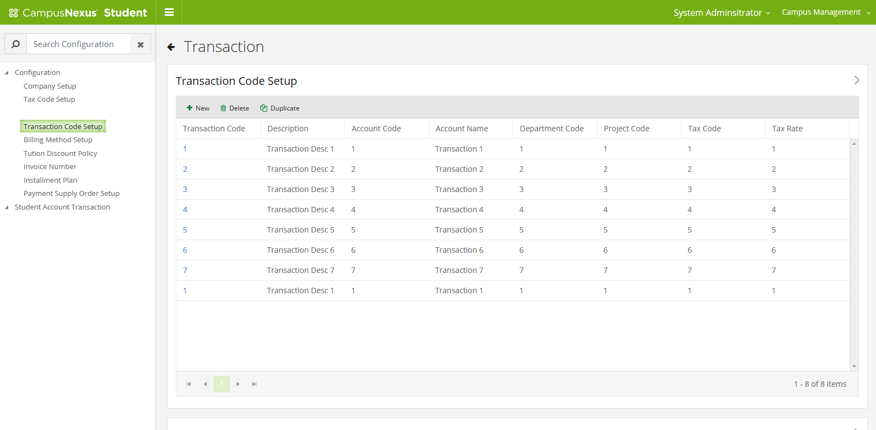

Billing Method Configuration
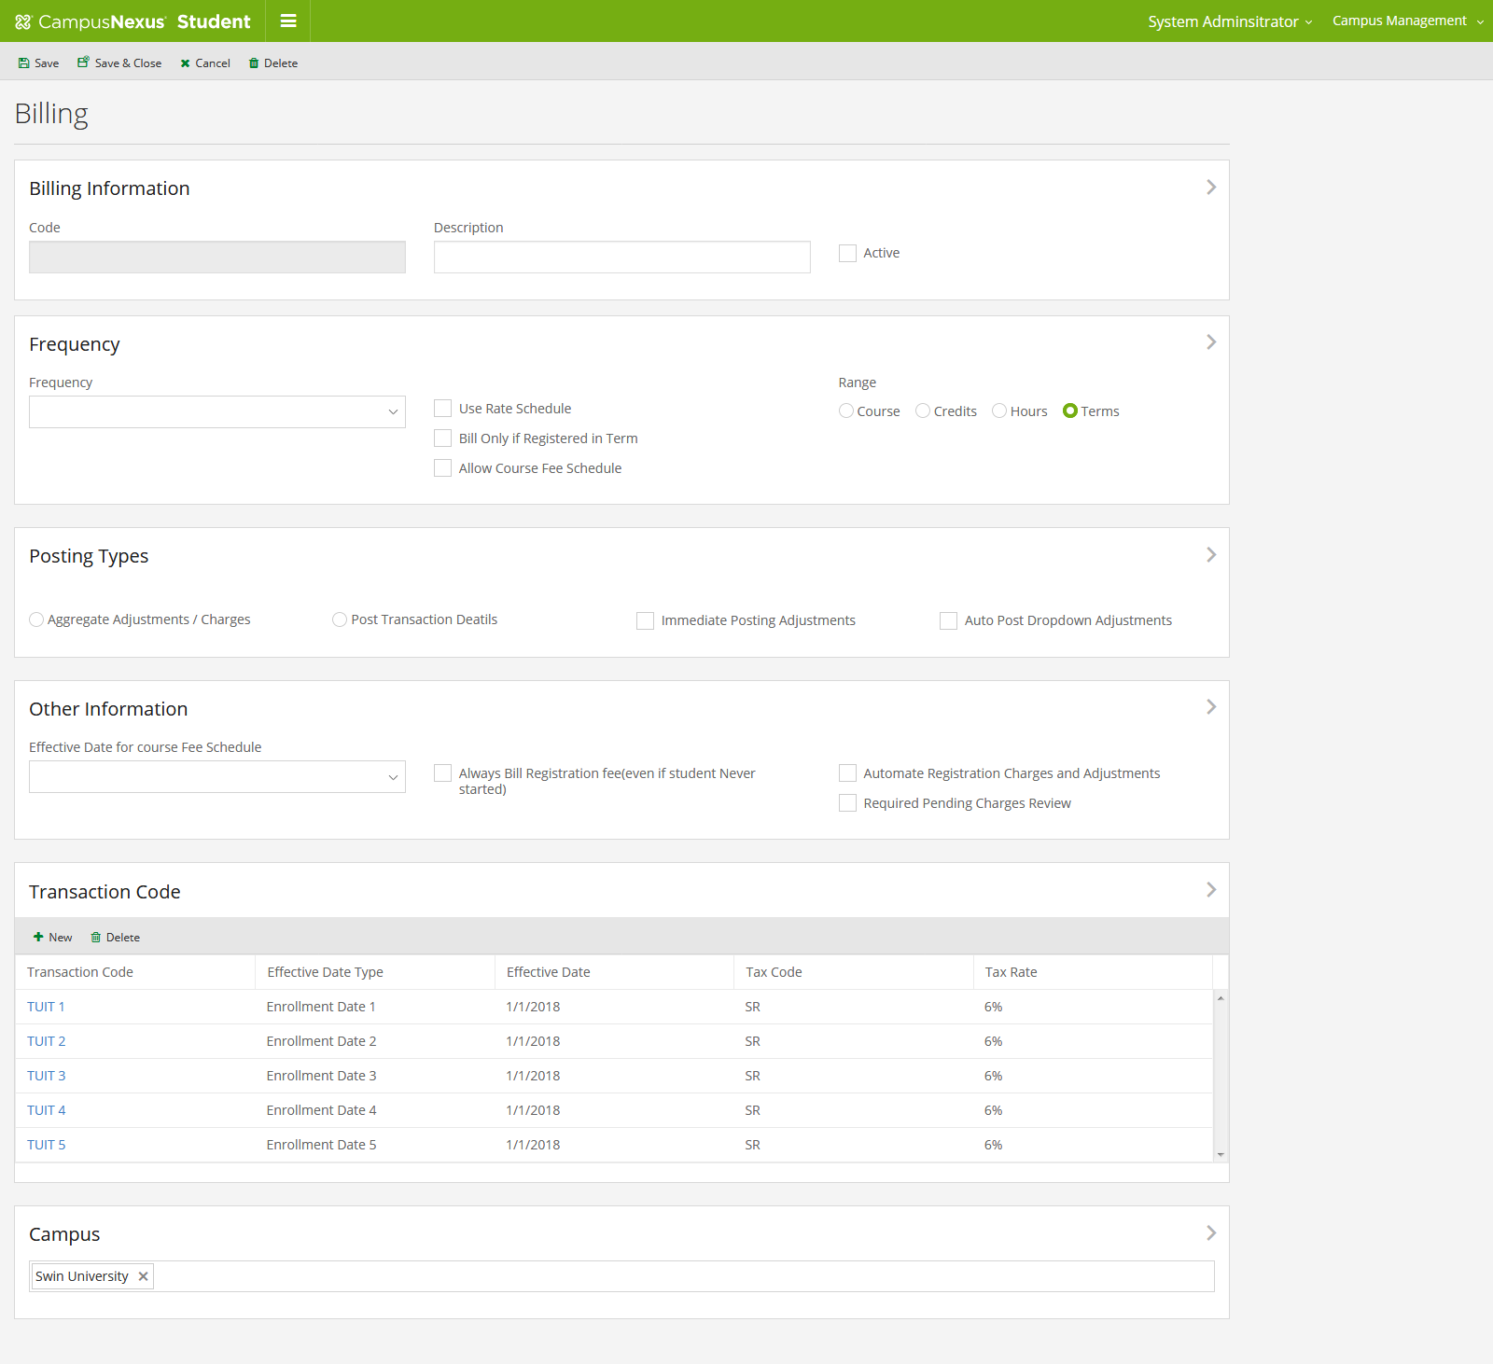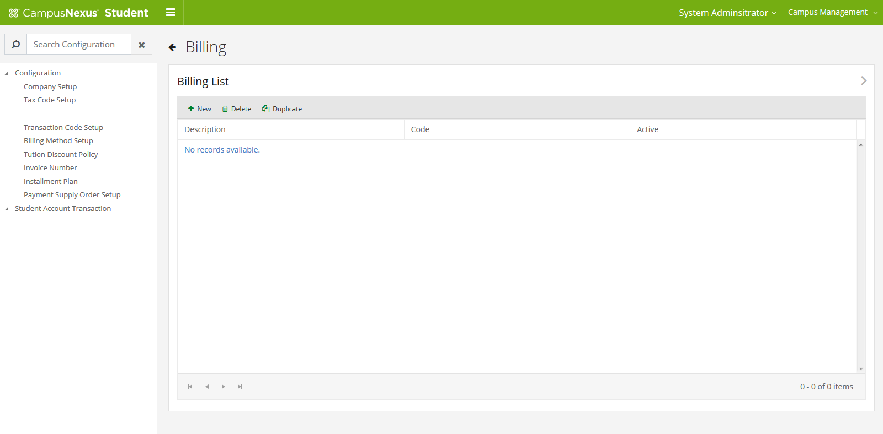
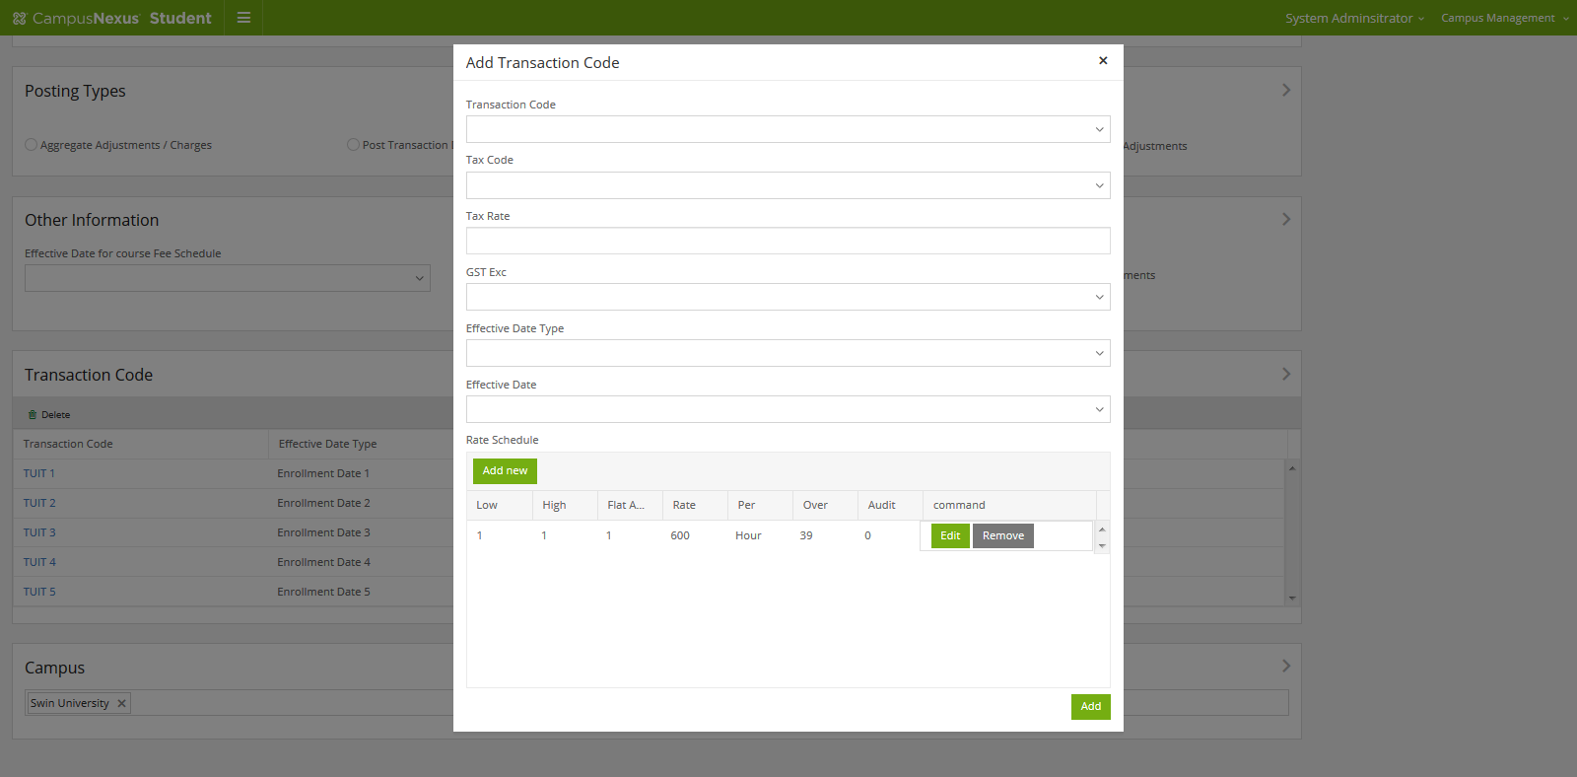
Tuition Discount
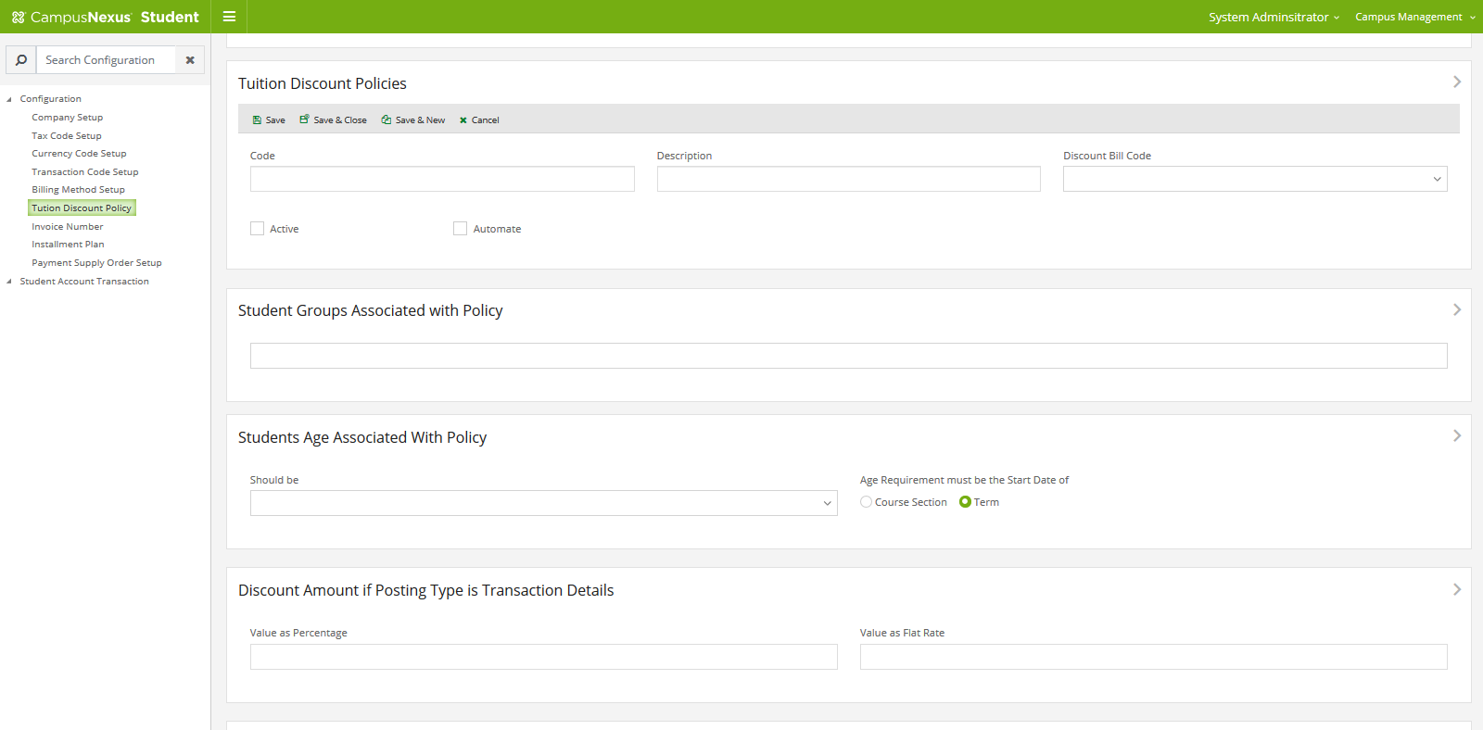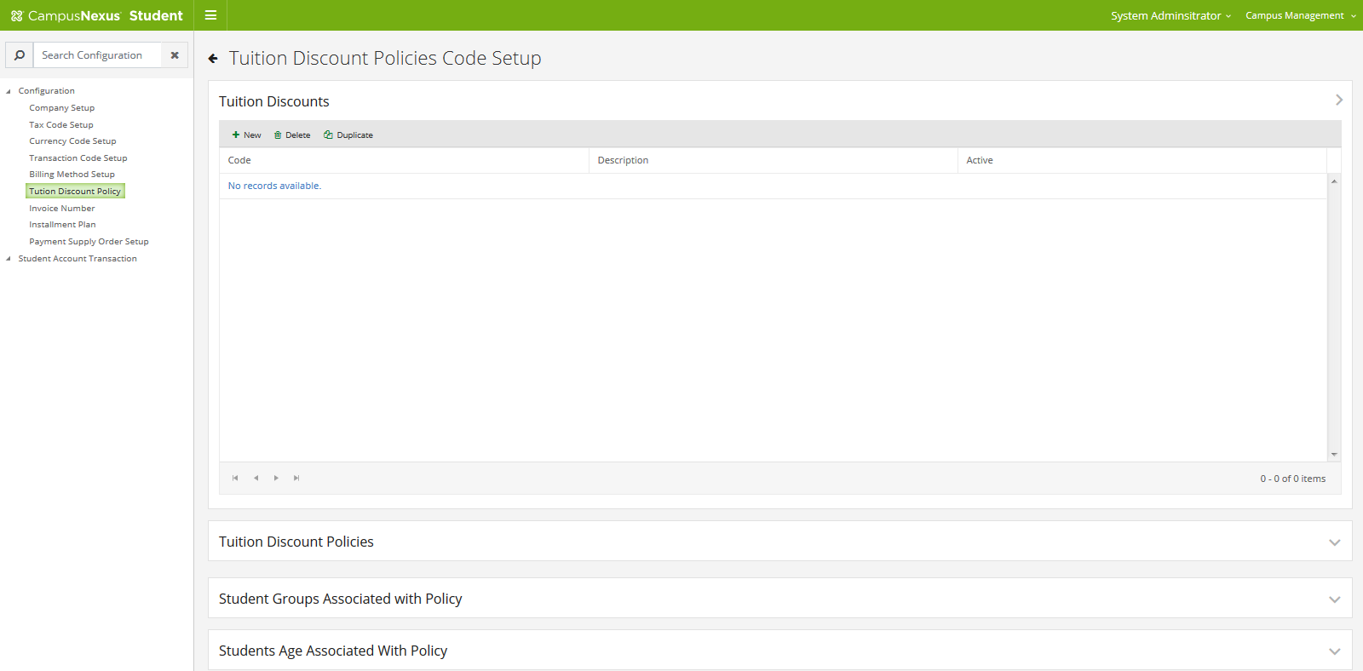

Loan Management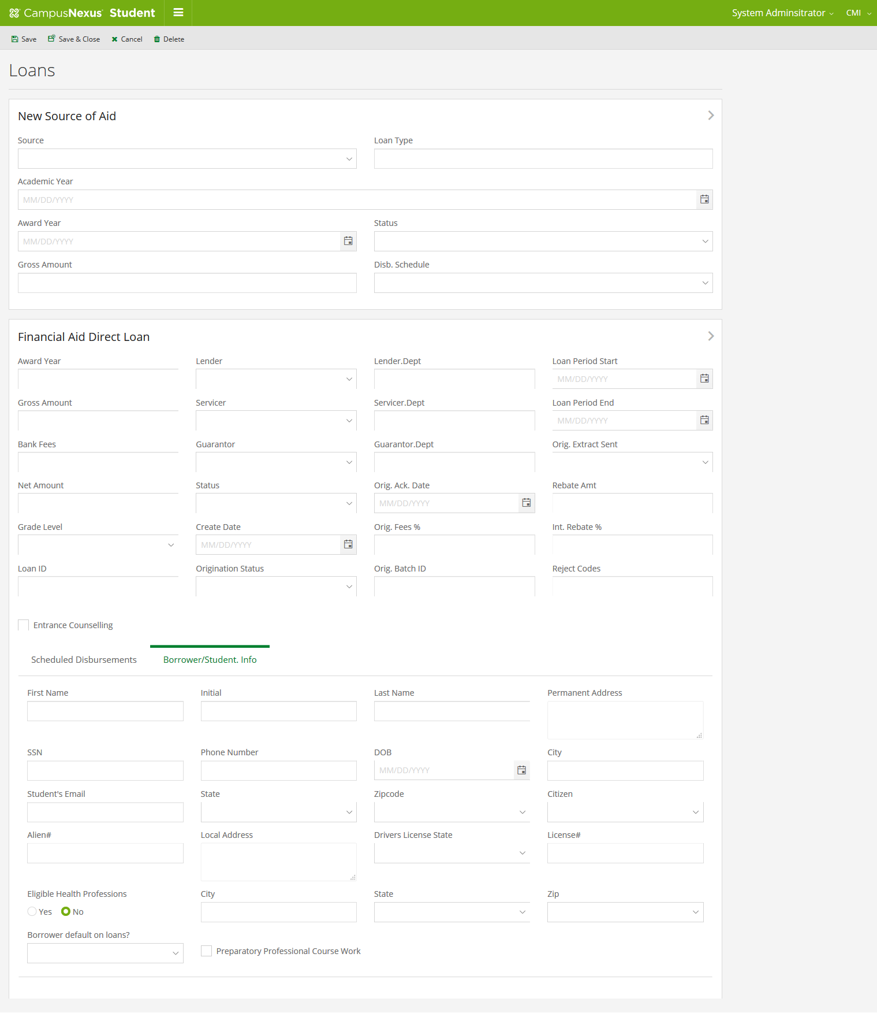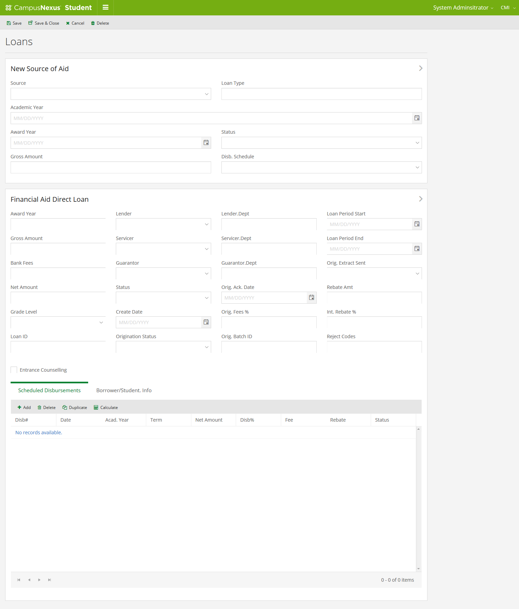

Instalment
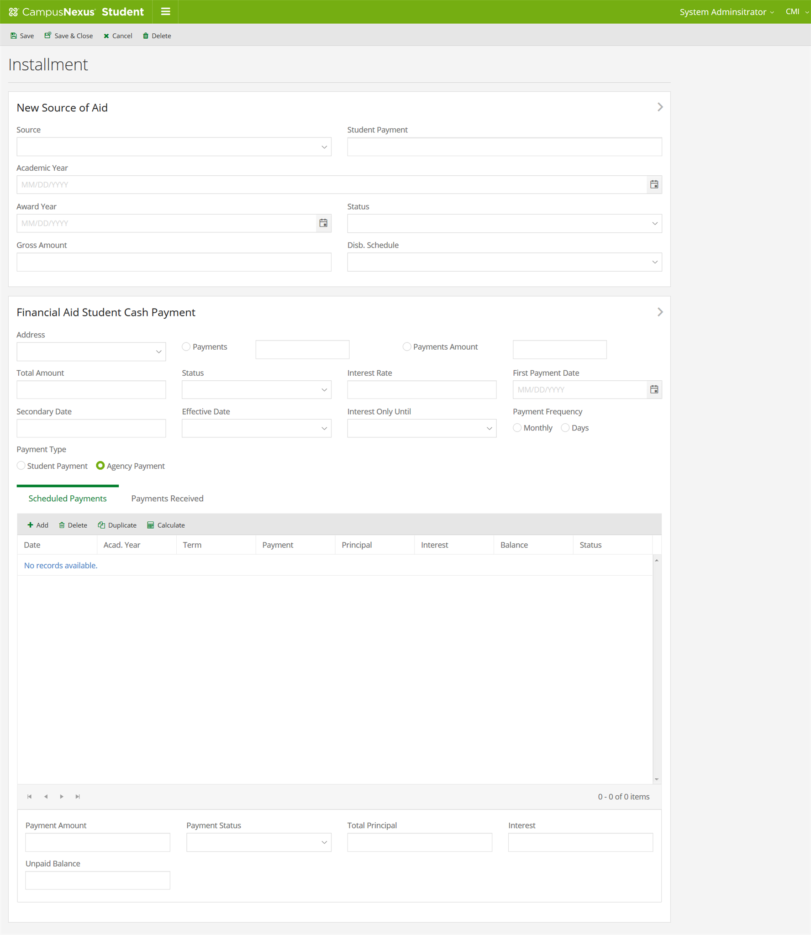

Student List
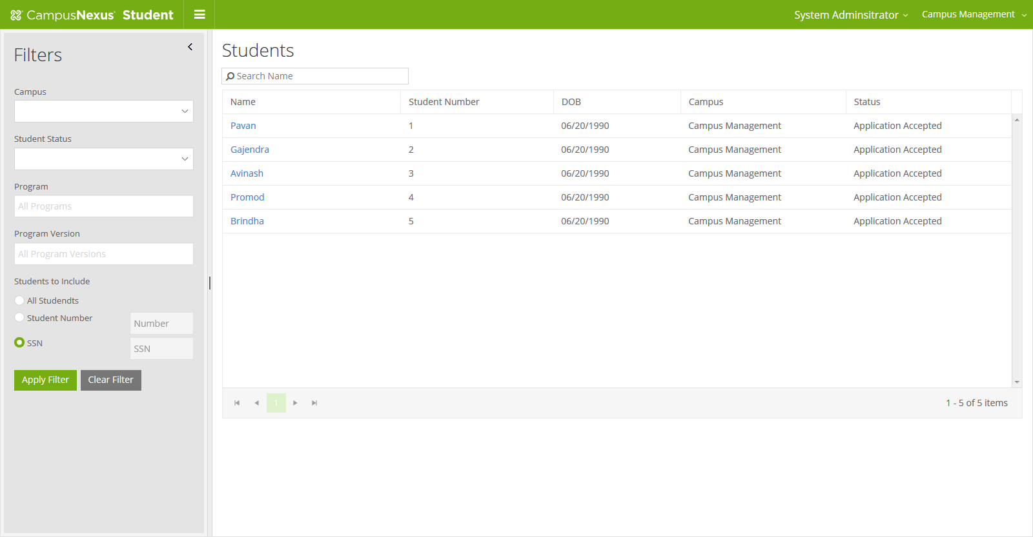

Student Details

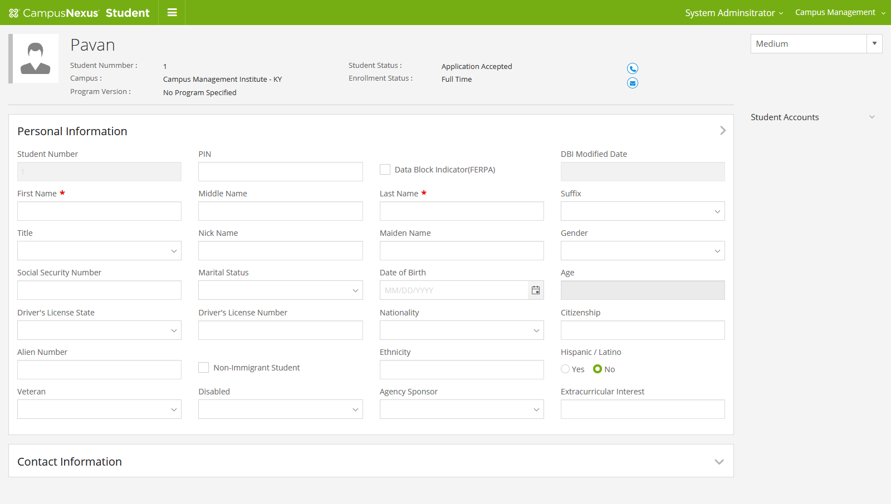

Ledger Screen
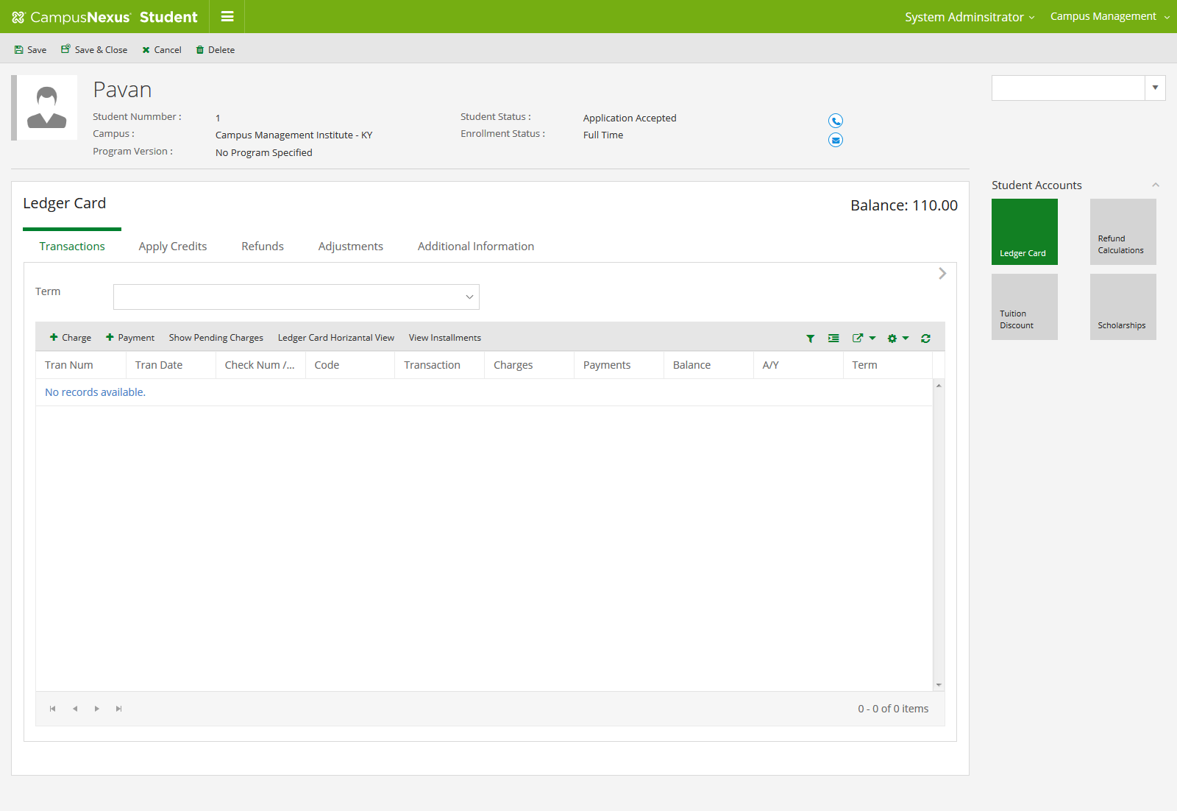
Post Charges Manually
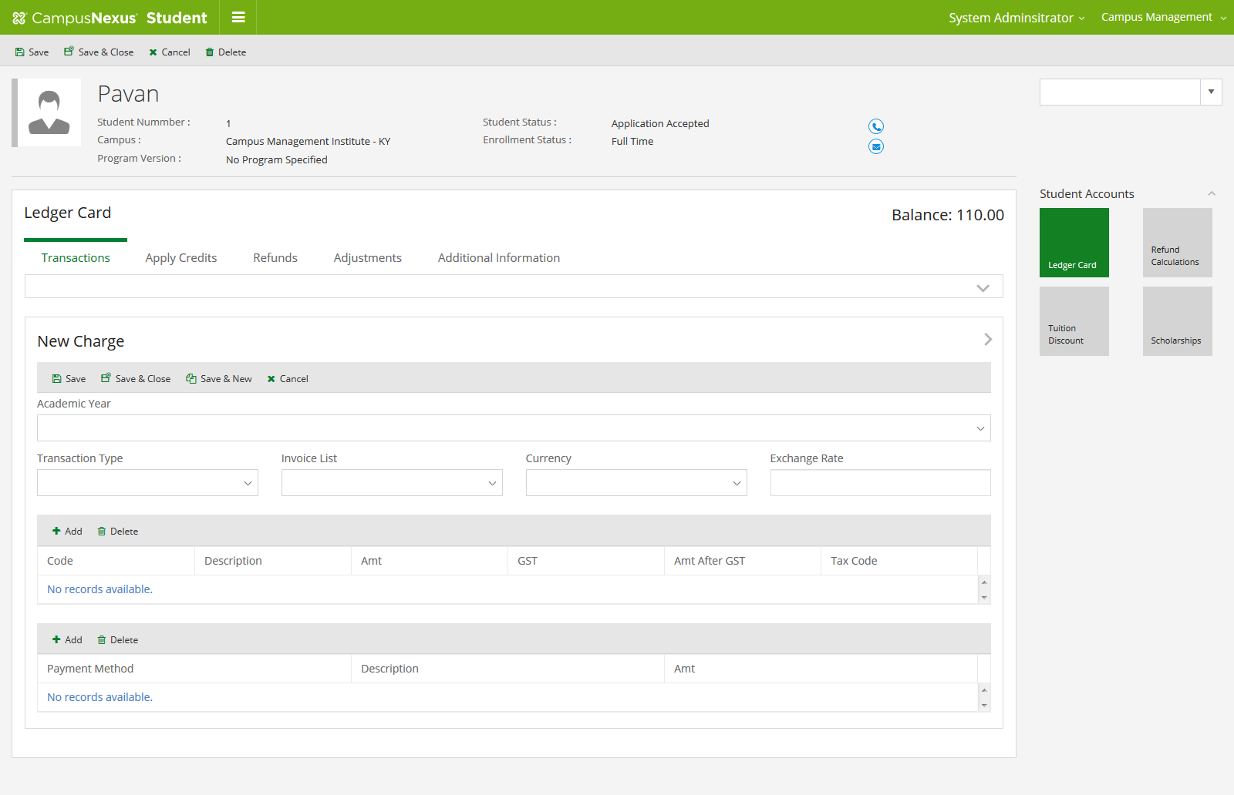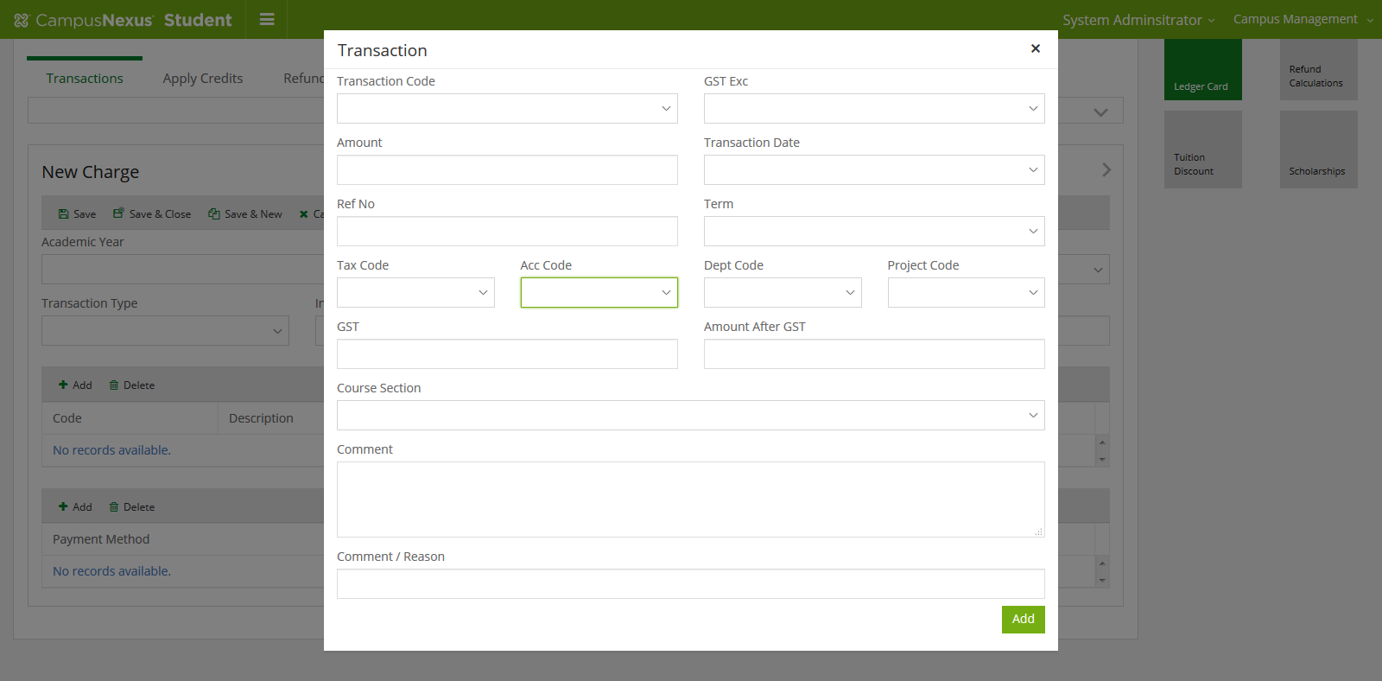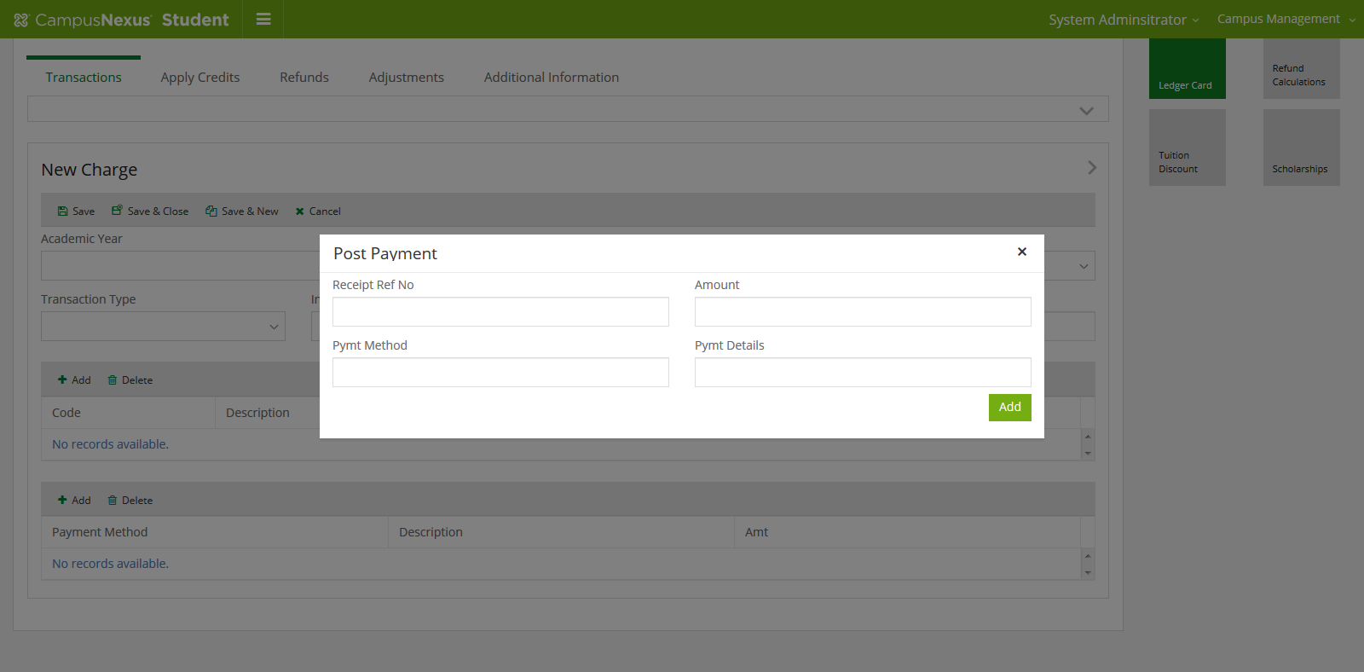
Post Payment
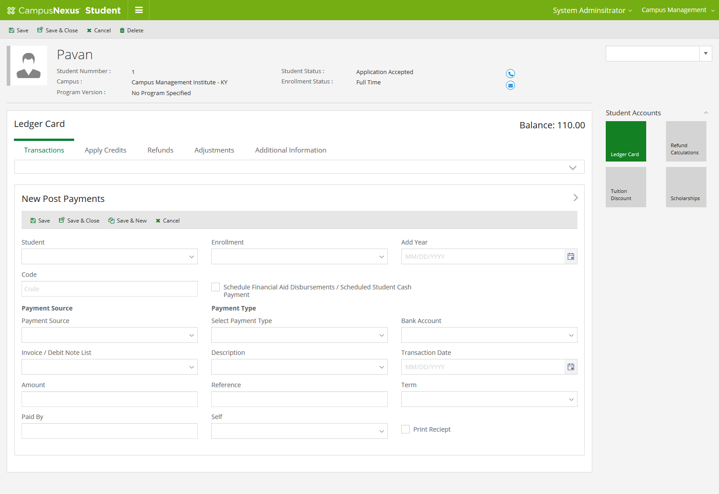
Apply Credit

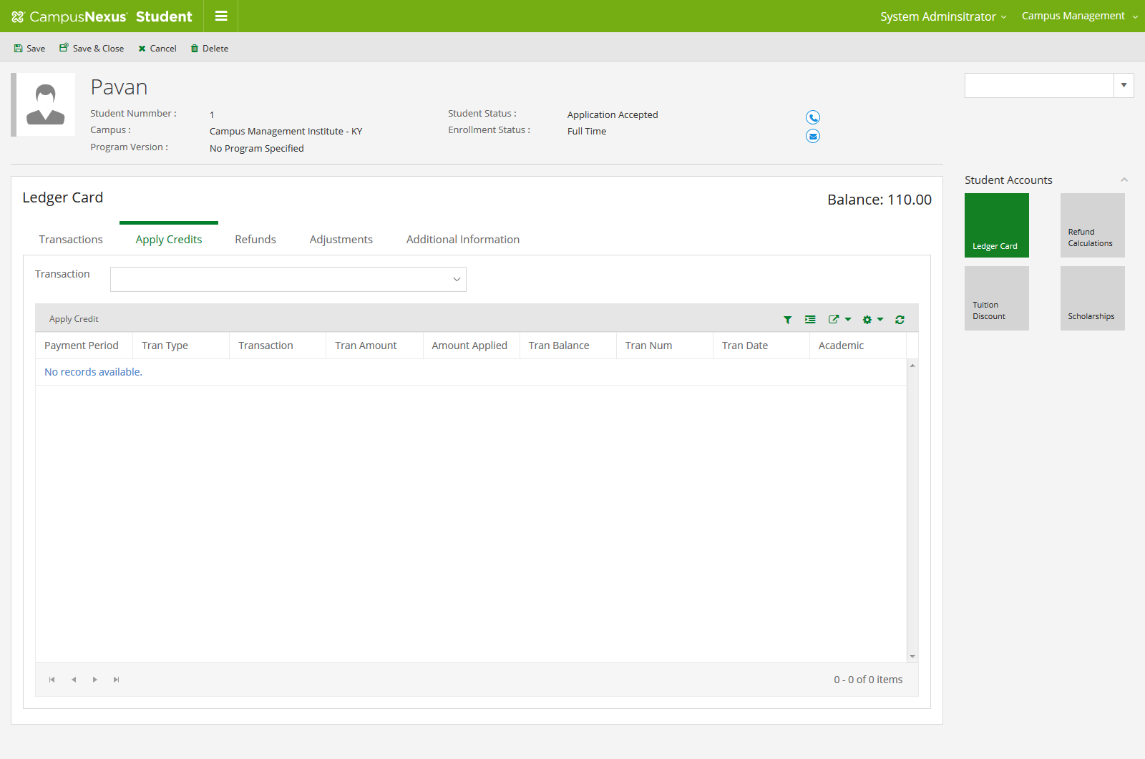
Refund
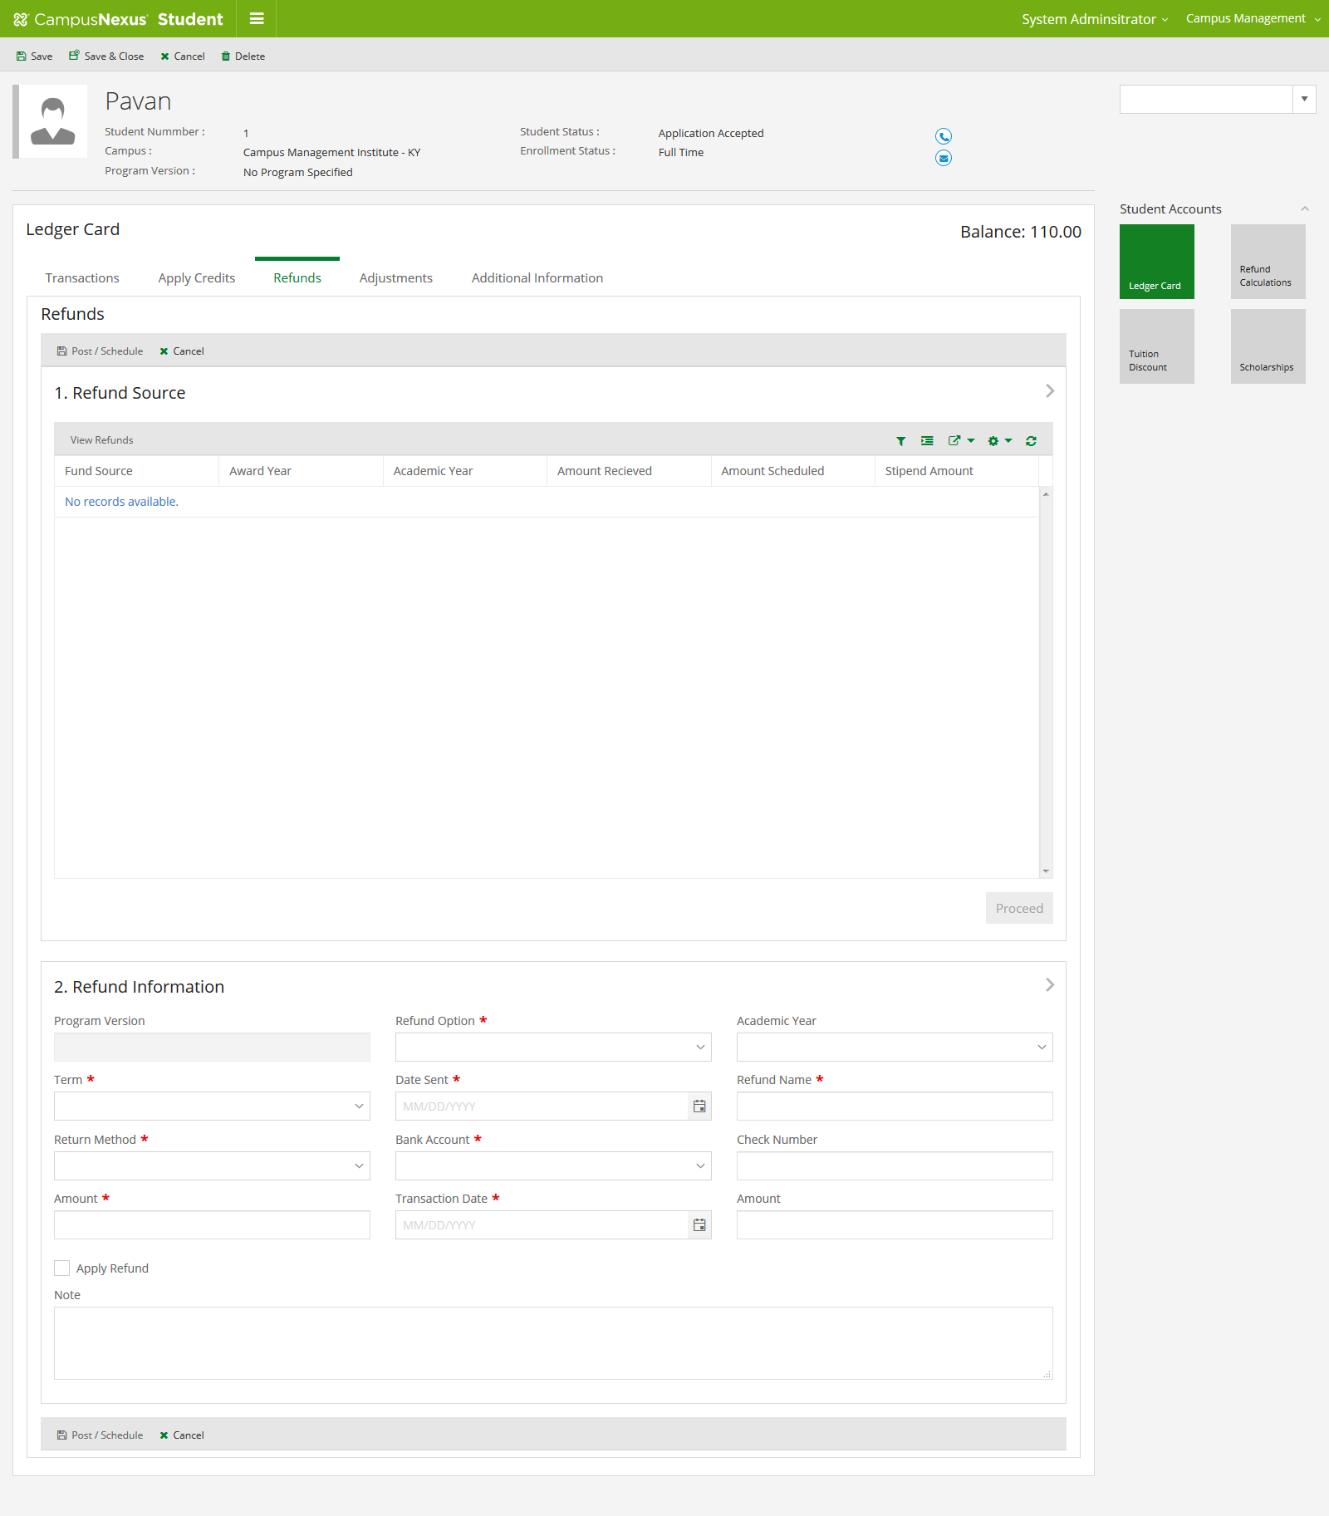

Adjustments
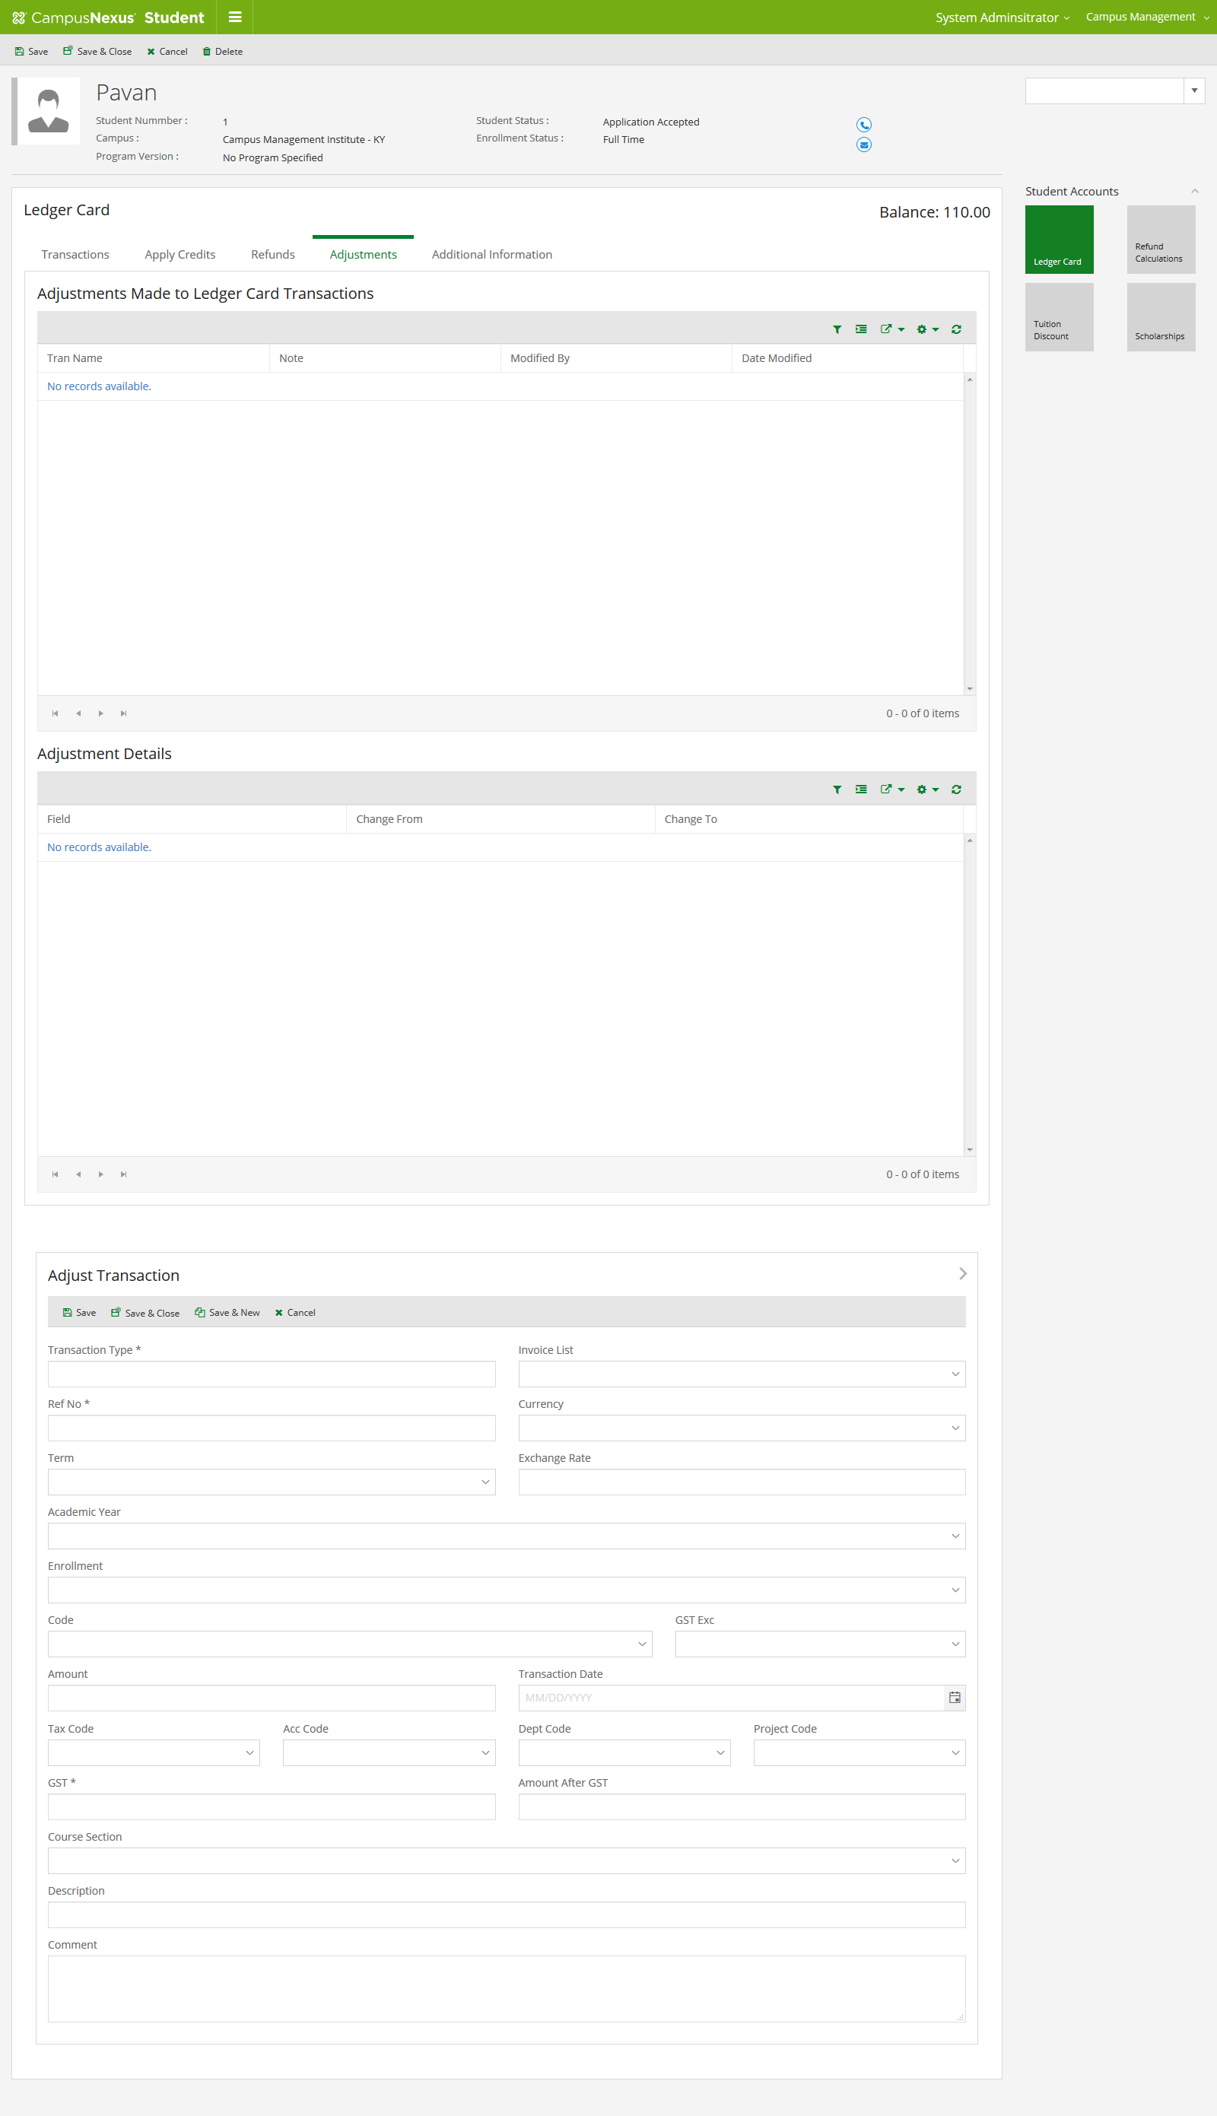

Scholarship