GST COMPLIANCE REPORT
on
Campus Nexus Student System
Assessment and Recommendations

14th November 2017

PREPARED BY:- PREPARED FOR:-



Table of Contents

No | Contents | Pages
 | Introduction | 3
 | Setup | 4
1.0 | Company Setup | 5-6
2.0 | GST Setup | 7
3.0 | Mapping of GST Tax Codes with GST-03 Return | 8-13
4.0 | Account Code Setup | 14
5.0 | Department Code Setup | 14
6.0 | Project Code Setup | 14
7.0 | Transaction Code Setup | 14-15
8.0 | Customer/Student Setup | 16
 | Transaction | 17
9.0 | Student Account Lists (Billing Methods) | 18-19
10.0 | Student Ledger Setup | 20-23
11.0 | Post Charges (INV,DN,CN,TI,TDN,TCN,MTI,STI,MDN and MCN) | 24-35
12.0 | Process Tuition Discounts | 36-37
13.0 | Scholarship (To rename to Award/Bursary/Rebate) | 37
 | Reporting | 38
14.0 | GST Report | 39-40
15.0 | GST Tax Amount Variance Report | 41
16.0 | Transaction Report | 41
17.0 | Invoice Listing (INV/TI/MTI/STI) | 42
18.0 | Debit Note Listing (DN/TDN/MDN) | 42
19.0 | Credit Note Listing (CN/TCN/MCN) | 43
20.0 | Receipt Listing | 43
21.0 | Student Details Listing | 44
 | Student Portal | 45
22.0 | Student Statement | 46-47
 | Other Requirements Towards GST Compliance | 48
23.0 | File Format Definition for GST Audit File (GAF) | 49-53
24.0 | Bad Debt | 54
25.0 | Deposit/Advance payment received | 55
26.0 | System Access | 55
27.0 | Data Security Control / Audit Trail | 55
28.0 | Backup Management | 56
29.0 | Currency Conversion | 56
30.0 | Training, Userguide and Product Knowledge | 56
31.0 | Keeping of Records | 56

INTRODUCTION

Swinburne University of Technology Sarawak Campus (SU) intends to make its newly implemented student management information system, called Campus Nexus Student System, fully compliant to Goods and Services Tax (GST) requirements. To this end, SU engaged the services of Salihin IT Curation Sdn Bhd (SALIHIN) (formerly known as Salihin GST Services Sdn Bhd) to assess the system and propose recommendations for GST compliance.
The objectives of this report are to provide the results of the assessment and recommendations for GST compliance in accordance with the GST Act 2014, GST Regulations and Guide on Accounting Software Enhancement towards GST Compliance revised as at 02 March 2017. It details the description of the GST components, interface enhancements and explains new functionalities and capabilities of the system.
** The system shall be Malaysia Goods and Services Tax (GST) compliant. The vendor must supply system verified and approved by the Royal Malaysian Customs Department and be listed under the “List of Accounting Software and Point of Sales (P.O.S) vendors has received advised and met the standard for GST requirement”. Vendor must be registered under Suruhanjaya Syarikat Malaysia (SSM) legislations or any designated agency, and comply with the Goods & Services Tax (GST) legislations.

SETUP

Setup
There should be five major setups in the system.
  - Company Setup
  - Company Information
Key Data Elements | Description
Business Name** | Company Name of business user  - Line 1  - Line 2
Business BRN** | Business Registration Number
GST No** | GST Registration Number of business user
Company Address** | - Line 1  - Line 2  - Line 3  - City  - Postal Code  - State  - Country
Telephone No** | Company contact no.
Fax No** | Company fax no.
Website** | Company website
Upload Logo** | Company Logo
Financial Year | 2018
Start Date | 1/1/2018
End Date | 31/12/2018
Currency Code | Functional currency used in accounting software (in 3 Char ISO). Empty means functional currency used in Malaysia Ringgit (MYR)
Product Version | Accounting software name and version
GAF Version | GST Audit File (GAF) version number
** Must appear on tax invoice/debit note/credit note.
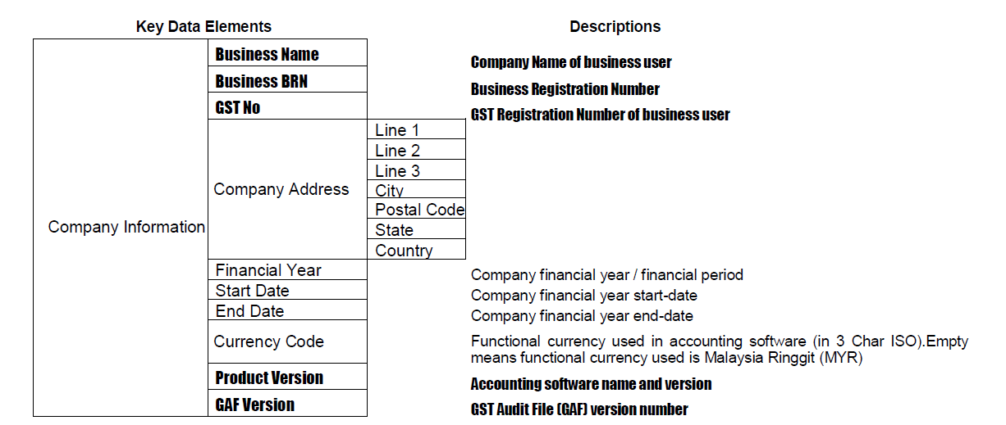

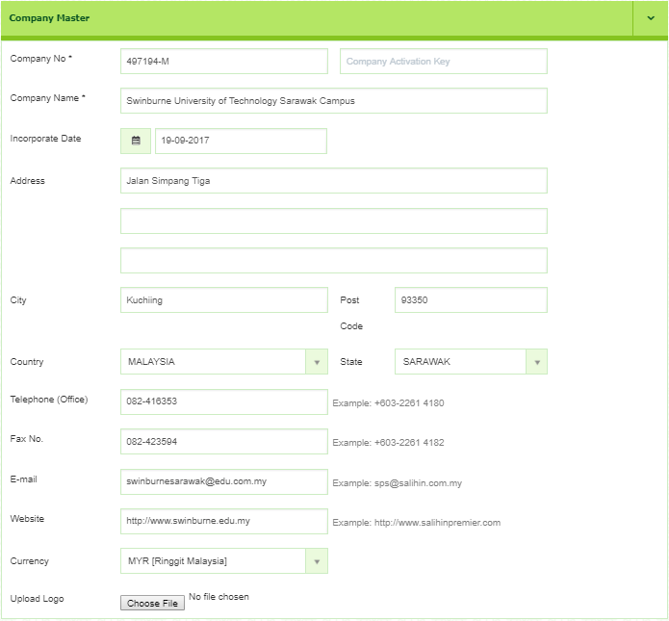
SAMPLE
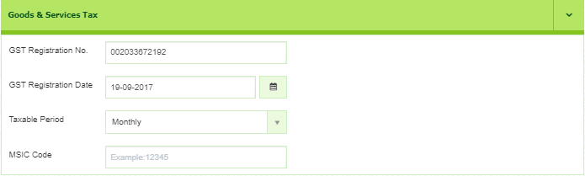
Listing : Monthly & Quaterly
Example of Company Setup screen.

  - GST Setup
  - GST Code Table
Key Data Elements |  |  | Description
TaxCodeTable | TaxCodeDetails | Tax Code | Tax code for lookup in tables
TaxCodeTable | TaxCodeDetails | Tax Percentage | Tax percentage
TaxCodeTable | TaxCodeDetails | Description | Description of tax code
TaxCodeTable | TaxCodeDetails | Link to Chart of Account | Link to Chart of Account
TaxCodeTable | TaxCodeDetails | GST Code | Official Tax code listed by the Royal Malaysian Customs Department (RMCD)

*** The Tax Code is a code made by the user and this tax code will be re-linked with the proposed GST code by the Royal Malaysian Customs Department (RMCD) code. All this Tax Code will appear to all relevant modules in selecting the Tax Code. Below the sample table for the Tax Code.

  - Example GST Code used by Swinburne
Tax Code | Tax Rate | Description | Link to Chart of Account | GST Code
SR | 6% | Standard-rated supplies with GST charged. | GST Output Tax Ledger | SR
DS | 6% | Deemed supplies under GST legislations | GST Output Tax Ledger | DS
ZRL | 0% | Local supply of goods or services which are subject to zero rated supplies. | - | ZRL
OS-1 | 0% | Out-of-scope supplies under GST legislations. | - | OS
OS-2 | 0% | Out-of-scope supplies under GST legislations. | - | OS
ES | 0% | Exempt supplies under GST legislations. | - | ES
NS | 0% | Matters to be treated as neither a supply of goods nor a supply of services, and no GST chargeable. | - | NS
NP | 0% | Matters to be treated as neither a purchase of goods nor a purchase of services, and no GST incurred. | - | NP
AJS | 6% | Any adjustment made to Output Tax (e.g., Bad Debt Recovered, & other output tax adjustments) | GST Output Tax Ledger | AJS
** Tax rate must be editable and the system should allow user to add new GST tax code

- Mapping of GST Tax Codes with GST-03 Return

This section provides a mapping between GST tax codes Supply with GST-03 return. These mapping of tax code listings are recommendation to allow correct declaration for GST-03 return. The mapping of tax code listings is not intend to be prescriptive nor comprehensive.
GST Code | Tax Rate | Description | GST-03 Field
SR | 6% | Field 5a & 5b: Output Tax | 5a,5b
DS | 6% | Field 5a & 5b: Output Tax | 5a,5b
ZRL | 0% | Field 10: Total Value of Zero-rated Supplies | 10
OS | 0% | - | -
ES | 0% | Field 12 : Total Value of Exempt Supplies | 12
NS | 0% | - | -
AJS | 6% | - Bad Debt Recoverd adjustment (AR)  Field 5b : (GST Payable amount only)  Field 18 : Total of Bad Debt Recovered  inclusive Tax | 5b, 18
AJS | 6% | - Outstanding purchase invoice more than 6 month (AP) | 5b
AJS | 6% | - Other output tax adjustments  Field 5b : (GST Payable amount only) | 5b

  - Example GST-03 Return for Information
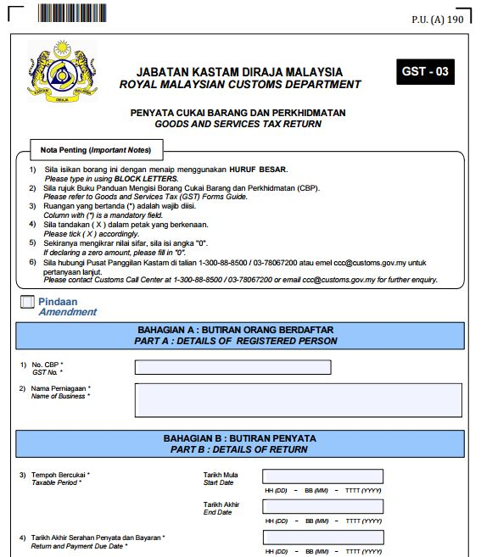

GST Number

Name of Business

Start Date : etc, 1 January 2018

End Date : etc, 31 March 2018

Due Date : etc, 30 April 2018

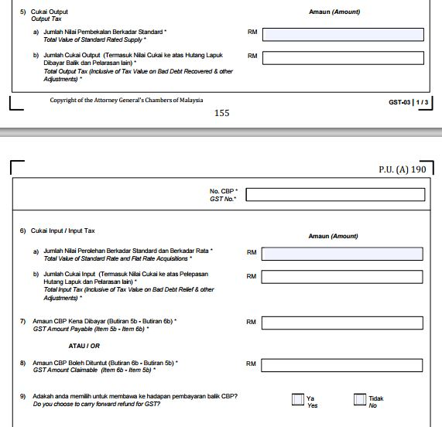
SR, DS
SR, DS, AJS
TX, TX-CG IM, TX-ES,TX-IES,TX-RE
TX, TX-CG, IM, TX-ES ,TX-IES, TX-RE, AJP
5b – 6b (Payable)
6b – 5b (Claimable)

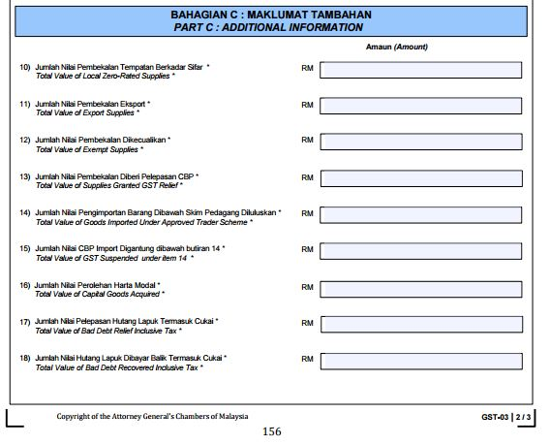

RS
ZRL

ZDA, ZRE

ES, IES

IS

6% OF ITEM 14

TX-CG

AJP

AJS

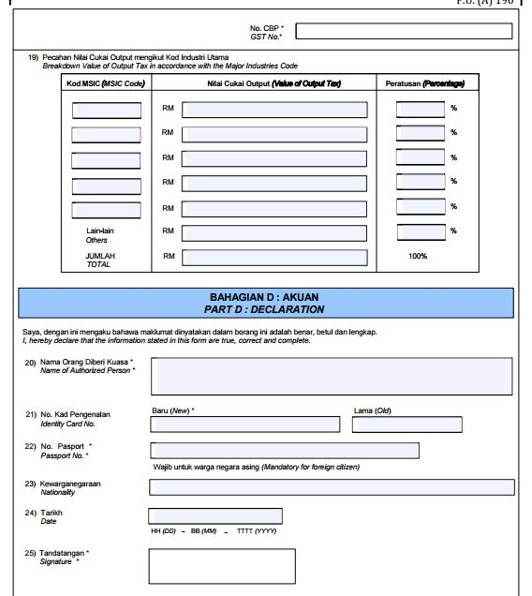

MSIC CODE

VALUE OF GST OUTPUT

  - File Format Definition for Taxpayer Access Point (TAP) File
The TAP file is a standard file format to be import into GST-03 return in Taxpayer Access Point website. The TAP file will autofill all the information require for GST-03 return based on the information being formatted into the TAP file. This is an alternative method to the taxpayers for submitting information into GST-03 return. The information provided includes all field required to complete a GST-03 return, and the TAP File must in format of Text Document (.txt). The system should be abled to attach the TAP Return File into Taxpayer Access Point (TAP) website portal.

    - TAP File Format Specification in Text File Format
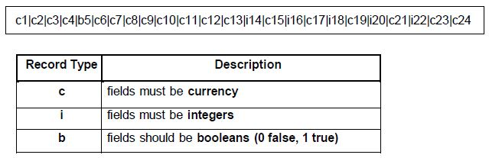

    - Format Specifications
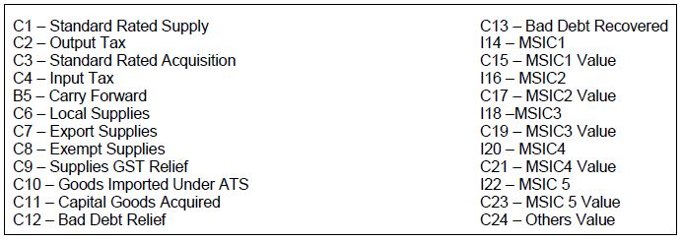

    - TAP File Example
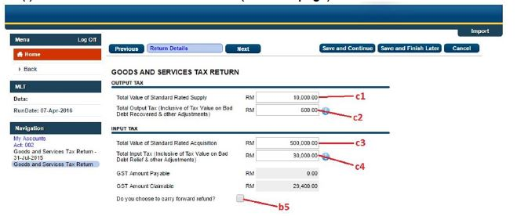
- Screenshot of the TAP File Format (TAP Webpage)

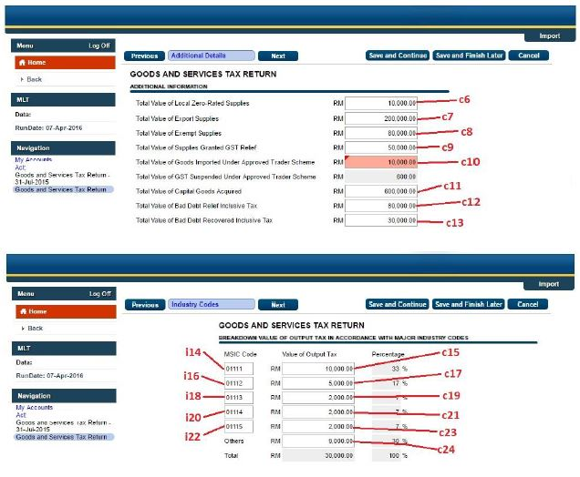

- Example of thr TAP File (TAP Webpage)

    - Screenshot on importing the TAP File

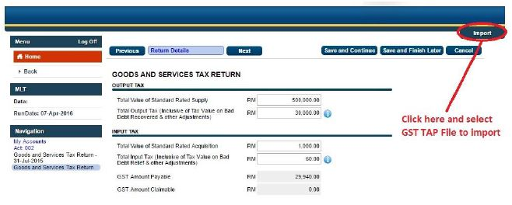

- Accounts Code Setup
  - Accounts Code Information
Key Data Elements | Description
Accounts Code | Accounts code for lookup in table
Accounts Name | Chart of Account name
Item | Description of accounts code

- Department Code Setup

  - Department Code Information
Key Data Elements | Description
Department Code | Department code for lookup in table
Item | Description of Department code

- Project Code Setup

  - Project Code Information
Key Data Elements | Description
Project Code | Project code for lookup in table
Item | Description of Project code

- Transction Code Setup

  - Transaction Code Information
Existing Key Data Elements | Description
Transaction Code | Transaction code
Description | Description of the Transaction code
Add New Key Data Elements | Description
Account Code | Accounts code for lookup in table  *Based on Accounts Code Setup
Accounts Name | Chart of Account name
Department Code | Department code for lookup in table  *Based on Department Code Setup
Project Code | Project code for lookup in table  *Based on Project Code Setup
Tax Code | Tax code for lookup in table  *Based on GST Setup
Tax Rate | Tax rate based on the tax code used

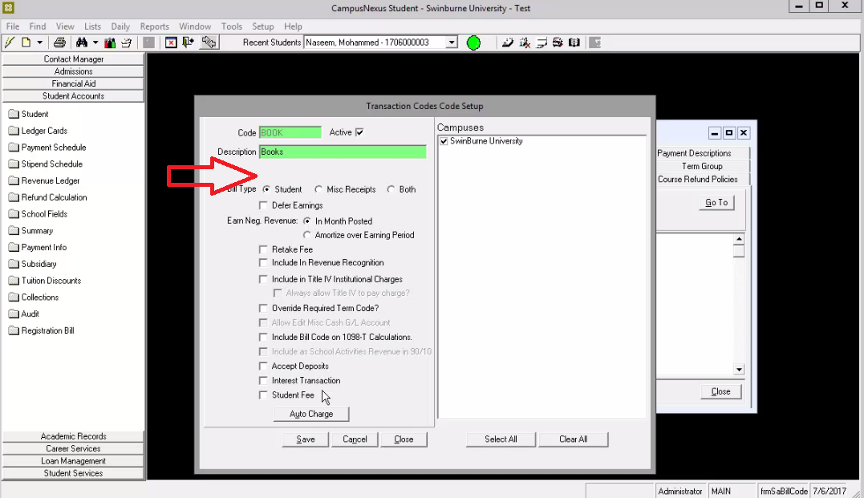
To setup Transaction Code, all new and existing key data elements under Transaction Code Setup must be added on this screen
(List > Student Account > Transaction Codes > Add / Edit).
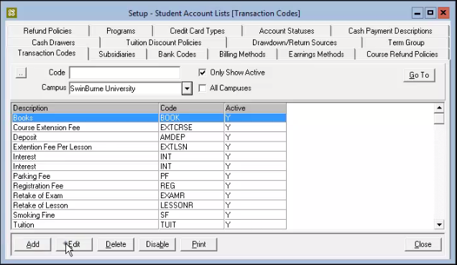
Old Transaction Codes

Example of New Transaction Code List Table :-
Transaction  Code | Description | Account Code | Account Name | Department  Code | Project  Code | Tax Code | Tax Rate
GRAD | Graduation | 8-1300 | Graduation Ceremony | p0063 | Project A | ES | 0%
OTHRF | Other Fee | 8-1600 | Other Income | p0000 | Project B | SR | 6%
Please refer to List of Accounts (Treasury) for further sample.

The Accounts Code, Department Code, Project Code and Tax Code can be set as default and can be also amended during the Post Charges.
Tax Code for each Transaction Code will be setup on this screen. User needs to select the Tax Code and the Tax Rate for each of the Transaction Code.
- Customer / Student Setup

  - Student Information
Key Data Elements | Description
Customer ID** | Unique code for customer / student
Customer Name** | Customer / Student Name
Customer BRN | Business Registration Number of customer (if any)
Date GST Status Verified | Date GST status last checked (if any)
Customer GST No | GST Registration Number of customer (if any)
Customer Billing Address** | - Line 1  - Line 2  - Line 3  - City  - Postal Code  - State  - Country
Telephone | Customer / Student contact no.
Fax | Customer / Student fax no.
Email | Customer / Student email
Website | Customer / Student website (if any)
** must be appeared on tax invoice/debit note/credit note/payment receipts.
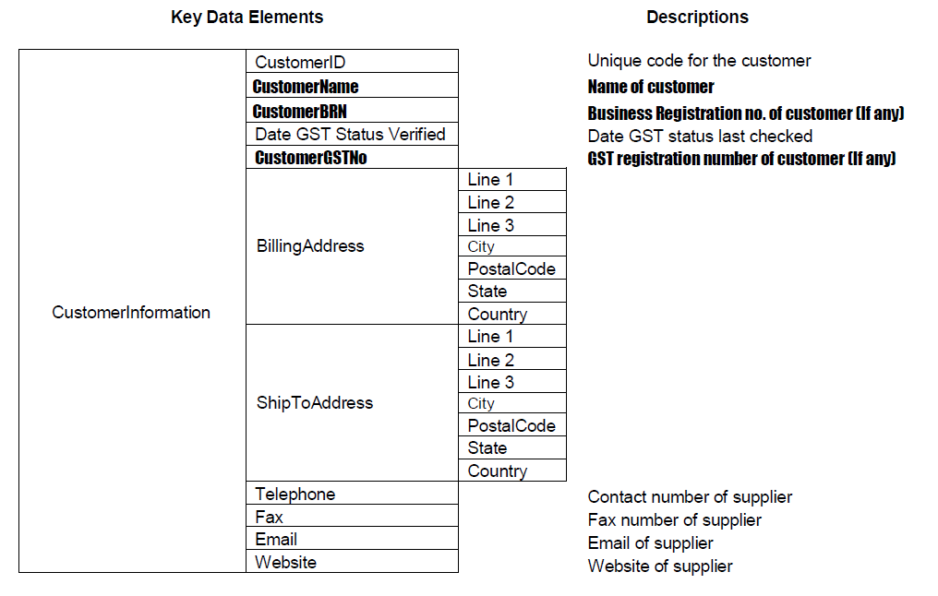

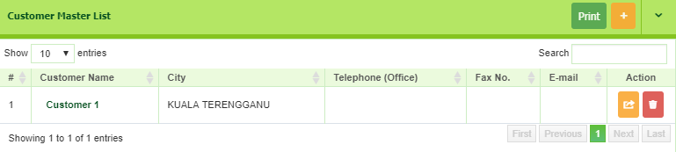
SAMPLE
Example of Customer List Screen

TRANSACTION

- Setup – Student Account Lists ( Billing Methods)

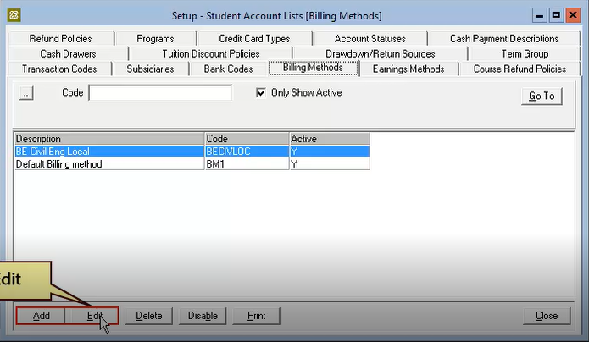
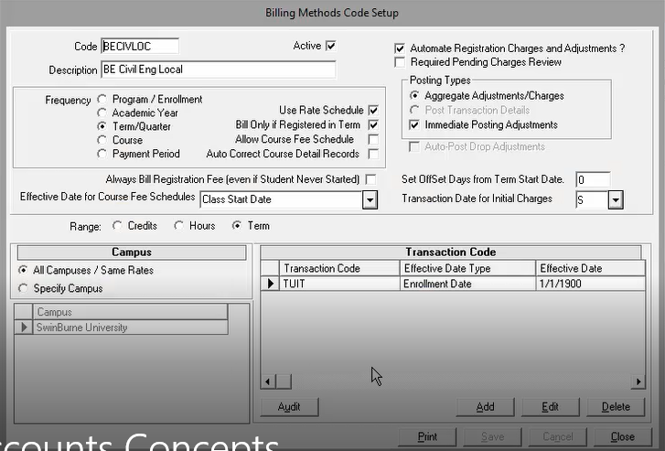
Transaction Code | Effective Date Type | Effective Date | Tax Code | GST Rate
TUIT-ES | Enrollment Date | 1/1/2018 | ES | 0%
TUIT-SR | Enrollment Date | 1/1/2018 | SR | 6%

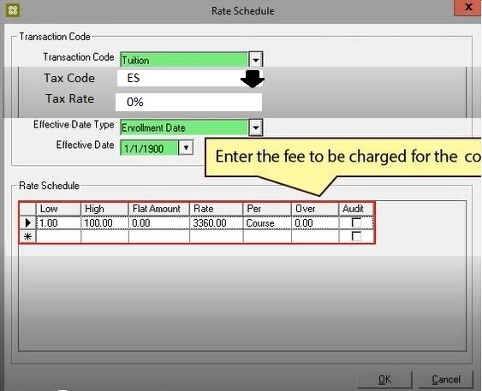
1

  - Requirement of change
No. | Fill | Description
1 | Tax Code & Tax Rate | Tax Code & Tax Rate will appear based on selected transaction code. Data can editable.  *Based on Transaction Code Setup

- Student Ledger Card

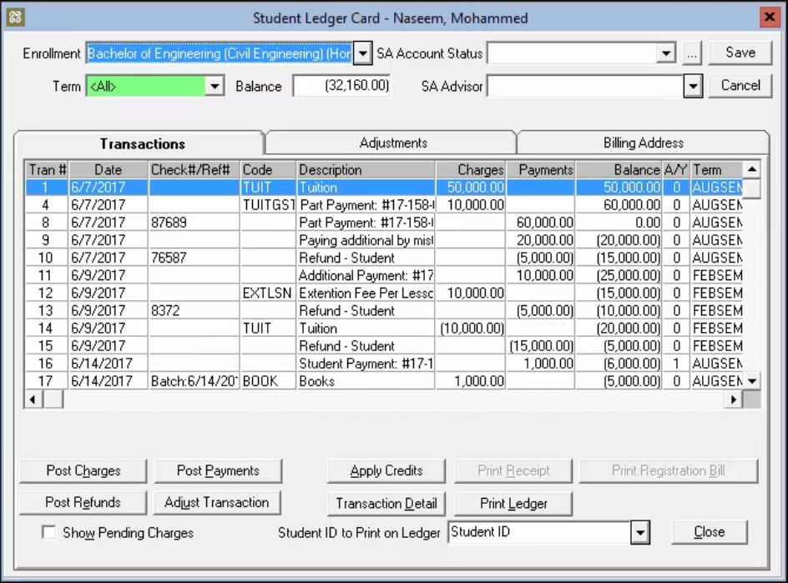
6
5
4
2
1
3
  - Requirement of changes
No. | Button | Tabs | Existing Process | New Process | Description
1 | Student Ledger Card | Transactions | Tran # | Tran # | To retain the same
1 | Student Ledger Card | Transactions | Date | Date | To retain the same
1 | Student Ledger Card | Transactions |  | Transaction Type | To show the following Transaction Type:  For Non-Taxable Supply only (GST Tax Code ES, OS and/or NS) – auto or manual issued by the system  - INV (Normal Invoice for fee for application and enrolment)  - DN (Normal Debit Note for add subjects or fee adjustment)  - CN (Normal Credit Note for drop subjects, discounts or fee adjustment)  For Taxable Supply only (GST Tax Code SR and/or ZRL) or Mixed Supplies (GST Tax Code SR, ZRL, ES, ZRL and/or NS) – auto or manual issued by the system  - TI (Tax Invoice for fee for application and enrolment)  - TDN (Tax Debit Note for add subjects or fee adjustment)  - TCN (Tax Credit Note for drop subjects, discounts or fee adjustment)  - MTI (Miscellaneous Tax Invoice for other students related fees more than RM500) – issued  - STI (Simplified Tax Invoice for other students related fees up to RM500)  - MDN (Miscellaneous Debit Note)  - MCN (Miscellaneous Credit Note)  - AWARD/ BURSARY/ REBATE  - REFUND  - PYMT (Payments)
1 | Student Ledger Card | Transactions | Check #/Ref # | Ref # | To change to show the running Documentation Number of INV/DN/CN/ TI/TDN/TCN /MTI/STI/MDN/MCN, AWARD/ BURSARY/ REBATE, REFUND and Receipt.
1 | Student Ledger Card | Transactions | Code | Code | To retain the same as Transaction Code
1 | Student Ledger Card | Transactions | Description | Description | To retain the same
1 | Student Ledger Card | Transactions | Charges | Charges | To show the charges issued under the Transaction Type of INV/DN/CN/ TI/TDN/TCN /MTI/STI/MDN/MCN.  The amount shown should inclusive of GST if any.
1 | Student Ledger Card | Transactions | Payments | Payments | To show the amount under the Transaction Type of AWARD/ BURSARY/ REBATE, REFUND and PYMT only.
1 | Student Ledger Card | Transactions | Balance | Balance | To remain the same as referring to total amount net owing from/to student
1 | Student Ledger Card | Transactions |  | Tax Code | To show the GST Tax Code of the transaction
1 | Student Ledger Card | Transactions |  | GST Amount | To show the GST amount of the transaction
1 | Student Ledger Card | Transactions | A/Y |  | To remove
1 | Student Ledger Card | Transactions | Term | Term | To retain the same
2 | Student Ledger Card | Transactions | Description | Description  (Print Transaction) | Details of the transaction can be viewed and shown by clicking the description of the transaction.
3 | Post Charges |  | Charge | INV | This function to create the normal, full, miscellaneous or simplified tax invoice/ normal, full, miscellaneous debit note/ normal, full, miscellaneous credit note.
 |  |  |  | TI
 |  |  |  | MTI
 |  |  |  | STI
3 | Post Charges |  | Adjustment | DN
 |  |  |  | CN
 |  |  |  | TDN
 |  |  |  | TCN
 |  |  |  | MDN
 |  |  |  | MCN
4 | Post Refund |  |  | Post Refund | Post Refund is only applicable when there is excess payments or balances in Student’s Accounts.
5 | Adjust Transaction | Transactions | Adjust Transaction |  | To allow this function with security control for authorized personnel only.
6 | Post Payment |  | Post Payment |  | To make a payment. Compulsory to select the original invoice.

  - Transaction list on Student Ledger Card
Each time user clicks here, it will display the invoice/ debit note/ credit note/ receipts/ refund/ award/ bursary/ rebate to be viewed or printed.

Tran # | Date | Tran. Type | Ref # | Code | Description | Charges | Payments | Balance | Tax Code | GST Amount | Term
1 | 6/7/2017 | INV | INV17BH-EEE000001 | TUIT | Tuit fee | 3,350.00 |  | 3,350.00 | ES | 0.00 | AUG  SEM
2 | 7/7/2017 | CN | CN17BH-EEE000001 | TUIT | Tuit fee – Drop subject | (1,000.00) |  | 2,350.00 | ES | 0.00 | AUG  SEM
3 | 8/7/2017 | AWARD/BURSARY/REBATE | ABR17BH-EEE000001 | AWARD | Award |  | 750.00 | 1,600.00 |  |  | AUG  SEM
4 | 8/7/2017 | PYMT | OR1234567890 |  | Pymt of tuit fee |  | 3,350.00 | (1,750.00) |  |  | AUG  SEM
5 | 10/7/2017 | REFUND | RF17BH-EEE000001 |  | Refund of payment |  | (1,750.00) | 0.00 |  |  | AUG  SEM
6 | 10/7/2017 | TI | TI17ACCA000001 | TUIT | Tuit fee | 2,544.00 |  | 2,544.00 | SR | 144.00 | AUG  SEM
7 | 10/7/2017 | TDN | TDN17ACCA00001 | TUIT | Tuit fee – Add subject | 2,544.00 |  | 5,088.00 | SR | 144.00 | AUG  SEM
8 | 10/7/2017 | TCN | TCN17ACCA00001 | TUIT | Tuit fee – Discount | (1,272.00) |  | 3,816.00 | SR | (72.00) | AUG  SEM
9 | 10/7/2017 | PYMT | OR1234567891 |  | Pymt of tuit fee |  | (3,816.00) | 0.00 |  |  | AUG  SEM
10 | 6/10/2017  Two transactions issued under one invoice. | MTI | MTI000001 | SVNR | Souvenirs | 636.00 |  | 636.00 | SR | 36.00 | AUG  SEM
11 | 6/10/2017 | MTI | MTI000001 | BOOKS | Sales of textbooks | 100.00 |  | 736.00 | ZRL | 0.00 | AUG  SEM
11 | 10/10/2017 | STI | STI000001 | GRAD | Graduation fee – extra ticket | 106.00 |  | 842.00 | SR | 6.00 | AUG  SEM
12 | 10/10/2017 | STI | STI000001 | GRAD | Graduation fee | 250.00 |  | 1,092.00 | ES | 0.00 | AUG  SEM
12 | 10/10/2017 | MCN | MCN00001 | SVNR | Return of Souvenirs | (53.00) |  | 1,039.00 | SR | (3.00) | AUG  SEM
12 | 10/10/2017 | PYMT | OR1234567892 |  | Graduation fee – extra ticket |  | (1,039.00) | 0.00 |  |  | AUG  SEM

- Post Charges (INV, DN, CN, TI, TDN, TCN, MTI, STI, MDN and MCN)

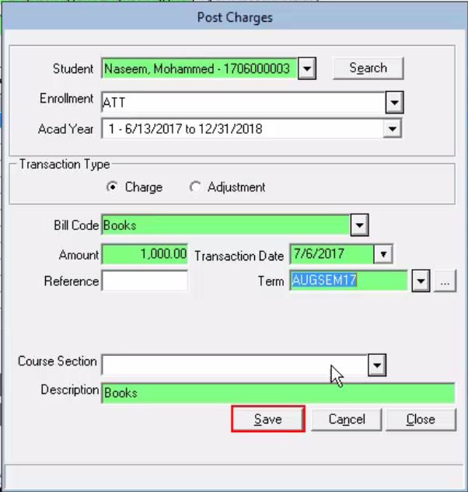
Add / Update
12
TI000001
Tax Invoice List :
2
10
1
TI

11
Remove
Edit
100.00
GRAD
Graduation Extra Ticket
6.00
106.00
SR

Code
Description
Amt
GST
Amt After GST
Tax Code
GRAD
TI000001
SR
106.00
Ref No
Tax Code
GST
3
4
6
Amount After GST
5
6.00
9
Project Code
Dept Code
8
Acc Code
7
MTI
STI
GST Exc

Graduation Extra Ticket
MDN
MCN
100.00
13
√
Print Receipt
√
Post Payments
RM106.00
OR1234567891
Receipt Ref No
CIMB123456
Pymt Details
Cheque
Pymt Method
Amount

14
Comment/Reason :

15
Save
Cancel
Close

  - Additional requirements

No. | Key Data Elements | Description
1 | INV/DN/CN/ TI/TDN/TCN/  MTI/STI/MDN/MCN | To allow user to select the below transactions types to be created:  INV (Normal Invoice), DN (Normal Debit Note), CN (Normal Credit Note);  TI (Full Tax Invoice), TDN (Full Tax Debit Note), TCN (Full Tax Credit Note);  MTI (Miscellaneous Tax Invoice), STI (Simplified Tax Invoice), MDN (Miscellaneous Debit Note), MCN (Miscellaneous Credit Note)  The title of the above must be displayed at the top of the documentation issued.
2. | Tax Invoice List | This function will appear when user want to issuance DN/CN/TCN/TDN/MCN/MDN. User have to select the original tax invoice related to DN/CN/TCN/TDN/MCN/MDN & report for the DN/CN/TCN/TDN/MCN/MDN have to show the number and date of the original tax invoice. Please refer the example.
3 | Ref No | Each transaction document above created must have auto-filled Documentation Number.
4,5,6 | GST elements – GST Tax Code, GST and Amount after GST | Each transaction document created must be labeled with the selected GST Tax Code, show the GST amount (auto-calculated by the system) and total amount after GST. Once the is clicked, the user can edit the GST amount auto-calculated by the system.  Should the transaction type of DN/CN/TDN/TCN/MDN or MCN has been chosen, the reference details towards the initially INV/TI/MTI or STI such as the tax invoice number and date can be updated into the Description section.  For the issuance of CN/TCN/MCN, all the amount keyed-in or auto-calculated will be in negative value.
7 | GST exclusive or GST inclusive | To allow the user to choose GST exclusive or inclusive. The system will auto-calculate the GST amount of the Amount keyed-in based on the selection by user.
8,9,10 | Acc Code, Dept Code and Project Code | To allow the user to assign the account code, department code and project code for the transaction.
11, 12 | Add, Edit and Remove buttons | To insert a table to allow the user to add multiple transactions under one Ref No.  To insert Add, Edit and Remove buttons to allow the user to modify the items listed in the table.
13 | Payment function | Once the “Post Payments” is clicked, this section of the form is enabled to allow the user to key in the payment details (Receipt Ref No, Amount, Pymt Method and other Pymt details) and post payment.  Once the “Print Receipt” is clicked, the Receipt will be auto-printed after this transaction has been saved.
14 | Comment/Reason | The reasons for its issue DN/CN/TCN/TDN/MCN/MDN. (Compulsory). Have to show in the report. If DN/CN/TCN/TDN/ from student, the system will indicate auto reason for issue DN/CN/TCN/TDN.
15 | Save, Cancel and Close buttons | To allow the user to Save, Cancel or Close the whole form.

  - Example of Complete Normal Invoice (INV)

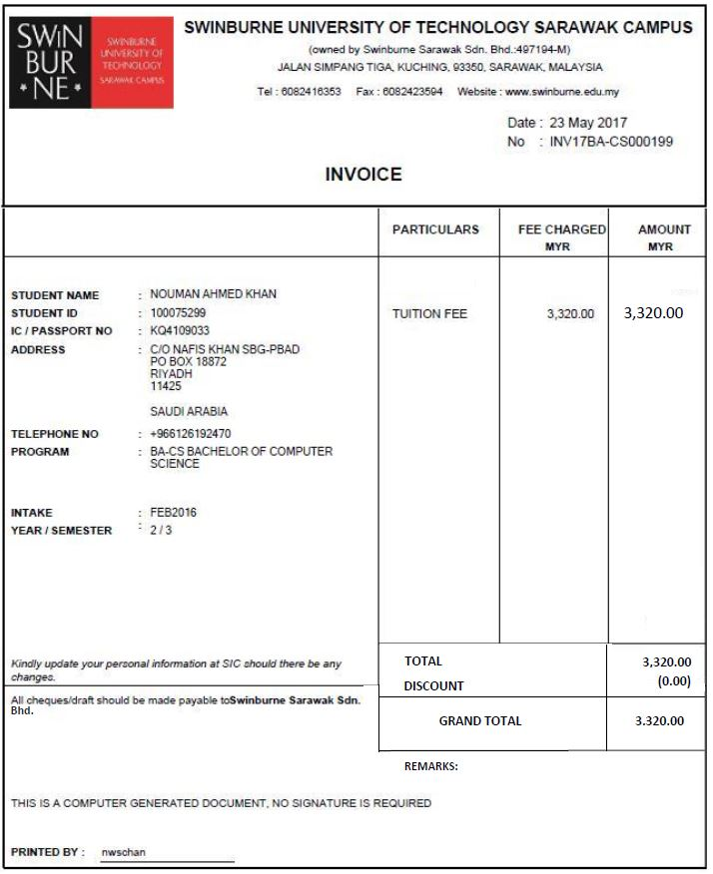

  - Example of Complete Full Tax Invoice (TI) or Miscellaneous Tax Invoice (MTI)

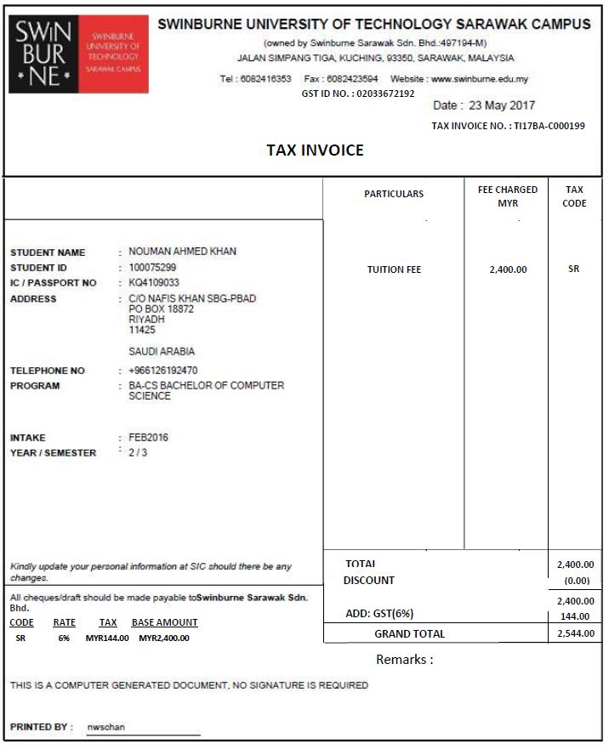

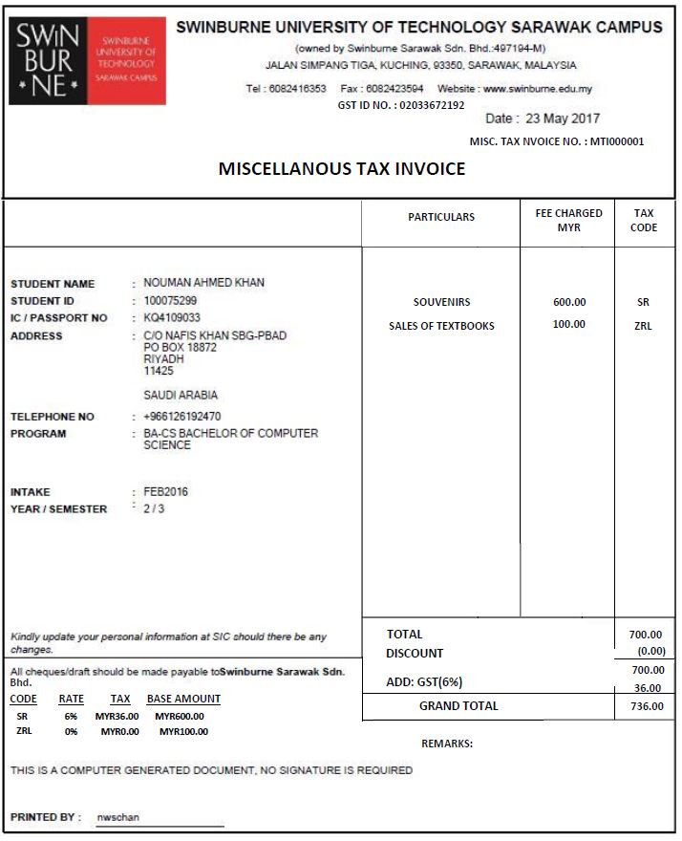

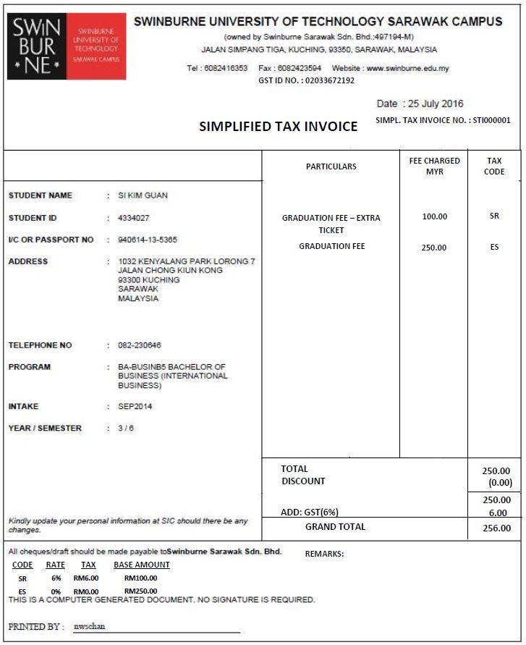
  - Example of Simplified Tax Invoice (STI)

  - Example of Complete Normal Debit Note (DN)

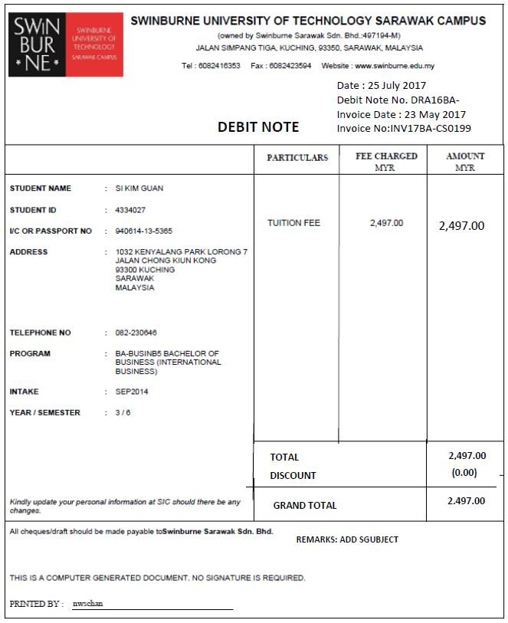

  - Example of Complete Full Tax Debit Note (TDN) or Miscellaneous Debit Note (MDN)

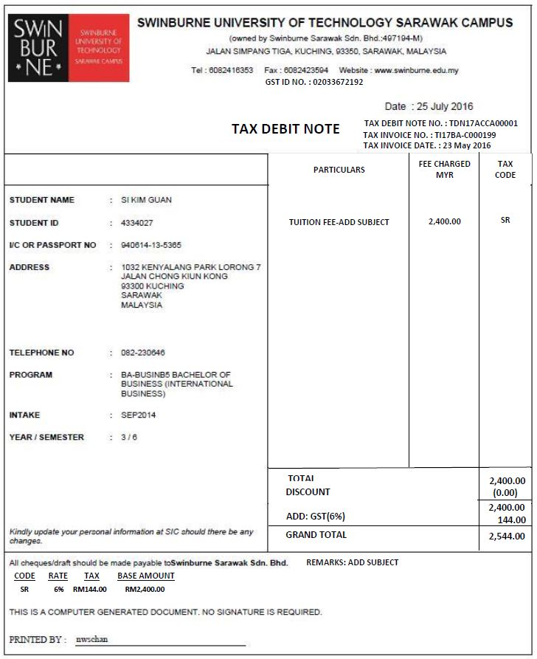

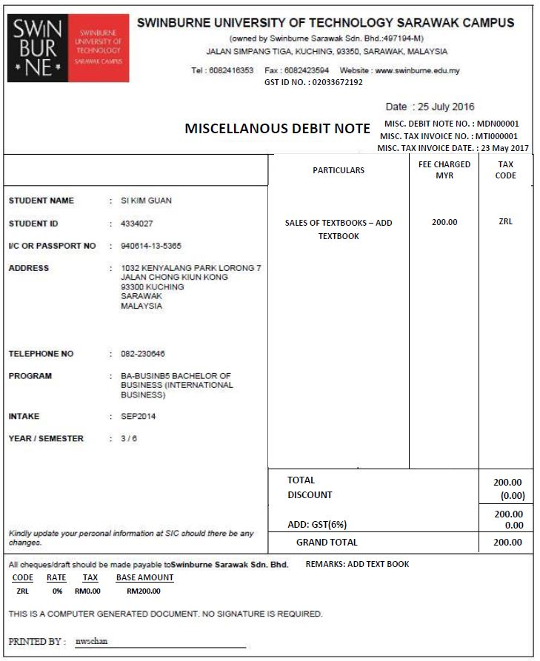

  - Example of Complete Normal Credit Note (CN)

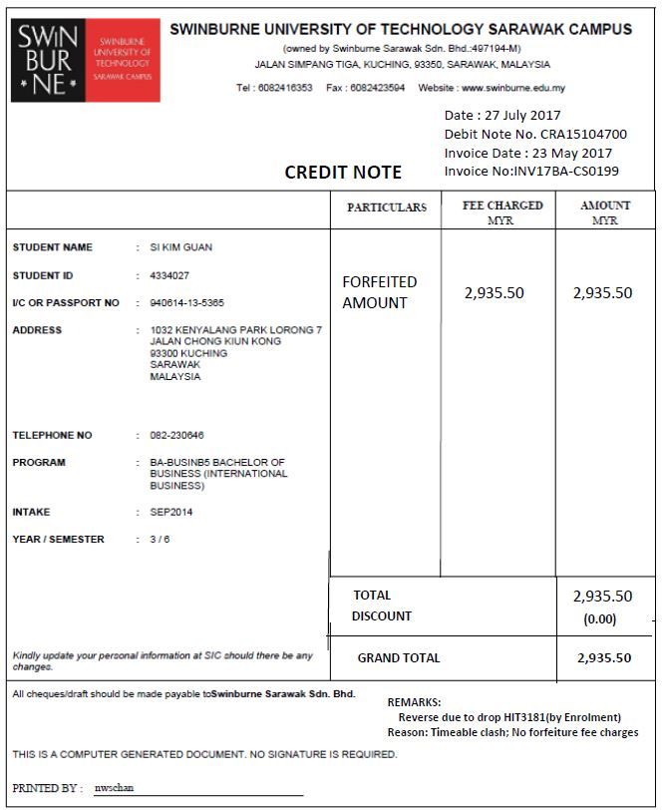

  - Example of Complete Tax Credit Note (TCN) or Miscellaneous Credit Note (MCN)

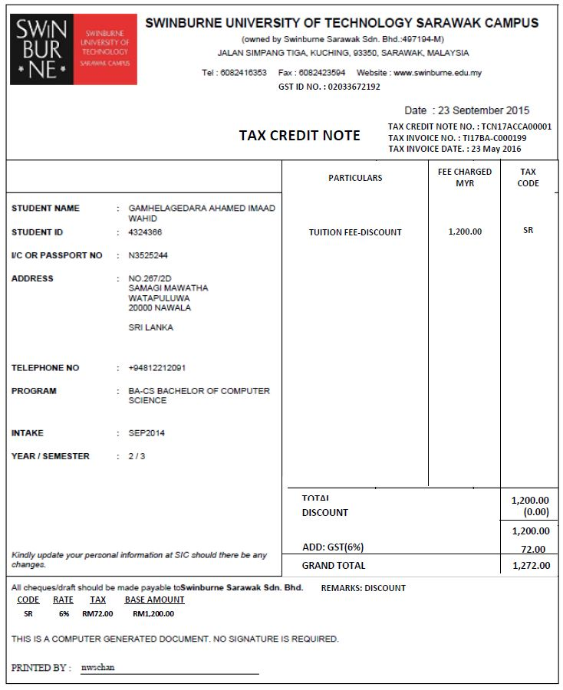

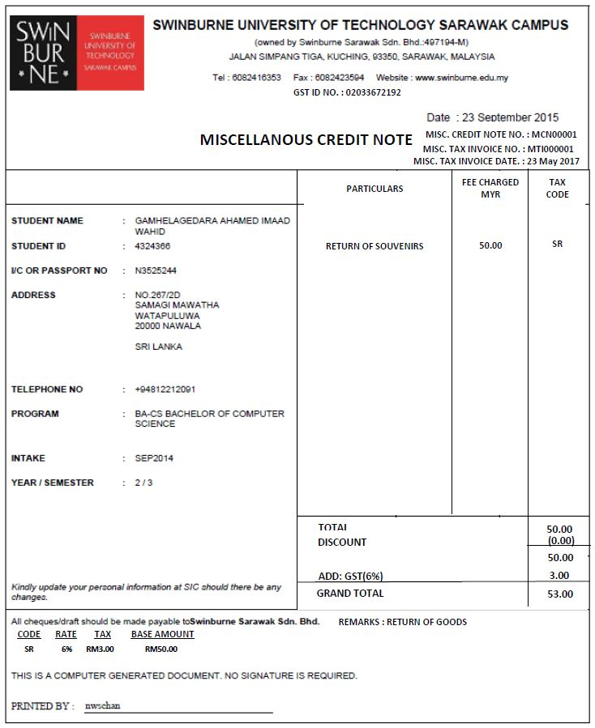

- Post Payment

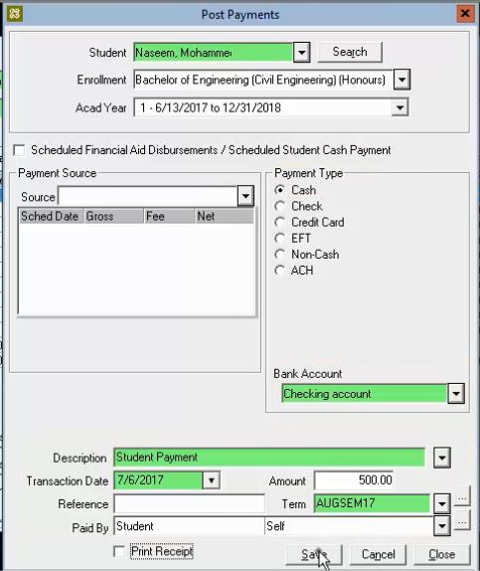
Tax Inv / Tax Debit Note Tax Inv List :
1
TI000001
  - Additional requirements

No. | Key Data Elements | Description
1 | Tax Invoice / Tax Debit Note List | User have to select the original tax invoice or Tax Debit Note before make any payment. This are important to handle GST bad debt relief & bad debt recovery.

- Adjust Transaction (INV/DN/CN/TI/TDN/TCB/MTI/STI/MDN/MCN)

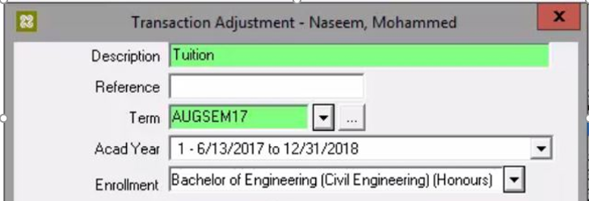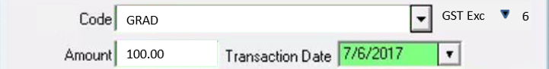
2
1
STI000001
Transaction Type
STI
Ref No
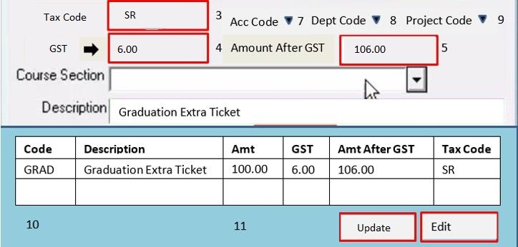
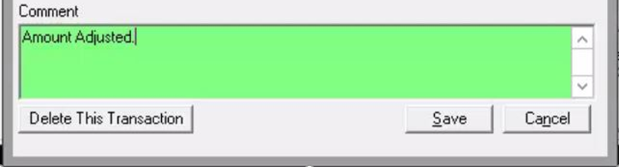

  - Additional requirements

No. | Key Data Elements | Description
1 | Transaction Type:  INV/DN/CN/ TI/TDN/TCN/  MTI/STI/MDN/MCN | To retrieve the Transaction Type for the transaction to be amended.  The title must be displayed at the top of the documentation issued.
2 | Ref No | To retrieve the Documentation Number for the the transaction to be amended.
3,4,5, 6,7,8, 9,10 | Please refer to “Post Charges” additional requirements | These functions are the same as per stated under “Post Charges” additional requirements
11 | Update & Edit | Don’t allow to add new and remove/delete. Only Account Code, Department Code, Project code, Course section, Description & Comment can be amended.

- Process Tuition Discounts

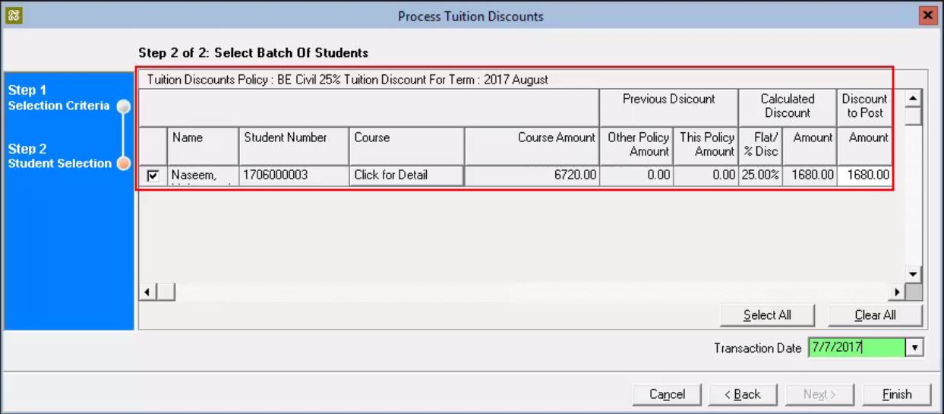
Replace the new table
7
6

Comment/Reason :
TI000001
Tax Invoice List :
1  2  3  4 |  |  |  |  |  |  | Previous Discount |  | Calculated Discount |  |  |  | Discount To Post
No. | Tran. Type | Ref No | Name | Student Number | Course | Course Amount | Other Policy Discount | This Policy Amount | Flat/% Disc | GST Tax Code | GST | Amount After GST | Amount
1 | CN | CN17BH-EEE000001 | Naseem | 1706000003 |  | 6720.00 | 0.00 | 0.00 | 25.00% | ES | 0.00 | 1680.00  5 | 1680.00
2
Step 2 of 2: Select Batch Of Students

  - Additional requirements

No. | Key Data Elements | Description
1 | Transaction Type:  CN/ TCN | To show the Transaction Type.  The title must be displayed at the top of the documentation issued.
2 | Ref No | Each transaction document above created must have auto-filled number for CN/ TCN.
3,4,  5 | GST elements – GST Tax Code, GST and Amount after GST | Each transaction document created must be labeled with the selected GST Tax Code which is initially setup under the tuition fee setting of each course, show the GST amount (auto-calculated by the system) and total amount after GST. Once the is clicked, the user can edit the GST amount auto-calculated by the system.  For the CN/ TCN issued, the reference details towards the initially INV/TI such as the invoice number and date can be updated into the Description section of the documentation.
6 | Tax Invoice List | This function will appear when user want to issuance CN/TCN. User have to select the original tax invoice related to CN/TCN & report for the CN/TCN have to show the number and date of the original tax invoice. Please refer the example.
7 | Comment/Reason | The reasons for its issue DN/CN/TI/TCN/TDN/MCN/MDN. (Compulsory). Have to show in the report.

- Scholarship (To rename to Award/ Bursary/ Rebate)
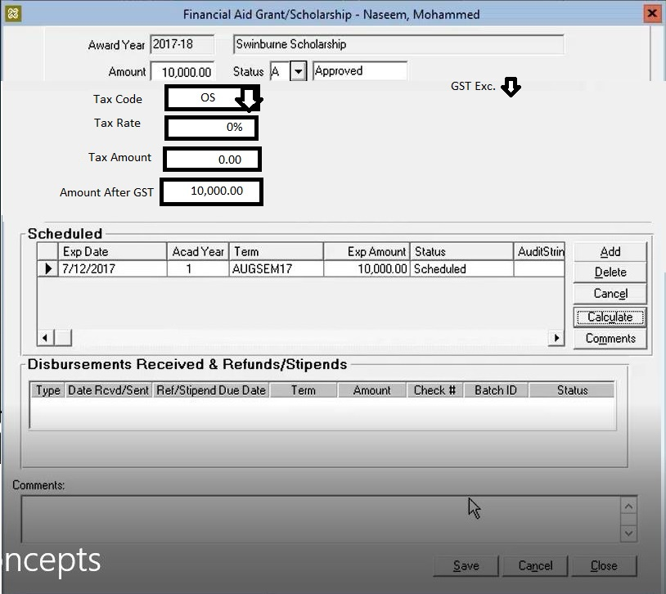
2
1

  - Requirement of change
No. | Fill | Description
1 | Tax Code, Tax Rate, Tax Amount & Amount After GST | Tax Code & Tax Rate will appear based on selected transaction code. Data must be editable  *Based on Transaction Code Setup
2. | GST exclusive or GST inclusive | To allow the user to choose GST exclusive or inclusive. The system will auto-calculate the GST amount of the Amount keyed-in based on the selection by user.

REPORTING

- GST Report
This report will show the details transaction by various options/filters. Filter parameters include:
- Filter by Year, Month and Date
- Filter by GST Code
- Filter by Tax Code
- Filter by Account Code

GST Report
PRINT

2017
Year
September
November
Month From
Month To

Date From
Date To

Account Code
ALL
GST Code
ALL
ALL
Tax Code

  - GST Report by GST Code

GST Report By GST Code
PRINT

Year
2017
Month To
November
September
Month From
Date From
Date To

GST Code
ALL

    - Example : Sample GST Report ( by GST Tax Code)

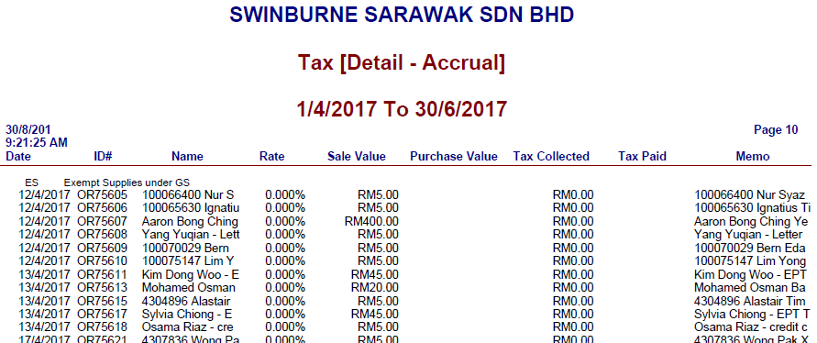
SAMPLE
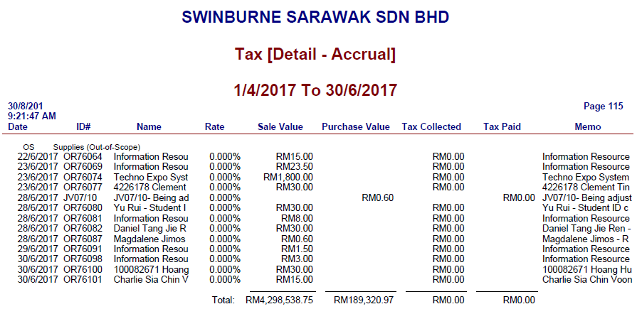
SAMPLE
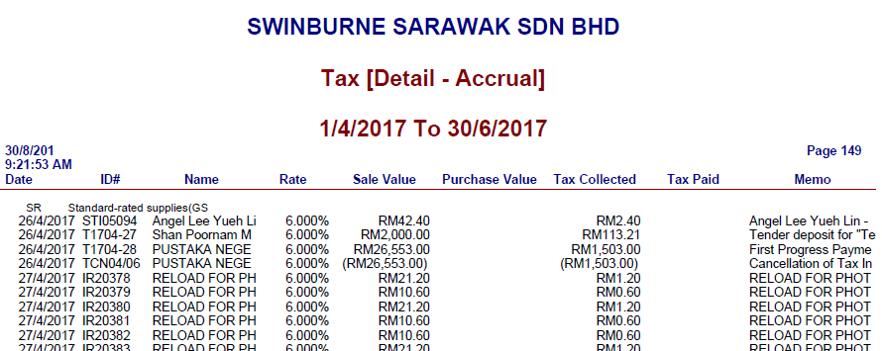
SAMPLE

  - GST Report by Tax Code
2017
September
November

Date From
Date To
Month From
Year
Month To
Tax Code
ALL
GST Report By Tax Code
PRINT

    - Example GST Report (by Tax Code)

SAMPLE

SAMPLE

  - GST Report by Account Code

2017
September
November

Date From
Date To
Month From
Year
Month To
Account Code
ALL
GST Report By Tax Code
PRINT

    - Example : Sample GST Report (by Account Code)

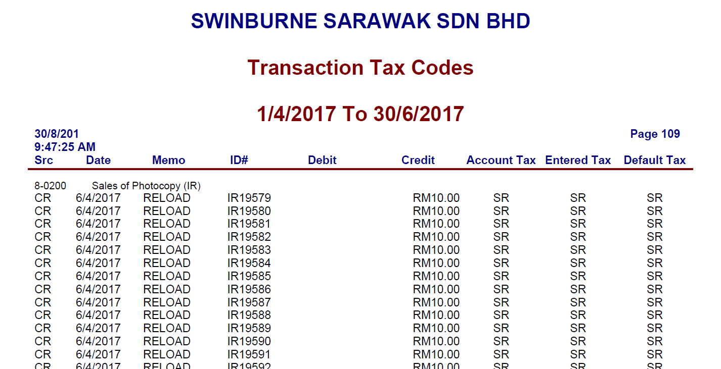
SAMPLE
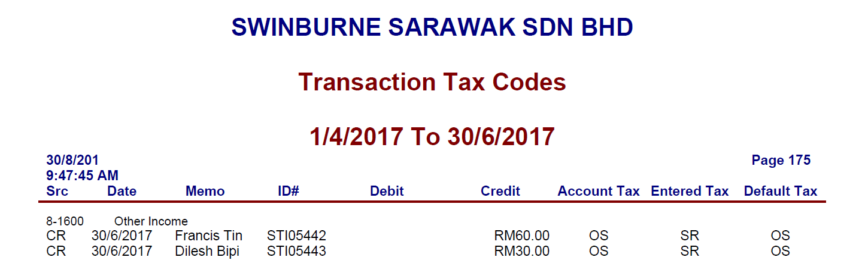
SAMPLE

- GST Report Summary
This report will show the details transaction by various options/filters. Filter parameters include:
- Filter by Year, Month and Date
- Filter by GST Code
- Filter by Tax Code
- Filter by Account Code

GST Report Summary
PRINT

2017
Year
September
November
Month From
Month To

Date From
Date To

Account Code
ALL
GST Code
ALL
ALL
Tax Code

  - GST Report Summary by GST Code

GST Report Summary by GST Code
PRINT

2017
Year
September
November
Month From
Month To

Date From
Date To

GST Code
ALL

  - GST Report Summary by Tax Code

PRINT
GST Report Summary by GST Code

2017
Year
September
November
Month From
Month To

Date From
Date To

Tax Code
ALL

  - GST Report Summary by Account Code

PRINT
GST Report Summary by Account Code

2017
Year
September
November
Month From
Month To

Date From
Date To

Account Code
ALL

***ScreenShot MYOB

- GST Tax Amount Variance Report

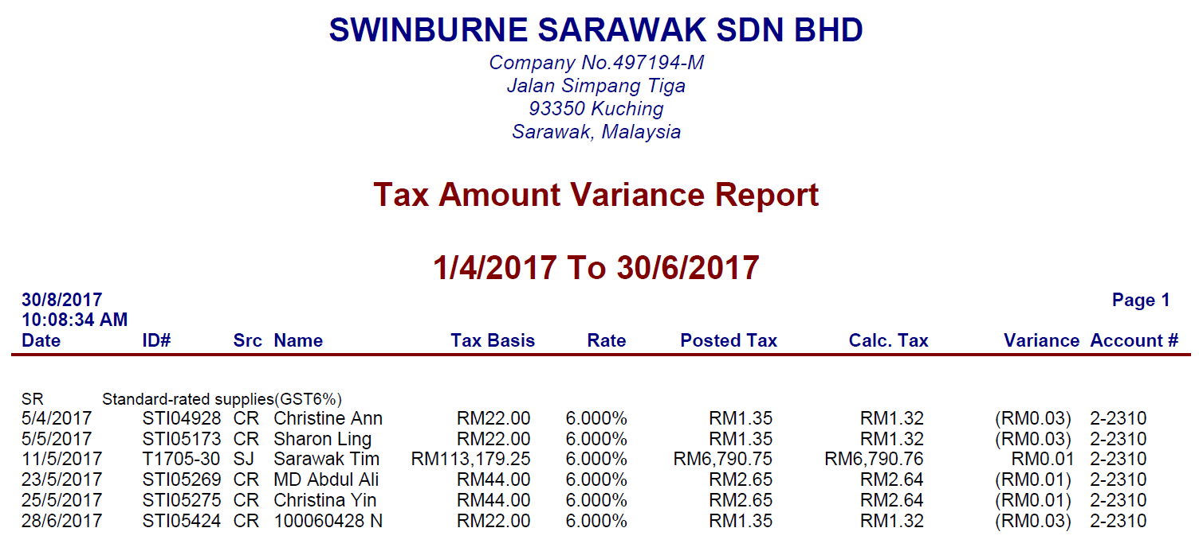
SAMPLE

****Add more Explanations.....

- Transaction Report
This report will show the details transaction by various options/filters. Filter parameters include:
- Filter by Year, Month and Date
- Filter by Transaction Code
- Filter by Account Code
- Filter by Department Code
- Filter by Project Code
- Filter by Student ID
- Filter by Student Nationality
- Filter by Courses
- Filter by Student Enrollment status (New or Current)

From this report, the user will know total revenue based on the above filter citeria. Please refer sample under GST report & GST summary for filter menu.

- Invoice Listing (INV/TI/MTI/STI)
The system should be able to produce the listing of normal/full/miscellaneous and simplified tax invoice.
SAMPLE
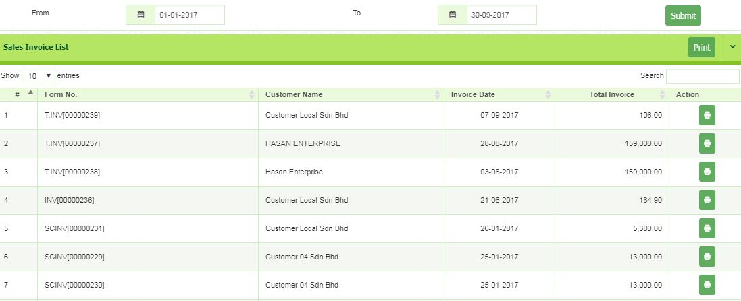
- Debit Note Listing (DN/TDN/MDN)
The system should be able to produce the listing of normal/full and miscellaneous debit note.
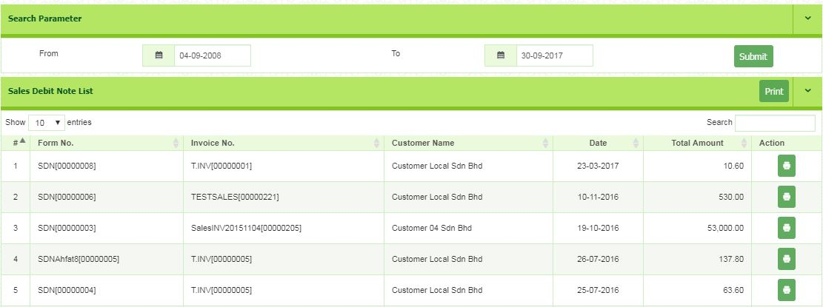
SAMPLE

- Credit Note Listing (CN/TCN/MCN)
The system should be able to produce the listing of normal/full and miscellaneous credit note.

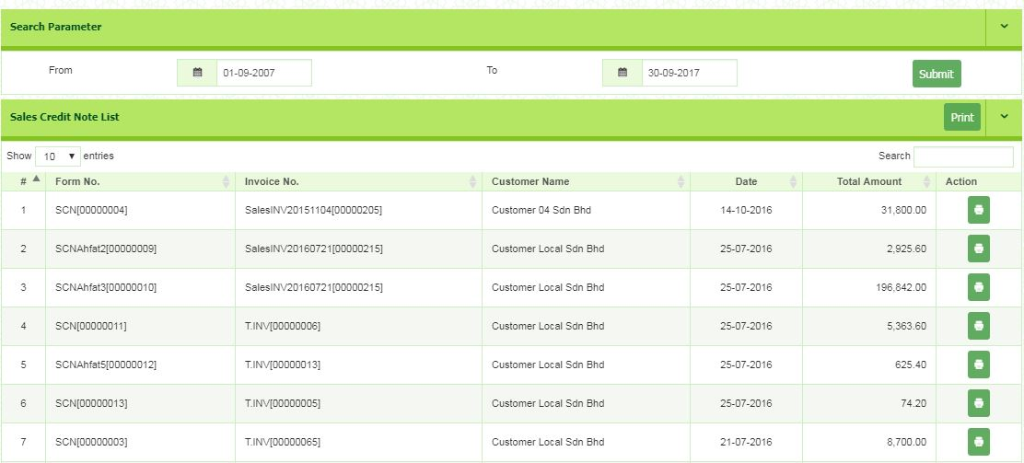
SAMPLE

- Receipt Listing
The system should be able to produce the listing of receipt for student payment.

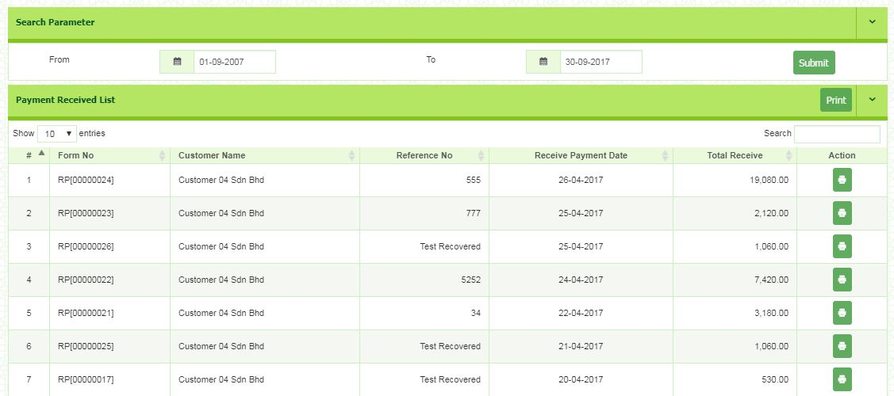
SAMPLE

- Student Outstanding Report
The system should be able to produce listing of student outstanding. **More explanation.

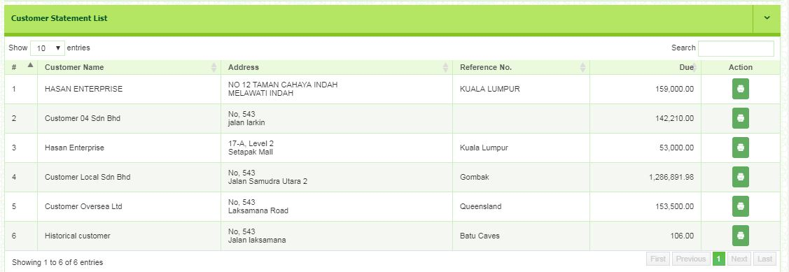
SAMPLE

STUDENT PORTAL

Student portal is a platform accessed by only registered student of Swinburne. Student can easily access and view the information needed. In this section, student can: -
- Check student mailbox (E-mail)
- Register semester subject
- Access online classroom
- Manage student enrolment
- Student Statement

- STUDENT STATEMENT
We are recommending improvements of student summary statement section, which is the summarrised version of the view from Student Ledger Card. Sample new screen layout as below: -

Sample New Screen Layout
The screen below is a sample of new main screen for student statement. We recommend to create a filtering section that will make it easier for student to search transaction history by date.

STUDENT STATEMENT
PRINT

Date To
Date From

Date | Ref # | Description | Charges | Payments | Balance | Term
6/7/2017 | INV17BH-EEE000001 | Tuit fee | 3,350.00 |  | 3,350.00 | AUG  SEM
7/7/2017 | CN17BH-EEE000001 | Tuit fee – Drop subject | (1,000.00) |  | 2,350.00 | AUG  SEM
8/7/2017 | ABR17BH-EEE000001 | Award |  | 750.00 | 1,600.00 | AUG  SEM
8/7/2017 | OR1234567890 | Pymt of tuit fee |  | 3,350.00 | (1,750.00) | AUG  SEM
10/7/2017 | RF17BH-EEE000001 | Refund of payment |  | (1,750.00) | 0.00 | AUG  SEM
10/7/2017 | TI17ACCA000001 | Tuit fee | 2,544.00 |  | 2,544.00 | AUG  SEM
10/7/2017 | TDN17ACCA00001 | Tuit fee – Add subject | 2,544.00 |  | 5,088.00 | AUG  SEM
10/7/2017 | TCN17ACCA00001 | Tuit fee – Discount | (1,272.00) |  | 3,816.00 | AUG  SEM
10/7/2017 | OR1234567891 | Pymt of tuit fee |  | (3,816.00) | 0.00 | AUG  SEM
6/10/2017 | MTI000001 | Souvenirs | 636.00 |  | 636.00 | AUG  SEM
6/10/2017 | MTI000001 | Sales of textbooks | 100.00 |  | 736.00 | AUG  SEM
10/10/2017 | STI000001 | Graduation fee – extra ticket | 106.00 |  | 842.00 | AUG  SEM
10/10/2017 | STI000001 | Graduation fee | 250.00 |  | 1,092.00 | AUG  SEM
10/10/2017 | MCN00001 | Return of Souvenirs | (53.00) |  | 1,039.00 | AUG  SEM
10/10/2017  Each time user clicks here, it will display the INV/TI/DN/TDN/CN/TCN/MTI/MDN/MCN/ receipts/ refund/ award/ bursary/ rebate to be viewed or printed. | OR1234567892 | Graduation fee – extra ticket |  | (1,039.00) | 0.00 | AUG  SEM

Once submitted, all the listing on the selected dates will be listed. Too see the details, student needs to click the link of Ref #. Once clicked, it will be directed to the details page.

OTHER REQUIREMENTS TOWARDS GST COMPLIANCE

26.0 File Format Definition for GST Audit File (GAF)
26.1 Introduction

The GST Audit file is a way for taxpayers to submit information relevant to auditors in response to an audit request on information for auditing purposes. The information provided includes company identifications, names, supply & purchases, and general ledger transactions. There is also a footer record to ensure file integrity.
There are two types of files that can be submitted, Bar-Delimited-File and XML file which contribute to the same goal that the information for auditing purposes will appear the same to auditors. We would like to suggest for developer to use the Bar-Delimited-File to develop GAF Audit file. The GAF can be generated by period of time flexibility. The system should be abled to attach the GAF into Taxpayer Access Point (TAP) website portal.

    - GST Audit File Specification of Bar-Delimited File

The bar delimited file is separated by the bar character “|”. The bar makes for a better delimiter than commas because it is less likely to be in names and elements in the file. The accounting software must run data purification to ensure that any bars in element data are removed, and the GAF must in a format of Text Document (.txt).

(a) Record Types
The bar delimited file is made up of lines that each correspond to a record type, there are five record types:
Record Type | Meaning
C | Company
P | Purchase
S | Supply
L | Ledger
F | Footer

(b) Data Types
The transactions data for bar delimited file that made up of lines must be formatted with a data types as stated below:
Record Type | Meaning | Example
C | Currency | 123.45
N | Numeric | 123
AN | Alphanumeric | 12345678A
DATE | Date | 31/12/2017 or dd/MM/yyyy

(c) Empty Values
(i) For Alphanumeric Data
For optional alphanumeric values, where no data is necessary, simply leave an empty space but retain the structure of the file. For see example below for elements Alpha through Delta where Charlie is optional and empty:
Alpha|Bravo|Charlie|Delta|
Alpha|Bravo||Delta|
(ii) For Currency and Numeric
For currency and numeric elements, zero amounts should be represented by a 0.
*All date fields are required
(d) Elements Heading
The bar delimited file will have a heading for each elements which follow the Element Name.

(e) Bar-Delimited File Record Elements

(i) C Record Elements
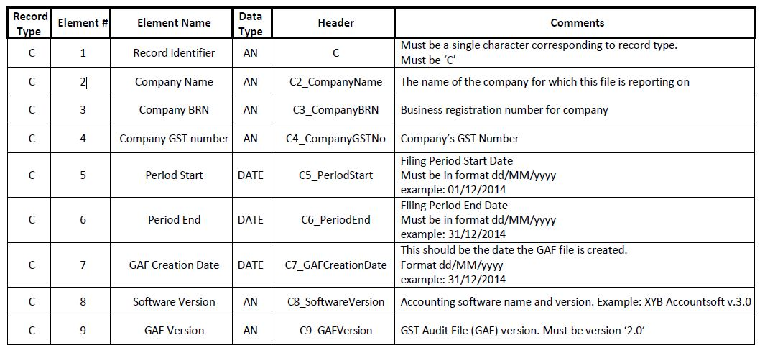
The C Records should contain information about the company for which this file is submitted. There should only be 1 record of this type in any GAF file submitted. If multiple companies need to submit this information it should be done via a separate web re quest and new file.

(ii) P Record Elements
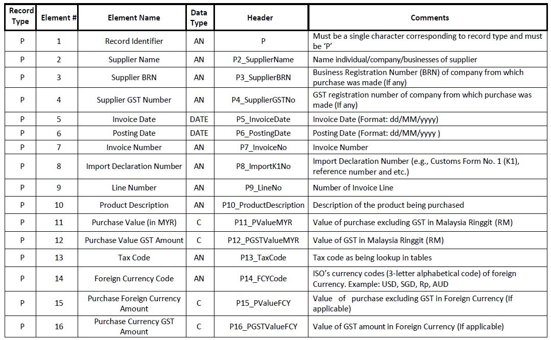
The P records should record purchases made by the company defined in the C record.

(iii) S Record Elements
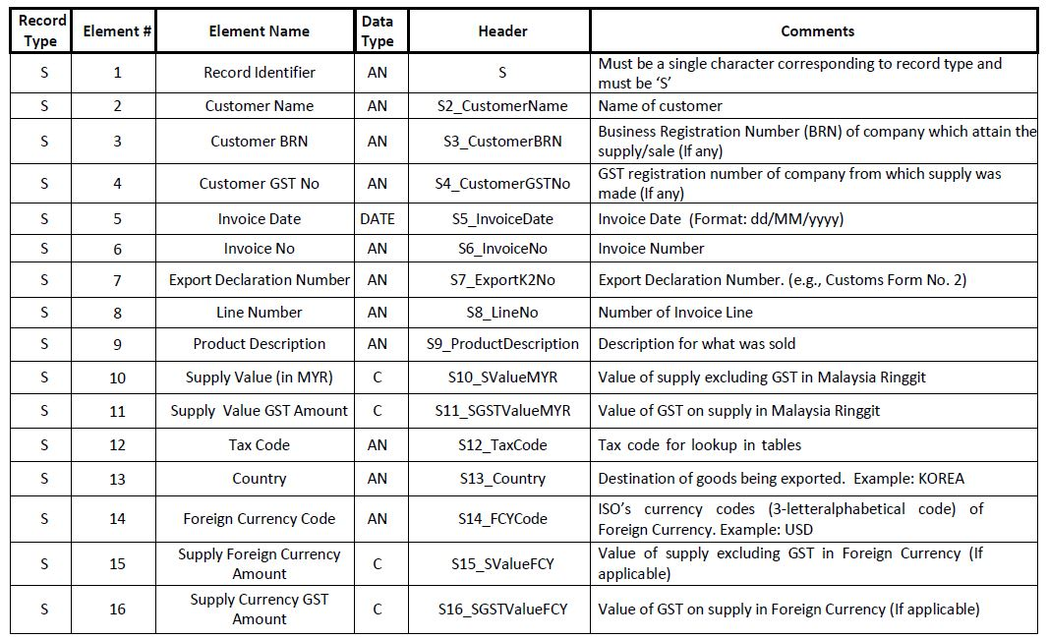
The S Records should record sales made by the company defined in the C record.

(iv) L Record Elements
The L record is used to record general ledger transactions by the company.
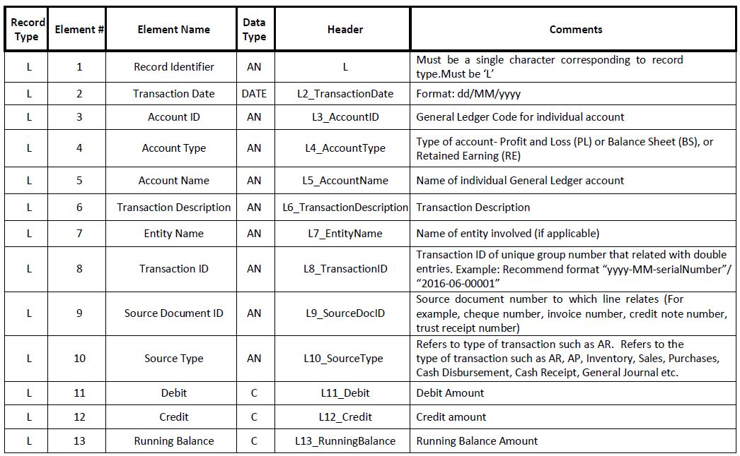

(v) F Record Elements
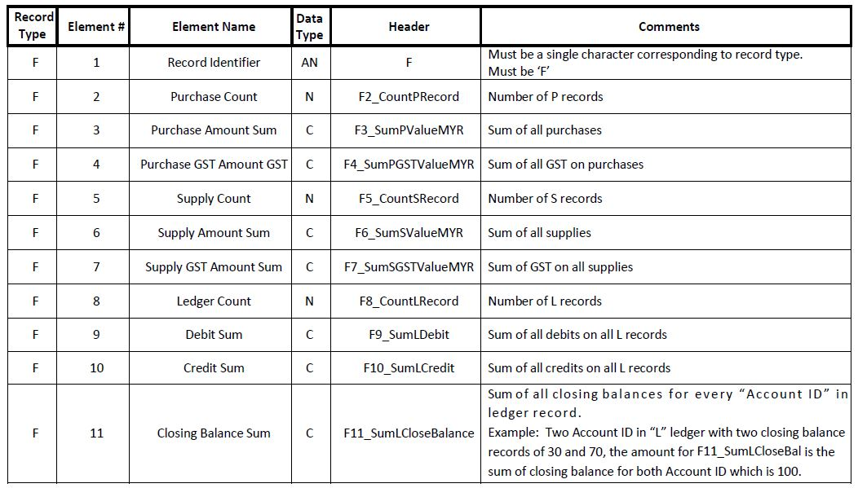
The F records are used to verify the accuracy of the file being submitted. Only one F record should ever be included on a file.

(f) Example of GAF (Bar-Delimited File) *(Note: This Bar-Delimited File must be in filename extension of “.txt”)
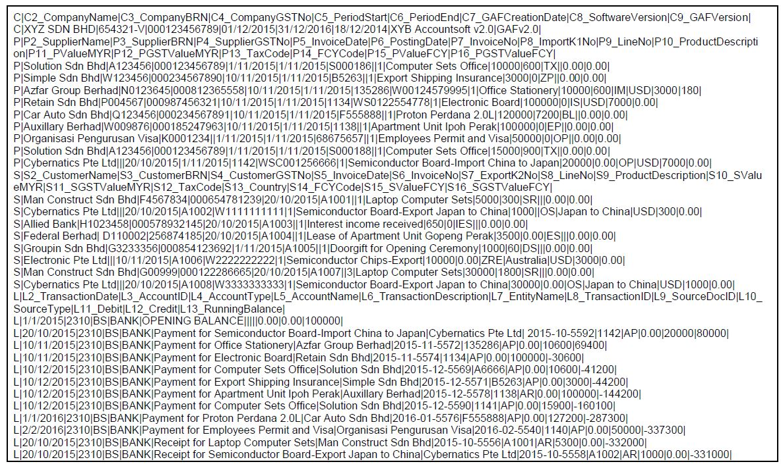

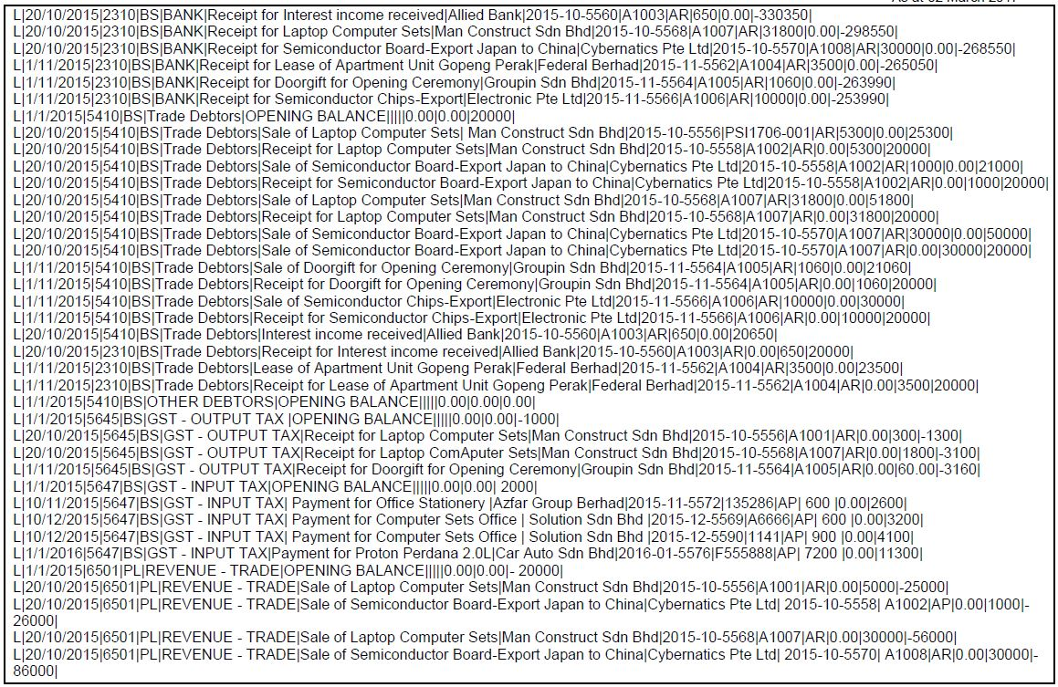

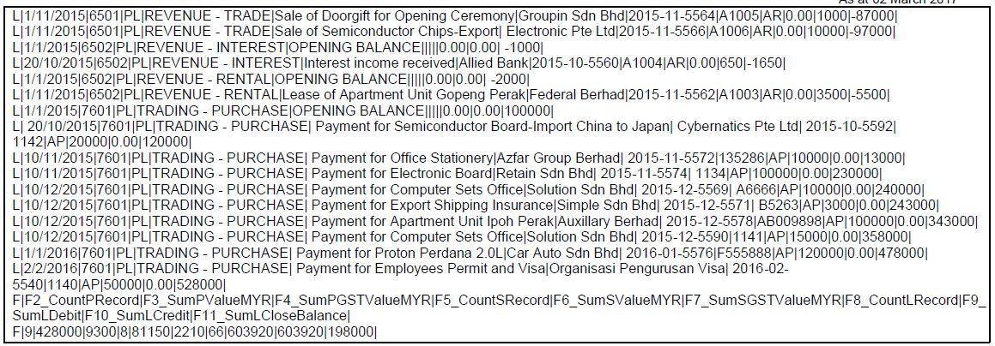

- Bad Debt
  - Bad Debt Relief
Adjustments need to be made on the following situations:
    - Bad debt due to non-payment
    - Bad debt due to insolvencys
    - Recovery of payment with regards to bad debt

A taxable person is entitled to a relief for bad debt on the whole or any part of the tax paid by him in respect of a taxable supply if:
- GST has been paid
- No payment has been received in 6 months from the date of supply
- The debtor has become insolvent before the period of 6 month has elapsed
- Sufficient efforts have been made by him to recover the debt.

The seller has not received any payment
- Claim for the whole of the tax paid

Seller received part payment for taxable supply
- Claim for an amount calculated accordance to this formula
$\frac{A1}{B}×C$
Where A1 is payment not received for the taxable supply;
B is consideration for the taxable supply; and
C is the tax due and payable on the taxable supply.

27.1.1 Example Bad debt Relief

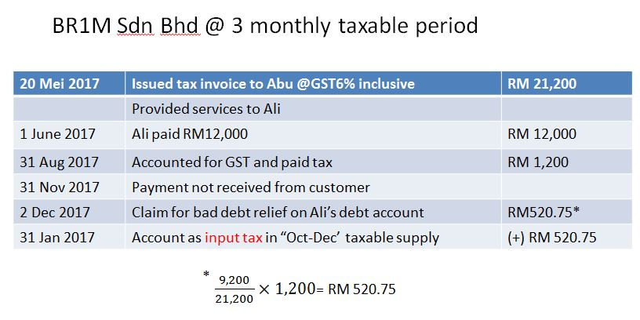

  - Bad Debt Recovery
When GST registered businesses have recovered the amount be it full or partial from their debtor, they must pay back to Customs the GST Tax amount claimed as Bad Debt Relief earlier. This GST tax amount will be calculated in proportion to the payment recovered from debtor.

27.2.1 Example Bad debt Recovery

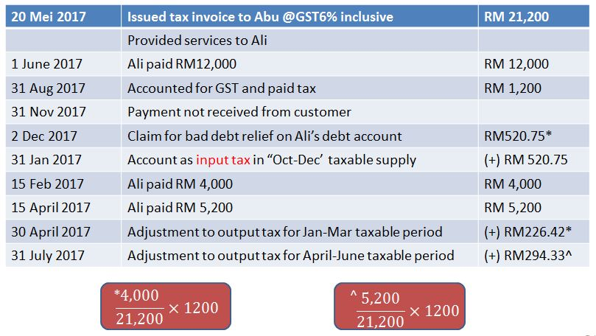

28.0 Deposit/Advance payment received
Deposit, whether refundable or not refundable or in the form of security given in respect of any supply of goods or services, is not part of the consideration for the supply if it does not form part of the payment for the supply. Generally most deposit payments represent consideration, as the amount paid over is intended by the parties to the contract to be offset against the purchase price once the supply has been made. Such payments fall within the scope of GST and tax must be accounted for on receipt of the deposit.
- Forfeit deposit
Generally, forfeit deposit is not consideration for any supply because it constitutes a compensation payment for damages due to non-performance of the contract or for breach of contract. However, in some circumstances, the deposit may still be a consideration for a supply. An example would be where a contract involving accommodation of hotel room provides for the letting of a room whether it was occupied or not.
- Security deposit
A deposit is taken as security, for example against the safe return of goods on hire or loan, is not consideration for a supply. The terms of the contract under which such a deposit is required will specify that the deposit is refundable to the customer subject to the safe return of the goods
- Return deposit
Return deposit is not a consideration for any supply because it is not part of payment but a return of money to the customer due to cancellation of the contract between the supplier and customer.

29.0 System Access
Access controls to ensure that only authorized users can access, and the authorized users are according to authorized level. The access data also shall according to the permissions given. Password control specification shall include into the accounting software. For example is password integrity such as minimum password length, password complexity, password history, etc.

27.0 Data Security Control/Audit Trail
Controls to prevent any editing and deleting of entries originally recorded. Changes to recorded entries should be made by journal entry and be adequately documented with information such as:
i. Person making modifications
ii. Date of change
iii. Previous & Current entry details

28.0 Backup and Restore Management

Backup controls to guarantee retention of back-up copies of electronic records, computer programs, system documentation and recovery of electronic records in case of system failure and allow user to restore back the data.

29.0 Currency Conversion
- The software should allow the capture of Malaysia Ringgit equivalent value of GST when the supplier’s tax invoice is denominated in a foreign currency (FCY) using the exchange rate indicated by the supplier. For companies not using Malaysia Ringgit (MYR) as its functional currency, the software should be capable of converting the value of supply and output tax into Malaysia Ringgit (MYR) currency based on prevailing exchange rate for GST reporting purposes.
- Other than that, the accounting software should not convert the amount before GST and the GST amount from foreign currency to Malaysia Ringgit (MYR) equivalent using its own exchange rate for accounting purposes as the rate could be difference from the exchange rate adopted by the supplier.

- For businesses transactions that use foreign currency (e.g., USD, SGD, Rp, AUD) as their functional currency, the accounting software must be capable of converting the value of supplies made and output tax charged to Malaysia Ringgit (MYR) based on the prevailing exchange rate for GST reporting purposes.

30.0 Training & Product Knowledge
To provide intensive training to all user and also FAQs as user guideline.

31.0 Keeping of Records
The software developer must design their accounting software to preserve all the records is in electronically readable form, and the record shall be kept in such manner as to enable the record to be readily accessible and convertible into writing. Other than that, if the record is originally in a manual form and is subsequently converted into an electronic form, the record shall be retained in its original form prior to the conversion.
Therefore, a taxable person is required to preserve all the records pertaining to any GST transactions, the apportionments and adjustments that he has made for a period of 7 years from the last date to which such apportionment and adjustment relates, it is align with the requirement under section 36 of the GST Act 2014. For more information on duty to keep record, please refer to Guide on Tax Invoice and Record Keeping.

