
User Manual

GST Module
Version | 1.3
Date | 16 February, 2015

1 Setup 1
1.1 GST Setup 1
1.2 Tax Code Setup 2
1.3 GST 03 Tax Codes Mapping 3
1.4 Source Document 4
1.5 Invoice Type Setup 5
1.6 Tax Year Setup 6
1.7 GST Account Setup 7
1.8 Deemed Supplies Account Setup 8
1.9 GST Customer Information 9
1.10 GST Vendor Information 10
2 Transactions 12
2.1 Receivables Bad Debts Relief Adjustment 12
2.2 Payables Bad Debts Relief Adjustment 14
2.3 Deemed Supplies Transaction 16
2.4 Gift Rule Transaction 18
2.5 Imported Services Reverse Charge 21
2.6 Payables Bad Debts Recovery Adjustment 23
2.7 Receivables Bad Debts Recovery Adjustment 25
2.8 Deemed Supplies - GST charged on private use of business asset 27
2.9 Staff Claims – Through Accounts Payable 32
3 Inquiry 37
3.1 Payables Bad Debts Relief Adjustment Inquiry 37
3.2 Receivables Bad Debts Relief Adjustment Inquiry 38
3.3 Imported Services Reverse Charge Inquiry 39
3.4 Deemed Supplies Inquiry 40
3.5 Gift Transaction Inquiry 41
3.6 Receivables Bad Debts Recovery Adjustment Inquiry 42
3.7 Payables Bad Debts Recovery Adjustment Inquiry 43
3.8 GST 03 Inquiry 44
4 Reports 45
4.1 GST 03 Report 45
4.2 GST 03 Report 46
4.3 Gift Items Transaction Report 47
4.4 GST Audit File 48
5 Tax Period End Closing 49

Setup

GST Setup
Path: Cards>>My GST >>GST Setup

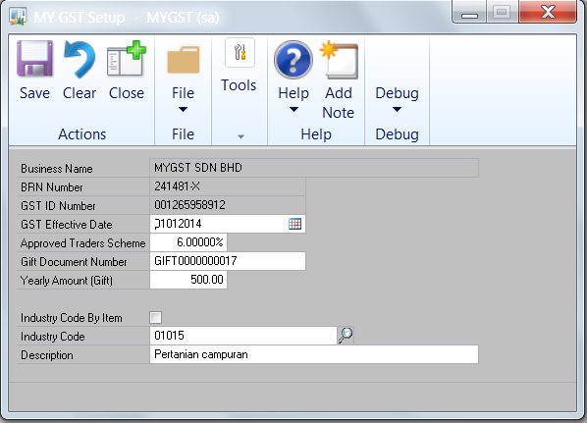

Use this window to setup GST Registration details.

- Enter GST Effective Date based on the GST company registration details with Customs.

- Approved Traders Scheme (ATS) is defaulted to 6%, based on current GST rate.
- Gift Document Number: Enter beginning running number for Gift Rule Transactions
- Yearly Amount (Gift): The default amount is RM500.00

- The Industry Code look up button is used to search and add the Malaysian Standard Industrial Classification (MSIC) Code. If there is more than one code to be added, tick the Industry Code By Item box. You can also manually enter the Industry Code and Description.

Tax Code Setup
Path: Cards>>My GST >>Tax Code Setup

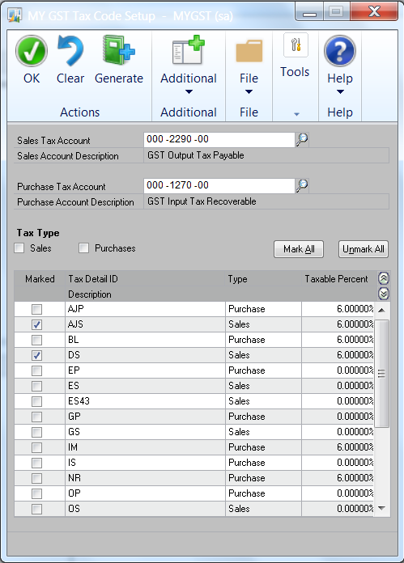

This window displays the Customs GST Tax Codes.

- Tax Type: Tick Sales, and mark the relevant Sales Tax Detail ID tax codes, and enter the Sales Tax Account (Output Tax). Subsequently, Tick Purchases, and mark the relevant purchases Tax Detail ID, and enter the Purchase Tax Account (Input Tax)

- Click Generate to generate the Tax Detail ID and Tax Schedules.

- The Tax Detail and Tax Schedules generated can be viewed in the respective windows.

- Path: Tools>Setup>Company>Tax Details
- Path: Tools>Setup>Company>Tax Schedules

GST 03 Tax Codes Mapping
Path: Cards>>My GST >>GST 03 Tax Codes Mapping

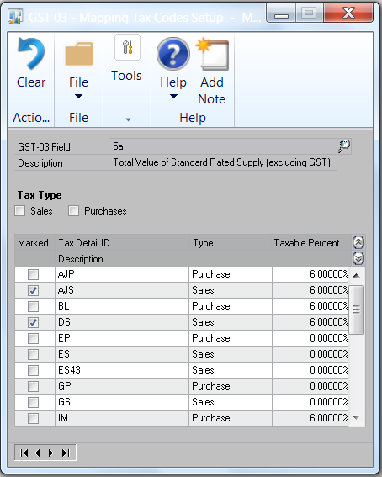

Use this window to map the GST Tax Codes to the GST 03 field specific to the official GST 03 Returns Form.

- The GST 03 Tax Codes Mapping is to map the Tax Detail IDs to the fields in the GST 03 Monthly/Quarterly returns.

- Look up the GST-03 Field, select the GST03 items, and mark the related Tax Detail IDs to the GST 03 items.

Source Document
Path: Cards>>My GST >>Source Document

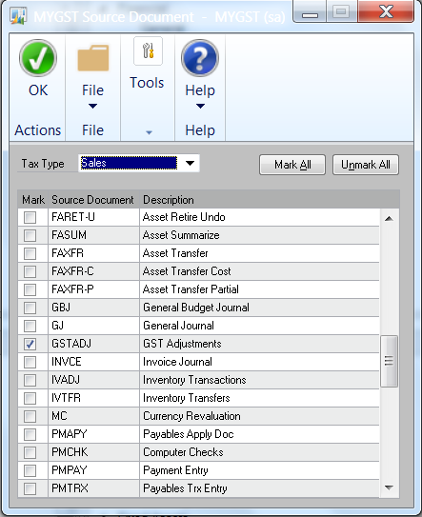

This window displays the source documents from Source Document setup.

- Source Document for GST transactions like deemed supplies can be created in Source Document Setup [Tools>Setup>Posting>Source Document] and will be available for tagging to the defined transaction.

- This provides a specific source document code for a related GST transaction that assists in filtering at account transaction details.

Invoice Type Setup
Path: Cards>>My GST >>Invoice Type Setup

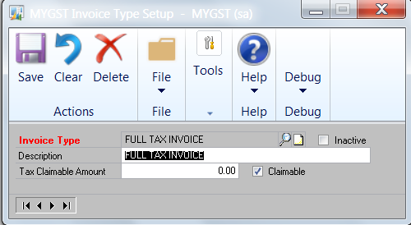

This window is used to create the Invoices Type codes for Staff Claims.

- Enter a code [Invoice Type]

- Enter description to describe the code

- Enter [Tax Claimable Amount] if there is a maximum amount of GST that can be claimed. Example: Simplified Invoices where the maximum tax amount that can be claimed is RM30.00.

- [Tick] Claimable for Invoice Types that have GST claimable.

- [Save] the record.

Tax Year Setup
Path: Cards>>My GST >>Tax Period Setup

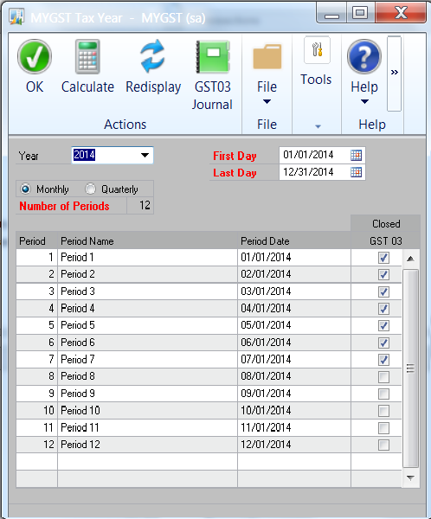

This window is used to create the GST Tax Year.

- Enter the Year

- Enter the First day and Last day of the tax year.

- Choose either Monthly or Quarterly

- Enter the Number of tax periods for the Tax Year

- Choose Calculate to calculate each period’s first day and last day

GST Account Setup
Path: Cards>>My GST >>Account Setup

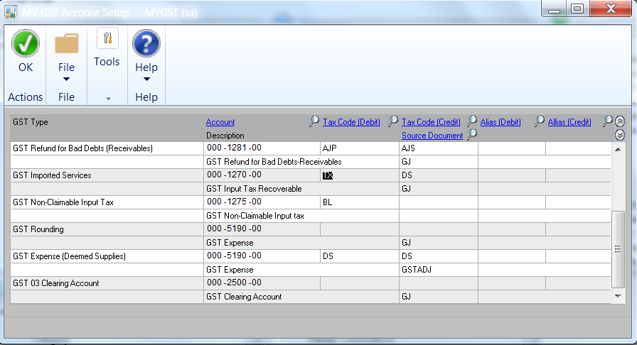

Use this window to setup the Posting accounts, Tax Code, Source Document and Analytical Accounting information.

- Setup the posting accounts, Tax Code, Source Document and Analytical Accounting (Alias) details for GST Type in the window.

- Repeat step 1 (above) until you have assigned the details to every GST Type in the window.

- Click [OK] to save the settings.

Deemed Supplies Account Setup
Path: Cards>>My GST >>Deemed Supplies Account Setup

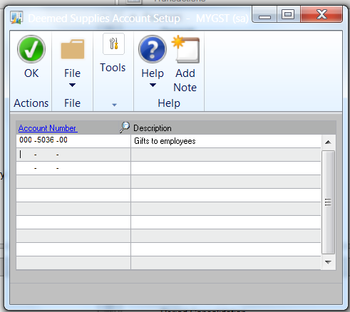

Use this window to setup posting accounts for deemed supplies transactions.

- Setup the posting accounts for expenses that has elements of deemed supplies for gifts costing more than RM500.

- Enter an account, or select one from the lookup window.

- Click [OK] to save the settings

GST Customer Information
Path: Cards>>My GST >>Customer

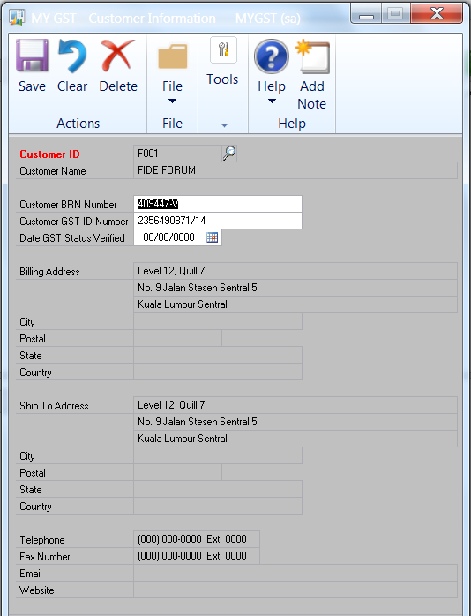

Use this window to enter GST registration details for customer

- Select the Customer from the lookup window

- Enter the Customer Business Registration Number (BRN).

- Enter the GST ID Number.

- Enter the GST Status Verified Date.

- Click [Save] to save the settings

GST Vendor Information
Path: Cards>>My GST >>Vendor

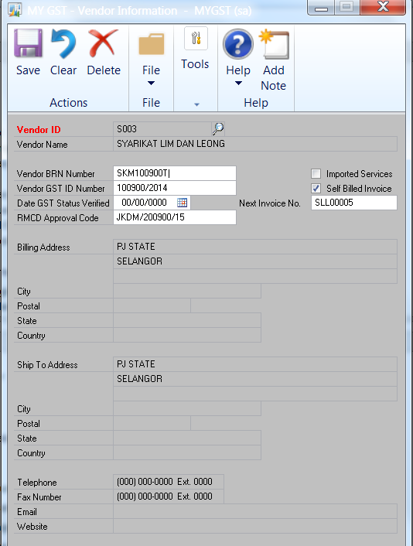

Use this window to enter GST registration details for vendor

- Select the Vendor from the lookup window

- Enter the Vendor Business Registration Number (BRN).

- Enter the GST ID Number.

- Enter the GST Status Verified Date.

- Tick Imported Services if services are purchased from this vendor. The services come under ‘Reverse Charge Mechanism’

- Tick Self Billed Invoice, if Self Billed Invoice is to be produced.

- Set Next Invoice No, which is the starting number for the self-billed invoice.

- Enter RMCD Approval Code for the Self Billed Invoice.

- Click [Save] to save the settings

Transactions

Receivables Bad Debts Relief Adjustment
Path: Transactions>>My GST >>Receivables Bad Debts Relief Adjustment

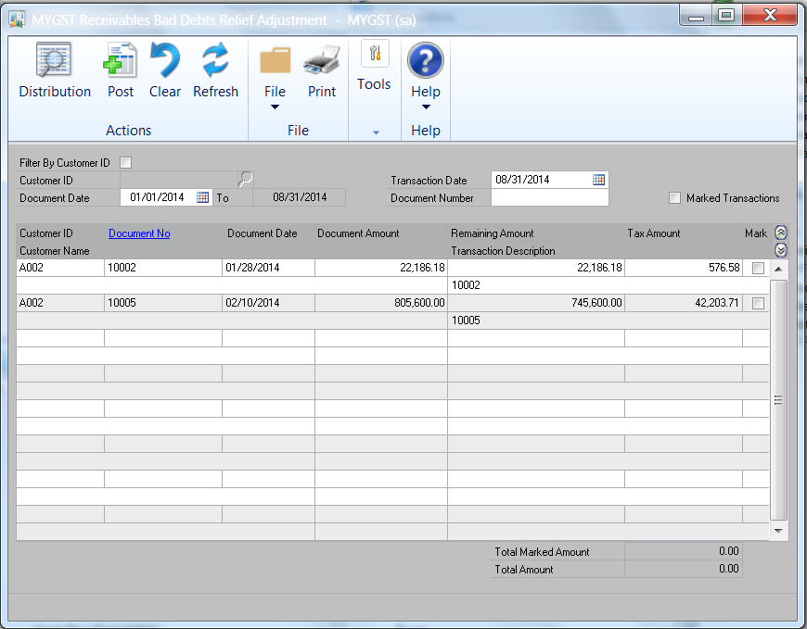
Select Options

This window displays receivable documents (invoices) that are due for bad debts relief adjustment. You can select the document (invoice) to claim bad debts relief adjustment.

- The documents (invoices) displayed in the window can be selected by:

- Customer ID
- Document Date
- Transaction Date
- Document Number

- Select [Mark] the document(s) to create transaction for bad debt relief adjustment.

- Click Distribution to view GL distribution entries and the tax code assigned.

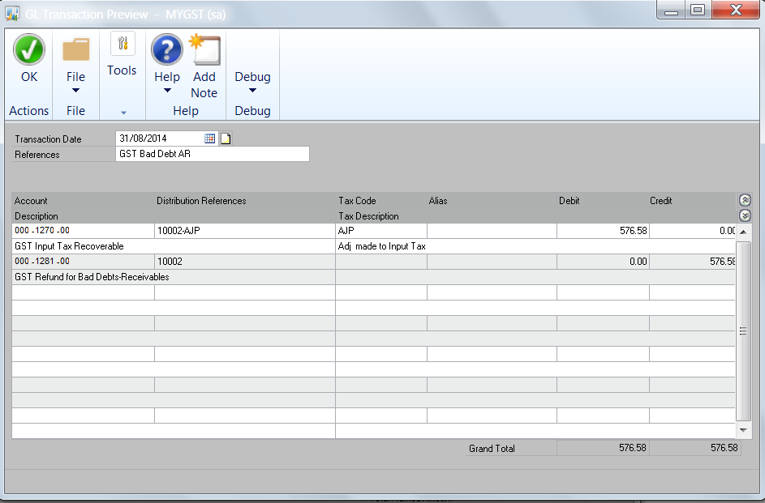

- Click OK and Go back to Receivables Bad Debts Relief Adjustment window and print edit list report.

- Post the transactions.

Payables Bad Debts Relief Adjustment
Path: Transactions>>My GST >>Payables Bad Debts Relief Adjustment

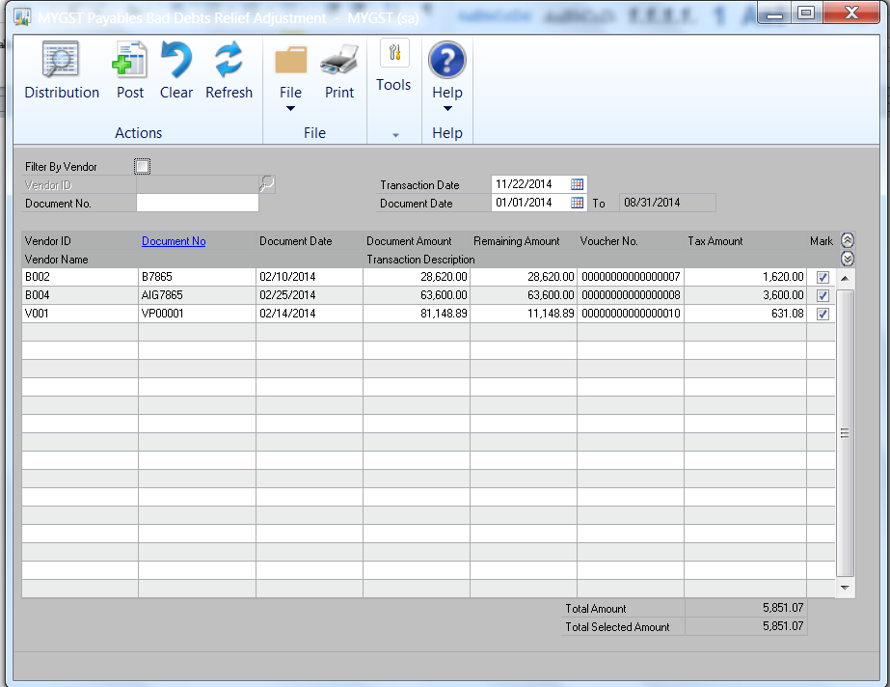
Select Options

This window displays payable documents (invoices) that are due for bad debts relief adjustment. The documents (invoices) to claim bad debts relief adjustment are marked, and cannot be edited.

- The documents (invoices) displayed in the window can be selected by:

- Vendor ID
- Document Date
- Transaction Date
- Document Number

- Click Distribution to view GL distribution entries and the tax code assigned.

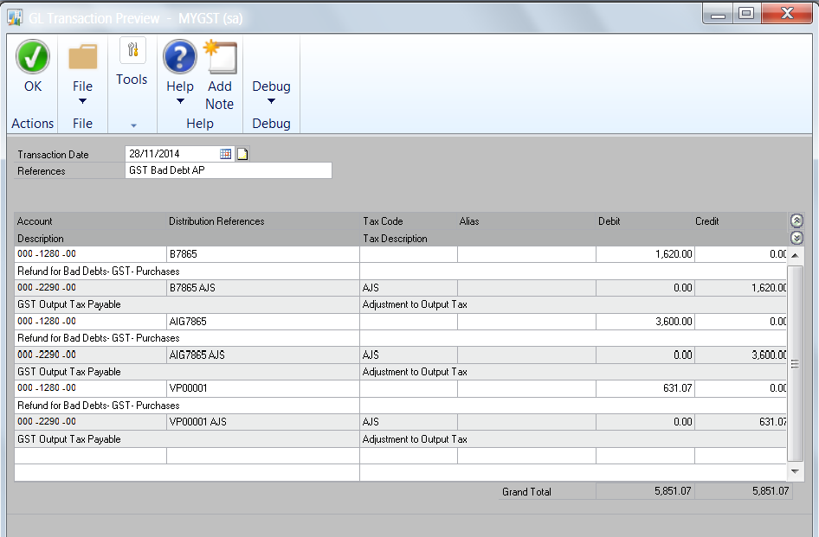

- Click OK and Go back to Payables Bad Debts Relief Adjustment window and print edit list report.

- Post the transactions

Deemed Supplies Transaction
Path: Transactions>>My GST >>Deemed Supplies

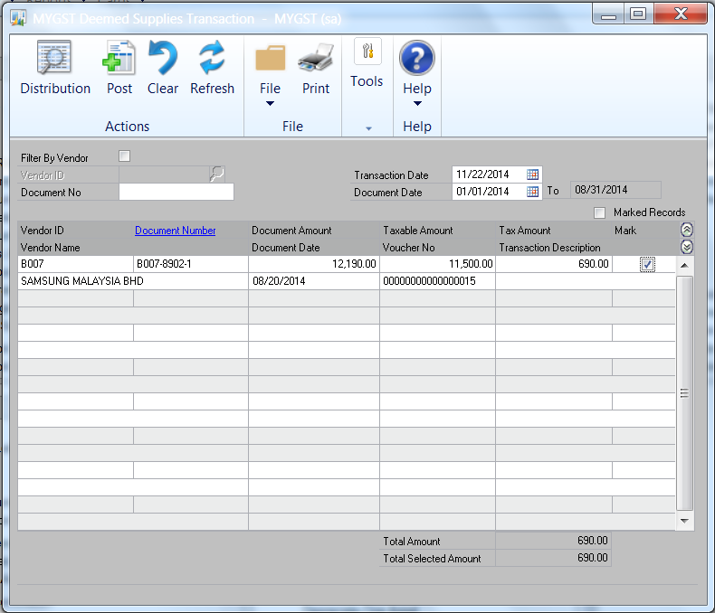
Select Options

This window displays purchase documents (invoices) that have been charged to deemed supplies related expense accounts.

- The documents (invoices) displayed in the window can be selected by:

- Vendor ID
- Document Date
- Transaction Date
- Document Number

- Select [Mark] the document (invoice) and enter the Taxable Amount

- Click Distribution to view GL distribution entries and the tax code assigned.

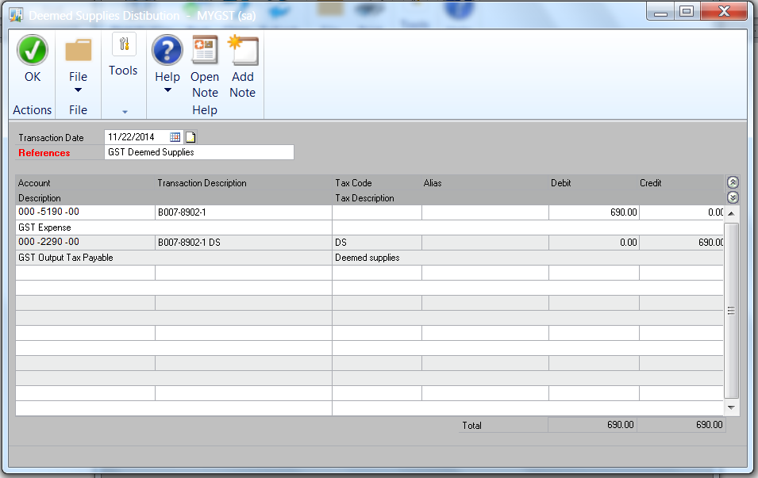

- Click OK and Go back to Deemed Supplies window and print edit list report.

- Post the transactions

Gift Rule Transaction
Path: Transactions>>My GST >>Gift Rule Transaction

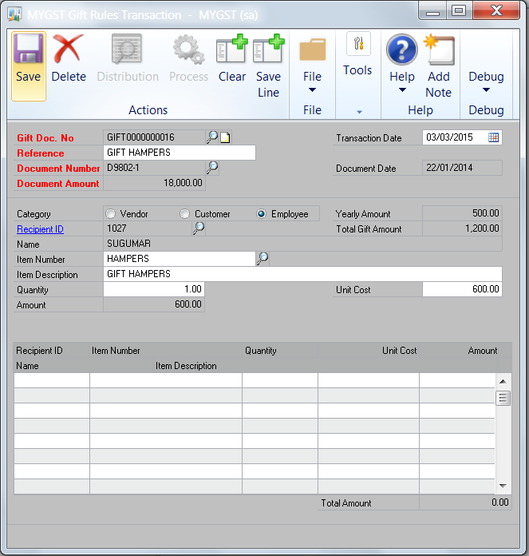

This window is for entry of gifts given free to Vendor, Customers and Employees.

- [Gift Doc No.]: The number is system generated.
- [Reference] Enter description of transaction
- [Document No] Select [Look-up] the vendor document number related to the purchase of the gifts.
- [Document Amount]: Displayed from selected Vendor document.
- [Select the category] : Vendor/Customer/Employee
- [Recipient ID]: Select the recipient based on the selected category.
- Select the gift item from the look up on [Item Number]
- [Enter]: Quantity and Unit Cost
- Click [Save Line]
- The saved item will appear in the bottom window.
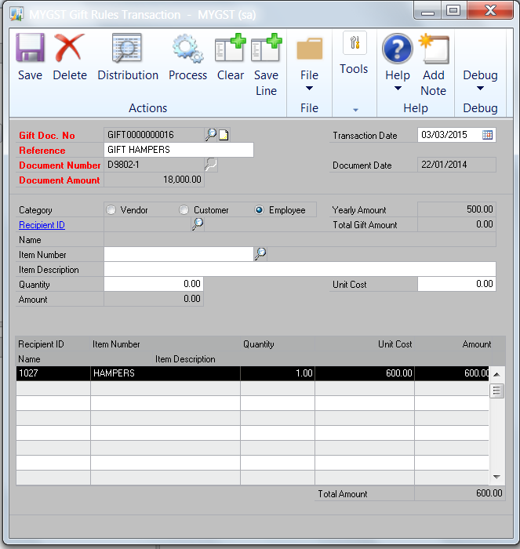

- Click [Distribution] to view transaction entry if the gift items per
Recipient has exceeded the threshold amount of RM500.00 per tax year.

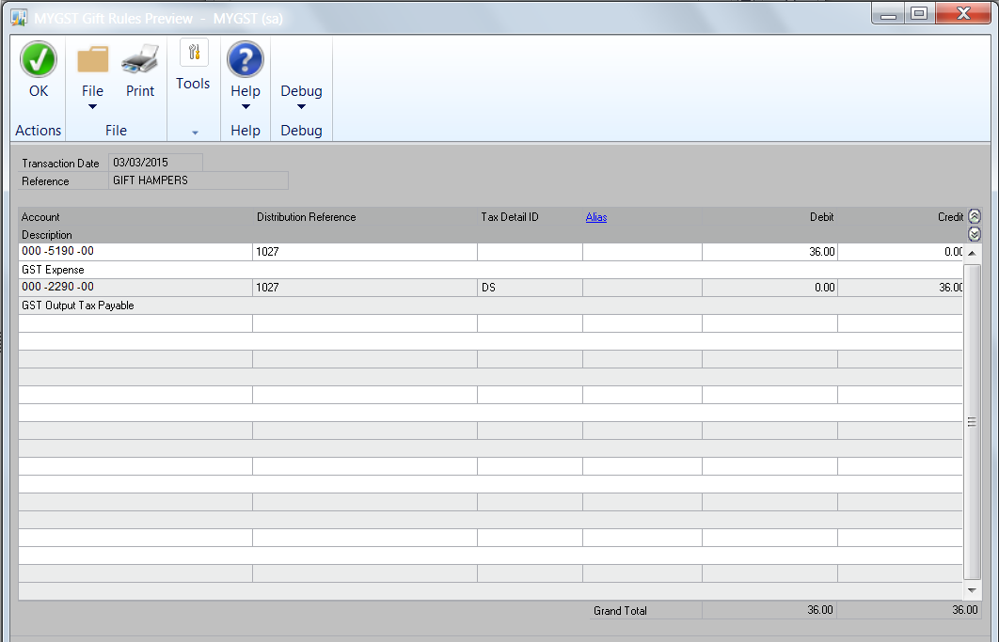

- The distribution entries will be displayed. The entries cannot be edited.
- [Click] Ok, to close the window.
- [Print] at File the edit list report at the Gift Rule Transaction Window.
- Upon confirmation of transactions, click [Process] at Gift Rule Transaction Window to post the transactions.

Imported Services Reverse Charge
Path: Transactions>>My GST >>Imported Services Reverse Charge

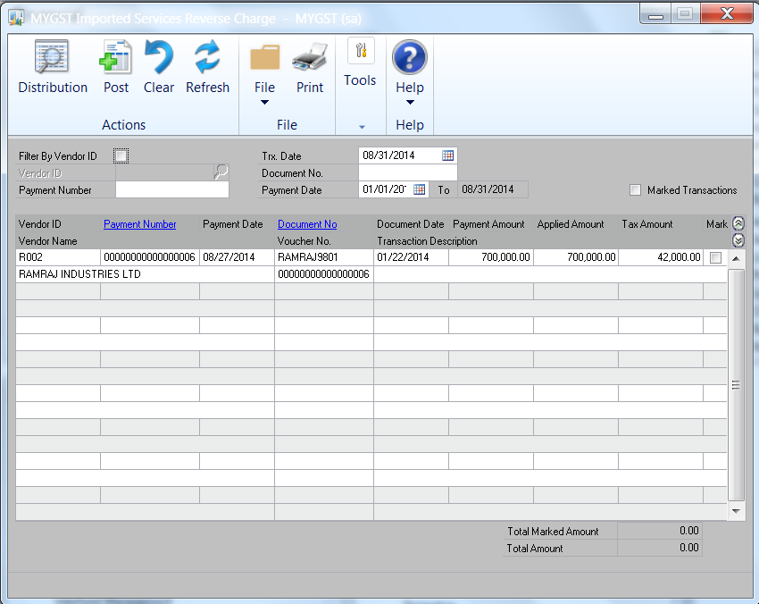
Select Options

This window displays payments for imported services which will account GST by ‘Reverse Charge Mechanism’.

- The documents displayed in the window can be selected by:

- Vendor ID
- Document Date
- Transaction Date
- Document Number
- Payment Number
- Payment Date

- Select [Mark] the transactions that are displayed in the window. The details of the transactions can be viewed by highlighting the transactions and clicking on [Payment Number] or [Document No].

- Click Distribution to view GL distribution entries and the tax code assigned.

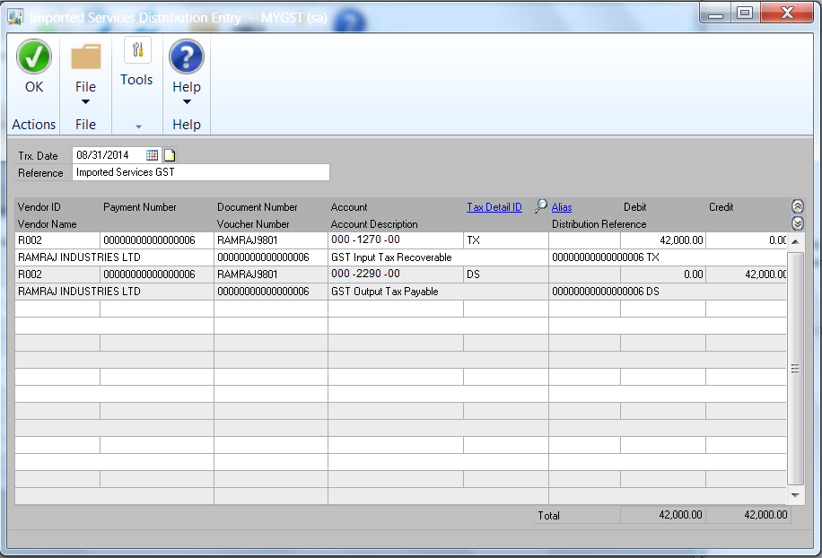

- Click OK and Go back to Imported Service Reverse Charge window and print edit list report.

- Post the transactions

Payables Bad Debts Recovery Adjustment
Path: Transactions>>My GST >>Payables Bad Debts Recovery Adjustment

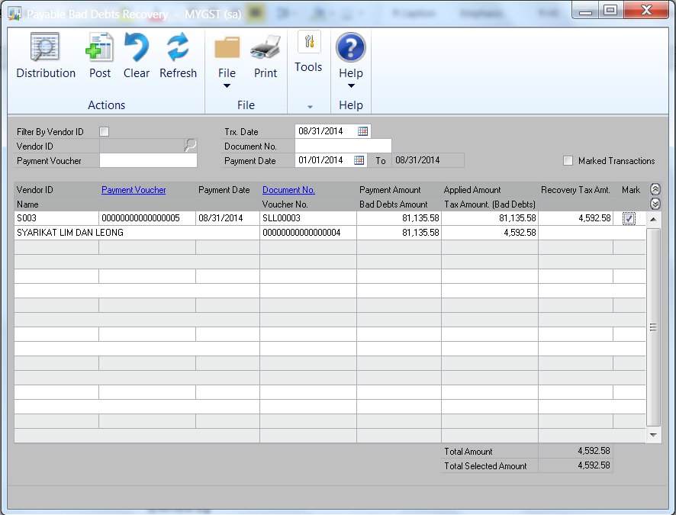
Select Options

This window displays payments for recovery of bad debts relief adjustments on purchases.

- The documents displayed in the window can be selected by:

- Vendor ID
- Document Date
- Transaction Date
- Document Number
- Payment Number
- Payment Date

- Select [Mark] the transactions that are displayed in the window. The details of the transactions can be viewed by highlighting the transactions and clicking on [Payment Number] or [Document No].

- Click Distribution to view GL distribution entries and the tax code assigned.

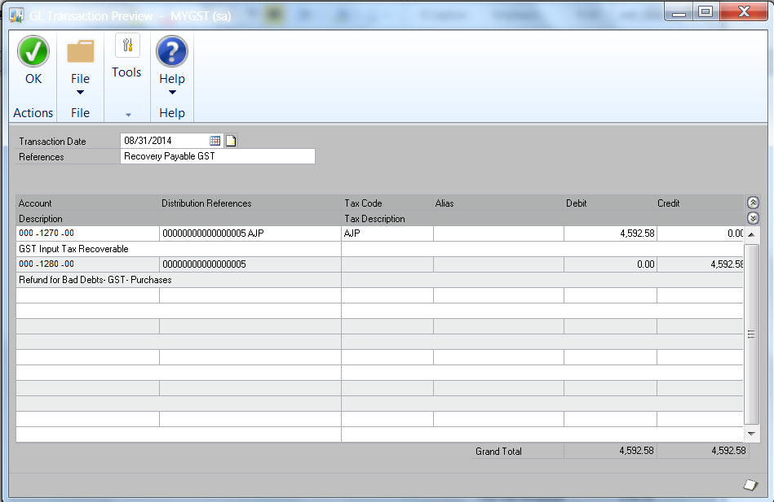

- Click OK and Go back to Payables Bad Debts Recovery Adjustment window and print edit list report.

- Post the transactions

Receivables Bad Debts Recovery Adjustment
Path: Transactions>>My GST >>Receivables Bad Debts Recovery Adjustment

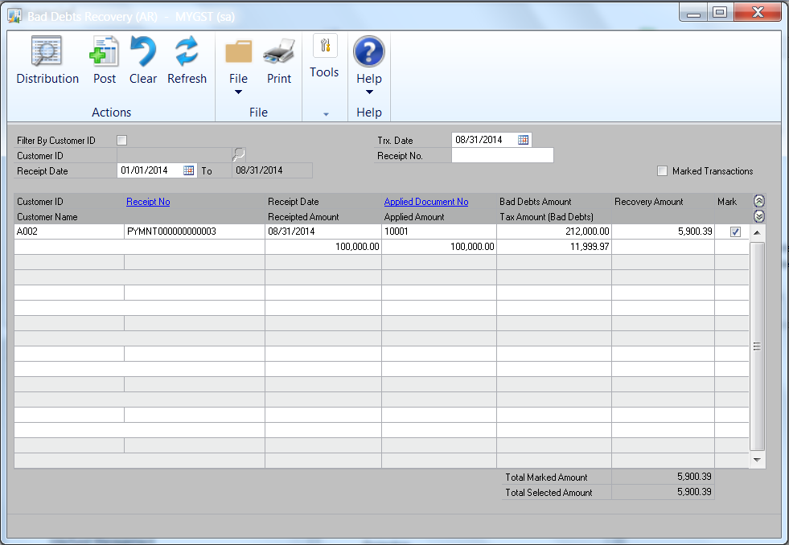
Select Options

This window displays payments received for recovery of bad debts relief adjustments on receivables.

- The documents displayed in the window can be selected by:

- Customer ID
- Receipt Date
- Transaction Date
- Receipt No.

- Select [Mark] the transactions that are displayed in the window. The details of the transactions can be viewed by highlighting the transactions and clicking on [Receipt Number] or [Applied Document No].

- Click Distribution to view GL distribution entries and the tax code assigned.

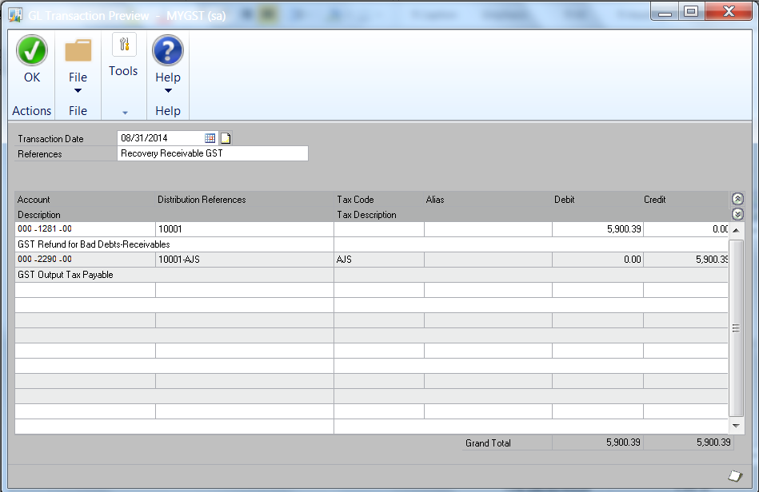

- Click OK and Go back to Receivables Bad Debts Recovery Adjustment window and print edit list report.

- Post the transactions

Deemed Supplies - GST charged on private use of business asset
Path: Transactions>>Financial>>Batch

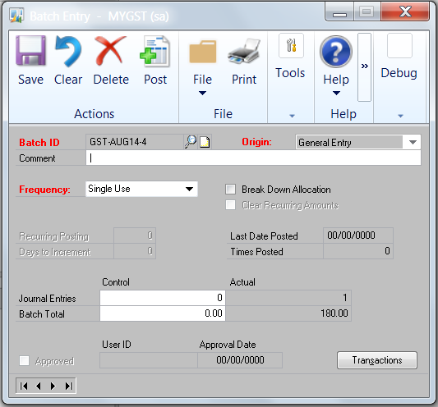

- Create Batch ID [Batch ID]

- Origin: Select [General Entry]

- Frequency: Select [Single Use]

- Click [Transactions] to open Transaction Entry window.

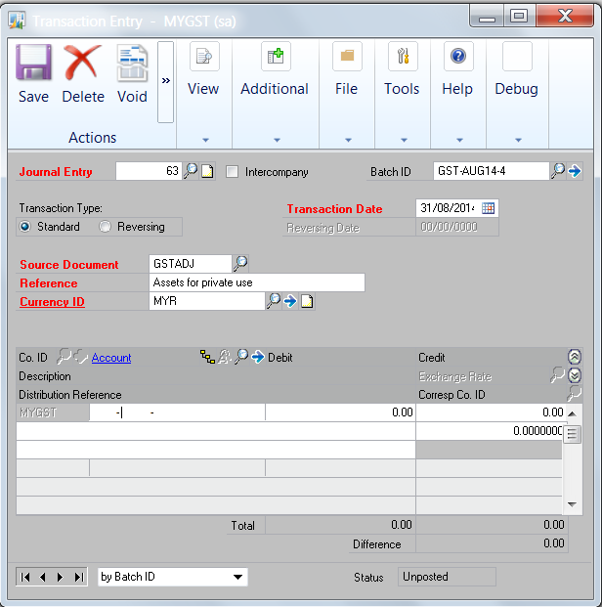
- [Journal Entry] is system generated

- [Transaction Date] is defaulted to system date.

- [Reference] enter description of transaction

- Click [Additional] to open transaction window for [deemed supplies]

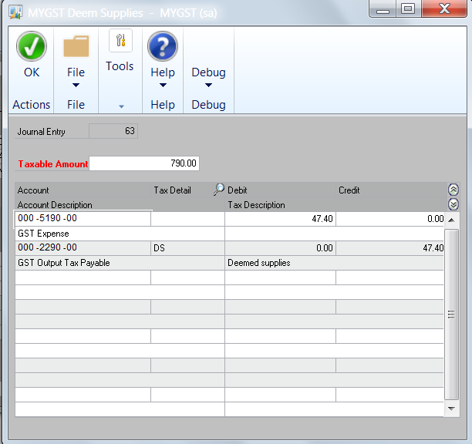

- [Taxable Amount] Enter taxable amount of deemed supplies

- The GL distribution for the tax amount and tax detail will be automatically created by the system.

- Click [Ok] to save transaction

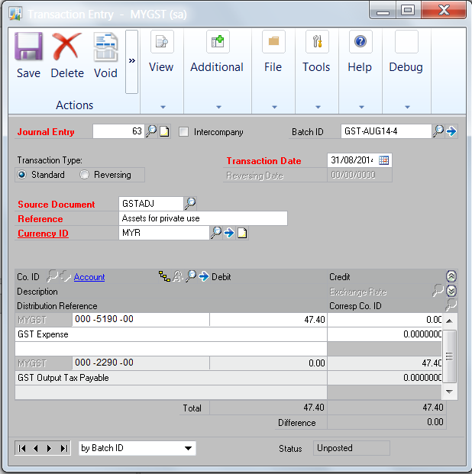

- The entries in the Deemed Supplies window will be created in the transaction window.

- [Save] transactions

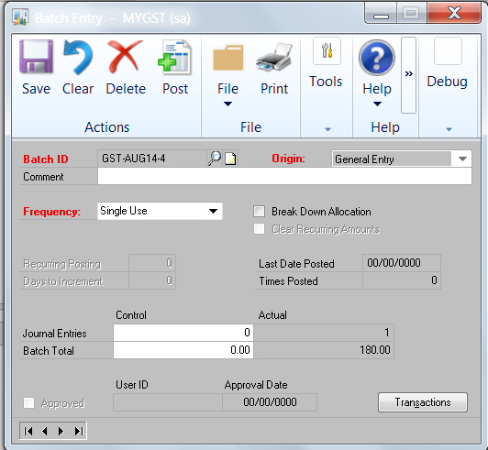

- Open [Batch] ; Path: Transaction>>Financial>>Batch

- [Print] batch edit list report to verify accuracy of transactions.

- [Post] batch to update General Ledger and Tax Details.

Staff Claims – Through Accounts Payable
Path: Transactions>>Purchasing>>Batches

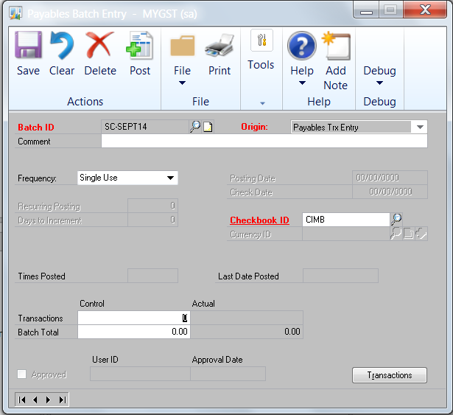

- Create Batch ID [Batch ID]

- Origin: Select [Payables Trx Entry]

- Frequency: Select [Single Use]

- Enter [Checkbook ID]

- Click [Transactions] to open Transaction Entry window.

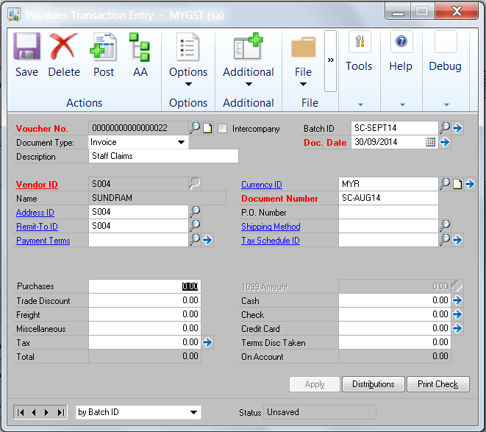

- Select [Staff Vendor]

- Enter [Document Date]

- Enter [Document Number]

- Click [Additional] to open GST Line Entry window

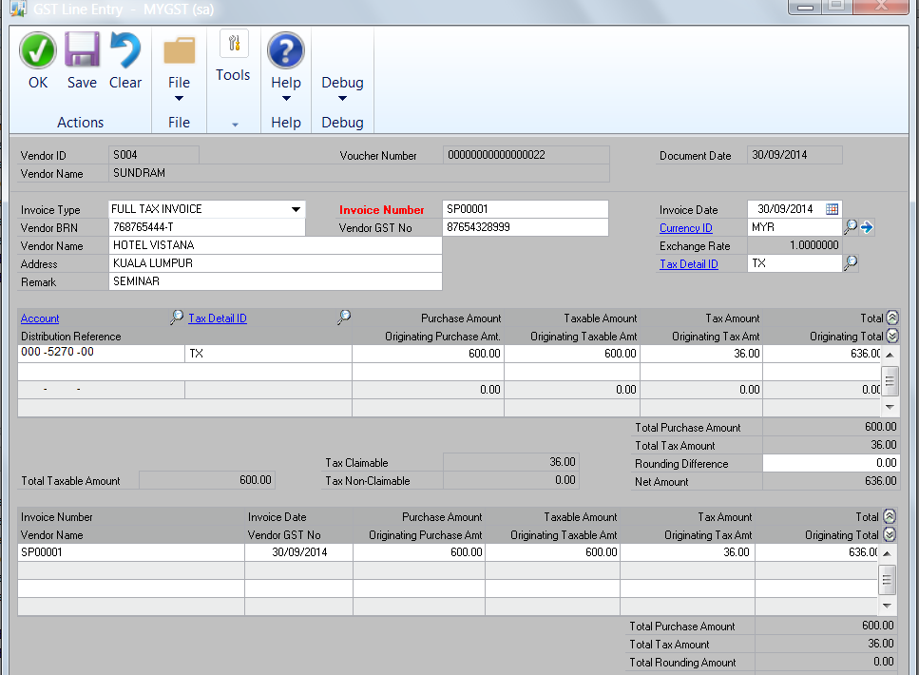

- Select [Invoice Type]

- Enter [Invoice Number]

- Enter transaction(s) for the invoice type(s) and [Save] the transactions

- Click [OK] to open the GL Distribution window

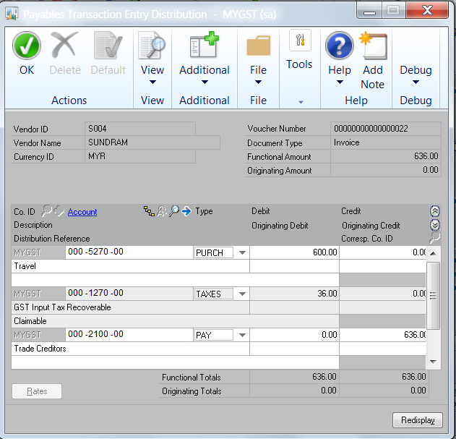

- The GL Distribution for the transaction entries will be displayed.

- Click [OK] to close the window

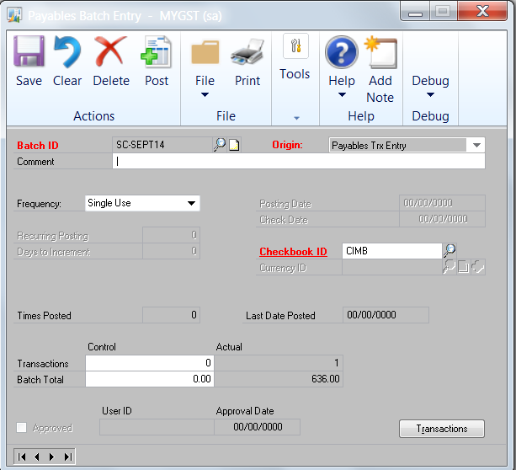

- Open [Batch] ; Path: Transaction>>Purchasing>>Batches

- [Print] batch edit list report to verify accuracy of transactions.

- [Post] batch to update Accounts Payable, General Ledger and Tax Details.

Inquiry

Payables Bad Debts Relief Adjustment Inquiry
Path: Inquiry>>My GST >>Payables Bad Debts Relief Adjustment

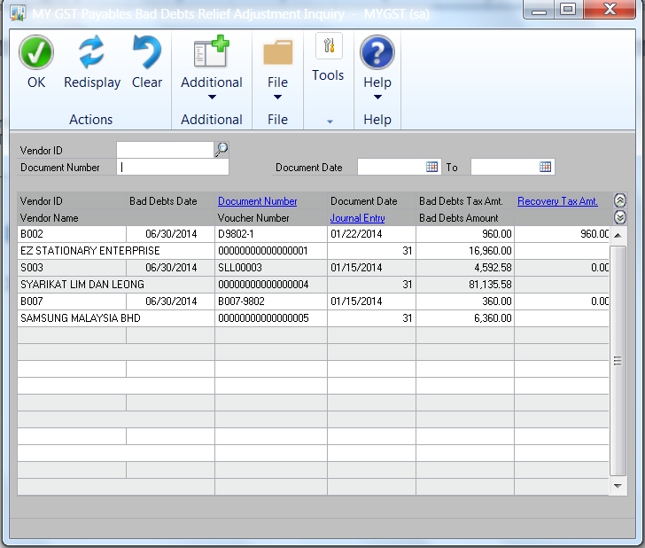
Select Options
Use this window to view information on Payables Bad Debts Relief Adjustment transactions and status of recovery on relief adjustments claimed/repaid.

- The documents displayed in the window can be selected by:

- Vendor ID
- Document Number
- Document Date

- The details of the transactions can be viewed by highlighting the transactions and clicking on [Document Number] or [Journal Entry] or [Recovery Tax Amount]

Receivables Bad Debts Relief Adjustment Inquiry
Path: Inquiry>>My GST >>Receivables Bad Debts Relief Adjustment

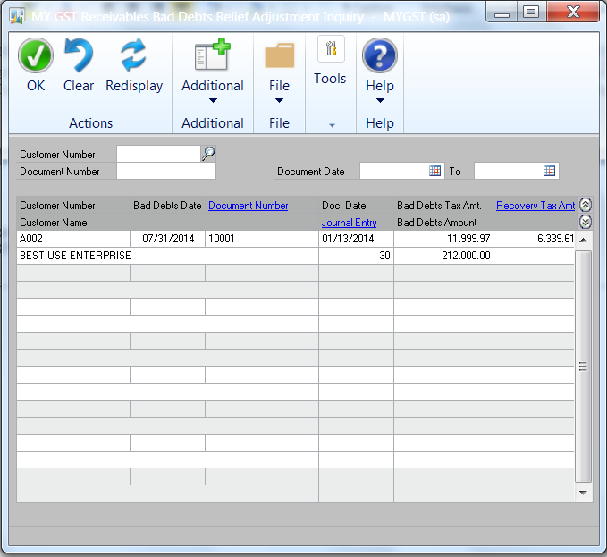
Select Options

Use this window to view information on Receivables Bad Debts Relief Adjustment transactions and status of recovery on relief adjustments claimed/repaid.

- The documents displayed in the window can be selected by:

- Customer ID
- Document Number
- Document Date

- The details of the transactions can be viewed by highlighting the transactions and clicking on [Document Number] or [Journal Entry] or [Recovery Tax Amount]

Imported Services Reverse Charge Inquiry
Path: Inquiry>>My GST >>Imported Services Reverse Charge

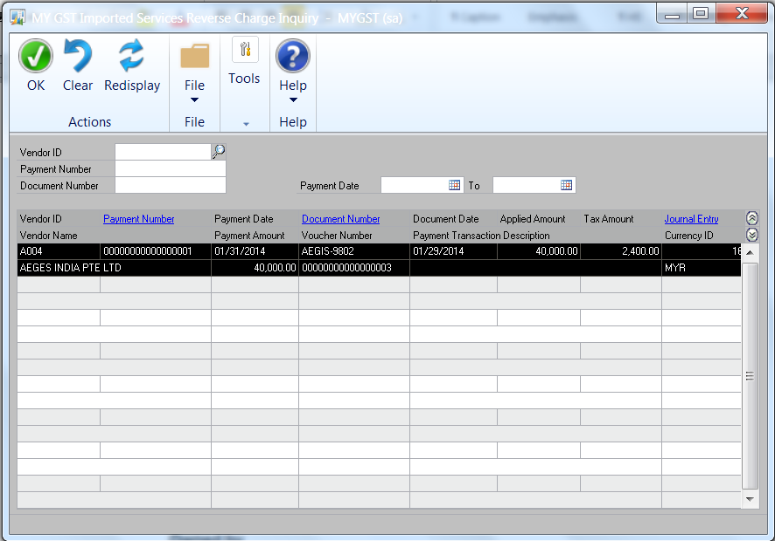
Select Options

Use this window to view information on posted Imported Services Reverse Charge transactions.

- The documents displayed in the window can be selected by:

- Vendor ID
- Payment Number
- Document Number
- Payment Date

- The details of the transactions can be viewed by highlighting the transactions and clicking on [Payment Number] or [Document Number] or [Journal Entry]

Deemed Supplies Inquiry
Path: Inquiry>>My GST >>Deemed Supplies

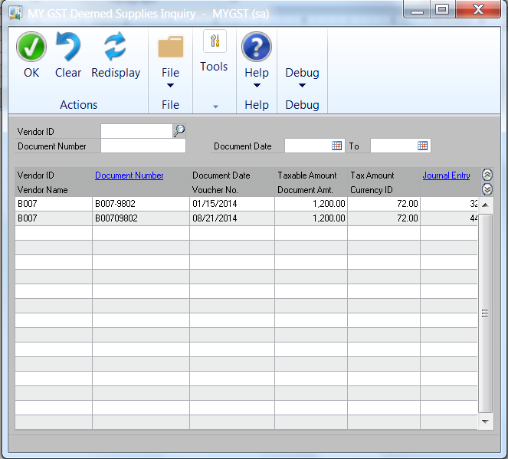
Select Options

Use this window to view information on posted Deemed Supplies transactions.

- The documents displayed in the window can be selected by:

- Vendor ID
- Document Number
- Document Date

- The details of the transactions can be viewed by highlighting the transactions and clicking on [Document Number] or [Journal Entry]

Gift Transaction Inquiry
Path: Inquiry>>My GST >>Gift Transaction

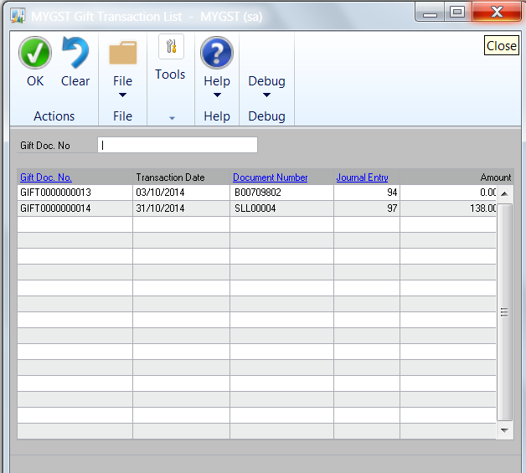

Use this window to view information on posted Gift transactions.

- The details of the transactions can be viewed by highlighting the transactions and clicking on [Gift Doc No], [Document Number] or
[Journal Entry]

Receivables Bad Debts Recovery Adjustment Inquiry
Path: Inquiry>>My GST >>Receivables Bad Debts Recovery Adjustment

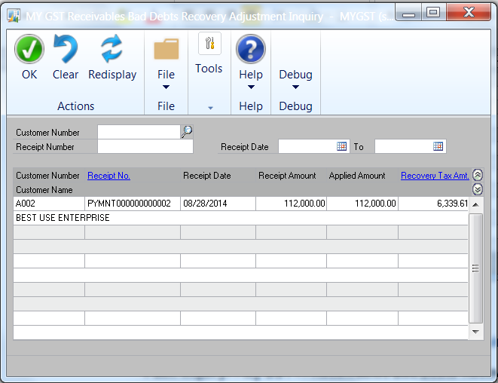
Select Options

Use this window to view information on posted Receivables Bad Debts Recovery Adjustment transactions.

1. The documents displayed in the window can be selected by:

- Customer ID
- Receipt Number
- Receipt Date

- The details of the transactions can be viewed by highlighting the transactions and clicking on [Receipt No] or [Recovery Tax Amt]

Payables Bad Debts Recovery Adjustment Inquiry
Path: Inquiry>>My GST >>Payables Bad Debts Recovery Adjustment

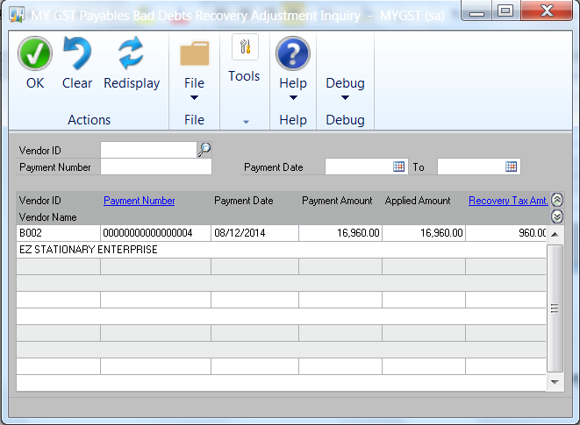
Select Options

Use this window to view information on posted Payables Bad Debts Recovery Adjustment transactions.

- The documents displayed in the window can be selected by:

- Vendor ID
- Payment Number
- Payment Date

- The details of the transactions can be viewed by highlighting the transactions and clicking on [Payment No] or [Recovery Tax Amt]

GST 03 Inquiry
Path: Inquiry>>My GST >>GST 03 Inquiry

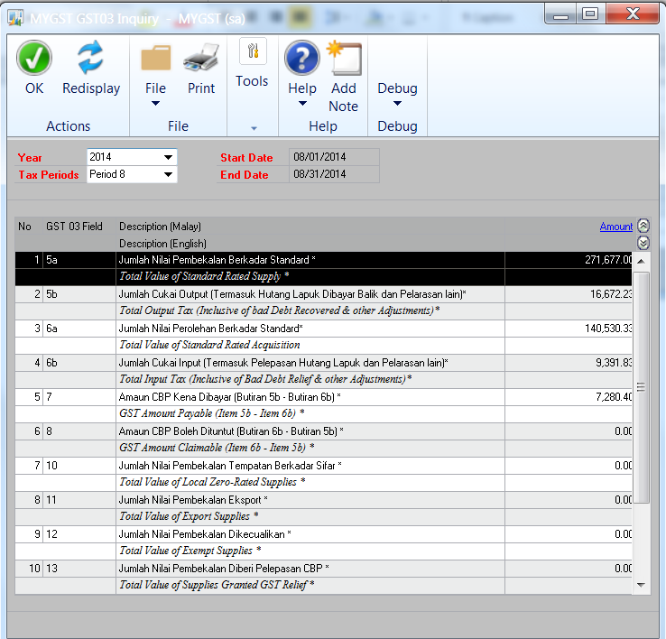

Use this window to view information on GST 03 returns, which are identified by GST 03 fields.

- To perform Inquiry:

- Select [Year] from drop-down list
- Select [Tax Periods] from drop-down list
- Start Date and End Date of the Tax Periods will be displayed.
- Click [Redisplay] to view the summary information of GST 03 Returns.

2. The details of the summary information can be viewed by highlighting the GST 03 Field and clicking on [Amount]

Reports

GST 03 Report
Path: Reports>>My GST >>GST 03
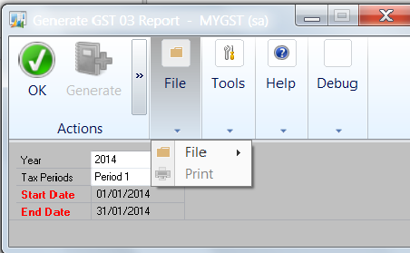

Use the GST 03 Report to print the GST 03 returns

1. Select the [Year] from the drop-down list

- Select the [Tax Periods] from the drop-down list

3. Start Date and End Date will be displayed.

4. Select [Print] to print the GST03 return form.

GST 03 Report
Path: Reports>>My GST >>GST Summary Report

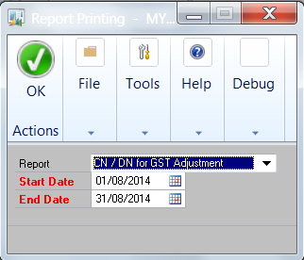

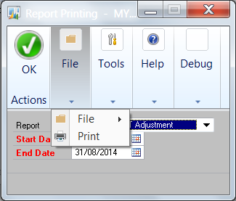

Use the GST Summary Report function to print the following reports;

- CN/DN for GST Adjustment
- GST Additional Information
- GST AP Bad Debt Claim
- GST AR Bad Debt Claim
- GST Total Acquisition and Input Tax
- GST Total Supply and Output Tax

- Select the [Report] from the drop-down list

- Start Date and End Date will be displayed.

- Select [Print] to print the selected report

Gift Items Transaction Report
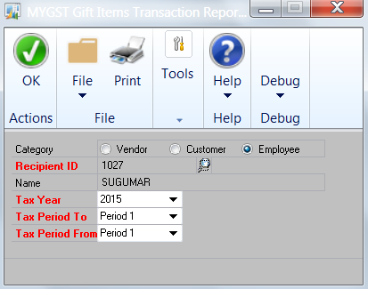

- Select the [Recipient ID]
- Elect [Tax Year]
- Select [Tax Period From]
- Select [Tax Period To]
- Click [Print] to print report

GST Audit File
Path: Reports>>My GST >>GST Audit File

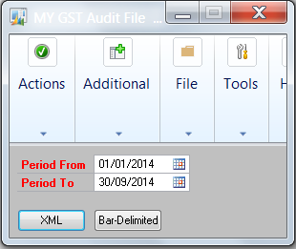

Use the GST Audit File (GAF) to upload details through GST Customs Portal.

- Enter the [Period From] and [Period To]

- Select [XML] or [Bar Delimited] to print report

3. Click [Additional] to open GAF Log

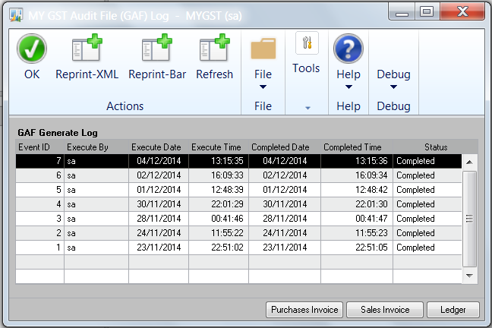

4. Click [Purchases] [Sales] and [Ledger] to export transactions to excel.
This allows the users to view the transactions before submitting the files
either in [XML] or [Bar Delimited] to Customs.

Tax Period End Closing
Path: Cards>>My GST >>Tax Period Setup

You need to perform period closing to close a tax period.

- Closed GST 03 will allow user to close the GST 03 returns which has been finalized and to be submitted to Customs.

- Click on GST03 journal to view GST closing journal, and print journal report.

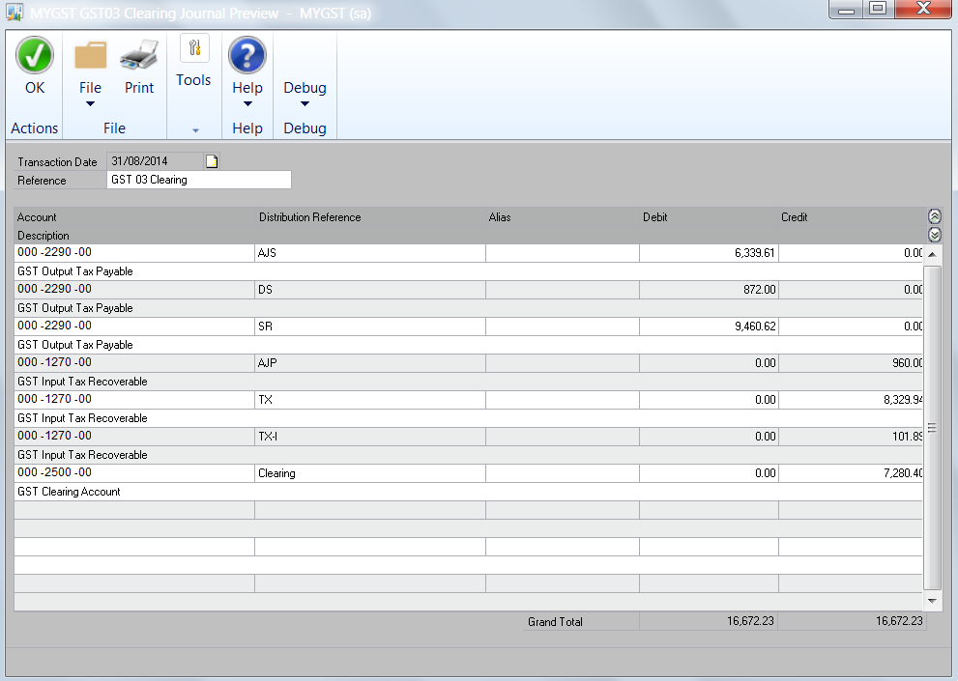

- When the GST 03 tax period is closed (ticked), the journal will be posted automatically.

.

END OF DOCUMENT

