

GST Setup Guide

Contents
Setup 3
Remove company Shipping Method option 3
Create Tax Detail 4
Create Tax Schedule 5
Assign default tax id to Receivable and Payable 6
Assign tax id to customer and vendor 8
Assign tax id to inventory item 10
Transaction 13
Receivable invoice 13
Payable invoice 14
SOP sale invoice 15
Purchase Order Entry 16
Receiving Transaction Entry (Non PO) 17
Report 19
GST Report 19

Setup

Remove company Shipping Method option

Path: Microsoft Dynamics GP > Tools > Setup > Company > Company > Options

This option is not required in local environment. You need to ensure it is unmark.

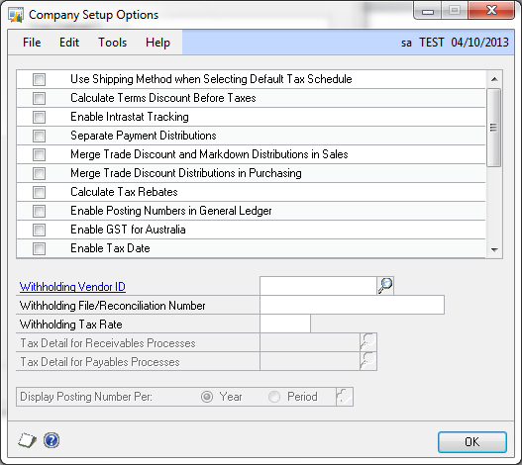

Create Tax Detail

Path: Microsoft Dynamics GP > Tools > Setup > Company > Tax Details

This window is used to setup the GST tax detail. You can create as many as Tax Detail that fit your company.

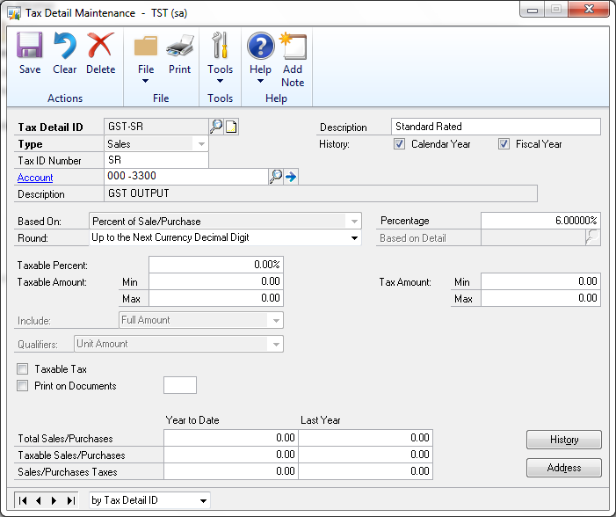

Enter tax detail as above.
Make sure you enter the ‘Tax ID Number’ by using the recommended tax code by Custom.

Create Tax Schedule

Path: Microsoft Dynamics GP > Tools > Setup > Company > Tax Schedules

Use Tax Schedule Maintenance window to group the Tax Detail so that GP can default the correct tax code during transactions entry.

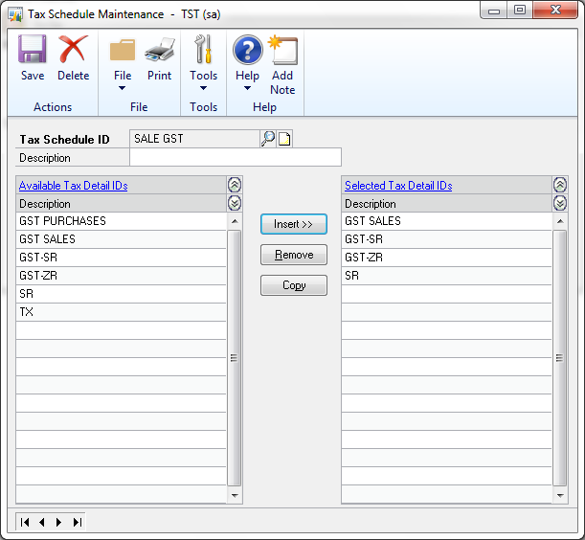

You can assign a single or multiple Tax Detail to the Tax Schedule.

Assign default tax id to Receivable and Payable

Path: Microsoft Dynamics GP > Tools > Setup > Sales > Receivables > Options

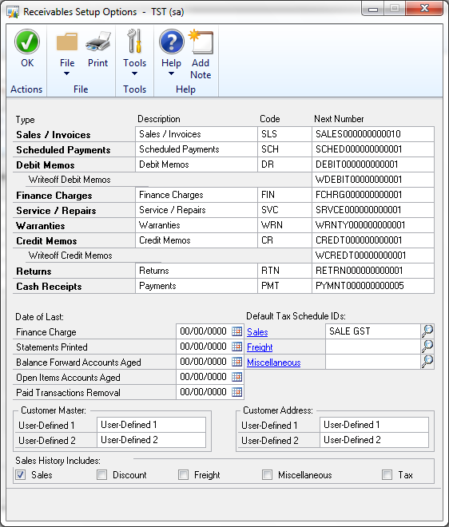

You need to select a default tax id for sales. This tax ID should contain all the sale Tax Detail ID that use while creating a sale invoice.

Path: Path: Microsoft Dynamics GP > Tools > Setup > Purchasing > Payables > Options

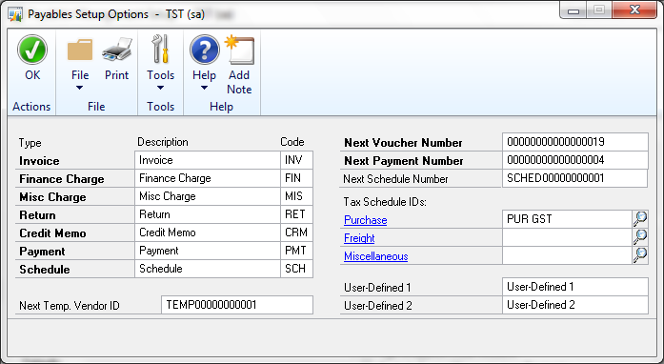

You need to select a default tax id for purchases. This tax ID should contain all the purchase Tax Detail ID that use while creating a purchase invoice.

Assign tax id to customer and vendor

Path: Cards > Sales > Customer

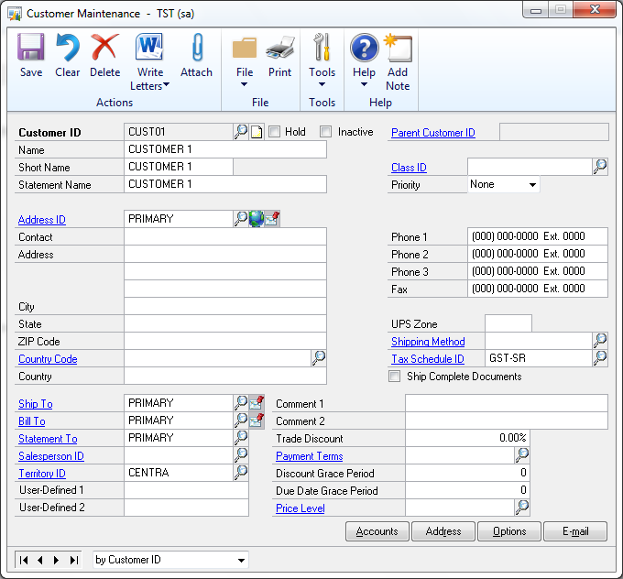

You need to select a default tax id for customer, the sale purchase for the customer will be based on this tax id.

Path: Cards > Purchasing > Vendor

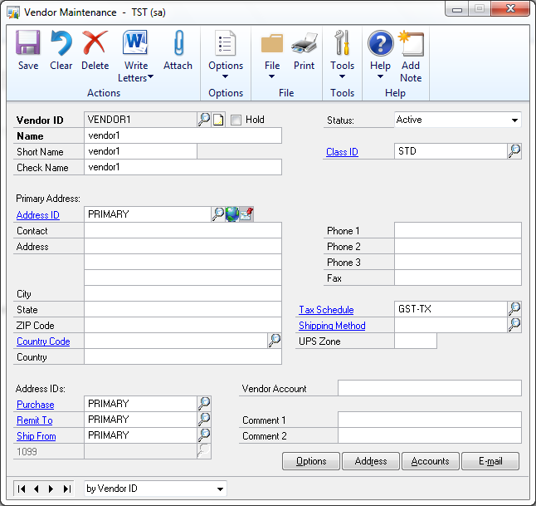

You need to select a default tax id for vendor , the vendor purchase invoice will based on this tax id.

Assign tax id to inventory item

Path: Cards > Inventory > Item

If you are using Sale Order Processing or Purchase Order Processing module, you need to use Item Maintenance window to setup the way how GP default the tax id for the item to the customer/vendor.

For GST, in Sale Tax Option and Purchase Tax Option, you have 2 options here:

- Taxable
- Base on customers (for sale); Base on vendor (for purchase).

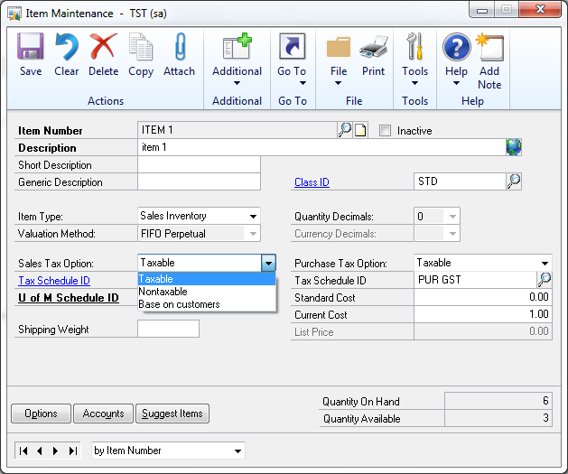

Option 1:

If you select Base on customers or Base on vendor, all the items in sale and purchase invoices will be based on the tax id that you created in Customer Maintenance and Vendor Maintenance.

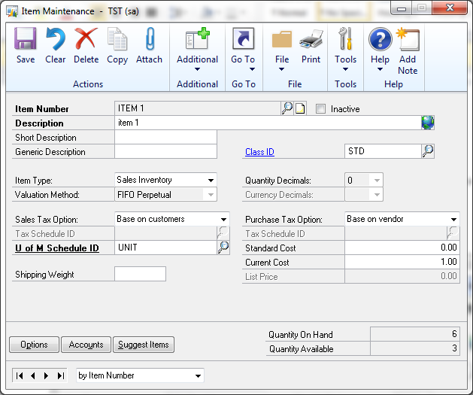

Option 2:

If you select Taxable, you need to select the tax id used for the item in Tax Schedule ID. Tax id will be defaulted to sale and purchase invoices when both the tax id from Customer Maintenance / Vendor Maintenance and Item Maintenance are matched.

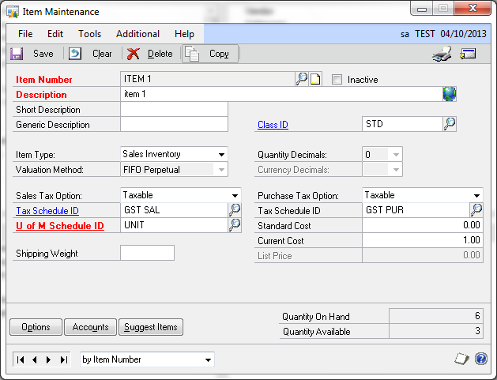

Transaction

Receivable invoice

Path: Transactions > Sales > Transaction Entry

Use Receivable Transaction Entry to enter a simple sale invoice.

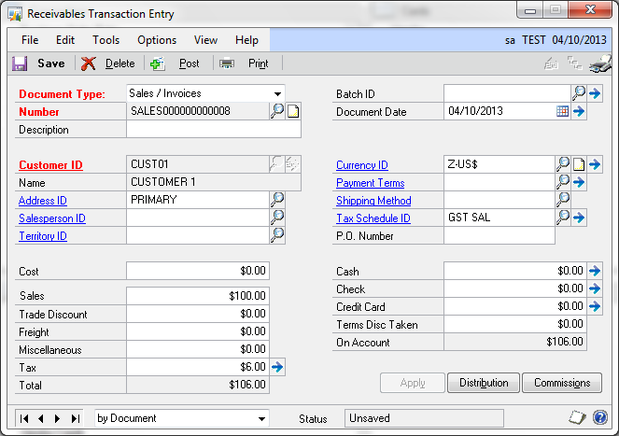

When entering invoice, after entering the Sales amount, you need to move/click on the Tax so that GP can default the tax amount for you. You can click on the blue arrow next to the Tax to show tax detail.

Payable invoice

Path: Transactions > Purchasing > Transaction Entry

Use Payables Transaction Entry to enter a simple purchase invoice.

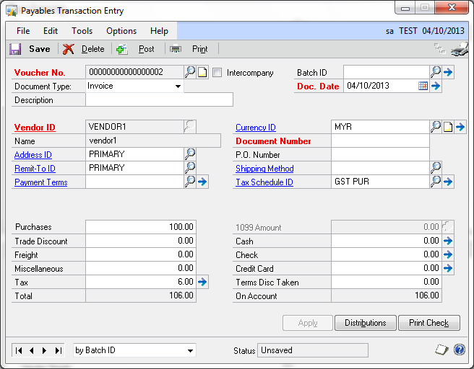

When entering invoice, after entering the Purchases amount, you need to move/click on the Tax so that GP can default the tax amount for you. You can click on the blue arrow next to the Tax to show tax detail.

SOP sale invoice

Path: Transactions > Sales > Sale Transaction Entry

Use Sales Transaction Entry window to enter a sale invoice.

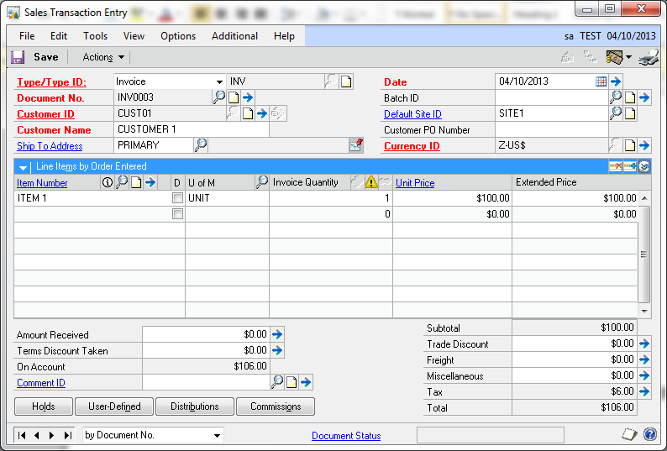

The tax will be calculated when you entering the line item.

The tax will be based on the setup that you defined in Item Maintenance; Whether by customer or by customer and match to the tax defined in Item Maintenance.

You can click on the blue arrow next to the Tax to show tax detail.

Purchase Order Entry

Path: Transactions > Purchasing > Purchase Order Entry

Use Purchase Order Entry window to enter a Purchase Order.

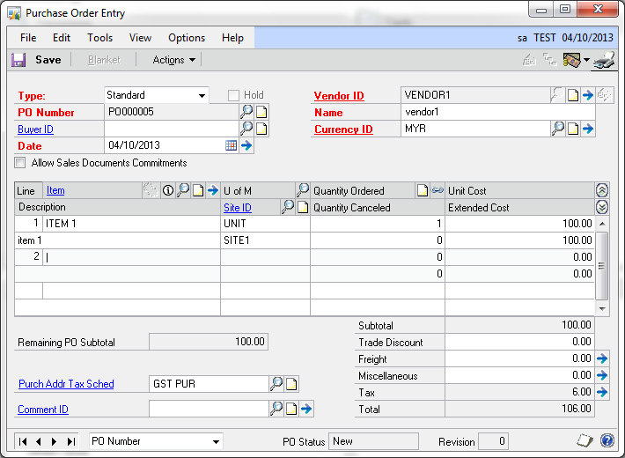

The tax will be calculated when you entering the line item.

The tax will be based on the setup that you defined in Item Maintenance; whether by vendor or by vendor and match to the tax defined in Item Maintenance.

You can click on the blue arrow next to the Tax to show tax detail.

Receiving Transaction Entry (Non PO)

Path: Transactions > Purchasing > Receiving Transaction Entry

Use Receiving Transaction Entry window to enter Non PO purchases

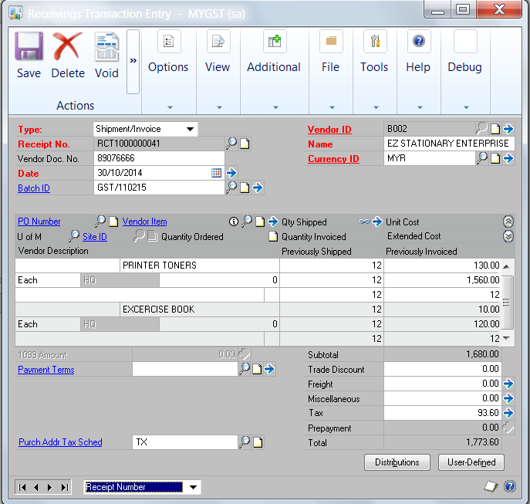
- Select Type: Shipment/Invoice
- Receipt No: The Receipt No. will be system generated. It can be edited.
- Enter Batch ID to save the transaction.
- The tax code will be defaulted from Vendor Master setup (Non Inventoried item) or Item Master (for Inventory Item)
- Enter purchase details for each item in the line details ( 3 rows details for each line item)
- Open the line item detail window to enter purchase account (COA). Click on the blue arrow

Item Details

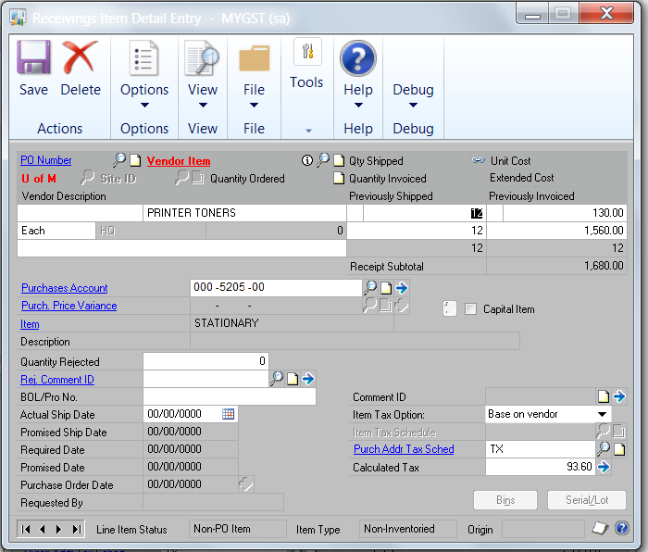

- Enter Purchases Account COA.
- The Calculated Tax Amount for the line item will be displayed based on the Tax Code settings.
- [Save] the line item, and enter the next purchase line item

Report

GST Report

Path: Reports > Company > Taxes

Use Company Taxes Reports to print GP standard tax reports.

